Table 1: Three dimensional structure of proteins showing ligand-protein complex through interacting amino acids
Protein Targets | 3D-strctures of proteins | Ligand-protein complex | Interacting Amino Acid
6W02 | 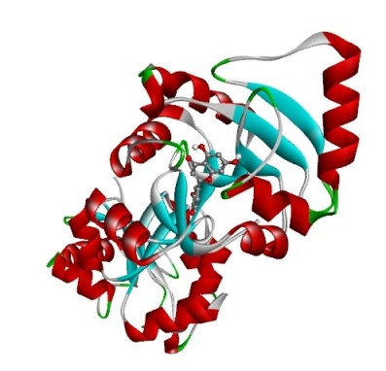 | 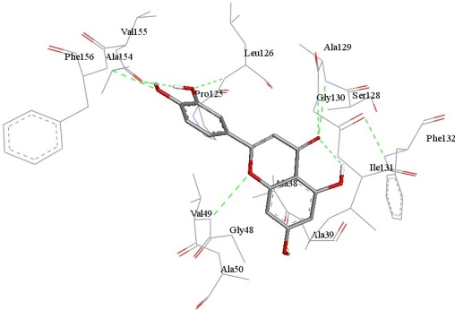 | Ala38, Ala39,Gly48, Val49, Ala50, Pro125, Leu126, Ser128, Ala129, Gly130, Ile131, Phe132, Ala154, Val155, Phe156
6Y2E | 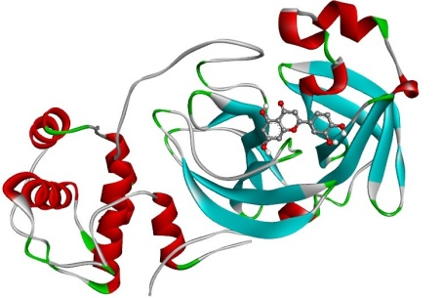 | 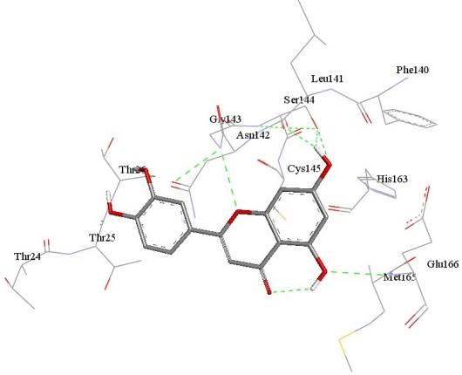 | Thr24, Thr25, Thr26, Phe140, Leu141, Asn142, Gly143, Ser144, Cys145, His163, Met165, Glu166
6M03 | 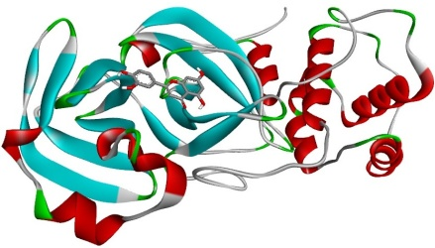 | 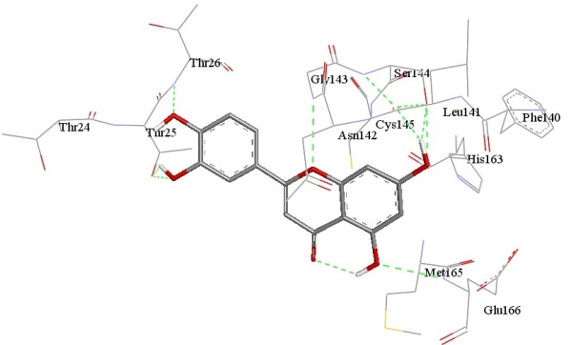 | Thr24, Thr25, Thr26, Phe140, Leu141, Asn142, Gly143, Ser144, Cys145, His163, Met165, Glu166
6VSB | 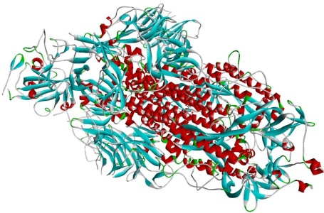 | 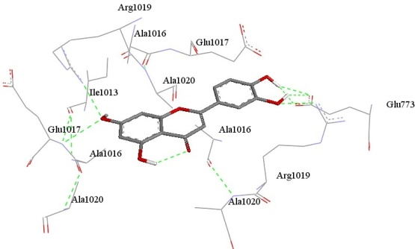 | Glu773, Ile1013, Ala1016, Glu1017, Arg1019, Ala1020
6VYO | 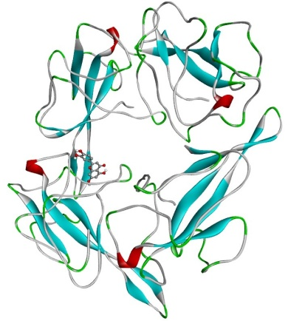 | 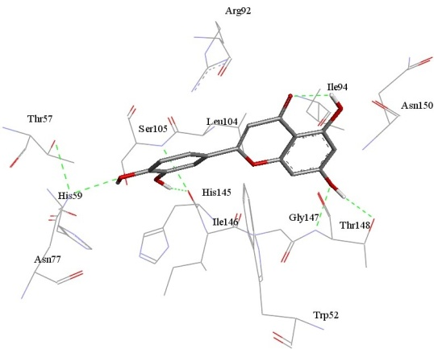 | Trp52, Thr57, His59, Asn77, Arg92, Ile94, Leu104, Ser105, His145, Ile14, Gly147, Thr148, Asn 150
6VXX | 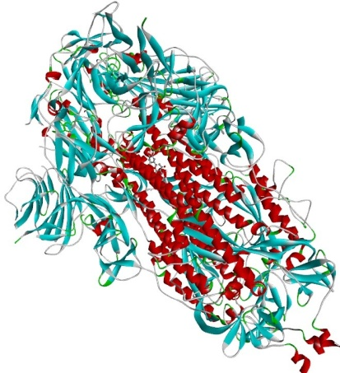 | 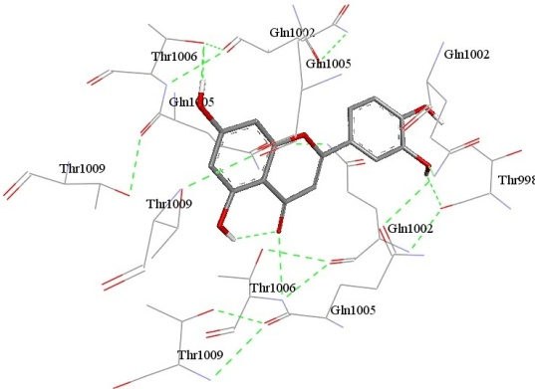 | Thr998, Gln1002, Gln1005, Thr1006, Thr1009

