Supplementary Material
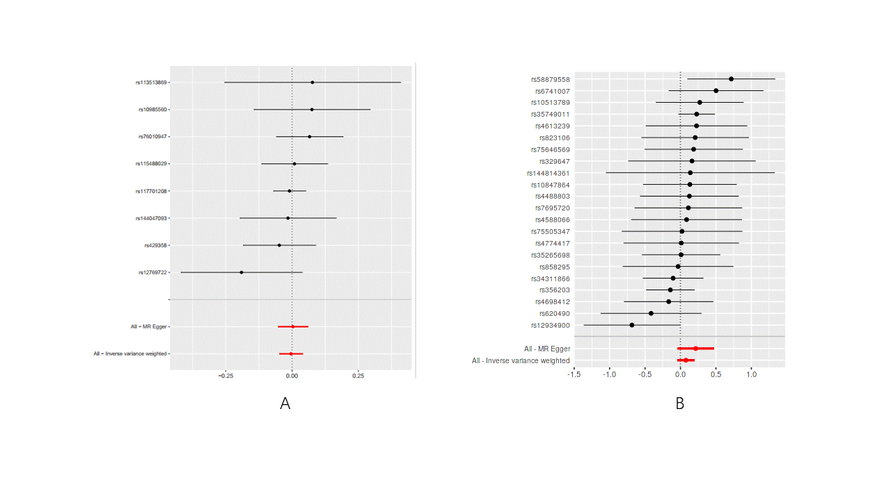
Figure S1：Forest plot of the MR results between PD and delirium. A: Delirium on PD. B: PD on delirium, MR: Mendelian randomization

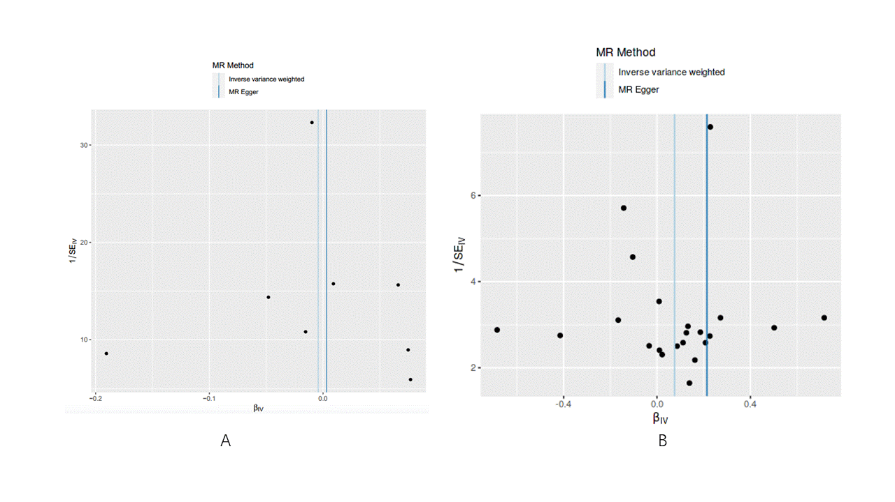
Figure S2： Funnel plots of the association between PD and delirium. A: Delirium on PD. B: AD on delirium, MR: Mendelian randomization

