Supplementary information

Safety profiles of sodium-glucose co-transporter 2 inhibitors in Japanese patients with diabetes mellitus: A literature review and meta-analysis

Junichi Mukai, Shinya Kanno, and Rie Kubota

Supplementary Table S1 Summary of subgroup analyses
 | Outcome | Trial,  n | Reference(s) excluded | SGLT2 inhibitors, n | Placebo,  n | Risk ratio  [95%CI] | I²  (%) | p
Only patients with type 2 DM | Hypoglycemia | 19 | Shimada 2018 ¹⁸ | 3028 | 1276 | 1.30 [1.01, 1.65] | 0 | 0.04
 | UTI | 21 | Shimada 2018 ¹⁸ | 3515 | 1444 | 0.78 [0.47, 1.31] | 0 | 0.35
 | Genital infection | 17 | Shimada 2018 ¹⁸ | 2846 | 1232 | 1.28 [0.63, 2.60] | 0 | 0.49
 | Hypovolemia | 10 | Shimada2018 ¹⁸ | 1518 | 605 | 1.12 [0.48, 2.61] | 0 | 0.80
 | Fracture | NA
Only patients treated with a SGLT2 inhibitor  as monotherapy | Hypoglycemia | 9 | Inagaki 2016 ¹², Kadowaki 2017 ¹³, Araki 2016 ¹⁴, Kawamori 2018 ¹⁷, Shimada 2018 ¹⁸, Ishihara 2016 ¹⁹, Kashiwagi 2015A ²¹, Kashiwagi 2015B ²², Kashiwagi 2015D ²⁴, Kashiwagi 2015E ²⁵, Terauchi 2017 ³¹ | 1769 | 595 | 0.89 [0.37, 2.13] | 0 | 0.79
 | UTI | 11 | Inagaki 2016 ¹², Kadowaki 2017¹³, Araki 2016 ¹⁴, Kawamori 2018 ¹⁷, Shimada 2018 ¹⁸, Ishihara 2016 ¹⁹, Kashiwagi 2015A ²¹, Kashiwagi 2015B ²², Kashiwagi 2015D ²⁴,  Kashiwagi 2015E ²⁵, Terauchi 2017 ³¹ | 2256 | 763 | 0.88 [0.37, 2.13] | 0 | 0.78
 | Genital infection | 9 | Inagaki 2016 ¹²,  Araki 2016 ¹⁴, Kawamori 2018 ¹⁷, Shimada 2018 ¹⁸, Ishihara 2016 ¹⁹, Kashiwagi 2015A ²¹, Kashiwagi 2015B ²², Kashiwagi 2015D ²⁴, Kashiwagi 2015E ²⁵, Terauchi 2017 ³¹ | 1657 | 619 | 1.21 [0.46, 3.19] | 0 | 0.7
 | Hypovolemia | 8 | Kawamori 2018 ¹⁷, Shimada 2018 ¹⁸, Terauchi 2017 ³¹ | 1196 | 442 | 0.76 [0.25, 2.33] | 0 | 0.63
 | Fracture | 3 | Kawamori 2018 ¹⁷ | 319 | 195 | 0.46 [0.07, 3.12] | 7 | 0.43
DM diabetes mellitus SGLT2 sodium-glucose co-transporter 2, UTI urinary tract infection, NA not applicable, I² heterogeneity
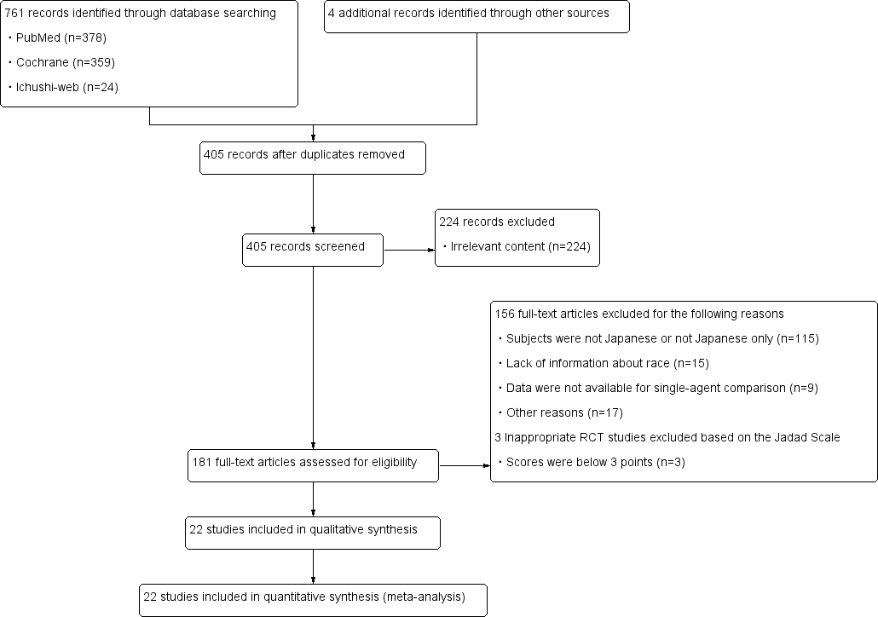
Supplementary Figure S1 Process to identify eligible randomized controlled trials following PRISMA
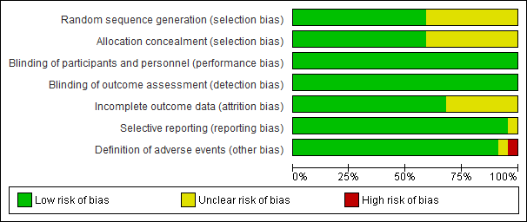

Supplementary Figure S2 Risk of bias graph of 22 randomized controlled trials

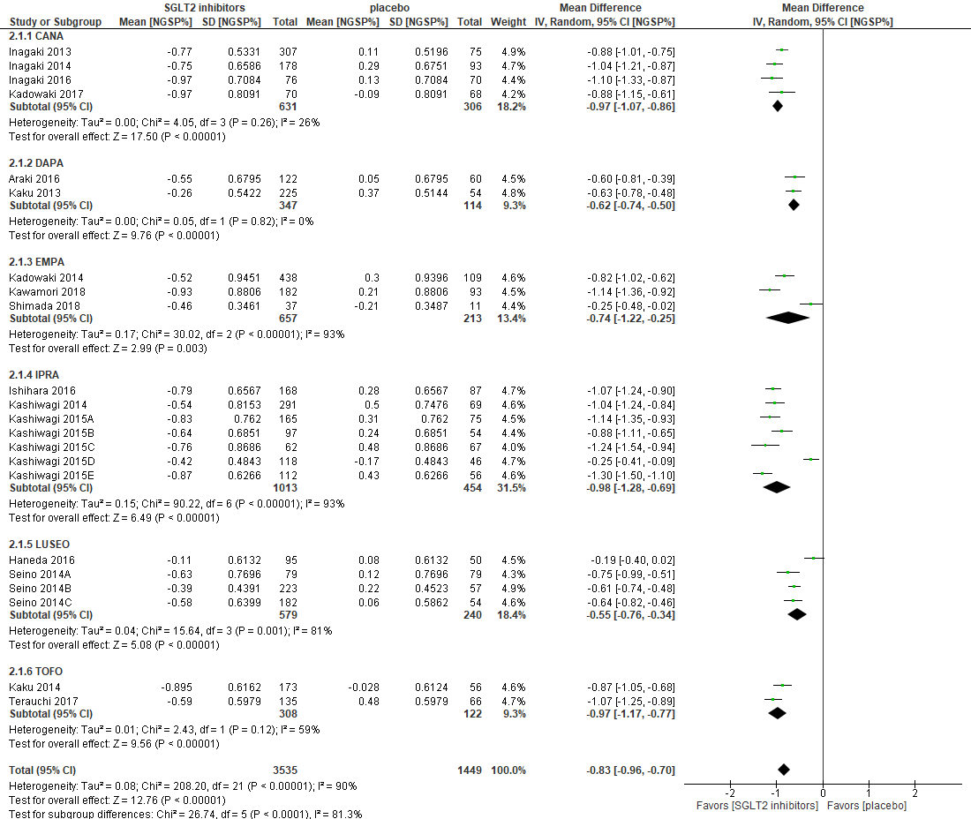

Supplementary Figure S3 Relationship between SGLT2 inhibitors and changes in HbA1c
Abbreviations: CANA, canagliflozin; DAPA, dapagliflozin; EMPA, empagliflozin; IPRA, ipragliflozin; LUSEO, luseogliflozin; TOFO, tofogliflozin; SGLT2, sodium-glucose co-transporter 2.

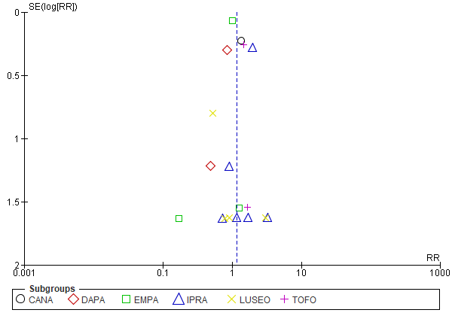
Supplementary Figure S4 Funnel plot for the risk of hypoglycemia
Abbreviations: CANA, canagliflozin; DAPA, dapagliflozin; EMPA, empagliflozin; IPRA, ipragliflozin; LUSEO, luseogliflozin; TOFO, tofogliflozin; SE, standard error; RR; risk ratio.

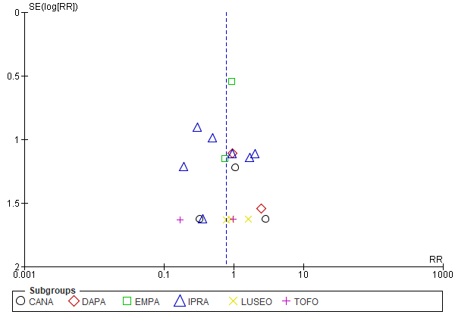
Supplementary Figure S5 Funnel plot for the risk of urinary tract infection
Abbreviations: CANA, canagliflozin; DAPA, dapagliflozin; EMPA, empagliflozin; IPRA, ipragliflozin; LUSEO, luseogliflozin; TOFO, tofogliflozin; SE, standard error; RR; risk ratio.

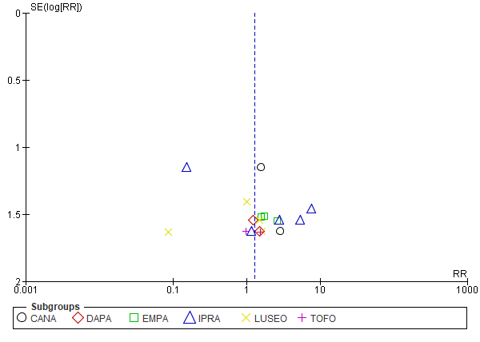
Supplementary Figure S6 Funnel plot for the risk of genital infection
Abbreviations: CANA, canagliflozin; DAPA, dapagliflozin; EMPA, empagliflozin; IPRA, ipragliflozin; LUSEO, luseogliflozin; TOFO, tofogliflozin; SE, standard error; RR; risk ratio.

