,Removal of Dye (%)
,Removal of Dye (%) |  | 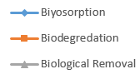
 | Concentration of Dye (mg L⁻)

