Supporting Information

CO residence time modulates multi-carbon formation rates in a zero-gap Cu based CO₂ electrolyzer
Siddhartha Subramanian, Jesse Kok, Pratik Gholkar, Asvin Sajeev Kumar, Hugo-Pieter Iglesias van Montfort, Ruud Kortlever, Atsushi Urakawa, Bernard Dam and Thomas Burdyny*
Corresponding author email: T.E.Burdyny@tudelft.nl
Materials for Energy Conversion and Storage (MECS), Department of Chemical Engineering,
Faculty of Applied Sciences, Delft University of Technology, van der Maasweg 9, 2629 HZ
Delft, The Netherlands.

Gas diffusion electrode architecture
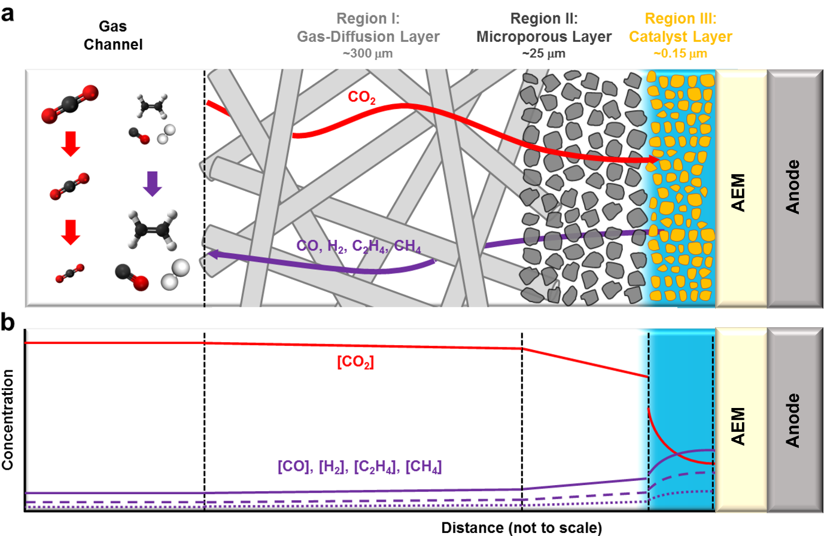
Supplementary Figure 1: Schematic of a gas diffusion electrode (GDE) architecture in an anion exchange MEA configuration. Shown here are the concentration gradients of various species inside the GDE.

Residence time distribution (RTD) measurements using mass spectrometry
RTD measurements were performed using a Omnistar Pfeiffer Vacuum mass spectrometer with a time resolution of 100 ms. The schematic of the tracer injection system is shown in Supplementary Figure 2. A pneumatic valve was used to switch the two gas streams, one containing the tracer (5 % CO in He) and the other containing pure He gas. The check valve depending on the position, switches the gas streams either to the cathode side of the MEA cell or to the exhaust. A LabVIEW program was used to control the injection and turn off for a fixed duration. For the pulse tracer tests, the tracer was injected for 30 s. For the negative tracer tests, the tracer was injected until the reactor reached saturation and turned off thereafter to record the release of the tracer.

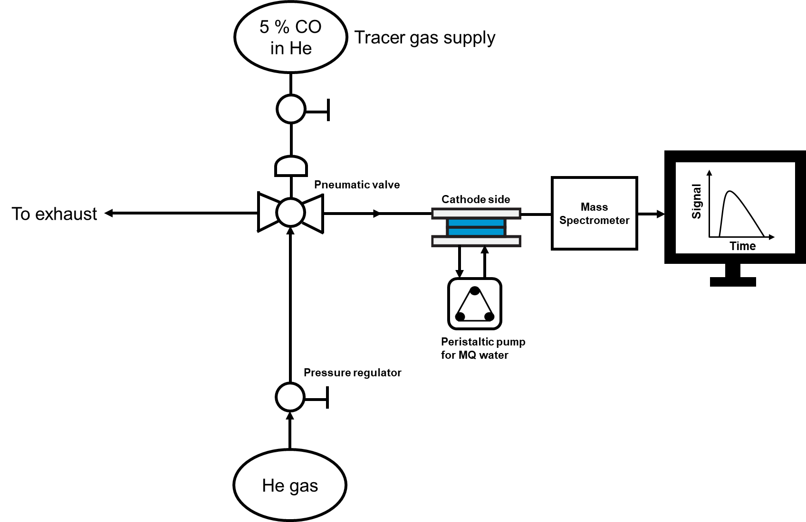
Supplementary Figure 2. Simplified process flow diagram of the RTD system used in the study.

Residence time distribution (RTD) measurements
All RTD tests were performed using commercially purchased carbon based GDL (Sigracet 39 BC) with a microporous layer. Two tests were performed to elucidate the differences between the dry and wetted MPL cases. In the first case, MEA cells were assembled similar to a CO₂ electrolyzer with carbon GDL, Sustainion AEM, Ni foam anode and the two gaskets for both sides. MQ water was constantly flowed at the anode compartment to keep the membrane wetted during RTD tests. At the cathode side, CO tracer was injected to monitor the RTD measurements.
In the second type of test, a pretreated Zirfon membrane was pressed on top of the microporous layer side of the GDL inside the MEA cell (Supplementary Figure 3b). Since water was flowing at the other compartment (anode side on Ni foam), porous Zirfon membrane was wetted and acted as a reservoir of water in contact with the carbon GDL at the cathode. This then mimicked a ‘wetted catalyst layer’ during real ECO₂ R experiments. In both these tests, Ni foam and two gaskets (Silicone for Ni and PTFE for GDL) were used to maintain actual compression occurring in the CO₂ electrochemical tests. For all tests, a non-reactive tracer ( 5% CO in He gas) was used. Pulse and negative tracer tests were performed for varied inlet flowrates and two flow field patterns (serpentine and parallel).
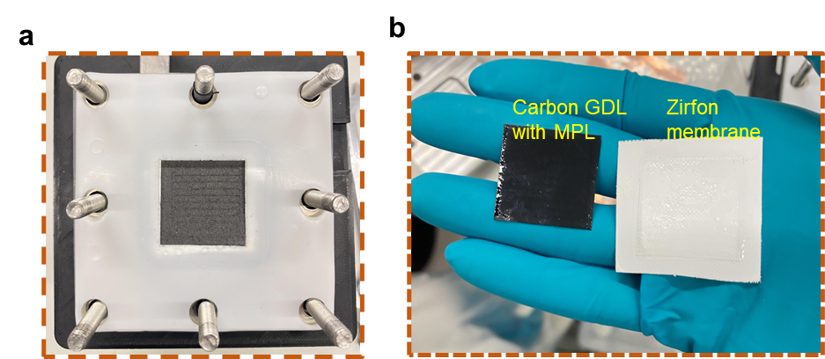
Supplementary Figure 3. (a) Images of Sigracet 39 BC carbon GDL and the MEA setup used in the RTD measurements. (b) Snapshots of MPL side of the carbon GDL and Zirfon membrane post RTD experiments.

Calculation of mean residence time
Mean residence time of the tracer inside the reactor was calculated for the pulse RTD tests for the 10 and 50 sccm flowrates. For the pulse RTD measurements, the RTD curves with the normalized tracer vs time were first plotted. To eliminate the contribution from the tubing to the reactor, we performed RTD measurements without the MEA cell to measure the ‘blank’ test. Time taken for the tracer signal to exit during the blank test was then subtracted from the original MEA cell pulse RTD tests. From the resulting plot, the mean residence time was calculated using Eq. S1.
$t_{mean}=\frac{\sum{t_{i}C_{i}}}{\sum{C_{i}}}$ (S1)
Here t represents the time, C- normalized tracer concentration, i represents the ‘i^{th}’ the data point in the concentration vs time plot.

Differences between gas and liquid phase pulse RTD measurements
Pulse RTD measurements performed with the non-wetted sigracet GDL (without Zirfon membranes) showed faster times for the tracer to exit the reactor. Supplementary Figure 4 shows the pulse RTD measurements for serpentine flow channel performed at 10 sccm with and without the Zirfon membrane in contact with the MPL side of GDL.
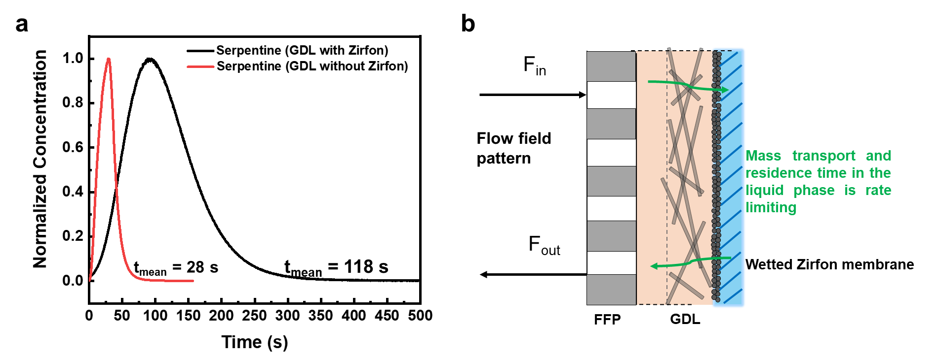
Supplementary Figure 4. (a) RTD pulse tracer output for an inlet flowrate of 10 sccm using serpentine flow field pattern. Black curve shows results for tests with Zirfon membrane placed on top of carbon GDL. Red curve shows output for carbon GDL without Zirfon membrane. (b) Schematic of the wetted zirfon membrane in contact with the GDL creating a reservoir of liquid where mass transport is rate limiting.
The mean residence time of the tracer in the first case without Zirfon membrane is only 28 s. Whereas, for the carbon GDL placed in contact with the Zirfon membrane, the calculated mean residence time comes out to be 118 s. This enhanced residence time with the Zirfon membrane clearly shows that the residence time differences for the flowrates and flow fields stems from the mass transport differences in the liquid phase. Hence, mass transport from the liquid phase of the catalyst is rate limiting during ECO₂R which is why the differences in product distribution are observed for the various flowrates and gas flow field patterns.
In addition to this difference in mean residence time, another evidence supporting this rate limiting step is the shape of the RTD curves as shown in Supplementary Figure 4. The red curve (without Zirfon) is more sharper than the black curve case (with Zirfon membrane). This clearly shows the delayed residence time occurs in the liquid region in direct contact with the MPL side of the GDL.
Differences between gas and liquid phase negative tracer measurements
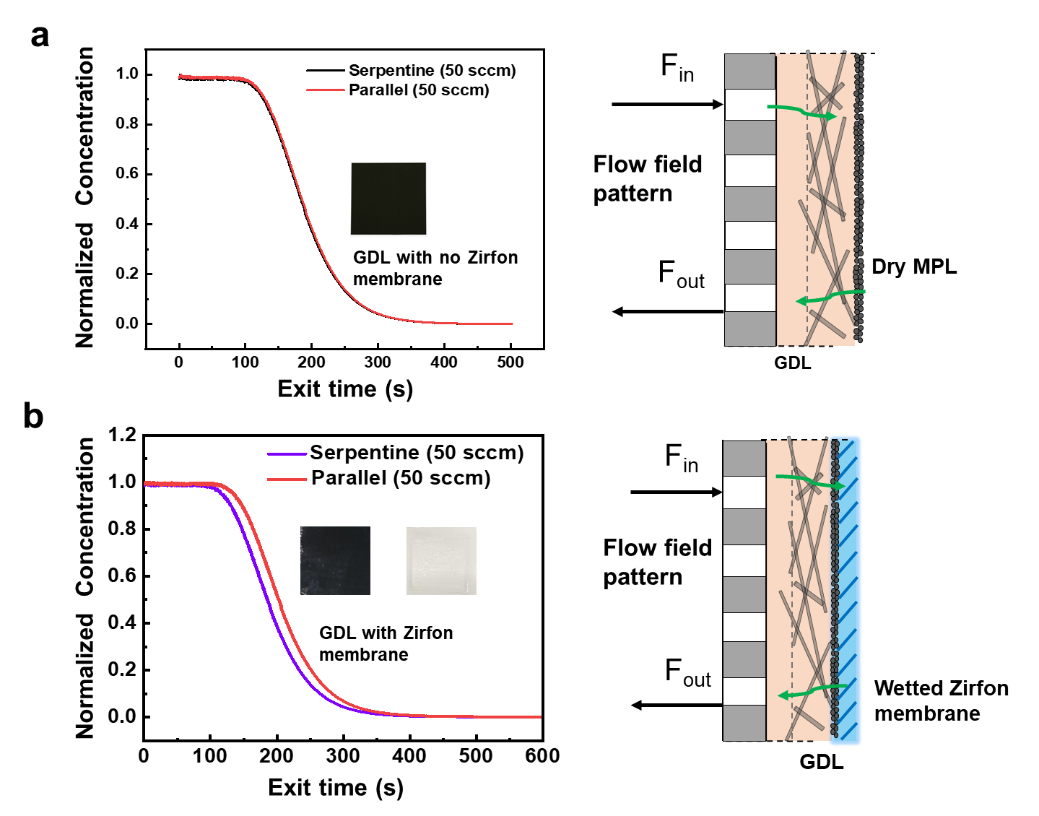
Supplementary Figure 5. Negative tracer results for the serpentine and parallel FFP at an inlet flowrate of 50 sccm without (a) Zirfon membrane pressed against the carbon GDL, (b) with Zirfon membrane pressed against the carbon GDL.

Comparison of negative tracer measurements with Zirfon membrane for both FFP
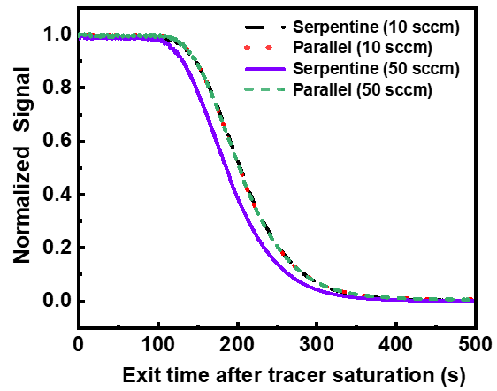
Supplementary Figure 6. Negative tracer results for the serpentine and parallel FFP at an inlet flowrate of 10 and 50 sccm with a wetted Zirfon membrane pressed against the carbon GDL.
Comparison of pulse tracer measurements with Zirfon membrane for parallel FFP
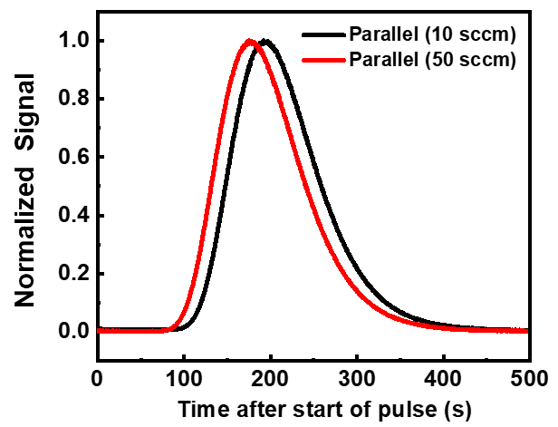
Supplementary Figure 7. Pulse RTD results of the parallel flow field pattern at an inlet flowrate of 10 and 50 sccm with a wetted Zirfon membrane pressed against the carbon GDL.

Experimental setup for CO₂ electrolysis
All experiments were performed in a custom made membrane electrode assembly (MEA) cell comprising of a pin type flow field on the anode and different flow field patterns at the cathode. Sigracet 38 BC gas diffusion layers (GDL) of 5.06 cm² area (2.25 cm x 2.25 cm) was used as the porous transport layer. Cu catalysts were deposited on top of microporous layer of GDL by direct current magnetron sputtering under 3 µbar Ar flow at 20 sccm to form a uniform film of 100 nm. Nickel foam (3 cm x 3 cm, Recemat BV) was used as the anode. Cu coated GDL and Ni foam were combined with an oversized 16 cm² (4cm x 4cm) Sustainion anion exchange membrane (X37-50 Grade RT) to assemble the MEA. 0.5 M KOH solution was fed at the anode at a constant flow rate of 20 ml/min and recirculated using a peristaltic pump (Supplementary Figure 8).
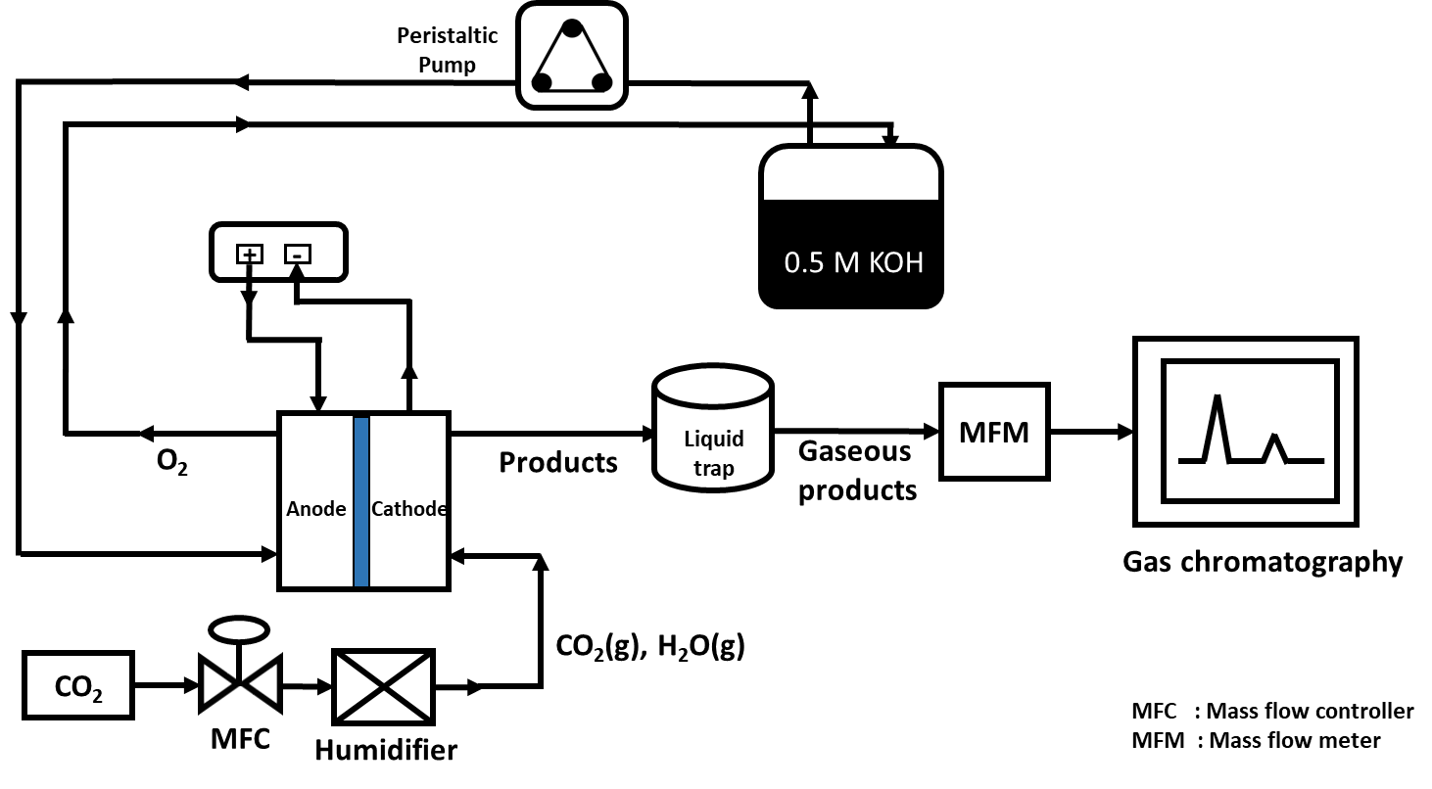
Supplementary Figure 8: Flow diagram of the experimental setup used for CO₂ electroreduction in an exchange MEA.

Different CO₂ flowrates were used and the humidity at the inlet was measured to be 75%. Electrolysis at a geometric current density of 200 mA/cm² was performed under various operating conditions. Gas product quantification was performed by measuring outlet gas flowrates using a mass flow meter (MFM) followed by a gas chromatography (GC) with periodic injections every 5 minutes.
Electrochemical reactions at the cathode
$CO_{2}+H_{2}O+2e^{-}→CO+2OH^{-}$ (S2)
$CO_{2}+{6H}_{2}O+8e^{-}→CH_{4}+8OH^{-}$ (S3)
$2CO_{2}+{8H}_{2}O+12e^{-}→C_{2}H_{4}+12OH^{-}$ (S4)
$2CO_{2}+{9H}_{2}O+12e^{-}→C_{2}H_{5}OH+12OH^{-}$ (S5)
$2CO_{2}+{6H}_{2}O+8e^{-}→CH_{3}COO^{-}+7OH^{-}$ (S6)
$3CO_{2}+{13H}_{2}O+18e^{-}→C_{3}H_{7}OH+18OH^{-}$ (S7)
$CO_{2}+H_{2}O+2e^{-}→HCOO^{-}+OH^{-}$ (S8)

Carbon balance at the cathode
The faradaic efficiency of gaseous products were calculated using GC injections and measured outlet gas flowrate. The liquid products were quantified using H-NMR analysis. An overall carbon balance was performed and the following equations were then used to calculate the volumetric flowrate of CO₂ reacting with hydroxide ions at the cathode.
$x_{CO2,out} = 1-(x_{CO} +x_{H2O} + x_{H2}+x_{C2H4}+ x_{CH4})$ (S9)
After calculating the mole fractions of all gaseous products, the volumetric flow rate at the outlet of the reactor measured with the MFM and was used to calculate the moles of each product.
$n_{CO}={\dot{V}}_{outlet}×x_{CO}$ (S10)
$n_{C2H4}={\dot{V}}_{outlet}×x_{C2H4}$ (S11)
$n_{CH4}={\dot{V}}_{outlet}×x_{CH4}$ (S12)
$n_{H2}={\dot{V}}_{outlet}×x_{H2}$ (S13)
$FE_{gas product}=\frac{n_{gas product}×n^{e}×F}{I }×100 \%$ (S14)
Here: $n_{gas product}$ - moles of produced gas product, $n^{e}$- number of electrons involved in CO₂RR, F- 96485 C/mol and I - applied current (in Amperes).
The following equations were then used to calculate the CO₂ consumption with OH⁻ ions by performing an overall carbon balance at the cathode.
${\dot{V}}_{ CO_{2} to CO}=x_{CO}×{\dot{V}}_{outlet}$ (S15)
${\dot{V}}_{ CO_{2} to C2H4}=x_{C2H4}×{\dot{V}}_{outlet}$ (S16)
${\dot{V}}_{ CO_{2} to CH4}=x_{CH4}×{\dot{V}}_{outlet}$ (S17)
${\dot{V}}_{ H_{2}}=x_{H_{2}}×{\dot{V}}_{outlet}$ (S18)
${\dot{V}}_{residual CO_{2}}={\dot{V}}_{outlet}-\left({\dot{V}}_{ CO_{2} to CO}+{{\dot{V}}_{ CO_{2} to C2H4}+\dot{V}}_{ CO_{2} to CH4}+ {\dot{V}}_{ H_{2}}\right)$ (S19)
${\dot{V}}_{ {CO}_{2 to liquid prod}}=(\left(1-x_{CO}-x_{H2}\right)×\frac{j× A }{n^{e}×F} mol/s×22.4×60×1000 ) ml/min$ (S20)
${\dot{V}}_{ {CO}_{2 to gas} = { \dot{V}}_{ CO_{2} to CO}+{{2 (\dot{V}}_{CO_{2} to C2H4})+ \dot{V}}_{ CO_{2} to CH4}}$ (S21)
${\dot{V}}_{{CO2 to OH}^{-}}={{\dot{V}}_{inlet}-(\dot{V}}_{residual CO_{2}}+{\dot{V}}_{ CO_{2} to gas products}+{\dot{V}}_{ {CO}_{2 to liquids}})$ (S22)
$n_{CO2 to OH^{-}}=\frac{{\dot{V}}_{{CO2 to OH}^{-}}}{(24.42 ×60×1000)} mol/s$ (S23)
$λ_{stoich}=\frac{{\dot{V}}_{CO2,in}}{{\dot{V}}_{CO2,consumed}}$ (S24)
$Single pass CO_{2} conversion=\frac{{\dot{V}}_{CO2 to C2+ products}}{{\dot{V}}_{inlet}}$ (S25)
$CO_{2} utilization efficiency=\frac{{\dot{V}}_{CO2 to gas }+ {\dot{V}}_{CO2 to liquid prod }}{{\dot{V}}_{CO2 to gas }+{ \dot{V}}_{CO2 to liquid prod }+{\dot{ V}}_{{CO2 to OH}^{-}}}$ (S26)

Moles of OH⁻ ions generated during the reaction can be calculated using Faraday’s law. For every mole of OH⁻ ions produced during reactions (S7-S10), 1e⁻ is used. So,
$n_{OH^{-}}=\frac{j_{geo}× A}{1×F}=\frac{200 mA{cm}^{-2}×5cm^{2}}{96485}=1.049×{10}^{-5 }moles$ (S27)

CO utilization towards C₂₊ products
From equations S4-S6, the normalized partial current densities of hydrocarbons and oxygenates by the number of e⁻ transferred per CO reduced to a specific product is as follows:
$CO_{generation rate} from CO_{2}RR =j_{CO}+\frac{j_{CH_{4}}}{4}+\frac{j_{C_{2}H_{4}}}{3}+\frac{j_{C_{2}H_{5}OH}}{3}+\frac{j_{CH_{3}COO^{-}}}{2}+\frac{j_{C_{3}H_{7}OH}}{3}$ (S28)
$CO_{dimerization rate}=\frac{j_{C_{2}H_{4}}}{3}+\frac{j_{C_{2}H_{5}OH}}{3}+\frac{j_{CH_{3}COO^{-}}}{2}+\frac{j_{C_{3}H_{7}OH}}{3}$ (S29)
$CO_{utilization rate}=\frac{CO_{dimerization rate}}{CO_{generation rate}}$ (S30)

Supplementary Table 1 : Faradaic efficiency of CO and C₂₊ products obtained from ECO₂R for the three FFP at 200 mA/cm².
Flow field pattern | FE CO (%) | FE C₂H₄ (%) C C2H4 | FE C₂H₅OH (%) C C2H4 | FE acetate (%) E acetate | FE n-propanol (%) | FE CH₄ (%) E methane | FE H₂ (%) E H2
Serpentine (10 sccm) | 3.2 | 40.3 | 30.8 | 10.5 | 2.7 | 1.4 | 7.2
Serpentine (50 sccm) | 12.2 | 39.1 | 20.3 | 4.1 | 4.6 | 0.3 | 6.3
Parallel (10 sccm) | 3.1 | 32 | 22.4 | 15.9 | 1.7 | 9.0 | 10.7
Parallel ( 50 sccm) | 5.1 | 36.2 | 22.1 | 14.7 | 2.3 | 3.1 | 10.8
Interdigitated (10 sccm) | 4.8 | 40.8 | 30.1 | 7.1 | 2.9 | 1.7 | 8.6

Supplementary Table 2: Calculated single pass CO₂ conversion and CO utilization to C₂₊ products at 200 mA/cm².
Inlet CO₂ flowrate (sccm) | Single pass CO₂ conversion to C2+ (%) | Stoichiometric excess of CO₂  λ_{stoich} | CO generation rate (mA/cm²) | CO dimerization rate (mA/cm²) | CO utilization towards C₂₊ products (%)
10 | 23.91 | 1.13 | 66.4 | 59.7 | 89.9
20 | 14.25 | 1.92 | 71.0 | 53.1 | 74.7
30 | 9.28 | 2.56 | 70.3 | 51.5 | 74.2
40 | 6.63 | 3.44 | 70.0 | 48.4 | 69.2
50 | 5.42 | 4.01 | 71.7 | 46.8 | 65.3
10 (parallel FFP ) | 19.38 | 1.16 | 63.9 | 53.4 | 81.5
50 (parallel FFP ) | 3.92 | 5.61 | 67.8 | 55.3 | 83.6

NMR analysis for liquid products
The NMR experiments were conducted with a Bruker-400 NMR spectrometer. A water suppression technique was applied to make the products’ peaks more visible. 25 mM of maleic acid dissolved in D₂O was used as the internal standard. 550 μL of aliquot from the anolyte of the MEA cell was taken and added to 50 μL of maleic acid (25 mM) for NMR analysis.

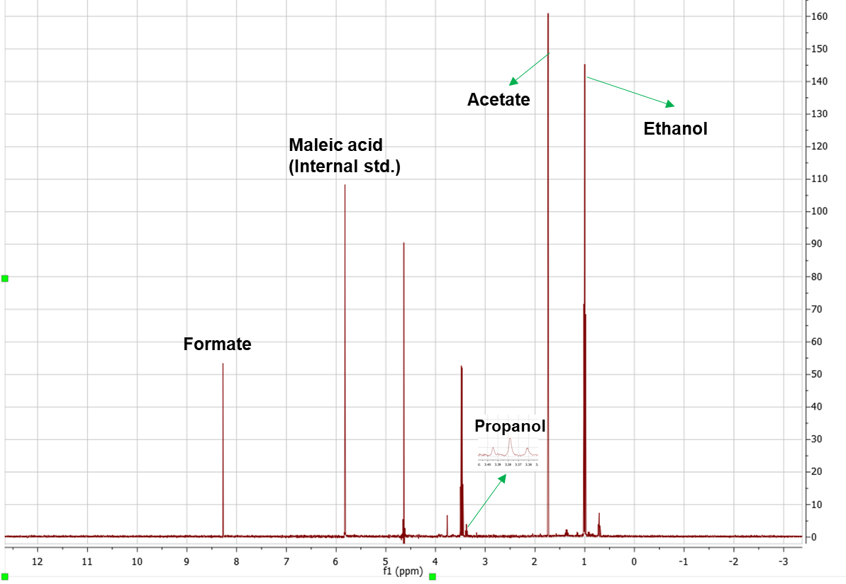
Supplementary Figure 9. H-NMR spectra of liquid products obtained from CO₂RR at an inlet flowrate of 10 sccm.
A total of 128 scans were performed for all tests and the molar concentration of liquid products were calculated using the equation:
$C_{x}=\frac{I_{x}}{I_{std}}× \frac{N_{std}}{N_{x}} ×C_{std}$ (S31)

where, “$C_{x}$ " is the molar concentration of the product, “$I_{x}$” is integral of the product, “$I_{std}$” is integral of the internal standard (maleic acid), ${"N}_{std}$” is the number of protons in maleic acid, ${"N}_{x}$” is the number of protons in the product, and ${"C}_{std}"$ is the total concentration of maleic acid. “n” is the number of electrons for the specific product produced from CO₂. A sample NMR spectra for products obtained at the inlet flowrate of 10 sccm for the serpentine FFP is shown in Fig. S9.
We also collected tiny liquid droplets from the cathode GDE into the liquid trap to quantify if any liquid products were present at the cathode side. The liquid drops from the liquid trap were diluted by adding MQ water to make a 10 mL solution and analyzed thereafter by NMR spectroscopy. NMR analysis showed only traces of ethanol with FE of 1-3 %, suggesting that most of the produced liquid products migrated to the anode through the AEM.
Supplementary Table 3. Liquid product selectivity produced from anode and cathode sides at different inlet CO₂ flowrates for the serpentine FFP.
Inlet flow rate of CO₂ (sccm) | FE of ethanol detected from anolyte (%) | FE of ethanol detected from cathode side (%) | Total FE of ethanol (%)
10 | 29.8 | 0.4 | 30.2
20 | 23.0 | 1.8 | 24.8
30 | 21.5 | 1.1 | 22.6
40 | 18.9 | 3.4 | 22.3
50 | 18.0 | 2.1 | 20.1

Proposed reaction pathways for CO₂ electroreduction to ethanol/ethylene
The following set of reactions are proposed for ethanol/ethylene pathway based on previous works by Goddard and co-workers⁴.
- $CO_{2}+e^{-}→ *CO_{2}^{-}$ (S32)
- $*CO_{2}^{-}+H_{2}O→ COOH^{*}+OH^{-}$ (S33)
- $COOH^{*}+$ $e^{-}→ *CO+OH^{-}$ (S34)
- $*CO+*CO+H^{+}+ e^{-}→ *COCOH$ (S35)
- $*COCOH+H^{+}+ e^{-}→ *COHCOH$ (S36)
- $*COHCOH+2(H^{+}+ e^{-})→CH_{2}CO$ (S37)
- $CH_{2}CO+H^{*} →CHCHOH^{*} (hydrogenation to ethanol)$ (S38)
- $CH_{2}CO+e^{-} →CCH^{*}+OH^{-}$ (dehydroxylation to ethylene) (S39)
- $CH_{2}CO+{OH}^{-}→CH_{3}COO^{-} (solution reaction)$ (S40)
The reaction of intermediate HOCCH* through a hydrogenation pathway (Eq.S38) or dehydroxylation pathway (Eq.S39) determines ethanol vs ethylene pathway. This means that the concentration of *H at the catalyst surface is an important metric in addition to *CO for ethanol formation.

SEM analysis of Cu coated GDL before and after CO₂RR
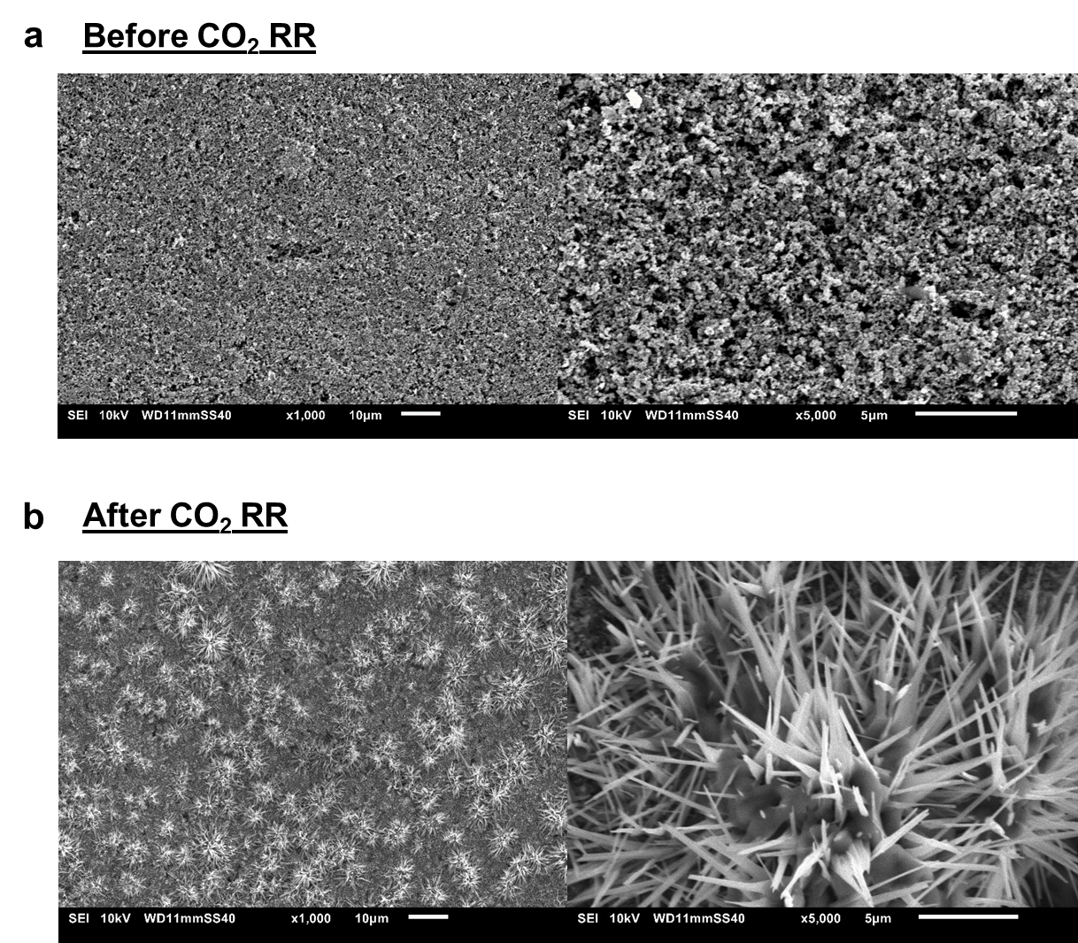
Supplementary Figure 10. SEM images of Cu catalyst layer sputtered on Sigracet 38 BC gas diffusion layer (a) before and (b) after 1 h of CO₂ electrolysis.

Model description
A 3D geometry of the cathode compartment (5cm² area) comprising of the three flow channel designs were modelled with the same length (2.1 cm), width (1 mm) and depth (1 mm) in COMSOL Multiphysics 5.5, similar to our previous work. A carbon GDL of dimensions (2.25 cm x 2.25 cm x 0.325 cm) was modelled and placed in contact with the flow field pattern with each one consisting of 11 channels and 10 ribs. The numerical simulations were performed using a MUMPS general solver with a relative tolerance of 0.001 to calculate the CO₂ concentration gradient in the gas channel and catalyst surface.
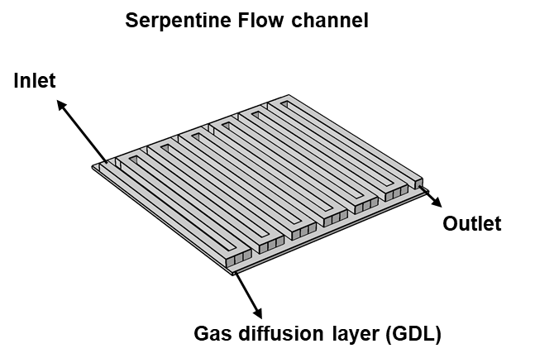
Supplementary Figure 11. 3D transport model of the cathode compartment of MEA cell modelled in COMSOL Multiphysics. Shown here is the serpentine flow field pattern.
All parameters used in the model were taken from the experimental conditions and the properties of the Sigracet 38BC GDL. The following assumptions were made in the model:
- The system operates at steady-state conditions
- Carbon GDL is assumed to be isotropic with constant porosity and permeability since the in-plane diffusion is higher than the through plane diffusion
- Both diffusion and convection from the channel to the catalyst surface are taken into account
- A uniform current distribution is assumed at the catalyst surface
- Isothermal at 298 K with no thermal diffusion gradients
Brinkmann equation and mixture diffusion model
The fluid flow in the flow channels were modelled Navier stokes equation and flow through the GDL using Brinkmann equation. A no-slip boundary condition was imposed on the channel walls. A slip condition was used at the channel-GDL interface since the normal component of velocity is zero at this interface. Single phase compressible flow was assumed. An inlet boundary condition was given by a normal inflow velocity defined by the flowrate (${\dot{V}}_{in}$) over inlet cross sectional area of the channel (Dirichlet boundary condition). ${\dot{V}}_{in}$ was fixed at 10 sccm as used in the experiments. Constant pressure at the outlet of the cell (1 atm) was used as the boundary condition at the outlet (Neumann boundary condition) with the suppression of backflow.
The Brinkman equation solves for the velocity and pressure distribution in the GDL. It was coupled with the mixture diffusion model which takes into account of diffusion and convection through the GDL. All parameters used in the model can be found in Table 5. For the meshing, a free tetrahedral mesh with a fine mesh size was used for the channels and a swept mesh was used for the GDL (98023 domain elements, 24196 domain elements and 2894 edge elements). The velocity and pressure field in the gas channels were solved using:
$ρ\left(u∙∇\right)u=∇∙\left[-pI+μ(∇u+\left({∇u)}^{T}\right)-\frac{2}{3} μ\left(∇∙u\right)I\right]+F$ (S41)
$∇∙\left(ρu\right)=0$ (S42)
In the GDL, the velocity and pressure was calculated using:
$\frac{1}{ϵ_{p}}ρ\left(u∙∇\right)u\frac{1}{ϵ_{p}}=∇∙\left[-pI+μ\frac{1}{ϵ_{p}}(∇u+\left({∇u}^{T}\right)-\frac{2}{3}μ\frac{1}{ϵ_{p}}\left(∇∙u\right)I\right]-\left(μκ^{-1}+\frac{Q_{m}}{ϵ_{p}^{2}}\right)u+F$ (S43)
$∇∙\left(ρu\right)=Q_{m}$ (S44)
In these equations,
$ρ$ is the density of the fluid, $µ$ is the dynamic viscosity of the fluid, $p$ is the pressure, $u$ is the velocity, $F$ is the force term, $κ$ is the permeability of the GDE, $ϵ_{p}$ is the porosity of the GDE and $Q_{m}$ is the mass source.
Mixture diffusion model
To solve for the species transport in the system, a mixture diffusion model was used. We accounted for only 2 gas species which are CO₂ at the inlet and C₂H₄ as the outlet since it was the dominant gas product. The molar flux of the species were calculated using the following equations:
$∇∙j_{i}+ρ\left(u∙∇\right)ω_{i}=R_{i}$ (S45)
$N_{j}=j_{i}+ρuω_{i}$ (S46)
$j_{i}=-(ρD_{i}^{m}∇ω_{i}+ρω_{i}D_{i}^{m}\frac{∇M_{n}}{M_{n}})$ (S47)
$R_{i}=\frac{v_{i}i_{v}}{nF}+j_{CO2 to OH^{-}}$ (S48)
Here:
N is the total flux vector of species i, R_{i} is the reaction rate for species i, u is the fluid velocity, j_{i} is the relative mass flux due to molecular diffusion of species i,$ω_{i}$ is the mass fraction of species i, i_{v} is the volumetric current density, F- Faraday’s constant. $D_{i}$ is the binary diffusivity of CO₂ with respect to C₂H₄ and was calculated using Fuller correlation.
CO₂ consumption calculation
Electrochemical reduction of CO₂ to C₂H₄ was modelled which is a 12e⁻ reduction reaction:
$CO2 RR to C_{2}H_{4} : 2CO_{2}+{8H}_{2}O+12e^{-}→C_{2}H_{4}+12{OH}^{-}$ (S49)
The CO₂ consumption to CO₂RR was calculated based on number of electrons involved for each molecule of CO₂ for the different products and their corresponding FEs. The FE of various products obtained from experiments was used for calculating CO₂ consumption.
$z_{avg}=\left\{\sum{\left(\frac{{FE}_{C_{i}}}{FE_{CO2RR}}×\frac{z_{e,C_{i}}}{ν_{CO2}}\right)} \right\}$ (S50)
where $z_{avg}$ is the average number of electrons utilized for CO₂RR, $z_{e,C_{i}}$ is the number of electrons involved in CO₂RR to the specific product $C_{i}$ (equations S2-S8), $ν_{CO2}$ is the stoichiometric coefficient of CO₂ for the specific CO₂RR.
The moles of CO₂ lost to OH⁻ ions calculated experimentally using carbon balance (Eq. S22) was used in the model and assumed to occur homogenously throughout the catalyst layer. Using $z_{avg}$ calculated from Eq. S50, an equivalent current density was calculated and incorporated into the model for calculating CO₂ consumption.
$j_{CO2 to OH^{-} = \frac{n_{CO2 to OH^{-} × z_{avg }× F}}{A}}$ (S51) ${j_{total}=j_{CO2RR}+j}_{CO2 to OH^{-} }$ (S52)
Here, $j_{CO2 to OH^{-}}$ is the equivalent current density per mole of CO₂ consumed due to reaction with OH⁻ ions, $F$ is Faraday’s constant and $A$ is the geometric area of the GDE (5.06 cm²).

Calculated CO₂ concentration at the G-L interface for ECO₂R at 10 sccm and 200 mA/cm²
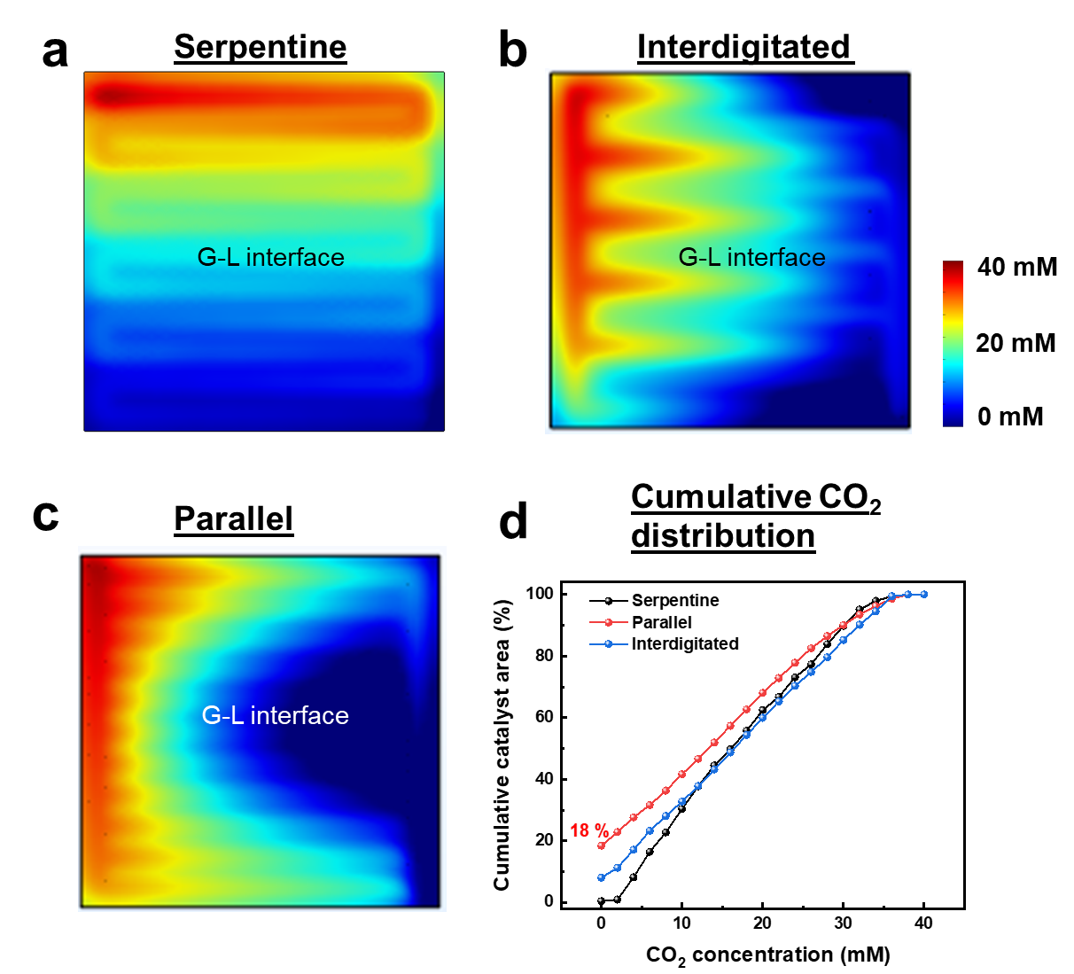
Supplementary Figure 12. Calculated gas phase CO₂ concentration at the G-L interface for (a) Serpentine, (b) Parallel and (c) Interdigitated flow field patterns at an inlet flowrate of 10 sccm and 200 mA/cm². (d) Cumulative CO₂ distribution at the G-L interface for all three FFPs.

Calculated CO₂ concentration at the G-L interface for CO₂ER at 50 sccm and 200 mA/cm²
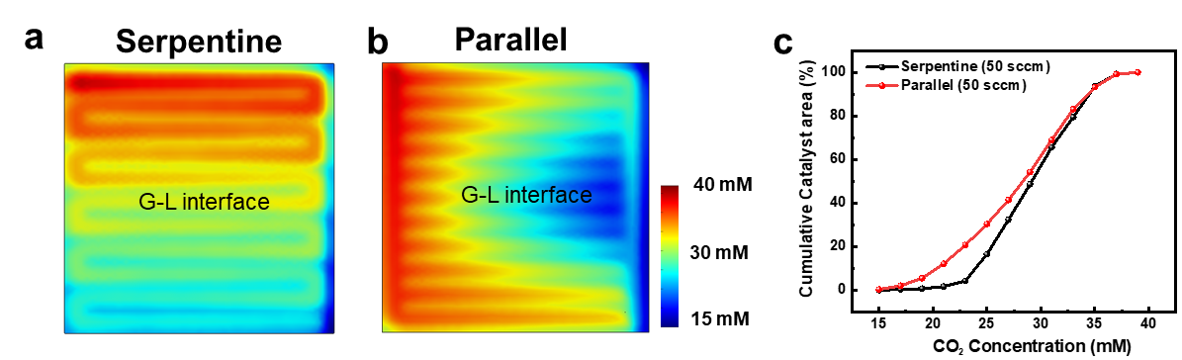
Supplementary Figure 13. Calculated gas phase CO₂ concentration at the G-L interface for (a) Serpentine, (b) Parallel flow field design at an inlet flowrate of 50 sccm and 200 mA/cm². (c) Cumulative CO₂ distribution for the two FFPs.

Supplementary Table 4: Calculated pressure drop and gas phase CO₂ concentration at the G-L interface from the model for the three flow field patterns.
Flow field pattern | Inlet CO₂ flowrate (sccm) | ΔP b/w inlet and outlet (Pa) | Avg. velocity in gas channels (mm/s) | Avg. [CO₂] at G-L interface (mM)
Serpentine | 10 | 22.2 | 1.3 | 17.8
Serpentine | 50 | 112.4 | 5.7 | 30.9
Parallel | 10 | 1.3 | 0.5 | 15.2
Parallel | 50 | 6.4 | 1.9 | 28.9
Interdigitated | 10 | 15.2 | 0.6 | 15.6

Supplementary Table 5 : Parameters used in the 3D mass transport and fluid flow model
Parameter | Symbol | Value | Units | Reference
Temperature | T | 298 | K | This work
Reference pressure | P | 1 | $$atm$$ | This work
Diffusivity of CO₂ into C₂H₄ | D_{CO2-C2H4} | $$1.245×{10}^{-5}$$ | $$m^{2}s^{-1}$$ | This work
Porosity of GDE | eps_gdl | 0.8 | $-$ | [2]
Permeability of GDE | kappa_gdl | $$7×{10}^{-12}$$ | $$m^{2}$$ | [2]
Inlet flowrate | Q_{sccm} | 10 | sccm | This work
Applied current density | $$i_{loc}$$ | -(2000 + j_{CO2 to OH-} ) | $$Am^{-2}$$ | This work
Length of channel | l | 2.1 | cm | This work
Width of channel | w | 1 | mm | This work
Depth of channel | h_ch | 1 | mm | This work
Thickness of GDE | dep_gdl | 325 | µm | [2]
Dynamic viscosity of CO₂ | mu | $$1.47×{10}^{-5}$$ | Pa.s | [1]
Average number of electrons | $$n_{avg}$$ | 5.52 | - | This work

CO electrolysis
Electrochemical CO reduction tests were performed at 200 mA/cm² and an inlet flow rate of 20 sccm, inside a fumehood containing potentiostat, mass flow meter and gas chromatography setup. All experiments for the three flow field patterns were repeated twice to verify reproducibility.
Supplementary Table 6 : Selectivity of products obtained from CO ER for the three FFP at 200 mA/cm².
Flow field pattern | FE C₂H₄ (%) C C2H4 | FE C₂H₅OH (%) C C2H4 | FE acetate (%) E acetate | FE n-propanol (%) | FE CH₄ (%) E methane | FE H₂ (%) E H2
Serpentine | 30.84 | 14.43 | 32.9 | 1.5 | 2.38 | 5.4
Parallel | 29.3 | 15.5 | 31.7 | 1.7 | 4.15 | 9.5
Interdigitated | 35.01 | 18 | 22.0 | 2.4 | 1.9 | 7.8

Supplementary Table 7: Comparison of performance metrics for ethylene production from ECO₂ RR and ECOR at a geometric current density of 200 mA/cm². Results of interdigitated FFP are used since ethylene selectivity obtained were the highest using this FFP for both electrochemical reactions.
Reaction | Full cell voltage obtained ($E_{cell}$) | TD Cell voltage for C₂H₄ $(E_{cell, C_{2}H_{4}}^{0})$ | TD Cell voltage for C₂H₅OH OH$(E_{cell, C_{2}H_{5}OH}^{0})$ | FE of C₂H₄ (%) | FE of ethanol (%) | Electrical Energy efficiency for ethylene + ethanol, (eEE) (%)
CO₂ ER | 2.81 | 1.15 | 1.14 | 41.5 | 29.5 | 28.96
CO ER | 2.47 | 1.06 | 1.04 | 35.0 | 20 | 23.42

The electrical energy efficiency for ethylene+ethanol production is calculated using the following equation :
$eEE=\left(\frac{{FE}_{C2H4 }× E_{cell, C_{2}H_{4}}^{0} }{E_{cell} }\right)+\left(\frac{{FE}_{C2H5OH }× E_{cell, C_{2}H_{5}OH}^{0} }{E_{cell} }\right)$ (S53)

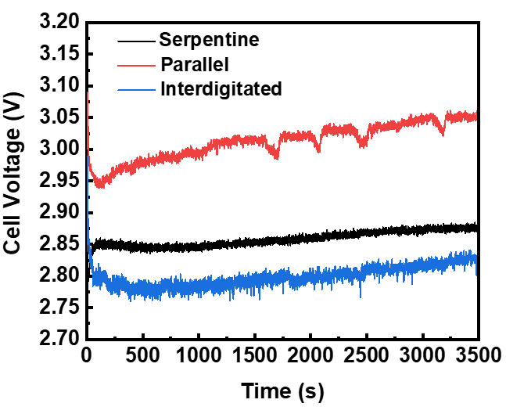
Supplementary Figure 14. Cell voltage for ECO₂R for the three FFP at an inlet flowrate of 10 sccm.
References
[1] E. L. Cussler, Diffusion, mass transfer in fluid systems, Cambridge University Press,
Cambridge Cambridgeshire ; New York, 1984.
[2] R. Schweiss, C. Meiser, T. Damjanovic, I. Galbiati and N. Haak, SIGRACET® Gas Diffusion
Layers for PEM Fuel Cells, Electrolyzers and Batteries (White Paper), SGL CARBON GmbH,
2016.
[3] Xiao, H., Cheng, T. & Goddard, W. A. Atomistic mechanisms underlying selectivities in C1 and C2 products from electrochemical reduction of CO on Cu(111). J. Am. Chem. Soc. 139, 130–136 (2017).

