Supplementary Information

Novel antimicrobial peptides against Cutibacterium acnes designed by deep learning
Qichang Dong^{1,4}, Shaohua Wang^{1,4}, Ying Miao^{3,4}, Heng Luo¹, Zuquan Weng³ and Lun Yu^{2, *}
¹ Shanghai MetaNovas Biotech Co., Ltd, Shanghai, 200120, China
² Metanovas Biotech Inc., Foster City, 94404, USA
³ College of Biological Science and Engineering, Fuzhou University, Fuzhou, 350108, China
⁴ These authors contributed equally to this work: Qichang Dong, Shaohua Wang and Ying Miao.
* Correspondence: lunyu@metanovas.com

Table of Contents
Methods of data curation
Methods of in vitro experiment
Figure 1 to 3
Supplementary References

Methods of data curation

DBAASP
From the comprehensive AMP dataset procured from the DBAASP website¹, we amassed a collection of 19,316 peptides. To ensure relevance and specificity, we implemented stringent criteria: the peptides needed to have a minimum length of 4, end with a free or amidated C-terminus or begin with an acetylated N-terminus, and exclusively comprise natural L-amino acids or their D-enantiomers.
Our classification system for activity relied on a dual-threshold metric. We labeled sequences as 'active' when they exhibited an activity concentration below 32 µg/ml or 10 µM and had at least one designated target species. In contrast, sequences that uniformly displayed activity concentrations surpassing 32 µg/mL or 10 µM were categorized as 'inactive' ².
To discern between hemolytic and non-hemolytic activities, we standardized all recorded concentrations to µM, utilizing the metrics against human erythrocyte cells. We deemed sequences as 'non-hemolytic' if they demonstrated hemolytic values under 20% at concentrations of 50 µM or more. On the other hand, sequences presenting a hemolytic value equal to or exceeding 20% at any concentration were labeled as 'hemolytic'².
Our final tally comprised 8,884 active peptides and 4,009 inactive peptides, along with 2,217 hemolytic peptides and 2,013 non-hemolytic peptides. It's crucial to note that the hemolysis dataset is inherently a subset of the broader activity dataset.
To foster a balanced dataset for our activity classifier, we embarked on the creation of 4,875 supplementary pseudo-inactive sequences. This process was bifurcated into two distinct strategies:
- Scrambling the sequences of active peptides, yielding 2,437 sequences. This involved rearranging the order of amino acids to derive sequences distinct from the parent active peptide, ensuring that the structural and functional attributes were disrupted.
- Fragmenting sequences from the renowned SwissProt database³, generating another 2,438 sequences. This method entailed segmenting longer protein sequences into shorter fragments, adhering to the length distribution characteristic of our known sequences.
For the hemolysis classifier, we had a fortuitous situation where the numbers of non-hemolytic and hemolytic peptides were relatively balanced. As such, we deemed it unnecessary to create artificial sequences. Instead, we directly leveraged the existing set of peptides to train the hemolysis classifier, ensuring authenticity in the model's learning process.

C. acnes associated AMP dataset
To pinpoint AMPs that target C.acnes and its closely related species, we embarked on the phylogenetic analysis. Our approach was as follows:
- Data Acquisition: We began by downloading the names of all bacterial species cataloged in the DBAASP database.
- 16S rDNA Sequence Retrieval: For each species name, we sourced its corresponding 16S rDNA sequence from the NCBI database. This ribosomal RNA sequence is universally present in bacteria and serves as a fundamental marker in microbial phylogenetics.
- Phylogenetic Tree Construction: Using the retrieved 16S rDNA sequences, we utilized the MEGA software to construct a comprehensive phylogenetic tree. This tree visually represents evolutionary relationships, allowing us to discern which species are closely related to C.acnes.
- Selection of Closely Related Species: From the constructed phylogenetic tree, we pinpointed 28 species that displayed close evolutionary ties with C.acnes.
- Extraction of Relevant AMPs: With our selected species in hand, we sifted through the DBAASP database to identify AMPs that exhibited inhibitory activity against these species. Filtering further for peptides that were both active and non-hemolytic, we amassed a collection of 653 AMPs. These were designated as AMPs intrinsically associated with C.acnes.
The end result of this rigorous process was a curated set of AMPs tailored to target C.acnes and its closely related bacterial species, providing a focused dataset for subsequent analysis and experimentation.

Methods of in vitro experiment

In vitro antimicrobial testing
To determine the minimal inhibitory concentration (MIC), the broth microdilution method was used. MIC of peptides was determined as the lowest concentration of test samples that inhibit 90% bacterial growth, which was measured by optical density⁴. Briefly, peptide samples were prepared as a stock solution in water and then diluted. 180 μL of the bacterial suspension (10⁷ CFU/mL) and 20 μL of the tested sample were added together into 96-Well Deep Well Plates and incubated 24 h for E.coli and S.aureus or 48h for C.acnes and C.albicans. For each test, two columns of the plate were kept for sterility control (broth only) and growth control (broth with bacterial inoculums, no antibiotics). The optical density of cultures was measured at 630 nm by a microplate reader (SYNERGY-H1, BioTek, USA) to estimate bacterial growth. All experiments were conducted in triplicate.

Hemolytic activity assay
The hemolytic activity of peptides was assayed on Rabbit red blood cells (rRBCs)⁵. Briefly, 2% rRBCs (150 μL) were incubated in the presence of various peptide concentrations (50 μL) at 37°C for 2 h. After centrifugation, the supernatants were collected for measuring absorbance at 545 nm. PBS and 0.01% Triton X-100 were used as the negative (no hemolysis) and positive (100% hemolysis) control, respectively. Triplicate tests were performed.

Cell culture and viability assay
HaCaT (IM-H225) cells from Xiamen Immocell Biotechnology Co.,Ltd were cultured in DMEM high glucose medium (4.5 g/L, Gibco, USA), supplemented with 10% fetal bovine serum (Gibco, USA), 100 U/mL of penicillin and 100 μg/mL of streptomycin in a 5% CO₂ fully humidified environment at 37℃.
Cell Counting Kit-8 (CCK-8; Biosharp, China) was used to assess the rate of cellular proliferation and quantify cell viability ⁶. In brief, HaCaT cells were seeded in 96-well plates with 100 μL of medium at a density of 1 × 10⁴ cells per well. After incubation of cells overnight, peptides were added into the medium for another 24 h incubation. Then, 10 μL of CCK8 solution was applied to each well and incubated for 1 h at 37℃. Finally, the absorbance values at 450 nm were determined using a microplate reader (SYNERGY-H1, BioTek, USA). Two columns of the plate were kept for negative control (medium only) and growth control (medium with HaCaT cell). All experiments were conducted in triplicate.

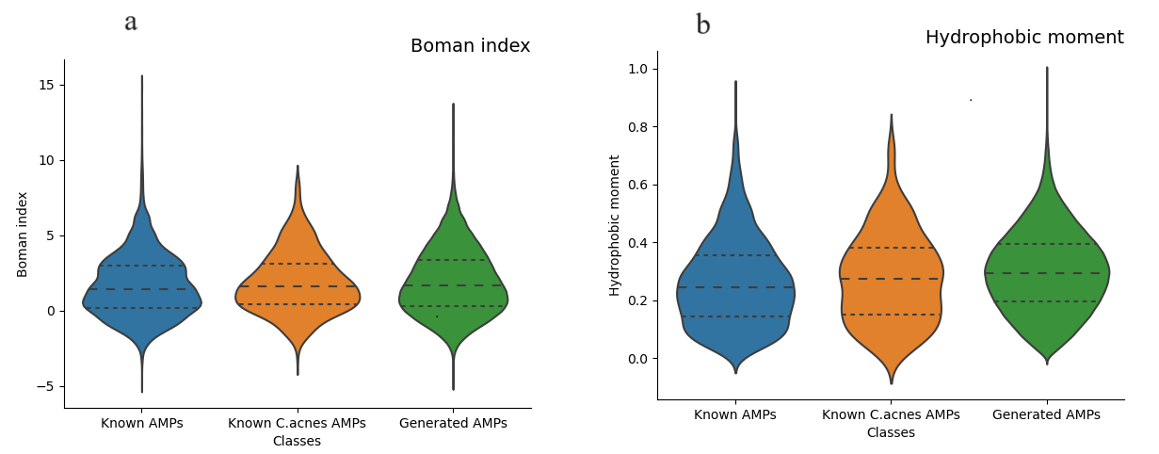
Figure 1. (a) Boman index, (b) hydrophobic moment. "Known AMPs" representing the 8884 known active AMPs in DBAASP, "Known C.acnes AMPs" representing the 653 active and non-hemolytic C.acnes-related AMPs, and "Generated AMPs" representing the 660,000 sequences generated in this study.


Figure 2. The length and novelty filtering pipeline and results.

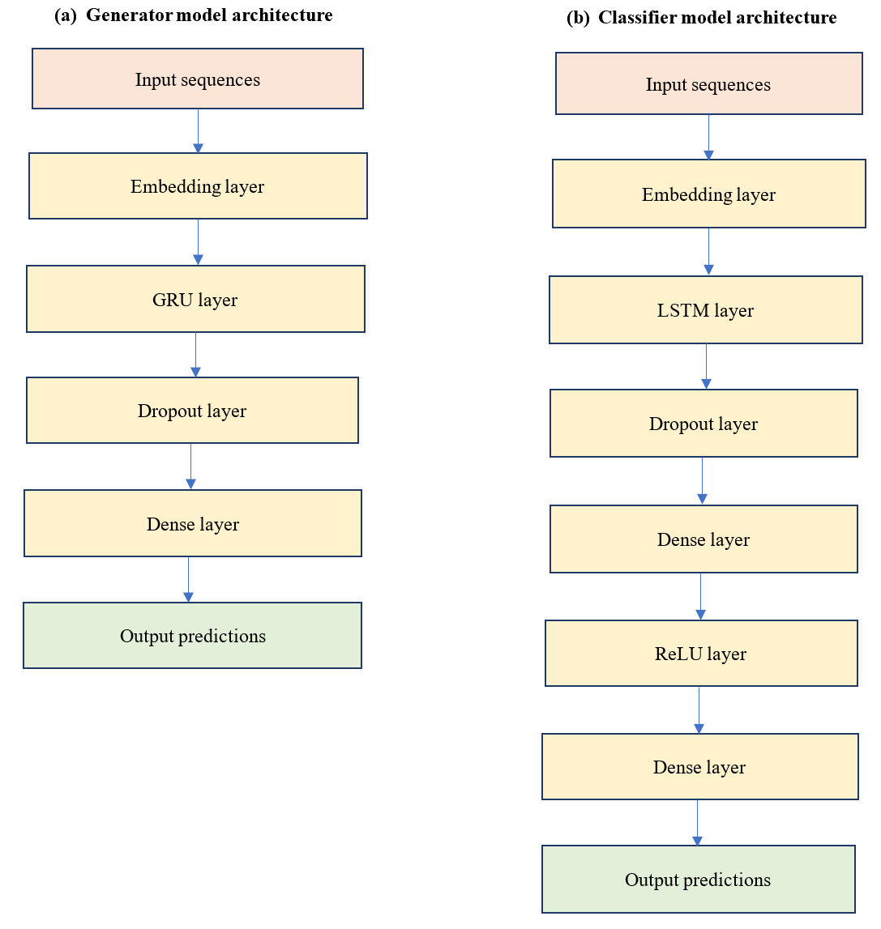
Figure 3. (a) The generator model structure, (b) the classifier model structure.

References
1. DBAASP. DBAASP dataset. https://dbaasp.org/statistics?page=general-statistics (2023).
2. Capecchi, A. et al. Machine learning designs non-hemolytic antimicrobial peptides. Chem Sci 12, 9221–9232 (2021).
3. Bateman, A. UniProt: a worldwide hub of protein knowledge. Nucleic Acids Res 47, D506–D515 (2019).
4. Theansungnoen, T. et al. Novel non-cytotoxic antimicrobial peptides WSKK11 and WSRR11 with potent activity against Cutibacterium acnes. Journal of Antimicrobial Chemotherapy 77, 1012–1019 (2022).
5. Rajasekaran, G., Kim, E. Y. & Shin, S. Y. LL-37-derived membrane-active FK-13 analogs possessing cell selectivity, anti-biofilm activity and synergy with chloramphenicol and anti-inflammatory activity. Biochim Biophys Acta Biomembr 1859, 722–733 (2017).
6. Zhuang, T. et al. Tranilast Directly Targets NLRP3 to Protect Melanocytes From Keratinocyte-Derived IL-1β Under Oxidative Stress. Front Cell Dev Biol 8, (2020).

