Diagram 1. XRD spectra of 45S5 BG

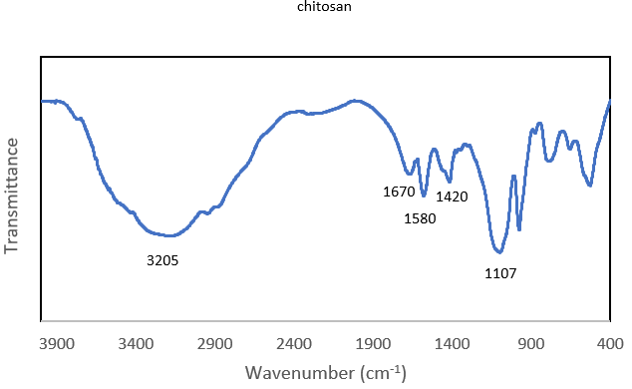
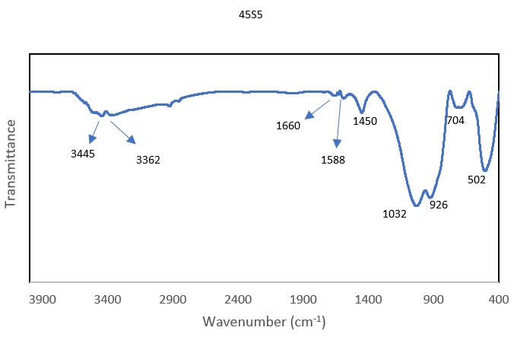
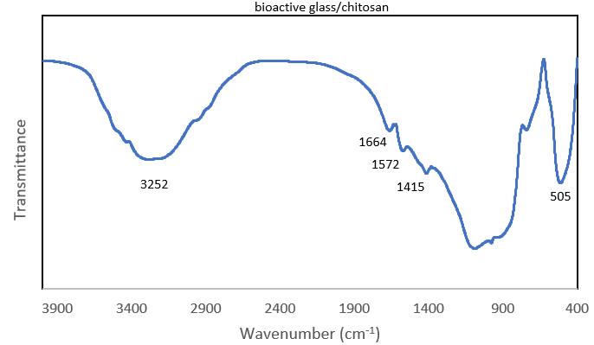
الف
ب
ج

Diagram 2. FTIR spectra of (A) BG, (B) CH solution, and (C) CH-BG compound

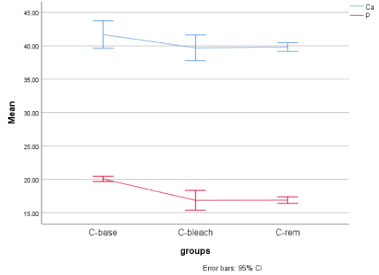
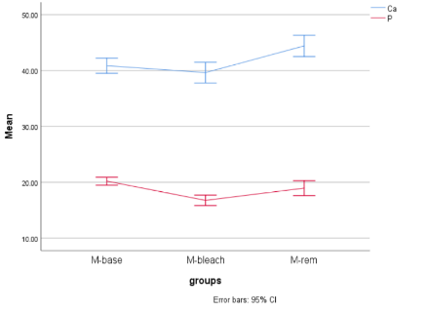
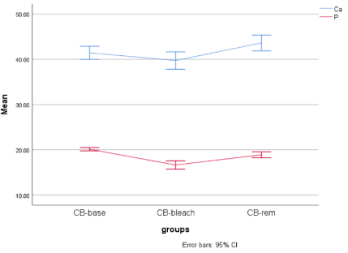

Diagram 3. Mass percentage of calcium and phosphorous ions in the three groups at different time points; (A) control group, (B) M group; (C) CH-BG group

