Supporting Information
Light-Matter Coupling in Scalable Van der Waals Superlattices
Pawan Kumar^{1, 2}, Jason Lynch¹, Baokun Song^{1$}, Haonan Ling³, Francisco Barrera¹, Huiqin Zhang¹, Surendra B. Anantharaman¹, Jagrit Digani³, Haoyue Zhu⁴, Tanushree H. Choudhury⁴, Clifford McAleese⁵, Xiaochen Wang⁵, Ben R. Conran⁵, Oliver Whear,⁵ Michael J. Motala⁶, Michael Snure⁷, Christopher Muratore⁸, Joan M. Redwing⁴, Nicholas R. Glavin⁶, Eric A. Stach², Artur R. Davoyan³, Deep Jariwala^{1*}

¹Electrical and Systems Engineering, University of Pennsylvania, Philadelphia, PA, 19104, USA
²Materials Science and Engineering, University of Pennsylvania, Philadelphia, PA, 19104, USA
³Department of Mechanical and Aerospace Engineering, University of California at Los Angeles, CA, 90095, USA
⁴2D Crystal Consortium-Materials Innovation Platform, Materials Research Institute, Pennsylvania State University, University Park, PA, 16802, USA
⁵AIXTRON Ltd., Anderson Road, Swavesey, Cambridge, CB24 4FQ, UK
⁶Air Force Research Laboratory, Materials and Manufacturing Directorate, Wright-Patterson AFB, Dayton, OH, 45433, USA
⁷Air Force Research Laboratory, Sensors Directorate, Wright-Patterson AFB, Ohio 45433, USA
⁸Department of Chemical and Materials Engineering, University of Dayton, Dayton, Ohio, 45469, USA

*Corresponding author: dmj@seas.upenn.edu
$Present Address: Huazhong University of Science and Technology, China

Superlattice Fabrication Details:
Wet-chemical transfer and stacking of van der Waals TMDCs layers: The wet chemical transfer technique (see supporting info Figure S2) was utilized throughout the stacking process of large area (∼1x1 cm²) atomically thin TMDCs layers grown under MOCVD. As received wafer scale uniformly grown 2-dimensional monolayer of MoS₂, WS₂ and 3 nm thin h-BN on 2” sapphire (single side polished) was first cut into several pieces of dimension 1x1 cm². Poly Methyl Metha Acrylate (PMMA) 950k A4 was used to spin coat on these 1x1 cm² based TMDCs samples and kept in air to dry overnight to prepare for wet chemical delamination process of atomic thin layers. PMMA thin film was deposited with a controlled thickness of ∼200 nm. PMMA coated samples were dipped in de-ionized (DI) water heated to 85° C on a hot plate, for 20-30 minutes until air-bubbles began to form at the outer edges of the sapphire substrate. Following the formation of air bubbles, samples were taken out of the hot water and placed on the top of 3M KOH solution which was maintained at 85° C. Crucial delamination of PMMA-supported TMDC layers from sapphire substrate occurred at this step where sapphire substrate was held manually with 45° inclination and slowly dipped inside the KOH solution with extremely slow movement. This allowed the delamination of the PMMA-supported TMDCs layers which finally floated to the top of the KOH solution. Using a cleaned glass slide, the floating PMMA-supported TMDCs layers were transferred to the fresh DI water, and this step was repeated multiple times to remove any residual contamination from the delamination steps. Finally, floating PMMA supported TMDCs were scooped on desired Si substrate covered with Au (Si/SiO₂/Au/Al₂O₃) and left to air-dry overnight. The final lift-off process (to remove the PMMA film) was done with the help of acetone for 6 hours at moderate temperature (45° C). To allow for better adhesion of the wet-chemical transferred TMDCs layers to their new substrate, they were heated for 1-2 hours at 70° C on a hot plate. The processes described above for producing the multilayer stacks including precise manual alignment at each scooping step were followed for the synthesisation of each heterostructure. Alumina-based superlattices were fabricated with additional steps of depositing a Al₂O₃ layer by ALD after each wet-chemical transfer of the TMDC layer. The topmost TMDCs layer in all superlattices were not coated with either Al₂O₃ or h-BN.

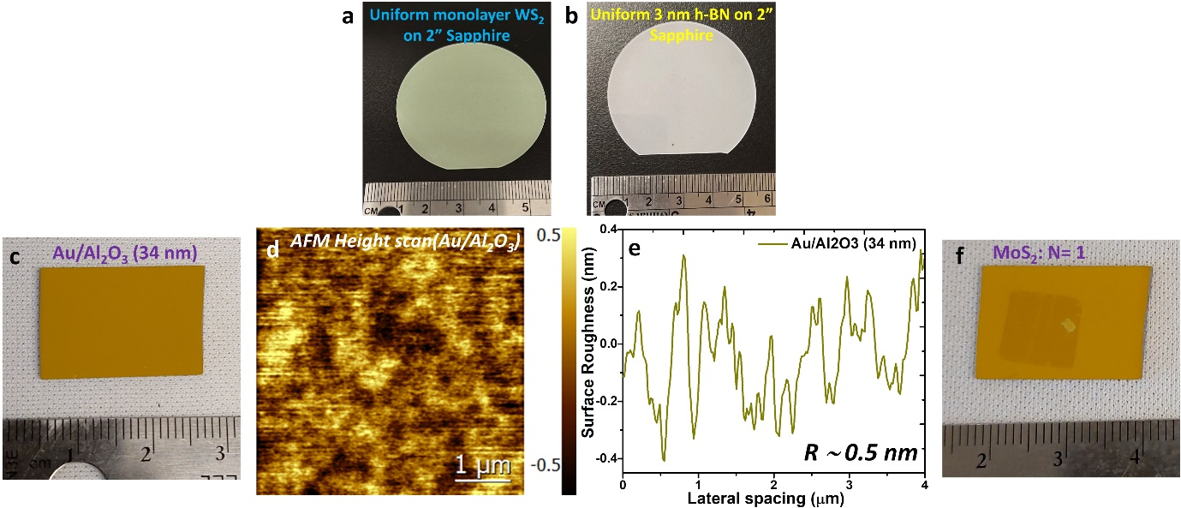
Figure S1: Camera clicked optical images of the 2” wafers of (a) monolayer WS₂ and (b) 3 nm thick h-BN. (c) Picture of 34 nm of atomic layer deposited Al₂O₃ on top of e-beam evaporated Au. (d) The atomic force microscopic (AFM) height image of the Al₂O₃/Au substrate and corresponding (e) Surface profile with measured surface roughness of $\sim$0.5 nm. (e) Picture of monolayer MoS₂ transferred on to Al₂O₃/Au surface.

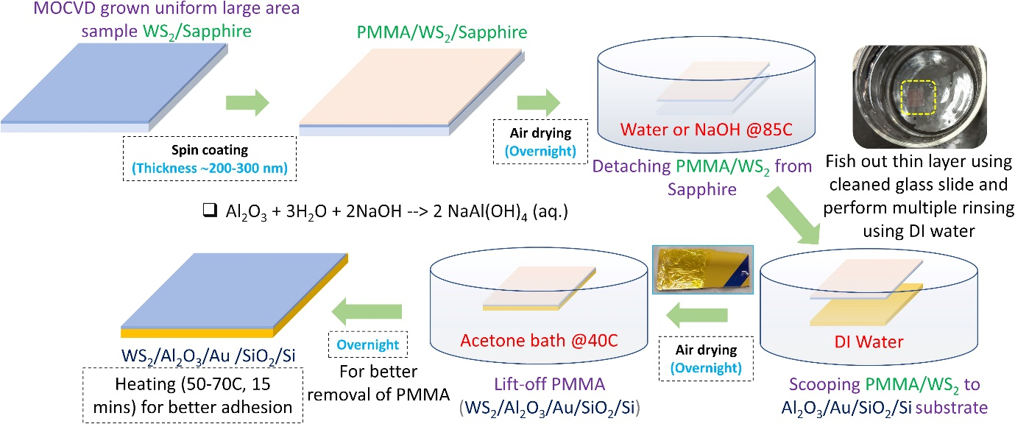
Figure S2: Wet chemical transfer technique shown with sequential steps needed with the appropriate time accounted for best result. Monolayer WS₂ as grown on c-plane sapphire substrate by MOCVD has been shown to transfer to new substrate (Al₂O₃/Au/SiO₂/Si).

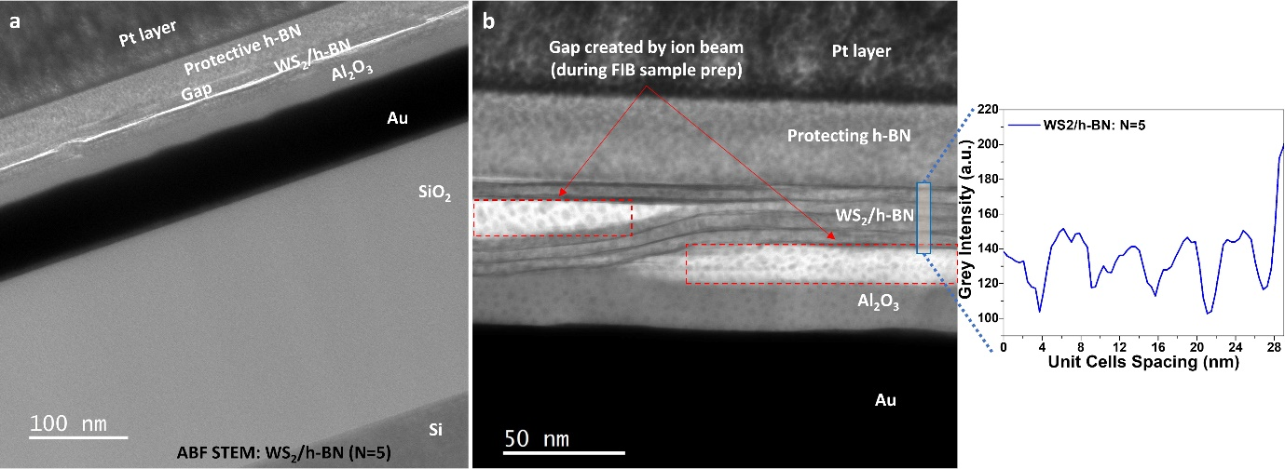
Figure S3: (a) Low magnification annular bright field (ABF) scanning transmission electron microscope (STEM) imaging of the WS₂/h-BN superlattice (N=5) covering the entire cross-sectional view. The protective h-BN and Pt layers were deposited on top to provide suitability of the plasma-FIB lamella preparation. (b) Magnified ABF STEM image shows the superlattice region where white contrast appears in the mid-section of the image formed due to air gap created by FIB milling process and corresponding line profile across the WS₂/h-BN unit cells as marked through blue rectangular region.

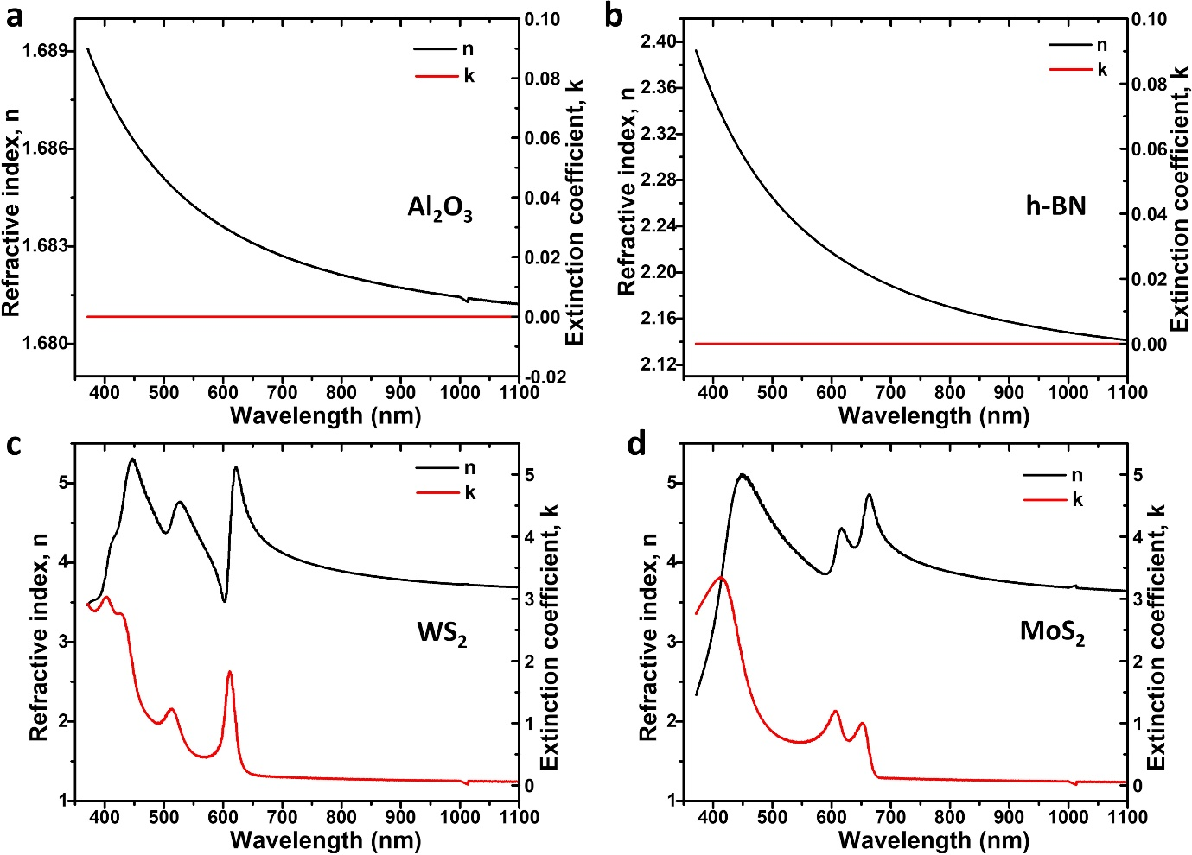Figure S4: The measured complex refractive index of (a) Al₂O₃, (b) h-BN, (c) WS₂, and (d) MoS₂. All were obtained using angle-resolved ellipsometry on single side polished sapphire. Samples that were grown on double side polished substrates were transferred on single side polished sapphire substrates before ellipsometry measurements and analysis. Al₂O₃ and h-BN were fitted using a Cauchy model, and WS₂ and MoS₂ were fitted using a series of Tauc-Lorentz oscillators. All optical constants were measured on single side polished sapphire substrates.

TMM Modeling and Genetic Algorithm Optimization:
Initial Transfer Matrix Method (TMM) modelling was carried out using a MATLAB script provided by the McGehee group¹ adapted to incorporate the repeating unit cell scheme. The standard script allows for the simulation of a multilayer superlattice in which the material, thickness, and relative order of each layer may be specified. Additionally, the script reads real and complex refractive index values for each properly referenced material from an external excel file. The script was converted to python and modified to allow for quicker simulations and angled incidence of both TE and TM polarized light. The algorithm follows the approach described by Petterson et al².
A genetic-algorithm-based optimization was implemented with the figure of merit being the primary excitonic absorptance for WS₂-based superlattices and the average absorptance of the primary and secondary excitons for MoS₂ and MoSe₂-based superlattices. Holding all other inputs constant, inputs controlling the number of unit cells, the thickness of the unit cell spacers, and the thickness of the bottom spacer were allowed to vary in this optimization.

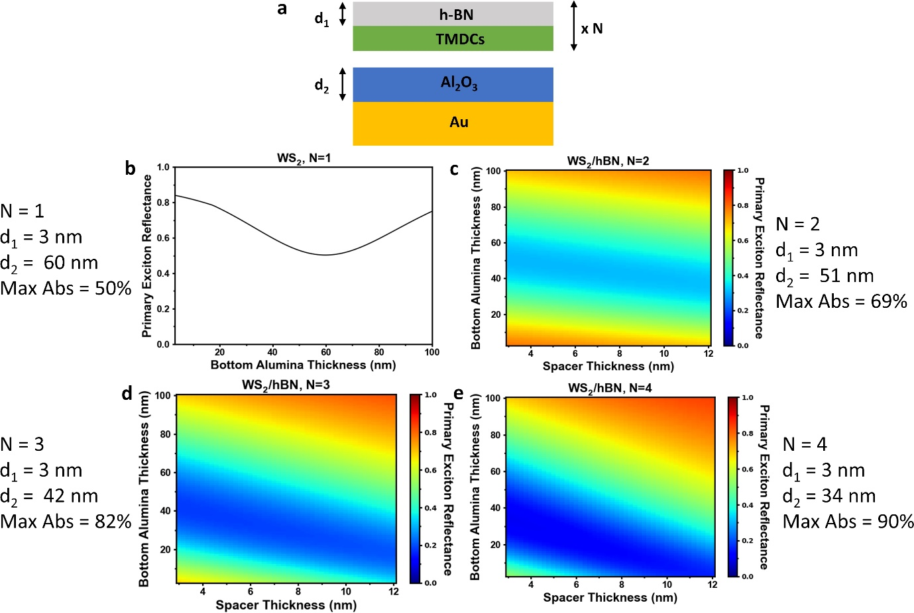
Figure S5: The results for optimizing the WS₂/Al₂O₃ superlattice for N=1 through N=4 for maximum primary exciton (613 nm) absorptance which corresponds to a minimum in the reflectance. (a) Schematic of our device with the optimized parameters marked. d₁ is called the spacer thickness, and d₂ is the bottom alumina thickness. (b-e) The optimization results for varying spacer and bottom alumina thickness with the optimal parameters listed for N=1 through 4.

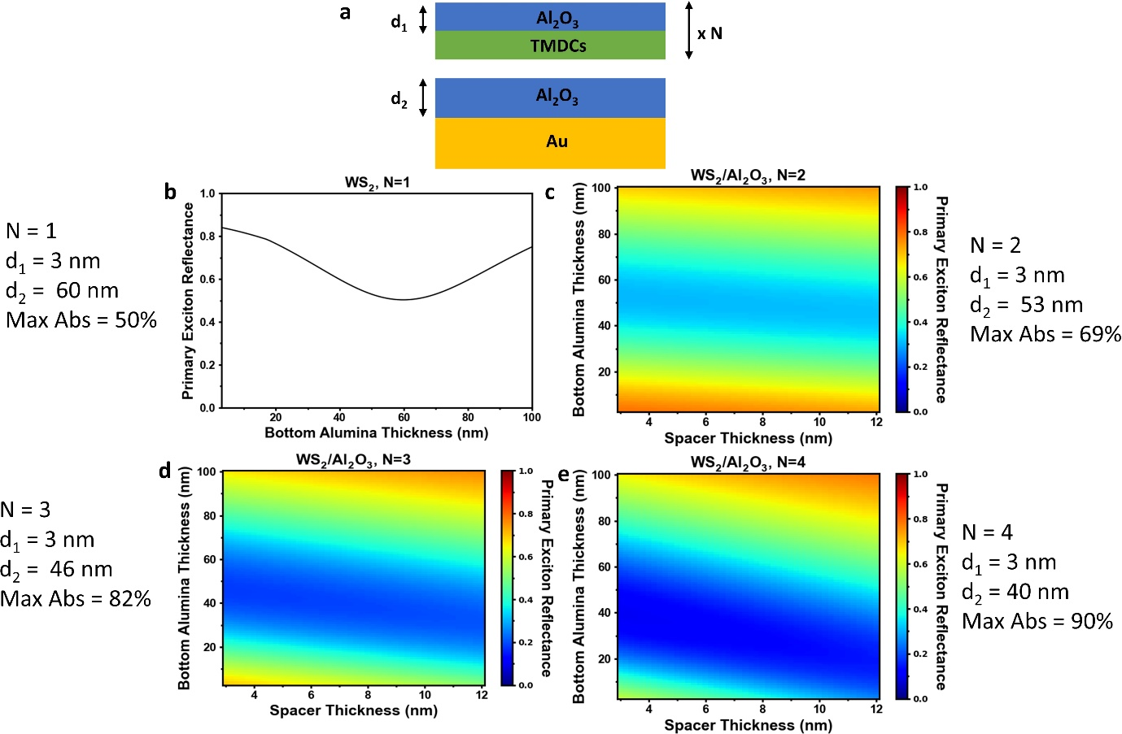
Figure S6: The results for optimizing the MoS₂/Al₂O₃ superlattice for N=1 through N=4 for maximum average absorptance of the A and B excitons (575 to 675 nm). (a-d) The optimization results for varying spacer and bottom alumina thickness with the optimal parameters listed for N=1 through 4. d₁ is the spacer thickness, and d₂ is the bottom alumina thickness.

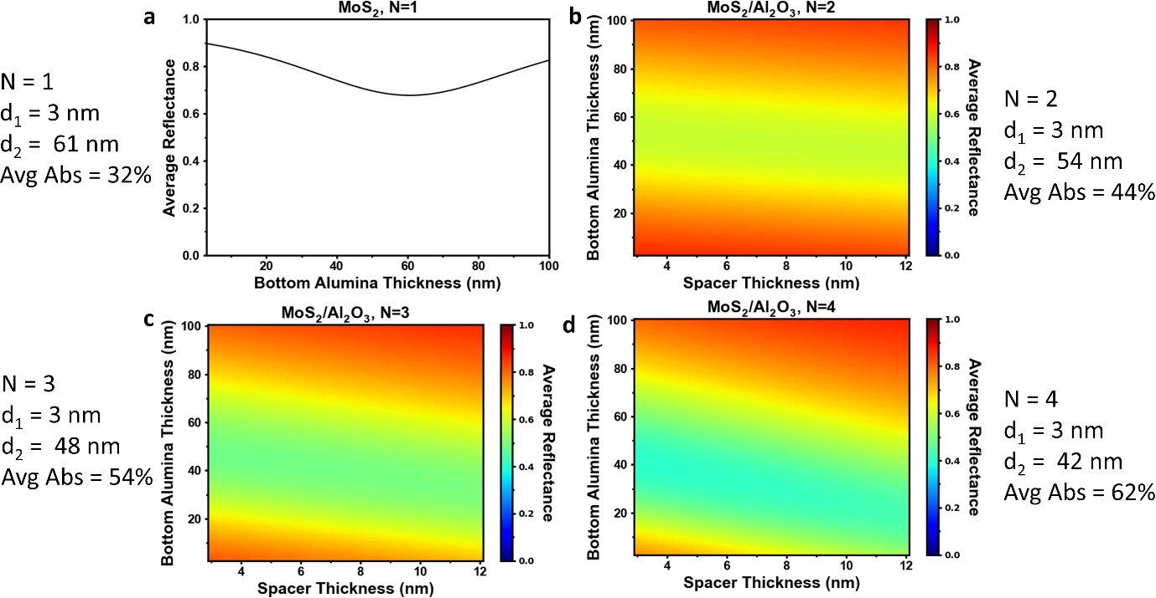
Figure S7: The results for optimizing the WS₂/hBN superlattice for N=1 through N=4 for maximum primary exciton (613 nm) absorptance which corresponds to a minimum in the reflectance. (a) Schematic of our device with the optimized parameters marked. d₁ is called the spacer thickness, and d₂ is the bottom alumina thickness. (b-e) The optimization results for varying spacer and bottom alumina thickness with the optimal parameters listed for N=1 through 4.

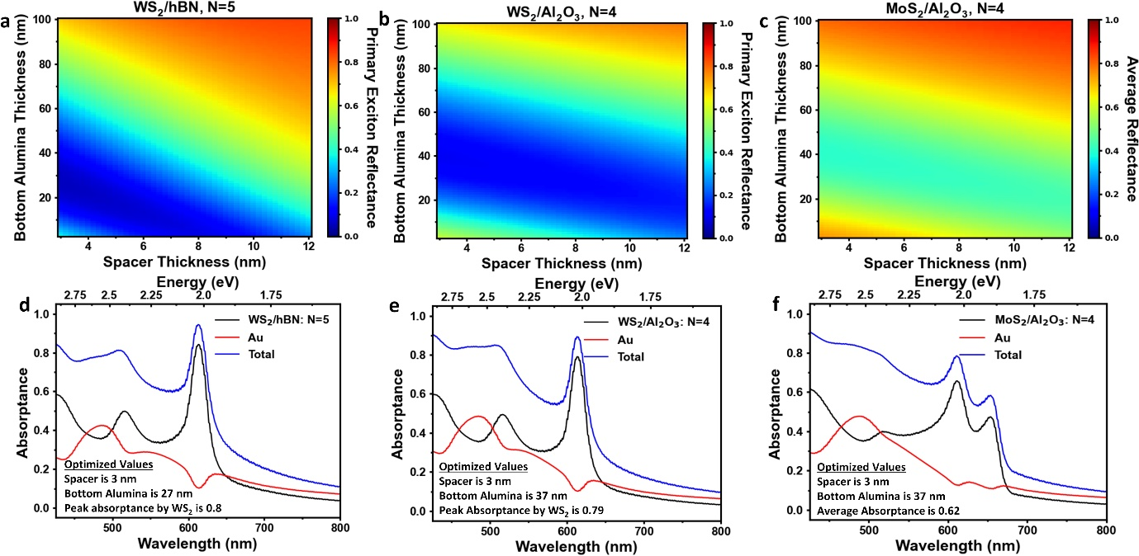
Figure S8: The optimization for the fabricated superlattices of (a) WS₂/h-BN (N=5), (b) WS₂/Al₂O₃ (N=4), and (c) MoS₂/Al₂O₃ (N=4) for varying bottom alumina and spacer thicknesses. The layer resolved absorptances of the optimized superlattices are shown in (d-f) for WS₂/h-BN (N=5), WS₂/Al₂O₃ (N=4), MoS₂/Al₂O₃ (N=4), respectively. The optimized parameters and absorptance values are indicated in the graphs.

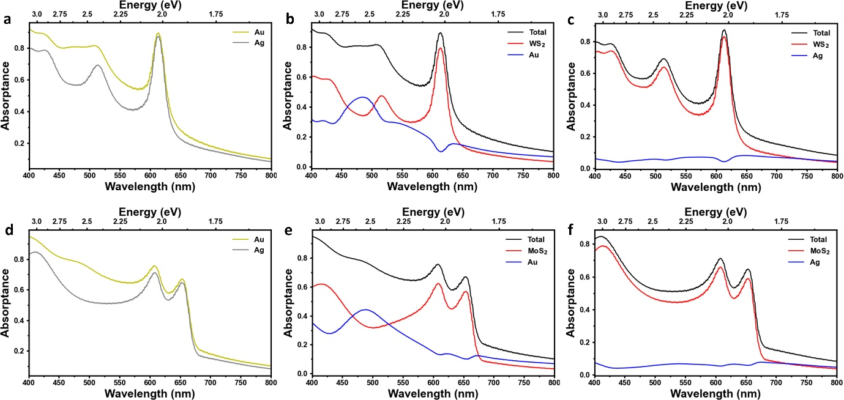
Figure S9: The absorptance dependence for superlattices with Au and Ag reflectors. (a, d) Comparison of the optimized spectra for WS₂/Al₂O₃: N=4 and MoS₂/Al₂O₃: N=4 superlattices, respectively. (b, c) The layer resolved absorptance for a WS₂/Al₂O₃: N=4 superlattice with Au and Ag reflectors. The Au has an absorptance of 0.10 at the primary exciton wavelength (613 nm) while the Ag reflector has an absorptance of 0.04 at the same wavelength. (e, f) The layer resolved absorptance for a MoS₂/Al₂O₃: N=4 superlattice with Au and Ag reflectors. The Au reflector has absorptances of 0.1 and 0.14 at the A (655 nm) and B (608 nm) exciton wavelengths, respectively, while the Ag reflector has absorptances of 0.06 and 0.06 as the same wavelengths.

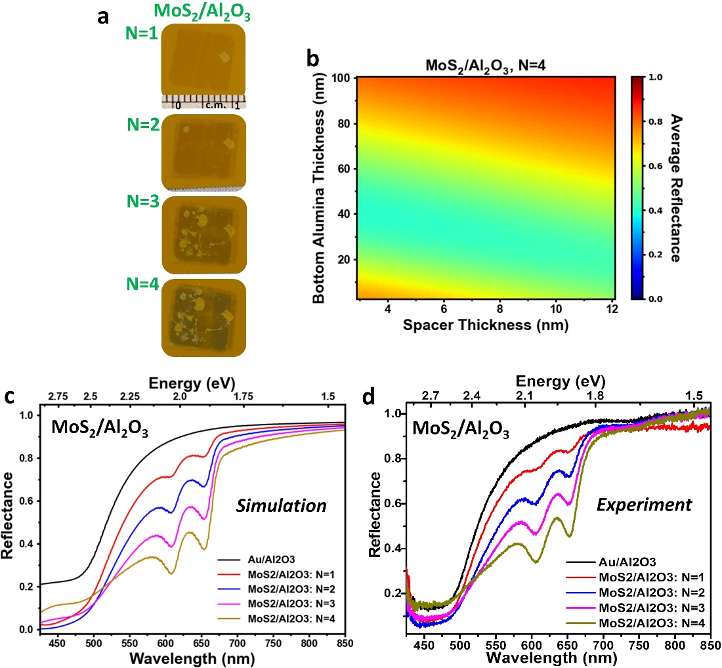
Figure S10: (a) Show the deposition of different number of unit cells of the MoS₂/Al₂O₃ superlattice. (b) The optimization process for the MoS₂/Al₂O₃ N=4 superlattice. (c) The simulated reflectance of the Al₂O₃/Au substrate and varying number of unit cells, and (d) the experimentally measured reflectance of the Al₂O₃/Au substrate and varying number of unit cells.

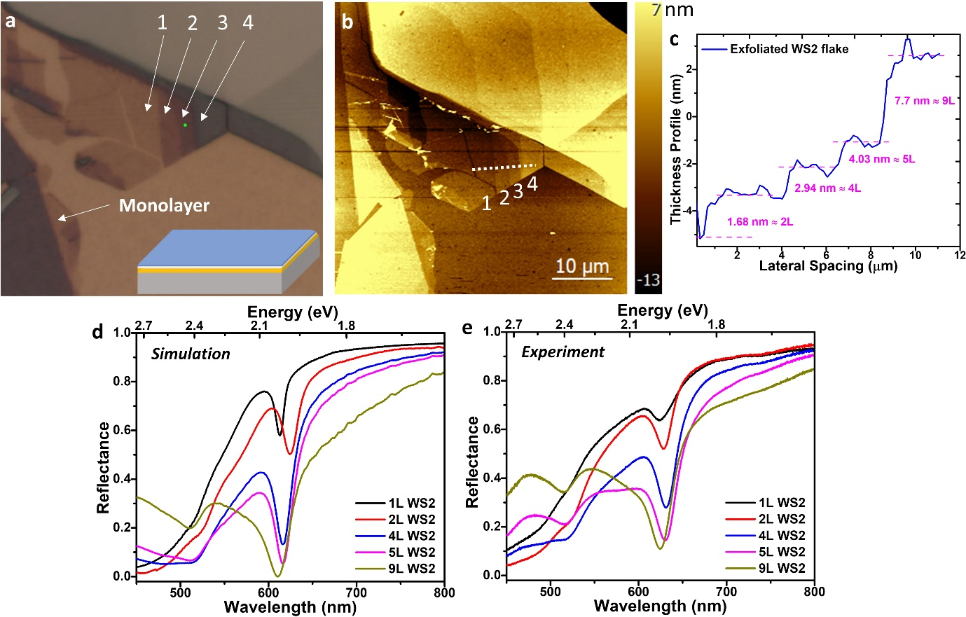
Figure S11: (a) A microscopic image of the exfoliated WS₂ sample on Al₂O₃ (34 nm)/Au with the monolayer, bi-layer, 4-layer, 5-layer, and 9-layer regions labelled monolayer, 1, 2, 3, and 4, respectively. (b) AFM image of the same area shown in (a). (c) shows the thickness profile along the dashed line in (b). (d) is the simulated reflectance of the different regions using WS₂ complex refractive indices obtained from literature. (d) the experimental reflectance of the regions.

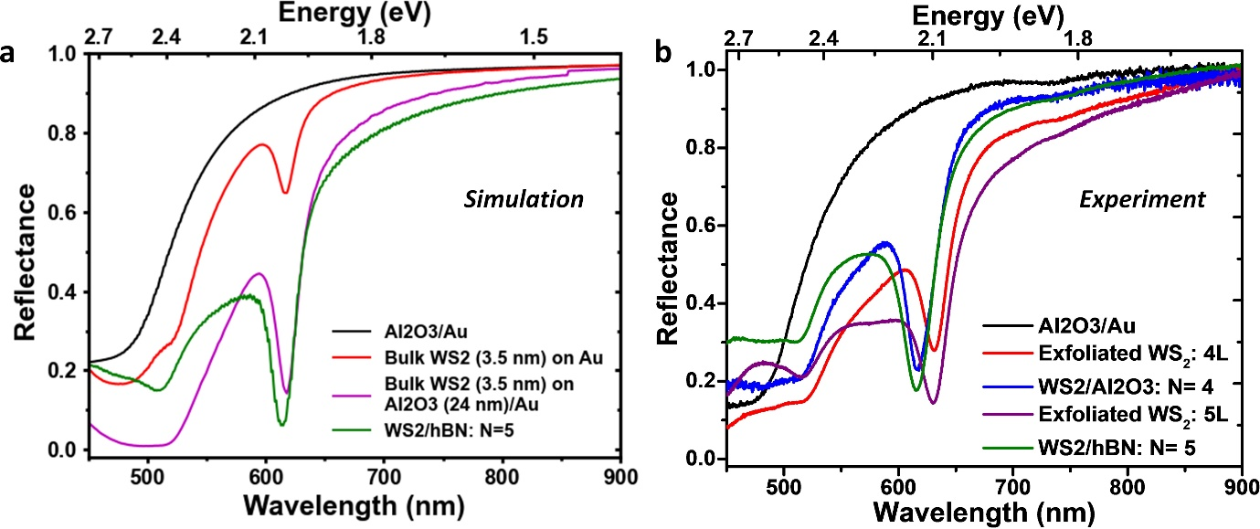
Figure S12: (a) The simulated reflectance of the WS₂/h-BN N=5 superlattice compared to architectures with similar thicknesses of bulk WS₂. (b) The experimental reflectance of the N=4 and N=5 superlattice WS₂/h-BN superlattices compared to the exfoliated sample of similar WS₂ thicknesses. Blue shift of superlattice peak showing the monolayer confined structure as opposed to bulk exfoliated WS₂. For 4L it is pretty clear that monolayer superlattice is superior compared to 4L thick WS₂, even for 5L case, superlattice is superior to exfoliated WS₂ as is evident from the simulations.

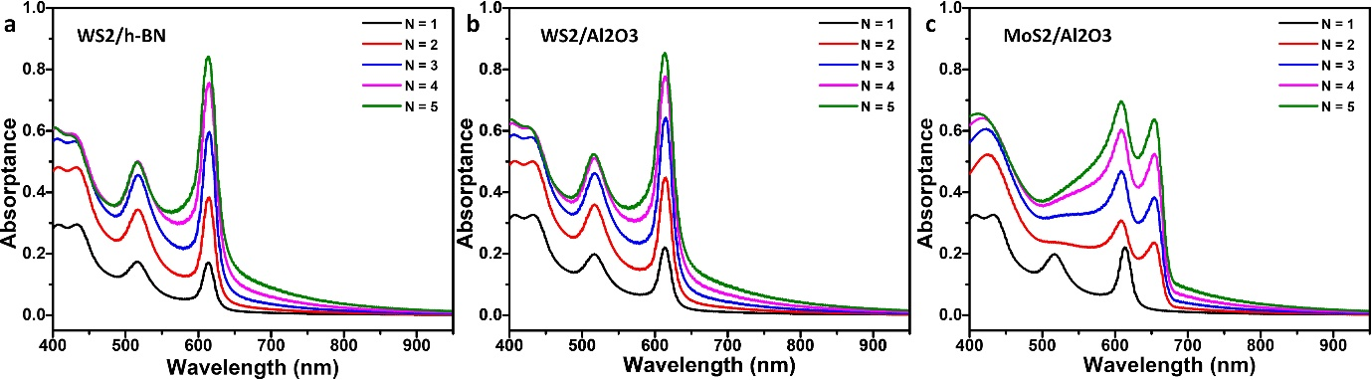
Figure S13: (a-c) Layer resolved absolute absorptance of the TMDC layers (WS₂ and MoS₂) in three different superlattice structure, simulated using TMM model for varying number of unit cells from N=1 to 5.

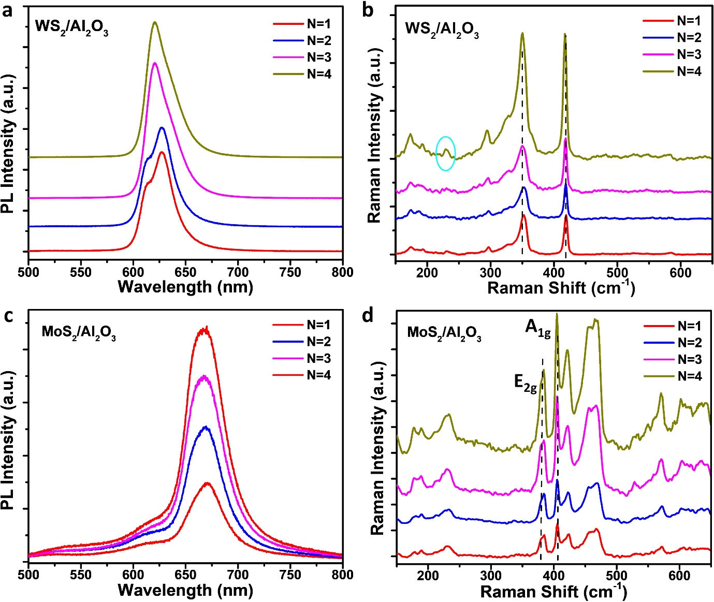
Figure S14: (a) The number of unit cells dependent PL of the WS₂/Al₂O₃ superlattice. The exciton and trion peaks merge with increasing N, and the main peak blue shifts. (b) The number of unit cells dependent Raman spectra of the WS₂/Al₂O₃ superlattice. The monolayer Raman spectra characteristics are maintained throughout the stacking process. The blue circle shows the emergence of a defect state with increased stacking. (c) The number of unit cells dependent PL of the MoS₂/Al₂O₃ superlattice. (d) The number of unit cells dependent Raman spectra of the MoS₂/Al₂O₃ superlattice. The monolayer Raman spectra characteristics are maintained throughout the stacking process.

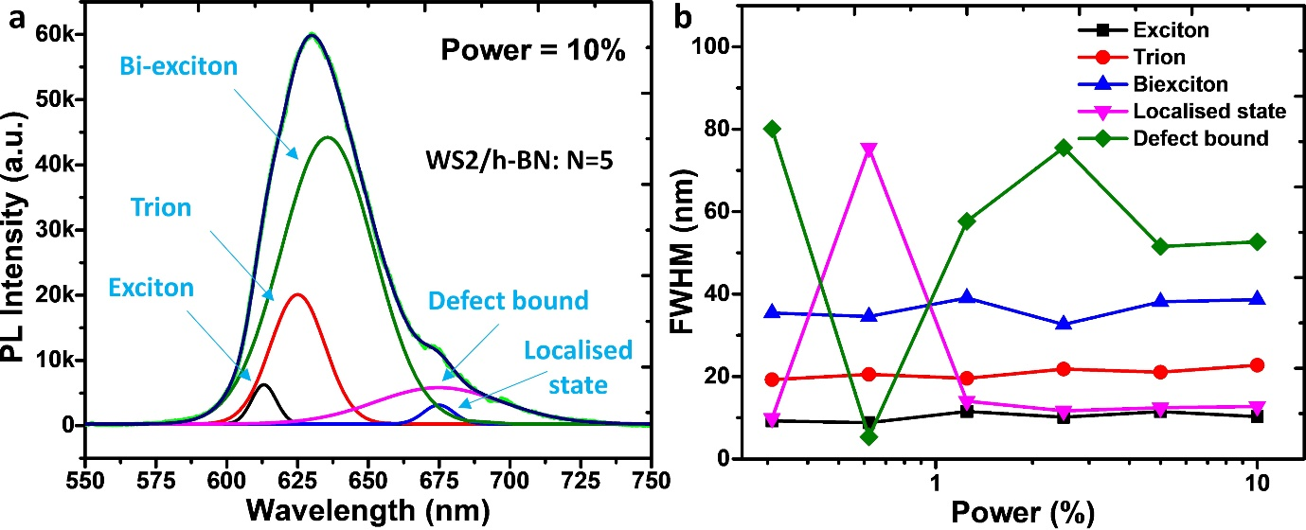
Figure S15: (a)The highest power (10%) PL spectrum for WS₂/h-BN decomposed into its constituent peaks using a series of Lorentzian multipeak fittings. (b) The line-width dependence on varying power density for the WS₂/h-BN: N=5 superlattice.

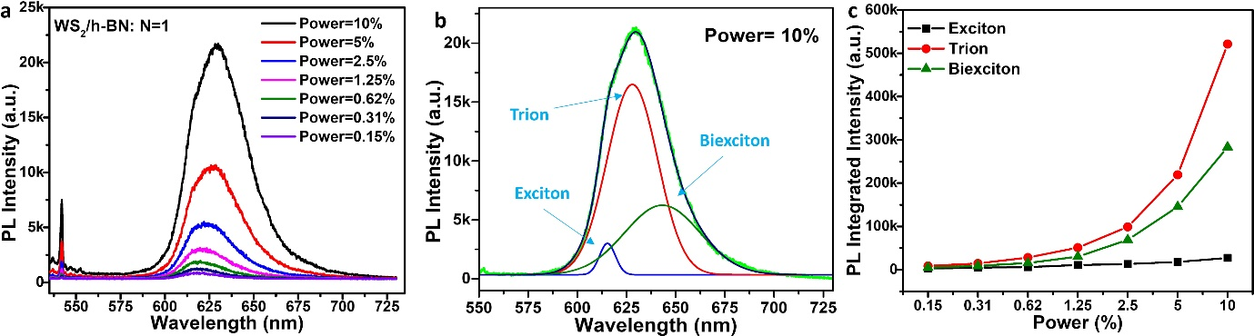
Figure S16: (a) The power dependent PL spectra for the WS₂/h-BN N=1 superlattice. (b) The highest power PL spectrum for WS₂/h-BN decomposed into its constituent peaks using a series of Lorentzian fits. (c) The intensities of the constituent PL excitonic peaks and their dependence on laser power.

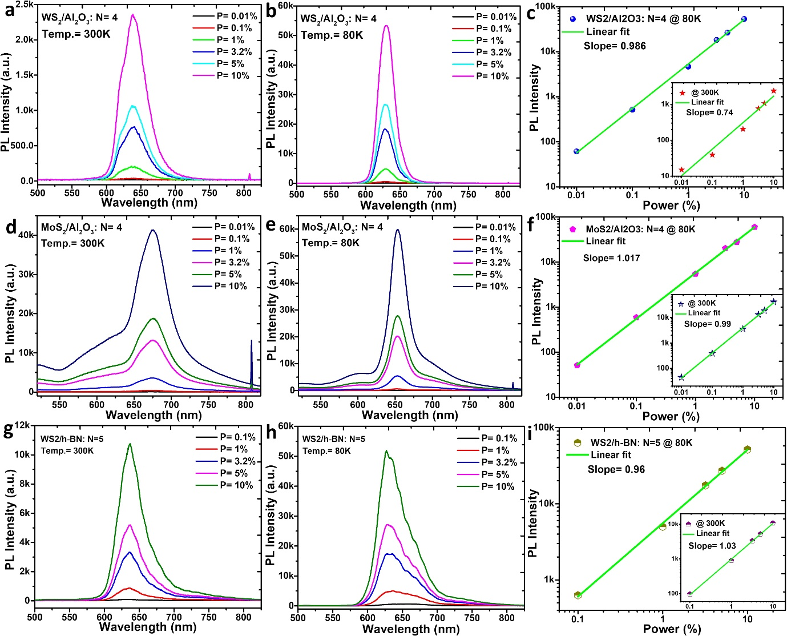
Figure S17: The dependent PL spectra for WS₂/Al₂O₃ superlattice at temperatures of (a) 300 K and (b) 80 K. The PL intensity increased by a factor of ∼23 when cooling the sample from 300 K to 80 K. (c) Shows the linear dependent of the maximum PL intensity on laser power for the WS₂/Al₂O₃ N=4 superlattice at 80 K. The dependent PL spectra for MoS₂/Al₂O₃ superlattice at temperatures of (d) 300 K and (e) 80 K. (f) Shows the linear dependent of the maximum PL intensity on laser power for the MoS₂/Al₂O₃ N=4 superlattice at 80 K. The dependent PL spectra for WS₂/h-BN superlattice at temperatures of (g) 300 K and (h) 80 K. The PL intensity increased by a factor of ∼5 when cooling the sample from 300 K to 80 K. (i) shows the linear dependent of the maximum PL intensity on laser power for WS₂/h-BN superlattice. Inset of figure c, f, i consist linear dependencies of laser power upon the PL peak intensities measured at room temperature.

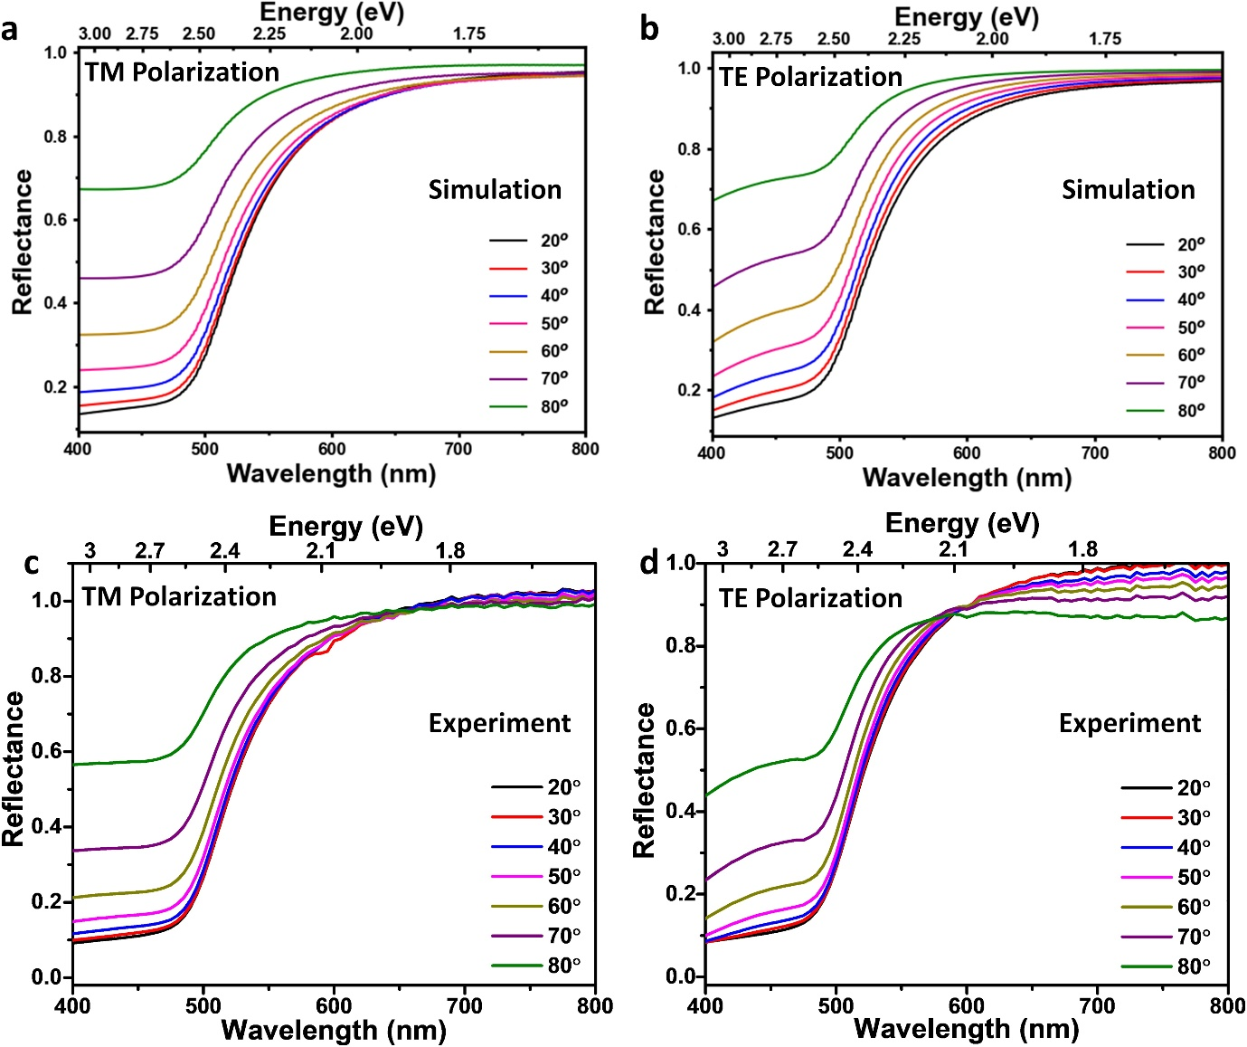
Figure S18: The simulated angle-resolved reflectance of 34 nm of Al₂O₃ on Au for (a) TM and (b) TE polarized light. The corresponding experimental spectra for (c) TM and (d) TE polarized light.

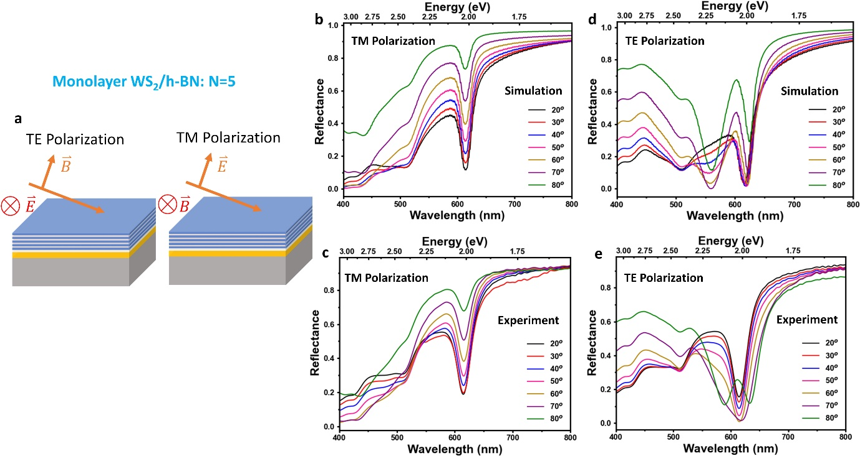
Figure S19: (a) depicts the two polarizations of incident light on the superlattice. For TE polarized light, the incident magnetic field tilts out of plane, and for TM polarized light, the incident electric field tilts out of plane. The (b) simulated and (c) experimental angle-resolved reflectance spectra of the WS₂/h-BN N=5 superlattice with TM polarized incident light. The (d) simulated and (e) experimental angle-resolved reflectance spectra of the WS₂/h-BN N=5 superlattice with TE polarized incident light.

The Poynting vector distribution of the cavity modes in WS₂ and MoS₂ superlattices are shown in Figure S20. The Poynting vector distribution was calculated using our transfer matrix method simulations. Since both of the superlattices have similar refractive index profiles owing to them have the same geometries. WS₂ and MoS₂ having similar refractive indices at λ=721 nm (n=4.04 for WS₂ and n=4.09 for MoS₂), both superlattices have the same cavity mode energy (1.72 eV). The Poynting vector of both superlattices was found to concentrate in the TMDC layers indicating that the increased absorption is due to waveguide modes in the TMDCs.

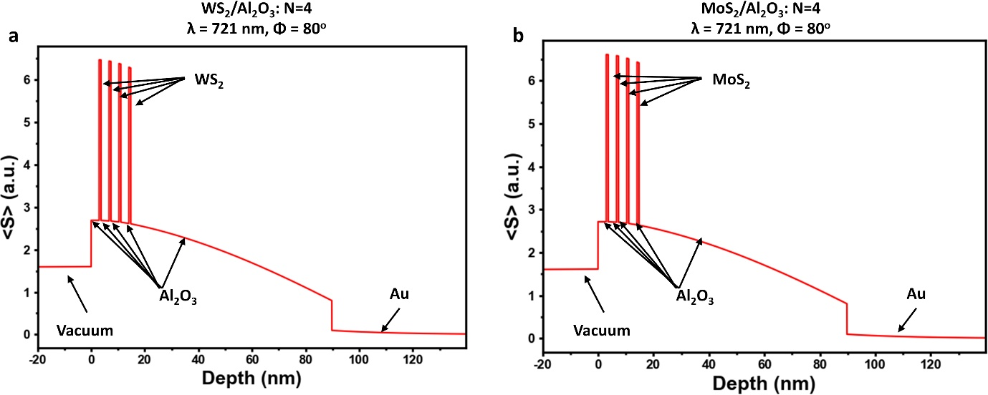
Figure S20: The Poynting vector distributions in (a) WS₂/Al₂O₃: N=4 and (b) MoS₂/Al₂O₃: N=4 superlattices. Both are for incident angles of 80º with bottom Al₂O₃ thicknesses of 75 nm. The arrows indicate the material in each region.

Rabi splitting and energy calculation:
We modelled the exciton-polaritons in WS₂-based superlattices using a coupled oscillator model which is based on the Jaynes-Cummings Model Hamiltonian³
$H=\left(\begin{matrix}E_{x} & g \\ g & E_{c}\left(t_{Al2O3}\right)\end{matrix}\right)$ ……. (1)
Where E_{x} and E_{c} are the uncoupled energies of the exciton and cavity modes, respectively, and g is the coupling parameter which is related to the Rabi splitting as $g=\frac{ℏΩ_{Rabi}}{2}$. E_{c} was determined to be linearly dependent on the thickness of the bottom alumina layer, t_{Al2O3}. Assuming the damping factor of the cavity mode is much larger than the damping factor of the exciton, the splitting of the exciton-polaritons is in the strong coupling regime when $g>\frac{γ_{C}}{4}$ ⁴ where $γ_{C}$ is the damping factor of the cavity mode which is related to the Q factor of the mode by $Q=\frac{E_{c}}{γ_{c}}$. We found that our superlattices were all in the strong coupling regime as the incident angle approached 90º, and strong coupling occurred at lower incident angles as N increased (see Figure S24A).
The model was fitted to the simulated values using g and the linear dependence of the cavity mode on the bottom alumina thickness (E_{c} = mt_{Al2O3} + b) as the fit parameters and by using a least squares optimization method. Figure S19A shows that our model and the simulated energies of the UEP and LEP agree.
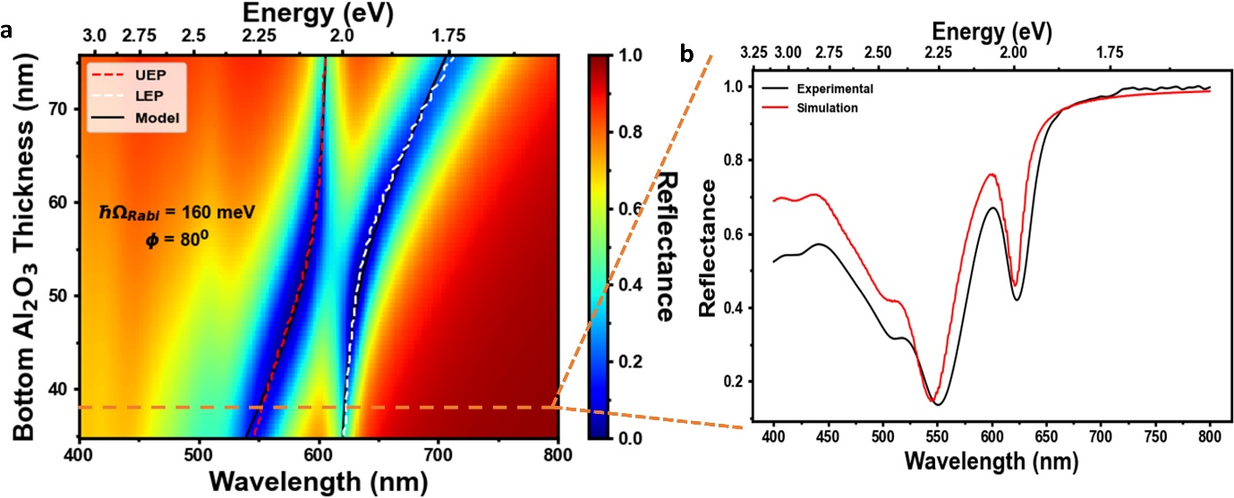
Figure S21: Depicts the coupled-oscillator model used on the WS₂ based superlattices. (a) Shows the simulated anti-crossing behavior of the WS₂/Al₂O₃ N=4. (b) Compared the simulated and experiment reflectance spectra of the WS₂/Al₂O₃ N=4 superlattice with a bottom alumina thickness of 34 nm.

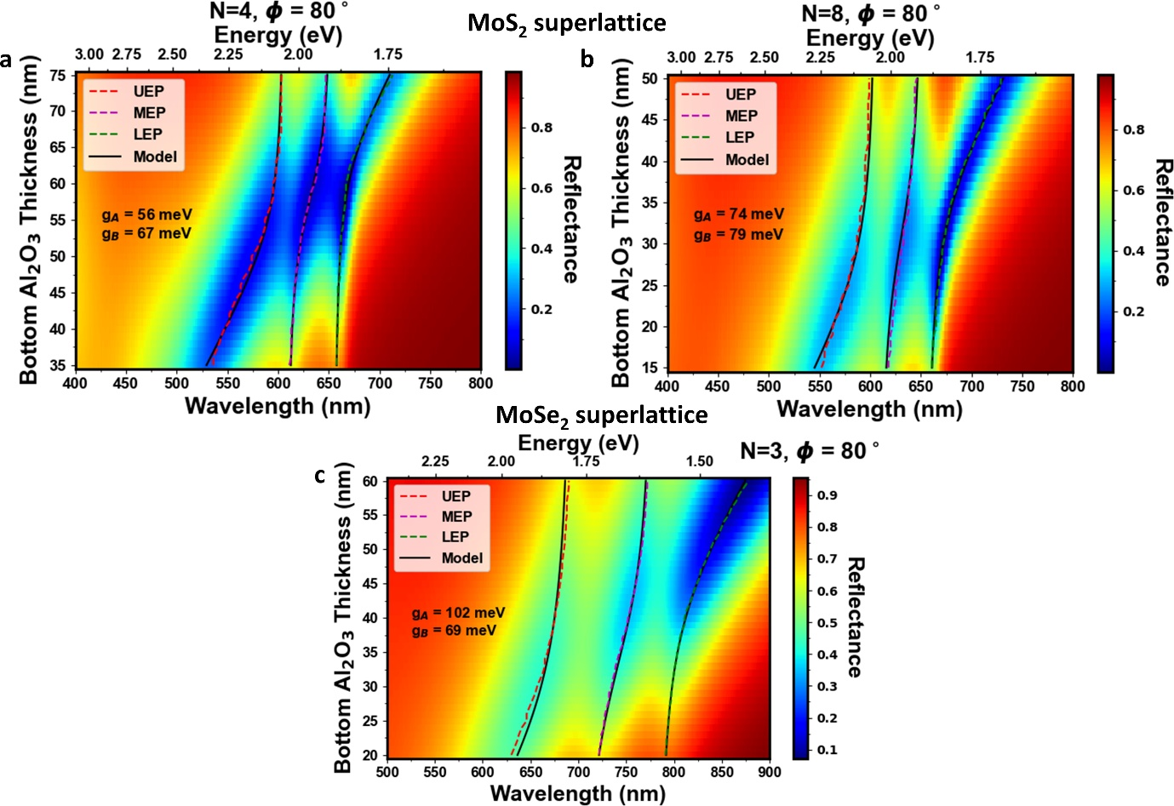
Figure S22: The three-coupled oscillator model used for MoS₂/Al₂O₃ superlattices. The simulated strong coupling behavior for MoS₂/Al₂O₃ superlattices with (a) N=4 and (b) N=8 unit cells. (c) Similar three coupled oscillator used in case of MoSe₂/Al₂O₃ superlattice with N= 3.
The energy difference between the A and B excitons in MoS₂ is smaller than in WS₂ allowing the cavity mode to interact with the A and B excitons simultaneously in MoS₂. This is reflected in the model as we used a three-coupled oscillator for MoS₂ where two of the oscillators are excitons while the third is the cavity. The Hamiltonian of this system can be written as⁵
$H=\left(\begin{matrix}E_{A} & 0 & g_{A} \\ 0 & E_{B} & g_{B} \\ g_{A} & g_{B} & E_{C}\left(t_{Al2O3}\right)\end{matrix}\right)$ ……. (2)
Similar to the coupled oscillator model, the diagonal terms (E_{A}, E_{B}, and E_{C}) are the uncoupled energies of the A exciton, B exciton, and cavity mode, respectively, while the off-diagonal terms determine the coupling strength between oscillators. g_{A} is the coupling parameter between the A exciton and the cavity mode while g_{B} is the coupling parameter between the B exciton and the cavity mode. The 0 terms are due to the assumption that the A and B excitons do not couple with one another. This assumption was checked by allowing the terms to vary when fitting the model, but this approached gave the coupling between the excitons to be 5 orders of magnitude smaller than g_{A} and g_{B}. The model was fitted to the simulated values using g_{A}, g_{B}, and the linear dependence of the cavity mode on the bottom alumina thickness as the fit parameters and a least square optimization approach.

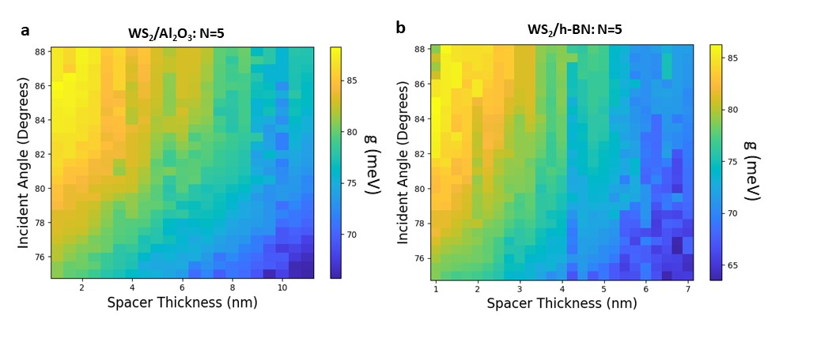
Figure S23: The angle and spacer thickness dependence on the coupling coefficient ($\frac{ℏΩ_{Rabi}}{2}=g$) for (a) WS₂/Al₂O₃ N=5 and (b) WS₂/h-BN N=5 superlattices.

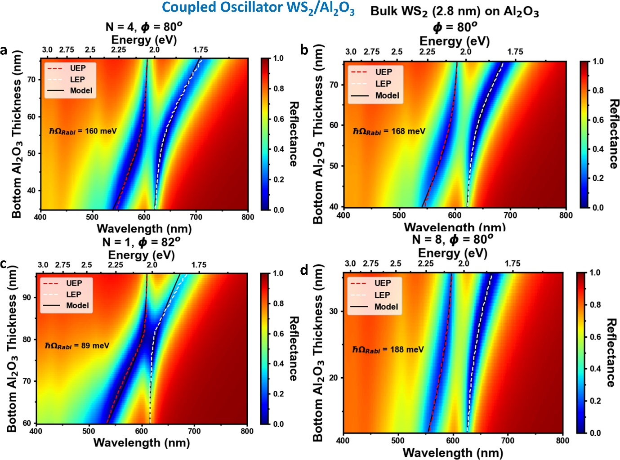
Figure S24: The simulated anti-crossing behavior of (a) WS₂/Al₂O₃ N=4, (b) bulk WS₂ (2.8 nm) on Al₂O₃ (34 nm) and Au, (c) WS₂/Al₂O₃ N=1, and (d) WS₂/Al₂O₃ N=8.

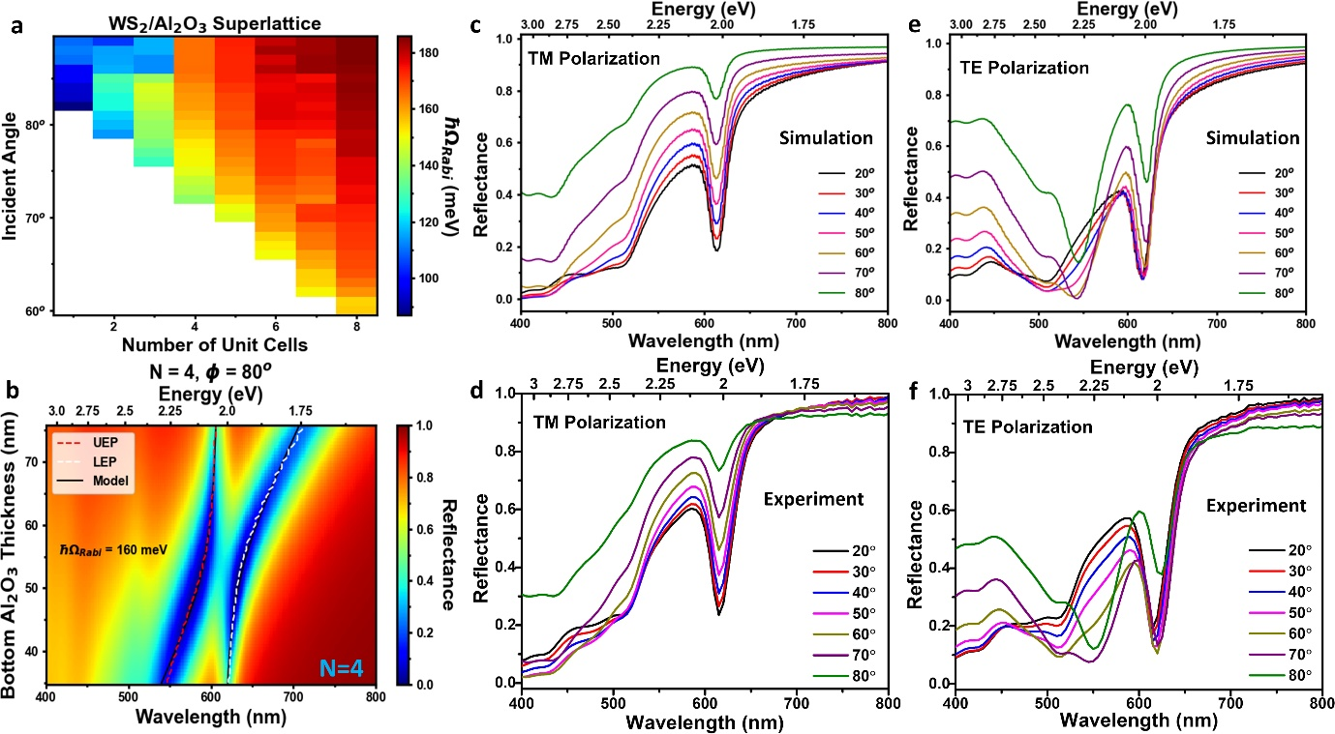
Figure S25: Spectra of the WS₂/Al₂O₃ N=4 superlattice. (a) The incident angle and number of unit cell dependence of the Rabi splitting under TE polarized light. (b) The anti-crossing behavior. The (c) simulated and (d) experimental reflectance spectra of TM polarized light. The (e) simulated and (f) experimental reflectance spectra of TE polarized light.

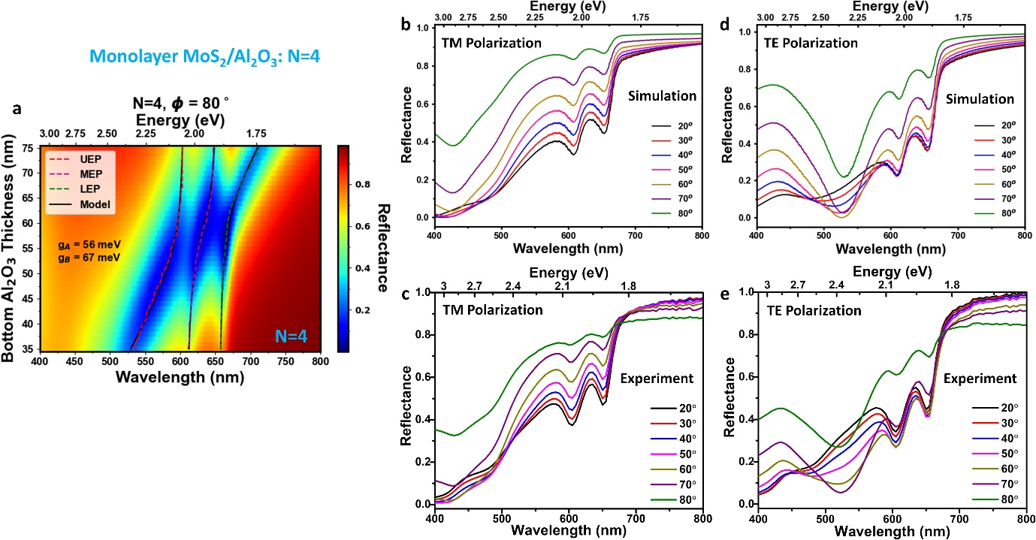
Figure S26: Spectra of the MoS₂/Al₂O₃ N=4 superlattice. (a) The anti-crossing behavior. The (b) simulated and (c) experimental reflectance spectra of TM polarized light. The (d) simulated and (e) experimental reflectance spectra of TE polarized light.

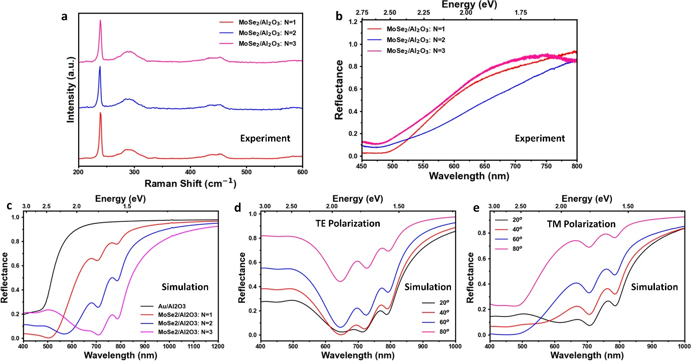
Figure S27: The fabrication of MoSe₂/Al₂O₃ superlattice. (a, b) The layer dependent (unit cell N) Raman and reflectance spectra and the corresponding (c) simulated layer dependent reflectance spectrum. (d, e) The angle dependent reflectance spectra for the N=3 superlattice for TE and TM polarized incident light.

References:

1 Burkhard, G. F. & Hoke, E. T. Transfer Matrix Optical Modeling. McGehee Group (Stanford Univ) (2011).
2 Pettersson, L. A. A., Roman, L. S. & Inganäs, O. Modeling photocurrent action spectra of photovoltaic devices based on organic thin films. Journal of Applied Physics 86, 487-496, doi:10.1063/1.370757 (1999).
3 Alvertis, A. M. et al. First principles modeling of exciton-polaritons in polydiacetylene chains. The Journal of Chemical Physics 153, 084103, doi:10.1063/5.0019009 (2020).
4 Reithmaier, J. P. et al. Strong coupling in a single quantum dot–semiconductor microcavity system. Nature 432, 197-200, doi:10.1038/nature02969 (2004).
5 Zhang, H. et al. Hybrid exciton-plasmon-polaritons in van der Waals semiconductor gratings. Nature Communications 11, 3552, doi:10.1038/s41467-020-17313-2 (2020).

