Supplemental Figures

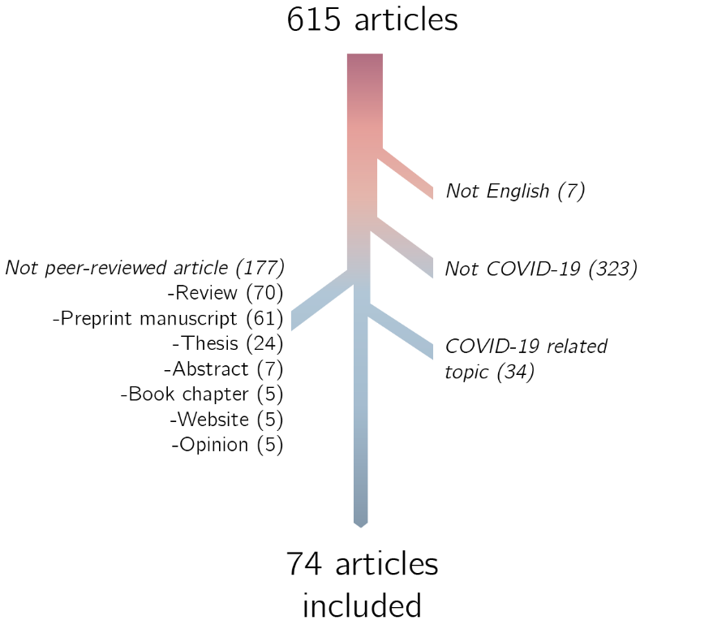
Figure S1. Selection of articles in the current study.

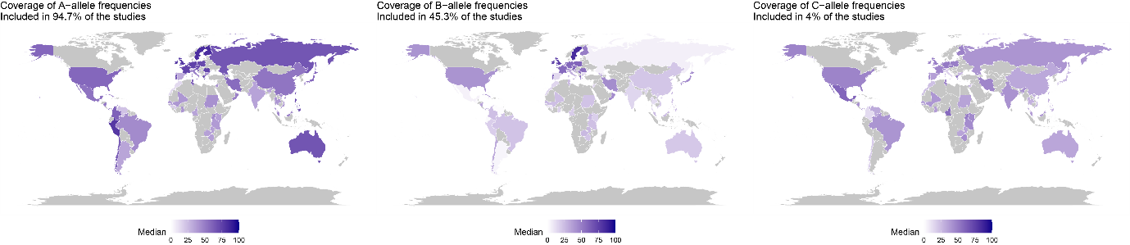
Figure S2 Coverage of alleles in studies investigated. Percentage in each country represents the coverage of alleles. White, low coverage, dark blue high coverage, gray no data.

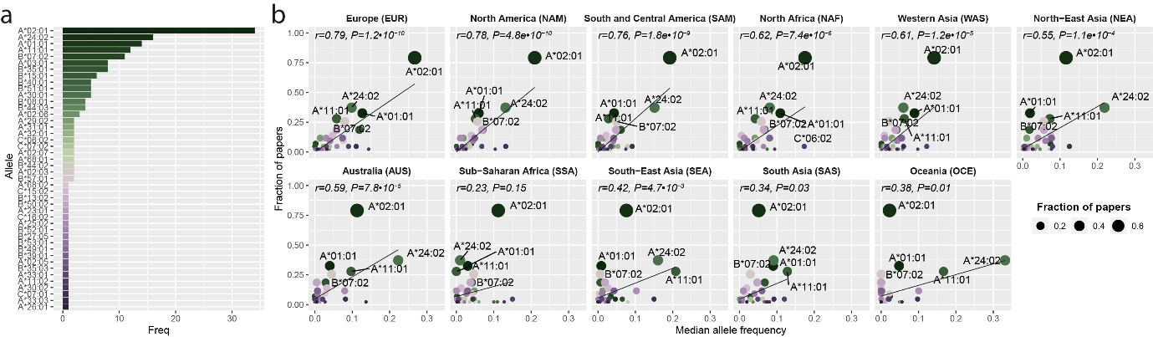Figure S3 Comparison of studied allele frequencies across geographical locations based on the systematic review of Jin et al. a Frequency of the alleles across included studies. X-axis number of papers; y-axis, studied alleles. b Correlation between fraction of papers and median allele frequency for each allele in a specific geographical location.

