Supplementary information

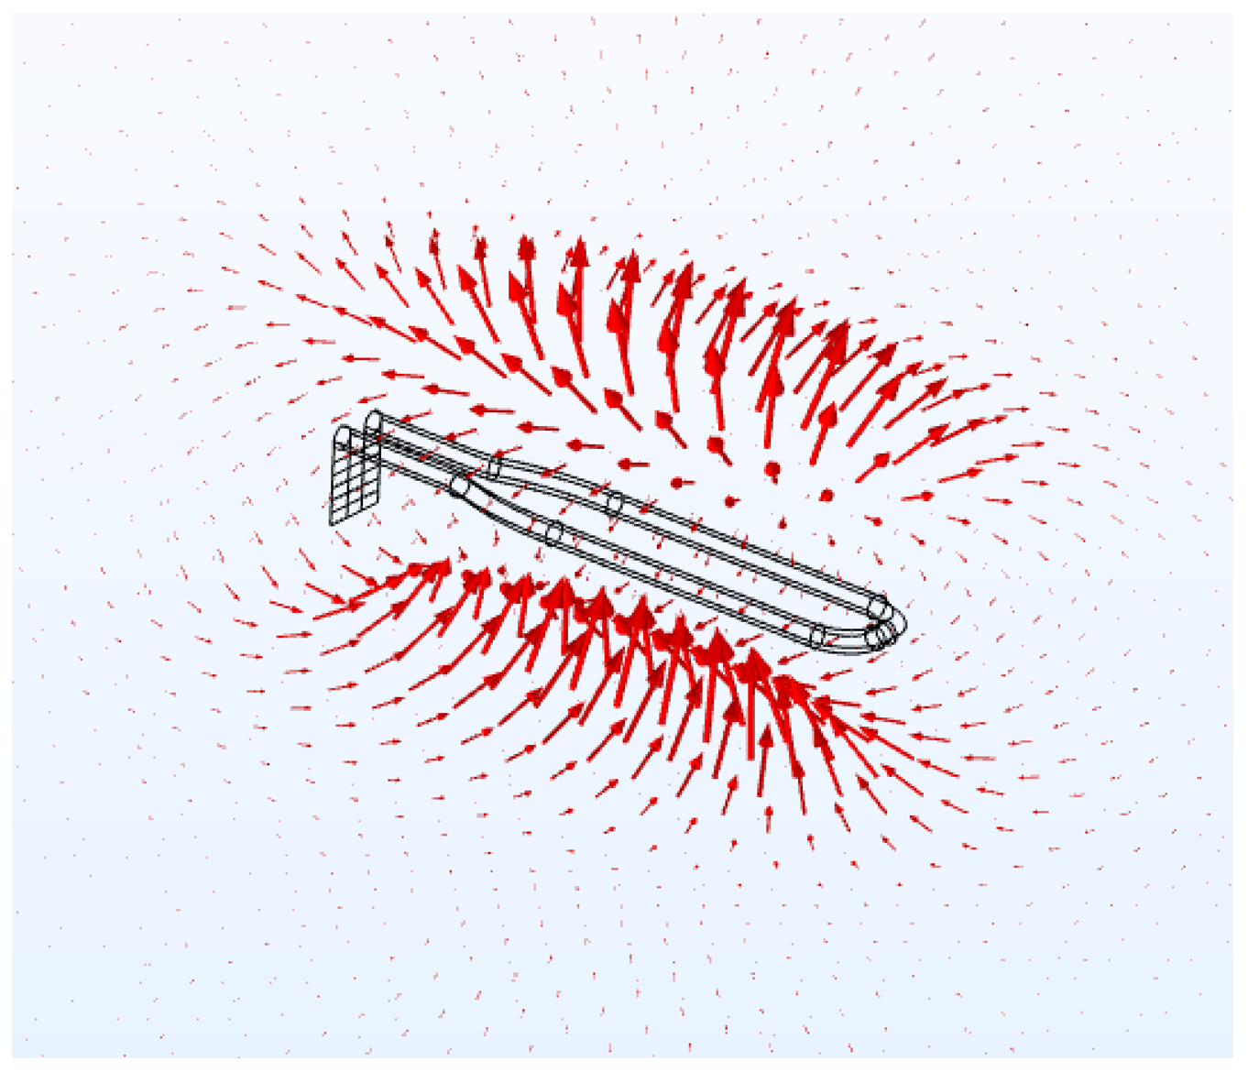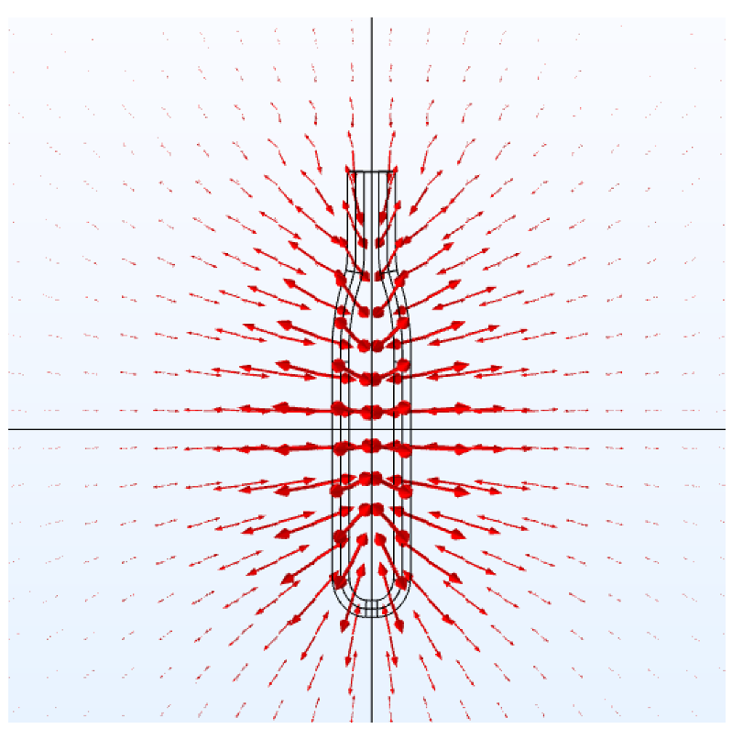
Fig. S1. 3D display of the B1 magnetic field generated by the microcoil obtained with a FEM modeling software. Red arrows are proportional to the B1 amplitude. (oblique view on the left, view from above the ellipse-shape coil on the right)

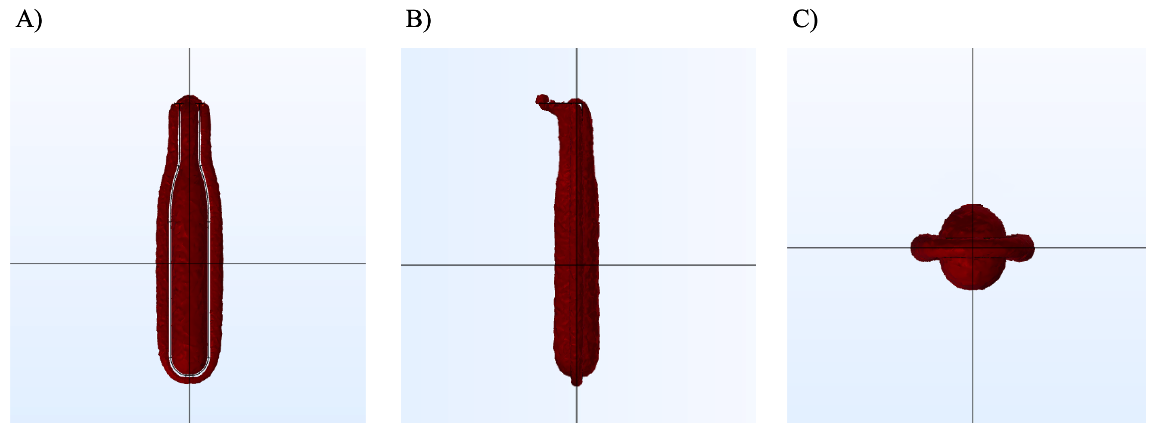
Fig. S2 Isosurface of the amplitude of the transverse component, relative to the static magnetic field, of the B₁ RF field seen in three orthogonal planes, (A) ellipse-shape view, (B) side view and (C) top view. Regions without B1 values in (A) correspond to the coil wire.

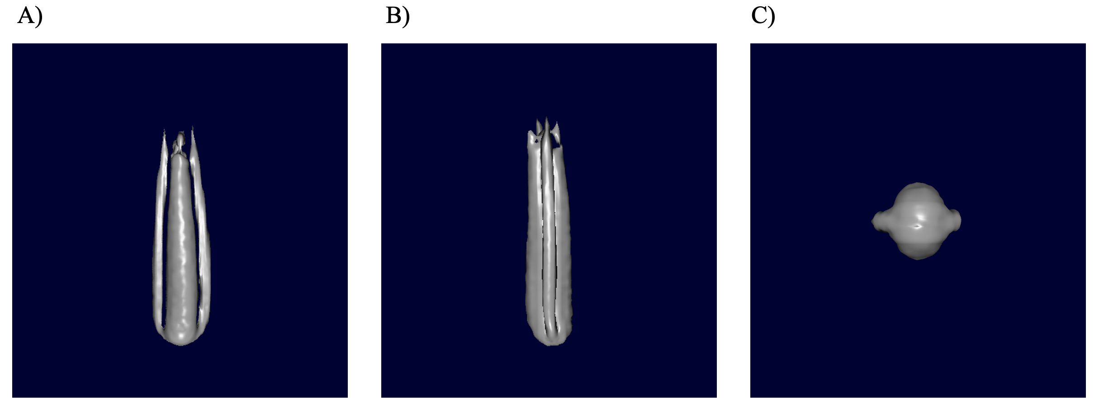
Fig. S3. Volume rendering of a 3D MRI acquisition obtained with the microcoil. The three views correspond to the orientation of the isosurface shown in Fig. S2.

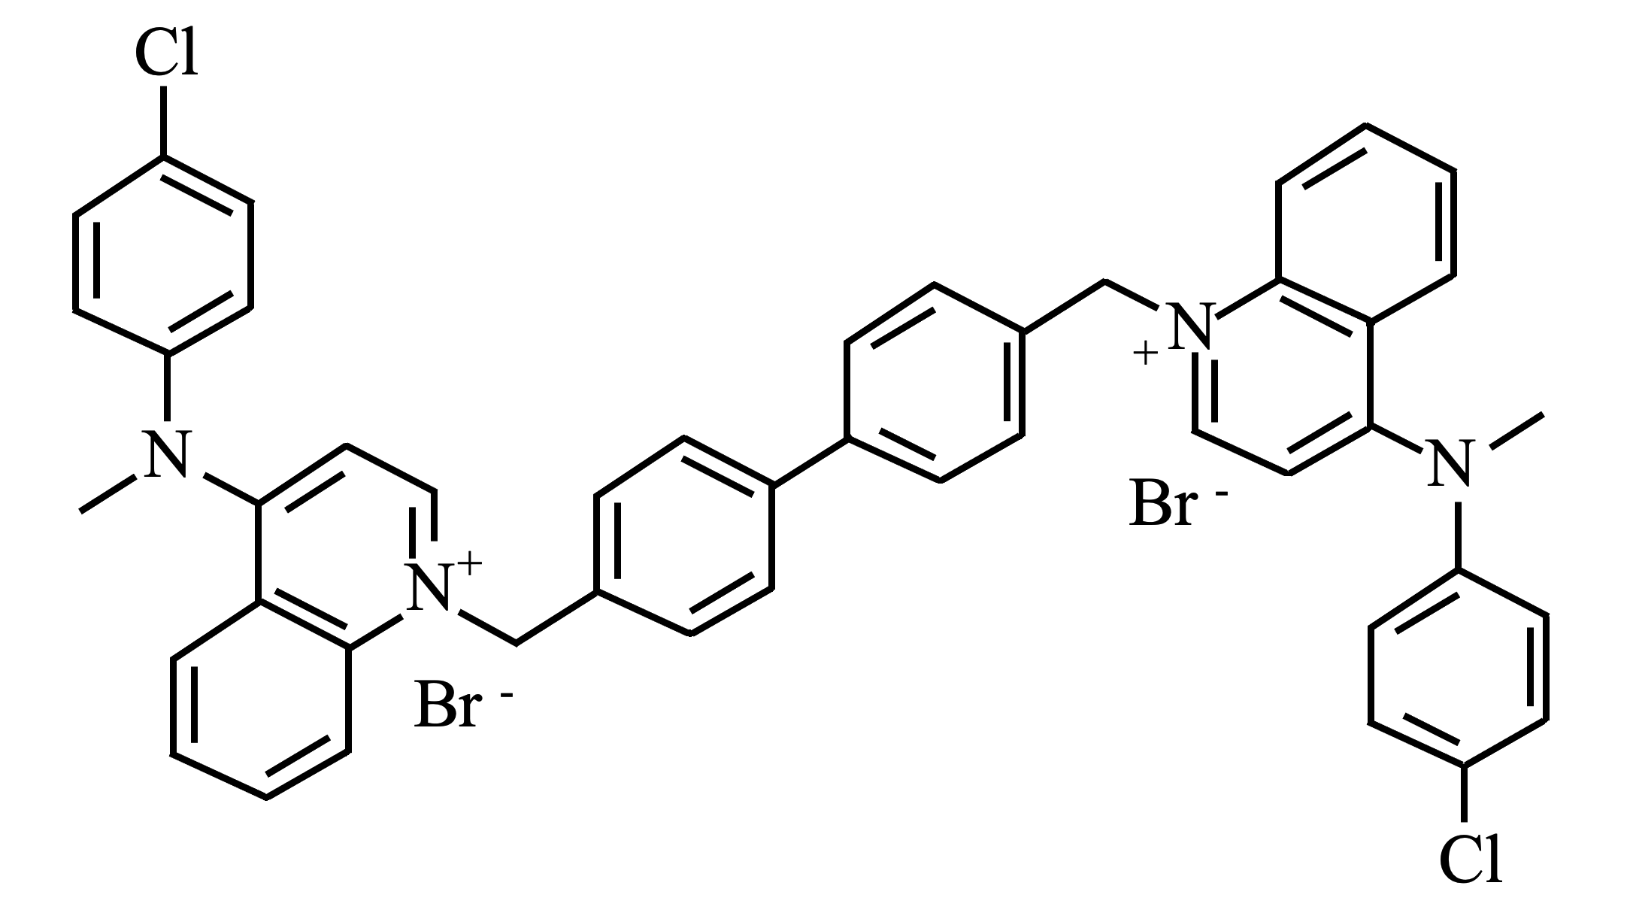
Fig. S4. Structural formula of the RSM-932A ChoK α inhibitor.

