Annex

Table: Sample size by village

District | Commune | Village | Samples for microscopy | Rapid diagnostic test | Dry blood spot for PCR
Ifanadiana (n=700) | Antaretra(n=169) | Amboatrotroka | 1 | Pf/Pan Pf/Pv | 169
Ifanadiana (n=700) | Antaretra(n=169) | Ambodiroanga | 30 | Pf/Pan Pf/Pv | 169
Ifanadiana (n=700) | Antaretra(n=169) | Ambodirotra | 4 | Pf/Pan Pf/Pv | 169
Ifanadiana (n=700) | Antaretra(n=169) | Ambohitsara | 1 | Pf/Pan Pf/Pv | 169
Ifanadiana (n=700) | Antaretra(n=169) | Ambongo | 1 | Pf/Pan Pf/Pv | 169
Ifanadiana (n=700) | Antaretra(n=169) | Andonabe | 2 | Pf/Pan Pf/Pv | 169
Ifanadiana (n=700) | Antaretra(n=169) | Andranimaintso | 7 | Pf/Pan Pf/Pv | 169
Ifanadiana (n=700) | Antaretra(n=169) | Ankofafa | 16 | Pf/Pan Pf/Pv | 169
Ifanadiana (n=700) | Antaretra(n=169) | Antaretra | 65 | Pf/Pan Pf/Pv | 169
Ifanadiana (n=700) | Antaretra(n=169) | Betampona | 2 | Pf/Pan Pf/Pv | 169
Ifanadiana (n=700) | Antaretra(n=169) | Havanja | 16 | Pf/Pan Pf/Pv | 169
Ifanadiana (n=700) | Antaretra(n=169) | Havintanona | 13 | Pf/Pan Pf/Pv | 169
Ifanadiana (n=700) | Antaretra(n=169) | Mahasoa | 1 | Pf/Pan Pf/Pv | 169
Ifanadiana (n=700) | Antaretra(n=169) | Mahatsara | 1 | Pf/Pan Pf/Pv | 169
Ifanadiana (n=700) | Antaretra(n=169) | Morafeno | 5 | Pf/Pan Pf/Pv | 169
Ifanadiana (n=700) | Antaretra(n=169) | Morarano | 1 | Pf/Pan Pf/Pv | 169
Ifanadiana (n=700) | Antaretra(n=169) | Vohimasina | 3 | Pf/Pan Pf/Pv | 169
Ifanadiana (n=700) | Tsaratanana (n=531) | Ambalaherana | 1 | Pf/Pan Pf/Pv | 418
Ifanadiana (n=700) | Tsaratanana (n=531) | Ambalakindresy | 1 | Pf/Pan Pf/Pv | 418
Ifanadiana (n=700) | Tsaratanana (n=531) | Ambanihaonana | 1 | Pf/Pan Pf/Pv | 418
Ifanadiana (n=700) | Tsaratanana (n=531) | Ambatohorenana | 14 | Pf/Pan Pf/Pv | 418
Ifanadiana (n=700) | Tsaratanana (n=531) | Ambatomainty | 11 | Pf/Pan Pf/Pv | 418
Ifanadiana (n=700) | Tsaratanana (n=531) | Ambatoranokely | 2 | Pf/Pan Pf/Pv | 418
Ifanadiana (n=700) | Tsaratanana (n=531) | Ambetoharanana | 2 | Pf/Pan Pf/Pv | 418
Ifanadiana (n=700) | Tsaratanana (n=531) | Ambinanindrano | 7 | Pf/Pan Pf/Pv | 418
Ifanadiana (n=700) | Tsaratanana (n=531) | Ambodigoavy | 10 | Pf/Pan Pf/Pv | 418
Ifanadiana (n=700) | Tsaratanana (n=531) | Ambodimanga | 11 | Pf/Pan Pf/Pv | 418
Ifanadiana (n=700) | Tsaratanana (n=531) | Ambodimanga Est | 7 | Pf/Pan Pf/Pv | 418
Ifanadiana (n=700) | Tsaratanana (n=531) | Ambodimanga Ouest | 5 | Pf/Pan Pf/Pv | 418
Ifanadiana (n=700) | Tsaratanana (n=531) | Ambodirafia | 11 | Pf/Pan Pf/Pv | 418
Ifanadiana (n=700) | Tsaratanana (n=531) | Ambodirano | 2 | Pf/Pan Pf/Pv | 418
Ifanadiana (n=700) | Tsaratanana (n=531) | Ambodiroanga | 2 | Pf/Pan Pf/Pv | 418
Ifanadiana (n=700) | Tsaratanana (n=531) | Ambodivoasary | 3 | Pf/Pan Pf/Pv | 418
Ifanadiana (n=700) | Tsaratanana (n=531) | Ambohimahatsinjo | 1 | Pf/Pan Pf/Pv | 418
Ifanadiana (n=700) | Tsaratanana (n=531) | Ambohimandroso | 1 | Pf/Pan Pf/Pv | 418
Ifanadiana (n=700) | Tsaratanana (n=531) | Ambohimita | 3 | Pf/Pan Pf/Pv | 418
Ifanadiana (n=700) | Tsaratanana (n=531) | Ambohipiaonana | 17 | Pf/Pan Pf/Pv | 418
Ifanadiana (n=700) | Tsaratanana (n=531) | Ambohipo | 19 | Pf/Pan Pf/Pv | 418
Ifanadiana (n=700) | Tsaratanana (n=531) | Ambohitsara | 70 | Pf/Pan Pf/Pv | 418
Ifanadiana (n=700) | Tsaratanana (n=531) | Ambohitsara 1 | 3 | Pf/Pan Pf/Pv | 418
Ifanadiana (n=700) | Tsaratanana (n=531) | Analamarina | 2 | Pf/Pan Pf/Pv | 418
Ifanadiana (n=700) | Tsaratanana (n=531) | Antaralava | 1 | Pf/Pan Pf/Pv | 418
Ifanadiana (n=700) | Tsaratanana (n=531) | Befary | 1 | Pf/Pan Pf/Pv | 418
Ifanadiana (n=700) | Tsaratanana (n=531) | Bekinagna | 1 | Pf/Pan Pf/Pv | 418
Ifanadiana (n=700) | Tsaratanana (n=531) | Kianjamarina | 4 | Pf/Pan Pf/Pv | 418
Ifanadiana (n=700) | Tsaratanana (n=531) | Mahamanina | 1 | Pf/Pan Pf/Pv | 418
Ifanadiana (n=700) | Tsaratanana (n=531) | Mahatsara | 2 | Pf/Pan Pf/Pv | 418
Ifanadiana (n=700) | Tsaratanana (n=531) | Manakana | 1 | Pf/Pan Pf/Pv | 418
Ifanadiana (n=700) | Tsaratanana (n=531) | Mananadaba | 1 | Pf/Pan Pf/Pv | 418
Ifanadiana (n=700) | Tsaratanana (n=531) | Manarinony | 2 | Pf/Pan Pf/Pv | 418
Ifanadiana (n=700) | Tsaratanana (n=531) | Mandritsara | 1 | Pf/Pan Pf/Pv | 418
Ifanadiana (n=700) | Tsaratanana (n=531) | Marofototra | 1 | Pf/Pan Pf/Pv | 418
Ifanadiana (n=700) | Tsaratanana (n=531) | Marolambo | 1 | Pf/Pan Pf/Pv | 418
Ifanadiana (n=700) | Tsaratanana (n=531) | Maromandia | 1 | Pf/Pan Pf/Pv | 418
Ifanadiana (n=700) | Tsaratanana (n=531) | Menarinony | 1 | Pf/Pan Pf/Pv | 418
Ifanadiana (n=700) | Tsaratanana (n=531) | Sahamaitso | 4 | Pf/Pan Pf/Pv | 418
Ifanadiana (n=700) | Tsaratanana (n=531) | Sahofika | 120 | Pf/Pan Pf/Pv | 418
Ifanadiana (n=700) | Tsaratanana (n=531) | sandrakely | 9 | Pf/Pan Pf/Pv | 418
Ifanadiana (n=700) | Tsaratanana (n=531) | Sandrasaty | 2 | Pf/Pan Pf/Pv | 418
Ifanadiana (n=700) | Tsaratanana (n=531) | Soanierana | 5 | Pf/Pan Pf/Pv | 418
Ifanadiana (n=700) | Tsaratanana (n=531) | Sohajika | 4 | Pf/Pan Pf/Pv | 418
Ifanadiana (n=700) | Tsaratanana (n=531) | Sohavika | 6 | Pf/Pan Pf/Pv | 418
Ifanadiana (n=700) | Tsaratanana (n=531) | Tanambao | 1 | Pf/Pan Pf/Pv | 418
Ifanadiana (n=700) | Tsaratanana (n=531) | Taralava | 1 | Pf/Pan Pf/Pv | 418
Ifanadiana (n=700) | Tsaratanana (n=531) | Tsarahonenana | 2 | Pf/Pan Pf/Pv | 418
Ifanadiana (n=700) | Tsaratanana (n=531) | Tsararivotra | 3 | Pf/Pan Pf/Pv | 418
Ifanadiana (n=700) | Tsaratanana (n=531) | Tsaratanana | 86 | Pf/Pan Pf/Pv | 418
Ifanadiana (n=700) | Tsaratanana (n=531) | Vatofotsy | 12 | Pf/Pan Pf/Pv | 418
Ifanadiana (n=700) | Tsaratanana (n=531) | Vohibavy 1 | 13 | Pf/Pan Pf/Pv | 418
Ifanadiana (n=700) | Tsaratanana (n=531) | Vohimarina | 2 | Pf/Pan Pf/Pv | 418
Ifanadiana (n=700) | Tsaratanana (n=531) | Vohimena | 1 | Pf/Pan Pf/Pv | 418
Ifanadiana (n=700) | Tsaratanana (n=531) | Vohipeno | 1 | Pf/Pan Pf/Pv | 418
Ifanadiana (n=700) | Tsaratanana (n=531) | Vohitrarivo | 32 | Pf/Pan Pf/Pv | 418
Ifanadiana (n=700) | Tsaratanana (n=531) | Volotara | 2 | Pf/Pan Pf/Pv | 418
Mandoto | Anjoma Ramartina (n=88) | Ambaravaranala | 5 | Pf/Pan Pf/Pv | 88
Mandoto | Anjoma Ramartina (n=88) | Ambatomanga | 2 | Pf/Pan Pf/Pv | 88
Mandoto | Anjoma Ramartina (n=88) | Ampanampahambozaka | 1 | Pf/Pan Pf/Pv | 88
Mandoto | Anjoma Ramartina (n=88) | Andasy | 1 | Pf/Pan Pf/Pv | 88
Mandoto | Anjoma Ramartina (n=88) | Anjoma Ramartina | 36 | Pf/Pan Pf/Pv | 88
Mandoto | Anjoma Ramartina (n=88) | Ankatsaka | 1 | Pf/Pan Pf/Pv | 88
Mandoto | Anjoma Ramartina (n=88) | Ankazondrano | 1 | Pf/Pan Pf/Pv | 88
Mandoto | Anjoma Ramartina (n=88) | Ankisiramena | 2 | Pf/Pan Pf/Pv | 88
Mandoto | Anjoma Ramartina (n=88) | Aonierana | 1 | Pf/Pan Pf/Pv | 88
Mandoto | Anjoma Ramartina (n=88) | Bemahatazana | 1 | Pf/Pan Pf/Pv | 88
Mandoto | Anjoma Ramartina (n=88) | Madiokely | 1 | Pf/Pan Pf/Pv | 88
Mandoto | Anjoma Ramartina (n=88) | Marotaolana | 1 | Pf/Pan Pf/Pv | 88
Mandoto | Anjoma Ramartina (n=88) | Morafeno | 17 | Pf/Pan Pf/Pv | 88
Mandoto | Anjoma Ramartina (n=88) | Morarano | 2 | Pf/Pan Pf/Pv | 88
Mandoto | Anjoma Ramartina (n=88) | Tsaramiakatra | 12 | Pf/Pan Pf/Pv | 88
Mandoto | Anjoma Ramartina (n=88) | Tsitalizy | 4 | Pf/Pan Pf/Pv | 88
Total |  |  | 788 |  | 675

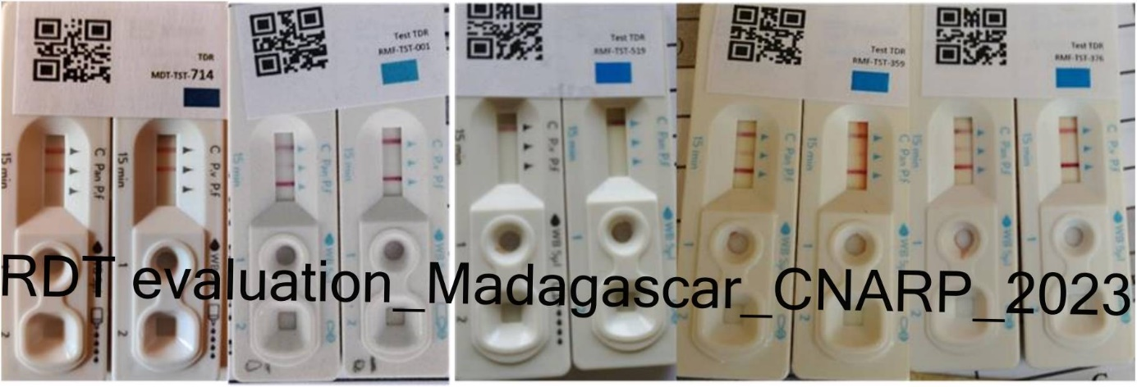
FigureA1: RDT samples on field

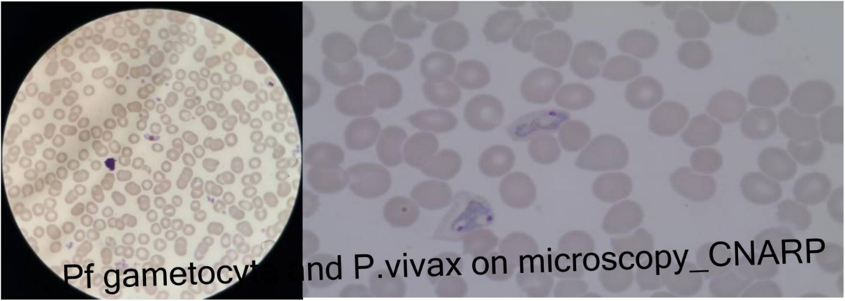
P. vivax
P. vivax
P. vivax
Figure A2: P. vivax—gametocytes (P. falciparum) by microscopy

