Supporting Information

Syntheses and Biological Activities of Calix[4]resorcinarene Derivatives Modified by Sulfonamides

Qing Wang, Meng Sun, Xin-Min Zhou, Xiao-Dan Ye, Ai-Quan Jia, and Qian-Feng Zhang*
Institute of Molecular Engineering and Applied Chemistry, Anhui University of Technology,
Ma’anshan, Anhui 243002, P. R. China
*Correspondence should be addressed to Qian-Feng Zhang; E-mail: zhangqf@ahut.edu.cn

¹H NMR and IR of 1a 1
¹H NMR and IR of 1b 2
¹H NMR and IR of 1c 3
¹H NMR and IR of 1d 4
¹H NMR and IR of 2a 5
¹H NMR and IR of 2b 6
¹H NMR and IR of 2c 7
¹H NMR and IR of 2d 8
¹H NMR and IR of 3b 9
¹H NMR and IR of 3c 10
¹H NMR and IR of 4a 11
IR spectra of 3a and 3d 12
IR spectra of 4b and 4c 13
IR spectrum of 4d 14
Sample effect on cellular activity in vitro absorbance values 15

2,8,14,20-tetramethyl calix[4]resorcinarene (1a) Yield: 12.4 g (82.8%) as light yellow solid.

¹H NMR (400 MHz, DMSO-d₆, ppm): δ 8.58 (s, 8H, Ar−OH), 6.75 (s, 4H, Ar−H, meta to OH), 6.14 (s, 4H, Ar−H, ortho to OH), 4.44 (q, J = 7.2 Hz, 4H, bridge CH), 1.28 (d, J = 7.2 Hz, 12H, CH₃). IR spectrum (KBr, cm⁻¹): ν(O−H) 3396 (s), ν(CH₃) 2967 (s), ν(C−C) 1619 (s) and 1516 (s), ν(C−OH) 1208 (s). Anal. Calc. for (C₃₂H₃₂O₈): C 70.58; H 5.92%; found: 70.54; H 5.90%.
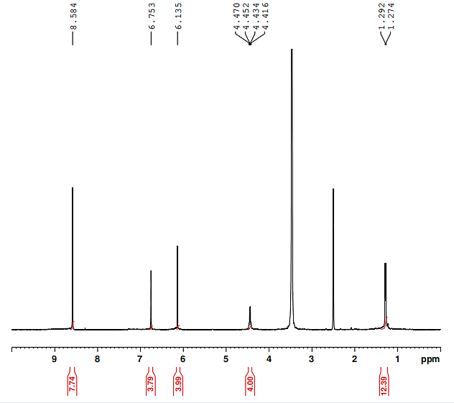

Figure S1: ¹H NMR spectrum of 1a

Figure S2: IR spectrum of 1a

2,8,14,20-tetraethyl calix[4]resorcinarene (1b) Yield: 11.5 g (84.1%) as beige solid.

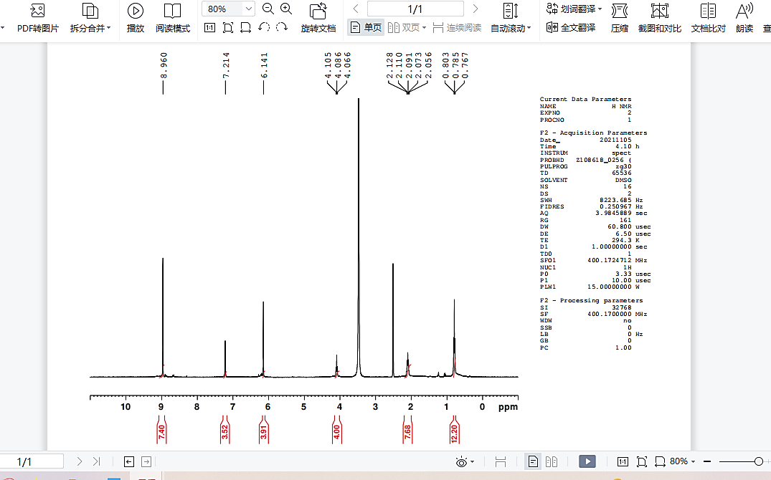
¹H NMR (400 MHz, DMSO-d₆, ppm): δ 8.96 (s, 8H, Ar−OH), 7.21 (s, 4H, Ar−H, meta to OH), 6.14 (s, 4H, Ar−H, ortho to OH), 4.09 (t, J = 7.6 Hz, 4H, bridge CH), 2.13~2.06 (m, 8H, CH₂CH₃), 0.78 (t, J = 7.2 Hz, 12H, CH₂CH₃). IR spectrum (KBr, cm⁻¹): ν(O−H) 3320 (s), ν(CH₃) 2960 (s), ν(C−C) 1615 (s) and 1505 (s), δ(O−H) 1377 (s), ν(C−OH) 1205 (s). Anal. Calc. for (C₃₆H₄₀O₈): C 71.98; H 6.71%; found: 72.00; H 6.70%.

Figure S3: ¹H NMR spectrum of 1b

Figure S4: IR spectrum of 1b

2,8,14,20-tetrapropyl calix[4]resorcinarene (1c) Yield: 13.0 g (87.0%) as white solid.

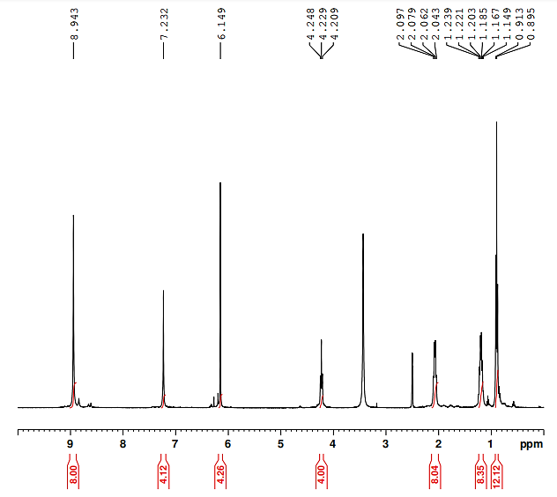
¹H NMR (400 MHz, DMSO-d₆, ppm): δ 8.94 (s, 8H, Ar−OH), 7.23 (s, 4H, Ar−H, meta to OH), 6.15 (s, 4H, Ar−H, ortho to OH), 4.23 (t, J = 7.6 Hz, 4H, bridge CH), 2.07 (q, J = 7.5 Hz, 8H, CH₂CH₂CH₃), 1.24~1.15 (m, 8H, CH₂CH₂CH₃), 0.90 (t, J = 7.2 Hz, 12H, CH₂CH₂CH₃). IR spectrum (KBr, cm⁻¹): ν(O−H) 3384 (s), ν(CH₃) 2955 (s), ν(C−C) 1617 (s) and 1501 (s), δ(O−H) 1379 (s), ν(C−OH) 1200 (s). Anal. Calc. for (C₄₀H₄₈O₈): C 73.15; H 7.37%; found: 73.17; H 7.33%.

Figure S5: ¹H NMR spectrum of 1c

Figure S6: IR spectrum of 1c
2,8,14,20-tetraisobutyl calix[4]resorcinarene (1d) Yield: 14.5 g (89.3%) as white solid.

¹H NMR (400 MHz, DMSO-d₆, ppm): δ 8.93 (s, 8H, Ar−OH), 7.12 (s, 4H, Ar−H, meta to OH), 6.15 (s, 4H, Ar−H, ortho to OH), 4.37 (t, J = 7.6 Hz, 4H, bridge CH), 1.88 (t, J = 6.8 Hz, 8H, CH₂CH(CH₃)₂), 1.37~1.27 (m, 4H, CH₂CH(CH₃)₂), 0.87 (d, J = 6.8 Hz, 24H, CH₂CH(CH₃)₂). IR spectrum (KBr, cm⁻¹): ν(O−H) 3366 (s), ν(CH₃) 2953 (s), ν(C−C) 1617 (s) and 1499 (s), δ(O−H) 1368 (s). Anal. Calc. for (C₄₄H₅₆O₈): C 74.13; H 7.92%; found: 74.16; H 7.93%.
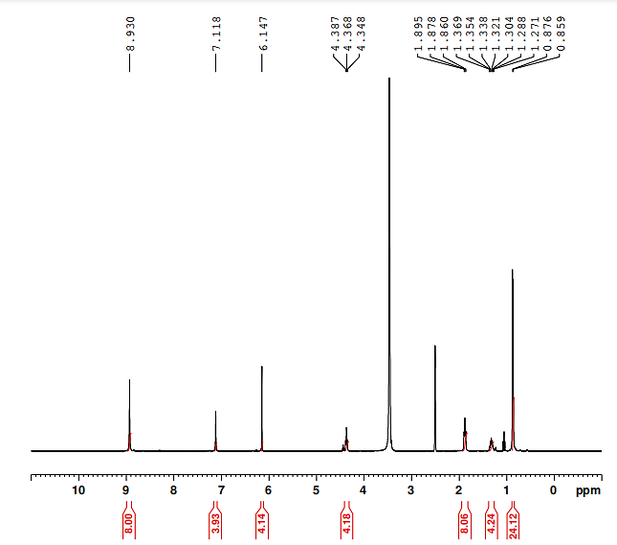

Figure S7: ¹H NMR spectrum of 1d

Figure S8: IR spectrum of 1d
2,8,14,20-tetramethyl-5,11,17,23-tetrasulfomethyl calix[4]resorcinarene (2a) Yield: 2.86 g (76.2%) as light yellow solid.

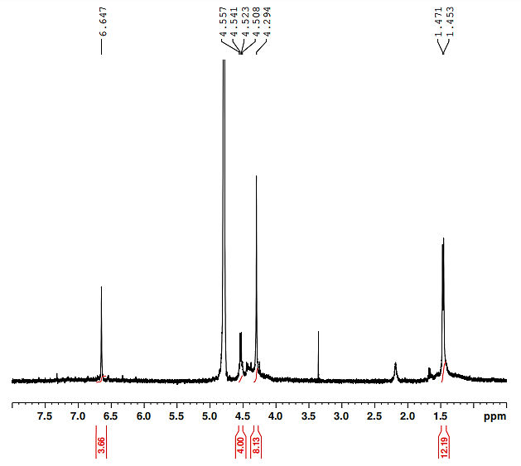
¹H NMR (400 MHz, D₂O, ppm): δ 6.65 (s, 4H, Ar−H), 4.53 (q, J = 6.4 Hz, 4H, bridge CH), 4.29 (s, 8H, Ar−CH₂), 1.46 (d, J = 7.2 Hz, 12H, CH₃). IR spectrum (KBr, cm⁻¹): ν(O−H) 3443 (s), ν(CH₃) 2966 (s), ν(C−C) 1635 (s) and 1474 (s), ν_{as}(S=O) 1150 (s), ν_{s}(S=O) 1040 (s). Anal. Calc. for (C₃₆H₄₀O₂₀S₄): C 46.95; H 4.38%; found: C 46.97; H 4.33%.

Figure S9: ¹H NMR spectrum of 2a

Figure S10: IR spectrum of 2a

2,8,14,20-tetraethyl-5,11,17,23-tetrasulfomethyl calix[4]resorcinarene (2b) Yield: 3.15 g (78.9%) as light yellow solid.

¹H NMR (400 MHz, D₂O, ppm): δ 7.05 (s, 4H, Ar−H), 4.30 (t, J = 7.6 Hz, 4H, bridge CH), 4.25 (s, 8H, Ar−CH₂), 2.07~2.00 (m, 8H, CH₂CH₃), 0.80 (t, J = 7.2 Hz, 12H, CH₂CH₃). IR spectrum (KBr, cm⁻¹): ν(O−H) 3435 (s), ν(CH₃) 2961 (s), ν(C−C) 1611 (s) and 1474 (s), δ(O−H) 1379 (s), ν(C−OH) 1211 (s), ν_{as}(S=O) 1148 (s), ν_{s}(S=O) 1040 (s). Anal. Calc. for (C₄₀H₄₈O₂₀S₄): C 49.17; H 4.95%; found: C 49.19; H 4.91%.

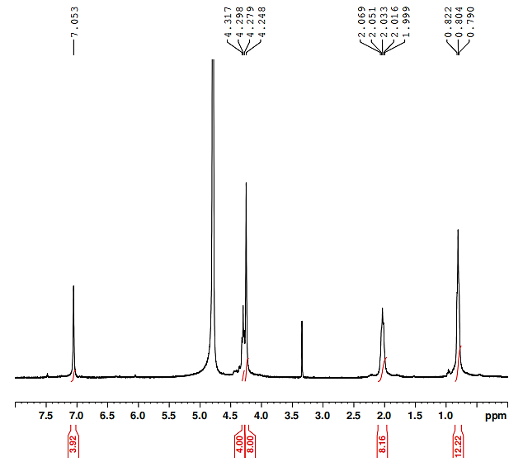

Figure S11: ¹H NMR spectrum of 2b

Figure S12: IR spectrum of 2b

2,8,14,20-tetrapropyl-5,11,17,23-tetrasulfomethyl calix[4]resorcinarene (2c) Yield: 3.31 g (78.5%) as light yellow solid.

¹H NMR (400 MHz, DMSO-d₆, ppm): δ 9.73 (s, 8H, Ar−OH), 7.37 (s, 4H, Ar−H), 4.24 (t, J = 7.2 Hz, 4H, bridge CH), 3.84 (s, 8H, Ar−CH₂), 2.07 (q, J = 7.6 Hz, 8H, CH₂CH₂CH₃), 1.29~1.24 (m, 8H, CH₂CH₂CH₃), 0.94 (t, J = 7.2 Hz, 12H, CH₂CH₂CH₃). IR spectrum (KBr, cm⁻¹): ν(O−H) 3444 (s), ν(CH₃) 2953 (s), ν(C−C) 1635 (s) and 1468 (s), ν(C−OH) 1188 (s), ν_{as}(S=O) 1147 (s), ν_{s}(S=O) 1040 (s). Anal. Calc. for (C₄₄H₅₆O₂₀S₄): C 51.50; H 5.46%; found: C 51.54; H 5.45%.
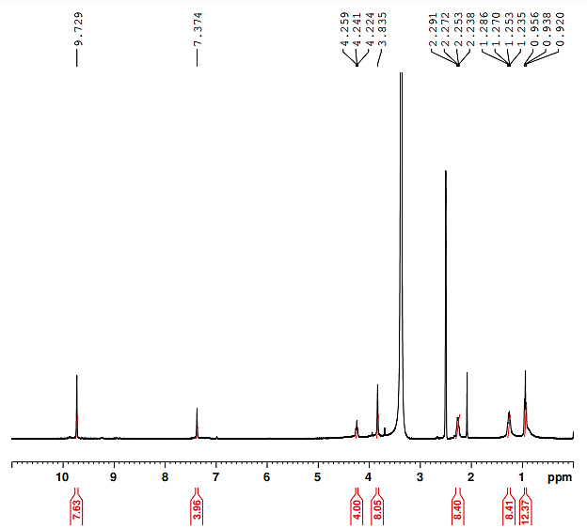

Figure S13: ¹H NMR spectrum of 2c

Figure S14: IR spectrum of 2c

2,8,14,20-tetraisobutyl-5,11,17,23-tetrasulfomethyl calix[4]resorcinarene (2d) Yield: 3.62 g (81.4%) as light yellow solid.

¹H NMR (400 MHz, DMSO-d₆, ppm): δ 9.73 (s, 8H, Ar−OH), 7.33 (s, 4H, Ar−H), 4.38 (t, J = 7.5 Hz, 4H, bridge CH), 3.88 (s, 8H, Ar−CH₂), 2.13 (t, J = 6.8 Hz, 8H, CH₂CH(CH₃)₂), 1.43~1.37 (m, 4H, CH₂CH(CH₃)₂), 0.94 (d, J = 6.4 Hz, 24H, CH₂CH(CH₃)₂). IR spectrum (KBr, cm⁻¹): ν(O−H) 3437 (s),ν(CH3) 2953 (s), ν(C−C) 1641 (s) and 1471 (s), δ(O−H) 1364 (s), ν(C−OH) 1182 (s), ν_{as}(S=O) 1150 (s), ν_{s}(S=O) 1040 (s). Anal. Calc. for (C₄₈H₆₄O₂₀S₄): C 52.93; H 5.92%; found: C 52.97; H 5.93%.
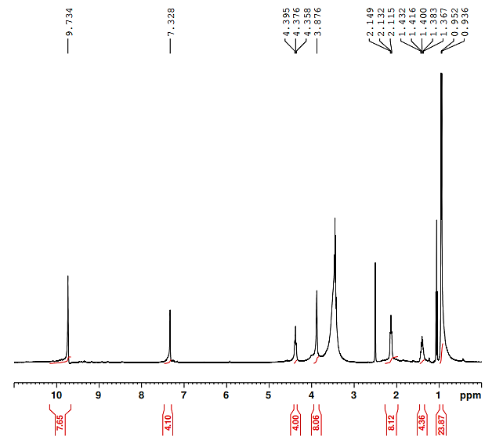

Figure S15: ¹H NMR spectrum of 2d

Figure S16: IR spectrum of 2d

2,8,14,20-tetrapropyl-5,11,17,23-tetrakis(N-(4-hydroxyphenethyl)methanesulfonamide) calix[4]resorcinarene (3b) Yield: 0.24g (69.1%) as an orange-yellow powdery precipitate.

¹H NMR (400 MHz, DMSO-d₆, ppm): δ 10.22 (s, 8H, Ar−OH), 9.74 (s, 4H, Ar−OH), 8.05 (s, 4H, NH), 7.40 (s, 4H, Ar−H), 7.03 (d, J = 8.4 Hz, 8H, Ar−H), 6.72 (d, J = 8.0 Hz, 8H, Ar−H), 4.24 (t, J = 7.6 Hz, 4H, bridge CH), 3.84 (s, 8H, Ar−CH₂SO₂), 3.16 (s, 8H, CH₂CH₂NH), 2.77~2.74 (m, 8H, CH₂CH₂NH), 2.29~2.24 (m, 8H, CH₂CH₂CH₃), 1.34~1.30 (m, 8H, CH₂CH₂CH₃), 1.00 (t, J = 7.2 Hz, 12H, CH₂CH₂CH₃). IR spectrum (KBr, cm⁻¹)): ν(O−H) 3420 (s), ν(N−H) 3229 (s), ν(CH₃) 2974 (s), ν(C−C) 1611 (s) and 1471 (s), δ(O−H) 1397 (s), ν(C−OH) 1221 (s), ν(S=O) 1171 (s).
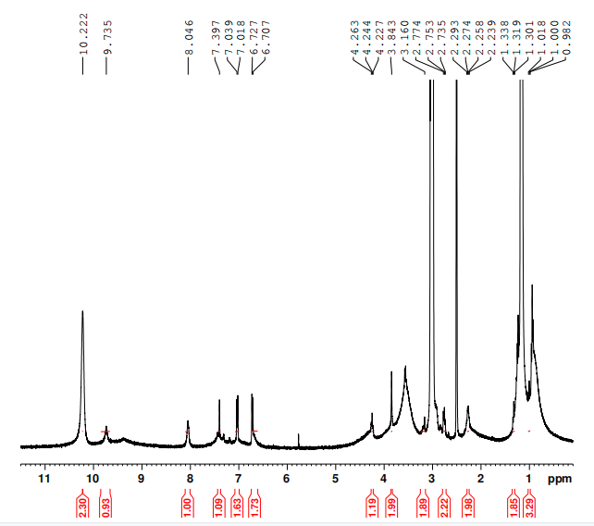

Figure S17: ¹H NMR spectrum of 3b

Figure S18: IR spectrum of 3b
2,8,14,20-Tetrapropyl-5,11,17,23-tetrakis(N-3,4-dihydroxyphenylethyl)methanesulfonamide) calix[4]resorcinarene (3c) Yield: 0.24 g (66.3%) as yellowish brown powdery precipitate.

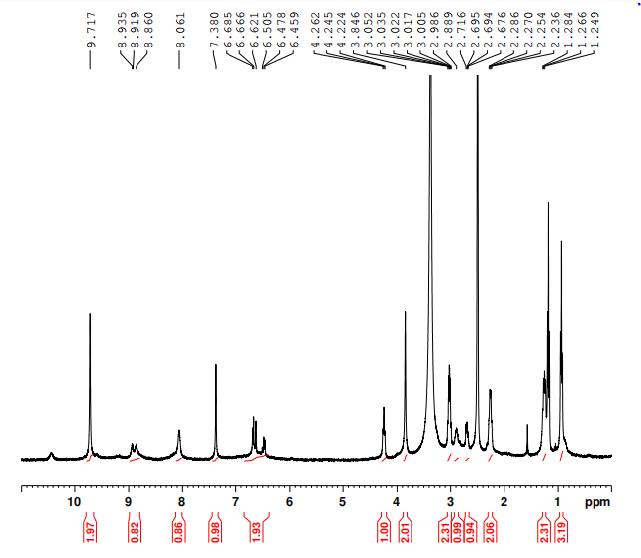
¹H NMR (400 MHz, DMSO-d₆, ppm): δ 9.72 (s, 8H, Ar−OH), 8.92 (m, 4H, ArH), 8.06 (s, 4H, Ar−H), 7.38 (s, 4H, Ar−H), 6.69~6.46 (m, 8H, Ar−H), 4.24 (t, J = 7.1 Hz, 4H, bridge CH), 3.85 (s, 8H, Ar−CH₂SO₂), 3.05~2.99 (m, 8H, CH₂CH₂NH), 2.89 (s, 4H, H_{a}H_{b}CH₂NH), 2.69 (s, 4H, H_{a}H_{b}CH₂NH), 2.26 (m, 8H, CH₂CH₂CH₃), 1.28~1.23 (m, 8H, CH₂CH₂CH₃), 0.94 (t, J = 7.2 Hz, 12H, CH₂CH₂CH₃). IR spectrum (KBr, cm⁻¹): ν(O−H) 3414 (s), ν(N−H) 3241 (s), ν(CH₃) 2974 (s), ν(C−C) 1611 (s) and 1471 (s), δ(O−H) 1397 (s), ν(C−OH) 1200 (s), ν(S=O) 1168 (s). Anal. Calc. for (C₇₆H₉₂O₂₄S₄N₄): C 58.00; H 5.89%; found: C 58.08; H 5.85%.

Figure S19: ¹H NMR spectrum of 3c

Figure S20: IR spectrum of 3c
2,8,14,20-Tetraisobutyl-5,11,17,23-tetraphenylethylmethanesulfonamide calix[4]resorcinarene (4a) Yield: 0.22 g (63.7%) as an orange-yellow powdery precipitate.

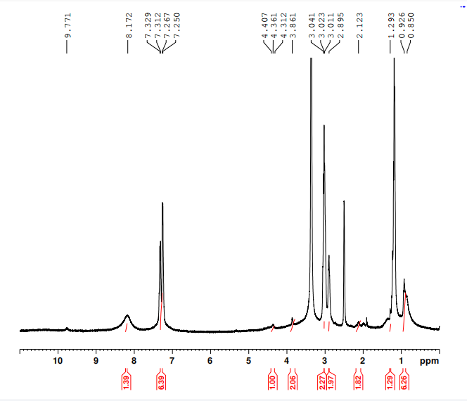
¹H NMR (400 MHz, DMSO-d₆, ppm): δ 9.77 (s, 8H, Ar−OH), 8.17 (s, 4H, NH), 7.33~7.25 (m, 24H, Ar−H), 4.36 (t, J = 18.4 Hz, 4H, bridge CH), 3.86 (s, 8H, Ar−CH₂SO₂), 3.04~3.01 (m, 8H, CH₂CH₂NH), 2.90 (s, 8H, CH₂CH₂NH), 2.12 (m, 8H, CH₂CH(CH₃)₂), 1.29 (m, 4H, CH₂CH(CH₃)₂), 0.89 (m, 24H, CH₂CH(CH₃)₂). IR spectrum (KBr, cm⁻¹): ν(O−H) 3429 (s), ν(N−H) 3247 (m), ν(CH₃) 2971 (s), ν(C−C) 1602 (s) and 1465 (s), δ(O−H) 1397 (s), ν(C−OH) 1209 (s), ν(S=O) 1171 (s). Anal. Calc. for (C₈₀H₁₀₀O₁₆S₄N₄): C 61.36; H 6.44%; found: C 61.35; H 6.42%.

Figure S21: ¹H NMR spectrum of 4a

Figure S22: IR spectrum of 4a

2,8,14,20-tetraisobutyl-5,11,17,23-tetraphenylethylmethanesulfonamide calix[4]resorcinarene (3a) Yield: 0.22 g (66.2%) as an orange-yellow powdery precipitate.

IR spectrum (KBr, cm⁻¹): ν(O−H) 3417 (s), ν(N−H) 3253 (m), ν(CH₃) 2971 (s), ν(C−C) 1611 (s) and 1471 (s), δ(O−H) 1400 (s), ν(C−OH) 1203 (s), ν(S=O) 1171 (s).

Figure S23: IR spectrum of 3a

2,8,14,20-tetrapropyl-5,11,17,23-tetrakis(N-(2-hydroxy-2-(4-hydroxyphenyl)ethyl)methanesulfonamide) calix[4]resorcinarene (3d) Yield: 0.23g (63.5%) as light yellow powdery precipitate.

IR spectrum (KBr, cm⁻¹): ν(O−H) 3423 (s), ν(N−H) 3247 (s), ν(CH₃) 2974 (s), ν(C−C) 1608 (s) and 1471 (s), δ(O−H) 1397 (s), ν(C−OH) 1206 (s), ν(S=O) 1171 (s). Anal. Calc. for (C₇₆H₉₂O₂₈S₄N₄): C 58.00; H 5.89%; found: C 58.05; H 5.82%.

Figure S24: IR spectrum of 3d

2,8,14,20-tetraisobutyl-5,11,17,23-tetrakis(N-(4-hydroxyphenethyl)methanesulfonamido) calix[4]resorcinarene (4b) Yield: 0.22 g (66.1%) as an orange-yellow powdery precipitate.

IR spectrum (KBr, cm⁻¹): ν(O−H) 3426 (s), ν(N−H) 3241 (s), ν(CH₃) 2953 (s), ν(C−C) 1611 (s) and 1519 (s), δ(O−H) 1367 (s), ν(C−OH) 1203 (s), ν(S=O) 1171 (s). Anal. Calc. for (C₈₀H₁₀₀O₂₀S₄N₄): C 61.36; H 6.44%; found: C 61.35; H 6.42%.

Figure S25: IR spectrum of 4b

2,8,14,20-tetraisobutyl-5,11,17,23-tetrakis(N-3,4-dihydroxyphenylethyl)methanesulfonamide) calix[4]resorcinarene (4c) Yield: 0.24 g (64.0%) as brown powdery precipitate.

IR spectrum (KBr, cm⁻¹): ν(O−H) 3372 (s), ν(N−H) 3241 (s), ν(CH₃) 2953 (s), ν(C−C) 1608 (s) and 1501 (s), δ(O−H) 1364 (s), ν(C−OH) 1287 (s), ν(S=O) 1174 (s). Anal. Calc. for (C₈₀H₁₀₀O₂₄S₄N₄): C 58.95; H 6.18%; found: C 58.99; H 6.14%.

Figure S26: IR spectrum of 4c
2,8,14,20-tetraisobutyl-5,11,17,23-tetrakis(N-(2-hydroxy-2-(4-hydroxyphenyl)ethyl)methanesulfonamido) calix[4]resorcinarene (4d) Yield: 0.23 g (61.4%) as yellow powdery precipitate.

IR spectrum (KBr, cm⁻¹): ν(O−H) 3426 (s), ν(N−H) 3250 (s), ν(CH₃) 2938 (s), ν(C−C) 1611 (s) and 1471 (s), δ(O−H) 1397 (s), ν(C−OH) 1206 (s), ν(S=O) 1171 (s). Anal. Calc. for (C₈₀H₁₀₀O₂₈S₄N₄): C 58.95; H 6.18%; found: C 58.98; H 6.15%.

Figure S27: IR spectrum of 4d

Table S1 Sample effect on cellular activity in vitro absorbance values (OD = 570 nm)
Serial Number | Absorbance
Serial Number | HUVEC | A549 | HepG2 | MDA-MB-321
1a | 0.087 | 0.322 | 0.136 | 0.081
1a | 0.073 | 0.236 | 0.138 | 0.081
1a | 0.101 | 0.250 | 0.126 | 0.082
1b | 0.077 | 0.073 | 0.141 | 0.075
1b | 0.077 | 0.075 | 0.135 | 0.077
1b | 0.076 | 0.075 | 0.139 | 0.082
1c | 0.076 | 0.105 | 0.124 | 0.077
1c | 0.075 | 0.079 | 0.187 | 0.115
1c | 0.076 | 0.099 | 0.139 | 0.077
1d | 0.908 | 0.730 | 0.748 | 1.095
1d | 0.930 | 0.719 | 0.731 | 0.999
1d | 0.916 | 0.721 | 0.672 | 1.053
2c | 0.546 | 1.096 | 1.384 | 1.314
2c | 0.585 | 1.083 | 1.462 | 1.270
2c | 0.601 | 1.083 | 1.410 | 1.265
2d | 0.916 | 0.789 | 0.310 | 0.948
2d | 0.940 | 0.855 | 0.170 | 0.969
2d | 0.860 | 0.801 | 0.264 | 0.945
3a | 0.914 | 0.783 | 0.775 | 1.461
3a | 0.921 | 0.849 | 0.794 | 1.413
3a | 0.916 | 0.800 | 0.717 | 1.442
3b | 0.913 | 0.810 | 0.657 | 1.365
3b | 0.922 | 0.804 | 0.663 | 1.374
3b | 0.921 | 0.936 | 0.606 | 1.398
3c | 0.932 | 0.790 | 0.698 | 1.434
3c | 0.904 | 0.876 | 0.694 | 1.456
3c | 0.921 | 0.881 | 0.703 | 1.403
3d | 0.925 | 0.947 | 0.709 | 1.353
3d | 0.912 | 0.924 | 0.727 | 1.473
3d | 0.912 | 0.943 | 0.787 | 1.403
4a | 0.671 | 1.103 | 1.478 | 1.702
4a | 0.616 | 1.069 | 1.455 | 1.699
4a | 0.679 | 1.118 | 1.477 | 1.689
4b | 0.578 | 1.014 | 1.445 | 1.424
4b | 0.607 | 1.029 | 1.456 | 1.470
4b | 0.595 | 1.091 | 1.560 | 1.453
4c | 0.932 | 0.914 | 0.833 | 1.427
4c | 0.924 | 0.948 | 0.843 | 1.446
4c | 0.933 | 0.851 | 0.865 | 1.438
4d | 0.886 | 1.060 | 1.257 | 1.673
4d | 0.907 | 1.075 | 1.350 | 1.679
4d | 0.883 | 1.099 | 1.236 | 1.659
Control | 0.938 | 0.953 | 0.854 | 1.479
Control | 0.964 | 0.946 | 0.874 | 1.422
Control | 0.972 | 0.955 | 0.868 | 1.476
Cisplatin | 0.126 | 0.096 | 0.459 | 0.084
Cisplatin | 0.121 | 0.099 | 0.425 | 0.088
Cisplatin | 0.169 | 0.096 | 0.446 | 0.083

