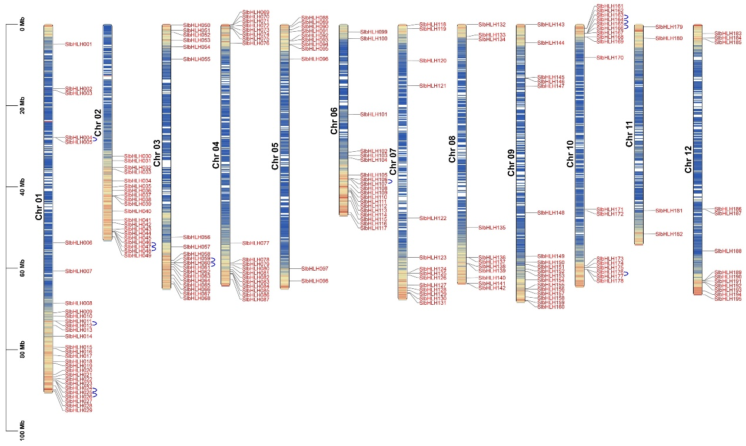
Figure S1 Localizations of 196 SlbHLHs in tomato chromosomes 1-12.
The blue arc behind some SlbHLHs represent the gene duplication of part of the bHLH genes in tomato.

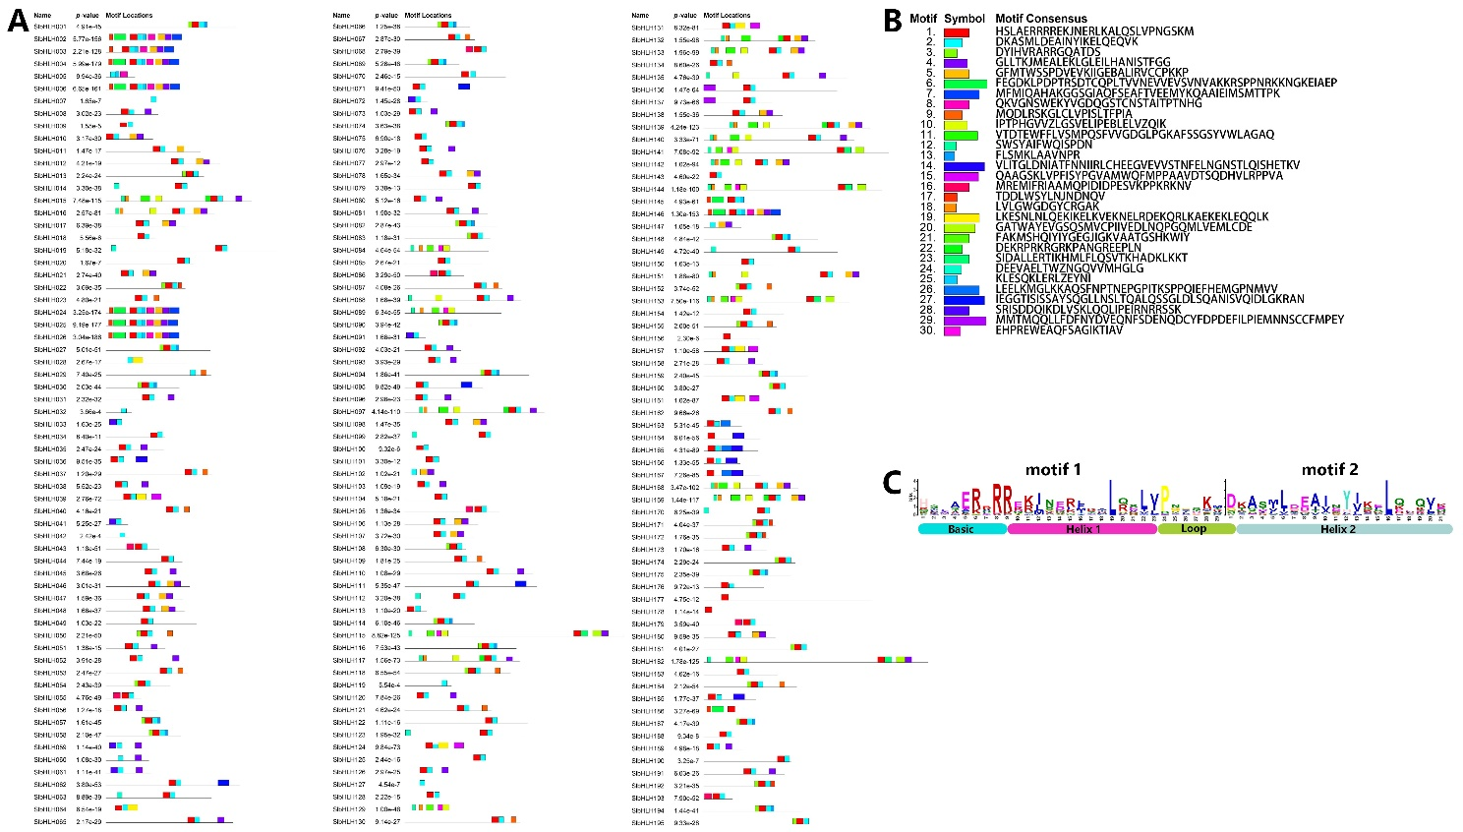
Figure S2 Distributions of 196 SlbHLH protein motifs identified by MEME data.
The number (30) and length (12-50) of conserved motifs are based on the settings in Arabidopsis. The distribution (A) and sequence consensus (B) of 30 most significantly conserved motifs in SlbHLHs. The colorful boxes denote different motifs. (C). Schematic representations of multiple sequence alignment of the helix–loop–helix (HLH) region and the basic region in SlbHLHs. The height of the letter at each position is positively correlated with the conservation of the corresponding amino acid residues at that position.

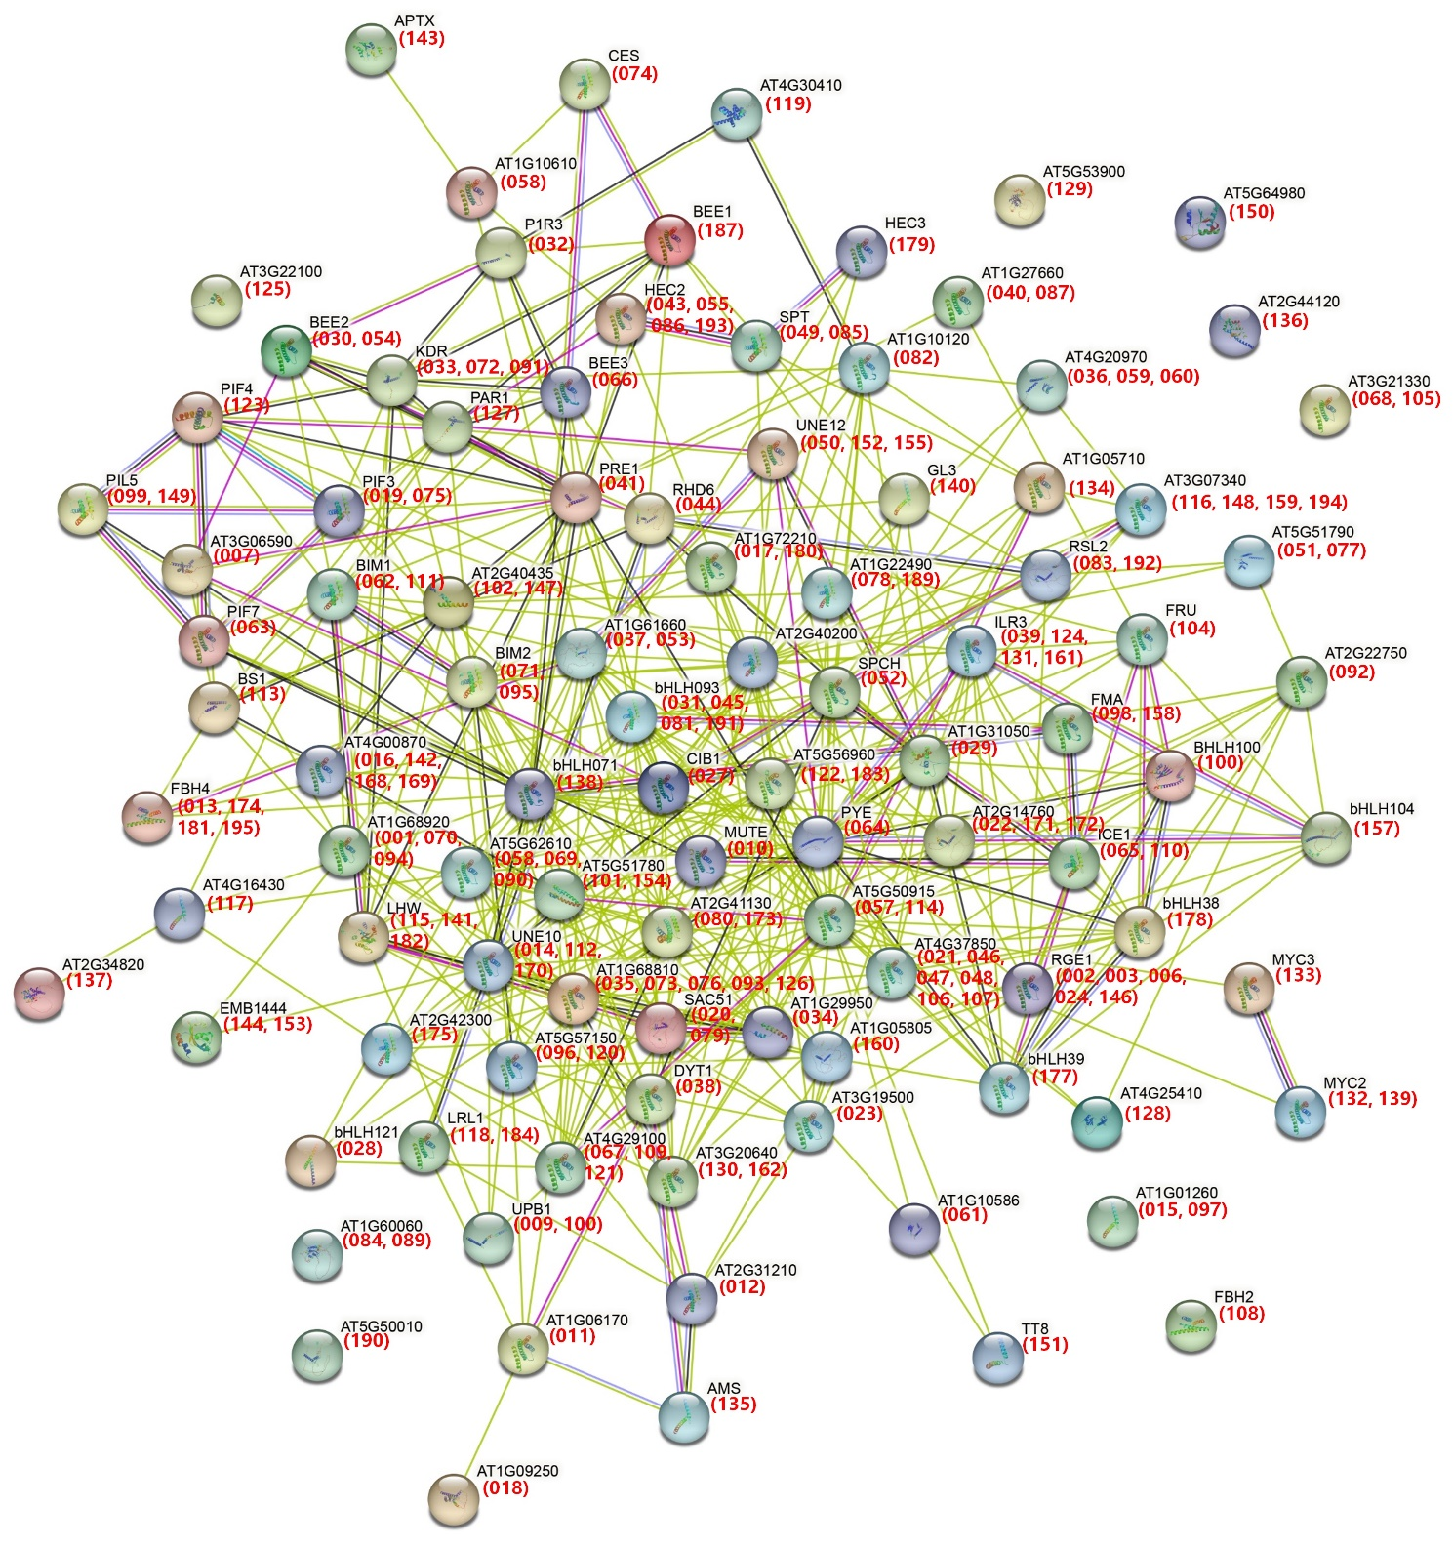
Figure S3 Interaction networks of SlbHLHs in tomato according to the orthologues in Arabidopsis.
The amino acid sequences of SlbHLHs in tomato were employed to search the STRING database. Network node represents proteins, and edge represents protein-protein associations. The different colored lines between the nodes indicate the different kinds of interactions. The numbers (SlbHLH gene name) in brackets represent the corresponding orthologues in tomato. The filled and empty nodes delineate the proteins with known or predicted 3D structures and unknown 3D structures, respectively.
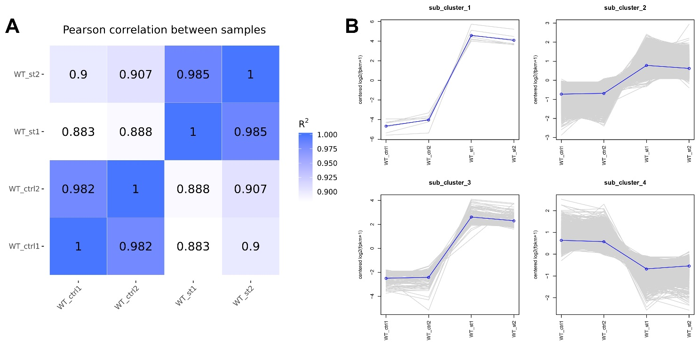
Figure S4 Correlation analysis and cluster analysis of DEGs.
(A). Correlation analysis (through Pearson’s correlation coefficient) of RNA-seq data between two replicates. (B). Cluster analysis of DEGs using H-cluster method.

