Supplementary Information for

Human-altered soil loss contributes to nearly half of water erosion in China

Keke Li^{1,8}, Jingya Yang^{1,8}, Jingyu Wang¹, Zhen Wang^{1,2,}*, Yi Zeng³, Pasquale Borrelli⁴, Klaus Hubacek⁵, Yuanchao Hu⁶, Baodong Xu^{1,}*, Nufang Fang³, Chen Zeng^{2,7}, Zhanhang Zhou^{1,2,7}, Zhihua Shi^{1*}

¹ College of Resource and Environment, Huazhong Agricultural University, Wuhan 430070, China;
² Interdisciplinary Research Center for Territorial Spatial Governance and Green Development, Huazhong Agricultural University, Wuhan 430070, China;
³ State Key Laboratory of Soil Erosion and Dryland Farming on the Loess Plateau, Institute of Soil and Water Conservation, Northwest A&F University, 26 Xinong Road, Yangling, Shaanxi Province 712100, PR China;
⁴ Department of Science, Roma Tre University, 00146, Rome, Italy;
⁵ Integrated Research on Energy, Environment and Society (IREES), Energy and Sustainability Research Institute Groningen (ESRIG), University of Groningen, 9747 AG Groningen, Nijenborgh 6, the Netherlands;
⁶ School of Resource and Environmental Sciences, Wuhan University, Wuhan 430079, China;
⁷ College of Public Administration, Huazhong Agricultural University, Wuhan 430070, China;
⁸ These authors contributed equally.

* Corresponding author.
Zhen Wang: sinoo@mail.hzau.edu.cn
Zhihua Shi: pengshi@mail.hzau.edu.cn
Baodong Xu: xubaodong@mail.hzau.edu.cn

This file includes:
Supplementary Methods……………………………………………………………….2
Supplementary Discussion…………………………………………………………….8
Supplementary Figures…………………………………………………………..….10
Supplementary Tables………………………………………………………....…….15
Supplementary References…………………………………………………....…….23

Supplementary Information

Method S1. RUSLE model to estimate actual soil erosion
Description. In this study, Revised Universal Soil Loss Equation (RUSLE) model ¹ is employed to estimate and predict soil erosion by water (water erosion) in China. With physical plausibility and availability of input data as well as easy compatibility with GIS, the RUSLE model is by far the most widely applied soil erosion prediction model globally ². RUSLE model belongs to a deterministic and empirical method and provides a legitimate route to approaching the representation of the physical process of water erosion at the macroscale ^{3,4}. The multiple components of the RUSLE model are listed in Table S1.

Calculation of R-, K-, and LS-factor. R-factor can be downloaded from the published research of Yue et al. ⁵ (accessed at http://clicia.bnu.edu.cn/data/erosivity.html). K-factor was obtained from the Liu et al.’s open database of the National Earth System Science Data Center (http://loess.geodata.cn/). LS-factor is the product of the L-factor and S-factor which were calculated based on SRTM DEM data with a cell size of 30m (accessed at USGS website: https://earthexplorer.usgs.gov/). The L-factor was calculated according to the method of Wischmeier et al. ⁶⁻⁸, and the calculation formula of the S-factor is based on the research of Liu et al. ⁹.

Calculation of C-factor. The C-factor on arable land and non-arable land in the actual situation including natural and anthropogenic processes is denoted as C_{crop} and C_{nonarable}, respectively. For arable land, the C-factor depends on the city-level agricultural statistics and C_{crop} of each city can be expressed as follows:
$$C_{crop}=\sum_{n=1}^{12}{C_{cropn}×\%{Region}_{cropn}}$$ | (1)
Where the C_{cropn} is the C value of n-crop which refers to the crop groups of Borrelli et al.’s ³ research and their corresponding base C-factors (listed in Table S2). The %Region_{cropn} represents the proportion of this n-crop in the sown area of the given city which can be collected from the provincial Statistical Yearbook linked on the website of the National Bureau of Statistics in China (accessed at http://www.stats.gov.cn/). Nevertheless, the city-level statistical data of agricultural sown areas in some provinces is not available. Due to data availability, we download the spatially-disaggregated crop production statistics data SPAM2010 ⁹³ from the International Food Policy Research Institute (IFPRI) (accessed at https://dataverse.harvard.edu/dataverse/harvestchoice) to count the proportions of various crops for calculating the weighted C_{crop} in the provinces lacking city-level agricultural statistics. Noteworthy, the food crops of the SPAM2010 data are assigned to the 12 crop groups (shown in Table S3) to ensure data consistency. For Xinjiang and Tibet, the C_{crop} of two regions are weighted according to the share of the agricultural sown area at the provincial scale.

For non-arable land, C_{nonarable} was calculated using the method of Li et al. ¹⁰ based on the reference range of C values denoted as C_{NA} (listed in Table S4) and the Normalized Difference Vegetation Index (NDVI) in 2017 with a resolution of 30m which can be downloaded from Liu et al.’s ¹¹ research.

$C_{nonarable}=Min\left(C_{NA}\right)+Range(C_{NA})×(1-F_{cover})$ | (2)
$F_{cover}=(NDVI-{NDVI}_{min})/({NDVI}_{max}-{NDVI}_{min})$ | (3)

Where C_{nonarable} represented the C value of each pixel of non-arable lands. F_{cover} is the vegetation coverage layer calculated by NDVI. Min(C_{NA}) is the minimum of the range of C_{NA}; Range(C_{NA}) is the difference between the maximum and minimum of the range of C_{NA}.

Calculation of P-factor. The P-factor captures the conservation effects of a specific support practice on soil erosion like contouring, strip cropping, terracing, and subsurface drainage ^{6,12}. P-factor is rarely considered in the soil erosion risk modelling above the field scale since soil erosion control is a very local activity and difficult to access at large scale ¹³. We use the method of Xiong et al. ^{14,15} to produce the P-factor on arable and non-arable lands (shown in Table S5).

Method S2. Modeling potential C-factor without human intervention
The random forest machine learning algorithm is used to predict the natural soil erosion rate by modeling a C-factor of potential natural vegetation cover in the protected areas in China based on a large number of explanatory variables (listed in Table S6). The protected areas database in China can be downloaded from the Digital Specimen Resources Sharing Platform for Nature Reserve (accessed at http://bhq.papc.cn/). Data preprocessing is required since the natural reserves include all kinds of categories. Therefore, three types of protected areas, grassland and meadow, forest ecosystems, and wild plants are selected and preserved. Moreover, only the land use types that are relatively free of human activities including forestland, grassland, and shrubland are retained to achieve semantically consistency of land use/cover data and protected areas data. Noteworthy, the natural vegetation cover in the relatively sparsely populated western regions such as Xinjiang and Tibet are different. The main land use types in these regions are snow mountains and bare land. Therefore, we train the random forest algorithms separately in the western areas and the other areas in China on the level of the river basin. The division of the two regions is based on the three-level River Basin dataset provided by the National Cryosphere Desert Data Center (http://www.ncdc.ac.cn). Two first-level river basins including the southwestern basin and northwestern basin are selected as the western areas. The types of protected areas including the desert ecosystem and the bare land have been preserved in the protected areas in western regions. Considering the resolution of the explanatory variables as well as model requirements, we extract the sampling points with the resolution of 1500m in China for the random forest classifier to ensure the performability and meanwhile accelerate the model running speed. Additionally, we remove noises of the C-factor in the protected areas to improve the robustness of the model. Finally, there are more than 400 million valid sampling points in China wherein a total of 1,706,796 points and 1,405,888 points in two regions respectively were fed to the random forest machine learning models for prediction. Accordingly, two predictive models are generated to estimate the C_{pot} outside of the protected areas under natural vegetation cover without human intervention. The outcome layer of C_{pot} in China is based on the inverse distance weight (IDW) interpolation of the valid sampling points. The R² of random forest algorithm is 0.83 in western areas and 0.76 in the other areas. The results of 5-fold cross-validation in western areas were 0.8266, 0.8253, 0.8258, 0.8253, and 0.7782, meanwhile, in the other areas were 0.7569, 0.7570, 0.7592, 0.7562, and 0.7600, respectively.

Method S3. Terrace mapping and P-value on the terrace
The spatial distribution of soil conservation practices is not accessible at a large scale since the types of soil conservation measures are various and require complex terrain. However, terraces as a key soil conservation practice are widely distributed in China and its accurate spatial information can be obtained by using the multisource and multi-temporal remote sensing data. In this study, we map the terrace in China with a spatial resolution of 30m and accuracy of greater than 84% by using supervised pixel-based classification based on the following 32 features: 2 topographical features including DEM and slope, 30 spectral features calculated from 4 bands (blue, green, red and near-infrared) and 6 indices (normalized difference vegetation index (NDVI), enhanced Vegetation Index (EVI), land surface water index (LSWI), modified normalized difference water index (MNDWI), normalized difference building index (NDBI), bold soil index (BSI)) synthesized every 4 months from the combination of Landsat-8 and Sentinel-2 in 2017. Based on the visual interpretation of Google Earth images on GEE (Google Earth Engine), we select a series of terrace and non-terrace samples in each primary regionalization of the cropping system categorized by Chen et al ¹⁶. The numbers of samples in 11 regions are listed in Table S7. Afterward, we classify the terrace and non-terrace based on the random forest algorithms in each region and mosaic all the maps of each region into a complete terrace map for China. The random forest classifier in each primary regionalization of the cropping system is trained and evaluated (shown in Table S8). The overall accuracy (OA), producer’s accuracy (PA), and user’s accuracy (UA) metrics from the confusion matrix were adopted to evaluate the performance of the generated terrace map. Accordingly, aiming to assess the soil conservation benefits of terraces, we adopt different P values (shown in Table S9) in different soil and water conservation regions to assess the soil conservation capacity of terraces in China. The soil and water regionalization map can be referred to Zhao, Y., et al.’s ¹⁷ study.

Method S4. EE-MRIO model
Description. EE-MRIO tables are the monetary input-output (IO) tables enriched by environmental extension factors. The source requirements and corresponding environmental repercussions transfer along the lines of intersectoral monetary flows in the IO table. In this study, we adopted the multiregional input-output (MRIO) table in 2017 wherein the basic economy-wide balance can be expressed as follows:
$$X=Z+F={(I-A)}^{-1}F$$ | (4)
Where the X is the total output matrix and its elements represent the total output of each sector ( yuan). Z is the intermediate use matrix and it can be further expressed as AX. A is the technical coefficient matrix and its elements present the inputs required to produce a unit production of each sector. F is the final demand matrix. The detailed description of the components and structure of MRIO as well as a simplified example describing how to link the environmental satellite account with the MRIO table based on a simplified 2-region-2-sector MRIO table can refer to our previous published studies ^{18,19}.

Matching with land use data. To match land use data with sectors in the MRIO table, we first integrate the 42 sectors in each province into seven aggregated sectors listed in Table S10 according to Zhang et al.’s method ²⁰. Therefore, the territorial HASE of the land use types including cropland, forest, grassland, and shrubland are linked with the Agriculture Sector, and the territorial HASE of impervious surface is linked with the rest of the sectors. Specifically, the proportions of the Mining Sector and Manufacturing Sector are allocated according to its occupied imperious surface areas, while other sectors divide the remaining land areas according to the number of employees. The relevant statistics can be obtained from the China Statistical Yearbook (accessed at http://www.stats.gov.cn/sj/ndsj/).

Method S5. Model Performance Evaluation
Cross-comparison. The validation of actual soil erosion is difficult or impossible to perform at large scale thus we compared the results of total soil erosion (i.e. natural and anthropogenic) (SE_{total}) with previous published studies to evaluate the performance of the RUSLE model. We searched two large bibliographic databases (Web of Science and CNKI) using the “soil erosion”, “RUSLE”, and the name of each province and region (31 provinces and key regions including “black soil erosion”, “red soil region”, “loess plateau”, “China”) as the topic (accessed at August 30, 2023). Then, we extracted nearly relevant 80 articles which described the annual average soil erosion rate (tonnes ha⁻¹ yr⁻¹) in each province or region from approximately 2000 retrieved results. The list of relevant literature is provided in Table S11. The analysis at the meta-data level (Figure S3) showed good agreement that our modelled SE_{total} results fell in the range of previously published data. This gave us confidence that the quantitative estimates of soil erosion by using the RUSLE model are reliable.

Sensitivity analysis. We employed sensitivity analyses (SA) ²¹ to evaluate the influence of RUSLE factors on estimated SE_{total}. Firstly, we used the random forest machine learning algorithms to analyze the effect of every single factor on SE_{total}. Due to the random exploration of features, random forest lends itself to feature selection well and the measure of feature importance adopted here is the average information gain achieved during forest construction²². Secondly, we employ the Classification and Regression Tree (CART) to analyze and visualize the interactions among RUSLE factors. CART is often able to uncover complex interactions between predictors which may be difficult or impossible to uncover using traditional multivariate techniques ²³. In this study, the depth of tree nodes is set to three in order to maintain the output to a lower level of complexity and to make the output understandable. Due to the computing power limit, we randomly and evenly selected 1% of total pixels summed up to approximately 9 million pixels to represent the results.

Random forest shows that the rainfall-runoff erosivity factor (R-factor) was the most sensitive in the RUSLE model (Figure S4), closely followed by the topographic factor (LS-factor) in this study, which was consistent with previous studies ²⁴. Our estimated SE_{total} results are the least sensitive to C-factor and K-factor. The CART tree plot (Figure S5) shows the influence of the most important parameters (R-factor, LS-factor, P-factor) and how their interaction affects the estimated SE_{total} (shown as a boxplot at the terminal nodes level). One of the advantages of using a partition model as CART is that the node membership can be spatially mapped. Figure S6 shows the node membership as a map, where each pixel in the map is attributed to the most frequent node class in the pixel. It is rather evident that many nodes are influenced by P-factor, LS-factor, and R-factor (implied by the importance of the three factors). Node 11 and node 12 mostly represent the cropland with flat terrain and soil and water conservation measures, and topography in pixels attributing to node 12 is a little higher than node 11. Node 5 and node 6 are differentiated between uneven areas with low and high rainfall intensity. Node 13 and node 14 are influenced by topographic features, the former represent higher elevations in western China and the latter denotes the areas with flat topography in southeastern China. Finally, node 9 and node 10 express areas of higher elevation and lack of soil and water conservation measures, but differentiate between more different vegetation cover.

Uncertainty analysis. We evaluate the uncertainty of estimated SE_{total} by modifying the method of Borreli et al ³. In this study, we used the data distribution to estimate the uncertainty in the prediction of SE_{total}. Given that the RUSLE is based on the product, for simplicity all the layers were log-transformed. Next, we treated the logarithmically transformed values of each layer as a normal distribution and created a square buffer with a side length of 1.5km around each pixel. In each buffer, the parameters, namely the RUSLE factors, can be defined according to the expectation and covariance, thereby we can estimate how the uncertainty of each RUSLE factor propagates to the RUSLE model output (SE_{total}). The model is expressed as:

$$logA_{p}=logR_{p}+logK_{p}+log{LS}_{p}+logC_{p}+logP_{p}$$ | (5)

Where logA_{p} is the logarithmic transformed simulated SE_{total}, and logR_{p}, logK_{p}, logLS_{p}, logC_{p}, and logP_{p} are the stochastically generated logarithmic transformed input layers for each sampling pixel. For each sampling point, we generated the new values according to the mean and standard deviation calculated from the original logarithmic transformed parameter layer, and the model was run 1000 times. The uncertainty is expressed as the standard deviation of the model outputs. Due to the computing power limit, we randomly and evenly selected approximately 4 million pixels to calculate the uncertainty and then interpolated by the inverse distance weight (IDW) method to create the uncertainty layer with a resolution of 30m. The map of uncertainty (Figure S7) gives the geographical distribution of the prediction variance, and it can be used to compare the potential error in different areas of the world.

Discussion S1. Limitation of this study
We recognize that this data-driven modelling-based study has limitations. First, the natural processes of soil erosion are modelled by machine-learning random forest algorithms. It requires the training features in the protected areas to feed the random forest algorithms, thereby it relies on the selection of training samples. Our HASE results could be sensitive to protected areas selection. Extensive field studies and data for calibration are essential to eliminate the bias, although such large-scale field surveys are expensive, laborious, and time-consuming. We also notice that the matching between land use types and the sectors in the input-output table is highly aggregated, due to the inconsistent sectoral classification between the two datasets. The aggregation is expected to bring limited deviation and cannot alter the trends of the results ²⁵. Addressing these limitations requires the common efforts of the scientific community and data sharing. The capacity of the model to accurately measure the amount of displaced soil could also represent a limitation, as the predictive capacity for large-scale modelling applications is still limited in both empirical and process-based physical models ²⁶. However, given the quantitative and harmonized nature of the employed data set ³, we argue that this approach guarantees the consistency between the estimates for the different scenarios as well as the reliability of the resulting sub-national assessments.

Discussion S2. Description for Figure S8
To measure to what extent human disturbance exceeds natural erosion processes, we compare territorial HASE rate and amount with SE_{nat} at the watershed level. We found that the mean territorial HASE rate in 209 watersheds was nearly 1.5 times SE_{nat} rate in China. While the territorial HASE rate can reach up to 8.13 times the SE_{nat} in the Taihu Lake watershed in Jiangsu province, the amount of its territorial HASE is comparatively low at 0.73 million tonnes yr⁻¹ due to its flat terrain, low territorial HASE rate (2.48 tonnes ha⁻¹ yr⁻¹ and SE_{nat} rate (0.31 tonnes ha⁻¹ yr⁻¹). Generally, the human impact on soil erosion is intensified with agricultural activities. For example, the mean territorial HASE rate and amount of watersheds in China’s first breadbasket (including the provinces of Shandong, Hebei, and Henan) were 5.57 tonnes ha⁻¹ yr⁻¹ (2.50 times SE_{nat}) and 0.20 billion tonnes yr⁻¹ (2.13 times SE_{nat}), and the territorial HASE amount can up to 6.78-fold SE_{nat} in southern Henan province, due to the extensive cropland areas. Similarly, in Northeast China, the territorial HASE of watersheds was characterized by 2.56-fold SE_{nat} by amount or 3.13-fold SE_{nat} by rate. The result is consistent with Lang et al.’s ²⁷ reports. Not surprisingly, the territorial HASE is demarcated by the Heihe-Tengchong Line (Figure S8), with 96% of the population living on 36% of the country’s land area southeast of the line. The territorial HASE of most watersheds lying southeast of this line were on average 1.91 times SE_{nat} rate and 1.64 times SE_{nat} amount. However, for areas in the northwest of the line, the territorial HASE was comparatively lower than SE_{nat} (on average 26% of SE_{nat} rate and 16% of the SE_{nat} amount).

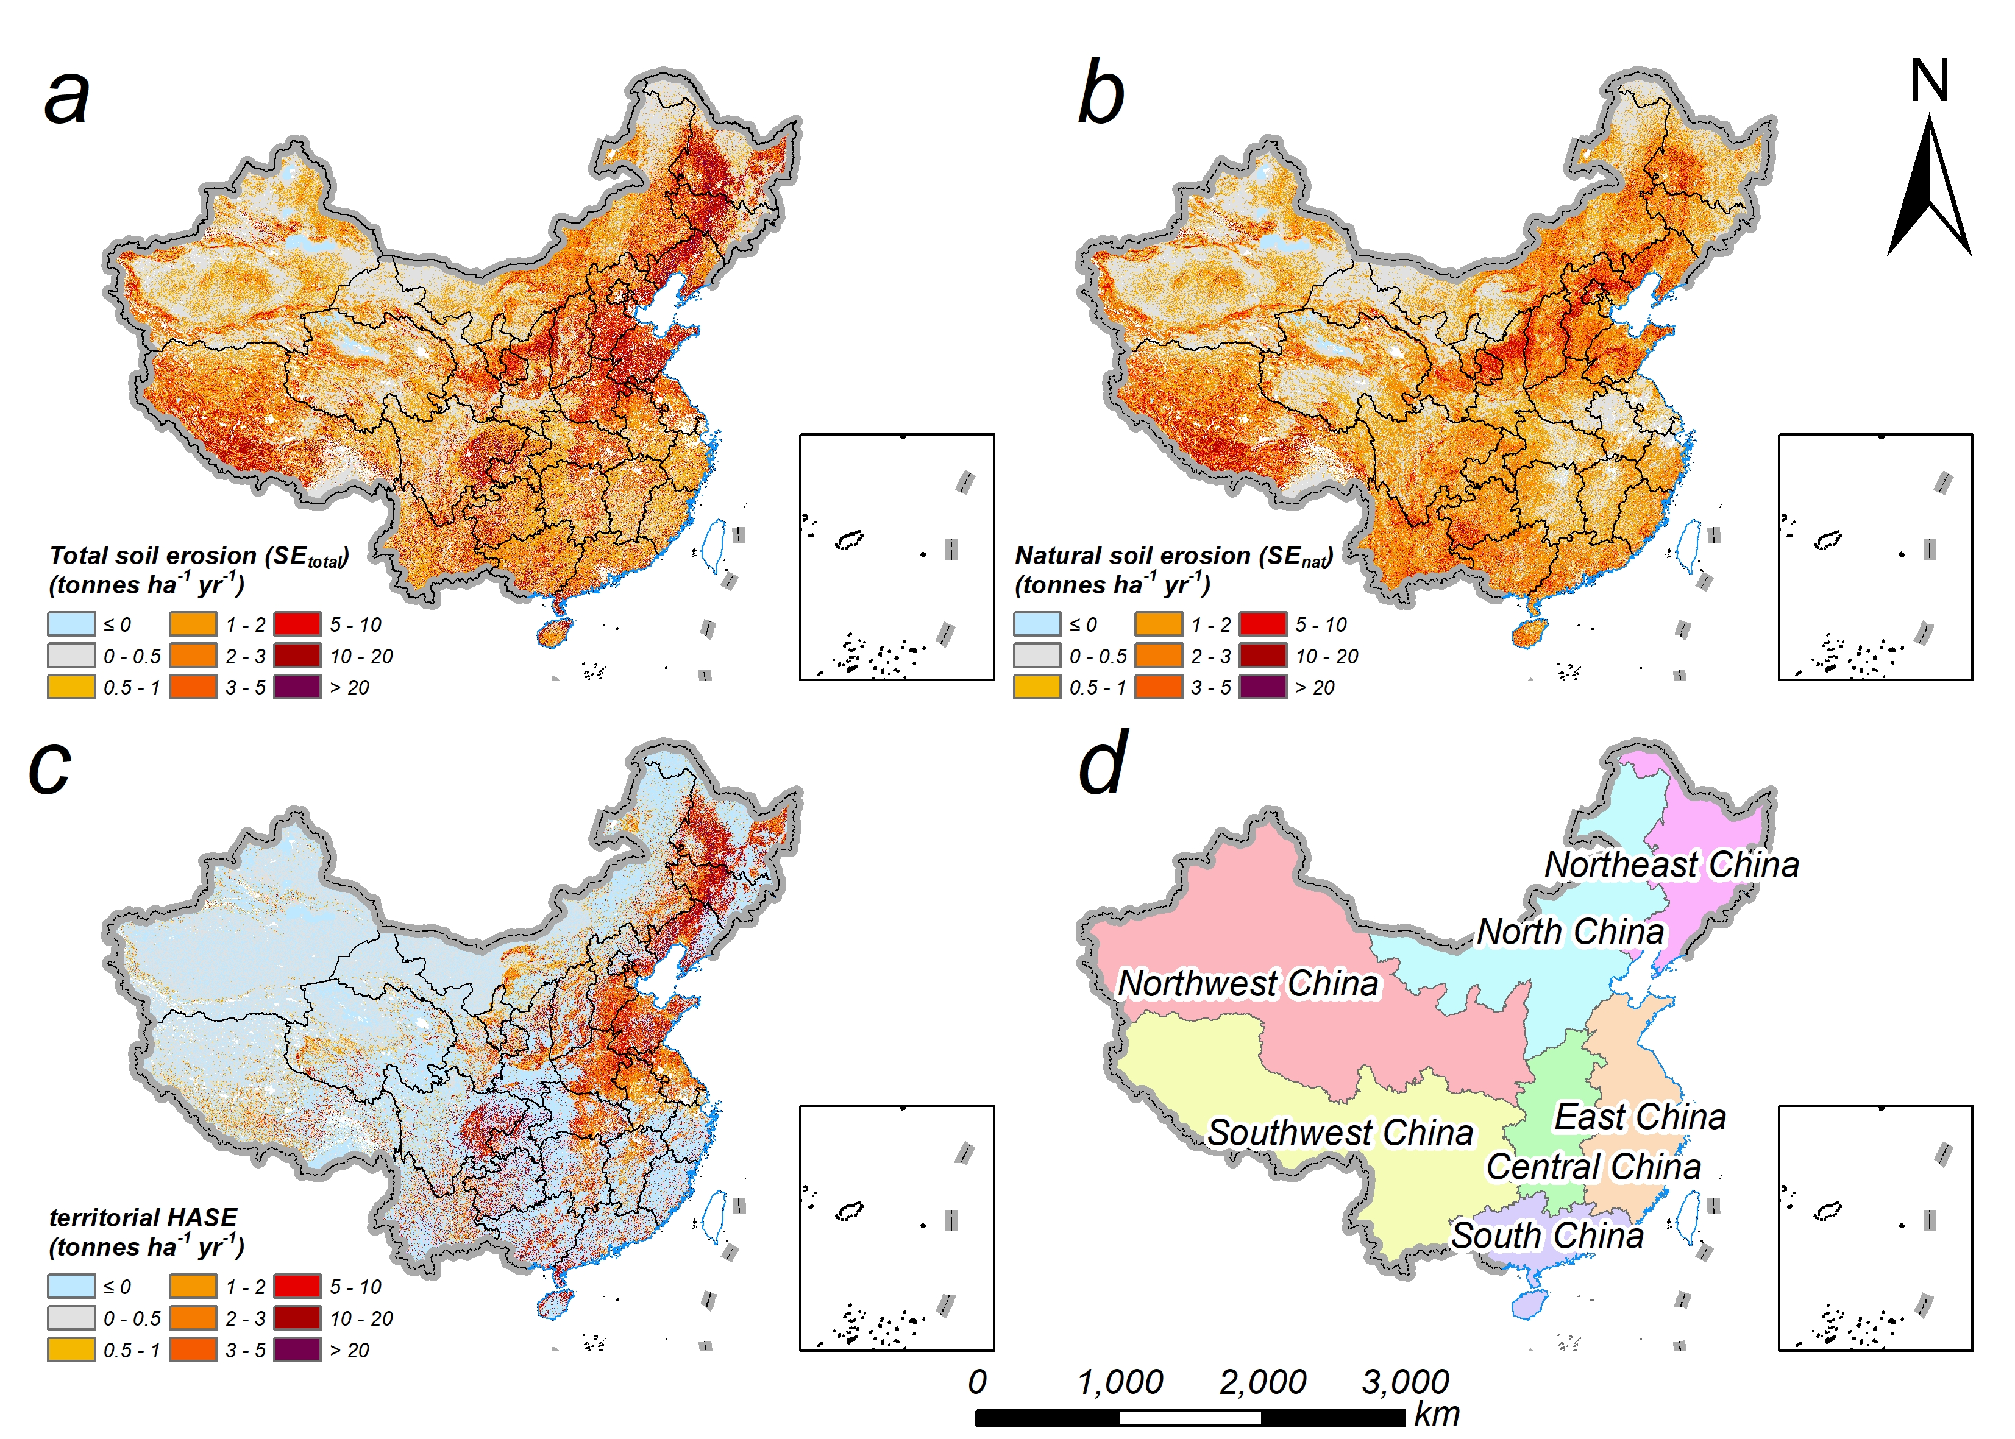

Figure S1. The total soil erosion (SE_{total}), natural soil erosion (SE_{nat}), territorial HASE, and the seven regions in mainland China (there is a lack of data in Hong Kong, Macau, and Taiwan).

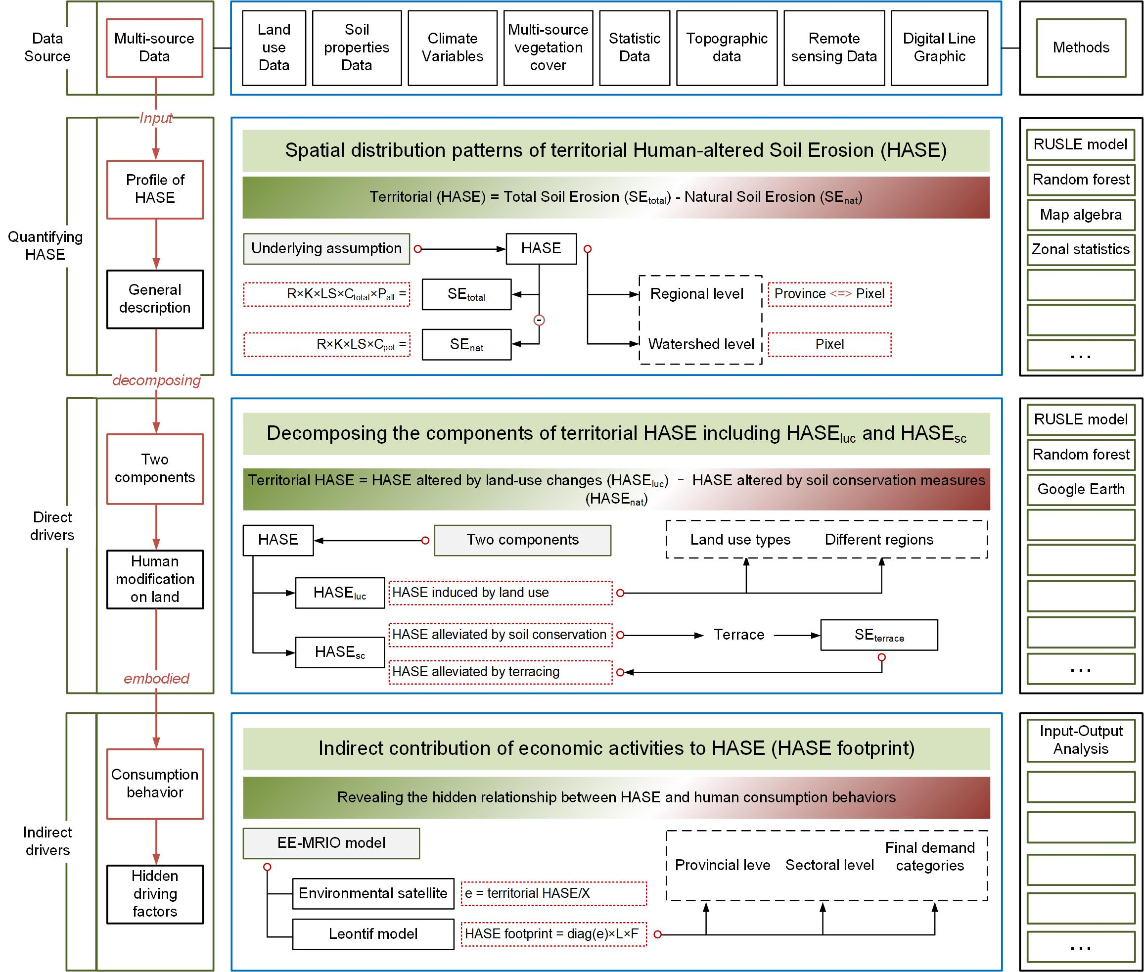

Figure S2. The framework of quantifying human-altered soil erosion (HASE).

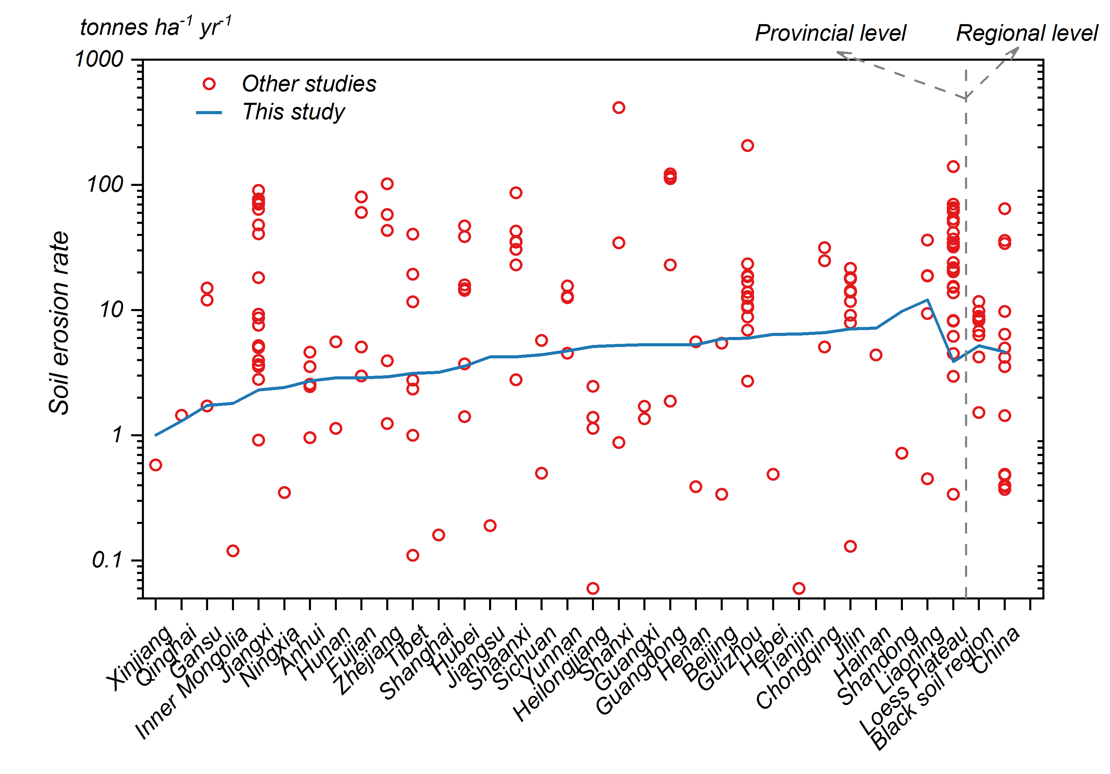

Figure S3. The comparison between the total soil erosion (SE_{total}) in this study with other studies.
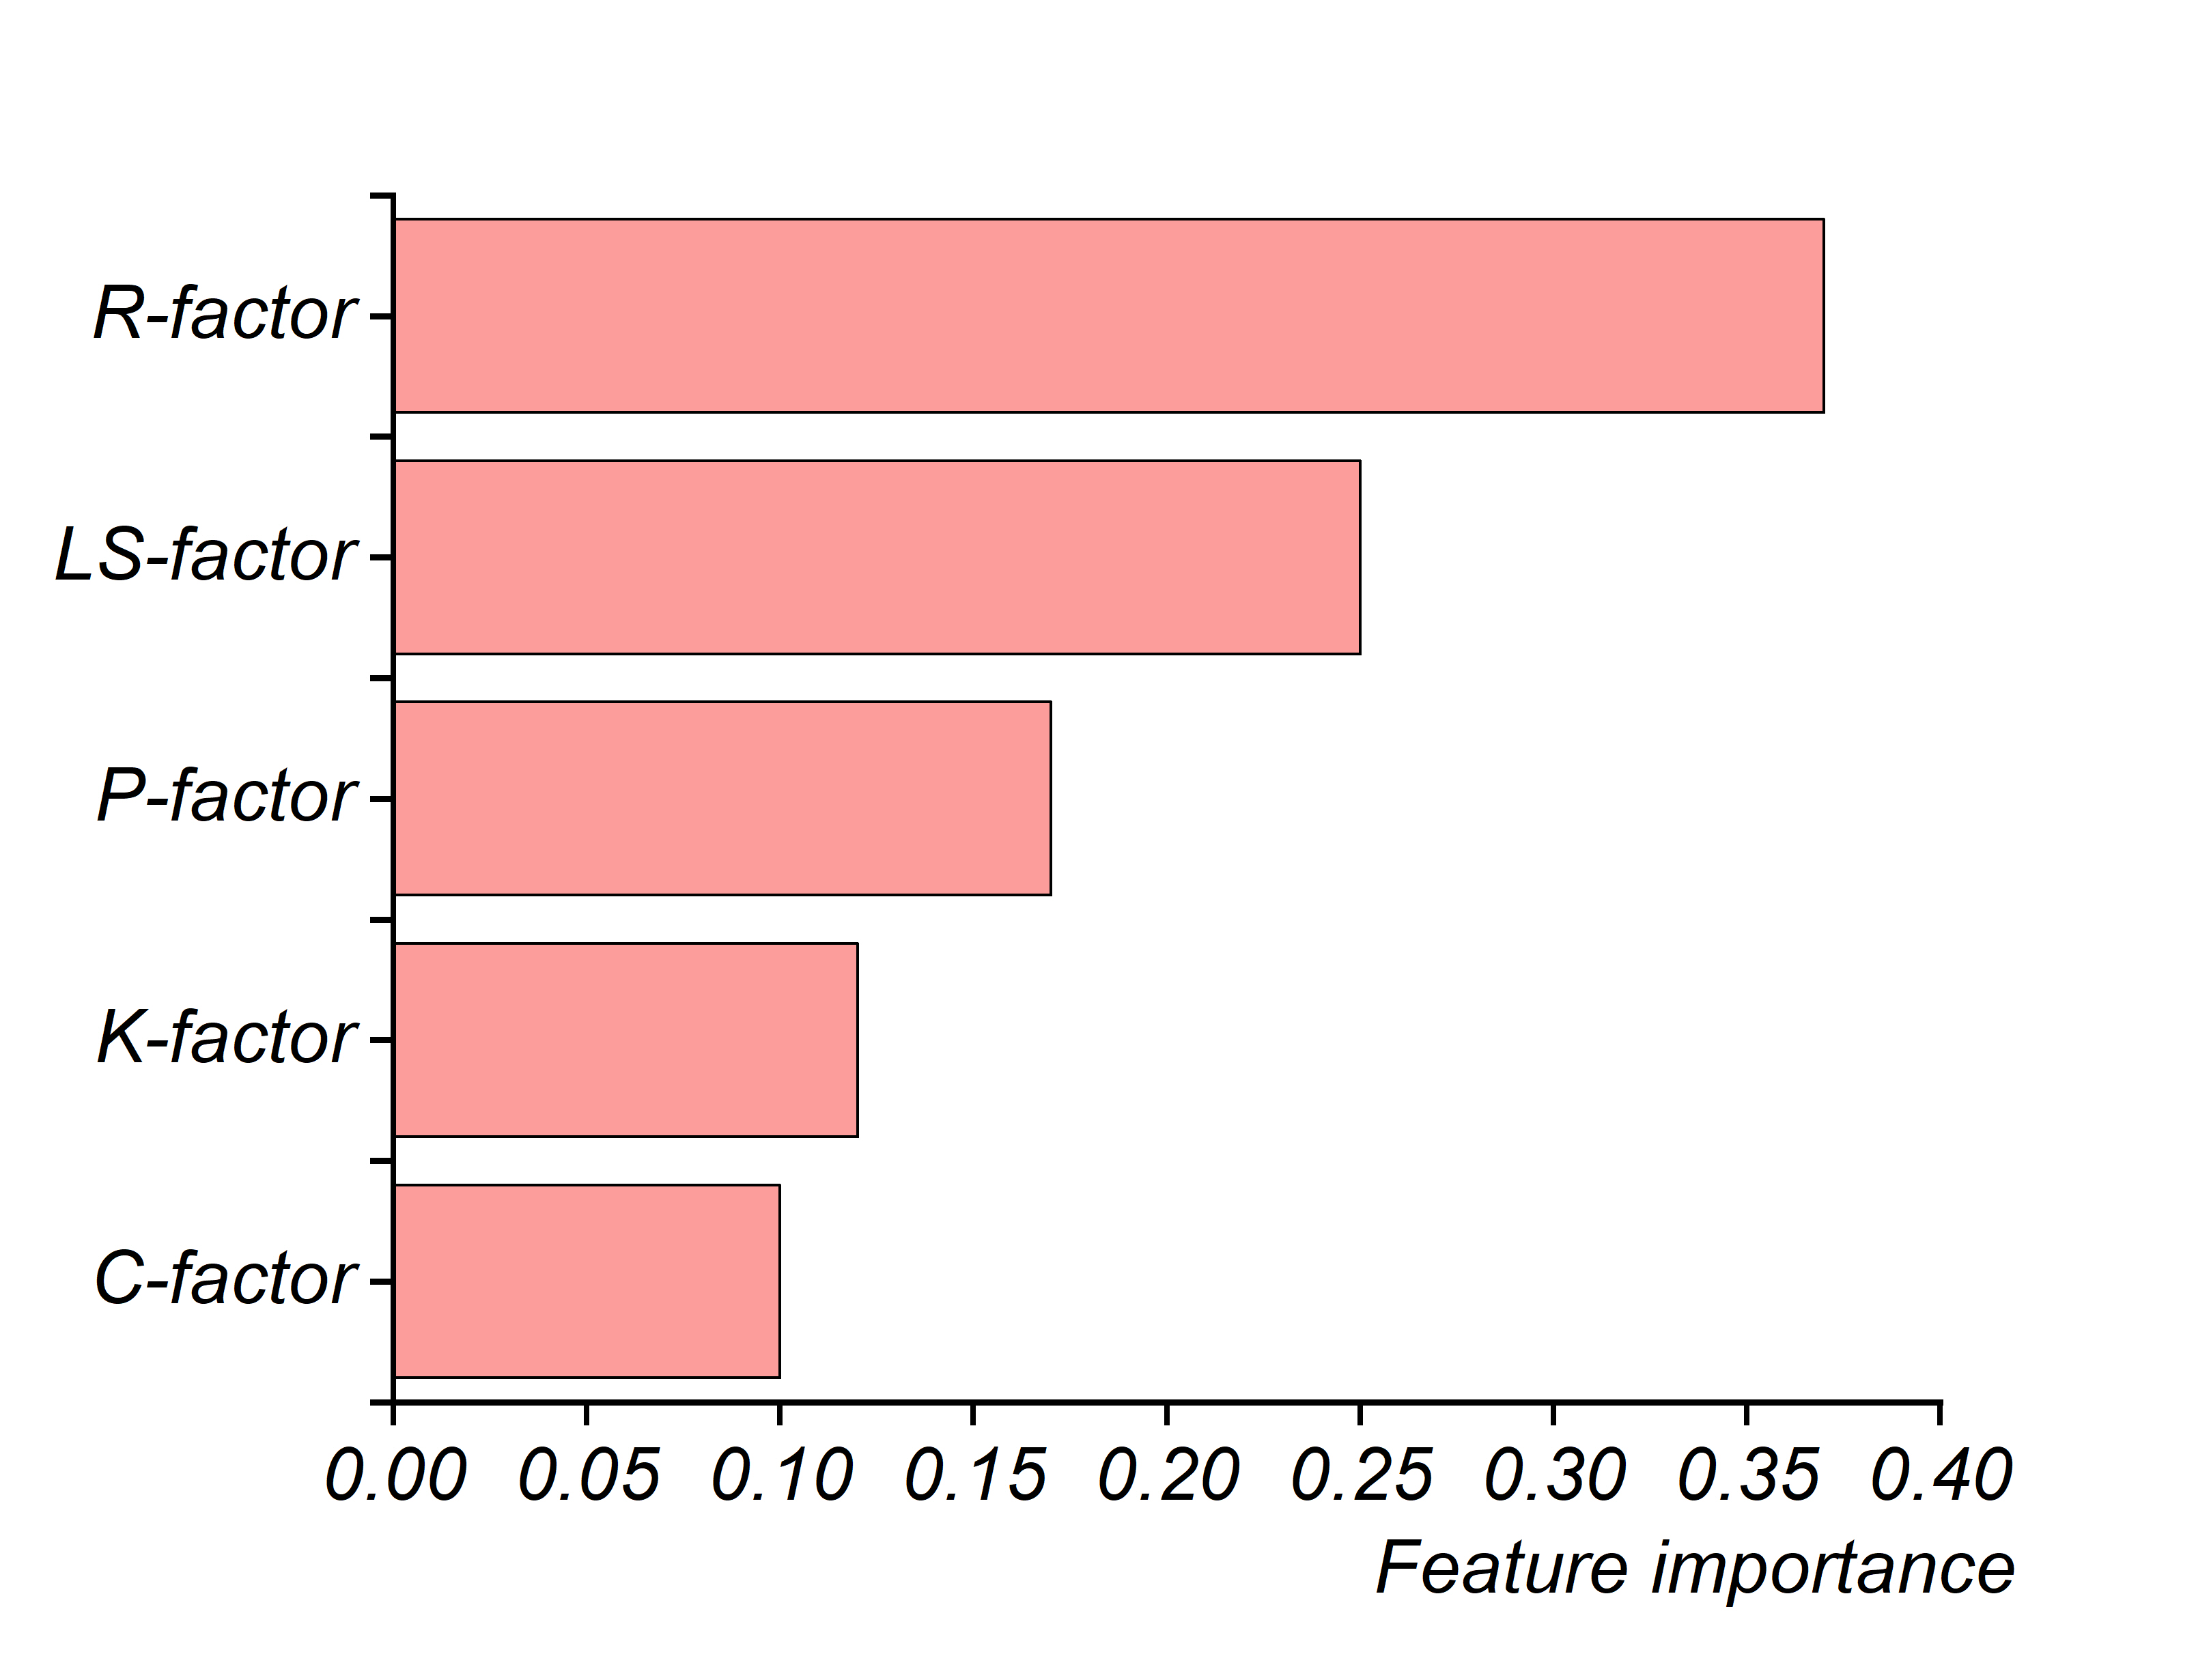

Figure S4. The feature importance of each RUSLE factor generated by random forest. It represents the sensitivity of each RUSLE factor to the estimated SE_{total}.

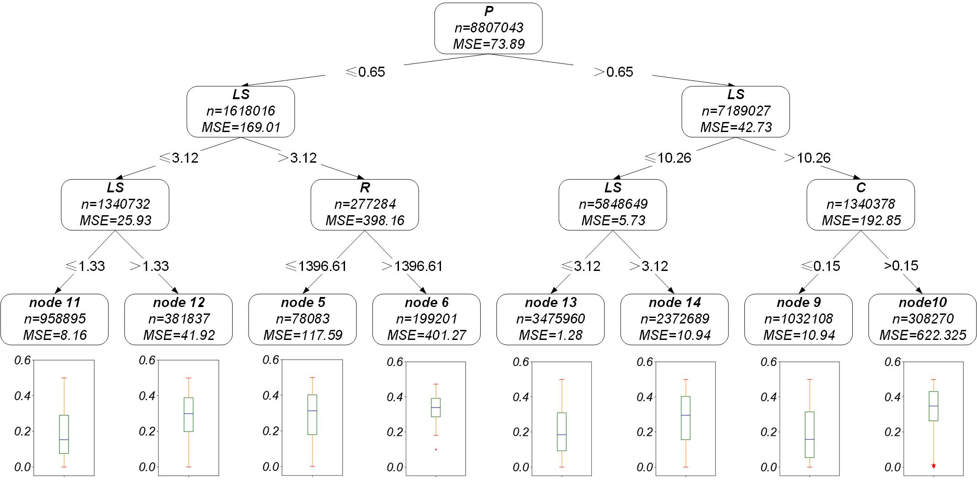

Figure S5. RUSLE factor interactions derived from the Classification and Regression Trees (CART). The dataset is represented as a tree plot (upper part), reporting the importance of the interactions between factors with a downward trend. The boxplot at the terminal nodes level (lower part) shows how their interaction affects the estimated SE_{total}.

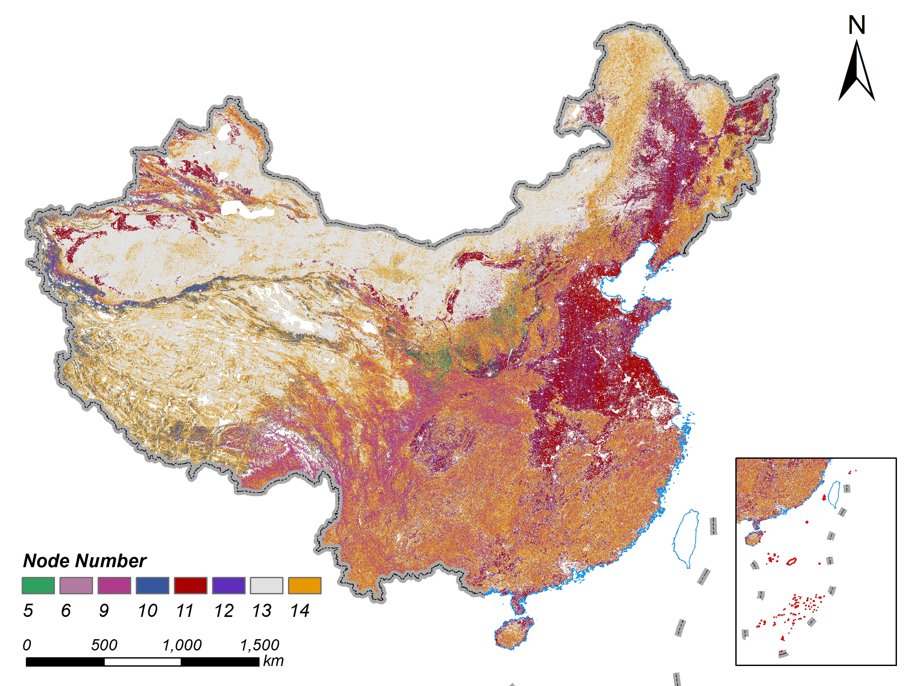

Figure S6. Spatial representation of the node membership derived from the sensitivity analysis. Each pixel in the map is attributed (colour) to the most frequent node class obtained from the Classification and Regression Trees (CART) analysis (Method S5).

Figure S7. The map of uncertainty at the pixel level is presented as the standard deviation of the simulated SE_{total} values.

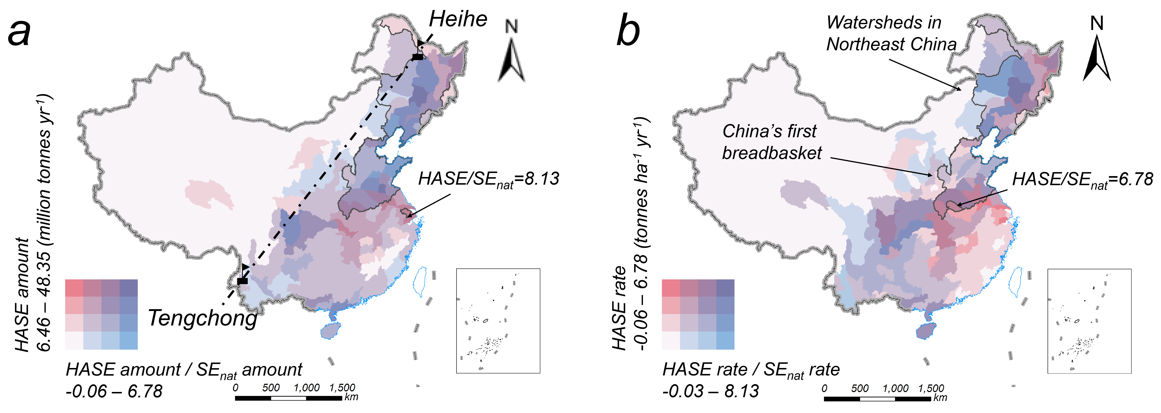

Figure S8. The spatial patterns of territorial HASE at the watersheds- level. a. territorial HASE rate and times of territorial HASE rate to SE_{nat} rate in different watersheds (the dotted line was the Heihe-Tengchong Line); b. territorial HASE amount and times of territorial HASE amount to SE_{nat} amount in different watersheds.

Table S1. Description of factors of the RUSLE model.
Factor | Unit and Resolution | Description
A | tonnes ha⁻¹ yr⁻¹ (30m) | estimates annual soil loss rate
R | MJ mm ha⁻¹ h⁻¹ yr⁻¹ (1km) | quantifies the effect of rainfall and runoff on the rate of soil loss
K | tonnes h MJ⁻¹ mm⁻¹ (30m) | measures the susceptibility of soil aggregates to detachment and transportation by rainfall and runoff
LS | dimensionless (30m) | corresponds to the effect of topography
C | dimensionless (30m) | captures the effect of land cover
P | dimensionless (30m) | reflects the soil conservation practices

Table S2. The reference C value of different crops in this study.
Crops in this paper | Corresponding crop group in reference | C value
Wheat | 1-Various | 0.2
Rice | 1-Rice | 0.15
Maize | 1-Maize | 0.38
Soybeans | 2-various | 0.32
Tubers | 3-various | 0.34
Oil bearing Crops | 10-various | 0.25
Cotton Crops | 10-cotton | 0.4
Hemp Crops | 11-fibre crops | 0.28
Sugar Crops | 3-various | 0.34
Tobacco Crops | 7-Tobacco | 0.5
Vegetable Crops | Mean (4+5+6) | 0.27
Others | Mode | 0.15

Table S3. The matching of the food crops of SPAM2010 with the 12 crop groups in this study.
Crops in this paper | SPAM name of food crops
Wheat | WHEA, BARL, PMIL, SMIL, SORG, OCER
Rice | RICE
Maize | MAIZ
Soybeans | BEAN, CHIC, COWP, PIGE, LENT, OPUL, SOYB, GROU
Tubers | POTA, SWPO, YAMS, CASS, ORTS
Oil bearing Crops | OILP, SUNF, RAPE, SESA, OOIL
Cotton Crops | COTT
Hemp Crops | OFIB
Sugar Crops | SUGC, SUGB
Tobacco Crops | ACOF, RCOF, COCO, TEAS, TOBA
Vegetable Crops | VEGE
Others | REST

Table S4. The constraining range of the C value of non-arable land use types.
Land use type | Reference constraining range of C value
Forest | 0.0001 – 0.04
Grassland | 0.01 – 0.15
Shrubland | 0.01 – 0.15
Tundra | 0.01 – 0.15
Bareland | 0.1 – 0.5
Note that the impervious surface was not considered since water erosion will not occur in the areas.

Table S5. P value of different land use types.
Land use type | Slope(degree) | P value
Cropland | 0 | 0.2
Cropland | 0-10 | 0.5
Cropland | 10-25 | 0.6
Cropland | 25-45 | 0.8
Cropland | >45 | 1
Forest |  | 0.7
Grassland |  | 0.9
Shrubland |  | 1
Tundra |  | 1
Bareland |  | 1

Table S6. Description and data sources of 32 explanatory variables which are used to train the random forest regressor when modeling potential C-factor without human intervention.
Description | Variables | Data sources
3 climate factors (1km) | annual mean temperature, annual precipitation, annual mean potential evapotranspiration | National Earth System Science Data Center (http://www.geodata.cn)
25 soil properties (90m) | Soil PH, SOC, TN, TP, TK, BD, CEC, CF, thickness at 0-5, 5-15, 15-30cm | Soil SubCenter, National Earth System Science Data Center (http://soil.geodata.cn)
2 vegetal factors (500m) | annual mean and maximum FPAR (Fraction of absorbed photosynthetically active radiation) | LAADS DAAC (https://ladsweb.modaps.eosdis.nasa.gov/)
2 topographical factors (30m) | DEM, Slope | USGS website (https://earthexplorer.usgs.gov/)
1 demographic factor (1km) | Population density | LandScan Global dataset (http://landscan.ornl.gov/)

Table S7. The number of terraces and non-terrace samples in each region when mapping terraces.
Region | Number of terrace samples | Number of non-terrace samples
A1 | 295 | 646
A2 | 1501 | 3869
A3 | 85 | 538
A4 | 176 | 194
A5 | 913 | 956
A6 | 1327 | 1972
A7 | 4208 | 1108
A8 | 210 | 331
A9 | 908 | 2477
A10 | 352 | 3174
A11 | 867 | 1013

Table S8. The accuracy of the random forest classifier to map the terraces in each region.
Region | Terrace |  | Non-terrace |  | Overall accuracy
Region | UA | PA | UA | PA | Overall accuracy
A1 | 83.8% | 92.3% | 85.7% | 72.1% | 85.1%
A2 | 95.7% | 87% | 95% | 98.4% | 95.2%
A3 | 94.4% | 68% | 99.2% | 94.6% | 94.6%
A4 | 95.1% | 88.6% | 91.2% | 96.2% | 92.8%
A5 | 97% | 95.8% | 95.7% | 97% | 96.4%
A6 | 98.1% | 97.2% | 98.1% | 98.7% | 98.1%
A7 | 92.7% | 96.7% | 86.9% | 76.8% | 92.4%
A8 | 98.2% | 98.2% | 98.8% | 98.8% | 98.6%
A9 | 78.5% | 61.2% | 86.1% | 93.5% | 84.5%
A10 | 93.5% | 79.3% | 97.7% | 99.3% | 97.3%
A11 | 99.5% | 97.1% | 97.6% | 99.6% | 98.4%

Table S9. The P value of terraces in different soil and water conservation regions.
Soil and water conservation region | P for region
Tibetan plateau | 1
Black soil area | 0.1342
Sand wind area | 1
Rocky mountain area | 0.0695
Red soil area | 0.1091
Loess plateau | 0.1079
Purple soil area | 0.1458
Karst area | 0.1264

Table S10. The aggregation of sectors in MRIO table.
Aggregated Sector | No. | Sector name
Agriculture, Forestry, Animal Husbandry, and Fishery Sector | 01 | Agriculture, Forestry, Animal Husbandry and Fishery
Mining Sector | 02 | Mining and washing of coal
Mining Sector | 03 | Extraction of petroleum and natural gas
Mining Sector | 04 | Mining and processing of metal ores
Mining Sector | 05 | Mining and processing of nonmetal and other ores
Manufacturing Sector | 06 | Food and tobacco processing
Manufacturing Sector | 07 | Textile industry
Manufacturing Sector | 08 | Manufacture of leather, fur, feather and related products
Manufacturing Sector | 09 | Processing of timber and furniture
Manufacturing Sector | 10 | Manufacture of paper, printing and articles for culture, education and sport activity
Manufacturing Sector | 11 | Processing of petroleum, coking, processing of nuclear fuel
Manufacturing Sector | 12 | Manufacture of chemical products
Manufacturing Sector | 13 | Manuf. of non -metallic mineral products
Manufacturing Sector | 14 | Smelting and processing of metals
Manufacturing Sector | 15 | Manufacture of metal products
Manufacturing Sector | 16 | Manufacture of general purpose machinery
Manufacturing Sector | 17 | Manufacture of special purpose machinery
Manufacturing Sector | 18 | Manufacture of transport equipment
Manufacturing Sector | 19 | Manufacture of electrical machinery and equipment
Manufacturing Sector | 20 | Manufacture of communication equipment, computers and other electronic equipment
Manufacturing Sector | 21 | Manufacture of measuring instruments
Manufacturing Sector | 22 | Other manufacturing and waste resources
Electricity/Gas/Water Sector | 24 | Production and distribution of electric power and heat power
Electricity/Gas/Water Sector | 25 | Production and distribution of gas
Electricity/Gas/Water Sector | 26 | Production and distribution of tap water
Construction Sector | 27 | Construction
Transport Sector | 29 | Transport, storage, and postal services
Services Sector | 28 | Wholesale and retail trades
Services Sector | 23 | Repair of metal products, machinery and equipment
Services Sector | 30 | Accommodation and catering
Services Sector | 31 | Information transfer, software and information technology services
Services Sector | 32 | Finance
Services Sector | 33 | Real estate
Services Sector | 34 | Leasing and commercial services
Services Sector | 35 | Scientific research
Services Sector | 36 | Polytechnic services
Services Sector | 37 | Administration of water, environment, and public facilities
Services Sector | 38 | Resident, repair and other services
Services Sector | 39 | Education
Services Sector | 40 | Health care and social work
Services Sector | 41 | Culture, sports, and entertainment
Services Sector | 42 | Public administration, social insurance, and social organizations

Table S11. The list of relevant literatures extracted to compare the total soil erosion result (SE_{total}) of this study with other studies. The unit of the total soil erosion rate in this study and other studies is tonnes ha⁻¹ yr⁻¹.
Province/Region | Result in this study | Results in other studies | year | Model
Anhui | 2.73 | 0.96 ²⁸ | 2002–2016 | RUSLE
Anhui | 2.73 | 2.57 ²⁹ | 2010 | RUSLE
Anhui | 2.73 | 4.61; 3.55; 2.45 ³⁰ | 1980; 2000; 2010 | RUSLE
Beijing | 5.91 | 0.34 ²⁸ | 2002–2016 | RUSLE
Beijing | 5.91 | 5.46 ³¹ | 2015 | RUSLE
Black Soil Region | 5.21 | 1.52 ³² | 2000-2020 | RUSLE
Black Soil Region | 5.21 | 4.22 ³³ | 1980, 1990, 2000, 2010, 2017 | RUSLE
Black Soil Region | 5.21 | 6.82 ¹⁰ | 1980, 1990, 2000, 2010, 2017 | RUSLE
Black Soil Region | 5.21 | 8.53 ³⁴ | 2001-2019 | RUSLE
Black Soil Region | 5.21 | 11.75; 8.56; 9.86; 6.29; 8.22; 8.94 ³⁵ | 2000; 2005; 2010; 2015; 2018; 2000-2018 | RUSLE
China | 4.64 | 0.39; 0.37; 0.49; 0.48 ³⁶ | 2000; 2005; 2010; 2015 | RUSLE
China | 4.64 | 0.40 ³⁷ | 1990、1995、2000、2005 | RUSLE
China | 4.64 | 1.44 ²⁸ | 2002–2016 | RUSLE
China | 4.64 | 3.54 ⁹⁶ | 2015 | RUSLE
China | 4.64 | 4.21 ³⁸ | 2003-2014 | RUSLE
China | 4.64 | 5.00 ³⁹ | 2011 | RUSLE
China | 4.64 | 6.42 ³ | 2001, 2012 | RUSLE
China | 4.64 | 9.75 ⁴⁰ | 1999-2018 | RUSLE
China | 4.64 | 34.16 ¹⁰ | 1992-2019 | RUSLE
China | 4.64 | 35.98 ⁴¹ | 2000, 2005, 2010, 2015 | RUSLE
China | 4.64 | 64.88 ⁴² | 2018 | RUSLE
Chongqing | 6.63 | 0.01 ⁴³ | 2020 | RUSLE
Chongqing | 6.63 | 5.07 ²⁸ | 2002–2016 | RUSLE
Chongqing | 6.63 | 24.75 ⁴⁴ | 2015 | RUSLE
Chongqing | 6.63 | 31.55 ⁴⁵ | 2015 | RUSLE
Fujian | 2.90 | 2.99 ⁴⁶ | 2010 | RUSLE
Fujian | 2.90 | 5.07 ²⁸ | 2002–2016 | RUSLE
Fujian | 2.90 | 15-30 ⁴⁷ | 1990, 2000, 2010, 2015 | RUSLE
Fujian | 2.90 | 60.35; 80.47 ¹⁰ | 2002-2015; 2010 | RUSLE
Gansu | 1.74 | 1.72 ²⁸ | 2002–2016 | RUSLE
Gansu | 1.74 | 12.07 ¹⁰ | 2002–2016 | RUSLE
Gansu | 1.74 | 15.00 ⁴⁸ | -- | USLE
Guangdong | 5.31 | 1.88 ²⁸ | 2002–2016 | RSLE
Guangdong | 5.31 | 22.94 ⁴⁹ | 2012 | USLE
Guangdong | 5.31 | 115.19 ⁴¹ | 2000, 2005, 2010, 2015 | RUSLE
Guangdong | 5.31 | 116.42; 122.88; 112.63 ¹⁰ | 2012; 2000/2005/2010/2015; 2002–2016 | RUSLE
Guangxi | 5.31 | 1.36 ⁵⁰ | 2015 | RUSLE
Guangxi | 5.31 | 1.71 ²⁸ | 2002–2016 | RUSLE
Guizhou | 5.99 | 0.02 ⁴³ | 2020 | RUSLE
Guizhou | 5.99 | 2.72 ²⁸ | 2002–2016 | RUSLE
Guizhou | 5.99 | 6.92 ⁵¹ | 2015 | RUSLE
Guizhou | 5.99 | 8.81 ⁵² | 2010 | RUSLE
Guizhou | 5.99 | 18.84; 10.51 ⁵³ | 2000; 2000—2018 | RUSLE
Guizhou | 5.99 | 10.83; 12.43; 12.85; 13.97 ⁵⁴ | 2015-2019; 2005-2009; 2010-2014; 2000-2004 | RUSLE
Guizhou | 5.99 | 16.82 ⁵⁵ | -- | RUSLE
Guizhou | 5.99 | 18.54 ⁹⁷ | 2020 | RUSLE
Guizhou | 5.99 | 23.48 ⁵⁶ | 2000-2015 | RUSLE
Guizhou | 5.99 | 206.66 ¹⁰ | 2002 | RUSLE
Hainan | 7.19 | 4.40 ²⁸ | 2002–2016 | RUSLE
Hebei | 6.43 | 0.49 ²⁸ | 2002–2016 | RUSLE
Heilongjiang | 5.16 | 0.06 ²⁸ | 2002–2016 | RUSLE
Heilongjiang | 5.16 | 1.14; 1.39 ⁵⁷ | 1980; 2020 | RUSLE
Heilongjiang | 5.16 | 2.46 ³³ | 1980、1990、2000、2010、2017 | RUSLE
Henan | 5.32 | 0.39 ²⁸ | 2002–2016 | RUSLE
Henan | 5.32 | 5.58 ⁴⁶ | 2010 | RUSLE
Hubei | 3.58 | 1.41 ²⁸ | 2002–2016 | RUSLE
Hubei | 3.58 | 3.73; 14.82; 14.38; 15.95 ⁵⁸ | 2000-2015; 2015; 2019; 2010 | RUSLE
Hubei | 3.58 | 47.11; 38.58 ⁵⁹ | 2009; 2019 | RUSLE
Hunan | 2.89 | 1.14 ²⁸ | 2002–2016 | RUSLE
Hunan | 2.89 | 5.58 ⁴⁶ | 2010 | RUSLE
Inner Mongolia | 1.81 | 0.12 ²⁸ | 2002–2016 | RUSLE
Jiangsu | 4.26 | 0.19 ²⁸ | 2002–2016 | RUSLE
Jiangxi | 2.31 | 0.92 ²⁸ | 2002–2016 | RUSLE
Jiangxi | 2.31 | 8.64; 2.81 ⁶⁰ | 1990; 2015 | RUSLE
Jiangxi | 2.31 | 3.54 ⁴⁶ | 2010 | RUSLE
Jiangxi | 2.31 | 5.02; 3.69; 3.97 ²⁷ | 2000; 2010; 2018 | RUSLE
Jiangxi | 2.31 | 9.31; 5.22 ⁶¹ | 1990; 2010 | RUSLE
Jiangxi | 2.31 | 7.59 ⁶² | 2005 | RUSLE
Jiangxi | 2.31 | 18.20 ⁶³ | 2000 | RUSLE
Jiangxi | 2.31 | 40.69; 73.31; 77.44; 48.01 ¹⁰ | 2001; 2010; 2015; 2002–2016 | RUSLE
Jiangxi | 2.31 | 70.42; 63.75 ⁶⁴ | 2001; 2015 | RUSLE
Jiangxi | 2.31 | 90.60 ^{36,41} | 2015 | RUSLE
Jilin | 7.12 | 0.13 ²⁸ | 2002–2016 | RUSLE
Jilin | 7.12 | 11.71; 13.91; 7.92; 9.13 ¹⁰ | 2005; 2010; 2015; 2002–2016 | RUSLE
Jilin | 7.12 | 17.7;18.25; 14.33 ⁶⁵ | 2005; 2010; 2015 | RUSLE
Jilin | 7.12 | 21.60 ⁶⁶ | 2019 | RUSLE
Liaoning | 12.12 | 0.45 ²⁸ | 2002–2016 | RUSLE
Liaoning | 12.12 | 9.43 ³³ | 1980、1990、2000、2010、2017 | RUSLE
Liaoning | 12.12 | 18.73 ⁶⁷ | 2016–2020 | RUSLE
Liaoning | 12.12 | 18.84 ¹⁰ | Average of 2016–2020 | RUSLE
Liaoning | 12.12 | 36.38 ⁶⁸ | 2011 | RUSLE
Loess Plateau | 3.90 | 0.34 ⁶⁹ | 2010 | RUSLE
Loess Plateau | 3.90 | 4.52; 2.97 ⁷⁰ | 1995-1999; 2000-2015 | RUSLE
Loess Plateau | 3.90 | 8.18; 6.17 ⁷¹ | 1990; 2015 | RUSLE
Loess Plateau | 3.90 | 8.27 ⁴¹ | 2000, 2005, 2010, 2015 | RUSLE
Loess Plateau | 3.90 | 13.74; 20.89; 21.81 ⁷² | 2015; 2000-2015; 2000-2010 | RUSLE
Loess Plateau | 3.90 | 15.20 ⁷³ | 2000-2010 | RUSLE
Loess Plateau | 3.90 | 15.56 ¹⁰ | 1992-2019 | RUSLE
Loess Plateau | 3.90 | 33.36; 21.74; 20.97 ⁷⁴ | 2000; 2007; 2012 | RUSLE
Loess Plateau | 3.90 | 63.26; 41.88 ⁹⁴ | 2000; 2015 | RUSLE
Loess Plateau | 3.90 | 33.62; 40.4; 24.05; 32.27 ⁷⁵ | 2000; 2003; 2008; 2010 | RUSLE
Loess Plateau | 3.90 | 34.76 ⁷⁶ | 1982–2016 | RUSLE
Loess Plateau | 3.90 | 50.57 ⁷⁷ | 1901-2016 | RUSLE
Loess Plateau | 3.90 | 70.26; 61.59; 53.36; 32 ⁷⁸ | 1990; 2000; 2005; 2010 | RUSLE
Loess Plateau | 3.90 | 65.89; 20.31; 37.05 ⁷⁹ | 2013; 2015; 2001-2015 | RUSLE
Loess Plateau | 3.90 | 140.00 ⁸⁰ | 2010 | RUSLE
Ningxia | 2.42 | 0.35 ²⁸ | 2002–2016 | RUSLE
Qinghai | 1.31 | 1.45 ²⁸ | 2002–2016 | RUSLE
Shaanxi | 4.27 | 2.78 ²⁸ | 2002–2016 | RUSLE
Shaanxi | 4.27 | 86.76; 42.75; 22.96; 30.59 ⁸¹ | 1980; 1990; 2010; 2015 | RUSLE
Shaanxi | 4.27 | 35.07 ⁸² | 2010 | USLE
Shaanxi | 4.27 | 35.31 ¹⁰ | 1992-2019 | RUSLE
Shaanxi | 4.27 | 41.74–43.34 ⁸³ | 2006 | CSLE
Shandong | 9.82 | 0.72 ²⁸ | 2002–2016 | RUSLE
Shanghai | 3.20 | 0.16 ²⁸ | 2002–2016 | RUSLE
Shanxi | 5.25 | 0.88 ²⁸ | 2002–2016 | RUSLE
Shanxi | 5.25 | 34.45 ⁸² | 2010 | USLE
Shanxi | 5.25 | 416.10 ⁸⁴ | 2016 | RUSLE
Sichuan | 4.42 | 0.50 ⁴³ | 2020 | RUSLE
Sichuan | 4.42 | 5.73 ²⁸ | 2002–2016 | RUSLE
Tianjin | 6.46 | 0.06 ²⁸ | 2002–2016 | RUSLE
Tibet | 3.15 | 0.11 ⁸⁵ | 1984-2013 | RUSLE
Tibet | 3.15 | 1.00 ²⁸ | 2002–2016 | RUSLE
Tibet | 3.15 | 2.35 ⁸⁶ | 2001-2017 | RUSLE
Tibet | 3.15 | 2.76 ⁸⁷ | 2002–2016 | RUSLE
Tibet | 3.15 | 11.67 ¹⁰ | 1992-2019 | RUSLE
Tibet | 3.15 | 19.40 ⁸⁸ | 1982—2015 | RUSLE
Tibet | 3.15 | 40.50 ⁸⁹ | 1990–2000 | RUSLE
Xinjiang | 1.01 | 0.58 ²⁸ | 2002–2016 | RUSLE
Yunnan | 4.74 | 4.54 ²⁸ | 2002–2016 | RUSLE
Yunnan | 4.74 | 12.56 ⁹⁰ | 2012 | CSLE
Yunnan | 4.74 | 12.90 ⁹¹ | 1996-2015 | RUSLE
Yunnan | 4.74 | 15.65 ⁹² | 2015 | RUSLE
Zhejiang | 2.95 | 1.24 ²⁸ | 2002–2016 | RUSLE
Zhejiang | 2.95 | 3.95 ⁴⁶ | 2010 | RUSLE
Zhejiang | 2.95 | 43.39; 58.01 ¹⁰ | 2002–2016; 2010 | RUSLE
Zhejiang | 2.95 | 102.23 ⁹⁵ | 2010 | RUSLE

References
1 Renard, K. G., Foster, G. R., Weesies, G. A. & Porter, J. P. RUSLE - REVISED UNIVERSAL SOIL LOSS EQUATION. Journal of Soil and Water Conservation 46, 30-33 (1991).
2 Borrelli, P. et al. Soil erosion modelling: A global review and statistical analysis. Science of the Total Environment 780, doi:10.1016/j.scitotenv.2021.146494 (2021).
3 Borrelli, P. et al. An assessment of the global impact of 21st century land use change on soil erosion. Nature Communications 8, doi:10.1038/s41467-017-02142-7 (2017).
4 Borrelli, P., Ballabio, C., Yang, J. E., Robinson, D. A. & Panagos, P. GloSEM: High-resolution global estimates of present and future soil displacement in croplands by water erosion. Scientific Data 9, doi:10.1038/s41597-022-01489-x (2022).
5 Yue, T. Y., Yin, S. Q., Xie, Y., Yu, B. F. & Liu, B. Y. Rainfall erosivity mapping over mainland China based on high-density hourly rainfall records. Earth System Science Data 14, 665-682, doi:10.5194/essd-14-665-2022 (2022).
6 Wischmeier, W. H. Predicting rainfall erosion losses-a guide to conservation planning. Agriculture Handbook 537 (1978).
7 Mccool, D. K., Brown, L. C., Foster, G. R., Mutchler, C. K. & Meyer, L. D. Revised Slope Steepness Factor for the Universal Soil Loss Equation. Transactions of the ASAE - American Society of Agricultural Engineers (USA) 30, 1387-1396 (1987).
8 Desmet, P. J. J. & Govers, G. A GIS procedure for automatically calculating the USLE LS factor on topographically complex landscape units. Journal of Soil and Water Conservation 51, 427-433 (1996).
9 Baoyuan, L., Keli, Z. & Yun, X. in Proceedings 12th International Soil Conservation Organization Conference.
10 Li, J. L., He, H. B., Zeng, Q. H., Chen, L. D. & Sun, R. H. A Chinese soil conservation dataset preventing soil water erosion from 1992 to 2019. Scientific Data 10, doi:10.1038/s41597-023-02246-4 (2023).
11 Yang, J., Dong, J., Xiao, X., Dai, J. & Ge, Q. Divergent shifts in peak photosynthesis timing of temperate and alpine grasslands in China. Remote Sensing of Environment 233 (2019).
12 Renard, K. G., Foster, G. R., Weesies, G. A., Mccool, D. K. & Yoder, D. C. Predicting soil erosion by water: a guide to conservation planning with the Revised Universal Soil Loss Equation (RUSLE). Agricultural Handbook (1997).
13 Dawen, Y., Shinjiro, K., Taikan, O., Toshio, K. & Katumi, M. Global potential soil erosion with reference to land use and climate changes. Hydrological ProcHydrological Processesesses (2003).
14 Xiong, M. Q., Sun, R. H. & Chen, L. D. Effects of soil conservation techniques on water erosion control: A global analysis. Science of the Total Environment 645, 753-760, doi:10.1016/j.scitotenv.2018.07.124 (2018).
15 Xiong, M. Q., Sun, R. H. & Chen, L. D. Global analysis of support practices in USLE-based soil erosion modeling. Progress in Physical Geography-Earth and Environment 43, 391-409, doi:10.1177/0309133319832016 (2019).
16 Chen, F., Jiang, Y. & Yin, X. ADJUSTMENT OF CHINA'S FARMING SYSTEM REGIONALIZATION SCHEME. Journal of China Agricultural Resources and Regional Planning 42, 1-6 (2021).
17 Zhao, Y. et al. A study on scheme of soil and water conservation regionalization in China. Journal of Geographical Sciences 23, 721-734, doi:10.1007/s11442-013-1040-8 (2013).
18 Keke, L. et al. Multiple perspective accountings of cropland soil erosion in China reveal its complex connection with socioeconomic activities. Agriculture Ecosystems & Environment 337, doi:10.1016/j.agee.2022.108083 (2022).
19 Wang, Z. et al. Telecoupling cropland soil erosion with distant drivers within China. Journal of Environmental Management 288, doi:10.1016/j.jenvman.2021.112395 (2021).
20 Zhang, H. Y. et al. Worsening Carbon Inequality Embodied in Trade within China. Environmental Science & Technology 57, 863-873, doi:10.1021/acs.est.2c05990 (2023).
21 Saltelli, A., Tarantola, S. & Chan, K. P. S. A quantitative model-independent method for global sensitivity analysis of model output. Technometrics 41, 39-56, doi:10.2307/1270993 (1999).
22 Rogers & Gunn. Identifying feature relevance using a random forest. LECT NOTE COMPUT SCI (2006).
23 Lewis, R. J. An Introduction to Classification and Regression Tree (CART) Analysis. annual meeting of the society for academic emergency medicine (2000).
24 Zhang, R. et al. Assessment of soil erosion sensitivity and analysis of sensitivity factors in the Tongbai-Dabie mountainous area of China. CATENA -GIESSEN THEN AMSTERDAM- 101, 92-98 (2013).
25 Zhang, D., Caron, J. & Winchester, N. Sectoral Aggregation Error in the Accounting of Energy and Emissions Embodied in Trade and Consumption. Journal of Industrial Ecology 23, 402-411, doi:10.1111/jiec.12734 (2019).
26 Lark & R., M. Environmental Modelling: Finding Simplicity in Complexity (2nd edition) ‐ edited by Wainwright, J. & Mulligan, M. European Journal of Soil Science 64, 822-822 (2013).
27 Lang, Y. Q., Yang, X. H. & Cai, H. Y. Quantifying anthropogenic soil erosion at a regional scale-The case of Jiangxi Province, China. Catena 226, doi:10.1016/j.catena.2023.107081 (2023).
28 Teng, H. F., Hu, J., Zhou, Y., Zhou, L. Q. & Shi, Z. Modelling and mapping soil erosion potential in China. Journal of Integrative Agriculture 18, 251-264, doi:10.1016/s2095-3119(18)62045-3 (2019).
29 Zhao, M. S., Li, D. C., Zhang, G. l. & Cheng, X. F. Evaluation of Soil Erosion and Soil Nutrient Loss in Anhui Province Based on RUSLE Model. Acta Pedologica Sinica 53, 28-38, doi:10.11766/trxb201503240666 (2016).
30 Zhao, M. S., Li, D. C. & Zhang, G. L. Dynamic Evolution and Prediction of Soil Erosion in Anhui Province from 1980 to 2010 (in Chinese). Soils 48, 588-596, doi:10.13758/j.cnki.tr.2016.03.026 (2016).
31 Gao, J. B., Jiang, Y., Wang, H. & Zuo, L. Y. Identification of Dominant Factors Affecting Soil Erosion and Water Yield within Ecological Red Line Areas. Remote Sensing 12, doi:10.3390/rs12030399 (2020).
32 Wang, S. H., Xu, X. L. & Huang, L. Spatial and Temporal Variability of Soil Erosion in Northeast China from 2000 to 2020. Remote Sensing 15, doi:10.3390/rs15010225 (2023).
33 Fang, H. Y. & Fan, Z. M. Assessment of Soil Erosion at Multiple Spatial Scales Following Land Use Changes in 1980-2017 in the Black Soil Region, (NE) China. International Journal of Environmental Research and Public Health 17, doi:10.3390/ijerph17207378 (2020).
34 Cao, Y. F., Hua, L., Tang, Q., Liu, L. & Cai, C. F. Evaluation of monthly-scale soil erosion spatio-temporal dynamics and identification of their driving factors in Northeast China. Ecological Indicators 150, doi:10.1016/j.ecolind.2023.110187 (2023).
35 Wang, S., Fang, H. & He, J. Effects of Variation in Vegetation Cover and Rainfall on Soil Erosion in Black Soil Region,Northeastern China. Bulletin of Soil and Water Conservation 41, 66-75 (2021).
36 Li, J., Sun, R., Xiong, M. & Yang, G. Estimation of soil erosion based on the RUSLE model in China. Acta Ecologica Sinica 40, 3473-3485 (2020).
37 Weng, X. R., Zhang, B., Zhu, J. X., Wang, D. G. & Qiu, J. X. Assessing Land Use and Climate Change Impacts on Soil Erosion Caused by Water in China. Sustainability 15, doi:10.3390/su15107865 (2023).
38 Teng, H. F. Assimilating multi-source data to model and map potential soil loss in China (in Chinese), Zhejiang University, (2017).
39 Liu, B. Y. et al. The assessment of soil loss by water erosion in China. International Soil and Water Conservation Research 8, 430-439, doi:10.1016/j.iswcr.2020.07.002 (2020).
40 Wang, H., Zhao, W. W., Li, C. J. & Pereira, P. Vegetation greening partly offsets the water erosion risk in China from 1999 to 2018. Geoderma 401, doi:10.1016/j.geoderma.2021.115319 (2021).
41 Li, J. L., Sun, R. H., Xiong, M. Q. & Chen, L. D. Methodology of Time Series of Soil Erosion Dataset in Water Erosion Area of China in Five-year Increments (2000-2015). Journal of Global Change Data & Discovery 5, 203-212 (2021).
42 Zhuang, H. C. et al. Large-Scale Soil Erosion Estimation Considering Vegetation Growth Cycle. Land 10, doi:10.3390/land10050473 (2021).
43 Ge, Y. K. et al. Study on Soil Erosion Driving Forces by Using (R)USLE Framework and Machine Learning: A Case Study in Southwest China. Land 12, doi:10.3390/land12030639 (2023).
44 Gao, S. Q., Liu, Q. & Luo, X. Land Use Change and Soil Erosion Characteristics in Chongqing Based on RUSLE Mode (in Chinese). Soil and Water Conservation in China 11, 32-36+37, doi:10.14123/j.cnki.swcc.2022.0266 (2022).
45 Saho, Z. H., Mu, F. Y., Huang, Q., Li, Q. Y. & Wang, X. Z. Spatial distribution and influencing factors analysis of soil conservation services in Chongqing (in Chinese). Science Technology and Engineering 23, 100-108 (2023).
46 Chen, S., Yang, X., Xiao, L. & Cai, H. Study of Soil Erosion in the Southern Hillside Area of China Based on RUSLE Model. Resources Science 36, 1288-1297 (2014).
47 Zeng, S. et al. Temporal and Spatial Variation of Soil Erosion in Fujian Province. Bulletin of Soil and Water Conservation 37, 305 (2017).
48 Zhang, C. & McBean, E. A. Estimation of desertification risk from soil erosion: a case study for Gansu Province, China. Stochastic Environmental Research and Risk Assessment 30, 2215-2229, doi:10.1007/s00477-015-1186-2 (2016).
49 Gao, F., Wang, Y. P. & Yang, J. X. in 3rd International Symposium on Earth Observation for Arid and Semi-Arid Environments (ISEO). (2017).
50 Liu, J., Lu, Y., Liu, B. & Hua, C. Relationship Between Land Use and Soil Erosion in Guangxi Zhuang Autonomous Region. Bulletin of Soil and Water Conservation 38, 41-46 (2018).
51 Zeng, C., Li, Y. B., Bai, X. Y., Luo, G. J. & Iop. in 3rd International Conference on Environmental Science and Material Application (ESMA). (2018).
52 Sun, D. et al. Research on Soil Erosion in Karst Area Based on GIS and RUSLE Model -A Case Study in Guizhou Province. Bulletin of Soil and Water Conservation 36, 271 (2016).
53 Niu, L. N. & Shao, Q. Q. Soil Conservation Service Spatiotemporal Variability and Its Driving Mechanism on the Guizhou Plateau, China. Remote Sensing 12, doi:10.3390/rs12142187 (2020).
54 Fang, F. Y. et al. RUSLE Model Evaluation of the Soil and Water Conservation Ratio of the Guizhou Province in China between 2000 and 2019. Sustainability 14, doi:10.3390/su14138219 (2022).
55 Zhang, Y. S., Li, R. & Jing, J. Soil erosion gradient and quantitative attribution in southwest China based on karst development degree. Ecological Indicators 144, doi:10.1016/j.ecolind.2022.109496 (2022).
56 Wang, J. Y., Zhu, Y. Q. & Chen, P. F. Methodology for 1-km Raster Dataset of Annual Soil Erosion Modulus in Southwestern Mountainous Region of China(2000-2015). Journal of Global Change Data & Discovery 5, 54-61 (2021).
57 Jiang, N. et al. Estimating the Soil Erosion Response to Land-Use Change Using GIS-Based RUSLE and Remote Sensing: A Case Study of Heilongjiang Province, China. Sustainability 15, doi:10.3390/su15108004 (2023).
58 Tian, P. et al. Soil erosion assessment by RUSLE with improved P factor and its validation: Case study on mountainous and hilly areas of Hubei Province, China. International Soil and Water Conservation Research 9, 433-444, doi:10.1016/j.iswcr.2021.04.007 (2021).
59 Wang, H. et al. Analysis on Temporal and Spatial Variation of Soil Erosion in Hubei Province from 2009 to 2019 (in Chinese). Soil and Water Conservation in China 6, 43-46 (2021).
60 Huang, D., Yang, X. H., Cai, H. Y., Xiao, Z. L. & Han, D. R. Identifying Human-Induced Spatial Differences of Soil Erosion Change in a Hilly Red Soil Region of Southern China. Sustainability 11, doi:10.3390/su11113103 (2019).
61 Xiao, L. L., Yang, X. H. & Cai, H. Y. The Indirect Roles of Roads in Soil Erosion Evolution in Jiangxi Province, China: A Large Scale Perspective. Sustainability 9, doi:10.3390/su9010129 (2017).
62 Shuhua, Q. I., Meixin, J. & Xiubo, Y. U. Evaluating soil erosion in Jiangxi Province with USLE model and remote sensing technology during 1995～2005. China Environmental Science 31, 1197-1203 (2011).
63 Li, H., Chen, X. L., Lim, K. J., Cai, X. B. & Sagong, M. Assessment of soil erosion and sediment yield in Liao watershed, Jiangxi Province, China, Using USLE, GIS, and RS. Journal of Earth Science 21, 941-953, doi:10.1007/s12583-010-0147-4 (2010).
64 Zhou, X. et al. Soil Erosion Changes in Jiangxi Province from 2001 to 2015 Based on USLE Model. Bulletin of Soil and Water Conservation 38, 8 (2018).
65 Zhao, M. X. Quantitative Study on Hydraulic Soil Erosion in Jilin Province Based on RUSLE Model (in Chinese). China University of Geosciences (Beijing ), doi:10.27493/d.cnki.gzdzy.2018.000060 (2022).
66 Zhou, P. et al. Assessment of Soil Erosion by the RUSLE Model Using Remote Sensing and GIS: A Case Study of Jilin Province of China. Preprints (2020).
67 Li, M. X. Evaluation of functional importance of soil and water conservation in Liaoning Province (in Chinese). Heilongjiang Hydraulic Science and Technology 50, 215-218, doi:10.14122/j.cnki.hskj.2022.02.059 (2022).
68 Gao, L., Wang, X., Qu, B. & Cao, Y. Quantitative Study on Soil Erosion in Liaoning Province Based on RUSLE Model. Journal of Yangtze River Scientific Research Institute 32, 25-29 (2015).
69 Gao, H. D. et al. Capacity of soil loss control in the Loess Plateau based on soil erosion control degree. Journal of Geographical Sciences 26, 457-472, doi:10.1007/s11442-016-1279-y (2016).
70 Lan, X. et al. Land-Use Intensity Reversed the Role of Cropland in Ecological Restoration Over the World's Most Severe Soil Erosion Region. Earths Future 11, doi:10.1029/2022ef003388 (2023).
71 Jin, F. M. Spatialtemporal variability and attribution of soil erosion on the Loess Plateau (in Chinese), Northwest A＆F University, (2022).
72 Guo, X. J. & Shao, Q. Q. Spatial Pattern of Soil Erosion Drivers and the Contribution Rate of Human Activities on the Loess Plateau from 2000 to 2015: A Boundary Line from Northeast to Southwest. Remote Sensing 11, doi:10.3390/rs11202429 (2019).
73 Wenyi, S., Quanqin, S. & Jiyuan, L. Soil erosion and its response to the changes of precipitation and vegetation cover on the Loess Plateau. Journal of Geographical Sciences 23, 1091-1106 (2013).
74 Wang, J. & Zhuo, J. Quantitative Assessment of Soil Erosion in Areas Under Grain for Green Project in Loess Plateau of Northern Shaanxi Province Based on GIS and RS. Bulletin of Soil and Water Conservation 35, 220 (2015).
75 Fu, B. J. et al. Assessing the soil erosion control service of ecosystems change in the Loess Plateau of China. Ecological Complexity 8, 284-293, doi:10.1016/j.ecocom.2011.07.003 (2011).
76 Li, P. F. et al. Determining the drivers and rates of soil erosion on the Loess Plateau since. Science of the Total Environment 823, doi:10.1016/j.scitotenv.2022.153674 (2022).
77 Mu, X. M. et al. Spatial-Temporal Development and Driving Mechanisms of Erosion on the Chinese Loess Plateau Between 1901 and 2016 (in Chinese). Yellow River 44, 36-45 (2022).
78 Liu, Y. L. Responses of Soil Erosion to Vegetation Restoration on the Loess Plateau (in Chinese), Research Center of Soil and Water Conservation and Ecological Environment, Chinese Academy of Sciences and Ministry of Education, (2022).
79 Geng, W. G., Zhu, Y. Q. & Chen, P. F. 1-km Raster Dataset of Annual Soil Erosion Modulus on the Loess Plateau (2001–2015) (in Chinese). Journal of Global Change Data & Discovery 6, 85-92, doi:10.3974/geodp.2022.01.12 (2022).
80 Meng, X. Spatial and Temporal Characteristics of Regional Soil Erosion and its Erosion Factors Based on Spatial Model and GIS Technology from Macro Perspective (in Chinese), Chang’an University, (2022).
81 Lin, J. F., Lin, Y. H., Zhao, H. F. & He, H. M. Soil Erosion Processes and Geographical Differentiation in Shaanxi during 1980-2015. Sustainability 14, doi:10.3390/su141710512 (2022).
82 Rao, E., Xiao, Y., Ouyang, Z. & Yu, X. National assessment of soil erosion and its spatial patterns in China. Ecosystem Health and Sustainability 1, 1, doi:10.1890/ehs14-0011.1 (2015).
83 Lin, C., Qin-ke, Y., Hong-xia, X. I. E., Chun-mei, W. & Wei-ling, G. U. O. GIS and CSLE Based Quantitative Assessment of Soil Erosion in Shaanxi, China. Journal of Soil and Water Conservation 23, 61-66 (2009).
84 Ning, T., Guo, X., Rong, Y., Du, S. & Li, C. Evaluation of Soil Conservation Function Importance of Ecosystems in Shanxi Province Based on RUSLE Model. Bulletin of Soil and Water Conservation 39, 205-210 (2019).
85 Sun, J., Liu, Y., Zhou, T. C., Liu, G. H. & Wang, J. S. Soil conservation service on the Tibetan Plateau, 1984-2013. Earth and Environmental Science Transactions of the Royal Society of Edinburgh 109, 445-451, doi:10.1017/s1755691018000609 (2019).
86 Teng, H. F. et al. Drivers of water erosion-induced lateral soil carbon loss on the Tibetan Plateau. Catena 211, doi:10.1016/j.catena.2021.105970 (2022).
87 Teng, H. F. et al. Current and future assessments of soil erosion by water on the Tibetan Plateau based on RUSLE and CMIP5 climate models. Science of the Total Environment 635, 673-686, doi:10.1016/j.scitotenv.2018.04.146 (2018).
88 Zhao, W. T. et al. Water erosion changes on the Qinghai-Tibet Plateau and its response to climate variability and human activities during 1982-2015. Catena 229, doi:10.1016/j.catena.2023.107207 (2023).
89 Xiao, Y., Xie, G. & An, K. The function and economic value of soil conservation of ecosystems in Qinghai-Tibet Plateau. Acta Ecologica Sinica 23, 2367-2378 (2003).
90 Duan, X. W. et al. Investigation method for regional soil erosion based on the Chinese Soil Loss Equation and high-resolution spatial data: Case study on the mountainous Yunnan Province, China. Catena 184, doi:10.1016/j.catena.2019.104237 (2020).
91 Rao, W. E., Shen, Z. H. & Duan, X. W. Spatiotemporal patterns and drivers of soil erosion in Yunnan, Southwest China: RULSE assessments for recent 30 years and future predictions based on CMIP6. Catena 220, doi:10.1016/j.catena.2022.106703 (2023).
92 Chen, Z. F. et al. Characteristics of Soil Erosion and Nutrient Loss in Yunnan Province Based on RUSLE Model (in Chinese). Journal of Soil and Water Conservation 35, 7-14, doi:10.13870/j.cnki.stbcxb.2021.06.002 (2021).
93 International Food Policy Research Institute, 2019, "Global Spatially-Disaggregated Crop Production Statistics Data for 2010 Version 2.0", https://doi.org/10.7910/DVN/PRFF8V, Harvard Dataverse, V4
94 Zhuang Y. An estimation of soil loss based on RS and GIS in China (in Chinese). Nanjing Agricultural University, (2020), doi:10.27244/d.cnki.gnjnu.2018.000059.
95 Wu, F. X. Research on Risk Assessment of Soil and Water Loss in Guizhou Province Based on RUSLE Model (in Chinese). Water Conservancy Science and Technology and Economy 29:50-53, (2023).
96 Jia, L. Study on the Driving Mechanism of Ecological Effect of Sloping land conversion program in Loess Plateau (in Chinese). Northwest A＆F University, (2023), doi:10.27409/d.cnki.gxbnu.2022.000670.
97 Zhang, C., Feng, X. L. Spatial-temporal evolution of erosion risk and driving forces analysis in Zhejiang Province based on RUSLE (in Chinese). Shanghai Land & Resources 44:46-52 (2023).

