Supporting Information (SI)
Acylation modification enhanced encapsulation ability of baicalin by liposome, and liposome improved physicochemical properties and cytotoxicity of baicalin esters
Wei Wangª, Xuan Xin^{a,}*, Mengmeng Zhang^{b,}*, Xiaofeng Li^{c}, Guanglei Zhao^{d}, Wei dong Baiª
Affiliation
ª College of Light Industry and Food Technology, Guangdong Key Laboratory of Science and Technology of Lingnan Special Food, Zhongkai University of Agriculture and Engineering, Dongsha Street 24, Guangzhou, Guangdong, 510225, China
^{b} College of Chemistry and Chemical Engineering, Zhongkai University of Agriculture and Engineering, Dongsha Street 24, Guangzhou, Guangdong, 510225, China
^{c} College of Food Science and Engineering, South China University of Technology, Wushan Road 381, Guangzhou, Guangdong, 510640, China
^{d} State Key Laboratory of Pulp and Paper Engineering, South China University of Technology, Wushan Road 381, Guangzhou, Guangdong, 510640, China

Corresponding authors:
*Xuan Xin, College of Light Industry and Food Technology, Guangdong Key Laboratory of Science and Technology of Lingnan Special Food, Zhongkai University of Agriculture and Engineering, Dongsha Street 24, Guangzhou, Guangdong, 510225, China.
Tel: (+86)20-89003180; E-mail: xinxuanbio@163.com; Fax: (+86)20-89003180

SI Materials and Methods
Pharmacokinetics Experiment. Male Sprague Dawley rats (body weight 250±20 g) were supplied by the Experimental Animal Center of Jinan University (Guangzhou, China). The experimental protocol was approved by the University Ethics Committee for the use of experimental animals and conformed to the Guide for Care and Use of Laboratory Animals. All rats were randomly divided into three groups of six animals each and were housed at a temperature of 22±2 °C, a relative humidity of 55±5%, and 12-hour light-dark cycles. Free access to food and water was allowed. All rats were fasted 12 h with free access to water prior to the experiment.
BAI, BEC4 and BEC8 were administered to rats by oral administration at a single dose of 112 μmol/kg, respectively. 0.3 mL of blood samples were collected from the tail vein at specified time intervals of 0, 0.5, 1, 2, 6, 12, 24 and 36 h after dosing. The blood samples were collected into heparinized polypropylene tubes, and then centrifuged at 4,000 rpm for 10 min to obtain plasma. The plasma was frozen at -20 °C until analysis.
100 μL of plasma was mixed with 25 μL KH₂PO₄ and 300 μL acetonitrile solution and mixed for 2 min using a vortex mixer to precipitate protein. The mixture was centrifuged at 12,000 r/min for 10 min to collect supernatant, and then the supernatant was evaporated to dryness under a nitrogen gas stream. The dried residue was then redisolved in 100 μL of 55% methanol solution and analyzed by HPLC.

Table S1. Pharmacokinetic parameters of BAI and its ester derivatives in rats
Parameters | BAI | BEC4 | BEC8
AUC_{0-∞}(μmol/L‧h) | 37.29±3.92b | 13.81±1.72e | 6.92±0.81f
C_{max} (μmol/L) | 3.00±0.28b | 1.46±0.15d | 1.40±0.09d
T_{max} (h) | 1.0 c | 1.0 c | 0.5 d
t_{1/2} (h) | 5.94±0.55b | 4.78±0.65bc | 2.24±1.85d
MRT₀₋₂₄ (h) | 8.28±0.51ab | 6.56±1.06b | 4.84±1.11b
MRT_{0-∞} (h) | 8.67±0.37b | 6.56±0.85c | 4.84±0.81d
Data are presented as mean ± SD (n = 3). Values with different letters (a, b, c) in an assay are significantly different one from another (p< 0.05) in a multiple-range analysis.

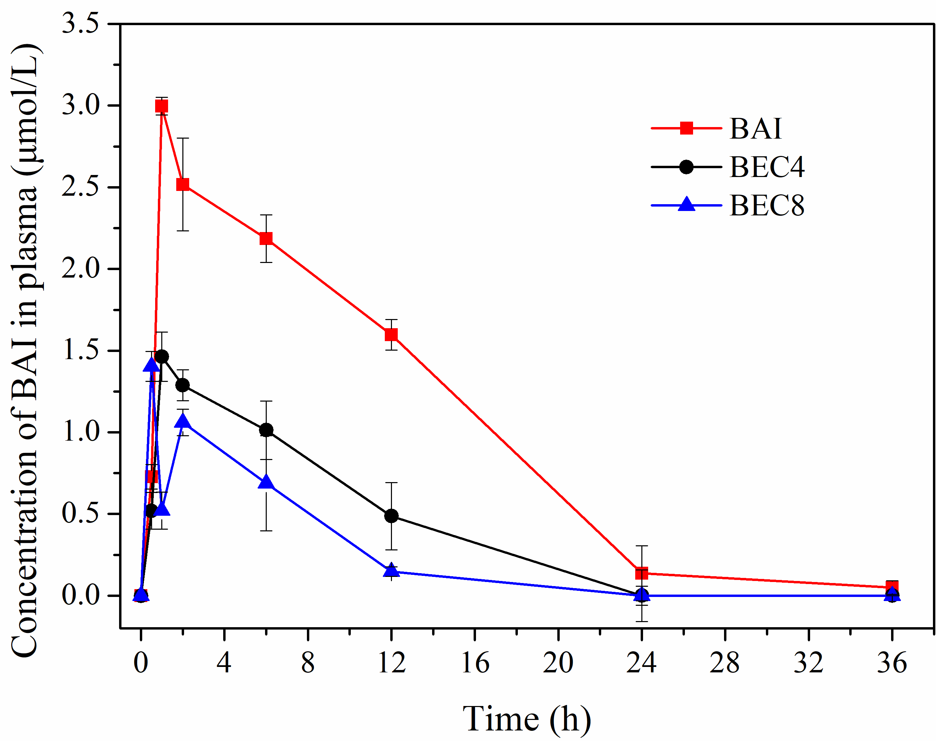
Figure S1. The plasma concentration-time curve of BAI (n=6)
As shown in Table S1 and Fig. S1, the C_{max} and AUC_{0-∞} values of BEC4 and BEC8 were significantly lower than that of BAI, indicated that the intestinal absorption of BEC4 and BEC8 in vivo was significantly lower than that of BAI.

