Structure and electrocatalytical properties of electrodeposited M-Ir (M=Co, Ni) bimetallic alloy catalysts with low Ir loading obtained on copper foams for hydrogen evolution reaction

Yicheng Zhou, Liu Ju, Yang Yang, Wangping Wu*

Electrochemistry and Corrosion Laboratory, School of Mechanical Engineering and Rail Transit, Changzhou University, Changzhou 213164, P.R. China

*Corresponding author: wwp3.14@163.com; wuwping@cczu.edu.cn

A conventional three-electrode cell was used for the electrodeposition of Ir, Ni and Co catalysts on the working electrode. The three electrodes consisted of a CF (10mm × 10mm × 3mm, porosity > 98%, Shenzhen Winfly New Material Co., LTD., Shenzhen, CN) as the working electrode, platinum foil as the counter-electrode, and a reference Ag/AgCl 3M KCl electrode. The current density was controlled by an electrochemical working station (CHI 660E, Chenhua Instrument, Shanghai, CN). The pH of the electrolyte was measured by a pH meter (PHS-3C) at deposition temperature and was adjusted by adding 5.0 M sodium hydroxide (NaOH) or 10% sulfuric acid (H₂SO₄) solution while being stirred. The bath temperature was controlled by a thermostatic bath (HH-501, JintanBaitaXinbao Instrument Factory, Changzhou, CN). The mass change was recorded by an analytical balance (FA2004B, resolution 0.1 mg, YoKe Instrument, Shanghai, CN). The bath chemistry and the process parameters for electrodeposited catalysts are shown in Table S1.
Table S1 Bath chemistry and process parameters for Ir, Ni and Co catalysts on CF
Samples | Na₃[Ir(III)Br₆]/mM | NiSO₄ /mM | CoSO₄/mM | pH | T /ºC | j/mA cm⁻² | t/min | ΔW/mg
Ir/CF | 26 | ---- | ---- | 2.5 | 80 | 20 | 5 | 1.1
Ni/CF | ---- | 40 | ---- | 4 | 50 | 30 | 5 | 2.8
Co/CF | ---- | ---- | 40 | 4 | 50 | 10 | 5 | 0.9

Voltammetric curves are recorded in a narrow potential range (a few tens of mV) at different scanning rates. The current in the middle of the potential range is then plotted as a function of the scanning rate.

Figure S1 CV curves of (a) Ni/CF, (b) Co/CF, (c) CF, (d) Ir/CF, (e) Co_{61.2}Ir_{38.8}/CF, (f) Ni_{61.8}Ir_{38.2}/CF catalysts with varied scanning rate in 1.0 M KOH solution.

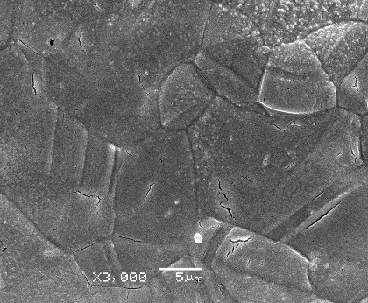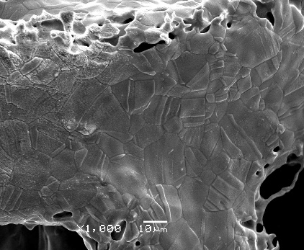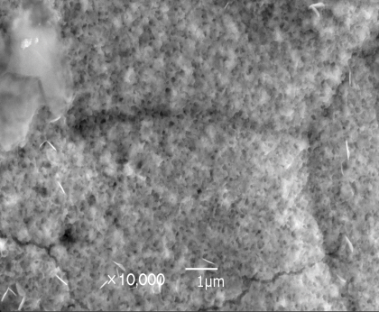
(c)
(b)
(a)
Figure S2 SEM images of samples, (a) Ir/CF, (b)Ni/CF, (c) Co/CF

