Supplementary Materials
Title: The impact on postoperative complications and analgesia of different nerve block techniques after hypospadias repair: a network meta-analysis
Journal: Scientific reports
Lan Feng^{1,3}, Jiang Zheng^{1,3}, Xiangqi Zheng^{2,3}, Yu Ma^{3*}, Hong Fu^{1,3*}
¹Department of Anesthesiology, Chongqing Emergency Medical Center, Chongqing University Central Hospital, School of Medicine, Chongqing University, Chongqing, China
²Department of Urology, Chongqing Emergency Medical Center, Chongqing University Central Hospital, School of Medicine, Chongqing University, Chongqing, China.
³Chongqing Emergency Medical Center, Chongqing University Central Hospital, School of Medicine, Chongqing University, Chongqing, China.
*Corresponding Authors
Hong Fu E-mail: fuhong1974@cqu.edu.cn; ORCID: 0000-0003-2863-3996
Yu Ma E-mail: 81846846@qq.com

Tables
Supplementary Table 1. Basic characteristics of literature included in meta-analysis.
Study | design | Sample size | Interventions (CB=Caudal block;PB=penile nerve block;PNB=pudendal nerve block) | comparator | Hypospadias type | Surgery | Primary Outcomes(PC=Postoperative complications;PA=  Postoperative urgent analgesics;) | Other outcomes
Naja2013 | RCT | 80 | CB(40): 0.25% bupivacaine 1mg/kg | PNB(40): 0.25% bupivacaine 0.75mg/kg | Subcoronal and distal hypospadia,mid-shaft and proximal hypospadia | Snodgrass technique | PA:28/12 vs 8/32 | OPS*: 3.5(2.5) vs 0.9(1.7); Paracetamol*: 16.1(3.2) vs 3.0(2.0)
Kendigelen2016 | RCT | 80 | CB(40): 0.25% bupivacaine 1.25mg/kg | PNB(40):0.2% bupivacaine 2mg/kg | Penoscrotal,Coronal,Midpenile,Subcoronal,Glanular | / | PA: 37/3 vs 2/38 | CHEOPS*: 9.5 (8-10) vs 6 (5-6)
Kundra2012 | RCT | 54 | CB(26): 0.25% bupivacaine 1.25 mg/kg | PB(27): 0.25% bupivacaine 0.5 mg/kg | Distal | Snodgrass urethroplasty,Snodgraft technique | PC: 5/21 vs 0/27;PA: 26/0 vs 27/0 | VAS*: 4.26(1.11) vs 3.70(1.43); morphine(mg)*: 1.28 ± 1.1 vs 0.5 ± 0.9
Seyedhejazi 2011 | RCT | 85 | CB(44)：0.25% bupivacaine 1 mg/kg | PB(41):0.5% bupivacaine 0.5mg/kg | distal penile, subcoronal and coronal type of hypospadias | Mathieu or Snodgrass repairs | PC: 0/44 vs 0/41;PA: 19/25 vs 29/12 | FLACC:/
Farshid Alizadeh2022 | RCT | 60 | CB (29):0.125% bupivacaine 0.5mg/kg | Control(31):/ | Distal,Proximal | All surgeries were performed by a single pediatric urologist. | PC: 7/22 vs 9/22 | /
Dinesh K Choudhry2022 | RCT | 57 | CB(27):0.2% Ropivacaine 2mg/kg | PNB(30):0.2% Ropivacaine 0.5 mg/kg | distal | post-tubularized incised plate (TIP) | PA: 4/23 vs 4/26 | FLACC: 0.7(1.1) vs 0.63(1.26)
Archna Koul2022 | RCT | 50 | CB(25):0.2% ropivacaine 2mg/kg | Control(25):/ | distal | / | PC: 1/24 vs 1/24;PA: 10/15 vs 25/0 | fentanyl*: 5.95 ±0.92 vs 17.00±7.77
Farshid Alizadeh2018 | RCT | 57 | CB(29):0.2% ropivacaine 2mg/kg | Control(28)：/ | distal | tubularised incised plate(TIP) urethroplasty | PC:7/22 vs 9/22 | fentanyl(ug)*: 25.34(10.93) vs 32.32(15.48)
Ahmed2021 | RCT | 50 | CB(25):0.25% bupivacaine 2.5mg/kg | PNB(25):0.25% bupivacaine 0.75mg/kg | Distal,Proximal,Mid-shaft | / | / | OPS*: 3.12 ± 1.51 vs 2.00 ± 1.47; acetaminophen(mg)*: 698.4 ± 312.67 vs 425.63 ± 175.03; Time to first analgesia(h)*: 10.56 ± 4.67 vs 18.5 ± 3.92
Alamzeb Khan 2016 | RCT | 26 | CB(13):0.25% Bupivacain 0.5mg/kg | PB(13):0.25% Bupivacain 0.5mg/kg | distal | post-tubularized incised plate (TIP) | PA: 2/11 vs 1/12 | VAS:/
Can Aksu2019 | RCT | 33 | PNB(16):0.25% Bupivacain 1.25mg/kg | PB(17):0.25% Bupivacain 1mg/kg | distal | tubularized incised plate hypospadias repair | PA: 7/9 vs 2/15 | FLACC*:2(1, 2.75) vs 1 (0,1); tramadol*: 2(2,3) vs 0(0, 0)
JC De Mey2010 | cohort | 60 | CB(27):0.2% ropivacaine 2mg/ kg | PB(33):0.5% bupivacaine 1mg/kg | distal penile, subcoronal and coronal type of hypospadia | Mathieu or Snodgrass techniques | PC: 15/12 vs 5/28;PA:0/27 vs 0/33 | VAS:/
Raza H. Zaidi2015 | case-control | 123 | CB(101):0.25% bupivacaine 4.75mg/kg | PB(22): 0.25% bupivacaine 4.75mg/kg | Distal,Midshaft,Proximal | Tubularized incised plate,Meatal advancement and glanuloplasty (MAGPI) | PC: 32/69 vs 9/13 | FLACC:/
M. H. Kim2016 | cohort | 342 | CB(216):0.15-0.2%ropivacaine 1.5-3.0mg/kg | Control(126):/ | Distal,Midshaft,Proximal | tubularised incised plate urethroplasty | PC:53/163 vs 19/107 | tramadol(mg): 42.5 (62.8) vs 48.6 (63.1)
McClelland2016 | cohort | 70 | CB(33):0.2% ropivacaine 2mg/kg | Control(37):/ | Distal | post-tubularized incised plate (TIP) | PC:4/29 vs 4/33 | /
Saavedra Belaunde2016 | cohort | 192 | CB(91):0.25% bupivacaine 2.5mg/kg | PB (101):0.25% bupivacaine 2.5mg/kg | glanular,coronal,subcoronal | Tubularized incised plate | PC: 10/81 vs 3/98 | /
Luis H.Braga 2017 | cohort | 518 | CB(367):0.25% bupivacaine 2.5mg/kg | PB (151):0.25% bupivacaine 2.5mg/kg | Distal,Midshaft,Proximal | post-tubularized incised plate (TIP) | PC: 32/335 vs 5/146 | /
B.M. Taicher 2017 | cohort | 395 | CB(230):0.25% bupivacaine 2-3mg/kg | PB(165):0.25% bupivacaine 2.5mg/kg | distal,proximal | hypospadias repairs performed by one surgeon (JSW) | PC: 21/209 vs 1/164 | /
Sarah Hecht2017 | cohort | 40 | CB(19):0.25% bupivacaine 2.5mg/kg | PB (21):0.25% bupivacaine 1.25mg/kg | distal,proximal | MAGPI,GAP,TIP | PC: 2/17 vs 3/18 | /
Splinter WM 2019 | cohort | 825 | CB(716):0.25% bupivacaine 2mg/kg | PB(94):0.25% bupivacaine 2mg/kg; control(15):/ | Coronal,Subcoronal,Distal,Mid shaft,Proximal | Snodgrass,Meatoplasty and Glanuloplasty | PC: 203/513 vs 29/65 vs 4/11 | /
Alexander Ngoo 2020 | cohort | 188 | CB(74):0.25% bupivacaine 2.5mg/kg | PB (114):0.25% bupivacaine 2.5mg/kg | Distal | TIP or Snodgrass Hypospadias Repair, MAGPI | PC: 7/67 vs 24/90 | /
Volkan Ozen 2020 | cohort | 26 | CB(13):0.25% Bupivacain 0.5mg/kg | PB(13): 0.25% Bupivacain 0.5mg/kg | Distal | post-tubularized incised plate (TIP) | PA: 12/1 vs 2/11 | CHEOPS*: 4.33(4-4.83) vs 4(4-4); Paracetamol(mg): 170±61.79 vs 120±0
Adler AC 2021 | cohort | 983 | CB(706):0.2% ropivacaine 2mg/kg | PB (191):0.2% ropivacaine 2mg/kg | distal,proximal | post-tubularized incised plate (TIP) | PC: 61/645 vs 25/166 | /
Jingqi Zhang 2021 | cohort | 246 | CB(130):0.2% ropivacaine 2mg/kg | Control(116):/ | distal | tubularized incised plate (TIP) repair | PC: 13/117 vs 17/99 | /
Karagozlu 2022 | cross-sectional | 279 | CB(95):0.25% bupivacaine 2.5mg/kg | PB (184):0.25% bupivacaine 1mg/kg | subcoronal | tubularized incised plate urethroplasty | PC: 10/85 vs 23/161 | /
YigitDogakan 2022 | cohort | 49 | CB(25):0.25% bupivacaine0.5mg/kg | PB(24):0.25% bupivacaine0.5mg/kg | distal | TIPU technique | PC:5/20 vs 1/23 | /
Volkan Ozen 2022 | cohort | 30 | PNB(15):0.25% bupivacaine0.5mg/kg; | PB(15):0.25% bupivacaine0.5mg/kg | distal | TIPU technique | PA: 4/11 vs 5/10 | CHEOPS: 4 (4-4) vs 4 (4-4); paracetamol(mg): 195 (180-345) vs 180 (157.5-270)
S Hakim1996 | cohort | 336 | CB (136): 0.25% bupivacaine0.5mg/kg | PB(200): 0.25% bupivacaine0.5mg/kg | distal | Mathieu repair | PC: 5/131 vs 6/194 | /
Ugras 2006 | cohort | 54 | CB(24): 0.25% bupivacaine0.5mg/kg | Control(30):/ | distal | Tubularized incised plate urethroplasty, Mathieu repair | PC: 9/15 vs 2/28 | /

Supplementary Table 2. Quality assessment of the included studies via the Newcastle-Ottawa Quality Assessment Scale.
Paper | Selectionª |  |  |  | Comparability^{b} |  | Outcome^{c} |  |  | Total
Adler AC at al 2021 | 1 | 1 | 1 | 1 |  |  | 1 | 1 | 1 | 7
Alexander Ngoo at al 2020 | 1 | 1 | 1 | 1 | 1 |  | 1 | 1 | 1 | 8
B.M. Taicher at al 2017 | 1 | 1 | 1 | 1 | 1 | 1 | 1 |  | 1 | 8
JC De Mey at al 2010 | 1 | 1 | 1 | 1 | 1 |  | 1 |  | 1 | 7
Jingqi Zhang at al 2021 | 1 | 1 | 1 | 1 | 1 | 1 | 1 |  | 1 | 8
Karagozlu Akgul A at al 2022 | 1 | 1 | 1 | 1 | 1 |  | 1 | 1 | 1 | 8
Luis H.Braga at al 2017 | 1 | 1 | 1 | 1 | 1 |  | 1 |  | 1 | 7
MH Kim at al 2016 | 1 | 1 | 1 | 1 | 1 |  | 1 |  | 1 | 7
McClelland at al 2016 | 1 | 1 | 1 | 1 |  | 1 | 1 | 1 | 1 | 8
Raza H Zaidi at al 2015 | 1 | 1 |  | 1 | 1 |  | 1 | 1 |  | 6
S Hakim at al 1996 |  |  | 1 | 1 | 1 |  | 1 |  | 1 | 6
Saavedra Belaunde at al 2016 | 1 | 1 | 1 | 1 |  |  | 1 | 1 | 1 | 7
Sarah Hecht at al 2017 | 1 | 1 | 1 | 1 |  | 1 | 1 |  | 1 | 7
Splinter WM at al 2019 | 1 | 1 | 1 | 1 |  |  | 1 |  | 1 | 6
Ugras at al 2006 | 1 | 1 | 1 | 1 |  |  | 1 |  | 1 | 6
Volkan Ozen at al 2020 | 1 | 1 | 1 | 1 | 1 | 1 | 1 |  | 1 | 8
Volkan Ozen at al 2022 | 1 | 1 | 1 | 1 | 1 | 1 | 1 |  | 1 | 8
Yigit Dogakan at al 2022 | 1 | 1 | 1 | 1 | 1 | 1 | 1 |  | 1 | 8

Figures
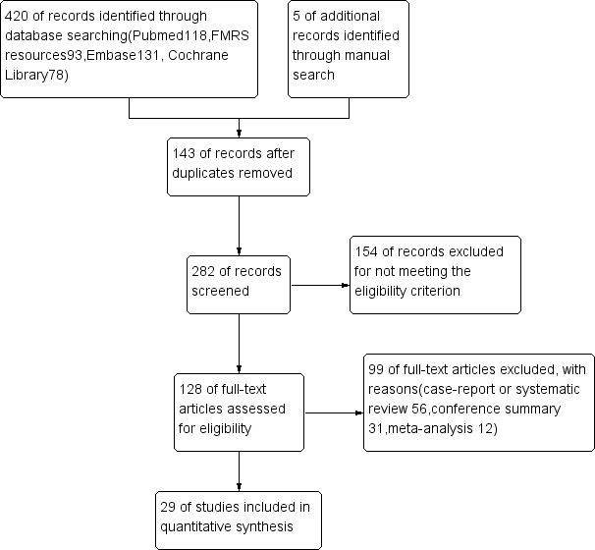
Supplementary Figure 1. Literature screening flow chart.

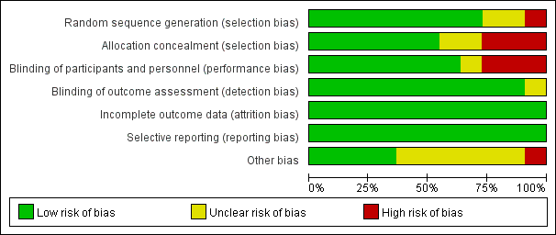
Supplementary Figure 2. Bias risk assessment of RCTs.

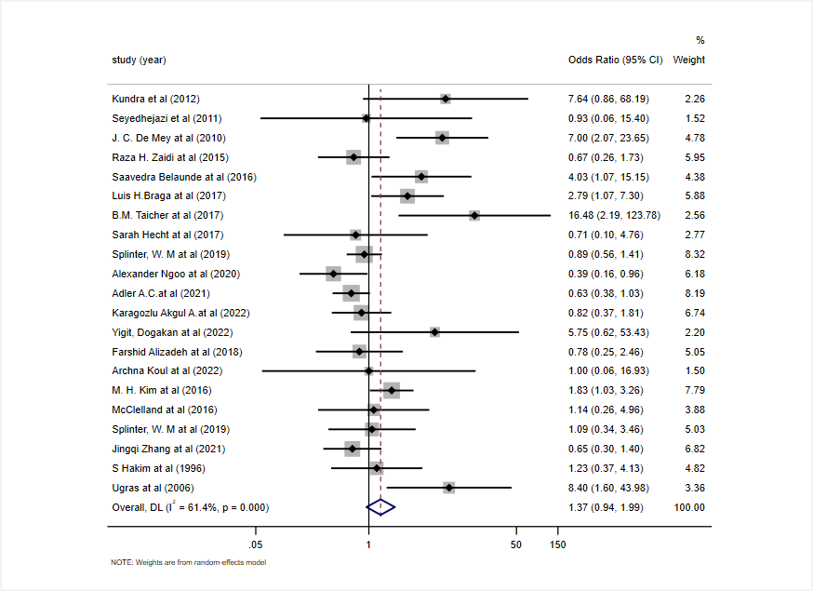
Supplementary Figure 3. Pairwise analysis for postoperative complications in CB versus NCB.

Supplementary Figure 4. The forest plot for postoperative complication in CB versus PB.

Supplementary Figure 5. The forest plot for postoperative complication in CB versus Control.

Supplementary Figure 6. Comparison-correction funnel plot of postoperative complications (A) and postoperative analgesia(B).

Supplementary Figure 7. Pairwise analysis for postoperative analgesia in CB versus NCB.

Supplementary Figure 8. Subgroup analysis for postoperative complication by study design.

Supplementary Figure 9. Subgroup analysis for postoperative complication by publication year.

Supplementary Figure 10. Sensitivity analysis for postoperative complication by ommiting each study.

Supplementary Figure 11. The forest plot for postoperative analgesia in CB versus PNB.

Supplementary Figure 12. The forest plot for postoperative analgesia in CB versus PB.

Supplementary Figure 13. The forest plot for postoperative analgesia in PB versus PNB.

Supplementary Figure 14. Subgroup analysis for postoperative analgesia by sample size.

Supplementary Figure 15. Sensitivity analysis for postoperative analgesia by ommiting each study.

