Supplementary Information

Harnessing Strong Aromatic Conjugation in Low-Dimensional Perovskite Heterojunctions for High-Performance Photovoltaic Devices

Bo Li^{1#}, Qi Liu^{2#}, Jianqiu Gong^{1#}, Shuai Li^{1#}, Chunlei Zhang^{1#}, Danpeng Gao¹, Zhongwei Chen³, Zhen Li¹, Xin Wu¹, Dan Zhao¹, Zexin Yu¹, Xintong Li¹, Yan Wang¹, Haipeng Lu^{3*}, Xiao Cheng Zeng^{2*}, Zonglong Zhu^{1*}

¹Department of Chemistry, City University of Hong Kong, Kowloon, Hong Kong, China

²Department of Materials Science & Engineering, City University of Hong Kong, Kowloon, Hong Kong, China

³Department of Chemistry, The Hong Kong University of Science and Technology, Clear Water Bay, Kowloon, Hong Kong, China

* Corresponding author’s email: zonglzhu@cityu.edu.hk, xzeng26@cityu.edu.hk, haipenglu@ust.hk

# These authors contributed equally

Keywords: p-i-n perovskite solar cells, strong aromatic conjunction, high efficiency, stability.

Materials and Methods
Materials
Formamidinium iodide (FAI), methylammonium bromide (MABr), methylammonium chloride (MACl) and cesium iodide (CsI) were purchased from Dysol (Australia). Lead iodide (PbI₂), lead bromide (PbBr₂) and [2-(3,6-Dimethoxy-9H-carbazol-9-yl)ethyl]phosphonic Acid (MeO-2PACz) were purchased from TCI (Japan). C₆₀, bathocuproine (BCP, purity of 99.9%) and (R)-(+)-α-methylbenzylamine iodide (R-MBAI) were purchased from Xi’an Polymer Light Technology Corporation (China). Nickel oxide particle (NiO_{x}) was purchased from Advanced Election Technology Co., Ltd (China), the average nanoparticle size is 7 nm. Solvents, including dimethylformamide (DMF), dimethyl sulfoxide (DMSO), isopropanol (IPA) and chlorobenzene (CB) were purchased from J&K (China) and used as received. 4,4-bipyridine (C₁₀H₈N₂, 98%) was purchased from Aladdin. High purity silver was purchased from commercial sources. was purchased from TCI (Japan). Glass substrates patterned with indium tin oxide (ITO) (15 Ω sq⁻¹) were received from Mishi Tech. Co., Ltd. (China).

Single crystal growth
For synthesis of MVPb₂I₆ and MBAPbI₃: PbI₂ (272 mg) and MVI₂ (128 mg) or MBAI (71.5 mg) were dissolved in DMSO (3 mL) and stirred overnight at 50 °C. The turbid crimson liquid was filtered and transferred into a 4 mL vial. The vial was then placed into a sealed bottle filled with 2 mL CB. The single crystals were grown along with the slow diffusion of the vapor of the antisolvent CB into the solution. The MVI₂ was prepared according to the reported method.¹

LD perovskite film fabrication
MVPb₂I₆: 38 mg MVI₂ and 81 mg PbI₂ were dissolved in 1 ml DMSO and filtered to obtain a clear solution. Before spin-coating, the substrate and solution were preheated on a hot plate at 70°C for 5 minutes. The solution was then immediately spin-coated onto the substrate at 3000 rpm for 30 s, and the resulting film was annealed at 150 °C for 10 min.

MBAPbI₃: 21.3 mg MBAI and 81 mg PbI₂ were dissolved in 1 ml DMSO. Before spin-coating, the substrate and solution were preheated on a hot plate at 70°C for 5 minutes. The solution was then immediately spin-coated onto the substrate at 3000 rpm for 30 s, and the resulting film was annealed at 100 °C for 10 min.

Device fabrication
ITO substrates were sequentially cleaned with detergent, deionized water, acetone and isopropyl alcohol under ultrasonication for 20 min, respectively. Then, the ITO substrates were dried and treated with oxygen plasma for 20 min. NiO_{x} was dispersed in DI water with a concentration of 10 mg/mL by ultrasonication for 10 min and filtered before using. 50 μL NiO_{x} solution was spin-coated onto ITO substrates at 4000 rpm for 30 s, annealed at 150 ℃ for 20 min in ambient atmosphere, and then transferred into a N₂-filled glovebox. 0.3 mg/mL Meo-2PACz was dissolved in EtOH. 80 μL as-prepared Meo-2PACz solution was spin-coated onto the NiO_{x} layer and annealed on a hotplate at 100 ℃ for 10 min.

For the control perovskite. The perovskite solution (1.73 M) was prepared by mixing CsI, FAI, MABr, PbI₂ and PbBr₂ in 1 ml mixed DMF:DMSO (5:1/v:v) solvent for a chemical formula (FA_{0.98}MA_{0.02})_{0.95}Cs_{0.05}Pb(I_{0.98}Br_{0.02})₃, 5 mol% of excess PbI₂ was needed to improve the device performance. Then 15.5 mol% MACl was added to the perovskite precursor solution and stirred for 2 h. 80 μL perovskite solutions were spin-coated onto ITO/MeO-2PACz at 1000 rpm for 10 s, subsequently at 5000 rpm for 40 s. 350 μL CB was dripped onto the center of film at 12 s before the end of spin-coating. The deposited perovskite films were subsequently annealed on a hotplate at 100 ℃ for 20 min.

For the MV and MBA based LD/3D perovskite. The spin-coating processes were all conducted at room temperature in a N₂-filled glovebox with the contents of O₂ and H₂O < 10 ppm. MVI₂ and MBAI are spin-coated onto perovskite in the same way. They are dissolved in a mixed solution of Methanol and DMF (150:1) at a certain concentration, and heated to 60 ℃ for 20 min until the solution became clear. 80 μL as-prepared MVI₂ or MBAI solution was spin-coated onto the perovskite at 5000 rpm for 30 s, and annealed on a hotplate at 100 ℃ for 10 min.

Finally, 20 nm C60 at a rate of 0.5 Å s⁻¹, 6 nm BCP a rate of 0.5 Å s⁻¹ and 100 nm silver electrode a rate of 1.0 Å s⁻¹ were thermally evaporated, respectively, under high vacuum (< 4 × 10⁻⁶ Torr).

Characterization
Surface and cross-section morphologies of the perovskite films were examined using scanning electron microscopy (SEM) on a QUATTROS instrument from Thermal Fisher Scientific. X-ray diffraction (XRD) measurements were performed using X-ray diffractometer (Rigaku SmartLab system) with Cu Kα radiation. X-ray photoelectron spectroscopy (XPS) measurements were performed using an AXIS Supra XPS system. Steady-state and time-resolved photoluminescence (PL) spectra were obtained using an Edinburgh FLS980 instrument with an excitation wavelength of 485 nm. Ultraviolet-visible (UV-vis) absorption spectra were recorded using a Perkin Elmer model Lambda 2S spectrometer. The film thickness was measured using a DektakXT stylus profiler. All atomic force microscopy (AFM)-based characterizations, including conductive AFM and Kelvin probe force microscopy, were conducted using a SHIMADZU SPM-9700HT system. The tDOS was obtained from the thermal admittance spectroscopy (TAS) on an LCR meter (Agilent E4980A).The photovoltaic performance of the perovskite solar cells was evaluated using a Xenon lamp solar simulator (Enlitech, SS-F5, Taiwan) in a N₂-filled glovebox at room temperature. The light intensity was calibrated to 100 mW cm⁻² using a silicon reference cell with a KG2 filter. Prior to the J-V measurements, a 120-nm thick magnesium fluoride layer was deposited on the back of the ITO substrate to enhance transmittance. J-V curves were acquired using a Keithley 2400 source meter under a reverse scan sweep mode (from 1.20 V to -0.01 V) and a forward scan sweep mode (from -0.01 V to 1.20 V), with a scan rate of 0.01 V s-1 and a delay time of 10 ms. The active area of the devices was defined as 0.0414 cm² for small-area devices using a metal shadow mask. The stabilized power output (SPO) was determined by monitoring the stabilized current density output at the maximum power point (MPP) bias, which was extracted from the reverse scan J-V curves. External quantum efficiency (EQE) measurements were performed using a QE-R EQE system (Enlitech, Taiwan)

Stability tests.
The ISOS-L-1I stability was conducted by applying the perovskite solar cells under a 1 sun equivalent LED lamp in a N₂-filled glovebox (with the contents of O₂ and H₂O <10 ppm) at room temperature. The PSCs were biased at maximum-power-point (MPP) voltage and the power output was tracked by using a multi-potentiostat (CHI1040C, CH Instruments, Inc.). During the MPP test, the current density-voltage (J-V) curves of the devices were obtained every 12 h to get the proper loads for the MPP. The ISOS-D-1 stability was conducted to study the evolution of normalized PCE for non-encapsulated solar cells aged at room temperature of RH of 20-40% in the dark.

Density functional theory (DFT) calculations.
The first-principles DFT simulations were performed with the Vienna Ab Initio Simulation Package (VASP 6.4) ²⁻⁴ to study the geometric and electronic structures of all the perovskite series. Unless otherwise specified, the projector augmented wave (PAW) pseudopotentials with the cutoff energy of 600 eV were employed.³ The generalized gradient approximation (GGA) exchange-correlation functional of Perdew-Burke-Ernzerhof (PBE) was adopted in the DFT calculations.⁴ The spin-orbit coupling (SOC) effect was adopted in the electronic structure calculations of the perovskite frameworks. The electronic constituents are 5d 6s 6p for Pb, 5p 6s for I, 2s 2p for C and N, and 1s for H. For the 2D perovskite structures, we adopted a 3 × 3 × 1 Γ-centered k-point grid, generated by the Monkhorst-Pack scheme, for detailed properties obtained with PBE functional. Considering the interaction between the hydrogen atoms and high-electronegativity groups, the PBE with the DFT-D3 dispersion correction of Grimme with zero-damping was applied to optimize the geometric structures.⁵⁻⁷ During the optimization of the geometries, all structures were allowed to relax to ensure that each atom was in mechanical equilibrium without any residual force larger than 10⁻⁴ eV/Å.

Supplementary Text
Supplementary Text 1: Space charge limited current (SCLC) measurements
The electron-only devices in Supplementary Fig. 13 were prepared to calculate the defect densities and carrier mobilities. In the SCLC regime, the current is dominated by charge carriers injected from the contacts and the current-voltage characteristics become quadratic (I~V²). Supplementary Fig. 13 shows the J-V curves of the fabricated devices on a double logarithmic scale, which comprises the Ohmic region, the trap-filling limit (TFL) region and the Child region. In the TFL region, the trap-state density (N_{t}) can be calculated by the following equation：
${ N}_{t}=\frac{2εε_{0}V_{TFL}}{qL^{2}}$ …. (S1)
where ε and ε₀ are the relative dielectric constant and vacuum permittivity, respectively. V_{TFL} is the onset voltage of TFL region, q is elementary charge. In the child regime, the carrier mobility is evaluated using the Mott-Gurney law:
μ=$\frac{8J_{D}L^{3}}{9εε_{0}V^{2}}$ …. (S2)
where J_{D} is the current density and L is the crystal thickness.

Supplementary Text 2: Light intensity dependent open-circuit voltage (V_{OC}) measurements
The ideality factor (n) can be extracted according to V_{OC}(P) = nkT/q·ln(P) + C, where T is the absolute temperature, P is the incident light intensity, q is the elementary charge, C is a constant, k is the Boltzmann constant, and T is the absolute temperature. In general, an ideality factor of 1 is associated to bimolecular bond-to-bond radiative recombination of carriers or dominating Shockley–Read–Hall (SRH) trap-assisted recombination with one pinned charge carrier density, while an ideality factor of 2 is associated with dominated SRH recombination without pinning of one charge carrier density.

Supplementary Text 3: V_{OC} loss analysis
The detailed V_{OC,loss} can be described by the equation listed below:
$$q∆V=E_{g}-{qV}_{OC}$$
$$=\left(E_{g}-{qV}_{OC}^{SQ}\right)+\left({qV}_{OC}^{SQ}-qV_{OC}^{rad}\right)+(qV_{OC}^{rad}-{qV}_{OC})$$
$$=\left(E_{g}-{qV}_{OC}^{SQ}+{q∆V}_{OC}^{SQ}\right)+∆qV_{OC}^{rad}+∆qV_{OC}^{non-rad}$$
$$=q\left(∆V_{1}+∆V_{2}+∆V_{3}\right)⋯ (S3)$$
where q, $∆$V, E_{g} is the elementary charge, the total voltage loss, and the bandgap of perovskite, respectively. V_{OC}^{SQ} is the S-Q limit of open circuit voltage, V_{OC}^{rad} is the V_{OC} without non-radiative recombination occurring in PSCs, $∆$V_{OC}^{SQ} is the V_{OC} loss due to the non-ideal EQE above the bandgap, $∆$V_{OC}^{rad} is the V_{OC} loss due to the sub-bandgap radiative recombination, and $∆$V_{OC}^{non-rad} is the V_{OC} loss of non-radiative recombination. The calculation method was following detailed balance theory. Therefore, the energy loss can be divided into three parts, ΔV₁, ΔV₂ and ΔV₃, which represent radiative recombination above E_{g}, energy loss from blackbody radiation and voltage loss induced by the nonradiative recombination, respectively.

Supplementary Text 4: fill factor (FF) loss analysis
The FF losses in high-performing PSCs are determined by two main factors, non-radiative loss and charge transport loss. The maximum FF (FF_{max}) can be empirically calculated according to the following equation:
$${FF}_{max}=\frac{ν_{OC}-ln⁡(ν_{OC}+0.72)}{ν_{OC}+1}⋯(S4)$$
where $ν_{OC}=\frac{V_{OC}}{nK_{B}T/q}$ (n is ideality factor, K_{B} is Boltzmann constant, T is temperature, q is elementary charge). The ideality factors were extracted from the V_{OC} as a function of light intensity on a logarithmic scale, which were shown in Fig. 4g.

Supplementary Figures
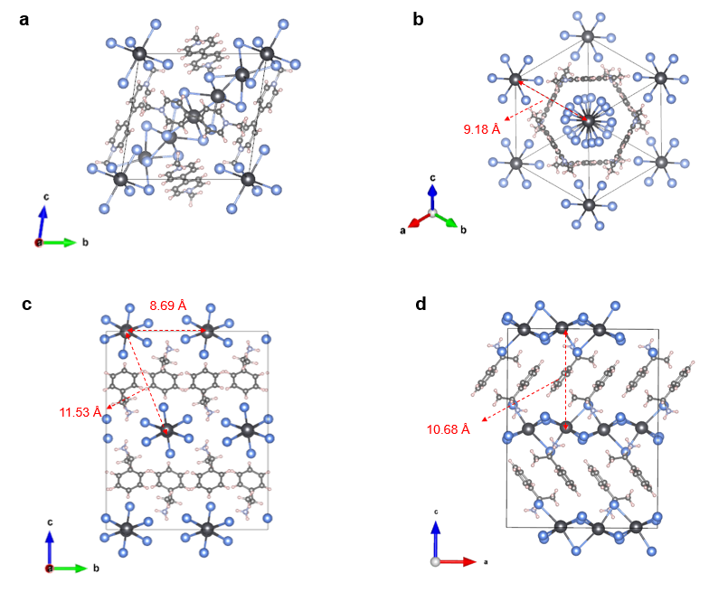
Supplementary Fig. 1 Crystal structure of 1D (a and b) MVPb₂I₆ and (c and d) MBAPbI₃ perovskite.

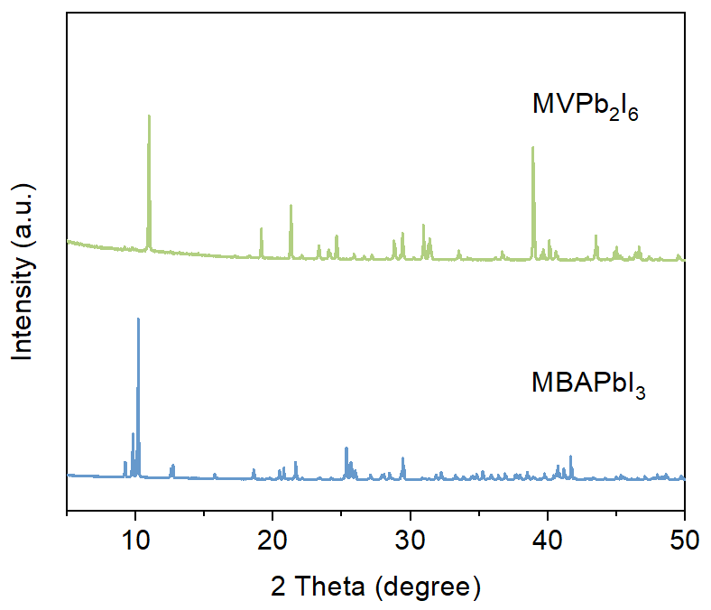
Supplementary Fig. 2 XRD patterns of 1D MBAPbI₃ and MVPb₂I₆ single crystals.

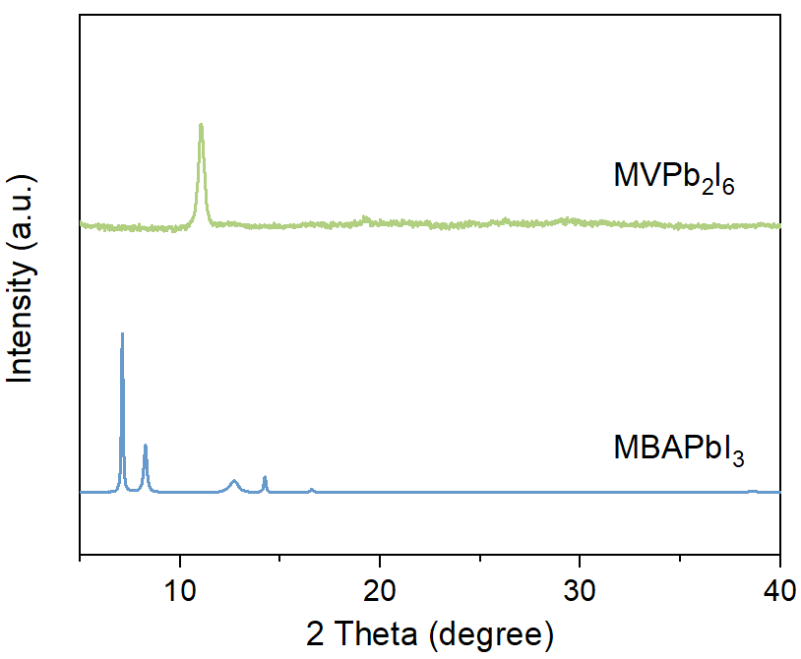
Supplementary Fig. 3 XRD patterns of 1D MBAPbI₃ and MVPb₂I₆ perovskite films.

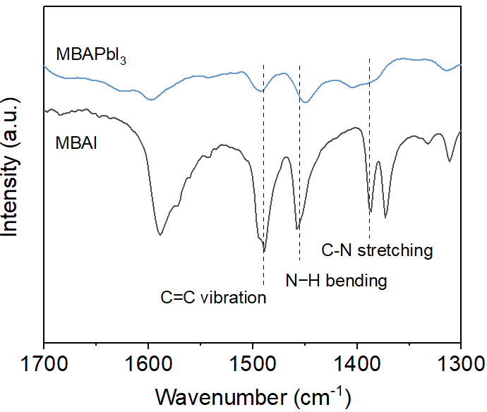
Supplementary Fig. 4 FTIR spectra of MBAI and 1D MBAPbI₃.

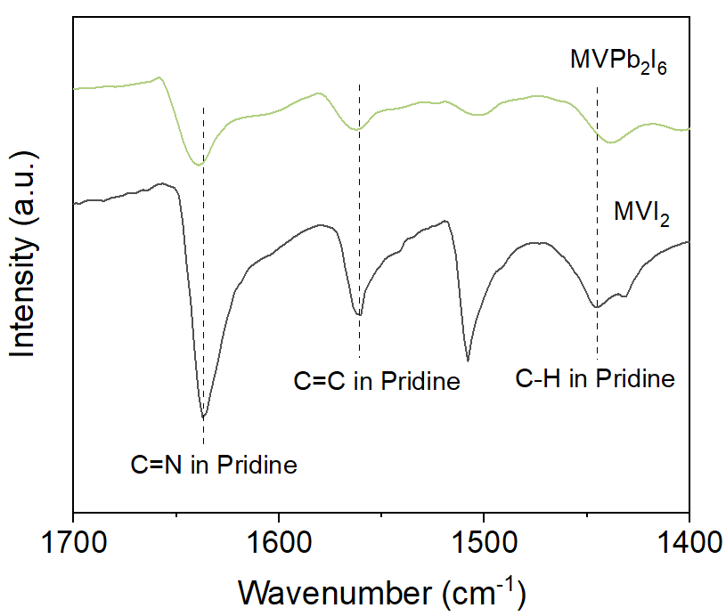
Supplementary Fig. 5 FTIR spectra of MVI₂ and 1D MVPb₂I₆.

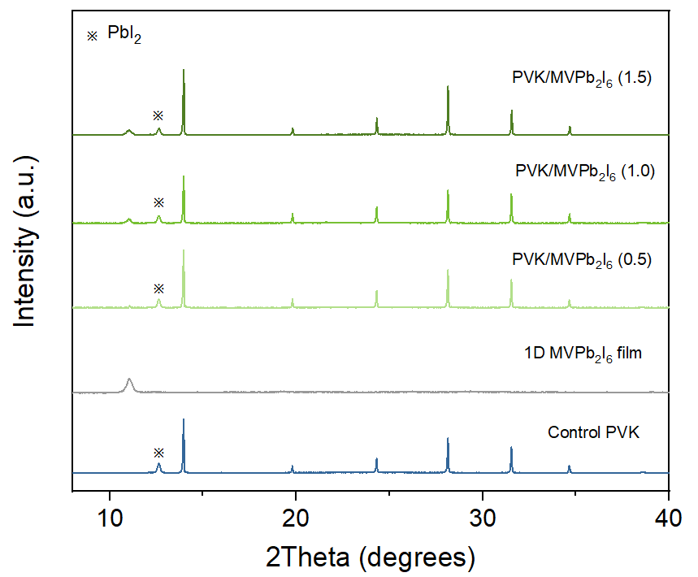
Supplementary Fig. 6 XRD patterns of control perovskite and 1D/3D perovskite films treated with 0.5, 1.0 and 2.0 mg/mL MVI₂ solution concentrations.

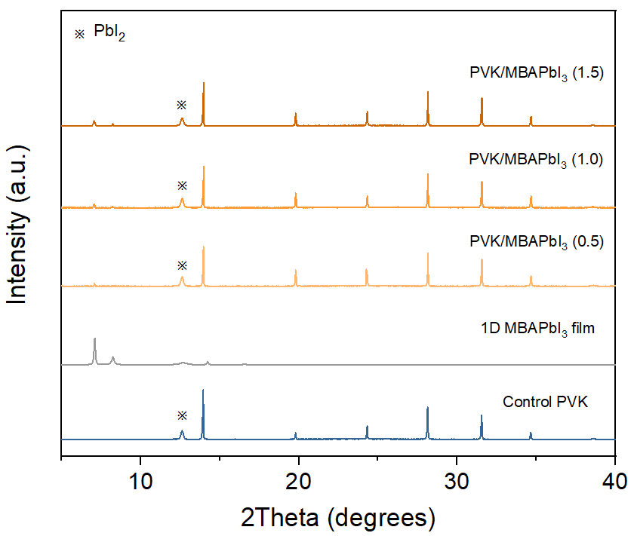
Supplementary Fig. 7 XRD patterns of control perovskite and 1D/3D perovskite films treated with 0.5, 1.0 and 2.0 mg/mL MBAI solution concentrations.

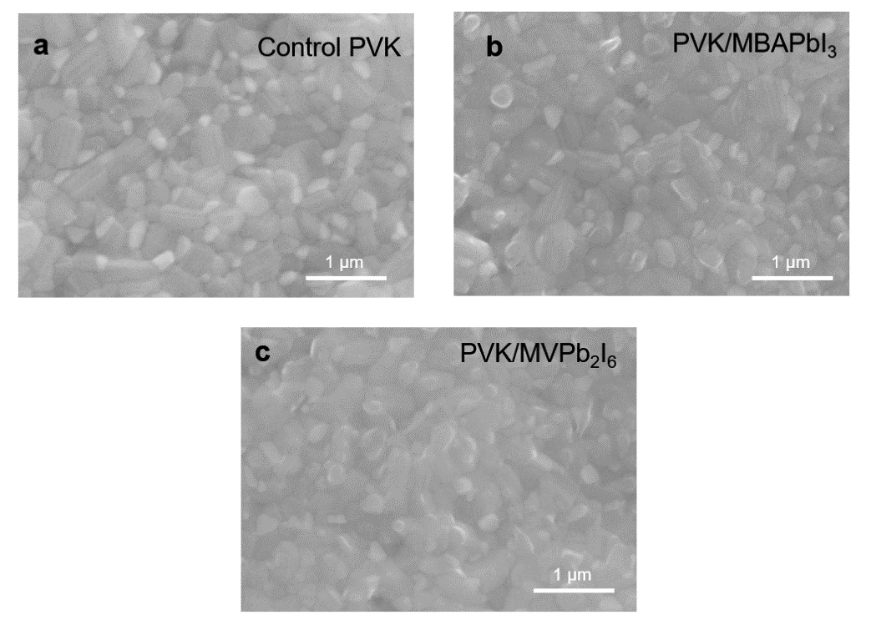
Supplementary Fig. 8 SEM images of control perovskite and 1D/3D perovskite films.

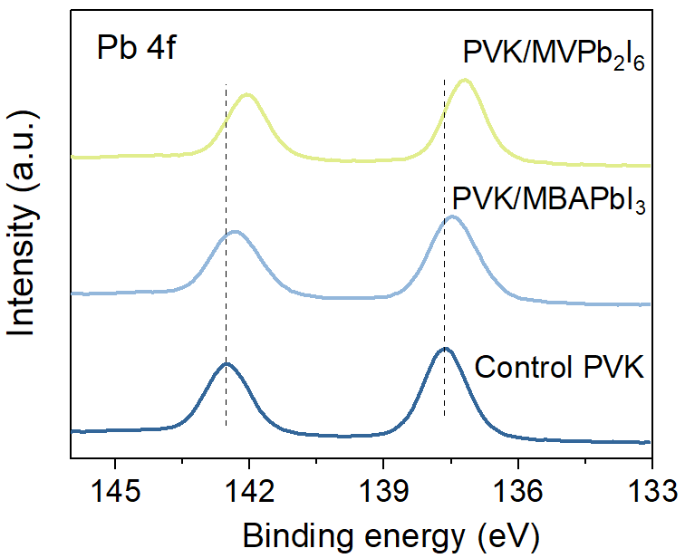
Supplementary Fig. 9 XPS for Pb 4f in control perovskite film and LD/3D perovskite films.

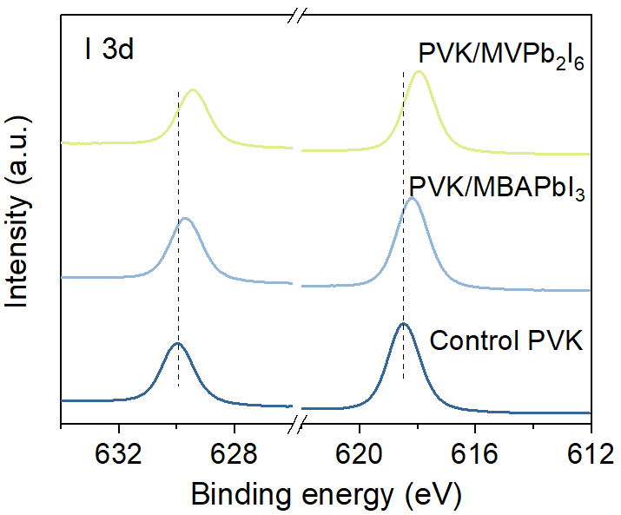
Supplementary Fig. 10 XPS for I 3d in control perovskite film and LD/3D perovskite films.

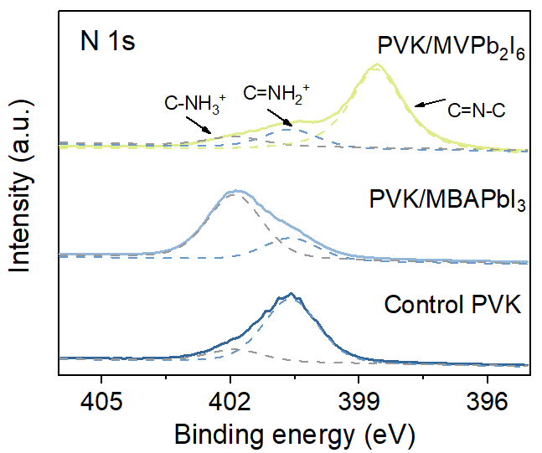
Supplementary Fig. 11 XPS for N 1s in control perovskite film and LD/3D perovskite films.

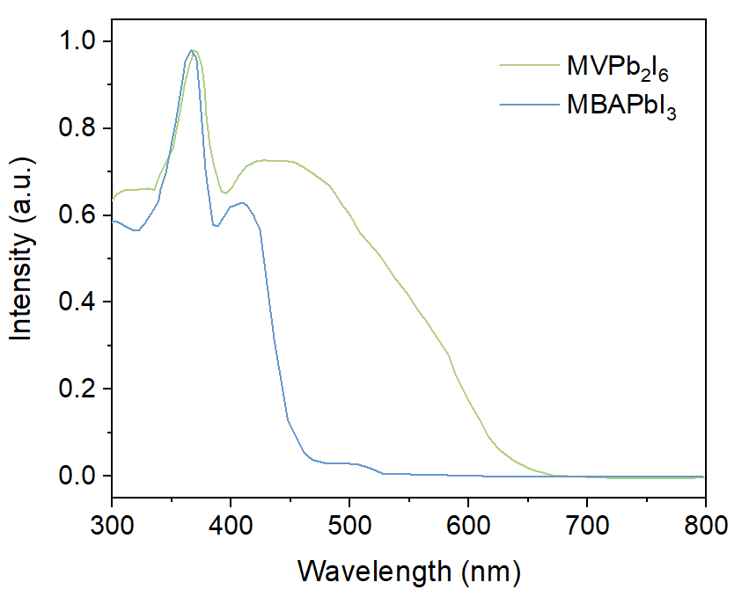
Supplementary Fig. 12 UV-vis spectra of 1D MBAPbI₃ and MVPb₂I₆ perovskite single crystals

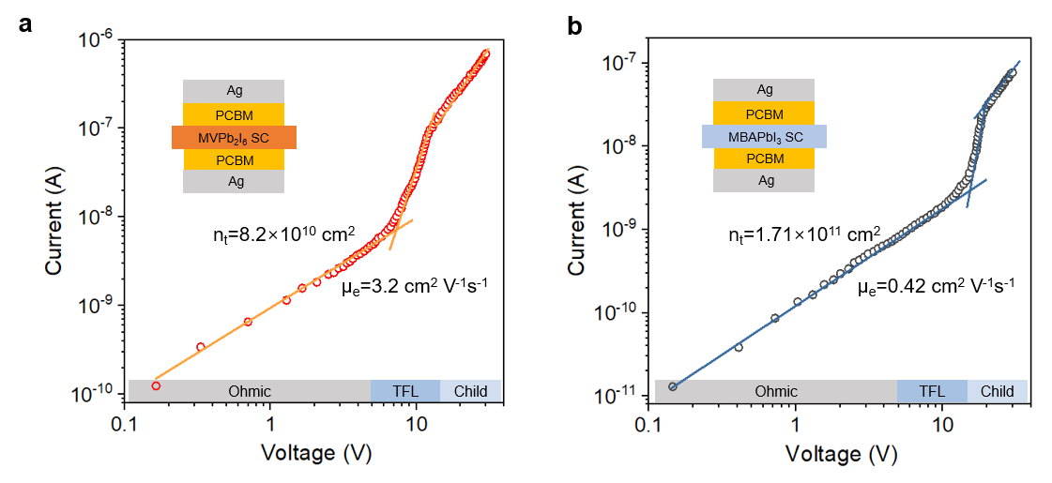
Supplementary Fig. 13 Current-voltage curves of electron devices of (a) MVPb₂I₆ SCs and (b) MBAPbI₃ SCs, respectively. Solid lines are obtained by fitting the data.

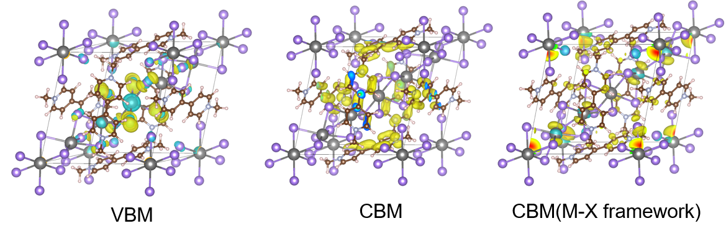
Supplementary Fig. 14 DFT results showing the CBM and VBM of 1D MVPb₂I₆

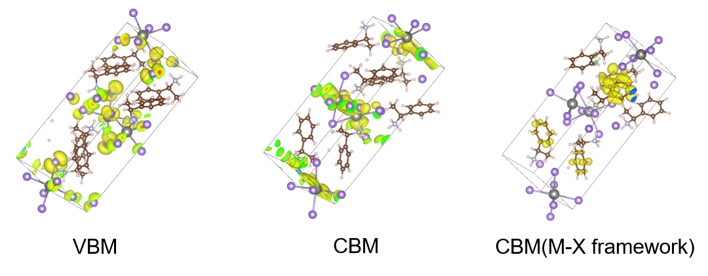
Supplementary Fig. 15 DFT results showing the CBM and VBM of 1D MBAPbI₃
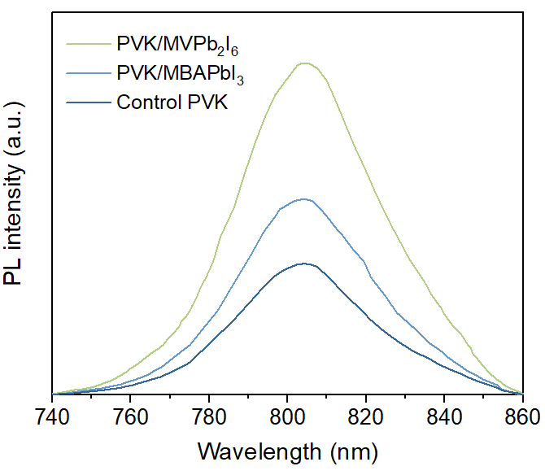
Supplementary Fig. 16 PL spectra of the control perovskite film, perovskite/MBAPbI₃ film and perovskite/MVPb₂I₆ film.

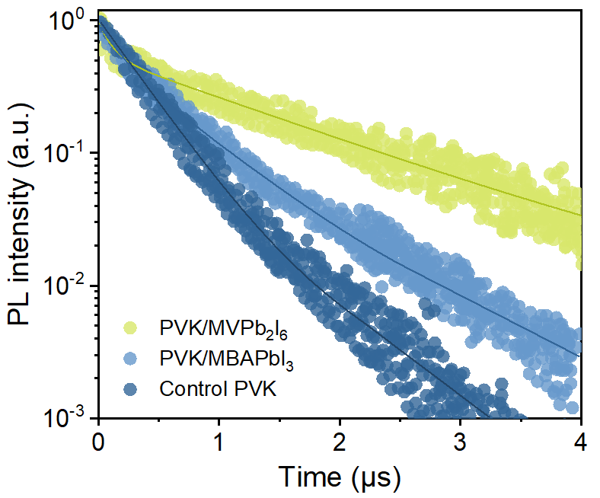
Supplementary Fig. 17 TRPL spectra of the control perovskite film, perovskite/MBAPbI₃ film and perovskite/MVPb₂I₆ film.

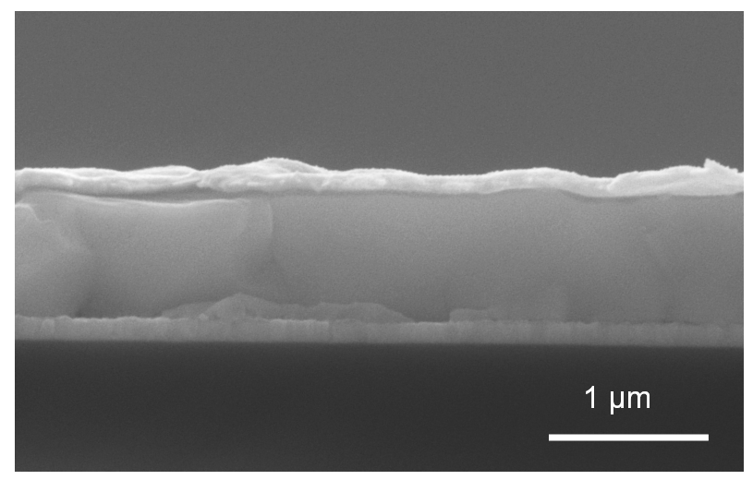
Supplementary Fig. 18 SEM images of 1D/3D MVPb₂I₆ based perovskite solar cells.

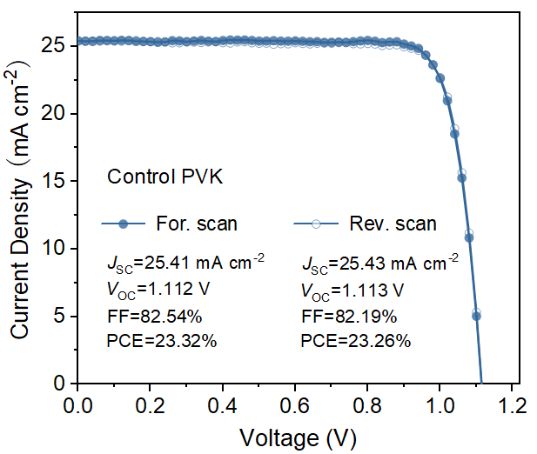
Supplementary Fig. 19 Forward and Reverse scan of the best performing devices based on control PVK.

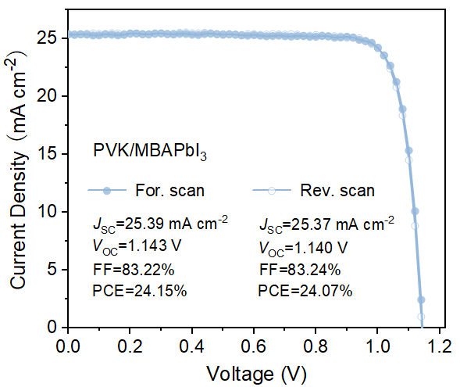
Supplementary Fig. 20 Forward and Reverse scan of the best performing devices based on PVK/MBAPbI₃.

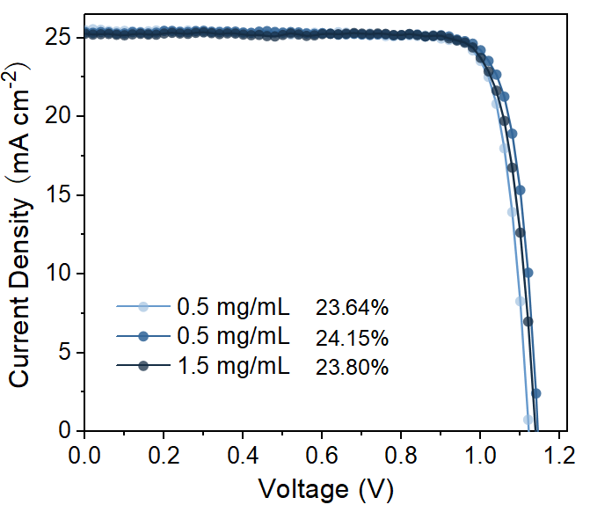
Supplementary Fig. 21 J-V curves of best-performing PSCs modified with different concentrations of MBAI.

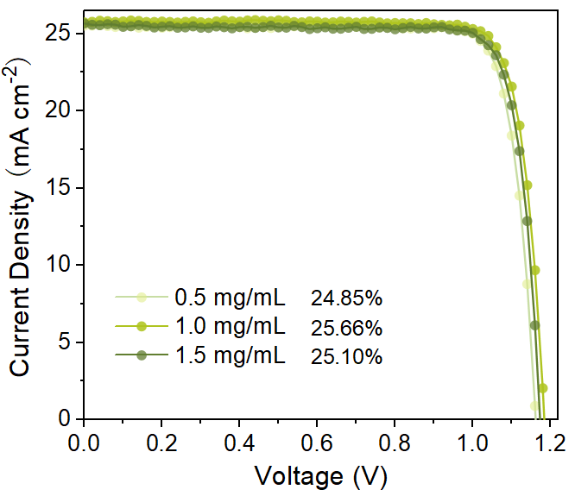
Supplementary Fig. 22 Photovoltaic parameters of best-performing PSCs modified with different concentrations of MVI₂.

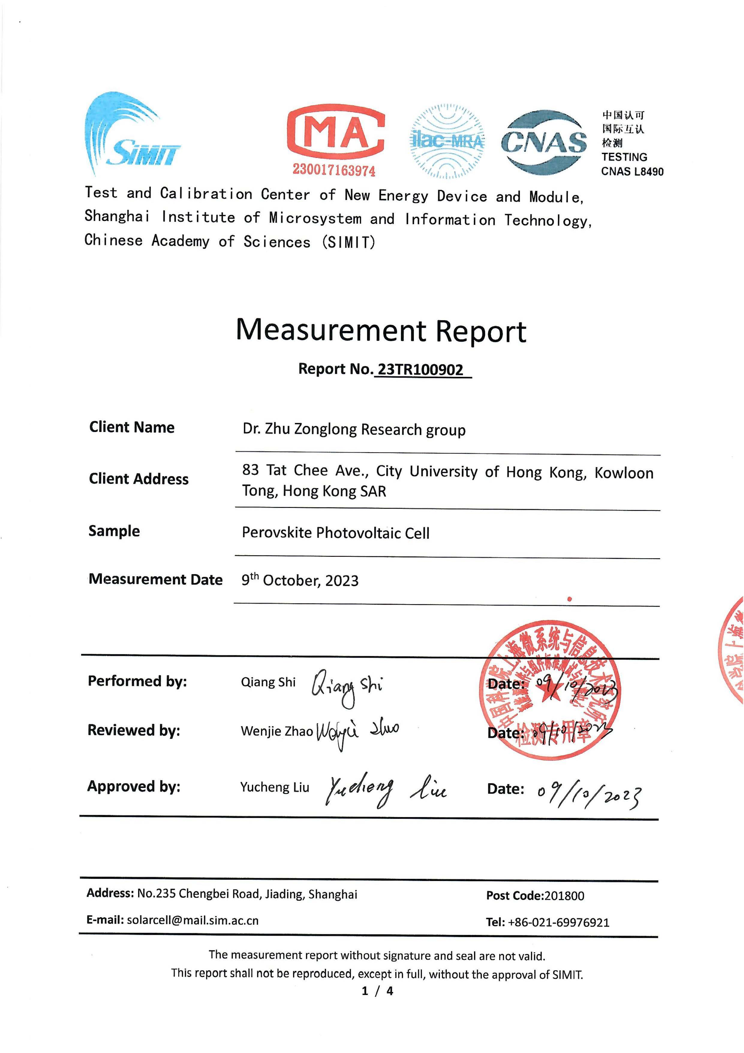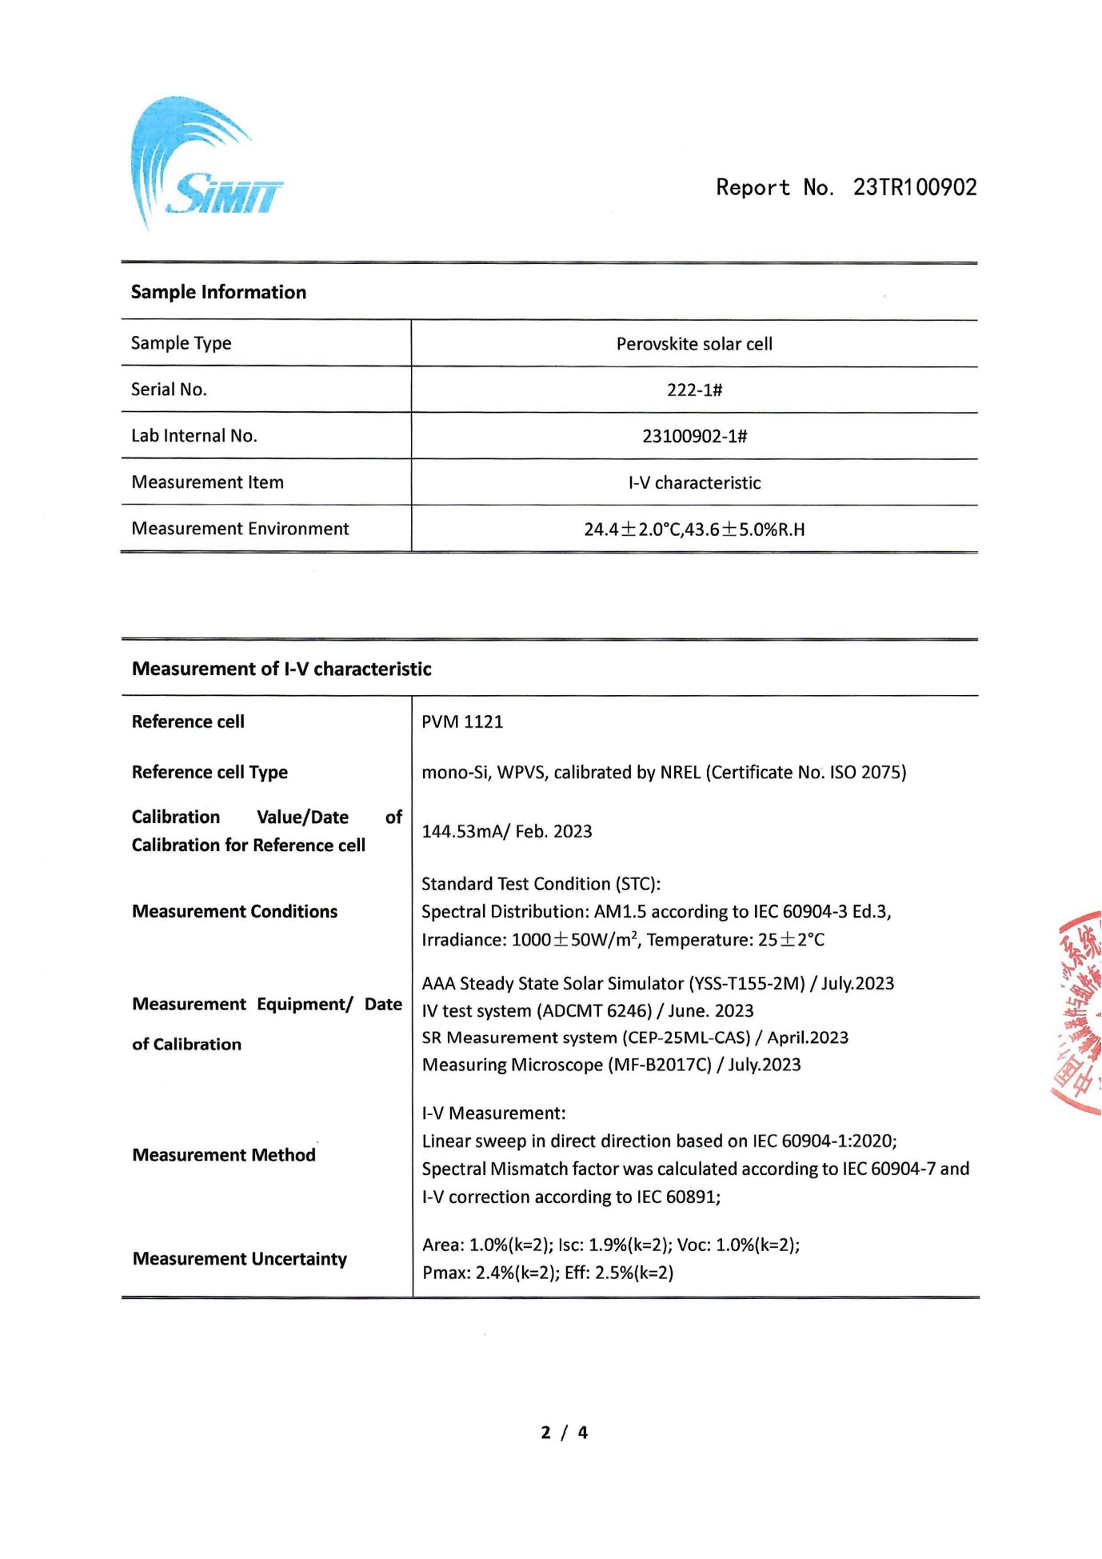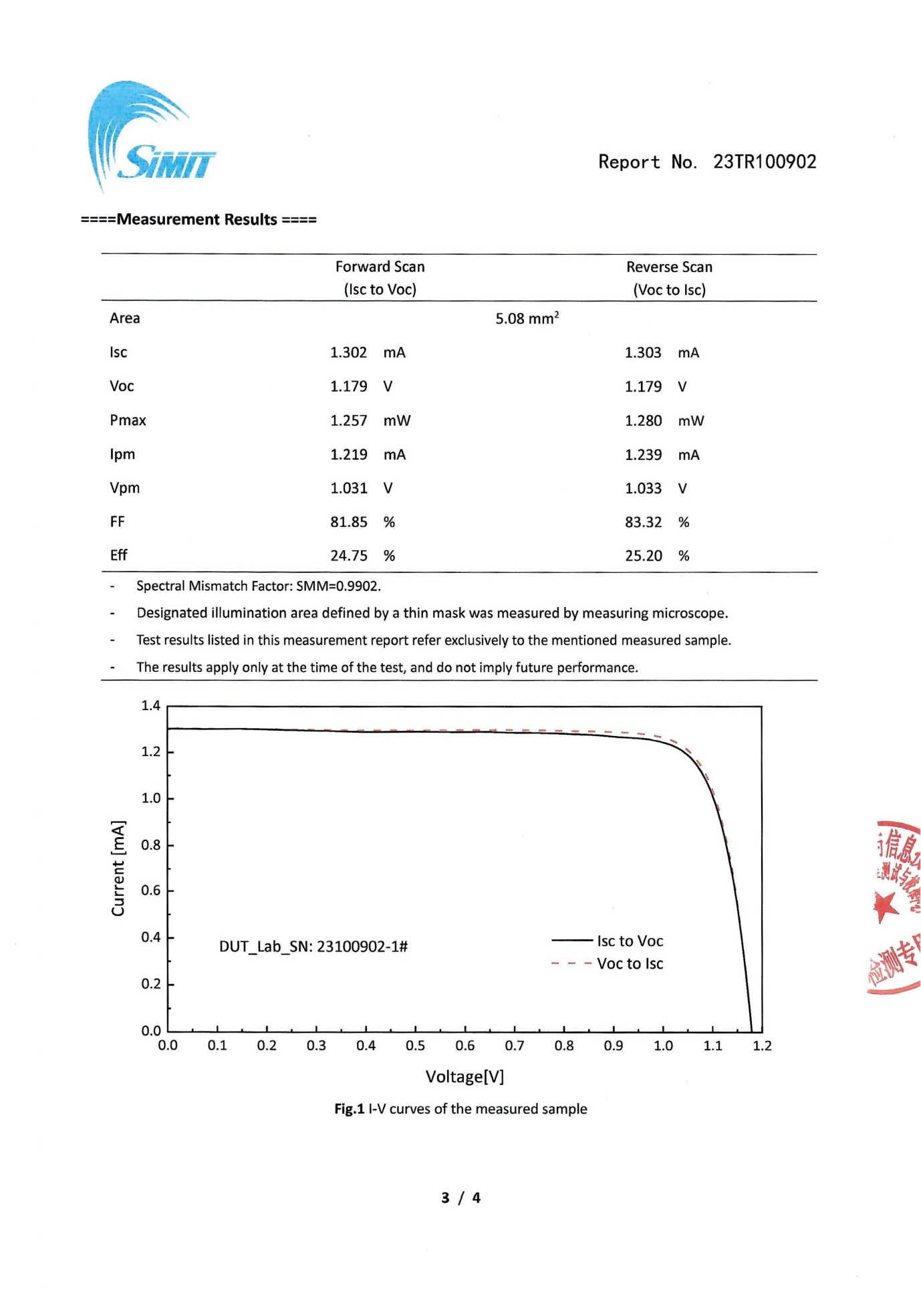
Supplementary Fig. 23 Independent efficiency certification of PVK/MVPb₂I₆ based solar cells by an accredited institute of Shanghai Institute of Microsystem and Information Technology, Chinese Academy of Sciences (SIMIT).

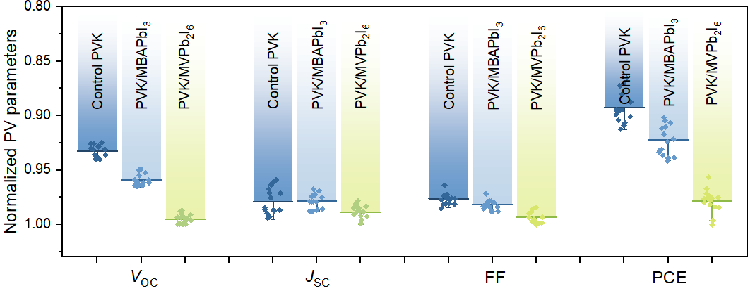
Supplementary Fig. 24 Photovoltaic parameters of 15 individual devices with different heterostructures. The scatter points represent the parameters of each device, and the histogram is the average value. Data are normalized to the highest value of each parameter.

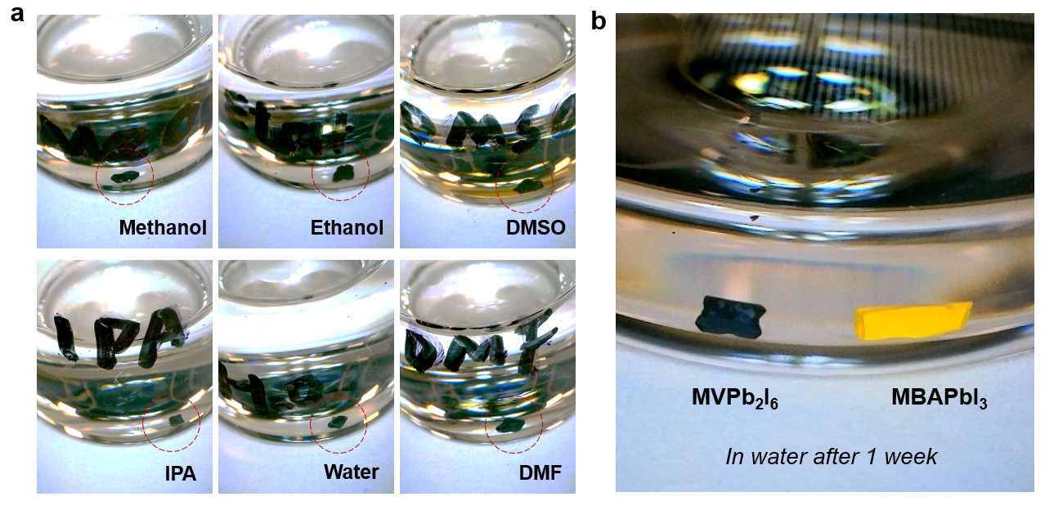
Supplementary Fig. 25 (a) Photos of the stability of the MVPb₂I₆ single crystals measured in different polar solvent and (b) comparison with MBAPbI₃ single crystals stored in water for 1 week.
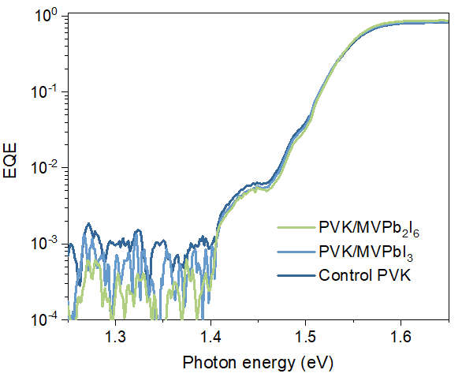
Supplementary Fig. 26 Sensitive-EQE curves of PSCs based on the control, PVK/MBAPbI₃ and PVK/MVPb₂I₆.

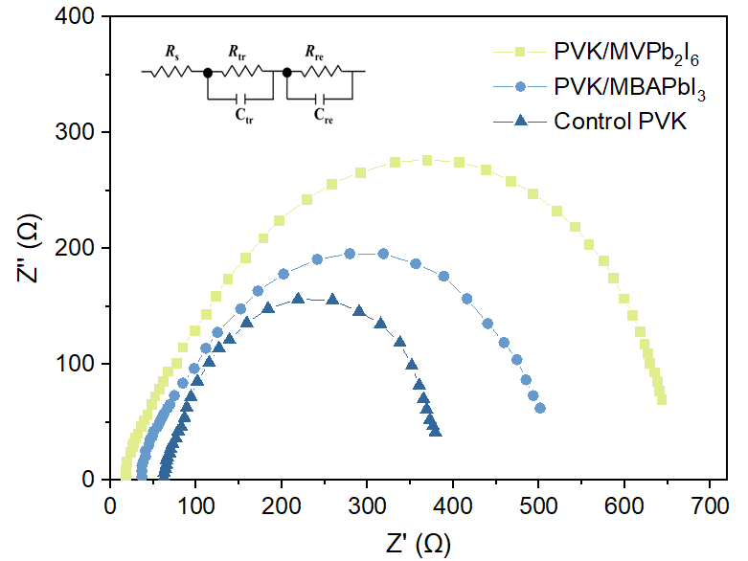
Supplementary Fig. 27 EIS spectra of PSCs based on the control the control, PVK/MBAPbI₃ and PVK/MVPb₂I₆.

Table S1. Fitting results of TRPL for the control perovskite film, perovskite/MBAPbI₃ film and perovskite/MVPb₂I₆ film. Bi-exponential fitting method with the equation y(t) = A₁exp(-t/τ₁)+A₂exp(-t/τ₂)+y₀ was used. The average lifetime can be calculated with the equation 𝜏_{𝑎𝑣𝑔} = (𝐴₁𝜏₁² + 𝐴₂𝜏₂²)/(𝐴₁𝜏₁ +𝐴₂𝜏₂).
Sample | A₁ | τ₁ (ns) | A₂ | τ₂ (ns) | τ_{avg} (ns)
Control PVK | 0.36 | 317.46 | 0.61 | 353.73 | 341.17
PVK/MBAPbI₃ | 0.38 | 180.74 | 0.55 | 627.71 | 553.54
PVK/ MVPb₂I₆ | 0.42 | 101.62 | 0.53 | 1343.45 | 1273.22

Table S2. Fitting results of TRPL for the control perovskite film, perovskite/MBAPbI₃ film and perovskite/MVPb₂I₆ film with ETL shown in Fig. 2f. Bi-exponential fitting method with the equation y(t) = A₁exp(-t/τ₁)+A₂exp(-t/τ₂)+y₀ was used. The average lifetime can be calculated with the equation 𝜏_{𝑎𝑣𝑔} = (𝐴₁𝜏₁² + 𝐴₂𝜏₂²)/(𝐴₁𝜏₁ +𝐴₂𝜏₂).
Sample | A₁ | τ₁ (ns) | A₂ | τ₂ (ns) | τ_{avg} (ns)
Control PVK/C₆₀ | 0.81 | 18.80 | 0.53 | 25.67 | 22.04
PVK/MBAPbI₃/C₆₀ | 0.62 | 16.52 | 0.21 | 59.48 | 40.12
PVK/ MVPb₂I₆/C₆₀ | 0.68 | 0.96 | 0.60 | 13.02 | 12.09

Table S3 Photovoltaic parameters of best-performing PSCs with different LD/3D perovskite.
 | V_{OC} (V) | J_{SC} (mA cm⁻²) | FF (%) | PCE (%)
Control-For. | 1.112 | 25.41 | 82.54 | 23.32
Control-Rev. | 1.113 | 25.43 | 82.19 | 23.26
PVK/MBAPbI₃-For. | 1.143 | 25.39 | 83.22 | 24.15
PVK/MBAPbI₃-Rev. | 1.140 | 25.37 | 83.24 | 24.07
PVK/MVPb₂I₆-For. | 1.184 | 25.73 | 84.24 | 25.66
PVK/MVPb₂I₆-Rev. | 1.185 | 25.65 | 84.13 | 25.57

Table S4 Photovoltaic parameters of best-performing PSCs modified with different concentrations of MBA.
Concen. (mg mL⁻¹) | V_{OC} (V) | J_{SC} (mA cm⁻²) | FF (%) | PCE (%)
0.5 | 1.120 | 25.50 | 82.78 | 23.64
1.0 | 1.143 | 25.39 | 83.22 | 24.15
1.5 | 1.137 | 25.27 | 82.83 | 23.80

Table S5 Photovoltaic parameters of best-performing PSCs modified with different concentrations of MV.
Concen. (mg mL⁻¹) | V_{OC} (V) | J_{SC} (mA cm⁻²) |  | FF (%) | PCE (%)
0.5 | 1.160 |  | 25.53 | 83.91 | 24.85
1.0 | 1.184 |  | 25.73 | 84.24 | 25.66
1.5 | 1.171 |  | 25.66 | 83.53 | 25.10

Table S6 Statistics of state-of-the-art LD/3D heterojunctions for efficient PSCs.
Strategies | Structure | Efficiency | Literatures
Intact 2D/3D halide junction with (BA)₂PbI₄ | n-i-p | 24.63% | Nat. Energy 6, 63-71 (2021)
Grade 2D/3D heterojunction with BABr | n-i-p | 23.78% | Nat. Photonics 15, 681-689 (2021)
3D/CLP/2D perovskite heterostructure with 4F-PEAI | n-i-p | 21.2% | Nat. Energy 8, 294-303 (2023)
Phase purity modulation of 2D/3D heterojunction with BAI | n-i-p | 24.5% | Science 377, 1425-1430 (2022)
2D/3D heterojunction with D-J DMePDAI₂ | n-i-p | 24.7% | Science 375, 71-76 (2022)
2D/3D heterojunction with (Cl₄Tm)₂PbI₄ | n-i-p | 24.6% | Sci. Adv. 9, eadg0032 (2022)
0D/3D heterojunction with m-PBAI₂ | n-i-p | 24.49% | Sci. Adv. 8, abk2722 (2022)
2D/3D heterojunction with RT  treatment using OLAI molecule | p-i-n | 24.3% | Science 376, 73-77 (2022)
2D/3D heterojunction with Quasi-2D treatment | p-i-n | 23.3% | Nat. Photonics 16, 352-358 (2022)
2D/3D heterojunction with 2-aminoindan hydrochloride | p-i-n | 25.12% | Nat. Energy 8 946-955 (2023)
0D/3D heterojunction with PEA₂ZnX₄ | p-i-n | 24.1% | Nat. Energy 8 284-293 (2023)
1D/3D heterojunction with MVPb₂I₆ | p-i-n | 25.66% | This work

Table S7. Results of calculated V_{OC} loss in the control PSCs and FcTc₂-based PSCs.
Device | E_{g,PV} (eV) | V_{OC,SQ} (V) | V_{OC} (V) | ΔV₁ (mV) | ΔV₂ (mV) | ΔV₃ (mV) | V_{OC,loss} (mV) | V_{OC}* (V)
Control | 1.548 | 1.276 | 1.112 | 273.91 | 84.41 | 88.98 | 447.31 | 1.101
MBA | 1.548 | 1.276 | 1.143 | 273.91 | 60.33 | 75.45 | 409.70 | 1.138
MV | 1.548 | 1.276 | 1.185 | 273.59 | 29.86 | 64.65 | 368.11 | 1.180
V_{OC} is the value extracted from J-V curve
V_{OC}* is the value based on the E_{g,PV} and V_{OC,loss}

References
- Liu, S. et al. A symmetric aqueous redox flow battery based on viologen derivative. Chin. Chem. Lett. 31, 1690–1693 (2020).
- Kresse, G. Ab-Initio Molecular-Dynamics for Liquid-Metals. J. Non-Cryst. Solids 193, 10239–10265 (1995).
- Blöchl, P. E. Projector Augmented-Wave Method. Phys. Rev. B 50, 17953–17979 (1994).
- Perdew, J. P., Burke, K.; Ernzerhof, M. Generalized Gradient Approximation Made Simple. Phys. Rev. Lett. 77, 3865–3868 (1996).
- Grimme, S. Semiempirical GGA-type density functional constructed with a long-range dispersion correction. J. Comp. Chem. 27, 1787–99 (2006).
- Grimme, S. et al. A consistent and accurate ab initio parametrization of density functional dispersion correction (DFT-D) for the 94 elements H-Pu. J. Chem. Phys. 132, 154104 (2010).
- Moellmann, J., Grimme, S. DFT-D3 Study of Some Molecular Crystals. J. Phys. Chem. C 118, 7615–7 (2014).

