Supplementary Materials for
Neoantigens heterogeneity as a prognostic marker in patients with resected intrahepatic cholangiocarcinoma
Jianzhen Lin, Bo Hu, Yang Shi, Jiaqian Wang, Xu Yang, Weikang Hu, Xiaobo Yang, Xin Lu,
Xinting Sang, Zhibo Gao, Ruibin Xi and Haitao Zhao.

*Corresponding authors, Email: zhaoht@pumch.cn (H. Zhao); ruibinxi@math.pku.edu.cn (R. Xi); gaozhb@yucebio.com (Z. Gao).

The supplementary materials include:
Supplementary Methods Page 2
Supplementary Figures Page 6

Supplementary Methods
DNA extraction and WES
Using a modification of the DNA/RNA AllPrep Kit (Qiagen), according to the manufacturer’s protocol, we extracted DNA from the tumors and adjacent normal liver tissue (fresh frozen specimens). Primary tumors and paired tumor-free liver tissues were obtained by surgical resection before chemotherapy and/or immunotherapy. The extracted DNA samples were subjected to quality and quantity controls. For WES, paired-end DNA libraries were prepared according to the manufacturer’s instructions (Agilent Technologies, Inc.). With the input DNA at least 500 ng for each library, the adapter-linked gDNA fragments were enriched by six cycles of PCR. Whole-exome capture was performed using the Agilent SureSelect Human All Exon V6 Kit. The samples were then sequenced on an Illumina HiSeq X Ten platform for paired-end 150 bp reads.
Calculating Chromosomal Instability (CIN) and Aneuploidy Score
The FACETS algorithm was used for copy number variation detection and estimation of tumor purity[1]. In the calculation of the CIN index, we calculated different thresholds for different purities to avoid the influence of tumor purity. For a tumor with purity p and ploidy T, assuming that the relative copy number of a certain region is R and the absolute copy number is q, the relationship between the two is as follows[2]:.
$$R=\frac{p*q+2*(1-p)}{p*T+2*(1-p)}$$
Based on the above formula between purity and relative copy number of a certain region, we adjusted the threshold for copy number variation (CNV) calls in each tumor sample[3]. For all segments judged as CNV, assuming that the total number of segments is L and the log R value of each segment 𝑙 is 𝑎, then:
$$CIN=\frac{\sum_{i=1}^{L}{l_{i}*\left|a_{i}\right|}}{\sum_{i=1}^{L}{l_{i}}}$$
To calculate the aneuploidy score, we referred to the method described in the original article [4].
RNA sequencing
For RNAseq, total RNA was extracted and purified from fresh frozen tissues using the TRIzol reagent (Invitrogen). RNA without contaminants and in sufficient amounts was used to prepare the transcriptome library. cDNA synthesis, end-repair, A-base addition, and ligation of Illumina index adapters were performed according to Illumina’s TruSeq RNA protocol (Illumina). Paired-end libraries were sequenced using an Illumina HiSeq X Ten platform for paired-end 150 bp reads. The sequencing reads were cleaned by trimming adapter sequences and low-quality bases and then aligned to the human reference genome (GRCh37) using HISAT2[5]. Stringtie2[6] was used to assemble transcripts and quantify the expression levels of the corresponding genes.
Functional enrichment analysis
To extract enriched GO categories in NeoITH-low iCCA compared with NeoITH-high tumors, we used the recently developed ee-MWW method[7] to compare unbalanced datasets. The group with a higher number of samples (majority class) is subsampled to have the same size as the subgroup with fewer samples (minority class), which is repeated several times (K = 10,000), and the MWW test statistics are averaged across the samplings. The MWW gene was applied to two classes of samples. The $U_{jk}$ value of the test statistic is retained for each sample subset k and gene j. The value associated with each gene is the mean $U_{jk}$ value across K random subsets,$\overline{U_{j}}=\frac{1}{K}\sum_{k=1}^{K}{U_{jk}}$. The collection of $\overline{U_{j}}$ values is a set of values that are the inputs of the NES enrichment method.
Gene expression analysis
We performed genome-wide correlative analysis to identify genes associated with counts (K) of clustered CDR3s in each individual. Briefly, we calculated the partial Spearman’s correlation between K and the expression level of each gene. Tumor purity was corrected in this analysis, as it is expected to impact gene expression profiles and is correlated with T cell infiltration. The false discovery rate was estimated using the Benjamini–Hochberg procedure by pooling all P values. After FDR calculation, we selected genes with $\left|correlation\right|≥0.1$ and FDR $≤0.05$. Unbiased GO term enrichment analysis was performed for all associated genes using GSEA.
TCR CDR3 sequencing and repertoire analysis
DNA was extracted from TIL-enriched areas (assessed by HE eosin staining) in tumor samples. A multiplex PCR system was designed to amplify the third complementarity-determining region (CDR3) of TCRβ to generate a template library for the T-cell repertoire. A set of nested primers specific for various V and C elements of the TCR β was involved in the first amplification cycle using a Multiplex PCR Kit (QIAGEN, Germany), followed by amplification using Illumina universal primers with a Phusion® High-Fidelity PCR Kit (New England Biolabs, USA) according to the manufacturer’s protocol. The Illumina HiSeq XTEN platform was used for sequencing to generate 151 bp pair-end reads. CutAdapt (https://github.com/marcelm/cutadapt) was used to remove sequencing reads that did not contain primers for multi-PCR. SOAPnuke (https://github.com/BGI-flexlab/SOAPnuke) was trimmed according to the base quality for low-quality 3’-ends. Trimmed pair-end reads were joined together through overlapping alignment using a modified Needleman-Wunsch algorithm. Both the forward and reverse reads were discarded without perfect matching in the overlapping region. Merged reads were mapped using MiXCR (https://github.com/milaboratory/mixcr/).
Non-productive reads and sequences with fewer than two read counts were not considered for further analysis. Each unique complementarity-determining region 3 (CDR3) nucleotide sequence was defined as one clone. We performed routine post-analysis on the extracted repertoires using VDJtools software[8]. Broad repertoire metrics (diversity and richness) were designed to normalize the sampling depth (the number of T cells sampled in a repertoire) to allow a fair comparison of samples with different numbers of T cells. The Simpson index (D) was used as an indicator of diversity, and clonality was defined as 1- Peilou’s evenness[9]. The gene usage of TRBV and TRBJ was measured by calculating the occurrence of each V and J gene segment of unique TCRβ clonotypes in each patient’s repertoire. The CDR3 length usage was estimated by the frequencies of CDR3 amino acid lengths of unique TCRβ clonotypes within the TCRβ repertoire of each patient. Count matrices based on the usage of the V and J genes and CDR3 length were generated and subjected to a RDI calculation. RDI was computed between pairwise combinations of intragroup patients with NeoITH-low iCCAs) and NeoITH-high iCCAs using the ‘rdi’ function of the ‘rdi’ R package based on an analytic method, as previously described[10, 11].
ICI-treated population and response evaluation
This study also reported a retrospective analysis of 60 patients with refractory iCCA who received combinational immunotherapy with lenvatinib and pembrolizumab in a clinical trial (NCT03895970). All patients received this treatment as second- and above-line treatments, and the baseline patient characteristics for our cohort are shown in Table 2. The dosage of lenvatinib (8 mg daily for patients with body weight <60 kg, or 12 mg daily for patients with body weight ≥60 kg) plus pembrolizumab (200 mg/kg every 3 weeks) was supposed to continue unless progression was confirmed or until intolerable toxicity. The standard for efficacy evaluation is referred to as RECIST 1.1. PFS was defined as the time from the initial dose to progressive events (progressive disease or death). Patients who discontinued treatment because of non-progressive disease were censored at the date of the final dose. The standard of therapeutic response evaluation was based on RECIST 1.1(17). Clinical benefit was defined as patients who achieved a radiology-confirmed objective response (complete or partial response) or over 6-months of stable disease.
Reference
1. Shen R, Seshan VE: FACETS: allele-specific copy number and clonal heterogeneity analysis tool for high-throughput DNA sequencing. Nucleic Acids Res 2016, 44:e131.
2. Carter SL, Cibulskis K, Helman E, McKenna A, Shen H, Zack T, Laird PW, Onofrio RC, Winckler W, Weir BA, et al: Absolute quantification of somatic DNA alterations in human cancer. Nat Biotechnol 2012, 30:413-421.
3. Wang K, Lim HY, Shi S, Lee J, Deng S, Xie T, Zhu Z, Wang Y, Pocalyko D, Yang WJ, et al: Genomic landscape of copy number aberrations enables the identification of oncogenic drivers in hepatocellular carcinoma. Hepatology 2013, 58:706-717.
4. Taylor AM, Shih J, Ha G, Gao GF, Zhang X, Berger AC, Schumacher SE, Wang C, Hu H, Liu J, et al: Genomic and Functional Approaches to Understanding Cancer Aneuploidy. Cancer Cell 2018, 33:676-689.e673.
5. Kim D, Paggi JM, Park C, Bennett C, Salzberg SL: Graph-based genome alignment and genotyping with HISAT2 and HISAT-genotype. Nat Biotechnol 2019, 37:907-915.
6. Kovaka S, Zimin AV, Pertea GM, Razaghi R, Salzberg SL, Pertea M: Transcriptome assembly from long-read RNA-seq alignments with StringTie2. Genome Biol 2019, 20:278.
7. Frattini V, Pagnotta SM, Tala, Fan JJ, Russo MV, Lee SB, Garofano L, Zhang J, Shi P, Lewis G, et al: A metabolic function of FGFR3-TACC3 gene fusions in cancer. Nature 2018, 553:222-227.
8. Shugay M, Bagaev DV, Turchaninova MA, Bolotin DA, Britanova OV, Putintseva EV, Pogorelyy MV, Nazarov VI, Zvyagin IV, Kirgizova VI, et al: VDJtools: Unifying Post-analysis of T Cell Receptor Repertoires. PLoS Comput Biol 2015, 11:e1004503.
9. Kirsch I, Vignali M, Robins H: T-cell receptor profiling in cancer. Mol Oncol 2015, 9:2063-2070.
10. Rubelt F, Bolen CR, McGuire HM, Vander Heiden JA, Gadala-Maria D, Levin M, Euskirchen GM, Mamedov MR, Swan GE, Dekker CL, et al: Individual heritable differences result in unique cell lymphocyte receptor repertoires of naïve and antigen-experienced cells. Nat Commun 2016, 7:11112.
11. Bolen CR, Rubelt F, Vander Heiden JA, Davis MM: The Repertoire Dissimilarity Index as a method to compare lymphocyte receptor repertoires. BMC Bioinformatics 2017, 18:155.

Supplementary Figures
Figure S1. Recurrence-free survival (RFS, right plot) and overall survival (OS, left plot) curves for iCCA patients using TMB classification (upper plots) and the number of neoantigens (Neo load, bottom plots).
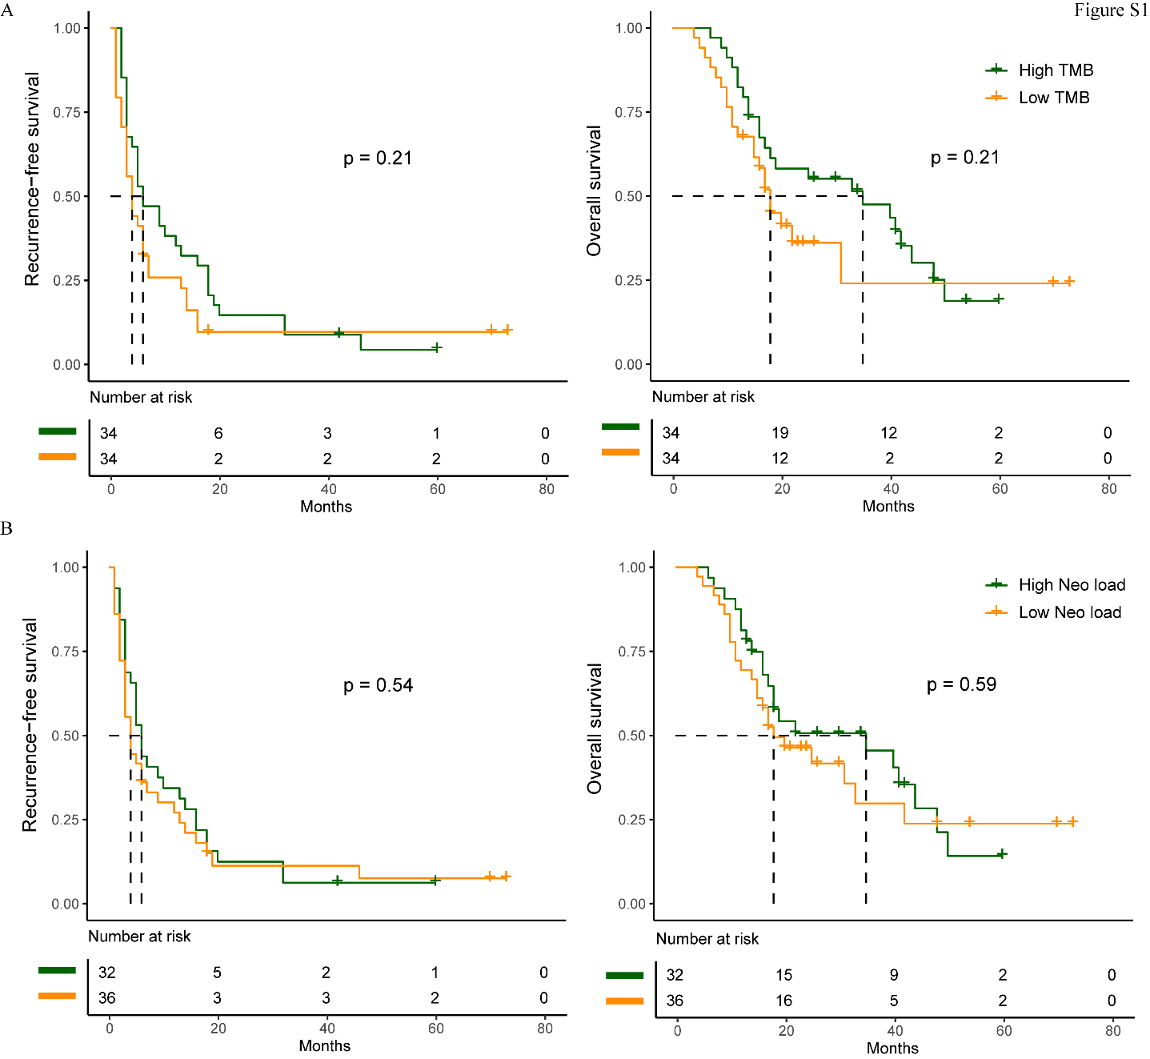

Figure S2. The forest plot shows hazard ratios for postoperative survival of NeoITH classification and clinico-pathological features evaluated by multi-variables Cox regression analysis in the study cohort.
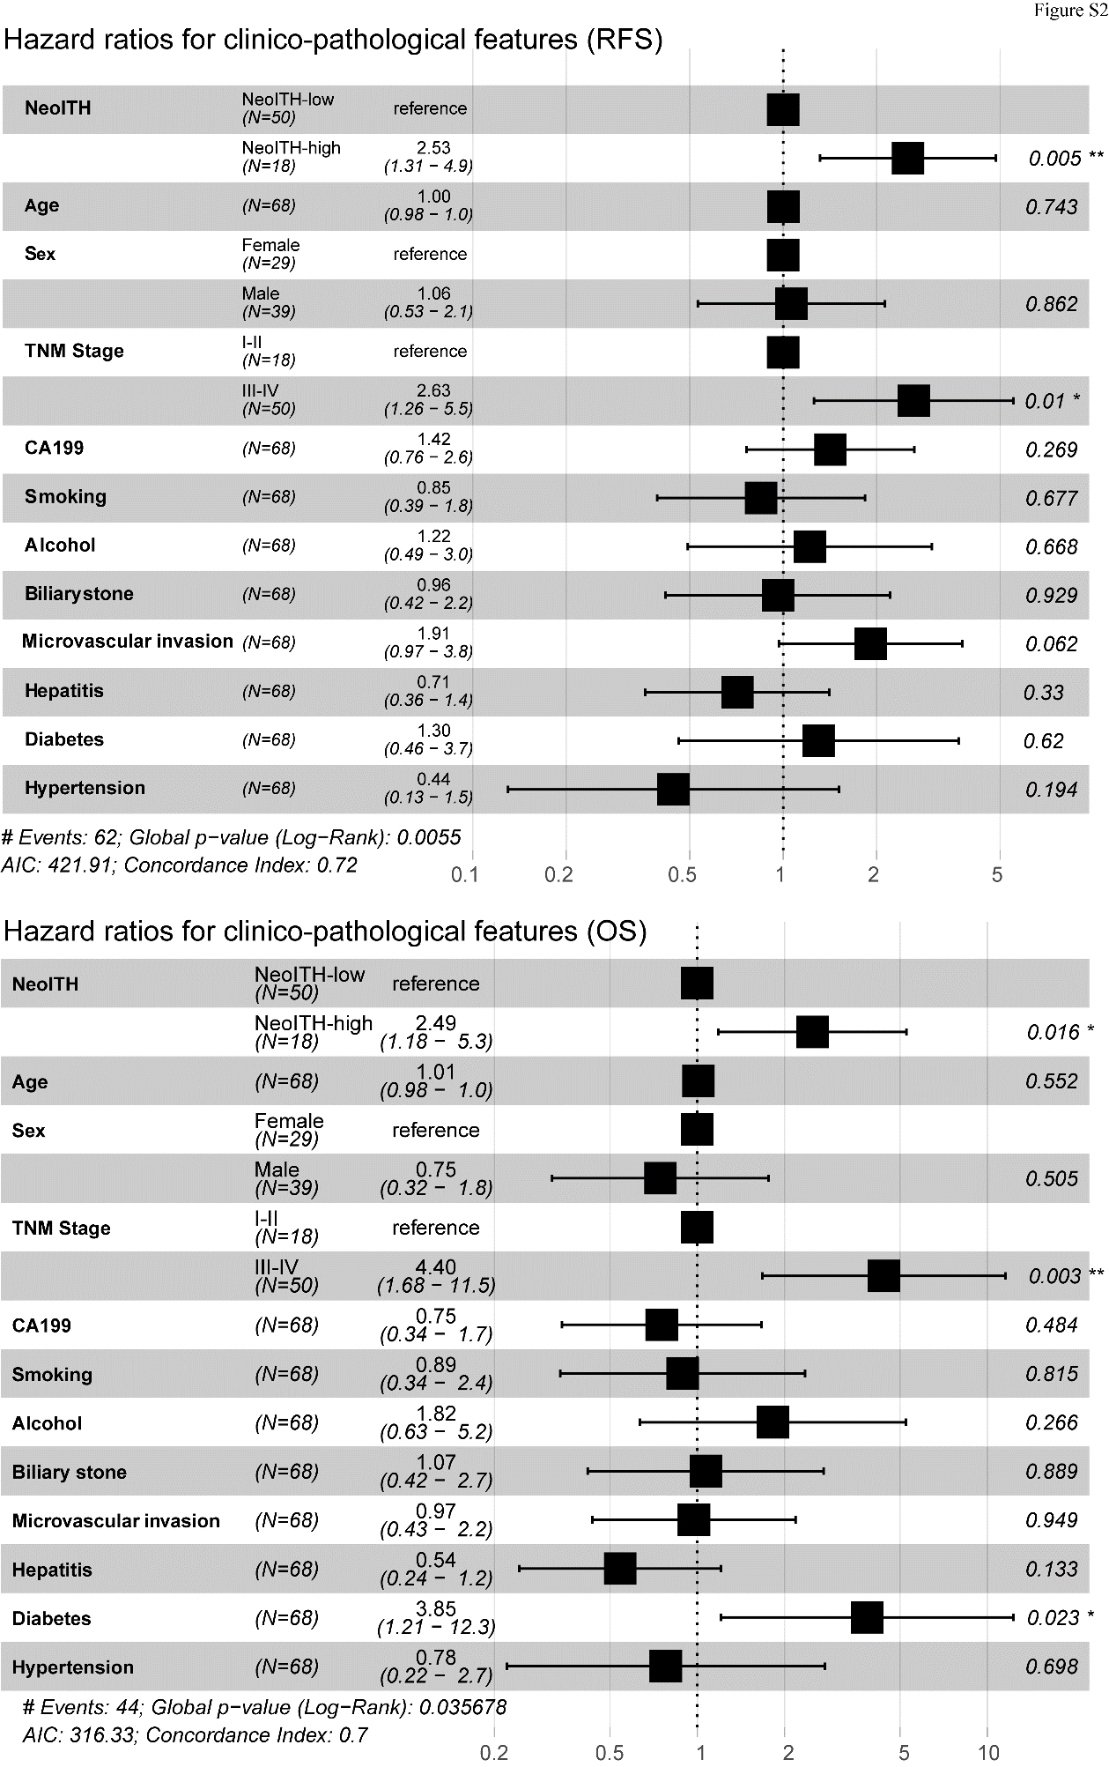

Figure S3. (A) The correlation of TCR richness with CD8⁺ T cell infiltration density. (B) The right plot shows the correlation of TCR diversity with CD8⁺ T cell infiltration density.

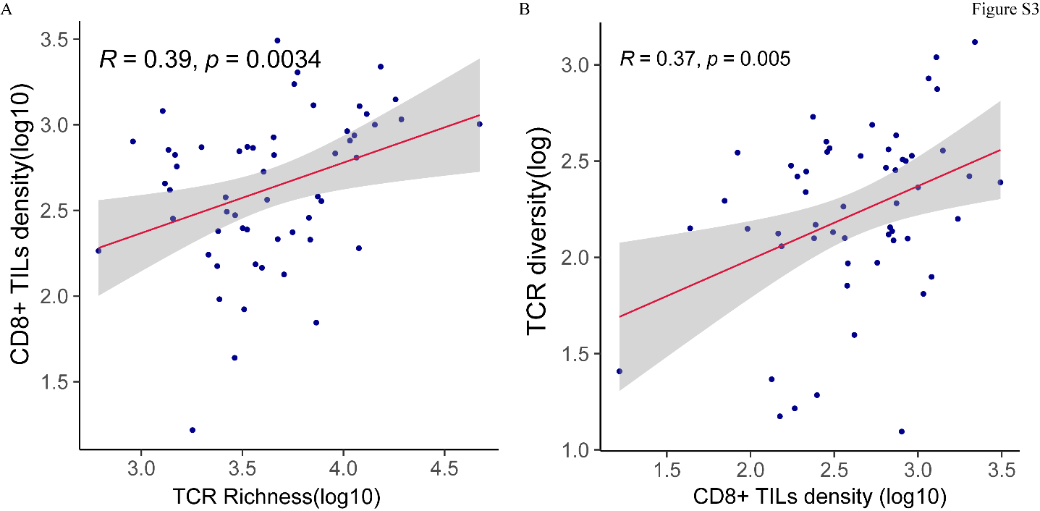

Figure S4. Positional amino acid bias in CDR3a motifs dominated by HBV, HCV, CMV and EBV, which were normalized by amino acid diversity in the unselected repertoire.
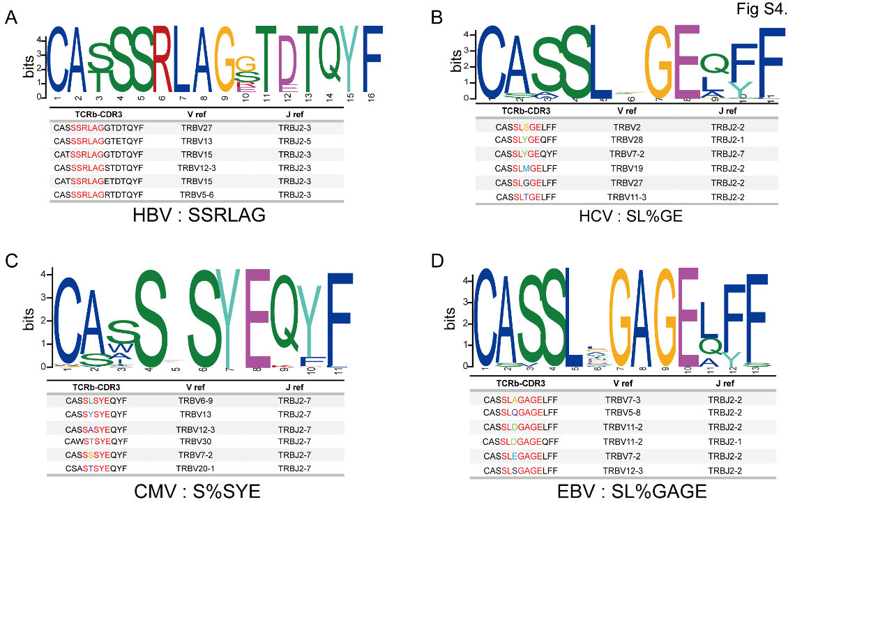

Figure S5. Kaplan–Meier curves showing the prognostic effects of K value. The K-low group and the K-high group were separated by the cut-off of median value. The log-rank test (p = 0.0096) for progression-free survival (left panel), K-high and K-low patients. The log-rank test (p = 0.043) for overall survival (right panel), between K-high group and K-low group.

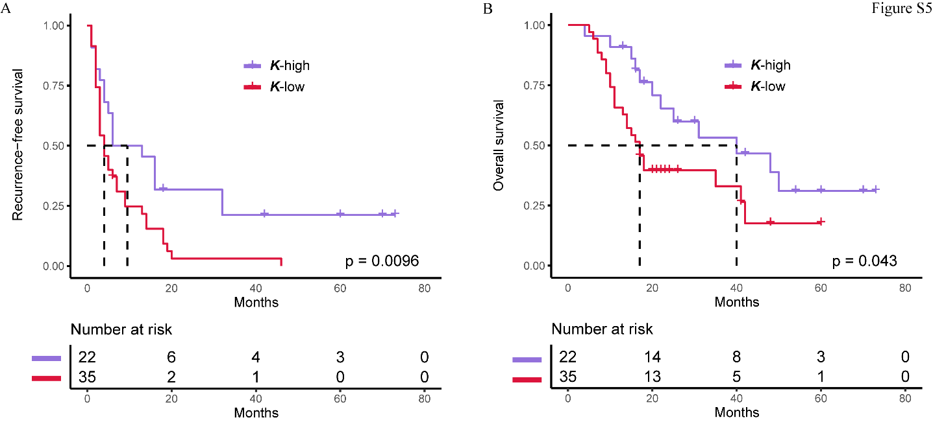

Figure S6. (A) The comparison of tumor mutation burden between patients who achieved responsive disease, controlled disease, or clinical benefits and those who did not achieve. (B) The comparison the objective response rate (ORR), disease-controlled rate (DCR), and clinical benefit rate between the TMB-high and TMB-low groups. (C) The progression-free survival (PFS) curves of the TMB-high and TMB-low groups are also shown (R: responder, NR: non-responder, C: controller, NC: non-controlled, B: benefit, NB: no-benefit).
