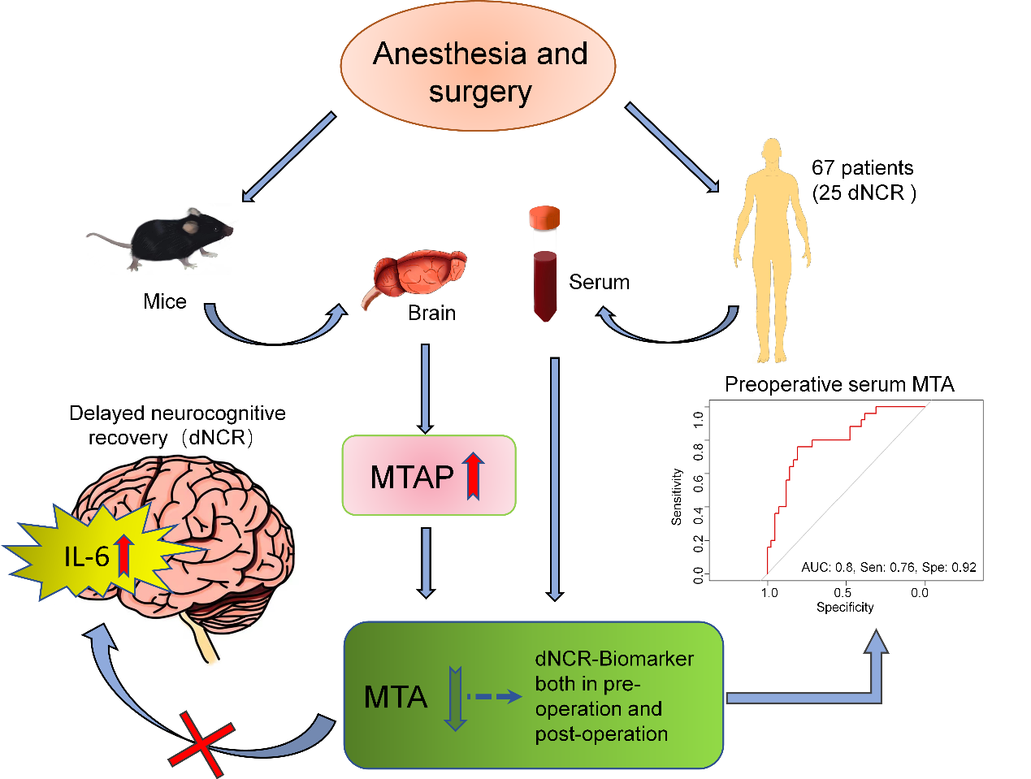
Graphical abstract: Transcriptomic and metabolomic analysis revealed that anesthesia/surgery activated MTA phosphorylase (MTAP) and decreased S-methyl-5-thioadenosine (MTA) levels in the brain of aged mice. Low blood MTA levels were associated with postoperative delayed neurocognitive recovery (dNCR) and thus could be used as a potential perioperative predictor.

