Appendix

Prediction target coding
Visit dates were used to determine length of time between revisits. Since the indicator column of the last visit would contain a zero, data was preprocessed to remove the last visit of each patient from the input data. The indictor column of the second last visit (n-1) was used to create a binary outcome variable for the data to be trained on, categorized as ‘1’ if the last visit was within the next 30 days (revisited), and ‘0’ otherwise (not revisited).

Model development
To ensure GNN and RNN model architecture were comparable, GNN models were constrained to one layer. Candidate GNN models were identified based on two criteria: 1) models were bipartite (a mathematical feature where nodes and edges are connected allowing for increased model complexity), and 2) the recency of the operator development (preference given to more recently developed, and innovative, operators). Models were developed and implemented using Python version 3.9 and PyTorch version 1.10.0. To aid the training process, a GPU with CUDA version 11.4 (a parallel computing software) was used to allow complex calculations with increased speed.

Data balancing
To balance the dataset, five random samples of 768 unique patients from the group without an ED revisit were selected. Each random sample was separately merged with the 768 patients with an ED revisit to create a separate balanced dataset, which resulted in having five balanced datasets. For each balanced dataset a five-fold cross validation approach was used to train and evaluate the models, in which the dataset was split into five equally sized ‘folds’. In each step of the five-fold cross validation, four of the five folds are selected as the training set and the remaining fold as the test set. This process is repeated until each fold has been used as the test set exactly once.

Technical information
- Python version 3.9 and PyTorch version 1.10.0
- GPU (NVIDIA GeForce GTX 1650 Ti with CUDA version 11.4
- The optimization of the networks was performed using the Adam Optimizer with an ExponentialLR Scheduler.
- Heterogenous (bipartite) patient graphs were used which, compared to homogenous graphs that only consider a single type of data, can better capture complex healthcare dynamics by considering interconnections among multiple factors.

Model calibration
Reliability diagrams are a visual approximation of a models’ confidence calibration. Confidence calibration plots the predictive probabilities (i.e., confidence) against its predictive accuracy. If a model correctly predicts classifications with a confidence of 0.67 and is well calibrated, it would also have 0.67 accuracy. Reliability diagrams chart mean confidence on the x-axis and accuracy within each bin on the y-axis for equally spaced bins. For each bin, bar height corresponds to the calculated mean accuracy of the predictions within that bin, showing how well the predicted probabilities align with the actual outcomes. A well-calibrated model would have bars that align well with the diagonal line ($y=x$).

Expected Calibration Error (ECE)
Expected Calibration Error (ECE) is a scalar measure that summarizes the difference between the model’s confidence and accuracy (Naeini et al., 2015). ECE is weighted average of the difference between the accuracy and confidence of each bin. Models with lower ECE values are more reliable. The reliability diagram and the ECE values of the best performing GNN, RNN and logistic regression classifiers for ten bins are shown in Figure A1. The blue bars represent the accuracy within each bin, and the red bars represent the gap (difference) between the classifier’s prediction accuracy and the average prediction confidence within each bin, i.e., the calibration gap. The GNN model has the lowest ECE value of 0.1776, followed by the RNN and logistic regression model.

Table A1. Candidate model types

Model type | Model | Description | Source
GNN | PTO | Proposed GNN architecture with a Transformer based graph | https://arxiv.org/abs/2009.03509
GNN | PGO | Proposed GNN architecture with a graph operator | https://arxiv.org/abs/1810.02244
GNN | BTO | Baseline GNN architecture with a Transformer based graph operator | https://arxiv.org/abs/2009.03509
GNN | BGO | Baseline GNN architecture with a graph operator | https://arxiv.org/abs/1810.02244
GNN | BETO | Baseline Enhanced GNN architecture with a Transformer based graph operator | Operator proposed in https://arxiv.org/abs/2009.03509 and a readout layer proposed in https://arxiv.org/abs/1811.01287
GNN | BEGO | Baseline Enhanced GNN architecture with a graph operator | Operator proposed in https://arxiv.org/abs/1810.02244 and a readout layer proposed in https://arxiv.org/abs/1811.01287
RNN | Bi-GRU | Bidirectional Gated Recurrent Unit | https://arxiv.org/abs/1406.1078
RNN | Bi-LSTM | Bidirectional Long Short-Term Memory | https://ieeexplore.ieee.org/abstract/ document/1556215
RNN | GRU | Gated Recurrent Unit | https://arxiv.org/abs/1406.1078
RNN | LSTM | Long Short-Term Memory | https://ieeexplore.ieee.org/abstract/ document/6795963

Table A2. F1 scores of candidate models.

Model type | Operator | F1 score
GNN | PTO | .6595
GNN | BETO | .6454
GNN | PGO | .6375
GNN | BEGO | .6366
GNN | BTO | .6289
GNN | BGO | .6406
RNN | Bi-GRU | .6307
RNN | Bi-LSTM | .5947
RNN | GRU | .6184
RNN | LSTM | .5874
Logistic regression |  | .5797

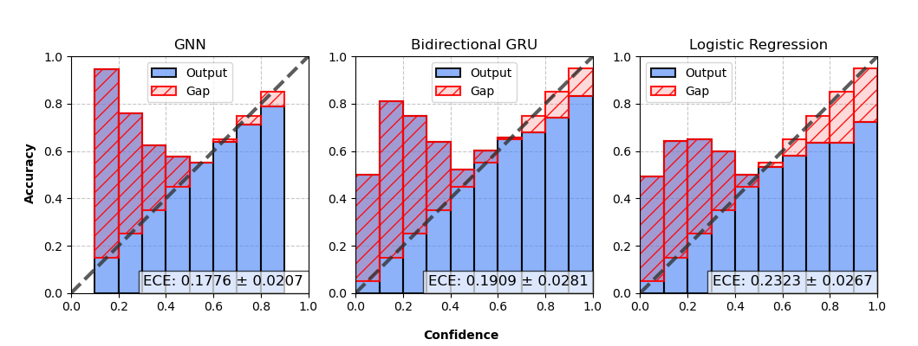
Figure A1. Reliability diagram and expected calibration error (ECE) for GNN, RNN and logistic regression models.

