Supplementary pages

Table S1: Observed travel speed based on OSM highway tags

Highway tag | Mode of transportation | Average travel speed (m/s) | Standard Error | Average travel speed (km/hr) | Applicable to
Residential | Bicycle | 2.89 | 0.25 | 10.40 | Residential & service
Residential | Car | 3.85 | 0.90 | 14.86 | Residential & service
Residential | Motorcycle | 5.06 | 0.55 | 18.22 | Residential & service
Residential | Walking | 1.41 | 0.08 | 5.07 | Residential & service
Tertiary | Bicycle | 4.82 | 0.41 | 17.35 | Primary, secondary & tertiary
Tertiary | Car | 8.19 | 0.31 | 29.48 | Primary, secondary & tertiary
Tertiary | Motorcycle | 9.14 | 0.38 | 32.90 | Primary, secondary & tertiary
Tertiary | Walking | 1.47 | 0.25 | 5.29 | Primary, secondary & tertiary
Track | Walking | 1.34 | 0.04 | 4.82 | Applicable to footway, path, track, trunk & cycleway
Unclassified | Unclassified | 1.39 | 0.08 | 5 | Applicable to all unclassified roads

Table S2: Analysis of variance table from the analysis to compare the travel speed between different models of transportation ts of the Analysis of Variance for the observations on travel speed computed when means of transportation, road surface and location is taken into account

 | DF | Sum Sq | Mean Sq | F-Value | Pr(>F)
Transportation | 3 | 4999 | 1666.5 | 626.953 | <2e-16 ***
Surface | 2 | 774 | 387.1 | 145.644 | <2e-16 ***
Location | 6 | 318 | 53.1 | 19.965 | <2e-16 ***
Transportation:Surface | 3 | 508 | 169.5 | 63.764 | <2e-16 ***
Transportation:Location | 12 | 298 | 24.9 | 9.355 | <2e-16 ***
Surface:Location | 4 | 12 | 3.1 | 1.160 | 0.3274
Transportation:Surface:Location | 5 | 31 | 6.2 | 2.343 | 0.0402 *
Residuals | 595 | 1582 | 2.7

Supplementary figures

Figure S1: Health facility catchment area, for Bangwe health centre, developed by HSAs.

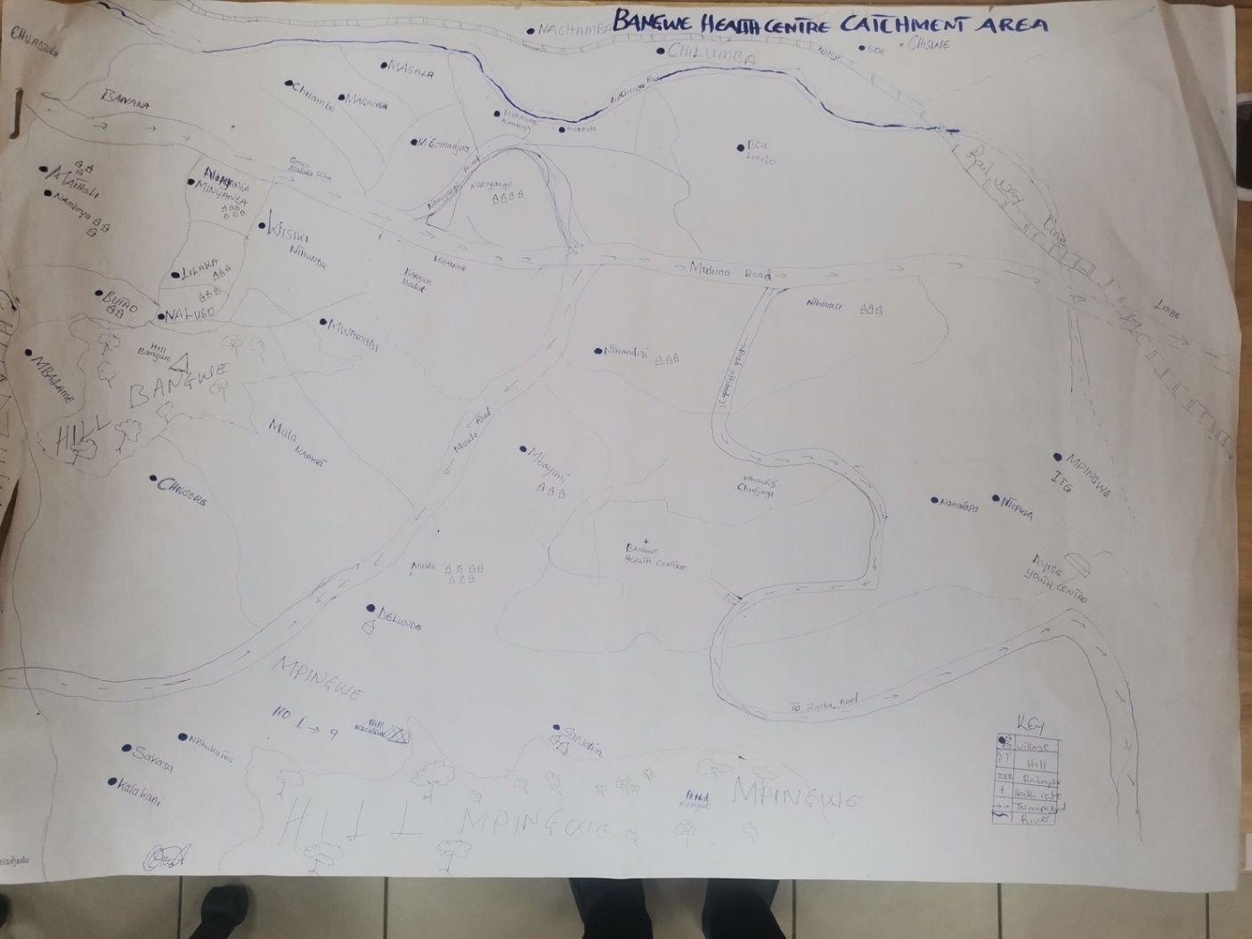

Figure S2: Sankey diagram for patients accessing health facilities that were considered for validation

