Table
Table 1 Instrumental variables for primary analysis screening
Micro nutrient | SNPs | EA | OA | BETA | SE | P-vale | F
Vitamin D | rs10277163 | G | A | -0.0143 | 0.0024 | 1.08E-09 | 37.181
 | rs1038165 | C | T | -0.0115 | 0.0021 | 2.15E-08 | 31.358
 | rs1042034 | C | T | 0.0151 | 0.0025 | 1.45E-09 | 36.599
 | rs10438978 | T | C | 0.0172 | 0.0026 | 7.34E-11 | 42.427
 | rs1047891 | A | C | -0.0134 | 0.0022 | 7.96E-10 | 37.769
 | rs1048328 | A | G | 0.0313 | 0.0037 | 5.58E-17 | 70.121
 | rs10859995 | T | C | 0.0436 | 0.0021 | 4.60E-100 | 450.898
 | rs11023215 | A | G | -0.0643 | 0.0021 | 1.00E-200 | 924.263
 | rs11207969 | G | A | 0.0209 | 0.0021 | 7.14E-23 | 96.943
 | rs11264361 | G | T | 0.0175 | 0.0023 | 7.97E-14 | 55.812
 | rs1128535 | C | T | -0.0164 | 0.0020 | 6.06E-16 | 65.416
 | rs1149605 | C | T | 0.0225 | 0.0027 | 1.30E-16 | 68.445
 | rs115288876 | A | G | 0.0788 | 0.0050 | 2.36E-56 | 250.188
 | rs11542462 | A | G | -0.0248 | 0.0030 | 9.72E-17 | 69.025
 | rs117862422 | C | T | -0.0505 | 0.0087 | 5.52E-09 | 33.997
 | rs11791258 | A | G | 0.0141 | 0.0026 | 4.85E-08 | 29.774
 | rs11867297 | T | C | 0.0135 | 0.0021 | 1.01E-10 | 41.809
 | rs12056768 | T | G | 0.0232 | 0.0021 | 2.65E-29 | 126.294
 | rs12153819 | T | C | -0.0178 | 0.0031 | 8.16E-09 | 33.237
 | rs12292350 | T | C | -0.0348 | 0.0038 | 6.01E-20 | 83.617
 | rs12462826 | A | G | -0.0132 | 0.0021 | 4.18E-10 | 39.025
 | rs1260326 | T | C | -0.0197 | 0.0021 | 1.96E-21 | 90.382
 | rs12775091 | T | C | 0.0156 | 0.0025 | 3.33E-10 | 39.472
 | rs13076508 | C | T | 0.0251 | 0.0045 | 2.78E-08 | 30.856
 | rs13108245 | G | A | -0.0122 | 0.0021 | 4.63E-09 | 34.338
 | rs13294734 | T | C | 0.0126 | 0.0021 | 1.02E-09 | 37.281
 | rs1343776 | A | G | 0.0181 | 0.0025 | 1.62E-13 | 54.423
 | rs138072379 | T | C | 0.0443 | 0.0073 | 1.29E-09 | 36.835
 | rs1384687 | A | G | -0.0169 | 0.0030 | 1.82E-08 | 31.674
 | rs142004400 | C | A | -0.0310 | 0.0056 | 3.01E-08 | 30.699
 | rs142158911 | A | G | 0.0263 | 0.0032 | 4.43E-16 | 66.036
 | rs146128209 | G | A | -0.0484 | 0.0040 | 2.61E-34 | 149.189
 | rs1532085 | A | G | -0.0253 | 0.0021 | 8.60E-34 | 146.818
 | rs1684600 | T | C | -0.0125 | 0.0022 | 1.59E-08 | 31.938
 | rs17207784 | C | T | -0.0135 | 0.0022 | 5.14E-10 | 38.622
 | rs1800588 | T | C | -0.0305 | 0.0025 | 4.73E-35 | 152.583
 | rs1800775 | A | C | -0.0174 | 0.0020 | 9.23E-18 | 73.671
 | rs1841850 | C | A | 0.0304 | 0.0032 | 6.73E-22 | 92.502
 | rs1858889 | A | C | -0.0135 | 0.0020 | 3.49E-11 | 43.880
 | rs1871395 | G | A | -0.0204 | 0.0028 | 5.72E-13 | 51.940
 | rs1949633 | T | C | -0.0114 | 0.0021 | 4.45E-08 | 29.941
 | rs2037511 | A | G | 0.0177 | 0.0027 | 9.41E-11 | 41.940
 | rs2171427 | A | G | -0.0165 | 0.0028 | 4.26E-09 | 34.502
 | rs2245133 | C | T | -0.0213 | 0.0027 | 7.80E-15 | 60.384
 | rs2297991 | T | C | -0.0128 | 0.0023 | 1.57E-08 | 31.970
 | rs2398113 | G | A | -0.0118 | 0.0021 | 1.10E-08 | 32.657
 | rs2494429 | A | G | 0.0148 | 0.0027 | 2.80E-08 | 30.839
 | rs2595644 | T | G | -0.0123 | 0.0021 | 4.97E-09 | 34.200
 | rs2710651 | G | A | 0.0116 | 0.0020 | 1.23E-08 | 32.441
 | rs2756119 | A | G | 0.0121 | 0.0021 | 8.71E-09 | 33.109
 | rs2807834 | T | G | 0.0151 | 0.0022 | 5.66E-12 | 47.444
 | rs28435470 | G | A | 0.0119 | 0.0021 | 3.29E-08 | 30.526
 | rs2847500 | A | G | -0.0225 | 0.0031 | 2.77E-13 | 53.363
 | rs290400 | G | A | 0.0131 | 0.0022 | 1.41E-09 | 36.649
 | rs296381 | C | T | 0.0611 | 0.0028 | 2.30E-108 | 489.048
 | rs3114045 | T | C | 0.0222 | 0.0030 | 1.00E-13 | 55.363
 | rs325393 | T | G | -0.0136 | 0.0023 | 2.03E-09 | 35.943
 | rs34186890 | G | A | -0.0157 | 0.0023 | 1.33E-11 | 45.773
 | rs34726834 | T | C | 0.0140 | 0.0023 | 2.42E-09 | 35.600
 | rs35270497 | T | C | 0.0157 | 0.0027 | 5.08E-09 | 34.160
 | rs35823191 | C | T | -0.0233 | 0.0021 | 1.65E-27 | 118.095
 | rs3732220 | A | G | -0.0478 | 0.0036 | 1.31E-39 | 173.437
 | rs3924150 | C | T | -0.0113 | 0.0021 | 4.82E-08 | 29.789
 | rs4147536 | A | C | 0.0148 | 0.0025 | 2.76E-09 | 35.345
 | rs4355358 | T | C | -0.0259 | 0.0027 | 9.75E-22 | 91.767
 | rs4364259 | A | G | 0.0172 | 0.0026 | 1.86E-11 | 45.118
 | rs4420638 | G | A | -0.0193 | 0.0027 | 3.95E-13 | 52.667
 | rs4580037 | C | A | -0.0136 | 0.0023 | 1.68E-09 | 36.310
 | rs4694423 | A | C | -0.0937 | 0.0021 | 1.00E-200 | 2076.29
 | rs4846913 | C | A | -0.0132 | 0.0021 | 2.19E-10 | 40.291
 | rs4944884 | C | T | -0.0714 | 0.0023 | 1.00E-200 | 967.496
 | rs512083 | C | T | 0.0122 | 0.0020 | 2.23E-09 | 35.766
 | rs532436 | A | G | -0.0151 | 0.0026 | 6.00E-09 | 33.834
 | rs5770794 | T | C | -0.0133 | 0.0022 | 1.74E-09 | 36.247
 | rs6129648 | G | A | 0.0141 | 0.0021 | 2.44E-11 | 44.579
 | rs61698755 | T | C | 0.0115 | 0.0021 | 2.25E-08 | 31.263
 | rs61747728 | T | C | 0.0303 | 0.0053 | 8.83E-09 | 33.084
 | rs62007299 | G | A | 0.0124 | 0.0022 | 3.12E-08 | 30.632
 | rs62012766 | C | T | -0.0161 | 0.0028 | 6.32E-09 | 33.735
 | rs6600876 | G | T | -0.0312 | 0.0020 | 3.94E-53 | 235.412
 | rs6834488 | T | C | -0.0145 | 0.0021 | 2.26E-12 | 49.247
 | rs7122671 | A | G | -0.0639 | 0.0044 | 1.26E-48 | 214.752
 | rs71601787 | A | G | 0.0448 | 0.0022 | 3.97E-94 | 423.622
 | rs727857 | G | A | 0.0121 | 0.0021 | 9.27E-09 | 32.989
 | rs73413596 | C | T | 0.0223 | 0.0039 | 9.15E-09 | 33.014
 | rs742493 | C | T | 0.0184 | 0.0032 | 1.04E-08 | 32.769
 | rs7528419 | G | A | 0.0215 | 0.0024 | 8.17E-19 | 78.460
 | rs7569755 | A | G | 0.0136 | 0.0023 | 1.49E-09 | 36.544
 | rs7580771 | T | G | -0.0166 | 0.0027 | 5.15E-10 | 38.618
 | rs7652808 | T | G | 0.0213 | 0.0021 | 1.36E-23 | 100.229
 | rs7657132 | G | A | -0.0136 | 0.0022 | 6.99E-10 | 38.023
 | rs7712001 | G | T | 0.0119 | 0.0021 | 7.05E-09 | 33.520
 | rs77532868 | T | C | 0.0260 | 0.0046 | 1.28E-08 | 32.357
 | rs77924615 | A | G | -0.0152 | 0.0026 | 3.94E-09 | 34.652
 | rs77960347 | G | A | -0.0526 | 0.0091 | 6.53E-09 | 33.669
 | rs804281 | A | G | -0.0159 | 0.0021 | 1.20E-14 | 59.539
 | rs9375037 | C | A | 0.0117 | 0.0021 | 1.21E-08 | 32.472
 | rs9409266 | G | A | 0.0168 | 0.0029 | 1.24E-08 | 32.419
 | rs9847248 | G | A | 0.0123 | 0.0022 | 4.19E-08 | 30.059
 | rs986649 | G | A | 0.0129 | 0.0022 | 3.51E-09 | 34.880
 | rs9946771 | T | C | -0.0234 | 0.0041 | 9.47E-09 | 32.947
Vitamin C | rs10051765 | C | T | 0.039 | 0.007 | 3.64E-09 | 31.04
 | rs10136000 | A | G | 0.04 | 0.007 | 1.33E-08 | 32.65
 | rs117885456 | A | G | 0.078 | 0.012 | 1.70E-11 | 42.25
 | rs13028225 | T | C | 0.102 | 0.009 | 2.38E-30 | 128.44
 | rs174547 | C | T | 0.036 | 0.007 | 3.84E-08 | 26.45
 | rs2559850 | A | G | 0.058 | 0.006 | 6.30E-20 | 93.44
 | rs33972313 | C | T | 0.36 | 0.018 | 4.61E-90 | 400.00
 | rs56738967 | C | G | 0.041 | 0.007 | 7.62E-10 | 34.31
 | rs6693447 | T | G | 0.039 | 0.006 | 6.25E-10 | 42.25
 | rs7740812 | G | A | 0.038 | 0.006 | 1.88E-09 | 40.11
 | rs9895661 | T | C | 0.063 | 0.008 | 1.05E-14 | 62.02
Zinc | rs1532423 | A | G | 0.178 | 0.026 | 6.40E-12 | 46.86
 | rs2120019 | C | T | -0.287 | 0.033 | 1.55E-18 | 75.63
selenium | rs7700970 | T | C | 0.265 | 0.033 | 7.17E-13 | 51.29
 | rs921943 | T | C | 0.222 | 0.034 | 9.33E-11 | 42.63
Vitamin B₆ | rs1256335 | A | G | -0.14 | 0.02 | 1.40E-15 | 219.04
Vitamin B₁₂ | rs1131603 | C | T | 0.222 | 0.015 | 2.11E-48 | 100.00
 | rs1801222 | G | A | 0.119 | 0.007 | 7.24E-74 | 43.56
 | rs34324219 | C | A | 0.235 | 0.011 | 2.54E-109 | 57.33
 | rs41281112 | C | T | 0.181 | 0.015 | 4.60E-34 | 219.04
folate | rs652197 | C | T | 0.069 | 0.01 | 5.73E-13 | 203.06
 | rs1801133 | G | A | 0.114 | 0.008 | 6.65E-53 | 47.61
Vitamin E | rs10245705 | T | C | 0.0663 | 0.0127 | 1.95E-07 | 27.25
 | rs11145330 | C | A | 0.0324 | 0.0068 | 1.95E-06 | 22.70
 | rs1404410 | G | C | 0.0236 | 0.0052 | 4.57E-06 | 20.59
 | rs2074731 | A | C | 0.0184 | 0.0039 | 2.31E-06 | 22.25
 | rs7238006 | C | T | 0.0281 | 0.0057 | 6.77E-07 | 24.30

Table 2 Instrumental variables for secondary analysis screening
Micro nutrient | SNPs | EA | OA | BETA | SE | P-vale | F
Vitamin D | rs10014468 | A | G | 0.01968 | 0.004177 | 3.00E-06 | 22.19838
 | rs10118061 | A | G | 0.012277 | 0.002461 | 1.00E-06 | 24.88635
 | rs10146891 | T | C | 0.010189 | 0.002071 | 1.00E-06 | 24.20488
 | rs10161491 | C | T | -0.009513 | 0.001956 | 1.00E-06 | 23.6536
 | rs10176324 | G | A | 0.025441 | 0.00536 | 2.00E-06 | 22.52884
 | rs10184054 | G | C | 0.011322 | 0.002327 | 1.00E-06 | 23.67301
 | rs10250582 | T | C | 0.009635 | 0.001991 | 1.00E-06 | 23.4186
 | rs10413905 | C | T | -0.010308 | 0.002079 | 1.00E-06 | 24.58328
 | rs1048940 | T | C | -0.016142 | 0.003292 | 1.00E-06 | 24.04335
 | rs10814274 | T | C | 0.009767 | 0.001969 | 1.00E-06 | 24.60543
 | rs10860218 | C | T | -0.014307 | 0.002913 | 1.00E-06 | 24.12216
 | rs10896045 | G | A | 0.010475 | 0.002121 | 1.00E-06 | 24.39084
 | rs11016566 | A | G | 0.044432 | 0.009664 | 4.00E-06 | 21.13868
 | rs11061056 | A | G | -0.026534 | 0.005509 | 1.00E-06 | 23.1985
 | rs11122449 | T | C | 0.010888 | 0.002242 | 1.00E-06 | 23.58441
 | rs112178027 | T | C | -0.012129 | 0.002636 | 4.00E-06 | 21.17187
 | rs11249058 | A | G | -0.01079 | 0.002237 | 1.00E-06 | 23.26542
 | rs112960862 | T | C | -0.021421 | 0.00448 | 2.00E-06 | 22.86249
 | rs113780007 | A | G | 0.025704 | 0.005172 | 1.00E-06 | 24.69929
 | rs114673443 | T | G | 0.037046 | 0.007658 | 1.00E-06 | 23.40194
 | rs11537654 | T | C | -0.010995 | 0.002222 | 1.00E-06 | 24.48513
 | rs11592540 | A | G | 0.011777 | 0.002397 | 1.00E-06 | 24.13978
 | rs11612819 | C | G | 0.010143 | 0.002096 | 1.00E-06 | 23.41803
 | rs11624558 | C | T | -0.010546 | 0.002133 | 1.00E-06 | 24.44521
 | rs11625746 | C | T | -0.009389 | 0.002045 | 4.00E-06 | 21.0791
 | rs116265747 | T | C | 0.019272 | 0.003996 | 1.00E-06 | 23.25962
 | rs11631408 | G | A | 0.009219 | 0.001955 | 2.00E-06 | 22.23689
 | rs11631567 | A | G | 0.01293 | 0.002741 | 2.00E-06 | 22.25251
 | rs11673587 | C | T | 0.012326 | 0.002563 | 2.00E-06 | 23.12848
 | rs1168100 | C | T | -0.010636 | 0.002129 | 1.00E-06 | 24.95774
 | rs116962777 | A | G | 0.036245 | 0.007261 | 1.00E-06 | 24.91744
 | rs117048193 | C | T | 0.040754 | 0.008831 | 4.00E-06 | 21.29711
 | rs118147862 | A | G | 0.023875 | 0.00475 | 1.00E-06 | 25.26385
 | rs11822160 | A | T | -0.016352 | 0.003276 | 1.00E-06 | 24.9146
 | rs12027616 | T | C | 0.009423 | 0.001956 | 1.00E-06 | 23.20816
 | rs12078655 | G | A | 0.011663 | 0.002378 | 1.00E-06 | 24.05453
 | rs12100917 | G | A | -0.01398 | 0.002927 | 2.00E-06 | 22.81229
 | rs12147588 | C | T | 0.016914 | 0.003385 | 1.00E-06 | 24.96751
 | rs12295437 | C | T | -0.022937 | 0.004733 | 1.00E-06 | 23.48552
 | rs1230023 | G | A | -0.011135 | 0.002331 | 2.00E-06 | 22.81896
 | rs12458814 | G | A | 0.012948 | 0.002809 | 4.00E-06 | 21.24721
 | rs1247708 | C | T | -0.012351 | 0.002462 | 1.00E-06 | 25.16681
 | rs12493498 | A | G | 0.013908 | 0.002845 | 1.00E-06 | 23.89818
 | rs12616915 | A | C | -0.015107 | 0.003072 | 1.00E-06 | 24.18321
 | rs12620004 | C | T | -0.009817 | 0.002083 | 2.00E-06 | 22.21156
 | rs12670798 | C | T | -0.011317 | 0.002262 | 1.00E-06 | 25.03096
 | rs12816349 | A | G | 0.010442 | 0.002273 | 4.00E-06 | 21.10418
 | rs12939053 | A | C | 0.010519 | 0.002167 | 1.00E-06 | 23.56303
 | rs12958051 | T | C | -0.011041 | 0.002206 | 1.00E-06 | 25.04989
 | rs13011875 | T | C | 0.010093 | 0.002021 | 1.00E-06 | 24.94066
 | rs13020391 | T | C | -0.009752 | 0.002023 | 1.00E-06 | 23.2378
 | rs13130892 | T | C | -0.018906 | 0.004032 | 3.00E-06 | 21.98661
 | rs13148767 | G | A | 0.009951 | 0.00202 | 1.00E-06 | 24.26782
 | rs1320782 | T | C | 0.009942 | 0.001983 | 1.00E-06 | 25.13634
 | rs1324190 | C | T | -0.009448 | 0.002016 | 3.00E-06 | 21.96336
 | rs13263105 | G | C | 0.010253 | 0.002055 | 1.00E-06 | 24.89306
 | rs13409011 | A | G | 0.010621 | 0.002112 | 1.00E-06 | 25.28966
 | rs1384687 | A | G | -0.0145 | 0.002895 | 1.00E-06 | 25.08643
 | rs140091898 | A | G | 0.039429 | 0.008177 | 1.00E-06 | 23.2511
 | rs141192319 | A | G | 0.027189 | 0.005629 | 1.00E-06 | 23.3305
 | rs141685696 | A | C | 0.017238 | 0.003577 | 1.00E-06 | 23.22394
 | rs142889360 | T | C | 0.012114 | 0.002577 | 3.00E-06 | 22.09766
 | rs145347194 | C | T | -0.017004 | 0.003496 | 1.00E-06 | 23.65698
 | rs146417206 | A | G | 0.029057 | 0.005792 | 1.00E-06 | 25.16775
 | rs146635149 | A | G | 0.015677 | 0.003324 | 2.00E-06 | 22.24354
 | rs1481024 | T | G | 0.013356 | 0.002689 | 1.00E-06 | 24.67012
 | rs148899426 | A | G | 0.022343 | 0.004503 | 1.00E-06 | 24.61949
 | rs150841811 | A | T | 0.017652 | 0.003713 | 2.00E-06 | 22.60154
 | rs151179502 | G | A | 0.019776 | 0.00427 | 4.00E-06 | 21.4497
 | rs164637 | A | G | 0.022017 | 0.004465 | 1.00E-06 | 24.31495
 | rs16823270 | G | A | 0.014982 | 0.003032 | 1.00E-06 | 24.41638
 | rs16844825 | G | A | -0.011662 | 0.002469 | 2.00E-06 | 22.31022
 | rs16886847 | C | T | -0.011122 | 0.002243 | 1.00E-06 | 24.5871
 | rs17035665 | T | C | 0.011763 | 0.002422 | 1.00E-06 | 23.58783
 | rs1704151 | G | T | -0.016513 | 0.003474 | 2.00E-06 | 22.59396
 | rs17526367 | T | C | 0.011666 | 0.002365 | 1.00E-06 | 24.33222
 | rs17712208 | A | T | -0.02633 | 0.005374 | 1.00E-06 | 24.00526
 | rs17886395 | G | C | -0.014336 | 0.002878 | 1.00E-06 | 24.81272
 | rs1843096 | A | G | 0.012206 | 0.002432 | 1.00E-06 | 25.1895
 | rs1854301 | T | G | 0.01031 | 0.002219 | 3.00E-06 | 21.58752
 | rs185575165 | A | T | -0.010959 | 0.002266 | 1.00E-06 | 23.38956
 | rs1868590 | A | C | -0.01463 | 0.003025 | 1.00E-06 | 23.39041
 | rs1871462 | T | G | -0.009725 | 0.002022 | 2.00E-06 | 23.1322
 | rs1879878 | G | A | 0.00952 | 0.001977 | 1.00E-06 | 23.18785
 | rs188265733 | T | C | -0.035257 | 0.00725 | 1.00E-06 | 23.6491
 | rs1931814 | G | A | -0.009103 | 0.001953 | 3.00E-06 | 21.72524
 | rs193261074 | T | G | 0.020329 | 0.004326 | 3.00E-06 | 22.08305
 | rs200640263 | A | G | -0.015461 | 0.003176 | 1.00E-06 | 23.69814
 | rs201920988 | A | C | 0.010169 | 0.002089 | 1.00E-06 | 23.69625
 | rs2023273 | G | T | -0.009424 | 0.001951 | 1.00E-06 | 23.33222
 | rs2157829 | G | A | -0.010282 | 0.002063 | 1.00E-06 | 24.84029
 | rs2173201 | A | C | -0.011579 | 0.002317 | 1.00E-06 | 24.97411
 | rs2229857 | C | T | -0.009803 | 0.002107 | 3.00E-06 | 21.64656
 | rs2252520 | T | A | 0.010666 | 0.002171 | 1.00E-06 | 24.13701
 | rs2301179 | G | A | 0.009051 | 0.001945 | 3.00E-06 | 21.65479
 | rs2417961 | G | A | 0.011841 | 0.002377 | 1.00E-06 | 24.81524
 | rs2446066 | T | G | -0.012598 | 0.002551 | 1.00E-06 | 24.38834
 | rs2585433 | G | C | 0.014209 | 0.002836 | 1.00E-06 | 25.10236
 | rs2608949 | T | C | -0.011293 | 0.00232 | 1.00E-06 | 23.69423
 | rs26579 | C | G | 0.009993 | 0.001995 | 1.00E-06 | 25.09031
 | rs271831 | G | A | -0.009819 | 0.001985 | 1.00E-06 | 24.46885
 | rs2737245 | T | G | 0.010811 | 0.002164 | 1.00E-06 | 24.95843
 | rs2741044 | A | G | 0.010452 | 0.00213 | 1.00E-06 | 24.07906
 | rs2823021 | A | G | -0.011178 | 0.002407 | 3.00E-06 | 21.56632
 | rs28895061 | T | C | -0.012771 | 0.002634 | 1.00E-06 | 23.50814
 | rs289714 | A | G | -0.012134 | 0.002606 | 3.00E-06 | 21.67999
 | rs2908806 | A | C | 0.012927 | 0.002751 | 3.00E-06 | 22.08078
 | rs2912332 | G | A | -0.01631 | 0.003535 | 4.00E-06 | 21.28772
 | rs2946405 | G | A | -0.01063 | 0.002188 | 1.00E-06 | 23.60325
 | rs2977269 | G | A | -0.011226 | 0.002261 | 1.00E-06 | 24.65182
 | rs2993263 | T | C | 0.009781 | 0.001996 | 1.00E-06 | 24.01295
 | rs34040779 | C | T | -0.017714 | 0.003774 | 3.00E-06 | 22.03076
 | rs34251103 | G | A | 0.010504 | 0.002166 | 1.00E-06 | 23.51757
 | rs34311816 | T | C | -0.010329 | 0.002249 | 4.00E-06 | 21.09297
 | rs34329 | C | G | -0.010474 | 0.002111 | 1.00E-06 | 24.61777
 | rs34368067 | A | G | 0.023141 | 0.00476 | 1.00E-06 | 23.63471
 | rs34699226 | G | A | -0.011595 | 0.002337 | 1.00E-06 | 24.61637
 | rs35456421 | T | C | 0.015258 | 0.003131 | 1.00E-06 | 23.74811
 | rs35634730 | T | C | 0.013975 | 0.002862 | 1.00E-06 | 23.84319
 | rs36099109 | T | C | -0.012305 | 0.002576 | 2.00E-06 | 22.81768
 | rs4078354 | G | A | -0.010205 | 0.002061 | 1.00E-06 | 24.51715
 | rs41302867 | A | G | 0.014003 | 0.002965 | 2.00E-06 | 22.30451
 | rs4505147 | A | C | -0.01032 | 0.002065 | 1.00E-06 | 24.97579
 | rs4612354 | C | T | -0.010758 | 0.002208 | 1.00E-06 | 23.73914
 | rs4619804 | C | A | -0.01095 | 0.002221 | 1.00E-06 | 24.30699
 | rs4626538 | T | G | 0.009085 | 0.001962 | 4.00E-06 | 21.44134
 | rs4686529 | G | A | -0.009163 | 0.001987 | 4.00E-06 | 21.2657
 | rs4692473 | A | C | -0.00973 | 0.002089 | 3.00E-06 | 21.69446
 | rs4711968 | C | T | 0.010254 | 0.002123 | 1.00E-06 | 23.32849
 | rs4722620 | T | C | 0.009775 | 0.002123 | 4.00E-06 | 21.19989
 | rs4793915 | T | C | -0.009145 | 0.001963 | 3.00E-06 | 21.70335
 | rs4865160 | A | G | -0.010184 | 0.002072 | 1.00E-06 | 24.15779
 | rs4970924 | G | A | 0.009349 | 0.001939 | 1.00E-06 | 23.24742
 | rs4971866 | C | G | -0.013101 | 0.002698 | 1.00E-06 | 23.57898
 | rs4980634 | C | T | -0.00967 | 0.001983 | 1.00E-06 | 23.77976
 | rs500328 | C | T | 0.009339 | 0.002005 | 3.00E-06 | 21.69562
 | rs523518 | G | A | -0.009757 | 0.001984 | 1.00E-06 | 24.18518
 | rs548972072 | G | C | -0.011147 | 0.002389 | 3.00E-06 | 21.77127
 | rs55728843 | T | C | -0.015346 | 0.003181 | 1.00E-06 | 23.27357
 | rs57601828 | T | A | 0.009742 | 0.002023 | 1.00E-06 | 23.1902
 | rs57766735 | T | A | 0.052241 | 0.010692 | 1.00E-06 | 23.87289
 | rs58114349 | C | T | 0.014169 | 0.00292 | 1.00E-06 | 23.54576
 | rs58725556 | G | A | 0.016528 | 0.003425 | 1.00E-06 | 23.28732
 | rs6016381 | C | T | 0.009706 | 0.002011 | 1.00E-06 | 23.29466
 | rs60566117 | A | G | -0.011521 | 0.00232 | 1.00E-06 | 24.66064
 | rs6068773 | T | C | -0.009773 | 0.001948 | 1.00E-06 | 25.16969
 | rs62011267 | T | C | -0.011039 | 0.002246 | 1.00E-06 | 24.15683
 | rs62011683 | C | T | -0.021718 | 0.004722 | 4.00E-06 | 21.15377
 | rs62078461 | A | G | 0.028409 | 0.006179 | 4.00E-06 | 21.13857
 | rs62109667 | G | A | -0.011125 | 0.002241 | 1.00E-06 | 24.64429
 | rs62261725 | G | A | -0.009571 | 0.002073 | 4.00E-06 | 21.31651
 | rs62308866 | G | A | 0.010071 | 0.002071 | 1.00E-06 | 23.64749
 | rs62471929 | G | A | 0.021357 | 0.00438 | 1.00E-06 | 23.77564
 | rs62493792 | A | T | 0.011249 | 0.002313 | 1.00E-06 | 23.65247
 | rs62493995 | G | T | -0.010929 | 0.002225 | 1.00E-06 | 24.12686
 | rs62530961 | T | C | -0.015615 | 0.003303 | 2.00E-06 | 22.34945
 | rs6438867 | C | T | -0.009913 | 0.002053 | 1.00E-06 | 23.31483
 | rs651007 | T | C | -0.011425 | 0.00241 | 2.00E-06 | 22.47389
 | rs667351 | A | G | 0.01401 | 0.002861 | 1.00E-06 | 23.97952
 | rs6700772 | G | C | 0.009784 | 0.001974 | 1.00E-06 | 24.56623
 | rs6921141 | G | A | 0.010178 | 0.002064 | 1.00E-06 | 24.31675
 | rs71615088 | C | T | -0.012937 | 0.002626 | 1.00E-06 | 24.27044
 | rs7251312 | T | C | 0.012375 | 0.002612 | 2.00E-06 | 22.44626
 | rs72681845 | T | G | -0.0221 | 0.00457 | 1.00E-06 | 23.3858
 | rs72787359 | C | A | 0.018298 | 0.003789 | 1.00E-06 | 23.32158
 | rs72793247 | T | C | -0.021439 | 0.004394 | 1.00E-06 | 23.80614
 | rs72800804 | T | G | -0.025017 | 0.005103 | 1.00E-06 | 24.03363
 | rs72866406 | C | T | -0.046749 | 0.009576 | 1.00E-06 | 23.83287
 | rs73030358 | G | A | -0.013085 | 0.002635 | 1.00E-06 | 24.65961
 | rs73178550 | C | G | -0.017206 | 0.003665 | 3.00E-06 | 22.04001
 | rs7395670 | T | C | 0.009636 | 0.001976 | 1.00E-06 | 23.78043
 | rs742493 | C | T | 0.015166 | 0.003077 | 1.00E-06 | 24.29333
 | rs74886767 | G | A | -0.024113 | 0.005005 | 1.00E-06 | 23.21103
 | rs75604577 | A | C | -0.031542 | 0.006785 | 3.00E-06 | 21.61119
 | rs75622376 | T | C | 0.026071 | 0.00536 | 1.00E-06 | 23.65842
 | rs76847001 | T | C | 0.01004 | 0.002085 | 1.00E-06 | 23.18757
 | rs7687826 | T | G | 0.019378 | 0.003888 | 1.00E-06 | 24.84079
 | rs7696851 | T | C | 0.021805 | 0.004393 | 1.00E-06 | 24.63711
 | rs7714980 | T | A | 0.011603 | 0.002403 | 1.00E-06 | 23.31487
 | rs78752474 | T | C | 0.020403 | 0.004231 | 1.00E-06 | 23.25423
 | rs78856761 | T | C | -0.02874 | 0.006011 | 2.00E-06 | 22.8602
 | rs79496165 | G | A | -0.017195 | 0.003553 | 1.00E-06 | 23.42146
 | rs8015301 | T | C | -0.015226 | 0.003261 | 3.00E-06 | 21.80068
 | rs8043085 | T | G | -0.011461 | 0.002302 | 1.00E-06 | 24.78759
 | rs8045120 | T | G | 0.009872 | 0.002026 | 1.00E-06 | 23.74277
 | rs8048397 | T | C | 0.011688 | 0.002395 | 1.00E-06 | 23.81603
 | rs8086642 | A | G | -0.009711 | 0.001952 | 1.00E-06 | 24.74961
 | rs8090363 | G | A | -0.009867 | 0.001997 | 1.00E-06 | 24.41261
 | rs821405 | G | A | -0.014652 | 0.002971 | 1.00E-06 | 24.3214
 | rs827419 | C | A | -0.009418 | 0.002014 | 3.00E-06 | 21.86746
 | rs888770 | G | T | -0.010671 | 0.002189 | 1.00E-06 | 23.76395
 | rs9381174 | C | T | 0.010832 | 0.002264 | 2.00E-06 | 22.89098
 | rs9514994 | C | A | -0.011648 | 0.002499 | 3.00E-06 | 21.72552
 | rs9537006 | C | A | -0.010597 | 0.002197 | 1.00E-06 | 23.26514
 | rs9598096 | C | T | 0.010258 | 0.002093 | 1.00E-06 | 24.02077
 | rs9817526 | A | G | 0.010267 | 0.002131 | 1.00E-06 | 23.21241
 | rs9932726 | G | A | 0.009882 | 0.002017 | 1.00E-06 | 24.00368
 | rs9940346 | C | T | -0.009812 | 0.00199 | 1.00E-06 | 24.31134
Vitamin E | rs111306778 | A | G | -0.0479658 | 0.00957227 | 5.40E-07 | 25.10924
 | rs12165526 | A | T | 0.0479017 | 0.00917775 | 1.80E-07 | 27.2414
 | rs12421920 | G | A | -0.0434479 | 0.00938496 | 3.70E-06 | 21.43249
 | rs12899673 | A | G | 0.0268951 | 0.00581803 | 3.80E-06 | 21.3695
 | rs2723979 | G | T | -0.0266142 | 0.00552745 | 1.50E-06 | 23.1834
 | rs35218694 | G | A | -0.0741637 | 0.0153104 | 1.30E-06 | 23.46441
 | rs4903544 | T | C | -0.0295098 | 0.0060211 | 9.50E-07 | 24.02043
 | rs536912 | A | C | 0.0304596 | 0.00620091 | 9.00E-07 | 24.1289
 | rs6033 | G | A | -0.0516563 | 0.0105563 | 9.90E-07 | 23.94546
 | rs71385328 | G | A | 0.130015 | 0.0262064 | 7.00E-07 | 24.61343
 | rs79966958 | T | C | -0.116527 | 0.024505 | 2.00E-06 | 22.61225
 | rs979218 | C | A | -0.0430325 | 0.00922259 | 3.10E-06 | 21.77145
Vitamin C | rs114598078 | T | C | 0.0655782 | 0.0137636 | 1.90E-06 | 22.70152
 | rs11650824 | A | T | 0.0794787 | 0.0158822 | 5.60E-07 | 25.04264
 | rs17482258 | T | C | 0.042829 | 0.00926045 | 3.70E-06 | 21.39004
 | rs1883993 | A | G | 0.044959 | 0.00935324 | 1.50E-06 | 23.10517
 | rs2018201 | G | T | -0.0808079 | 0.0171646 | 2.50E-06 | 22.1636
 | rs4238567 | C | T | 0.0253068 | 0.00550812 | 4.30E-06 | 21.109
 | rs4481190 | C | A | -0.0306375 | 0.00574377 | 9.60E-08 | 28.45198
 | rs61868302 | T | C | -0.0571013 | 0.0118391 | 1.40E-06 | 23.26241
 | rs7626478 | A | G | 0.0279796 | 0.00610134 | 4.50E-06 | 21.02967
 | rs9540734 | A | G | -0.0259285 | 0.00548469 | 2.30E-06 | 22.34862
Vitamin B₁₂ | rs10924919 | T | C | -0.0286276 | 0.0056423 | 3.90E-07 | 25.7429
 | rs112961770 | C | G | -0.0888494 | 0.0184324 | 1.40E-06 | 23.23514
 | rs12776611 | A | G | -0.0878135 | 0.0188958 | 3.40E-06 | 21.59693
 | rs1419875 | G | T | -0.0315231 | 0.00683151 | 3.90E-06 | 21.29239
 | rs148901823 | G | A | -0.0486291 | 0.0100516 | 1.30E-06 | 23.40572
 | rs388561 | C | T | 0.040271 | 0.00854945 | 2.50E-06 | 22.18751
 | rs6088761 | G | A | 0.0292724 | 0.00627081 | 3.00E-06 | 21.79061
 | rs61994378 | C | T | 0.0934555 | 0.0197741 | 2.30E-06 | 22.33656
 | rs67568068 | C | T | -0.0317378 | 0.00664671 | 1.80E-06 | 22.80028
Zinc | rs10484100 | G | A | -0.209 | 0.045 | 3.30E-06 | 21.57086
 | rs11232535 | C | T | 0.325 | 0.065 | 6.73E-07 | 25
 | rs11763353 | G | A | -0.192 | 0.039 | 6.90E-07 | 24.23669
 | rs1532423 | G | A | -0.178 | 0.026 | 6.40E-12 | 46.86982
 | rs2120019 | C | T | -0.287 | 0.033 | 1.55E-18 | 75.63728
 | rs4333127 | A | G | 0.218 | 0.047 | 3.00E-06 | 21.51381
 | rs7148590 | A | G | -0.14 | 0.026 | 1.37E-07 | 28.99408
Vitamin B₆ | rs10138490 | C | T | -0.0534963 | 0.0114138 | 2.80E-06 | 21.96782
 | rs12226112 | T | G | 0.0283412 | 0.00572659 | 7.50E-07 | 24.49313
 | rs12412051 | C | G | 0.0708635 | 0.0149768 | 2.20E-06 | 22.38758
 | rs141933624 | A | G | -0.0897347 | 0.0192811 | 3.30E-06 | 21.65994
 | rs155599 | C | T | 0.0342533 | 0.00598463 | 1.00E-08 | 32.75897
 | rs183178622 | T | C | -0.0989483 | 0.0206841 | 1.70E-06 | 22.8846
 | rs188211816 | A | G | -0.0786243 | 0.0162809 | 1.40E-06 | 23.32152
 | rs361294 | C | A | -0.0273612 | 0.00595181 | 4.30E-06 | 21.13354
 | rs3745438 | C | T | -0.071266 | 0.0155965 | 4.90E-06 | 20.87904
 | rs3772928 | C | T | -0.0292449 | 0.00553405 | 1.30E-07 | 27.92635
 | rs67450584 | T | C | 0.036705 | 0.00745732 | 8.60E-07 | 24.22618
 | rs7205927 | C | A | -0.0257861 | 0.00553457 | 3.20E-06 | 21.70719
 | rs77806858 | C | T | -0.0505124 | 0.0106104 | 1.90E-06 | 22.66379
 | rs9560457 | T | C | 0.0255037 | 0.00553964 | 4.10E-06 | 21.19548
Folate | rs139588363 | C | T | 0.05368 | 0.0116503 | 4.10E-06 | 21.23004
 | rs148031795 | T | C | 0.104439 | 0.0223794 | 3.10E-06 | 21.77853
 | rs1502443 | G | C | 0.0258943 | 0.00563529 | 4.30E-06 | 21.11426
 | rs16956822 | A | G | -0.0792943 | 0.017182 | 3.90E-06 | 21.29789
 | rs2449166 | T | C | 0.0252219 | 0.00546681 | 4.00E-06 | 21.28569
 | rs3772928 | C | T | -0.0272574 | 0.00552739 | 8.20E-07 | 24.31804
 | rs57185514 | G | A | -0.138679 | 0.0301895 | 4.40E-06 | 21.10132
 | rs7074988 | G | A | -0.051278 | 0.0111147 | 4.00E-06 | 21.28466
 | rs76630415 | G | T | -0.0373906 | 0.00670304 | 2.40E-08 | 31.11582
 | rs76802001 | A | G | -0.0677158 | 0.0147765 | 4.60E-06 | 21.00085
 | rs78074774 | T | C | 0.0601471 | 0.0131667 | 4.90E-06 | 20.86774
 | rs79748722 | T | C | -0.0756746 | 0.0164864 | 4.40E-06 | 21.06923
 | rs79975477 | T | C | 0.0731991 | 0.0156345 | 2.80E-06 | 21.92015
 | rs8085166 | G | A | 0.0278138 | 0.00581169 | 1.70E-06 | 22.90423
Seleium | rs11948804 | T | C | 0.236 | 0.047 | 3.90E-07 | 25.21322
 | rs12951643 | A | G | -0.232 | 0.047 | 8.01E-07 | 24.36578
 | rs2631524 | G | A | 0.15 | 0.032 | 1.98E-06 | 21.97266
 | rs6823178 | A | G | -0.125 | 0.026 | 2.32E-06 | 23.11391
 | rs921943 | T | C | 0.264 | 0.03 | 1.43E-18 | 77.44
 | rs9609603 | C | T | 0.123 | 0.027 | 4.00E-06 | 20.75309

Table 3 Association circulating micronutrient levels-related with frailty using heterogeneity test in primary analysis.
Exposures | Outcome | No.of Ivs | Heterogeneity
Exposures | Outcome | No.of Ivs | Q | P-Cochran's
Vitamin E | Frailty | 5 | 0.654 | 0.956
Vitamin D | Frailty | 101 | 214.96 | 2.14E-10
Vitamin C | Frailty | 11 | 28.792 | 0.001
Vitamin B₁₂ | Frailty | 4 | 10.733 | 0.15
Vitamin B₆ | Frailty | 1 | 0.832 | 0.361
folate | Frailty | 2 | 0.888 | 0.345
zinc | Frailty | 2 | 2.718 | 0.099
selenium | Frailty | 2 | 0.331 | 0.564

Table 4 Association circulating micronutrient levels-related with frailty using heterogeneity test in secondary analysis.
Exposures | Outcome | No.of Ivs | Heterogeneity
Exposures | Outcome | No.of Ivs | Q | P-Cochran's
Vitamin E | Frailty | 12 | 23.015 | 0.017
Vitamin D | Frailty | 198 | 363.67 | 4.99E-12
Vitamin C | Frailty | 10 | 13.962 | 0.123
Vitamin B12 | Frailty | 9 | 4.696 | 0.789
Vitamin B6 | Frailty | 14 | 17.816 | 0.164
folate | Frailty | 14 | 21.366 | 0.065
zinc | Frailty | 7 | 6.884 | 0.331
selenium | Frailty | 6 | 3.15 | 0.676

Table 5 Results of pleiotropy tests for primary analysis
Exposures | Outcome | MR-Egger |  | MR-PRESSO
Exposures | Outcome | P-value | Intercept | No. of outlier | P
Vitamin E | Frailty | 0.677 | -0.003 | NA | 0.29
Vitamin D | Frailty | 0.583 | -0.0005 | NA | 0.85
Vitamin C | Frailty | 0.744 | -0.0011 | NA | 0.49
Vitamin B₁₂ | Frailty | 0.149 | 0.005 | NA | 0.68
Vitamin B₆ | Frailty | \ | \ | \ | \
folate | Frailty | \ | \ | \ | \
selenium | Frailty | \ | \ | \ | \
zinc | Frailty | \ | \ | \ | \

Table 6 Results of pleiotropy tests for secondary analysis
Exposures | Outcome | MR-Egger |  | MR-PRESSO
Exposures | Outcome | P-value | Intercept | No. of outlier | P
Vitamin E | Frailty | 0.724 | -0.001 | NA | 0.55
Vitamin D | Frailty | 0.118 | -0.0022 | NA | 0.0004
Vitamin C | Frailty | 0.379 | -0.0045 | NA | 0.10
Vitamin B₁₂ | Frailty | 0.915 | -0.0004 | NA | 0.27
Vitamin B₆ | Frailty | 0.033 | 0.007 | NA | 0.33
folate | Frailty | 0.599 | -0.002 | NA | 0.17
zinc | Frailty | 0.065 | -0.014 | NA | 0.73
selenium | Frailty | 0.357 | 0.005 | NA | 0.48

Figures

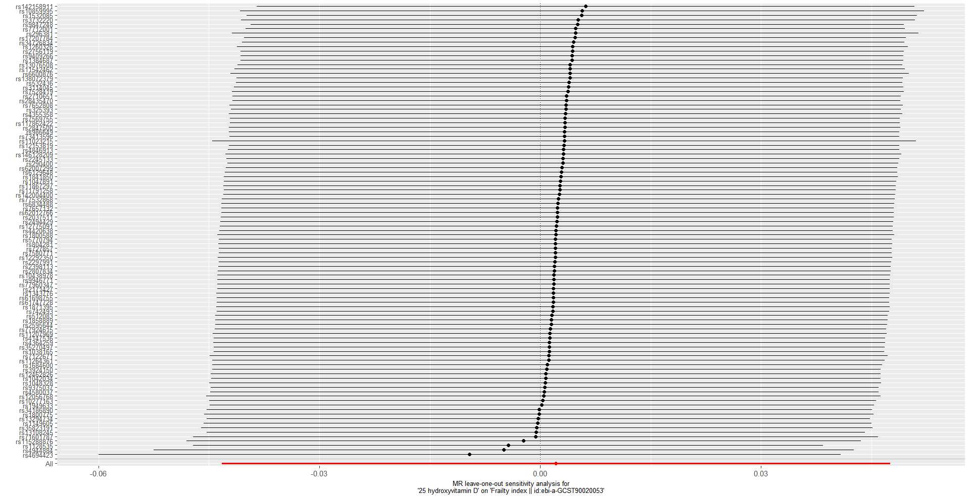
Figure 1 The leave-one-out method of analysis of frailty and vitamin D in the primary analysis

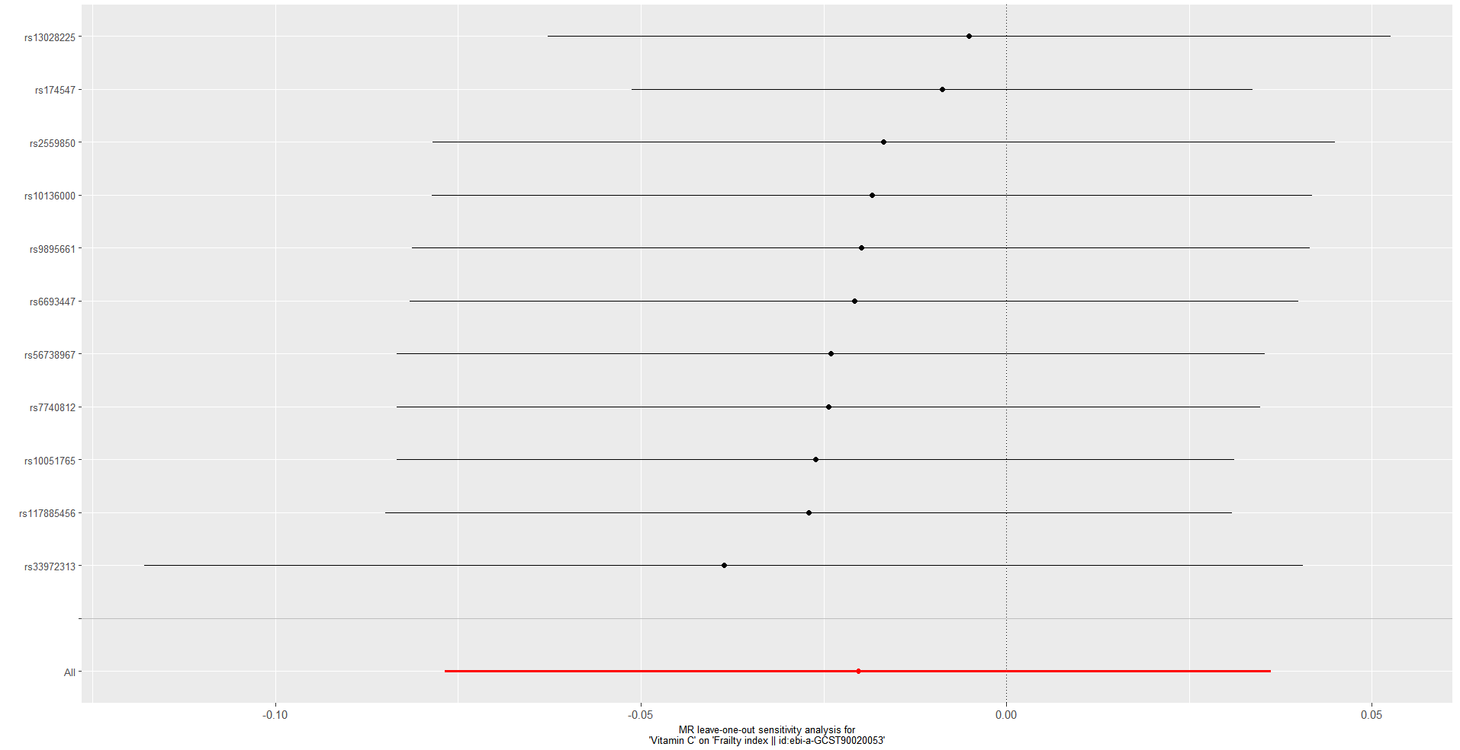
Figure 2 The leave-one-out method of analysis of frailty and vitamin C in the primary analysis

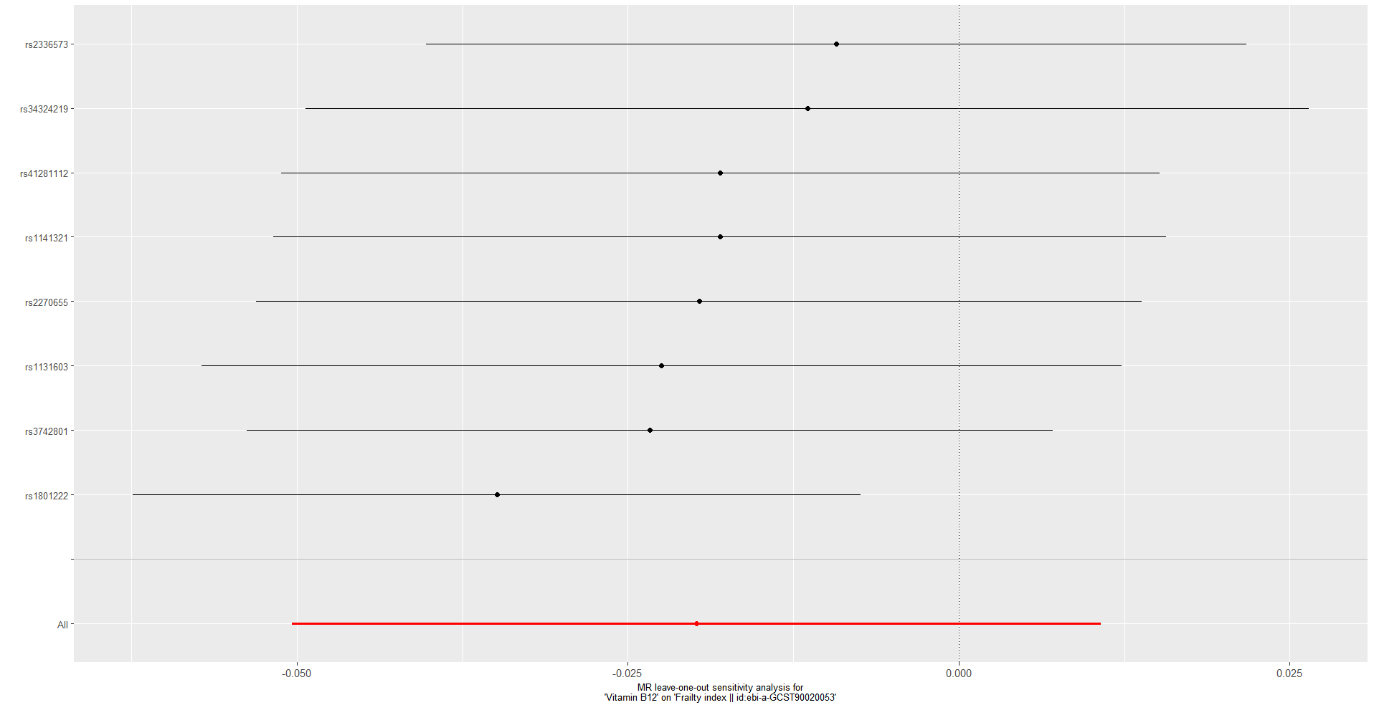
Figure 3 The leave-one-out method of analysis of frailty and vitamin B₁₂ in the primary analysis
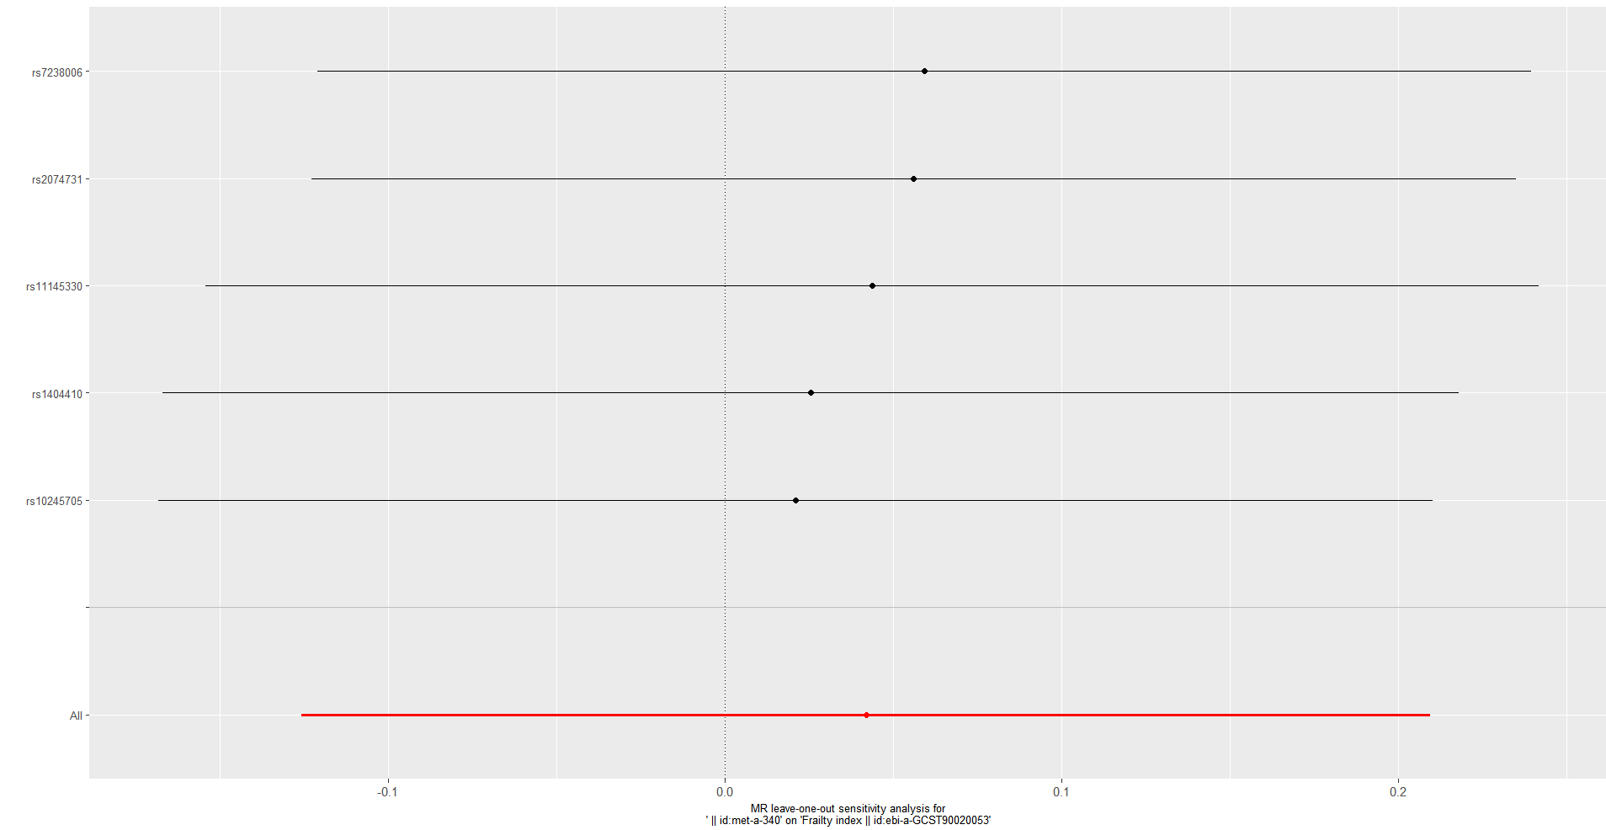
Figure 4 The leave-one-out method of analysis of frailty and vitamin E in the primary analysis

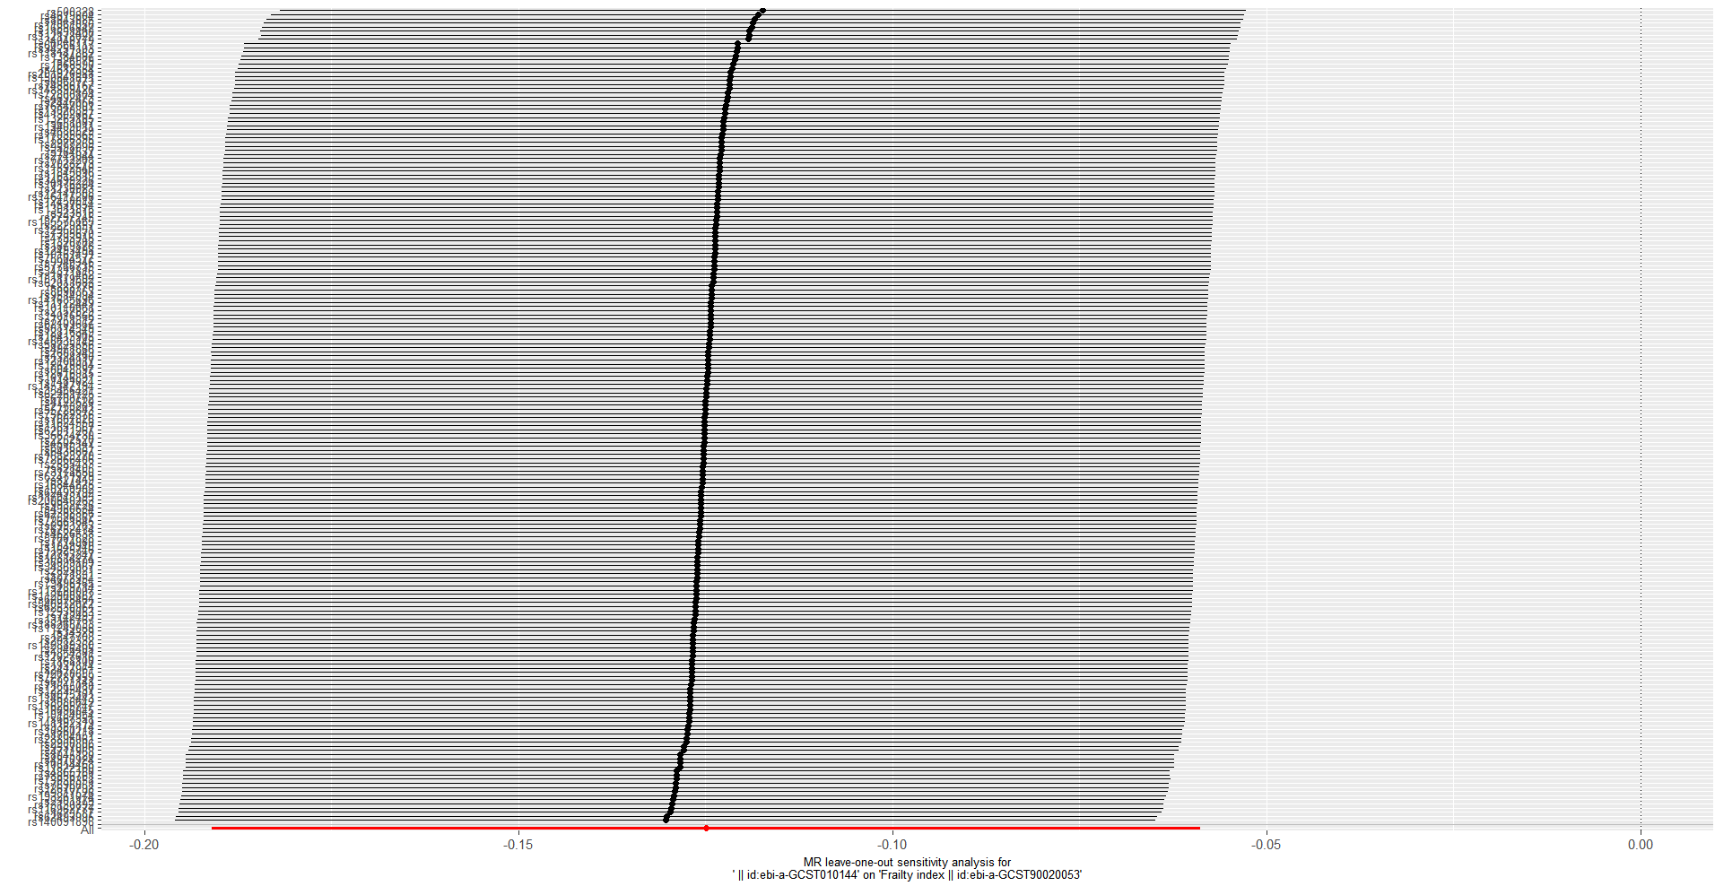
Figure 5 The leave-one-out method for the analysis of frailty and vitamin D in secondary analysis
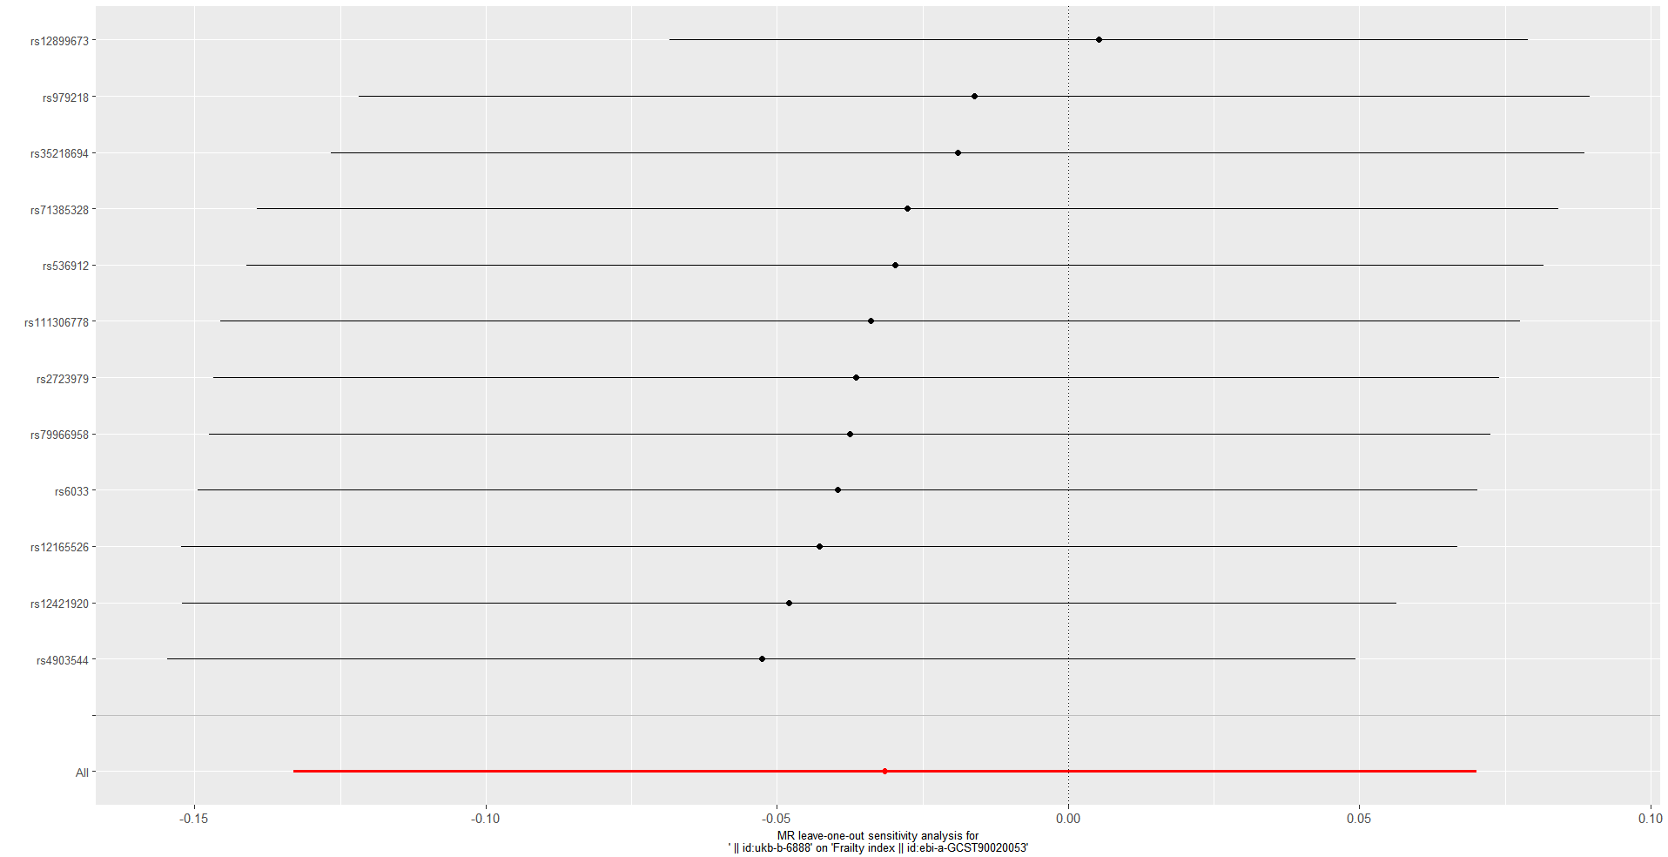
Figure 6 The leave-one-out method for the analysis of frailty and vitamin E in secondary analysis

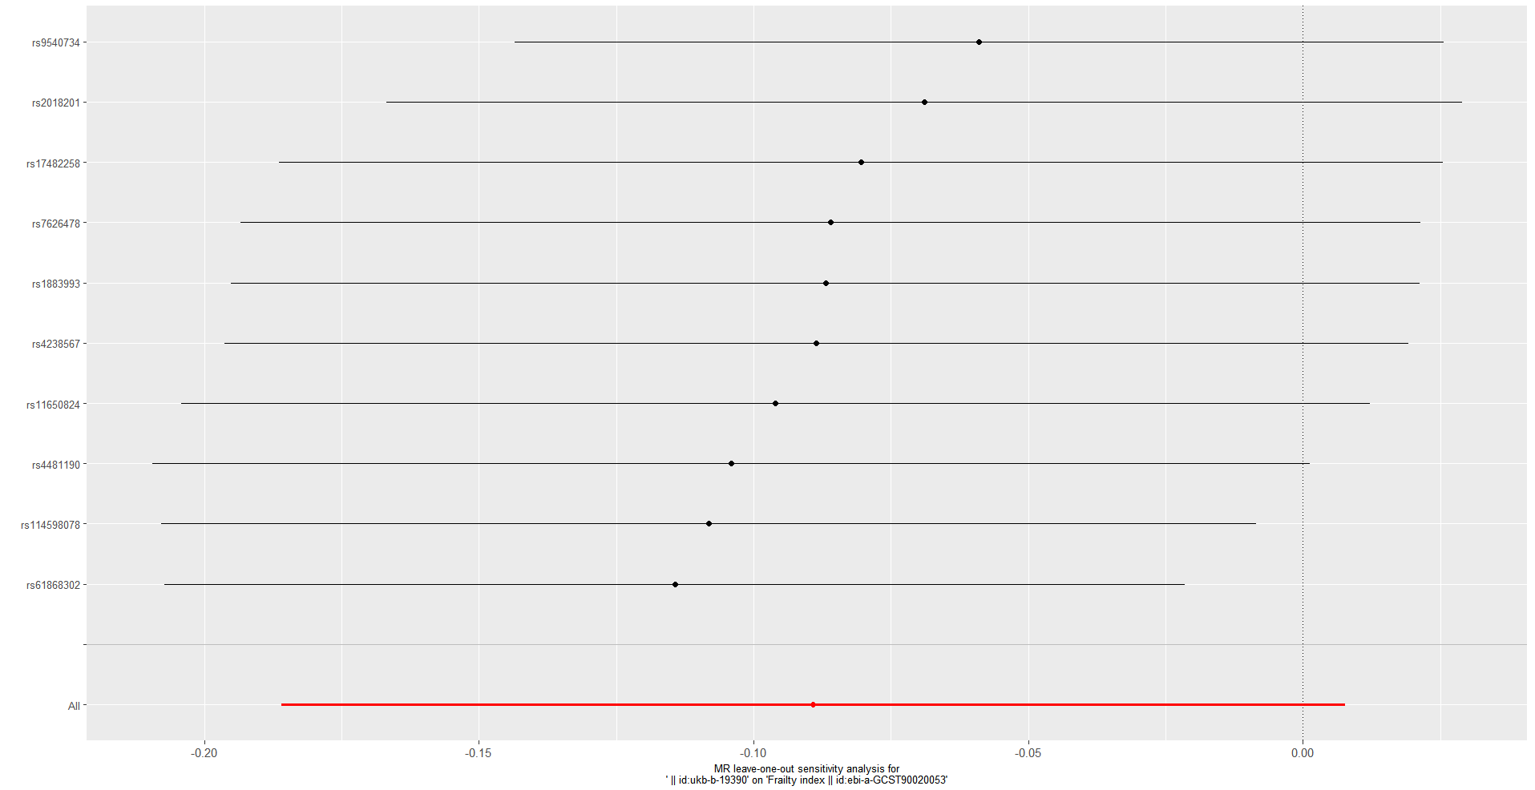
Figure 7 The leave-one-out method for the analysis of frailty and vitamin C in secondary analysis

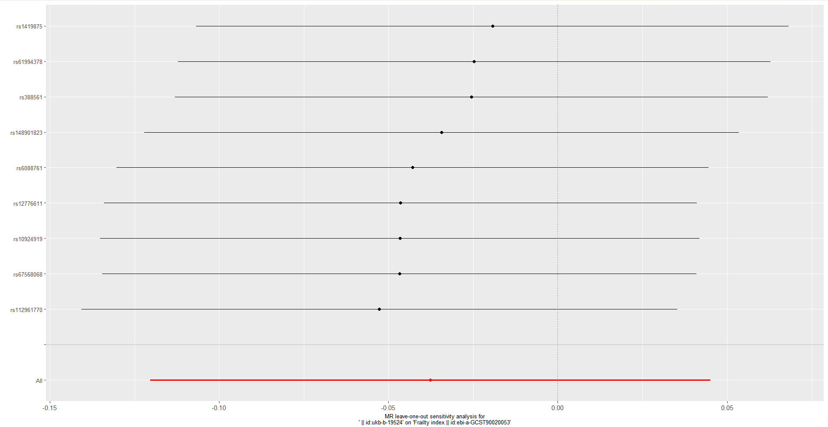
Figure 8 The leave-one-out method for the analysis of frailty and vitamin B₁₂ in secondary analysis

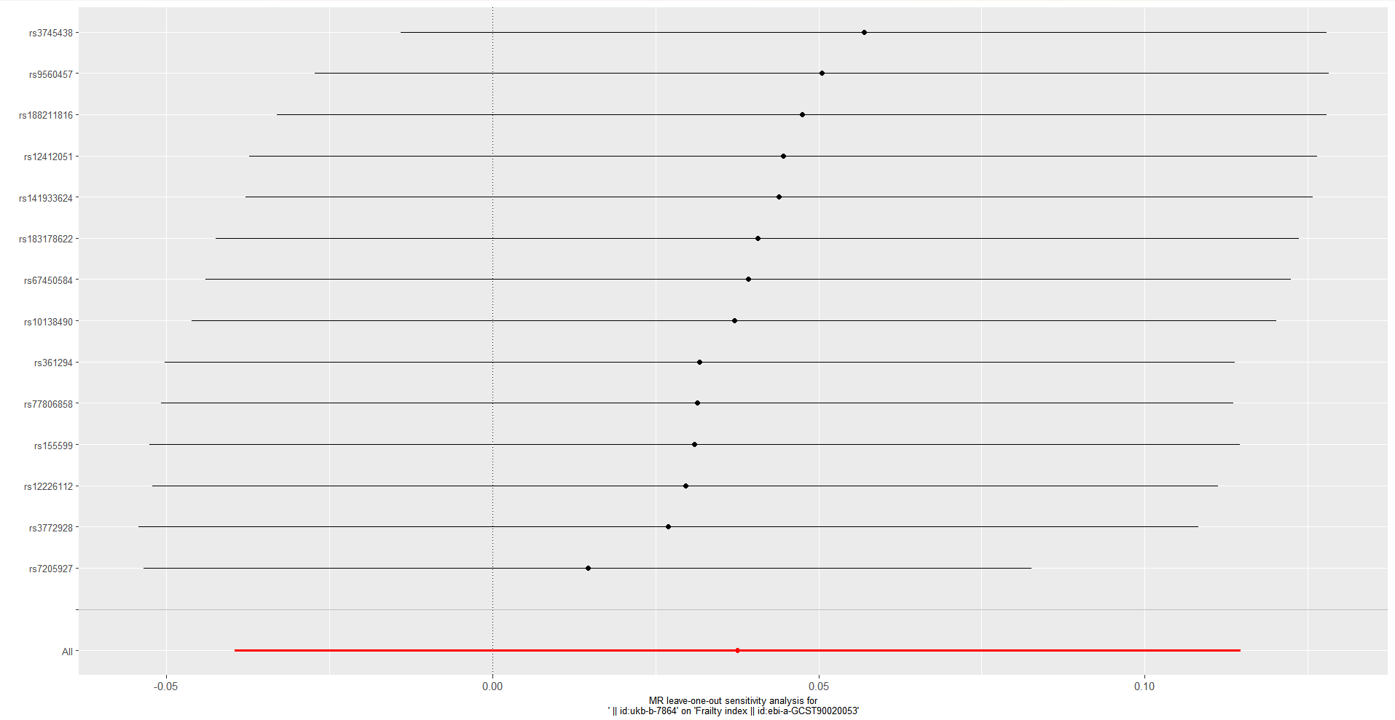
Figure 9 The leave-one-out method for the analysis of frailty and vitamin B₆ in secondary analysis

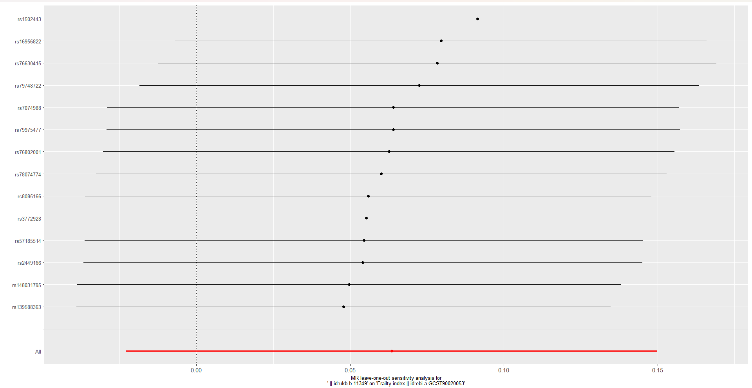
Figure 10 The leave-one-out method for the analysis of frailty and folate in secondary analysis

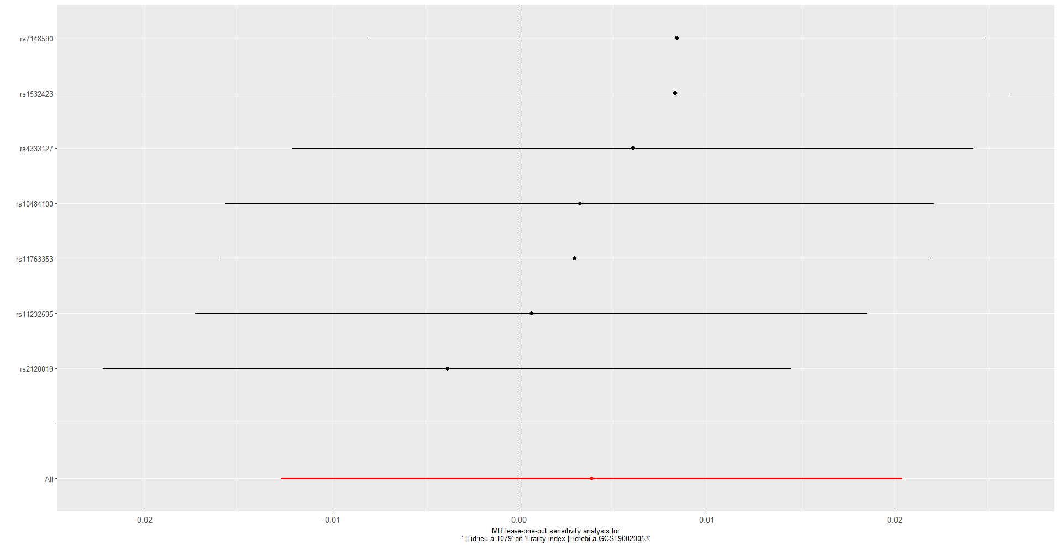
Figure 11 The leave-one-out method for the analysis of frailty and zinc in secondary analysis

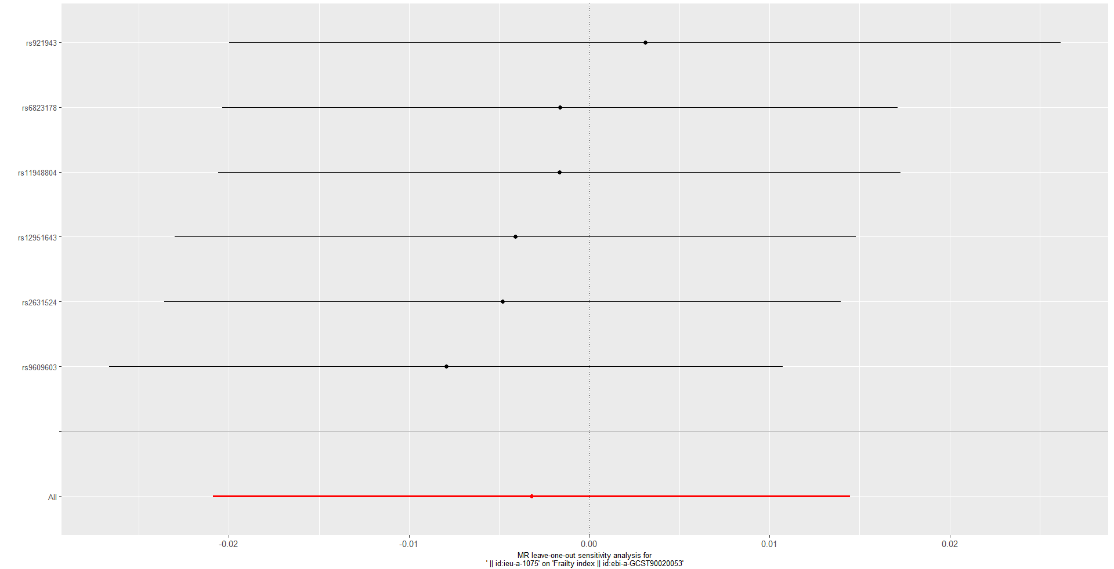
Figure 12 The leave-one-out method for the analysis of frailty and selenium in secondary analysis

