Supply Figures
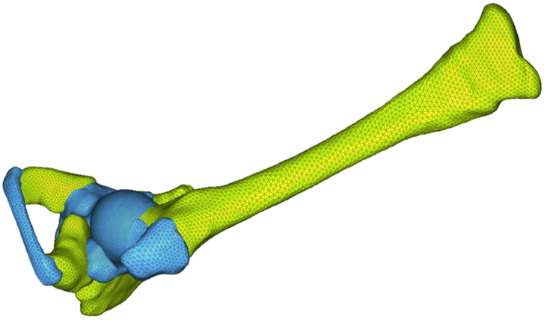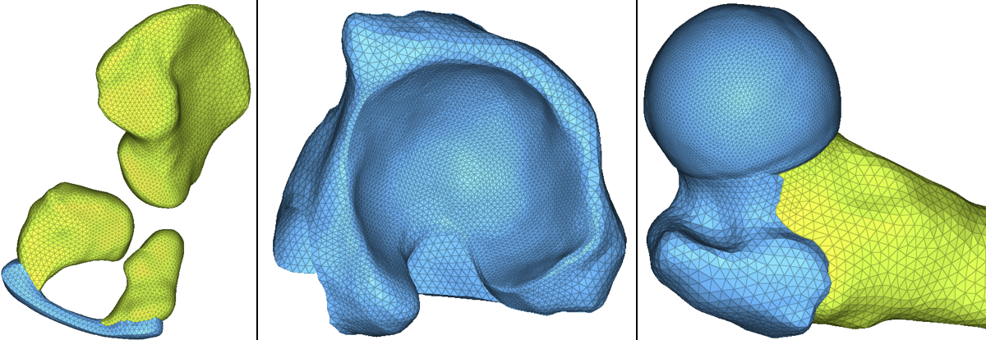
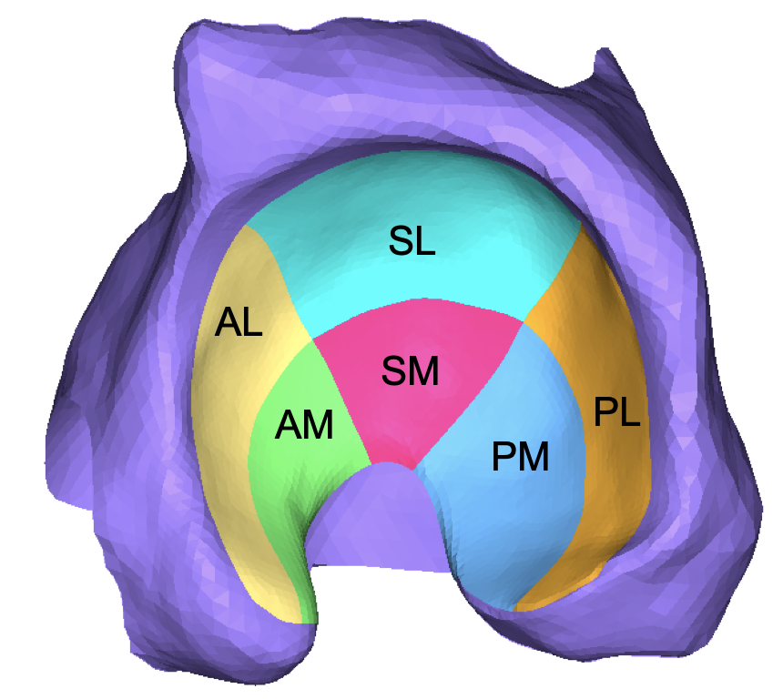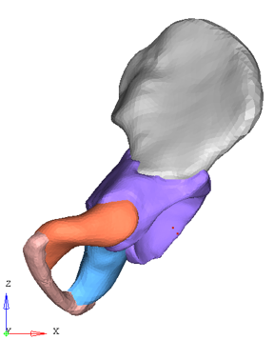
The established FEA models and anatomical regions defined on the acetabulum and defined X, Y, Z axis. X axis: from medial to lateral. Y axis: from anterior to posterior, Z axis: from inferior to superior.

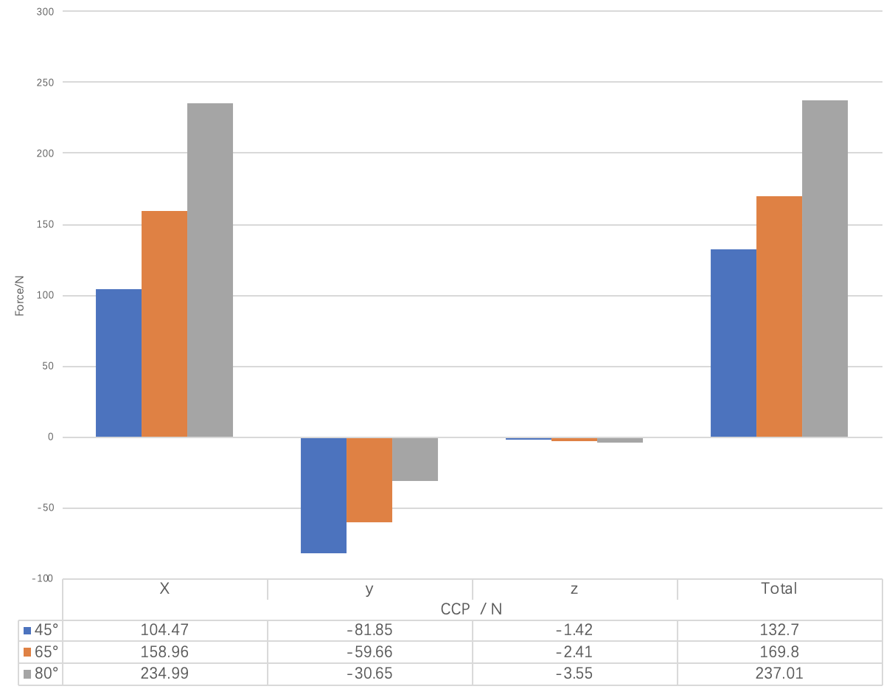

CCP under three axes with different abduction angles.

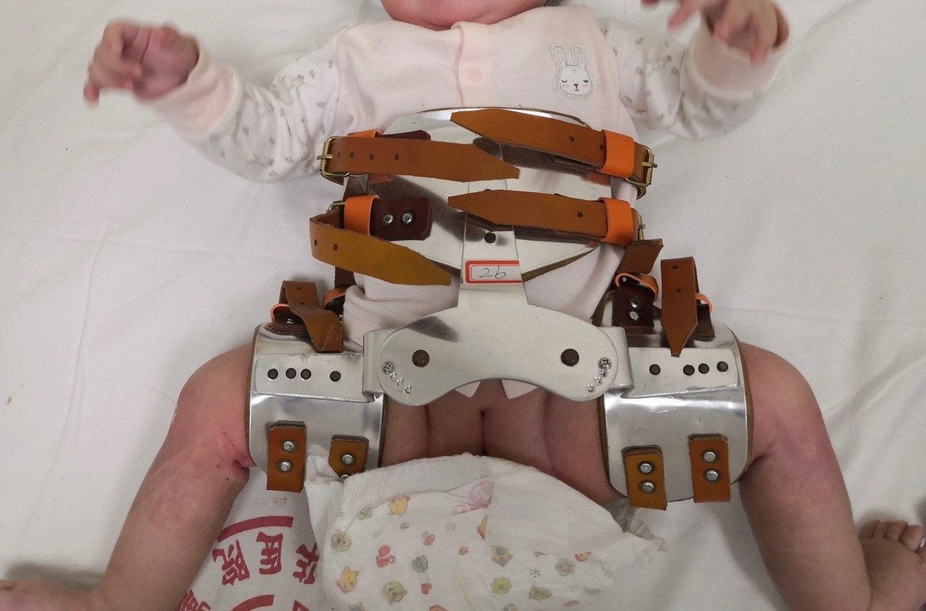
The orthosis used after plaster immobilization

