Supporting information

Exploration of novel TOSMIC tethered imidazo[1,2-a]pyridine compounds for the development of potential antifungal drug candidate.
Pratibha Shukla^{#1}. Deepa Deswal¹ . Mansi Pandit² . N Latha² . Divyank Mahajan³. Tapasya Srivastava³. Anudeep K. Narula^{#1*}

A.K.Narula
aknarula@ipu.ac.in

Pratibha Shukla
pratibhashukla987@gmail.com

Deepa Deswal
deswaldeepa@gmail.com

Mansi Pandit
mansipandit17@gmail.com
N Latha
lata@bic-svc.ac.in

Divyank Mahajan
divyankgene@gmail.com

Tapasya Srivastava
tapasya@south.du.ac.in

# University School of Basic and Applied Sciences Guru Gobind Singh Indraprastha University
New Delhi-110078, India
¹Centre of Excellence in Pharmaceutical Sciences (CEPS) Guru Gobind Singh Indraprastha University, Delhi-110078, India
² Bioinformatics Infrastructure Facility, Sri Venkateswara College, University of Delhi, Benito Juarez Road, New Delhi, 110021, India
³Department of Genetics, University of Delhi South Campus, Benito Juarez Road, New Delhi, 110021, India
Experimental details
General considerations
All the chemicals used in the study were purchased from commercial suppliers. Thin Layer Chromatography (TLC) was performed using Merk F254 aluminum sheets as stationary phase and Ethyl acetate and methanol (70:30) as mobile phase to monitor the reactions. The TLC plate spots were detected by dipping in the Dragendorff’s reagent and by viewing under UV light. The synthesized compounds were purified using column chromatography. ¹HNMR and ¹³CNMR spectra were obtained using JEOL-400 NMR spectrophotometer at room temperature (RT) using deuterated chloroform (CDCl₃ ) as solvent and Tetramethylsilane (TMS) as an internal standard. The chemical shifts in NMR spectra are reported as ᵟ (ppm), coupling constants were reported in Hertz (Hz) and splitting patterns are described as s (singlet), d (doublet), t (triplet), q (quartet), m (multiplet), and dd (doublet of doublet).

General reaction procedure:
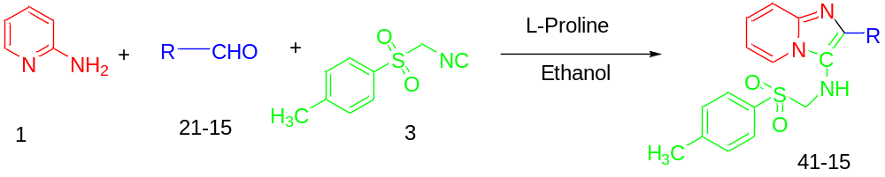
Figure 1: Model Reaction
The title compounds were synthesized as outlined in Figure 1. 2-Aminopyidine (1mmol, 1equiv.), TOSMIC (1mmol, 1equiv.) and the corresponding aldehydes (1mmol, 1equiv.) and L-Proline (20 mol %) were placed in a 50 ml sealed flask equipped with magnetic stirring bar in Ethanol [1mmol= 3ml of ethanol]. Then the mixture was stirred at room temperature (RT) for 6h. Completion of the reaction was observed by TLC using Hexane: Ethyl acetate (1:1) which clearly indicated the disappearance of starting materials and the spot was stained in dragendorff’s reagent which confirmed the formation of new ring system. The solvent was removed by rotary evaporation; complete content was washed with water for the removal of non reacted L- Proline and dried over anhydrous Na₂SO₄ to remove aqueous traces. Finally the product was washed with chloroform: ethanol (8:2) v/v to obtained pure compound. Residue was purified by column chromatography using mixtures of Hexane – EtOAc (v/v) in different proportions to afford the different imidazo[1, 2-a] pyridine derivatives.

Spectra’s of the most promising compounds [12 and 15]

12. 2-(2, 3-dimethoxynaphthalen-1-yl)-N-(tosylmethyl)imidazo[1,2-a]pyridin-3-amine.

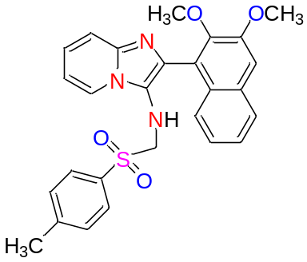

Yield 82%; ¹H NMR (400 MHz, Chloroform-d) δ 8.00 (1 H, dt, J = 6.3, 3.5 Hz), 7.62 (1 H, dt, J = 7.0, 3.5 Hz), 7.32 (2 H, dq, J = 7.0, 3.6 Hz), 7.19 (2 H, s), 7.08 (1 H, s), 4.91 (1 H, s) 3.88 (6 H, d, J = 27.5 Hz), 3.50 (2 H, t, J = 6.6 Hz), 2.24 (3 H, m), 1.16 ( 1 H, s). ¹³C NMR (101 MHz, Chloroform -d) δ 151.85, 150.75,144.42, 143.21, 141.57, 131.56, 130.49, 130.17, 128.94, 128.54, 126.94, 125.93, 125.38, 124.58, 124.36, 120.16, 119.31, 115.03, 113.17, 107.67, 77.43, 63.56, 62.14, 55.71, 29.80. LC-MS : m/z calculated [M+H]⁺ = 488.1644, found = 488.1646

Figure: ¹H and ¹³C spectra of compound 12
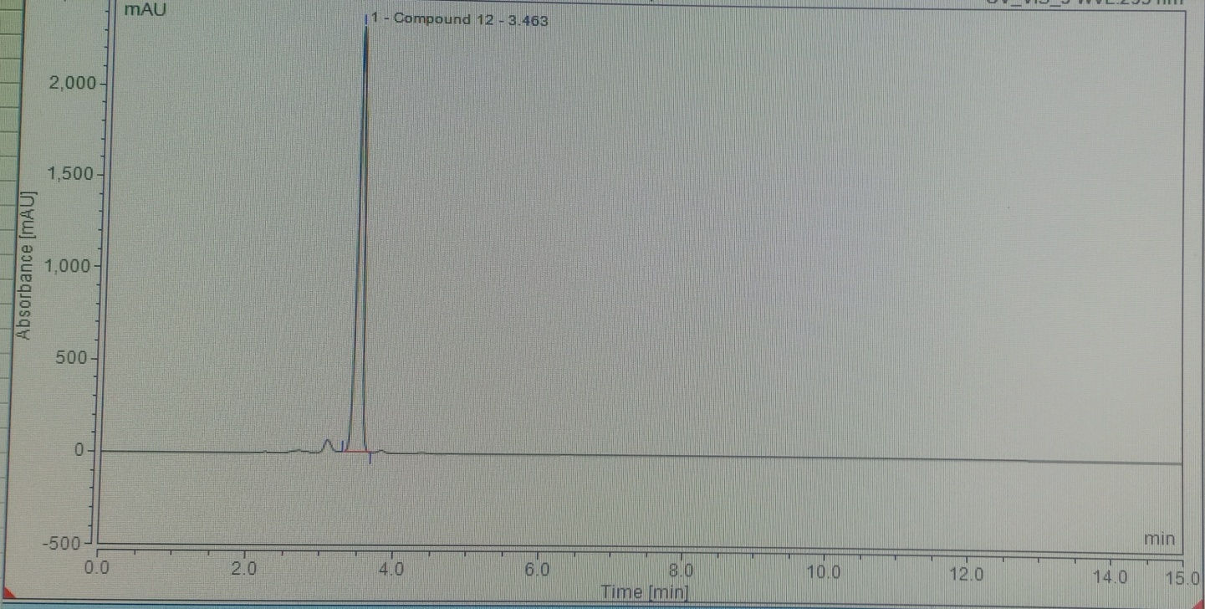
Figure: HPLC data of Compound 12.

15. 2-(1H-pyrrol-2-yl)-N-(tosylmethyl)imidazo[1,2-a]pyridin-3-amine.

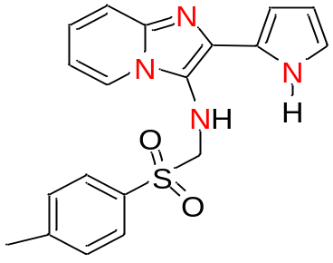

Yield 94%; ¹H NMR (400 MHz, Chloroform-d) 8.23 (1 H, s), 7.96 – 7.88 (2 H, m), 7.48 (1 H, d, J = 2.8 Hz), 7.34 – 7.23 (2 H, m), 7.00 (`1 H, dd, J = 4.0, 2.8 Hz), 6.80 (1 H, dd, J = 3.8, 1.2 Hz), 4.91 (1 H, s), 2.39 (3 H, s), 1.23 (2 H, s).¹³C NMR (101 MHz, Chloroform -d) δ 148.59, 144.55, 141.16, 138.80, 136.59, 129.82, 128.69, 127.95, 123.76, 118.58, 115.44, 113.96, 106.28, 62.82, 21.74. LC-MS : m/z calculated [M+H]⁺ = 367.1228, found = 367.1235.

Figure: ¹H and ¹³C spectra of compound 15.
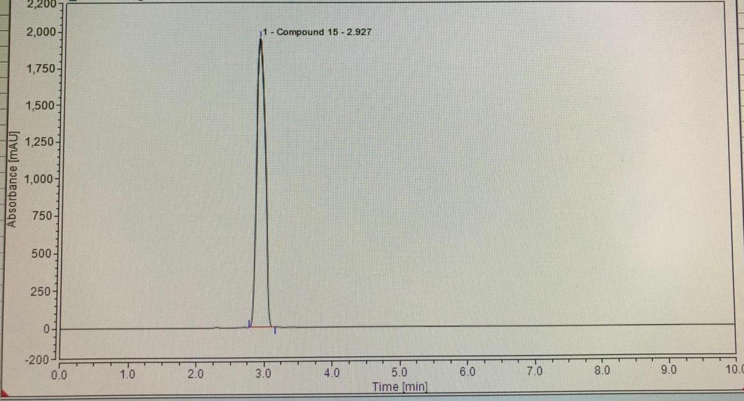
Figure: HPLC data of the Compound 15.

