Supplementary data
Novel fabricated chitosan supported bimetallic nanocomposites for paracetamol removal from homogeneous solutions and heterogeneous mixtures with focused antibacterial studies
Gautam V. Priyadarshiª, Nirav P. Raval^{b}, Damia Barcelo^{c,d}, and Mrugesh H. Trivedi^{a,*}
ª Department of Earth and Environmental Science, KSKV Kachchh University, Bhuj-Kachchh, Gujarat – 370001, India
^{b} Department of Environmental Science and Engineering, School of Engineering and Sciences, SRM University-AP, Amaravati, Andhra Pradesh – 522 240, India
^{c} Department of Environmental Chemistry, Institute of Environmental Assessment and Water Research, IDAEA-CSIC, Jordi Girona, 18-26, 08034 Barcelona, Spain.
^{d} Sustainability Cluster, School of Engineering, UPES, Dehradun, India.

*Corresponding Author:
Mrugesh H. Trivedi, Ph.D.
Assistant Professor | Dept. of Earth and Environmental Science | Block-A|
Krantiguru Shyamji Krishna Verma Kachchh University | Bhuj-Kachchh |
Gujarat - 370015 | India |
+91-9429613901 |
drmrugesh.trivedi@gmail.com | drmrugesh.trivedi@kskvku.ac.in|

List of Supplementary Figures and Tables

Fig. S1. | TEM images of synthesized ZnO NPs (a), Fe₃O₄ NPs (b) and bimetal-oxide (Zn-Fe) NPs (c).
Fig. S2. | EDS spectra of synthesized nanocomposite beads before and after PCM adsorption.
Fig. S3. | XPS analysis of CTS-TPP/Zn, CTS-TPP/Fe & CTS-TPP/Zn-Fe beads high resolution spectrum for C 1s (a-c), N 1s (d-e) and O 1s (g-i).
Fig. S4. | Proposed adsorptive removal mechanism for PCM using CTS supported metal-oxide nanocomposite beads.
Table S1 | Physicochemical characteristics of PCM.
Table S2 | Isotherm and kinetic equations used to model the PCM adsorption onto nanocomposite beads.

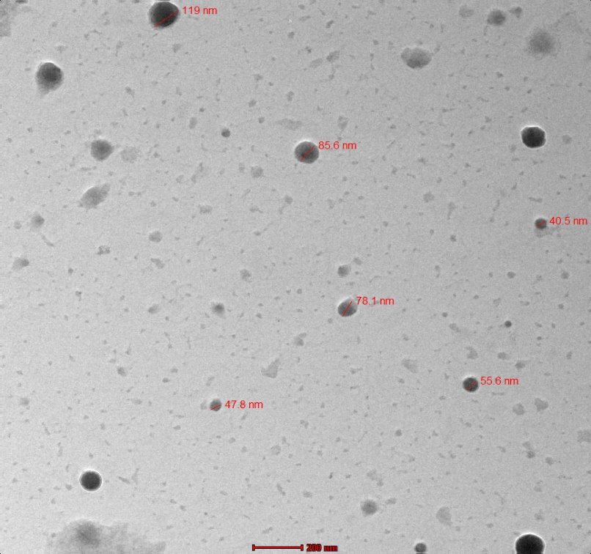
(a)
(b)
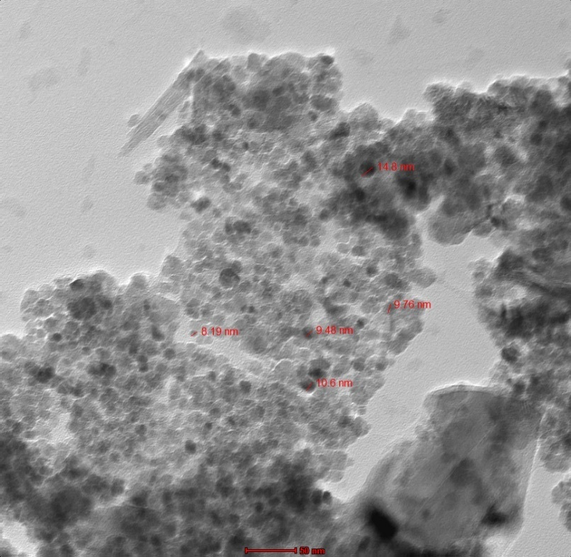
(c)

Fig. S1.

Fig. S2.

Fig. S3.

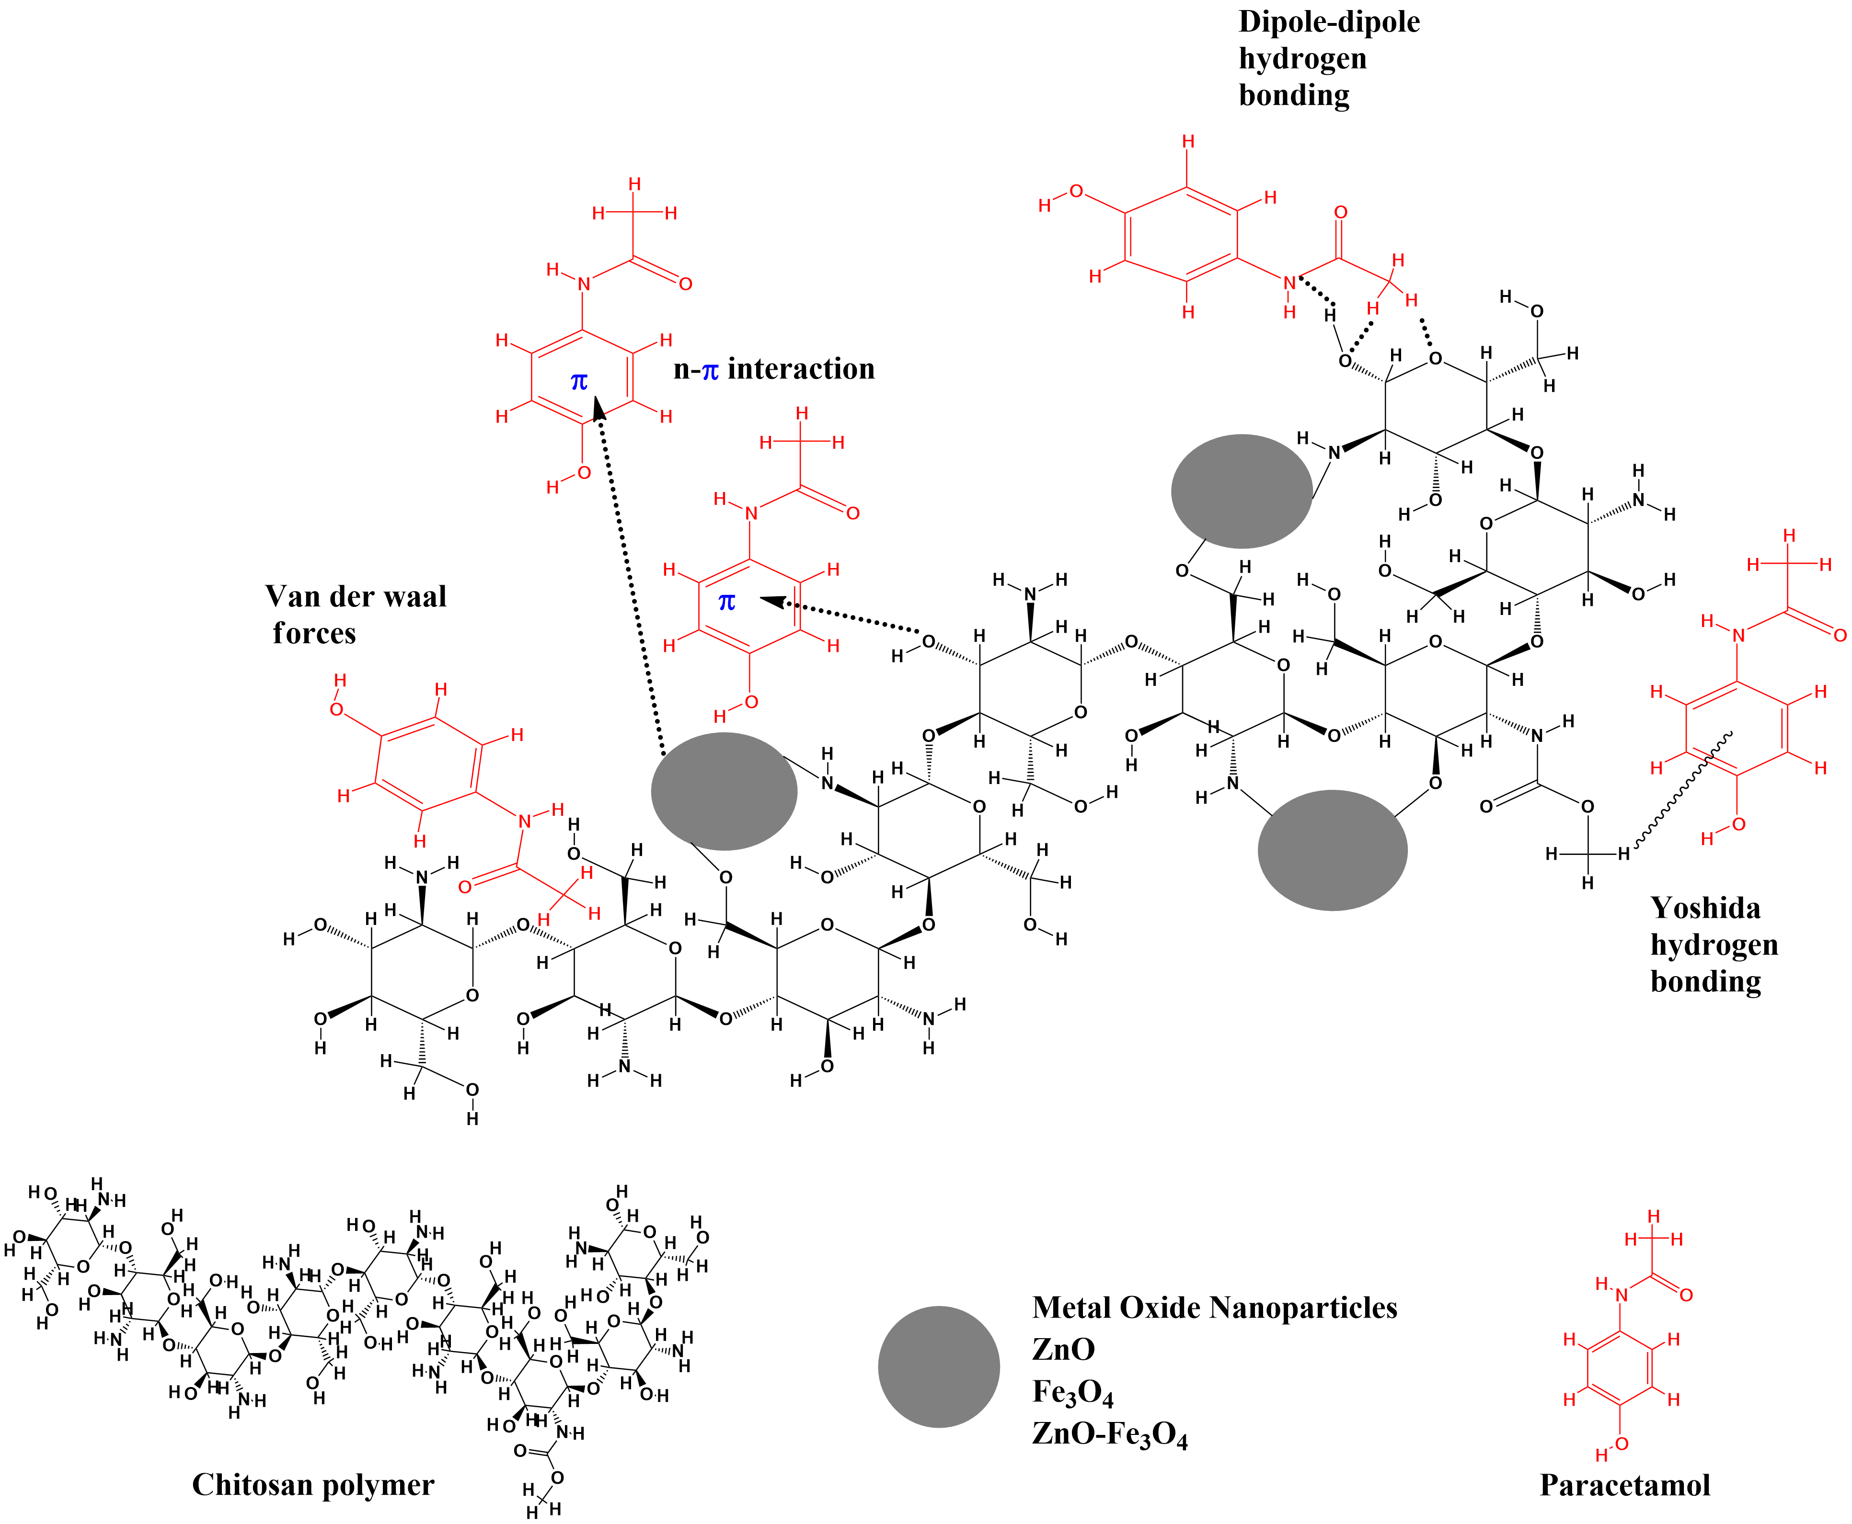
Fig. S4.

Table S1. Physicochemical characteristics of PCM.

Molecular Weight | 151.16
Molecular Formula | C₈H₉NO₂
Molecular weight | 151.16
CAS No. | 103-90-2
Melting Point | 169 °C (336 °F)
Solubility in water at 28 °C | 19 g L⁻¹
pH speciation curve for PCM
pH | 5.5 – 6.5 at 20 °C
Decomposition temperature | > 180 °C

Table S2: Isotherm and kinetic equations used to model the PCM adsorption onto nanocomposite beads.
PCM removal efficiency (%) |  | $$\frac{\left(C_{i}-C_{f}\right)}{C_{i}} X 100 \%$$ | C_{i} (mg L⁻¹) = Initial concentrations of PCM  C_{f} (mg L⁻¹) = Equilibrium concentrations of PCM.
PCM adsorption capacity onto beads (mg g⁻¹) |  | $$\frac{\left(C_{i} - C_{f}\right) ×(V)}{W}$$ | V (L) = PCM solution volume  W (g) = Amount of adsorbent.
Isotherm | Model |  | Parameters
Langmuir | $$Q_{e}{=}\frac{Q_{max} K_{L} C_{f}}{1+ K_{L} C_{f}}$$ |  | C_{f} (mg L⁻¹) = equilibrium concentrations of PCM,  Q_{max} (mg g^{–1}) = Langmuir monolayer adsorption capacity,  Q_{e} (mg g^{–1}) = Equilibrium adsorption concentration of PCM onto beads,  K_{L} (L mg^{–1}) = Langmuir constant
Freundlich | $$Q_{e}{= K_{F} C_{f}^{1/n}}$$ |  | K_{F} (L mg⁻¹) and 1/n = the empirical Freundlich adsorption constant and exponent associated with the adsorption capacity and intensity, respectively.
Kinetics | Model |  | Parameters
Pseudo-first-order | $Q_{t}{= Q_{e} (1 - e^{-k_{1} t}}$) |  | $Q_{e}{ and Q}_{t}$ (mg g⁻¹) = PCM adsorption capacity at time equilibrium and at time t, respectively. $k_{1}$(min⁻¹) = the pseudo-first order rate constant.
Pseudo-second-order | $$Q_{t}=\left(\frac{Q_{e}^{2} k_{2} t}{1+ Q_{e}k_{2} t}\right)$$ |  | $k_{2}$ (g mg⁻¹ min⁻¹) = the pseudo-second order rate constant.

