Supplementary Materials for

Kirigami-Inspired, Three-Dimensional Piezoelectric Pressure Sensors Assembled by Compressive Buckling

Yi Zhang et al.

*Corresponding author. Changbo, Liu liuchb@buaa.edu.cn; Yuan Deng, dengyuan@buaa.edu.cn

This PDF file includes:

Supplementary Text
Figs. S1 to S7

Supplementary Text
The formation device of 3D Kirigami structures.
In order to produce a 3D structure of the 2D film, an elastic substrate with pre-strain is used to provide stable support for the structure. Four reciprocating sliding rails with a range of 50 mm and a control accuracy of 1mm are symmetrically placed which enabled bidirectional stretching of the elastic substrate on the X and Y axes (see Fig. S1a, SI). The front end of the slide rail is provided with a fixed device for fixing the elastic substrate.
Characterization of the packaging materials.
To test the Young’s moduli of encapsulation materials, the sample is made into a strip with a length of 30mm and a width of 20mm, and stretched on the tensile testing machine at a constant rate to obtain the relationship curve of load with displacement. Then the stress-strain curve is calculated according to the size of the specimen. As shown in Fig. S5, SI, the Young's modulus of the sample is calculated from the elastic part of the stress-strain curve. The test results show that the Young's modulus of EcoflexTM is about 50 kPa, which is in accordance with the instructions. And the Young's moduli of the other three AB type silicones are 170 kPa, 410 kPa and 1000 kPa respectively.
Equivalent stiffness in finite element analysis.
Owing to the deformation complexity of PVDF films with 3D structure, it is difficult to calculate the overall stiffness of the structure. Therefore, the equivalent stiffness is used to denote the deformation resistance of the film. The equivalent stiffness is calculated through the following equation:
$$k=\frac{F}{d_{upper}}$$
Here, $k$ is the equivalent stiffness of the film with 3D Kirigami structures, $F$ is the vertical pressure acting on the upper surface of the sensor, and $d_{upper}$ is the longitudinal displacement that the upper surface of the sensor moves.
The model of packaging in finite element analysis.
Here, the Yeoh model is used to establish the finite element model of the encapsulation material. The Yeoh model, which provides the smallest residual sum of squares (RSS) of the three hyperelastic constitutive equations, is more reliable, efficient, and accurate than the neo-Hookean, Mooney-Rivlin models. As with other hyperelastic models, we describe this model in terms of elastic strain energy functions. The elastic strain energy function of the Yeoh model is:
$$W=\sum_{i=1}^{N}{c_{i0}}{({\overline{I}}_{1}-3)}^{i}+\sum_{k=1}^{N}{\frac{1}{D_{k}}{(J-1)}^{2k}}$$
where J is the volume ratio after deformation to before deformation, and for incompressible materials, J = 1. I₁ is the first strain tensor invariant. N, C_{i0} and D_{i} are input parameters. From the strain energy function, it can be seen that Yeoh also belongs to the family of polynomial forms. Owing to regardless of the role of the second tensor invariant I₂, Yeoh is much simpler formally than Mooney–Rivlin at the same order, except that terms with incompressible parameter D have higher-order complexity. Although the order parameter N can be large, in practice, we only use order 3 at most. Since when N = 1, it is equivalent to the neo-Hookean model, the 3rd-order version of N = 3 is generally used to reflect the superiority of the Yeoh model.

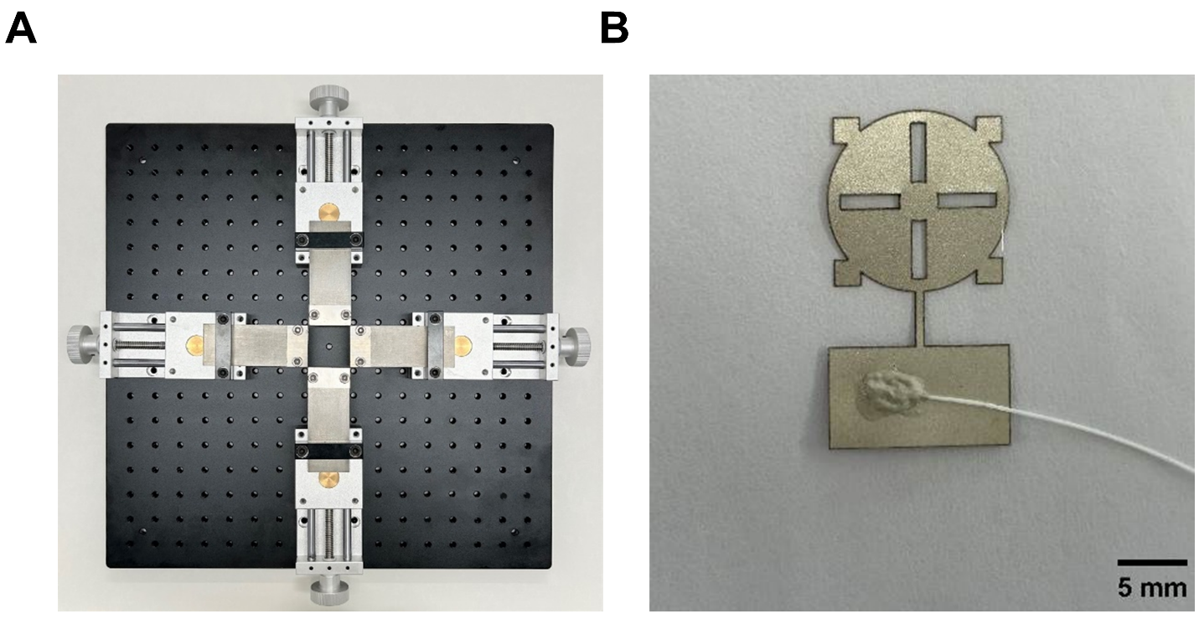

Fig. S1. Fabrication details of the 3D Kirigami structures. (A) manual tensile platform. (A) patterned PVDF film with wires.

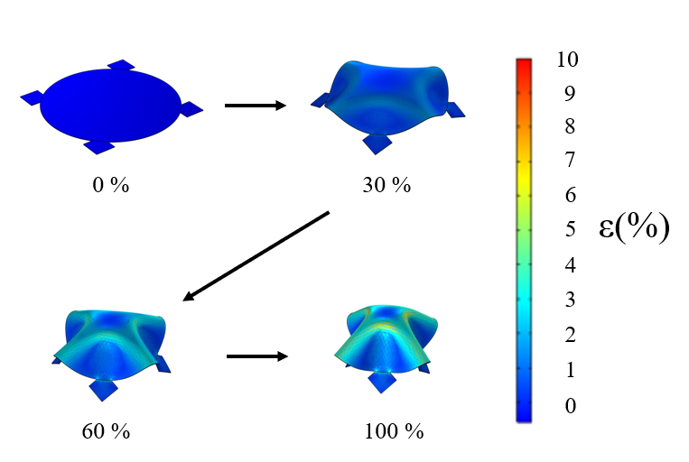

Fig. S2. Schematic of 3D-forming (elastic substrate shrinkage varies from 0% to 100%).

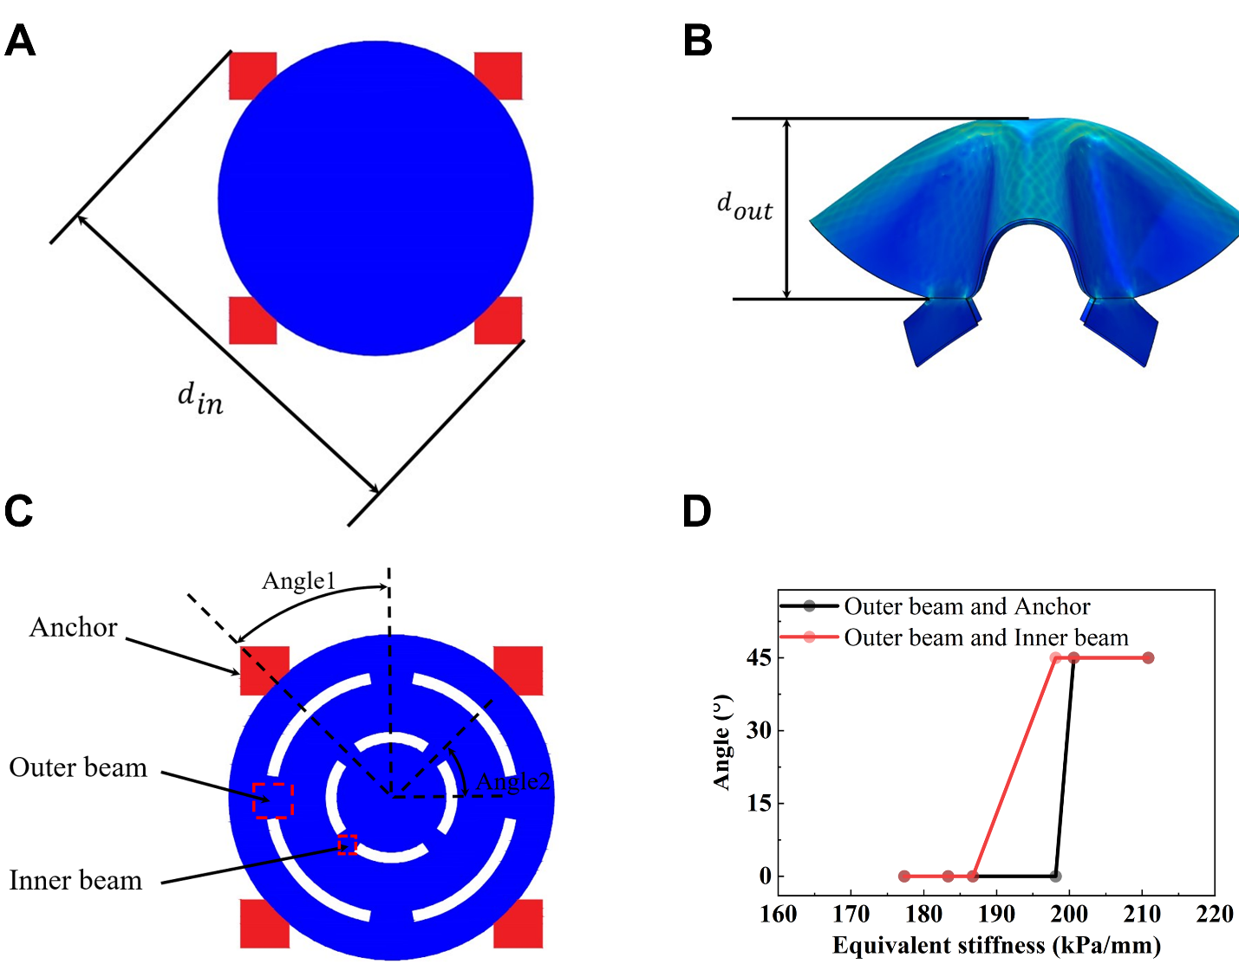

Fig. S3. Schematic of (A) d_{in}, (B) d_{out} in 3D structure. (C) Schematic of support, outer beam and inner beam in pattern design. (D) Dependence of angle between outer beam and support and inner beam on different equivalent stiffness.

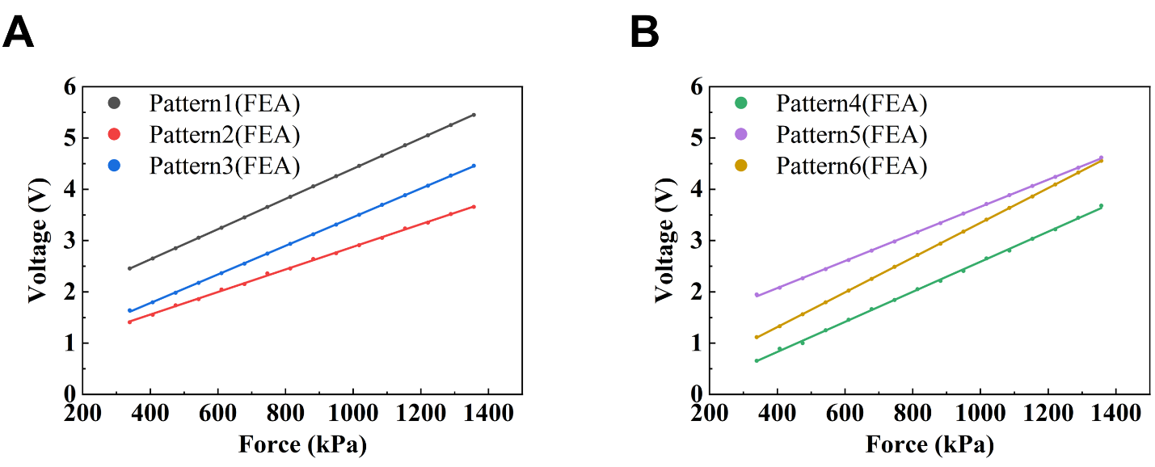

Fig. S4. Dependence of open-circuit voltage on different force. (A) Pattern 1, Pattern 2, Pattern 3. (B) Pattern 4, Pattern 5, Pattern 6 in FEA.

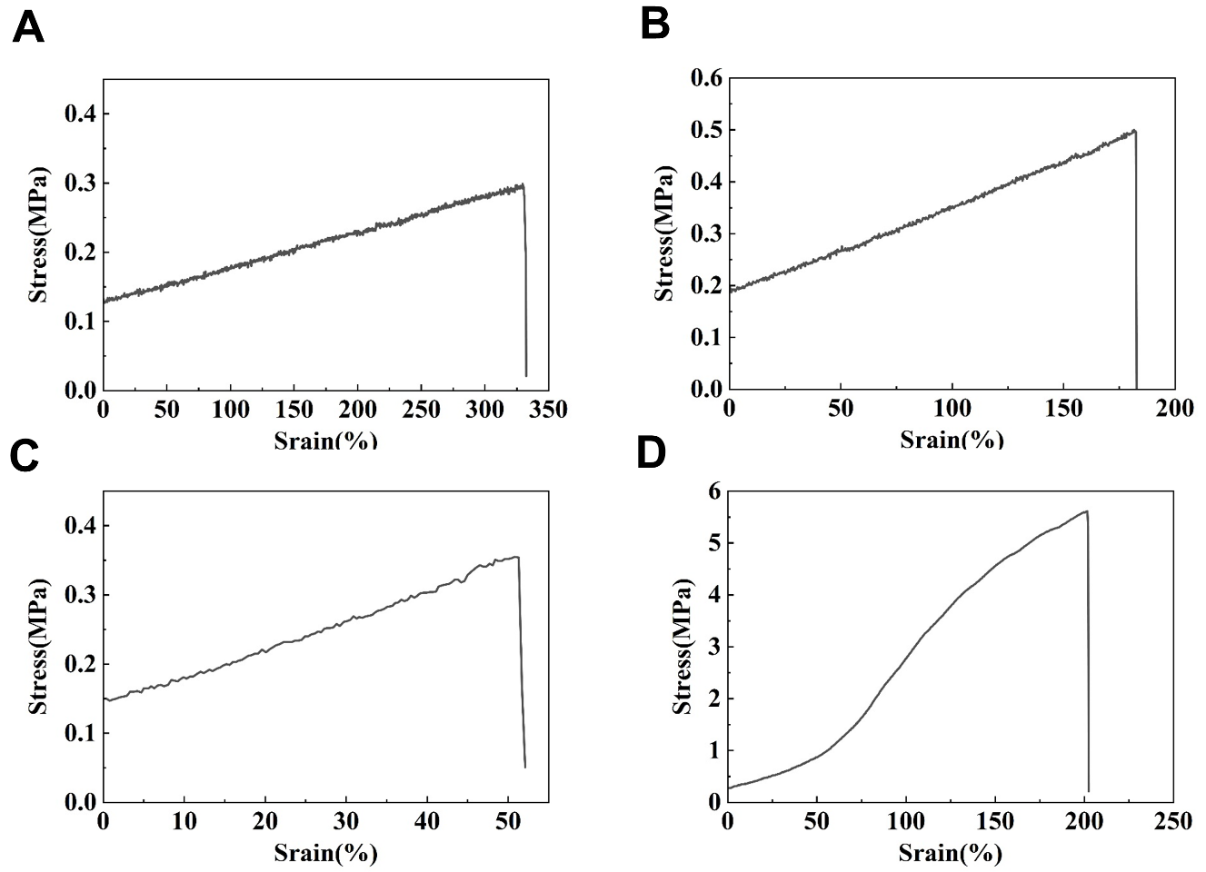

Fig. S5. Stress-strain curves. (A) M1. (B) M2. (C) M3. (D) M4.

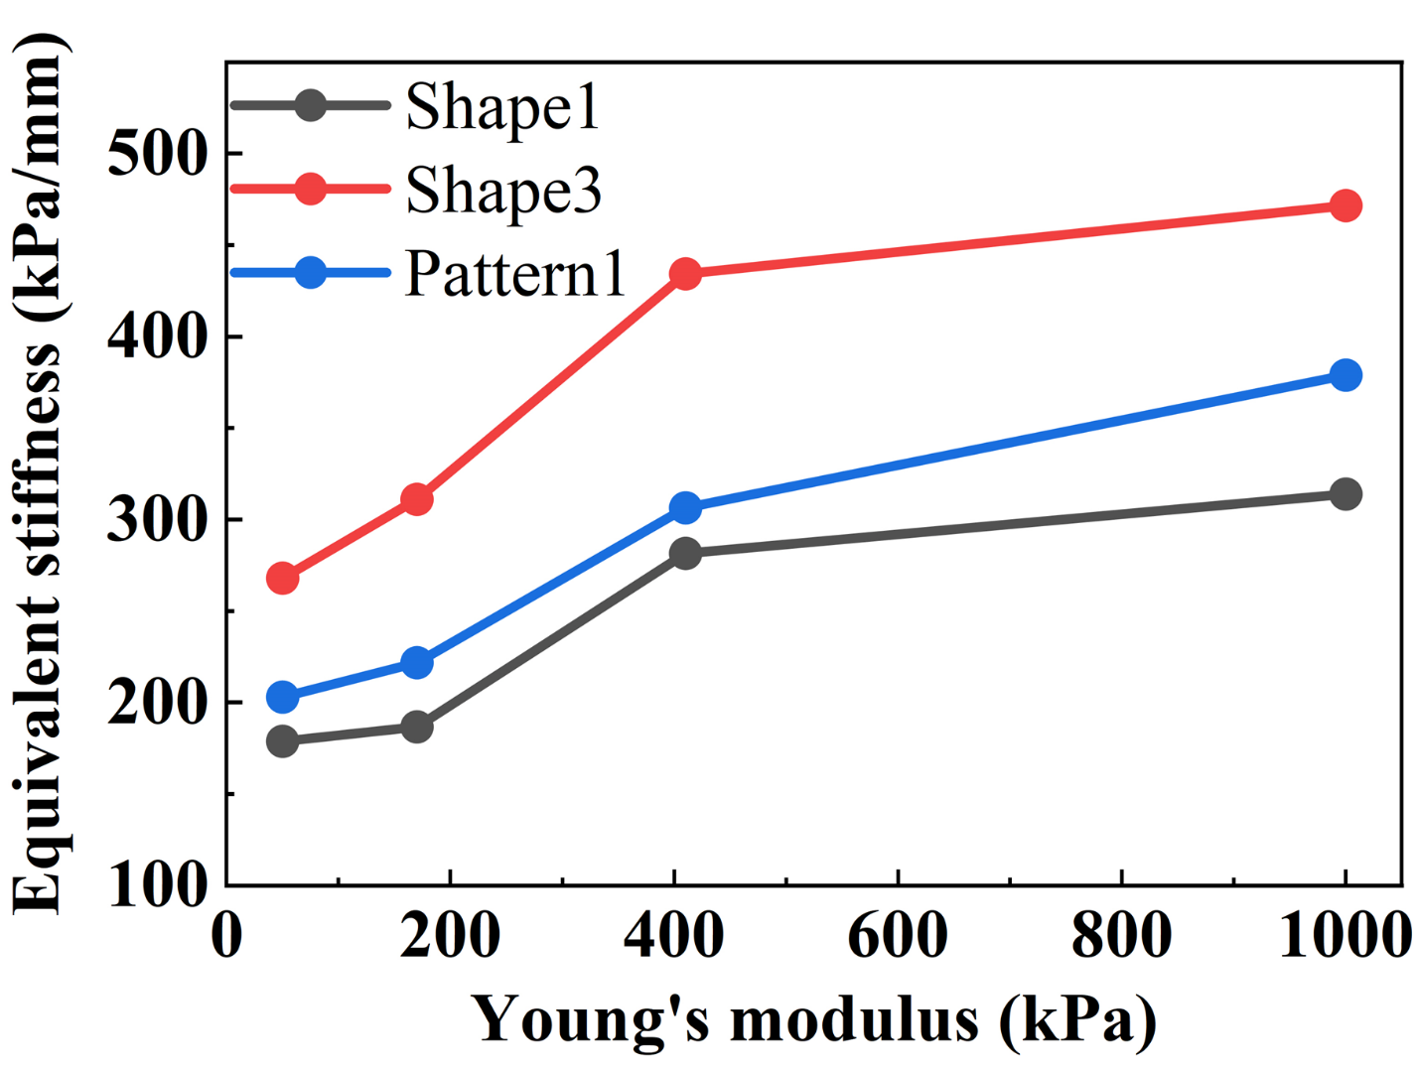

Fig. S6. Dependence of equivalent stiffness on different elastic modulus of packaging materials.

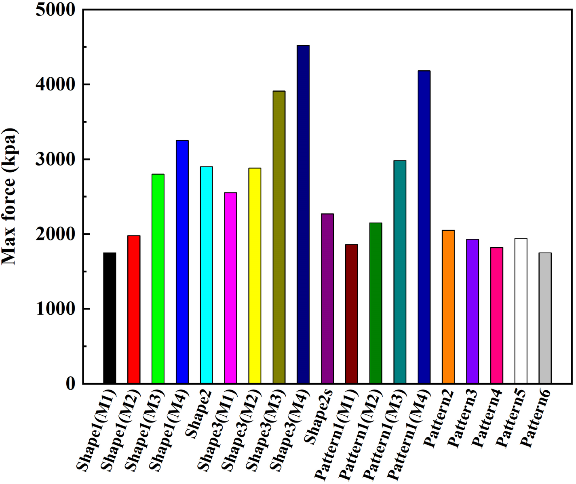

Fig. S7. The maximum pressure value predicted by finite element simulation.

