a b
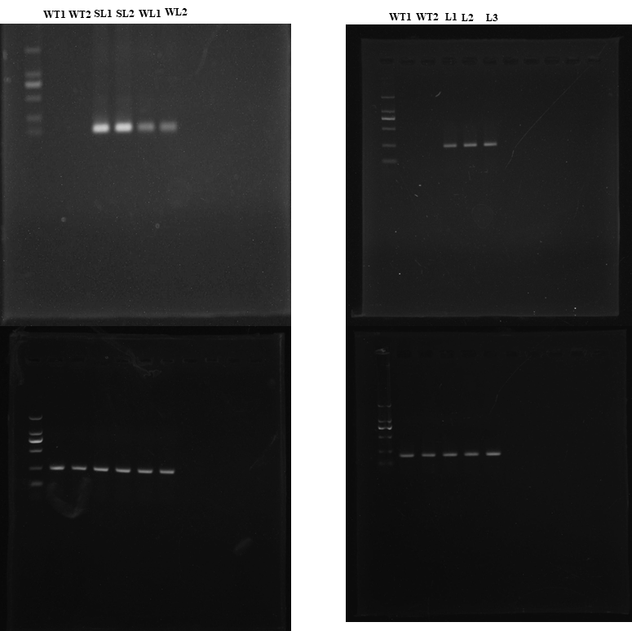

c d
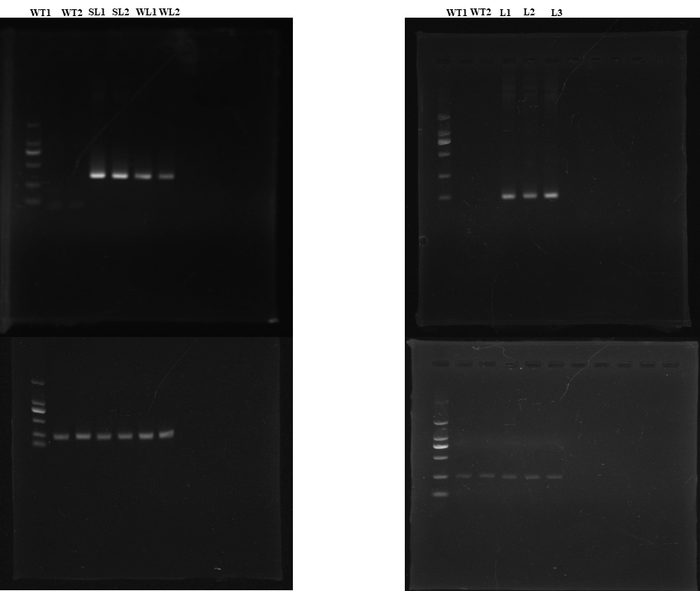
Fig. S3 Expression of TeAG1, TeAG2, TeAGL11-1 and TeAGL11-2 in seedlings of T1 transgenic lines by semi-quantitative RT-PCR. (a) 35S:TeAG1 transgenic lines. (b) 35S:TeAG2 transgenic lines. (c) 35S:TeAG11-1 transgenic lines. (d) 35S:TeAG11-2 transgenic lines. WT: wild type line; SL: strong phenotypic line; WL: weak phenotypic line; L: transgenic line. The constitutive gene is Arabidopsis keeping-house gene AtEF1α

