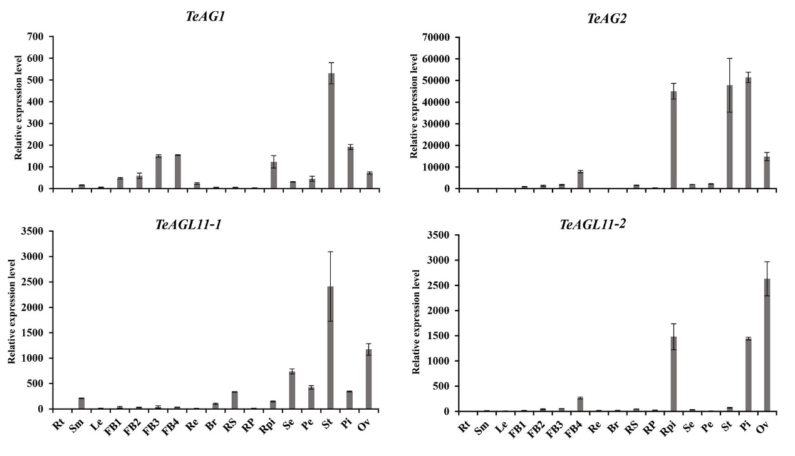
Fig. S1 Expression levels of TeAG1, TeAG2, TeAGL11-1 and TeAGL11-2 in different tissues and organs. Rt: root; Sm: stems; Le: leaf; FB1-FB4: flower buds were 0-1mm, 2-3mm, 4-5 mm and 6-7mm in diameter, respectively; Re: receptacle; Br: bract; RS: sepal of ray floret; RP: petal of ray floret; RPi: pistil of ray floret; Se: sepal of disk floret; Pe: petal of disk floret; St: stamen of disk floret; Pi: pistil of disk floret; Ov: ovary.

