Supporting Information

A New Workflow for the Effective Curation of Membrane Permeability Data from Open ADME Information

Tsuyoshi Esaki^{1,2*}, Tomoki Yonezawa³, Kazuyoshi Ikeda^{3,4}

- Graduate School of Data Science, Shiga University, 1-1-1 Banba, Hikone, Shiga 522-8522, Japan
- Faculty of Culture and Information Science, Doshisha University, 1-3 Tatara Miyakodani, Kyotanabe, Kyoto 610-0394, Japan
- Faculty of Pharmacy, Keio University, 1-5-30 Shibakoen, Minato-ku, Tokyo 105-8512, Japan
- HPC-and AI-driven Drug Development Platform Division, RIKEN Center for Computational Science, 1-7-22 Suehiro-cho, Tsurumi-ku, Yokohama, Kanagawa 4230-0045, Japan

Table of Contents
- Table S1: Keywords used for data extract from ChEMBL database S2
- Table S2: Units collected from database S3
- Table S3: Number of measurements for each article S4
- Table S4. Summary the distributions between filtered and curated datasets S5
- Fig S1: Shema of phase 1: data extraction from ChEMBL S6
- Fig S2: Shema of phase 2: data filtration S7
- Fig S3: Shema of phase 3: data check from original literature S8
- Fig S4: Shema of phase 4: data export S9
- Fig S5. The relationships between compound features S10

Table S1. Keywords used for data extraction from ChEMBL database.
Collected table | Collected column | Filter word | Number of collected data
activities | activity_id  assay_id  molregno  standard_relation  standard_value  standard_units  standard_type | standard_type LIKE Papp | 13,672
assays | assay_id  doc_id  description  assay_type  assay_organism  assay_tissue  assay_cell_type  curated_by | description LIKE  %permeability%  and  assay_type = “A” | 6,308
docs | doc_id  journal  year  volume  issue  first_page  last_page  pubmed_id |  | 80,480
molecule_dictionary | molregno  chembl_id |  | 2,086,898
compound_property | molregno  full_mw  full_molformula |  | 2,069,935
compound_record | molregno  compound_name | groupby in molregno | 2,005,207
compound_structure | molregno  molfile  canonical_smiles |  | 2,066,376
Table S2. Units collected from the database.
Units | Number of entry | Units | Number of entry
cm/s | 4054 | 10'-8m/s | 9
cm/s * 10E6 | 4011 | 10^-6/cm | 8
10'-5cm/s | 1855 | cm'-6/s | 7
uL/hr/cm2 | 575 | nM s-1 | 6
10'-5 cm/s | 183 | 10-6 cm s-1 | 6
10^6cm/s | 125 | 10'-6cm | 6
10'-4 cm/s | 97 | 10'-6m/s | 4
10^7cm/s | 88 | uM | 4
10^-8cm/s | 87 | um/s | 4
10^-7 cm/s | 86 | 10'-6/s | 4
10'-6/cm | 70 | 10'-9cm/s | 4
10'-8cm/s | 67 | cm2/sec | 3
10'-6nanometer/s | 62 | microg/cm2 | 2
10'-2 cm/s | 50 | microg/cm3 | 2
10'-6cm/min | 50 | nanometer/sec | 2
10-6 cm/s | 41 | cm/s | 2
10'-6cm/s | 28 | cm/s * 10E6 | 1
10'-6cm/s2 | 26 | 10'-5cm/s | 1
10^-5 cm/s | 19 | uL/hr/cm2 | 1
nm s-1 | 16 | 10'-5 cm/s | 1
ucm | 11 | 10^6cm/s | 1
umol/L/s | 11 | 10'-4 cm/s | 1
10'-3cm/min | 11

Table S3. Number of measurements for each article.
Number of measurements | Number of articles | Sum of article | Ratio
1 | 77 | 77 | 0.1754
2 | 72 | 149 | 0.3394
3 | 32 | 181 | 0.4123
4 | 44 | 225 | 0.5125
5 | 13 | 238 | 0.5421
6 | 28 | 266 | 0.6059
7 | 16 | 282 | 0.6424
8 | 21 | 303 | 0.6902
9 | 5 | 308 | 0.7016
10 | 19 | 327 | 0.7449
11-12 | 25 | 352 | 0.8018
13-14 | 14 | 366 | 0.8337
15-16 | 10 | 376 | 0.8565
17-18 | 12 | 388 | 0.8838
19-20 | 10 | 398 | 0.9066
21-22 | 13 | 411 | 0.9362
23-24 | 6 | 417 | 0.9499
25-26 | 4 | 421 | 0.9590
27-28 | 3 | 424 | 0.9658
29-30 | 3 | 427 | 0.9727
31-35 | 3 | 430 | 0.9795
36-40 | 3 | 433 | 0.9863
41-50 | 1 | 434 | 0.9886
51-60 | 3 | 437 | 0.9954
61-70 | 1 | 438 | 0.9977
71-100 | 1 | 439 | 1.0000

Table S4. Summary of the distributions between filtered and curated datasets. The upper row shows the distribution of MDCK dataset. The middle and lower rows show the distribution of LLC-PK1 and RRCK dataset, respectively.
Cell line | Number of entry in the filtered dataset  (only filtered dataset) | Number of entry in the curated dataset  (only curated dataset) | Number of entry in both dataset
MDCK | 826  (92) | 811  (77) | 734
LLC-PK1 | 363  (93) | 337  (67) | 270
RRCK | 515  (36) | 543  (64) | 479

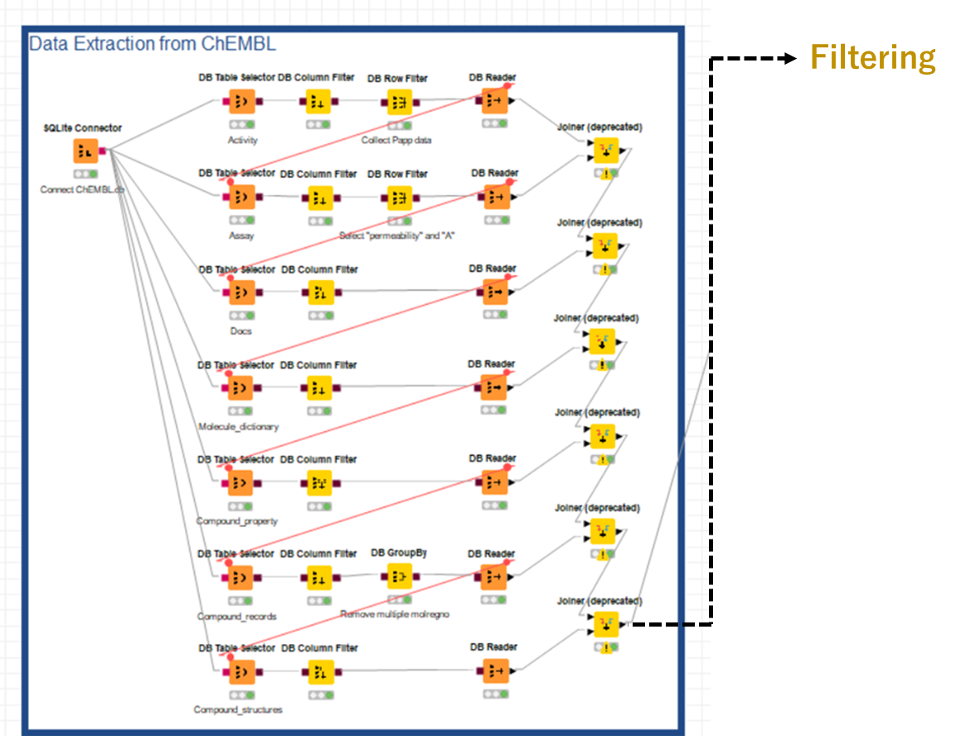
Fig S1. Shema of phase 1: data extraction from ChEMBL

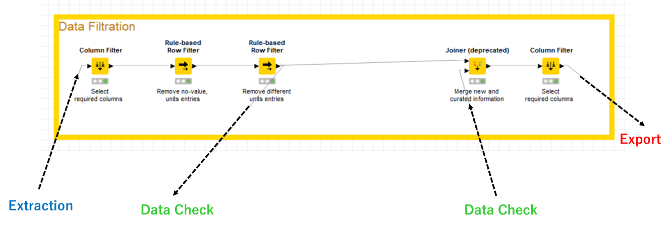
Fig S2. Shema of phase 2: data filtration

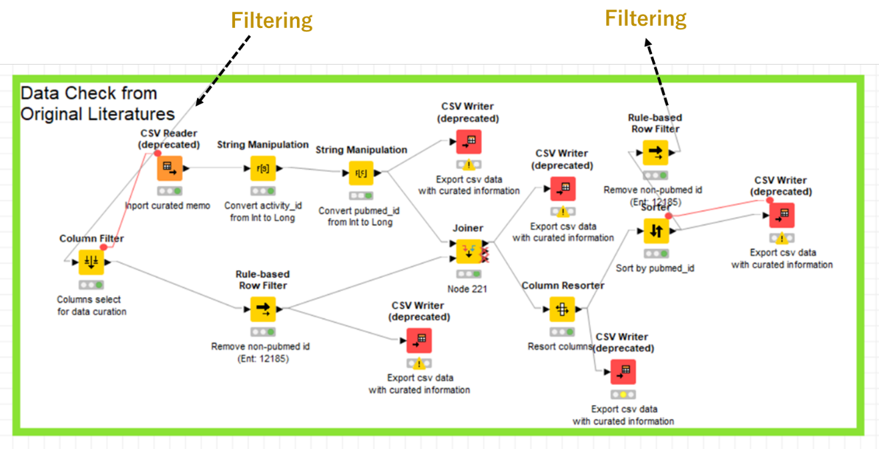
Fig S3. Shema of phase 3: data check from original literatures

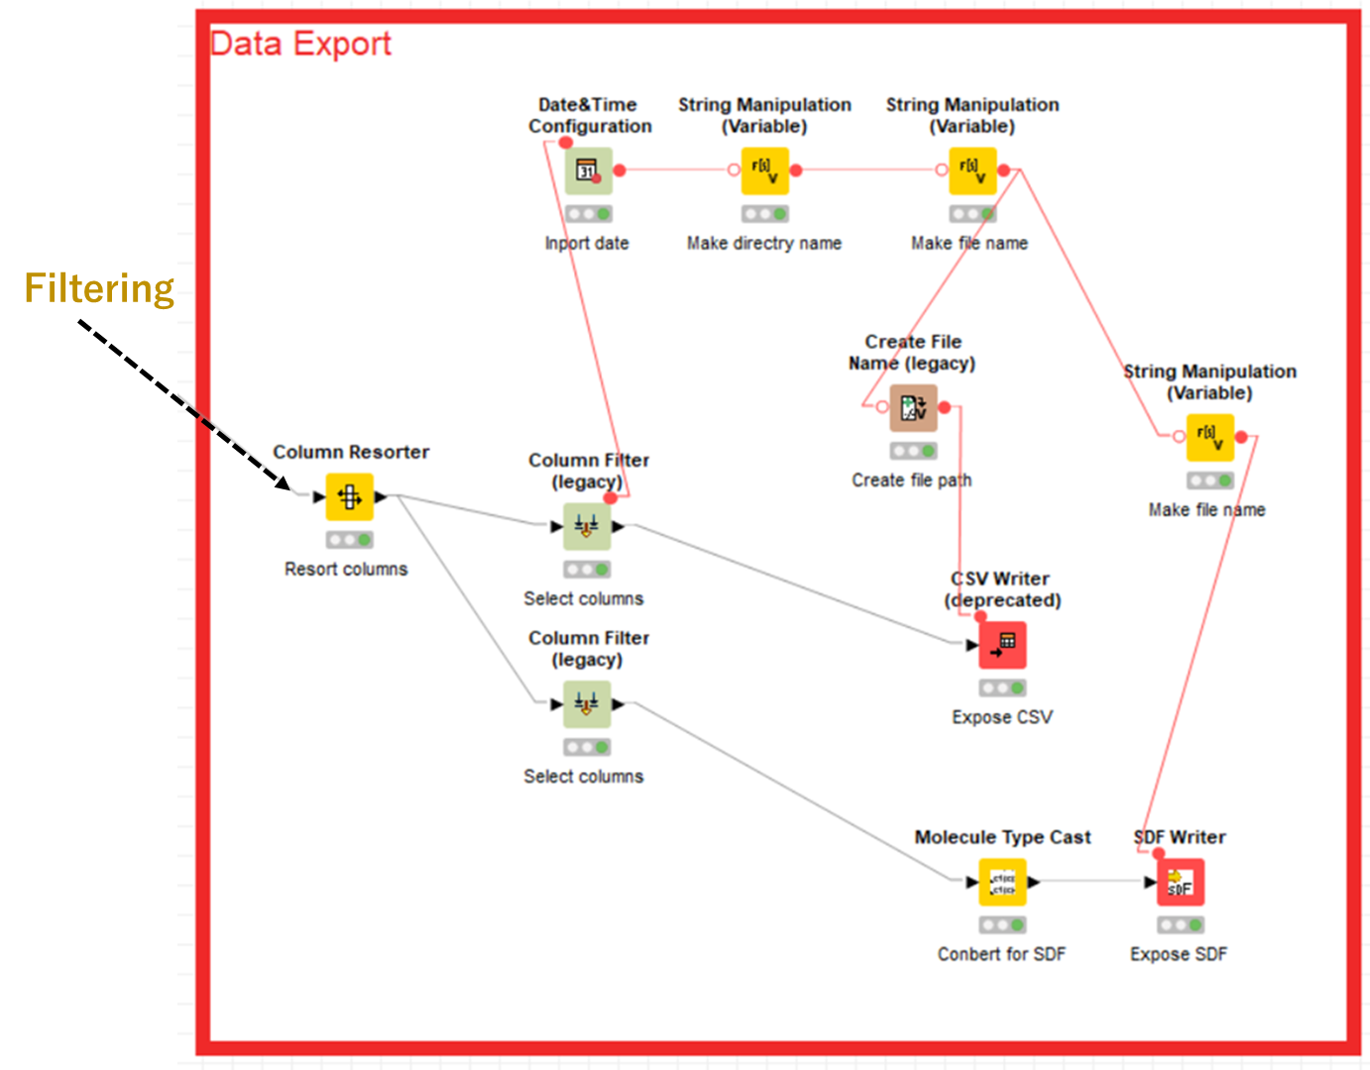
Fig S4. Shema of phase 4: data export

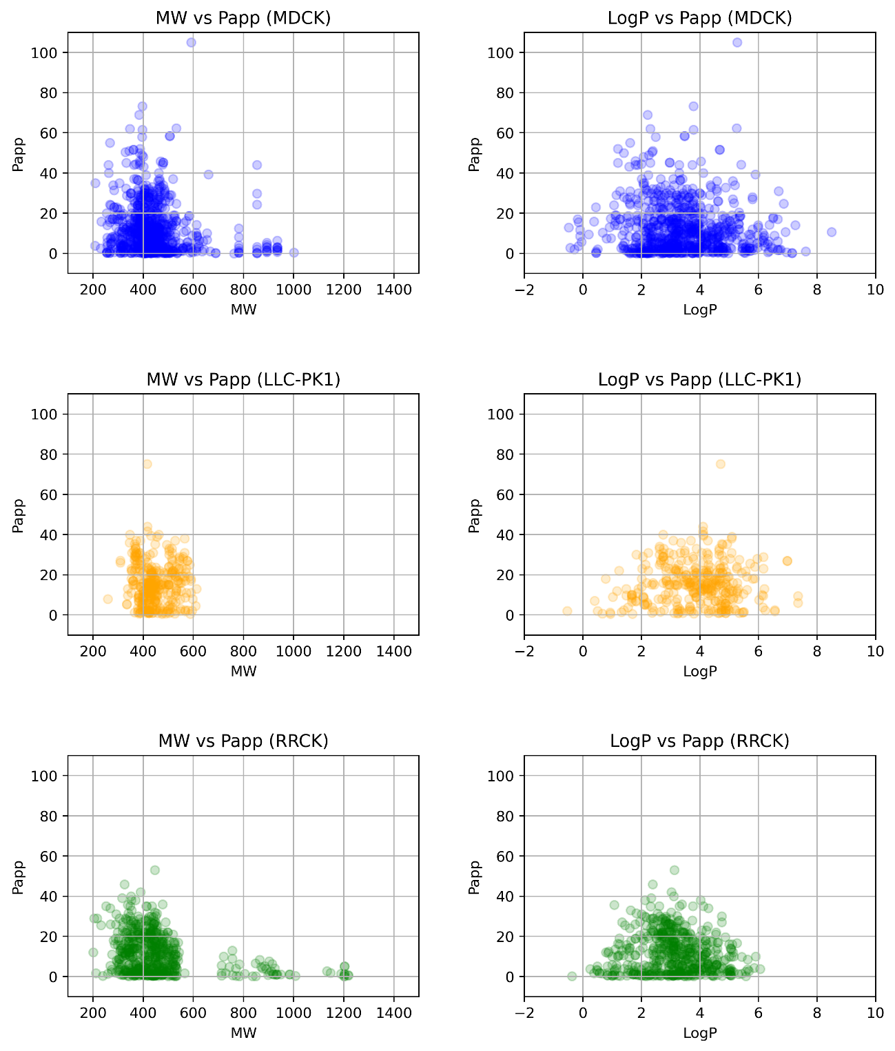
Fig S5. The relationships between compound features (molecular weight (MW) and LogP). The left side of the scatter plots show the relationship between MW and Papp. The right side of the scatter plots show the relationship between LogP and Papp. The upper two scatter plots with blue points represent the compounds in curated MDCK cell dataset. The middle two scatter plots with orange points represent the compounds in curated LLC-PK1 cell dataset. The lower two scatter plots with green points represent the compounds in curated RRCK cell dataset.

