Supplementary information

Revisit hydrophobically modified urethane-ethoxylate polymers: terminal sticker groups influences on thickening and dispersing

- GPC results
Table 1 Molecule weight of the ethoxylated urethane polymer series by GPC
No. | TP series (TSP) | Mn | MP series (MPEG2000) | Mn
1 | TP-1 | 21965 | MP-1 | 20426
2 | TP-2 | 22863 | MP-2 | 19881
3 | TP-3 | 25521 | MP-3 | 25651
4 | TP-4 | 34835 | MP-4 | 33655
5 | TP-5 | 44223 | MP-5 | 46086
6 | TP-6 | 56105 | MP-6 | 57048
7 | TP-7 | 65644 | MP-7 | 67982
8 | TP-8 | 78287 | MP-8 | 68942
9 | TP-9 | 81428 | MP-9 | 76936

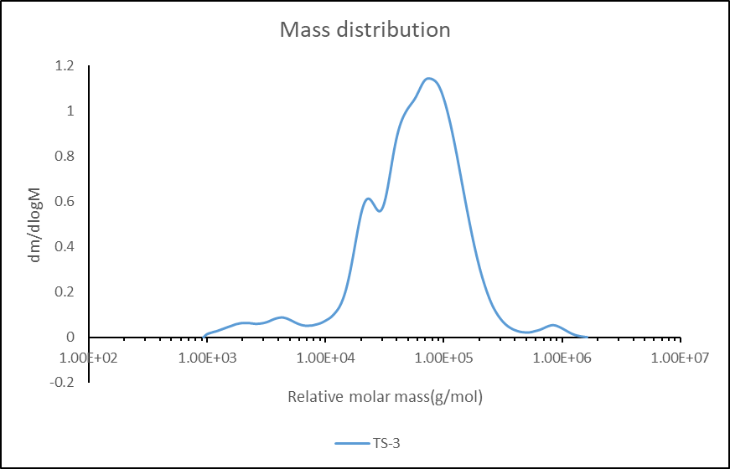
Figure 1 GPC graph of Sample TP-3

- TEM of carbon black dispersion with different polymers
Figure 2 TEM images of carbon black preparations. (a)(c) TP-4, (b)(d) MP-4

Fig 3 TEM images of carbon black preparations. (a)(c) TP-6, (b)(d) MP-6

Fig 4 TEM images of carbon black preparations. (a)(c) TP-8, (b)(d) MP-8

3. The storage stability of pigment preparations
Figure 5 Storage stability of carbon black dispersions:(a) TP , (b) MP series

4.Estimation of CMC by fluorescence spectra in polymer solutions.
Figure 6 CMC of polymer solution by fluorescence spectrometry.
(a)TP-1, (b)MP-1 (c)TP-3, (d)MP-3, (e)TP-9, (f)MP-9

