Supplementary Information
RNAi-mediated downregulation of AcCENH3 can induce in vivo haploids in onion (Allium cepa L.)
Tushar K. Manape¹, Viswanathan Satheesh^{2#}, Saravanakumar Somasundaram^{1##}, Parakkattu S. Soumia¹, Yogesh P. Khade¹, Pawan Mainkar¹, Vijay Mahajan¹, Major Singh¹ & Sivalingam Anandhan^{1*}
- ICAR-Directorate of Onion and Garlic Research, Rajgurunagar, Pune, 410505, Maharashtra, India
- ICAR-National Institute of Plant Biotechnology, Pusa Campus, New Delhi 110012, India

# Present address: Genome Informatics Facility, Office of Biotechnology, Iowa State University, Ames, Iowa 50010, USA
## Present address: Leibniz Institute of Plant Genetics and Crop Plant Research (IPK) Gatersleben, 06466, Seeland, Germany
*Corresponding author: anandhans@gmail.com, anandhan.s@icar.gov.in

C
B
A

Supplementary Fig. 1 PCR analysis of putative AcCENH3-RNAi transgenic plants (T₀) to confirm the presence of A. sense strand (793bp), B. Antisense strand (888bp), C. hptII gene (686bp) sequences
(Lane 1: 1 kb ladder, 2: AcCENH3-RNAi plasmid, 3: Bhima Super (WT), 4 to 8: 5 independent transgenic events). The expected amplicon size (bp) is marked as a blue arrow. To amplify sense and antisense strand of AcCENH3, PDK intron from silencing construct was included, and to avoid amplification from native AcCENH3.

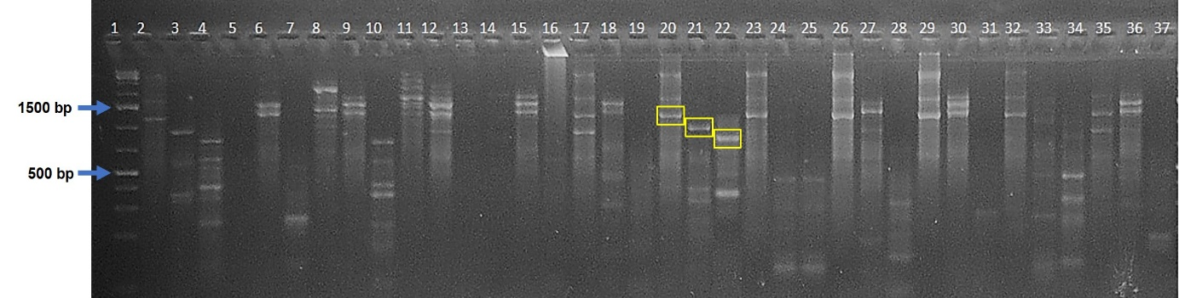

Supplementary Fig. 2 Representative image of TAIL PCR of T₀ AcCENH3-RNAi knockdown lines.
TAIL-PCR carried out with three sets of nested primers located on left border (LB) or right border (RB) of T-DNA sequence and arbitrary primers; Lane 1- 1 kb plus ladder; Lane 2, 5, 8, 11, 14, 17- shows primary PCR product with left border specific (LBS) and 6 different degenerate primers; 3, 6, 9, 12, 15, 18- shows secondary PCR product with LBS and 6 different degenerate primers; 4, 7, 10, 13, 16, 19- shows tertiary PCR product with LBS and 6 different degenerate primers; 20, 23, 26, 29, 32, 35- shows primary PCR product with right border specific (RBS) and 6 different degenerate primers; 21, 24, 27, 30, 33, 36- shows secondary PCR product with RBS and 6 different degenerate primers; 22, 25, 28, 31, 34, 37- shows tertiary PCR product with RBS and 6 different degenerate primers. Yellow marked PCR products had shown expected size difference-based distance between the three nested primers located on RB or LB of T-DNA sequence.

Supplementary Fig. 3 Information on stage-wise AcCENH3-RNAi knockdown lines.
Onion is a biennial crop. The crop undergoes bulbing in the first season and bulbs are replanted to induce flowering and seed set in the next season. Transgenic plantlets from tissue culture were hardened in pots to produce bulbs and bulbs are harvested and replanted to produce seeds. The schematic figure represents fate of transgenic events developed in the study. X-indicates crop progress in the designated event was stopped in earlier stage and not included in the current experiment.

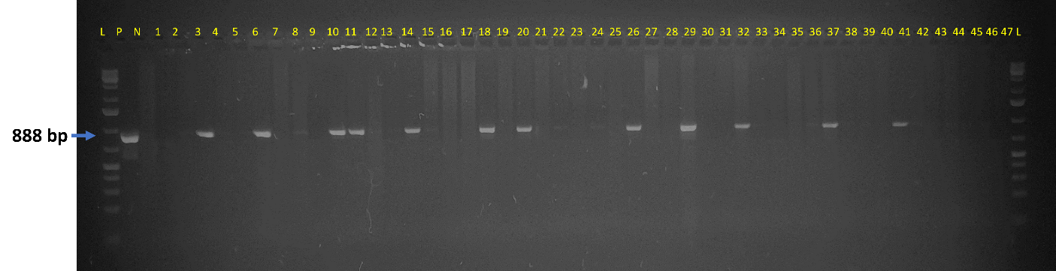
Supplementary Fig. 4A Representative image of segregation analysis of AcCENH3-RNAi transgene in AcCENH3-RNAi knockdown lines using transgene-specific primer set.
Antisense strand-specific primer set was used to confirm the presence of AcCENH3-RNAi cassette in F₁ plants of AcCENH3-RNAi knockdown lines.
[Lane 1: 1 kb plus ladder, P: AcCENH3-RNAi plasmid, N: Bhima Super DNA (WT), 1 to 47: F₁ plants of AcCENH3-RNAi event #1]. The amplicon of size 888bp shown with blue arrow.

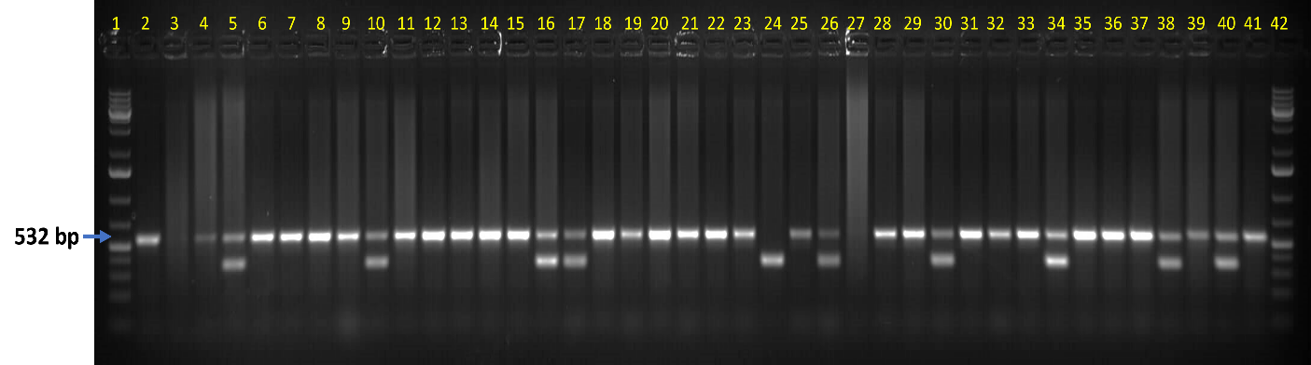
Supplementary Fig. 4B Representative image of segregation analysis of AcCENH3-RNAi transgene in AcCENH3-RNAi knockdown lines using event specific primer set.
A PCR was performed using T-DNA specific primers and site of insertion specific primer to identify homozygous and heterozygous lines of AcCENH3-RNAi knockdown lines.
[Lane 1 & 42: 1 kb ladder, 2 & 41: Bhima Super (WT), 3 to 40: T₁ plants of RNAi event #2]. A single amplicon of size 532 bp (lane 2) and 371 bp (lane 24) indicate azygous and homozygous, respectively, while two amplicons of size 532 and 371 bp represent heterozygous for transgene locus.

Supplementary Fig. 5A Relative AcCENH3 transcript abundance in the AcCENH3-RNAi knockdown transgenics.
Total RNA was extracted from leaves of Bhima Super (WT) and T₁ plants (T₀ plant of event #3) expressing AcCENH3-RNAi construct. qRT-PCR was carried out to estimate relative abundance of AcCENH3 and AcUbiquitin was used as an internal control. The relative transcript abundance was assessed using 2^{-ΔΔCt} method. The relative abundance was expressed as fold change over control (WT). The onion cultivar Bhima Super was used as control. Data is represented as mean ± SE. The data was analyzed using completely randomized design (CRD, n=14, p=0.000).

Supplementary Fig. 5B Relative AcCENH3 protein abundance in the AcCENH3-RNAi knockdown lines.
Total protein was isolated from leaves of WT and T₁ transgenic lines (T₀ plant of event #3) and equal quantity of protein (100 µg) from each sample was used for ELISA using rabbit-AcCENH3 specific antibody. Relative expression was calculated as percentage over WT. Data is represented as mean ± SE. The data was analyzed using CRD (n=42, p=0.000).

B
A

Supplementary Fig. 6 Western blot analysis of AcCENH3-RNAi knockdown lines with AcCENH3 antibody.
Total protein was isolated from leaves of Bhima Super (WT) and T₁ transgenic plants (T₀ plant of event #3), and equal quantity of protein (1 mg) from each sample was used for western blot analysis using rabbit AcCENH3-specific antibody. The blot showed a single band of 17.3 kDa, indicating specific reaction of AcCENH3 antibody.
A. L: Prestained protein ladder, 1: purified AcCENH3 (E. coli expressed), 2 to 3: WT control plants, 4 to 6: RNAi event #1 plants, 7 to 9: RNAi event #2 plants.
B. L: Prestained protein ladder, 10: purified AcCENH3 (E. coli expressed), 11 to 13: WT control plants, 13 to 15: RNAi event #3 plants, 15 to 18: RNAi event #5 plants.

Supplementary Fig. 7 Seed set efficiency upon selfing of the T₁ population of AcCENH3-RNAi knockdown lines.
The umbels of T₁ plants of event #1, #2, #5 and Bhima Super (WT) were covered with bags and allowed to self. The number of seeds per umbel were recorded in triplicate and expressed as relative seed set over control (WT). Data is represented as mean ± SE. The data was analyzed using CRD (n=16, p=0.000).

Supplementary Fig. 8 Linear regression analysis of AcCENH3-RNAi transgenic lines.
A regression analysis was carried out between the relative seed set efficiency of selfed WT and T₁ plants (T₀ in case of E#3) and the levels of AcCENH3 protein (OD values @ 405nm in ELISA). The linear regression analysis revealed a strong direct relationship between AcCENH3 protein level and relative seed set efficiency, with a calculated R² value of 0.901 and correlation R value of 0.9492 (n=14, p=0.000).

Supplementary Fig. 9 Seed set efficiency upon outcrossing of the T₁ population of AcCENH3-RNAi transgenic lines.
Reciprocal crosses were made with T₁ AcCENH3-RNAi knockdown lines and wild-type and relative seed set efficiency was calculated as percentage over the number of seeds obtained from control crosses (WT X WT). Data is represented as mean ± SE. The data was analyzed using CRD (n=24; p=0.000).

Supplementary Fig. 10 Comparative analysis of stomatal aperture size in diploid and haploid plants.
Stomatal size was measured in length and width in diploid (Bhima Super) and haploid Plants. Haploid plants showed reduction in size. Data is represented as mean ± SE. The data was analyzed using CRD (n=12, p=0.000).

Supplementary Table 1 List of primers used in the study
Primer Name | Primer sequences (5'-3') | Amplicon size and region | PCR conditions
Primers used for cloning transgenic confirmation
AcCenh3 F | GACGAAGCTGGTCCTTCAAC | 397 bp of AcCenH3 sense strand sequence | 1 cycle of 94 °C for 5 min; 35 cycles of 94 °C for 45 sec, 55 °C for 45 sec, 72 °C for 30 sec, and 1 cycle of 72 °C for 10 min
AcCenh3 R | TAGCACCACCAATCCTCCTC | 397 bp of AcCenH3 sense strand sequence
Sense F | CCGCTCGAGCCATGGGACGAAGCTGGTCCTTCAAC | 397 bp of AcCenH3 sense strand sequence | 1 cycle of 94 °C for 5 min; 35 cycles of 94 °C for 45 sec, 55 °C for 45 sec, 72 °C for 30 sec, and 1 cycle of 72 °C for 10 min
Sense R | CGGGGTACCTAGCACCACCAATCCTCCTC | 397 bp of AcCenH3 sense strand sequence
Antisense F | CCCAAGCTTTAGCACCACCAATCCTCCTC | 397 bp of AcCenH3 antisense strand sequence | 1 cycle of 94 °C for 5 min; 35 cycles of 94 °C for 45 sec, 57 °C for 45 sec, 72 °C for 45 sec, and 1 cycle of 72 °C for 10 min
Antisense R | CTAGTCTAGACACGTGGACGAAGCTGGTCCTTCAAC | 397 bp of AcCenH3 antisense strand sequence
CaMV35s F | CCAACCACGTCTTCAAAGCAAG | 793 bp (partial sequence of CaMV35s prom + sense strand+ partial sequence of pdk intron | 1 cycle of 94 °C for 3 min; 35 cycles of 94 °C for 45 sec, 58 °C for 45 sec, 72 °C for 60 sec and 1 cycle of 72 °C for 10 min
pDK intron R | TCTTCTTCGTCTTACACATCACTTG
pDK intron F | TGCTAATATAACAAAGCGCAAGAT | 888 bp (partial sequence of pdk intron + antisense strand+ partial sequence of Tnos terminator | 1 cycle of 94 °C for 3 min; 35 cycles of 94 °C for 45 sec, 58 °C for 45 sec, 72 °C for 60 sec and 1 cycle of 72 °C for 10 min
tNOS R | TCCTAGTTTGCGCGCTATATTTTG
Hpt F | GACGTCTGTCGAGAAGTTTC | 686 bp of internal sequence of hptII | 1 cycle of 94 °C for 3 min; 35 cycles of 94 °C for 45 sec, 57 °C for 45 sec, 72 °C for 45 sec and 1 cycle of 72 °C for 10 min
Hpt R | GCCTCCAGAAGAAGATGTTG | 686 bp of internal sequence of hptII
Primers used for qRT-PCR
qUBI F | TCTGATTGTGCTTGTGGTGGTT | 131 bp of AcUbiquitin | 1 cycle of 95 °C for 2 min; 40 cycles of 95 °C for 10 sec, 58 °C for 10 sec  Melt curve 60 °C to 95 °C.
qUBI R | AAAGCGGAAATTAAGATGATGTTGC | 131 bp of AcUbiquitin
qAcCENH3 F | CAGTTTTCCCAACGGCAGAA | 250 bp of N-tail region AcCENH3
qAcCENH3 R | TCGAGCTCCAGTCCCTCTAT | 250 bp of N-tail region AcCENH3
Primers used for detection of homozygous/heterozygous transgenic lines
Primer Name | 5’ to 3’ sequence | Amplicon size and region | PCR conditions
RNAi Event 1
RB F3 | GCATGACGTTATTTATGAGATGG | In hetero: 703 & 652 bp  In azygous: 703 bp | 1 cycle of 95 °C for 5 min; 35 cycles of 94 °C for 45 sec, 58 °C for 45 sec, 72 °C for 45 sec and 1 cycle of 72 °C for 10 min
Insert E1 R | GCATCCATAGCGACTATCGCTA | In hetero: 703 & 652 bp  In azygous: 703 bp
Insert E1 F | GGAAAATCTAACTTGGATTTGG | In hetero: 703 & 652 bp  In azygous: 703 bp
RNAi Event 2
RB F3 | GCATGACGTTATTTATGAGATGG | In hetero: 572 & 355 bp  In azygous: 572 bp | 1 cycle of 95 °C for 5 min, 35 cycles of 94 °C for 45 sec, 56 °C for 45 sec,72 °C for 1 min and 1 cycle of 72 °C for 10 min
Insert E2 R | GCATTTGGAGATTTCGTCGAAG | In hetero: 572 & 355 bp  In azygous: 572 bp
Insert E2 F | CTTGCATCCCTGGTATGGTATC | In hetero: 572 & 355 bp  In azygous: 572 bp
RNAi Event 3
LB F2 | CAAAATCCAGTACTAAAATCCAGATCC | In hetero: 316 & 338 bp  In azygous: 338 bp | 1 cycle of 95 °C for 5 min, 35 cycles of 94 °C for 45 sec, 60 °C for 45 sec, 72 °C for 45 sec and 1 cycle of 72 °C for 10 min
Insert E3 R | GCAAAGCAAGATGAGCACGAG | In hetero: 316 & 338 bp  In azygous: 338 bp
Insert E3 F | CTACTAGTGCTTAGCTCTATGG | In hetero: 316 & 338 bp  In azygous: 338 bp
RNAi Event 4
RB R1 | GGTGTCATCTATGTTACTAGATCG | In hetero: 418 & 546 bp  In azygous: 540 bp | 1 cycle of 95 °C for 5 min, 35 cycles of 94 °C for 45 sec, 52 °C for 45 sec, 72 °C for 45 sec and 1 cycle of 72 °C for 10 min
Insert E4 R | CACTTGGTTTATGTAACGATCCCGA | In hetero: 418 & 546 bp  In azygous: 540 bp
Insert E4 F | GAAATTATGTTAAAGTCCCTAGTCTTG | In hetero: 418 & 546 bp  In azygous: 540 bp
RNAi Event 5
LB F1 | GTGTTATTAAGTTGTCTAAGCGTC | In hetero: 324 & 287 bp  In azygous: 324 bp | 1 cycle of 95 °C for 5 min, 35 cycles of 94 °C for 45 sec, 60 °C for 45 sec, 72 °C for 45 sec and 1 cycle of 72 °C for 10 min
Insert E5 R | GATTTAAAGGGTAATCGTTTATCTC | In hetero: 324 & 287 bp  In azygous: 324 bp
Insert E5 F | TAATTATCTTTACGCAATTAATTACCTTG | In hetero: 324 & 287 bp  In azygous: 324 bp
Primers for cloning and transgenics confirmation
Primer Name | Primer sequences (5'-3') | Amplicon size and region | PCR conditions
Sense F | CCGCTCGAGCCATGGGACGAAGCTGGTCCTTCAAC | 397 bp of AcCenH3 sense strand sequence | 1 cycle of 94 °C for 5 min; 35 cycles of 94 °C for 45 sec, 55 °C for 45 sec, 72 °C for 30 sec, and 1 cycle of 72 °C for 10 min
Sense R | CGGGGTACCTAGCACCACCAATCCTCCTC | 397 bp of AcCenH3 sense strand sequence
Antisense F | CCCAAGCTTTAGCACCACCAATCCTCCTC | 397 bp of AcCenH3 antisense strand sequence | 1 cycle of 94 °C for 5 min; 35 cycles of 94 °C for 45 sec, 57 °C for 45 sec, 72 °C for 45 sec, and 1 cycle of 72 °C for 10 min
Antisense R | CTAGTCTAGACACGTGGACGAAGCTGGTCCTTCAAC | 397 bp of AcCenH3 antisense strand sequence
CaMV35s F | CCAACCACGTCTTCAAAGCAAG | 793 bp (partial sequence of CaMV35s prom + sense strand+ partial sequence of pdk intron | 1 cycle of 94 °C for 3 min; 35 cycles of 94 °C for 45 sec, 58 °C for 45 sec, 72 °C for 60 sec and 1 cycle of 72 °C for 10 min
pDK intron R | TCTTCTTCGTCTTACACATCACTTG
pDK intron F | TGCTAATATAACAAAGCGCAAGAT | 888 bp (partial sequence of pdk intron + antisense strand+ partial sequence of Tnos terminator | 1 cycle of 94 °C for 3 min; 35 cycles of 94 °C for 45 sec, 58 °C for 45 sec, 72 °C for 60 sec and 1 cycle of 72 °C for 10 min
tNOS R | TCCTAGTTTGCGCGCTATATTTTG
Hpt F | GACGTCTGTCGAGAAGTTTC | 686 bp of internal sequence of hptII | 1 cycle of 94 °C for 3 min; 35 cycles of 94 °C for 45 sec, 57 °C for 45 sec, 72 °C for 45 sec and 1 cycle of 72 °C for 10 min
Hpt R | GCCTCCAGAAGAAGATGTTG | 686 bp of internal sequence of hptII
Primers used for qRT-PCR
qUBI F | TCTGATTGTGCTTGTGGTGGTT | 131 bp of AcUbiquitin | 1 cycle of 95 °C for 2 min; 40 cycles of 95 °C for 10 sec, 58 °C for 10 sec  Melt curve 60 °C to 95 °C.
qUBI R | AAAGCGGAAATTAAGATGATGTTGC | 131 bp of AcUbiquitin
qAcCENH3 F | GTGGTCCTTCAACACCAGTAAC | 184 bp of N-tail region AcCENH3
qAcCENH3 R | GGAGCAGCAGGAATCAGTAATTC | 184 bp of N-tail region AcCENH3
Primers for detection of homozygous/heterozygous transgenic lines
Primer Name | 5’ to 3’ sequence | Amplicon size and region | PCR conditions
Event 1
RB F3 | GCATGACGTTATTTATGAGATGG | In hetero: 703 & 652 bp  In azygous: 703 bp | 1 cycle of 95 °C for 5 min; 35 cycles of 94 °C for 45 sec, 58 °C for 45 sec, 72 °C for 45 sec and 1 cycle of 72 °C for 10 min
Insert E1 R | GCATCCATAGCGACTATCGCTA | In hetero: 703 & 652 bp  In azygous: 703 bp
Insert E1 F | GGAAAATCTAACTTGGATTTGG | In hetero: 703 & 652 bp  In azygous: 703 bp
Event 2
RB F3 | GCATGACGTTATTTATGAGATGG | In hetero: 572 & 355 bp  In azygous: 572 bp | 1 cycle of 95 °C for 5 min, 35 cycles of 94 °C for 45 sec, 56 °C for 45 sec,72 °C for 1 min and 1 cycle of 72 °C for 10 min
Insert E2 R | GCATTTGGAGATTTCGTCGAAG | In hetero: 572 & 355 bp  In azygous: 572 bp
Insert E2 F | CTTGCATCCCTGGTATGGTATC | In hetero: 572 & 355 bp  In azygous: 572 bp
Event 3
LB F2 | CAAAATCCAGTACTAAAATCCAGATCC | In hetero: 316 & 338 bp  In azygous: 338 bp | 1 cycle of 95 °C for 5 min, 35 cycles of 94 °C for 45 sec, 60 °C for 45 sec, 72 °C for 45 sec and 1 cycle of 72 °C for 10 min
Insert E3 R | GCAAAGCAAGATGAGCACGAG | In hetero: 316 & 338 bp  In azygous: 338 bp
Insert E3 F | CTACTAGTGCTTAGCTCTATGG | In hetero: 316 & 338 bp  In azygous: 338 bp
Event 4
RB R1 | GGTGTCATCTATGTTACTAGATCG | In hetero: 418 & 546 bp  In azygous: 540 bp | 1 cycle of 95 °C for 5 min, 35 cycles of 94 °C for 45 sec, 52 °C for 45 sec, 72 °C for 45 sec and 1 cycle of 72 °C for 10 min
Insert E4 R | CACTTGGTTTATGTAACGATCCCGA | In hetero: 418 & 546 bp  In azygous: 540 bp
Insert E4 F | GAAATTATGTTAAAGTCCCTAGTCTTG | In hetero: 418 & 546 bp  In azygous: 540 bp
Event 5
LB F1 | GTGTTATTAAGTTGTCTAAGCGTC | In hetero: 324 & 287 bp  In azygous: 324 bp | 1 cycle of 95 °C for 5 min, 35 cycles of 94 °C for 45 sec, 60 °C for 45 sec, 72 °C for 45 sec and 1 cycle of 72 °C for 10 min
Insert E5 R | GATTTAAAGGGTAATCGTTTATCTC | In hetero: 324 & 287 bp  In azygous: 324 bp
Insert E5 F | TAATTATCTTTACGCAATTAATTACCTTG | In hetero: 324 & 287 bp  In azygous: 324 bp

Supplementary Table 2 Segregation analysis of AcCENH3-RNAi transgene in T₁ AcCENH3-RNAi transgenic lines.
Transgenic line | Total plants analysed | Antisense strand positive | Antisense strand negative | χ ² | Fitness to 3:1 | p
E1 | 99 | 24 | 75 | 136.03 | No | 0
E2 | 85 | 20 | 65 | 120.098 | No | 0
E5 | 24 | 9 | 15 | 18.00 | No | 0.00002209
Segregation analysis of T₁ generation of 3 AcCENH3-RNAi knockdown lines. The segregation analysis with test of goodness of fit to ratio 3:1 indicates segregation distortion in transgenic events #1, #2 and #3. χ²_{0.05/df1}=3.814

Supplementary Table 3 Segregation analysis for zygosity of transgene locus of AcCENH3-RNAi in T₁ transgenic lines.
Transgenic line | Total plants analysed | Homozygous | Heterozygous | Azygous | χ² | Fitness to 1:2:1 | p
E1 | 99 | 0 | 24 | 75 | - | No | *3.76
E2 | 85 | 1 | 19 | 65 | 122.365 | No | 0
E5 | 24 | 0 | 9 | 15 | - | No | *0.005
Segregation analysis for independent assortment of T₁ generation of 3 AcCENH3-RNAi knockdown lines. The segregation analysis with test of goodness of fit to ratio 1:2:1 indicates segregation distortion in transgenic lines. χ²_{0.05/df2}=5.991.* Fisher’s Exact Test was performed for E1 and E5, because the number of homozygous lines obtained was <1.

Supplementary Table 4 Segregation analysis of AcCENH3-RNAi transgene in F₁ AcCENH3-RNAi knockdown lines.
Transgenic line | Total plants analysed | Antisense strand positive | Antisense strand negative | χ² | Fitness to 1:1 | p
E1 as ♀ | 40 | 12  (30.0%) | 28 | 6.400 | No | 0.0114
E1 as ♂ | 80 | 20  (25.05) | 60 | 20.000 | No | <0.0001
E2 as ♀ | 31 | 10  (32.25%) | 21 | 3.903 | No | 0.0482
E2 as ♂ | 95 | 26  (27.26%) | 69 | 19.463 | No | <0.0001
E5 as ♀ | 22 | 9  (40.91%) | 13 | 0.727 | Yes | 0.3938
E5 as ♂ | 29 | 11  (37.93%) | 18 | 1.690 | Yes | 0.1936
Segregation analysis of F₁ generation of the transgenic lines. The segregation analysis with fitness to ratio 1:1 indicates segregation distortion in transgenic events #1 and #2. χ²_{0.05/df1}=3.814. Numbers in parenthesis indicate the percentage of transgenic-positive plants.

Supplementary Table 5 Genbank accession numbers provided by the NCBI.
Events | Genbank accession numbers
E1 | OR581163
E2 | OR581164
E3 | OR581165
E4 | OR581166
E5 | OR581167

