Figures and details:

Figure 1. Comparison of Ethanol percentage in various Jackfruit sample

Figure 2. Comparison of ethanol percentage in Rain tree leaves sample

Figure 3. Variation of BSFC with BP for Diesel and various blend of ethanol

Figure 4. Variation of BTE with BP for Diesel and various blend of ethanol

Figure 5. Variation of EGT with BP for Diesel and various blend of ethanol

Figure 6. Variation of Peak pressure rise with BP for Diesel and various blend of ethanol

Figure 7. Variation of CO emissions with BP for Diesel and various blend of ethanol

Figure 8. Variation of CO₂ emissions with BP for Diesel and various blend of ethanol

Figure 9. Variation of HC emissions with BP for Diesel and various blend of ethanol

Figure 10. Variation of NO_{x} emissions with BP for Diesel and various blend of ethanol

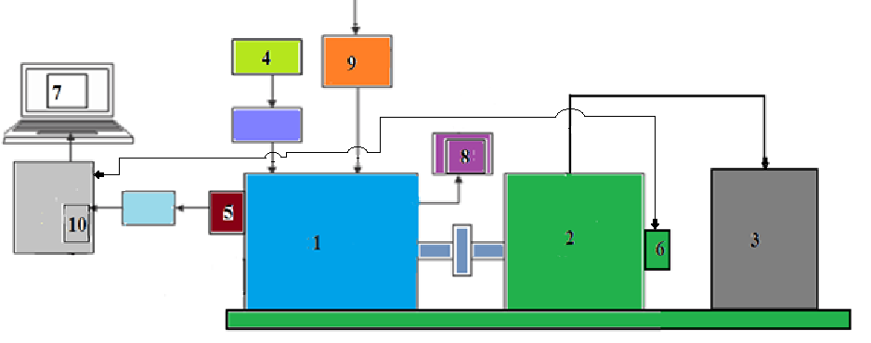

Figure 11. Line diagram of single cylinder, four stroke Diesel engine

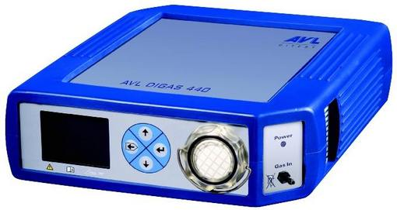

Figure 12. Exhaust gas analyser

