Supporting information – Figures 21-46
Figure S21. Expanded and annotated ¹H NMR spectrum of 1. 2
Figure S22. Expanded and annotated ¹H NMR spectrum of 1. 3
Figure S23. Expanded and annotated ¹H NMR spectrum of 1. 4
Figure S24. Expanded and annotated ¹H NMR spectrum of 1. 5
Figure S25. Expanded and annotated HSQC spectrum of 1. 6
Figure S26. Expanded and annotated HSQC spectrum of 1. 7
Figures S27. Annotated HSQC spectrum of 1. 8
Figure S29. Assignment of NHs in key amino acid residues using COSY correlations between α to NH of amino acid residue. 10
Figure S30. Key correlations in the ROESY spectrum showing link between Ala(S1)-11 and aminoethane-1,2-dithiol group. 11
Figure S31. The planar structure of 1 with COSY/HSQC-TOCSY, HMBC (H→C) observed correlations of 1. 12
Figure S34. Observed ROE correlation between Aaa-7-2 and the methyl group of Abu(S₂)-22-4. 15
Figure S35. Observed ROE correlation between Ala-21-2 and Asp-24-3A. 16
Figure S36. Observed ROE correlation between Ala-21-2 and Leu-14-3A. 17
Figure S38. MS analysis of 1 identified from heterologous expression system. 19
Figure S39. Tandem MS analysis of 1 identified in the heterologous expression system. 20
Figure S40. EIC extraction of 1 in the variants. 21
Figure S41. Tandem MS analysis of the intermediate 2 accumulated in the kinO variant. 22
Figure S42. Tandem MS analysis of the intermediate 3 accumulated in the kinI variant. 23
Figure S44. EIC analysis of the product generated in the assay of incubation of KinO with 2 accumulated. 25
Figure S45. Proposed biosynthetic pathway to form kintamdin. 26

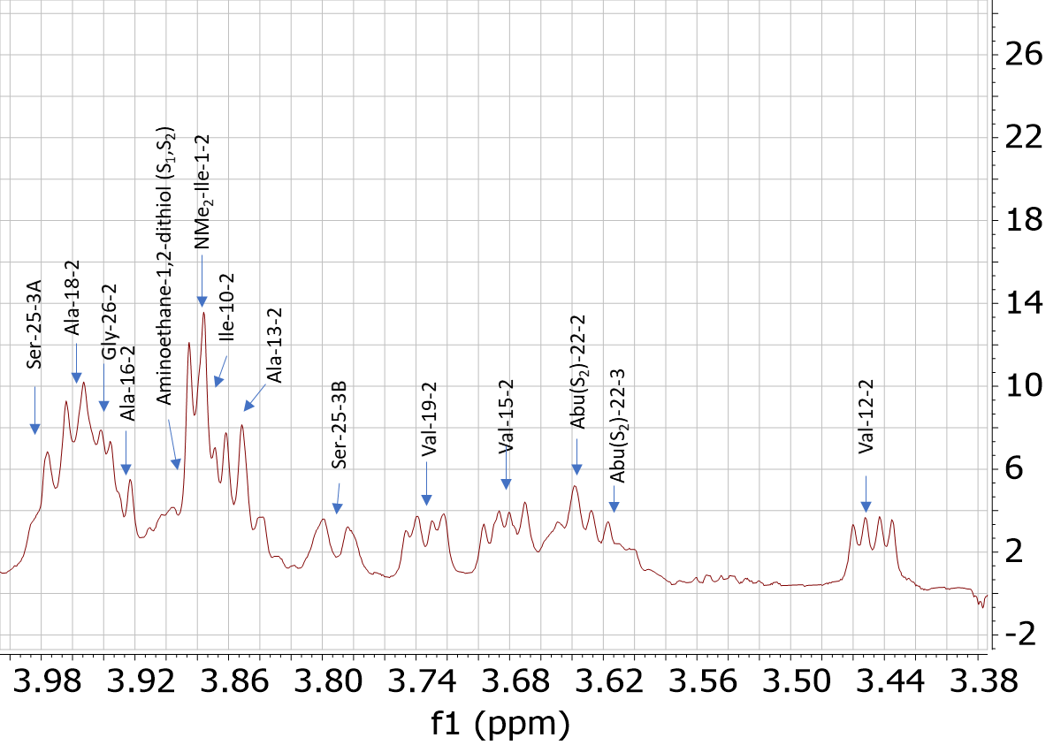

Figure S21. Expanded and annotated ¹H NMR spectrum of 1.

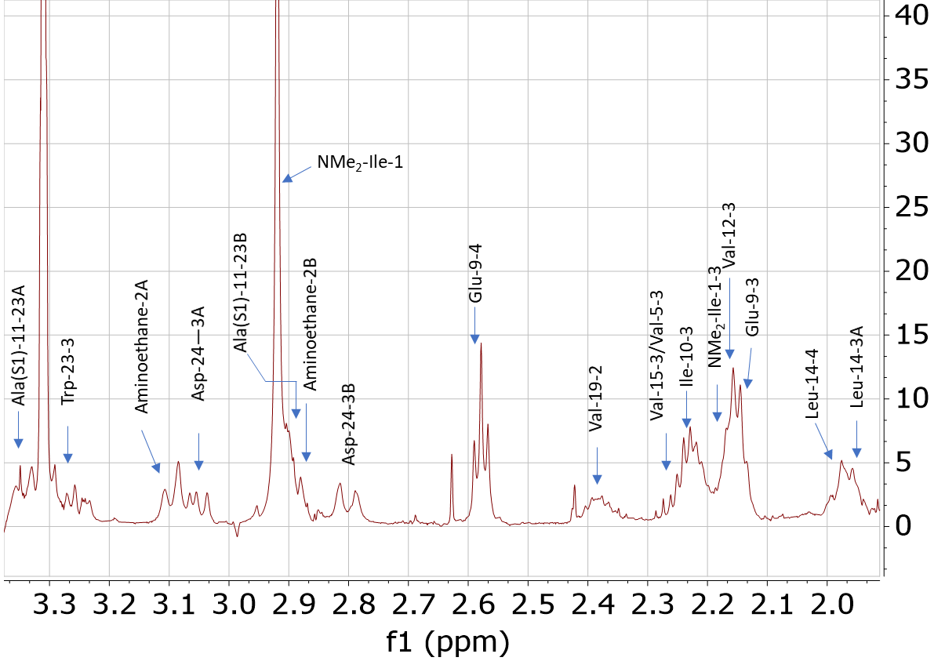

Figure S22. Expanded and annotated ¹H NMR spectrum of 1.

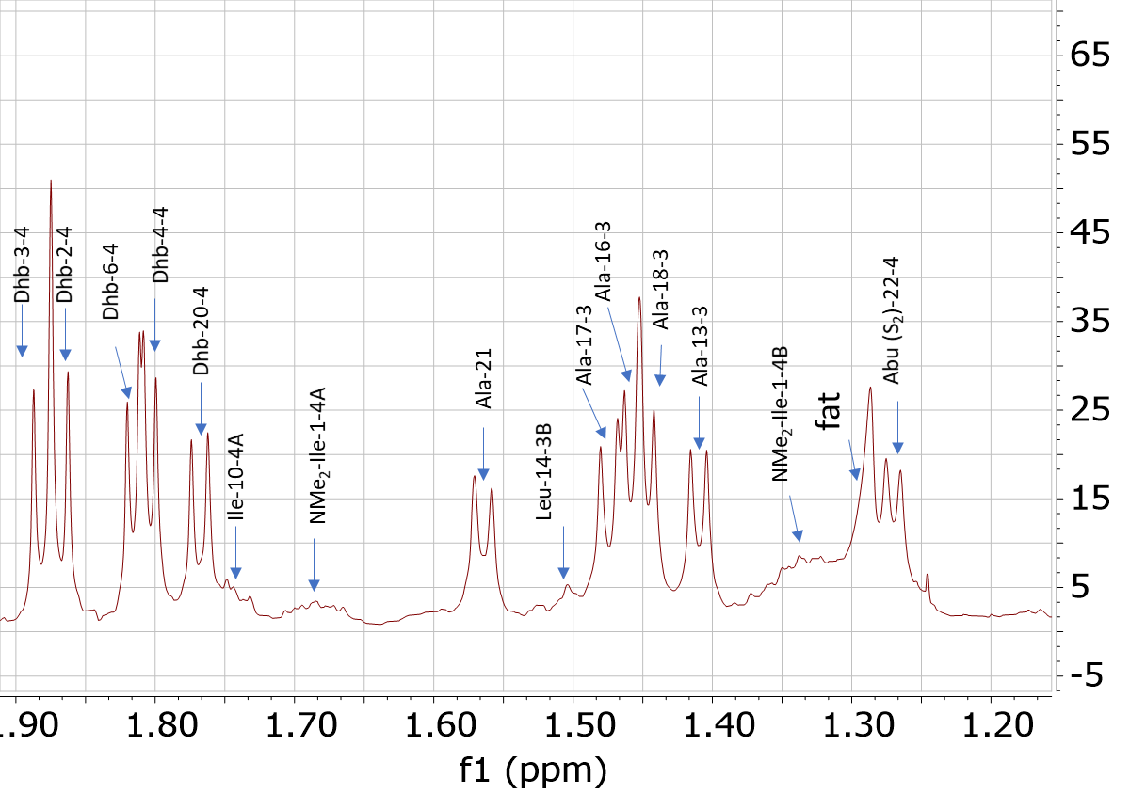

Figure S23. Expanded and annotated ¹H NMR spectrum of 1.

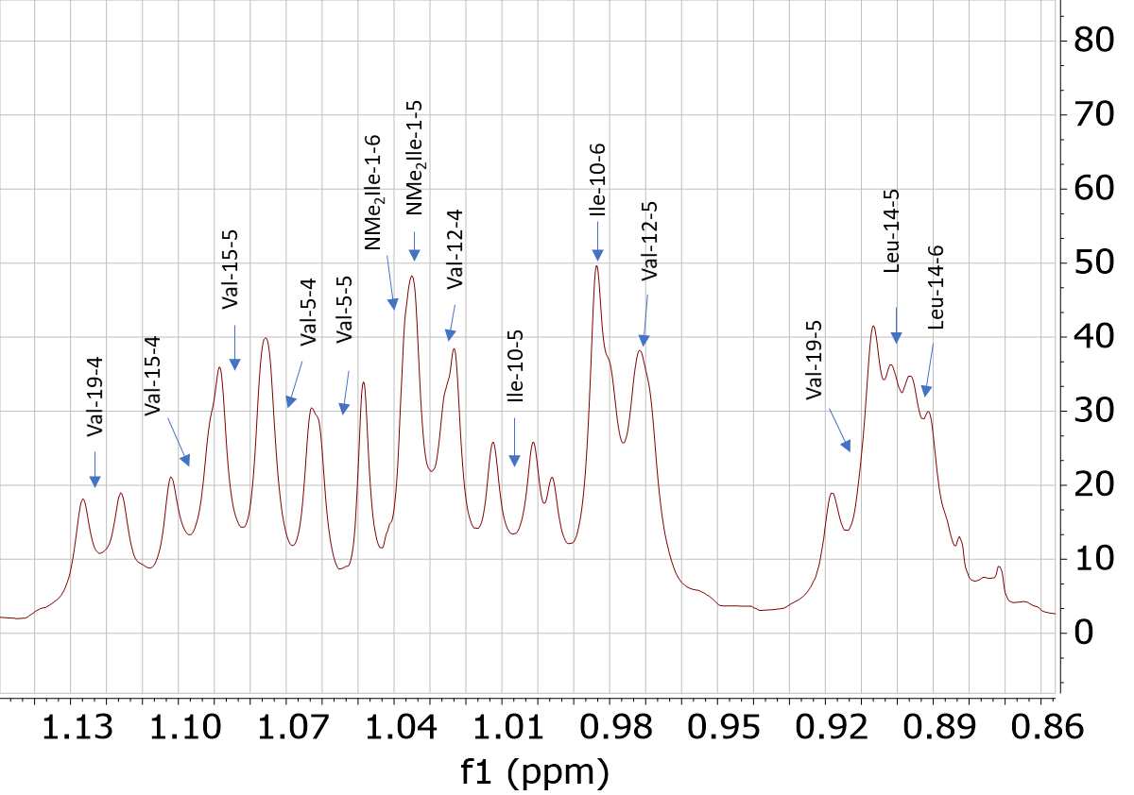

Figure S24. Expanded and annotated ¹H NMR spectrum of 1.

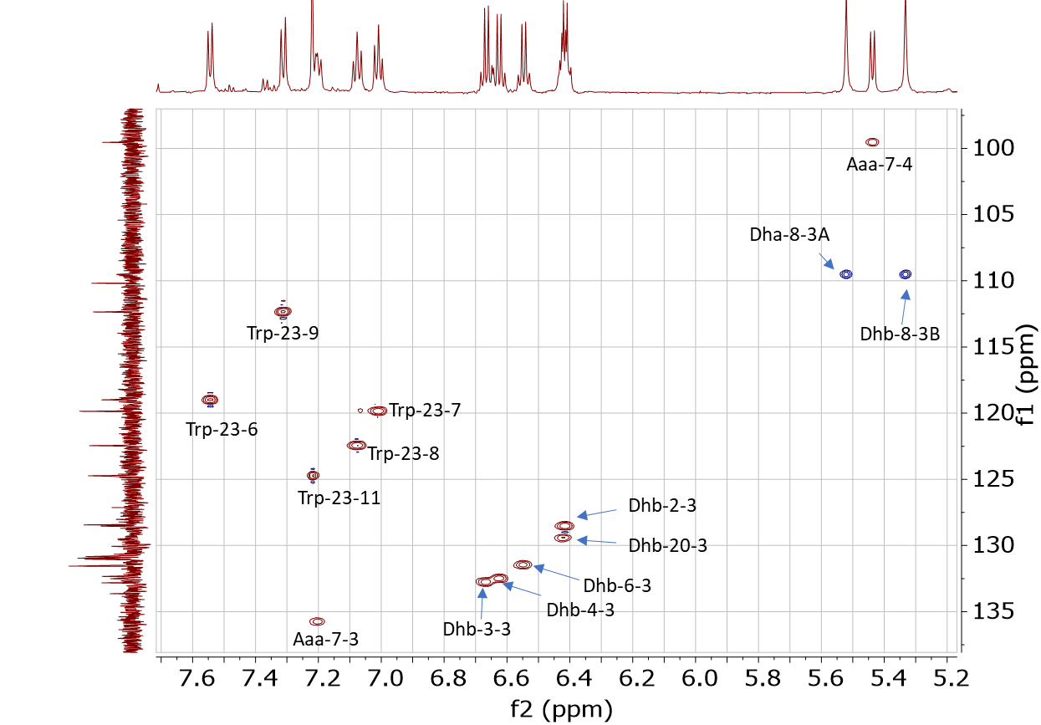

Figure S25. Expanded and annotated HSQC spectrum of 1.

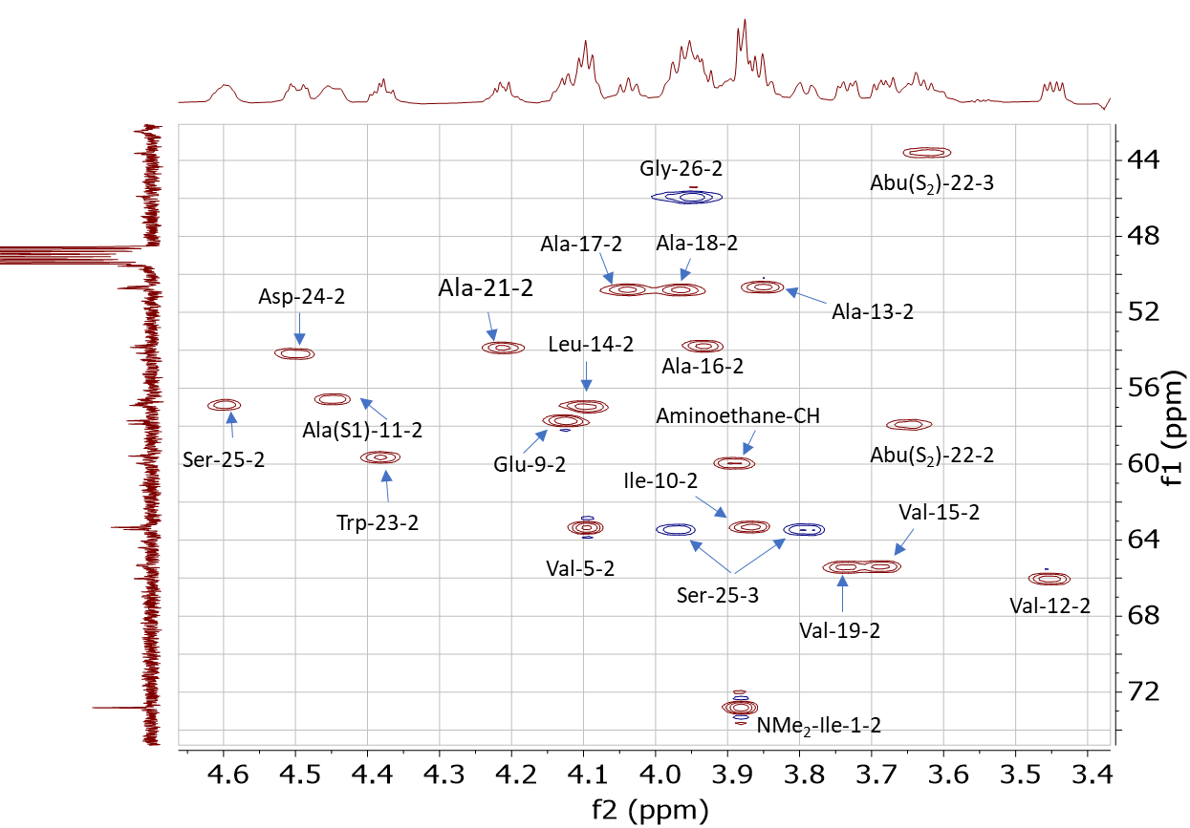

Figure S26. Expanded and annotated HSQC spectrum of 1.

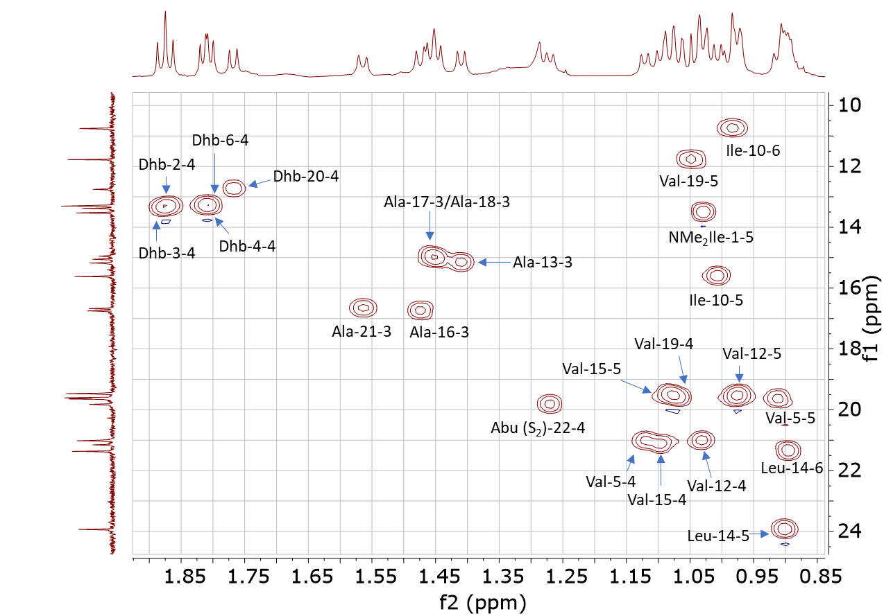

Figures S27. Annotated HSQC spectrum of 1.

Figure S28. Key cross-peaks in the COSY, HMBC, and ROESY spectra of the bis-thioethane unit of 1, indicating an unprecendented bis-thiothane cross link has been found to be present in 1.

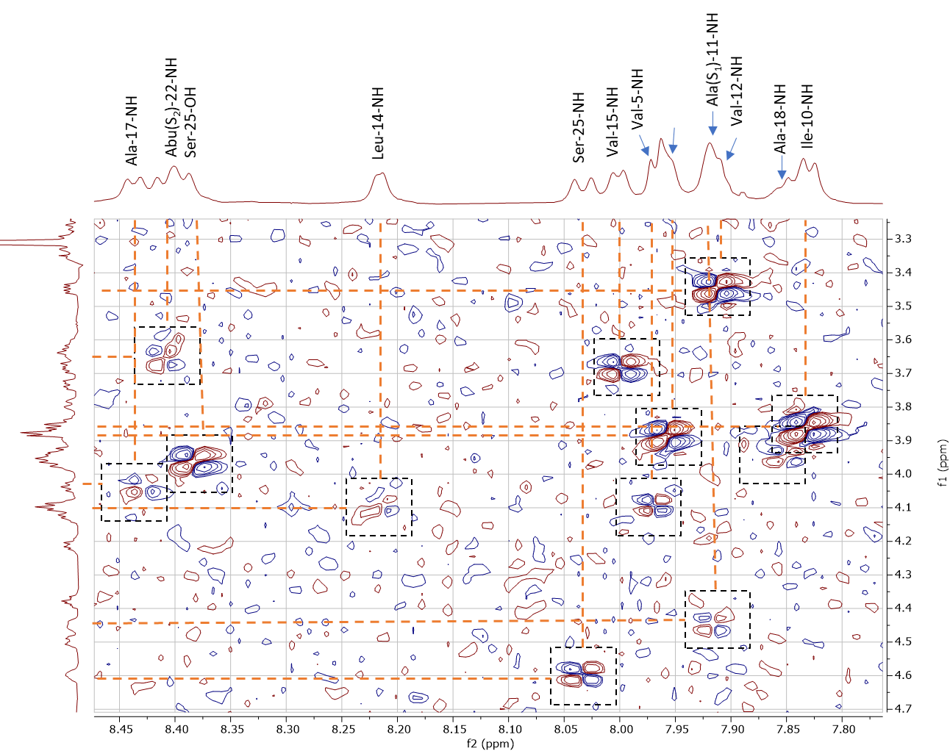

Figure S29. Assignment of NHs in key amino acid residues using COSY correlations between α to NH of amino acid residue.

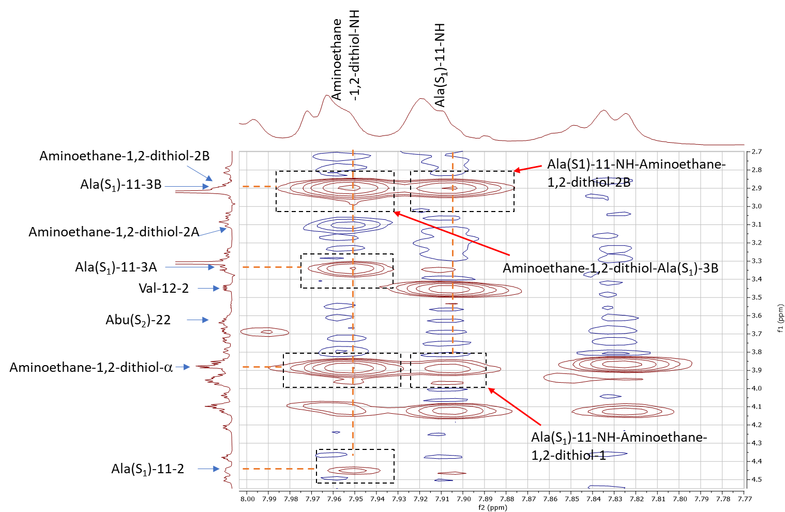

Figure S30. Key correlations in the ROESY spectrum showing link between Ala(S1)-11 and aminoethane-1,2-dithiol group.

Figure S31. The planar structure of 1 with COSY/HSQC-TOCSY, HMBC (H→C) observed correlations of 1.

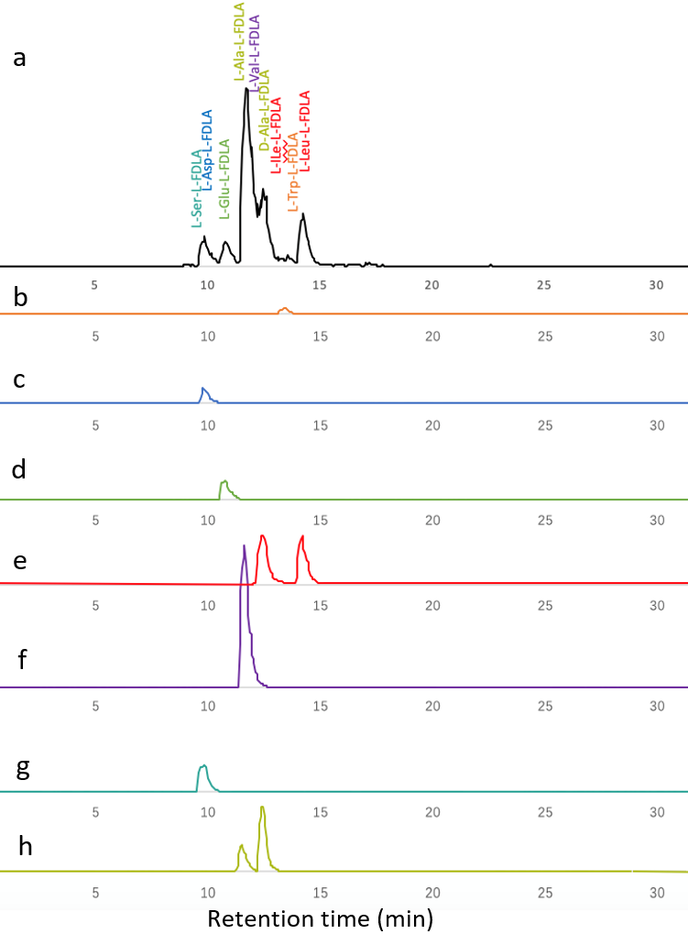

Figure S32. a. EIC chromatography of proteinogenic amino acids residues from kintamdin from advanced Marfey’s derivatization. b-h. EIC chromatography of individual derivatized proteinogenic amino acid residues, Trp, Ser, Glu, Ile, Leu, Val, Asp and Ala, respectively.

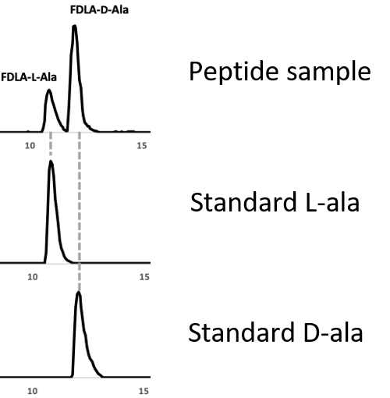

Figure S33. EIC chromatography of derivatized Ala residues from 1 (top), standard L-Ala (middle) and standard D-Ala, indicating the presence of three D-Ala residues in 1.

Aaa-7-2
Dha-8-3A
Dha-8-3B
Abu (S₂)-22-4
Fat

Figure S34. Observed ROE correlation between Aaa-7-2 and the methyl group of Abu(S₂)-22-4.

Ala-21-2
Asp-24-3A
Aminoethane-2B

Figure S35. Observed ROE correlation between Ala-21-2 and Asp-24-3A.

Leu-14-3A
Aminoethane-1,2-dithiol-1

Figure S36. Observed ROE correlation between Ala-21-2 and Leu-14-3A.

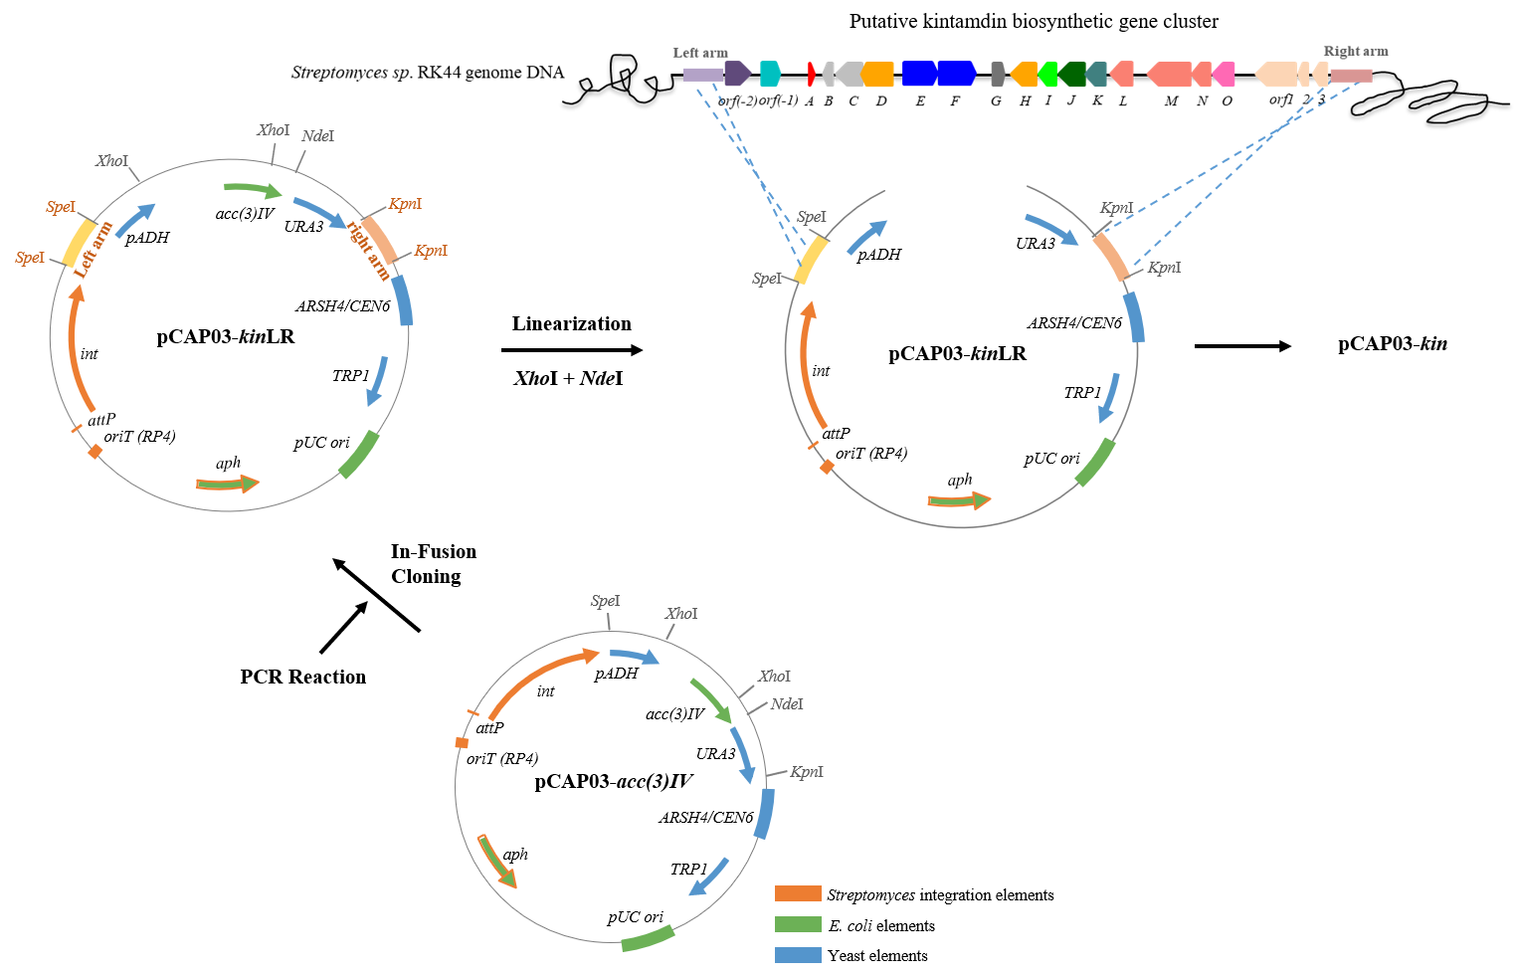

Figure S37. Scheme of a modified TAR cloning strategy by inserting two arms into the original pCAP03-acc(3)IV plasmid to generate pCAP03-kinLR construct. To improve the capture efficiency, two 1kb homologous arms that flank the upstream and downstream regions of the BGC of interest were amplified and inserted into the SpeI site and the KpnI site of pCAP03-acc(3)IV, respectively. In this construction method, the pADH-ura3 counter selection system was kept for counteracting plasmid recircularization in yeast due to nonhomologous end joining (NHEJ).

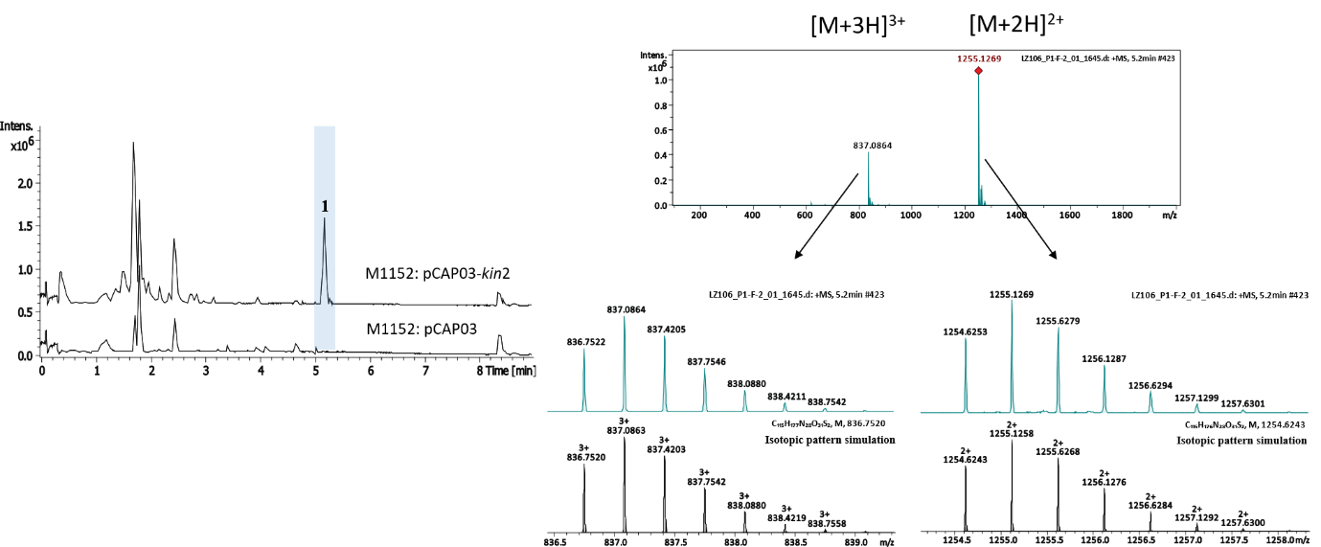

Figure S38. MS analysis of 1 identified from heterologous expression system.

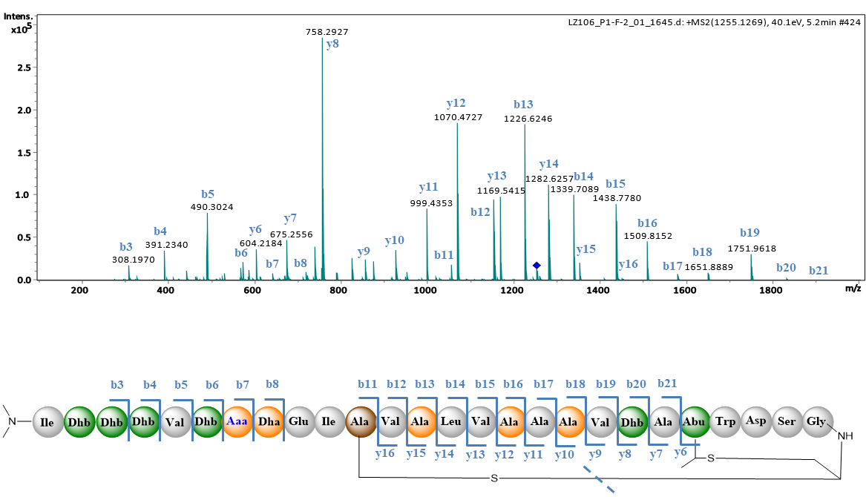

Figure S39. Tandem MS analysis of 1 identified in the heterologous expression system.

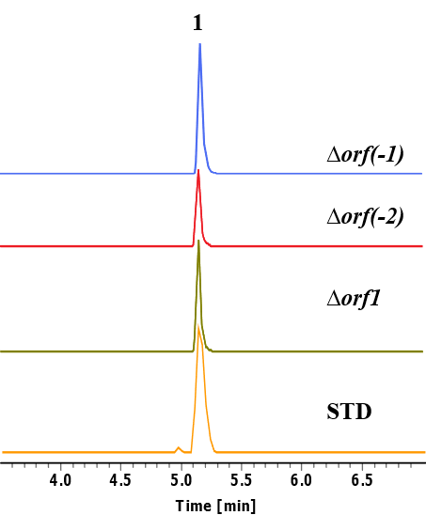

Figure S40. EIC extraction of 1 in the variants.

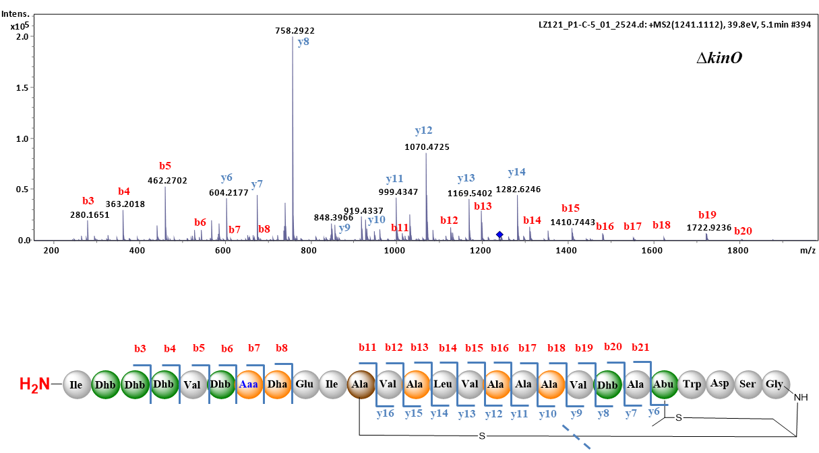

Figure S41. Tandem MS analysis of the intermediate 2 accumulated in the kinO variant.

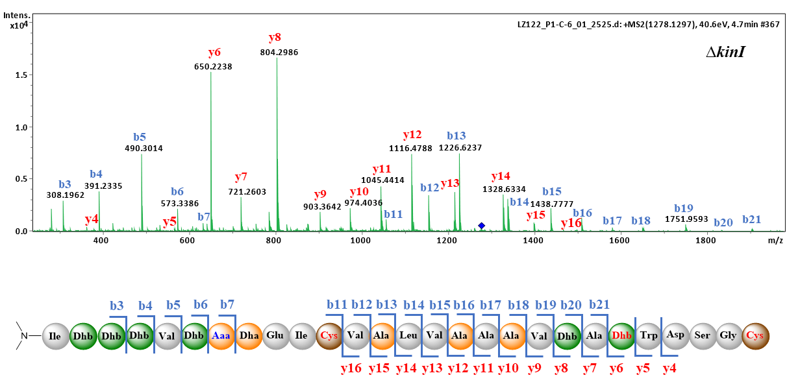

Figure S42. Tandem MS analysis of the intermediate 3 accumulated in the kinI variant.

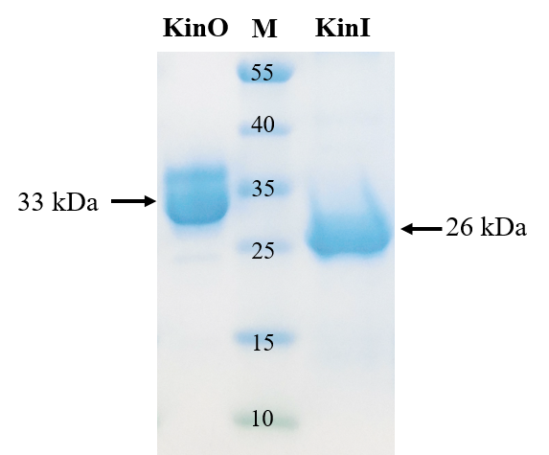

Figure S43. SDS page analysis of recombinant KinI (Right) and KinO (Left) with the corrected molecular weights, respectively.

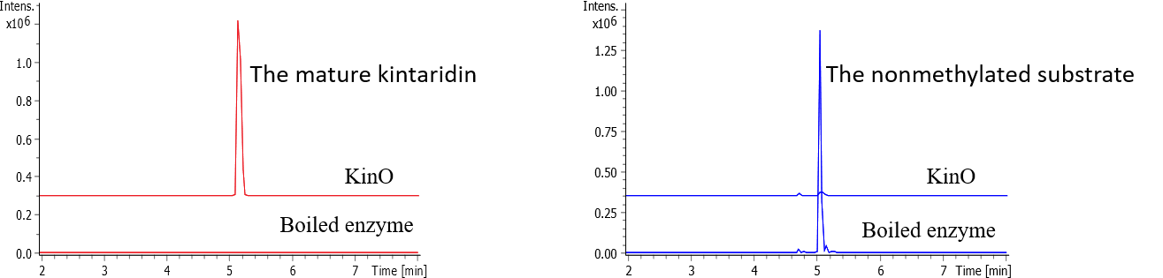

Figure S44. EIC analysis of the product generated in the assay of incubation of KinO with 2 accumulated.

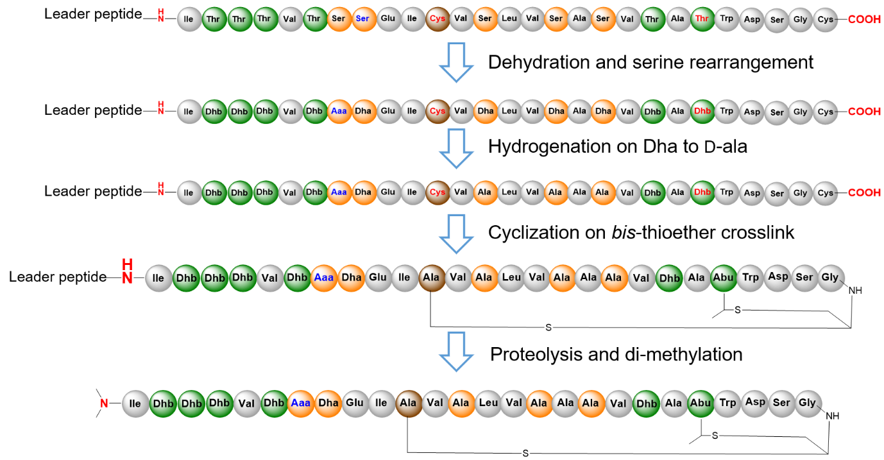

Figure S45. Proposed biosynthetic pathway to form kintamdin.

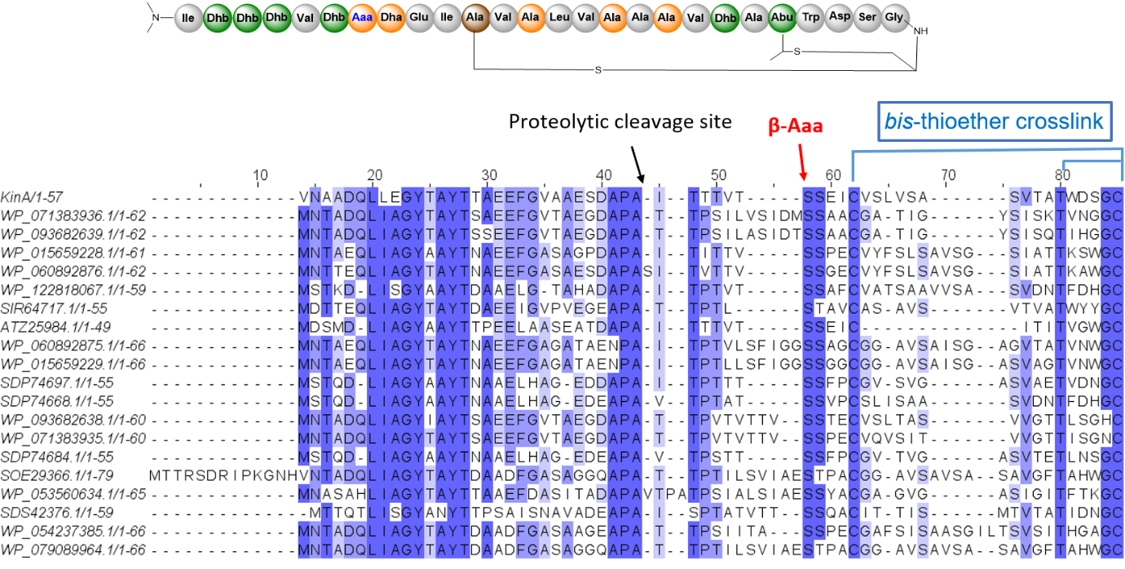

Figure S46. Conserved genome context suggested that a group of hypothetical protein are the kintamdin-like precursor peptides with characteristic motifs.

