Supporting information -Figures 1-20
Supplementary figures 2
Figure S2. ¹H NMR of kindtamdin in CD₃OD at 600 MHz. 3
Figure S3. ¹³C NMR spectrum for 1 in CD₃OD at 150 MHz. 4
Figure S4. COSY spectrum of 1. 5
Figure S5. HMBC spectrum of 1. 6
Figure S6. HSQC-TOCSY of 1. 7
Figure S7. HSQC spectrum of 1. 8
Figure S8. Substructure of 1 containing multiple (Z)-Dhb motif. 9
Figure S9. Key ROESY correlations indicating Z configurations of Dhbs 2, 3, 4, and 6. 10
Figure S10. Key correlations in the ROESY spectra in support of configuration shown in Figure S3. 11
Figure S17. Expanded and annotated ¹H NMR spectrum of 1. 18
Figure S18. Expanded and annotated ¹H NMR spectrum of 1. 19
Figure S19. Expanded and annotated ¹H NMR spectrum of 1. 20
Figure S20. Expanded and annotated ¹H NMR spectrum of 1. 21

Supplementary figures
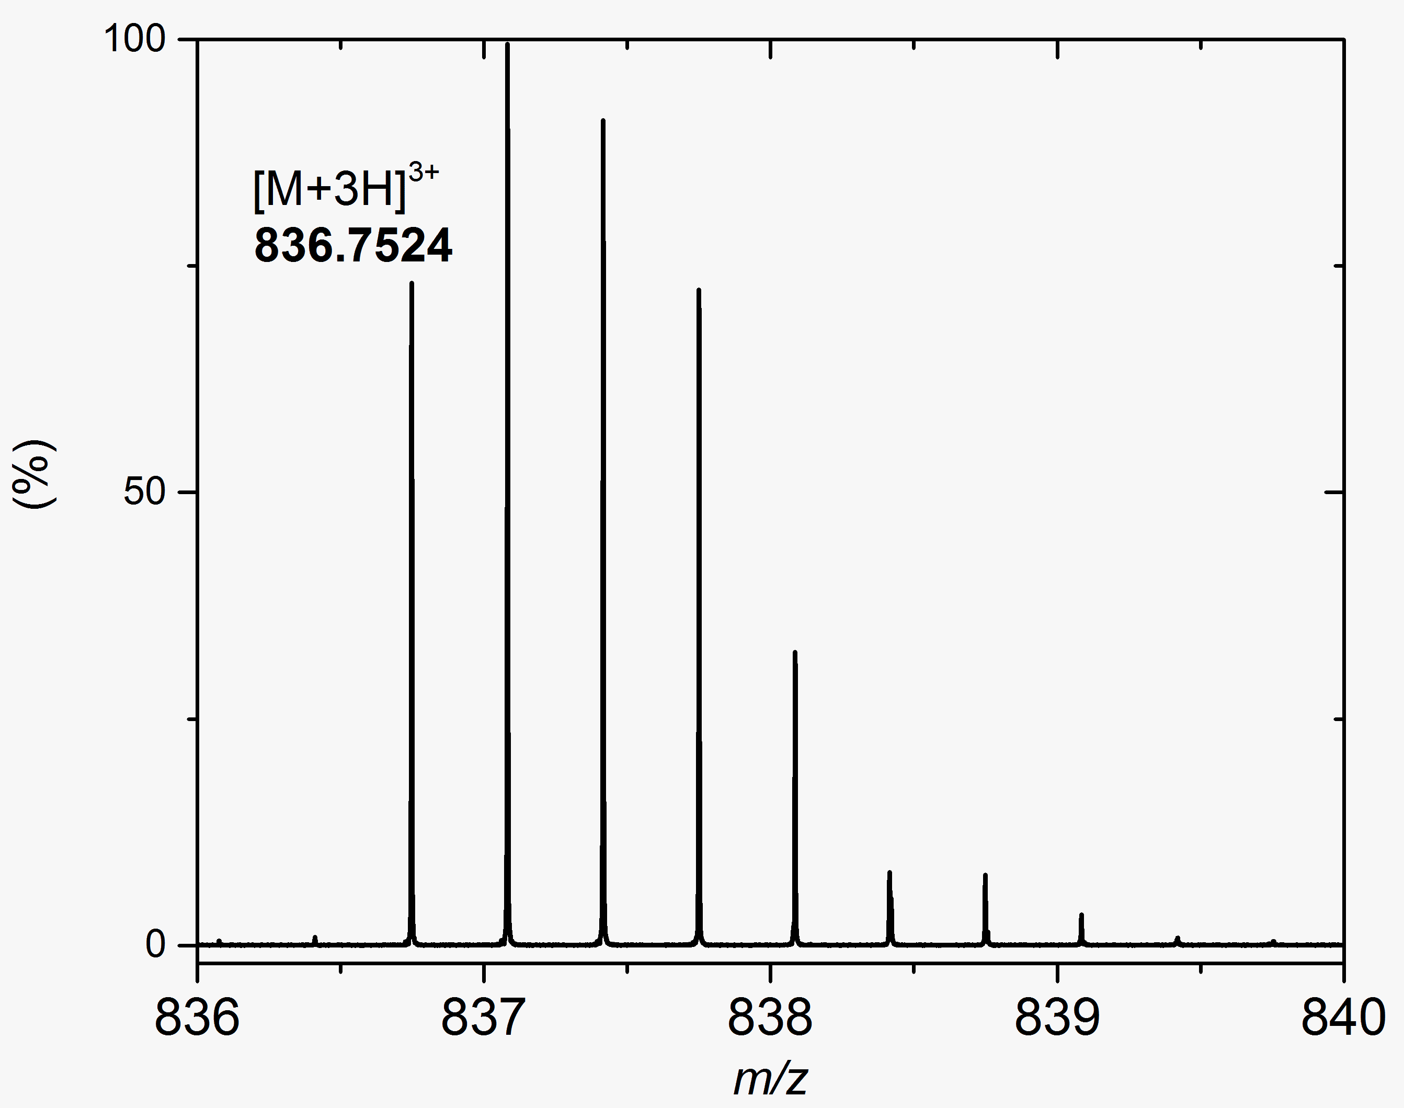
Figure S1. High Resolution ESI FT-ICR Mass Spectrometry analysis of 1. MS analysis revealed a dominant [M+3H]³⁺ ion of m/z 836.7524, consistent with a neutral molecular mass of 2507.2349 Da.

Figure S2. ¹H NMR of kindtamdin in CD₃OD at 600 MHz.

Figure S3. ¹³C NMR spectrum for 1 in CD₃OD at 150 MHz.

Figure S4. COSY spectrum of 1.

Figure S5. HMBC spectrum of 1.

Figure S6. HSQC-TOCSY of 1.

Figure S7. HSQC spectrum of 1.

Figure S8. Substructure of 1 containing multiple (Z)-Dhb motif.

Dha-8-NH
Val-19-3
Dha-8-4
Dha-8-NH-Dha-8-4
Dhab-20-NH-Dhb-20-4
Dhab-20-NH-Val-19-3
Dhab-6-NH-
Dhb-6-4
Dhab-4-NH-
Dhb-4-4
Dhab-4-NH-Dhb-3-3
Dhab-4-NH-
Val-5-2
Dhb-3-3
Val-5-2

Figure S9. Key ROESY correlations indicating Z configurations of Dhbs 2, 3, 4, and 6.
Dbh-2-3
Dbh-2-NH-Me₂-Ile-1-2
DBh-2-NH-
Dbh-2-4
DBh-3-NH-
Dbh-3-4
DBh-3-NH-
Dbh-2-3
Dbh-2-4
Dbh-3-4

Figure S10. Key correlations in the ROESY spectra in support of configuration shown in Figure S3.

Figure S11. Three key substructures based on detail analysis of Hα-NH (i, i+1) ROESY correlations and NH to -CO, Hα to -CO HMBC cross peaks between adjacent amino acids allowed partial determination of peptide sequence. The fragments were unambiguously assigned by NMR and these were: (NMe₂Ile-Dhb-Dhb-Dhb-Val-Dhb), Dha-Glu-Ile-Ala(S₁)-Val-Ala, Ala-Ala-Ala-Val-Dhb-Ala-Abu(S₂)-Trp.

Figure S12. HSQC chemical shifts for Aaa-7. Inset, ¹H splitting of 7.2 Hz indicating cis-geometry for Aaa-7. An unprecedented unsaturated β amino acid, (cis)-3-amino-acrylic acid (Aaa) was found to be present in 1 based on characteristic NMR ¹H coupling constants and chemical shifts in the HSQC.

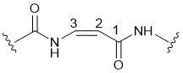

Figure S13. Key COSY correlation within Aaa-7 subunit. An unprecedented unsaturated β amino acid, (cis)-3-amino-acrylic acid (Aaa) was found to be present in 1 based on cross peaks in COSY.

Figure S14. Key HMBC Correlation within Aaa-7. An unprecedented unsaturated β amino acid, (cis)-3-amino-acrylic acid (Aaa) was found to be present in 1 based on HMBC.

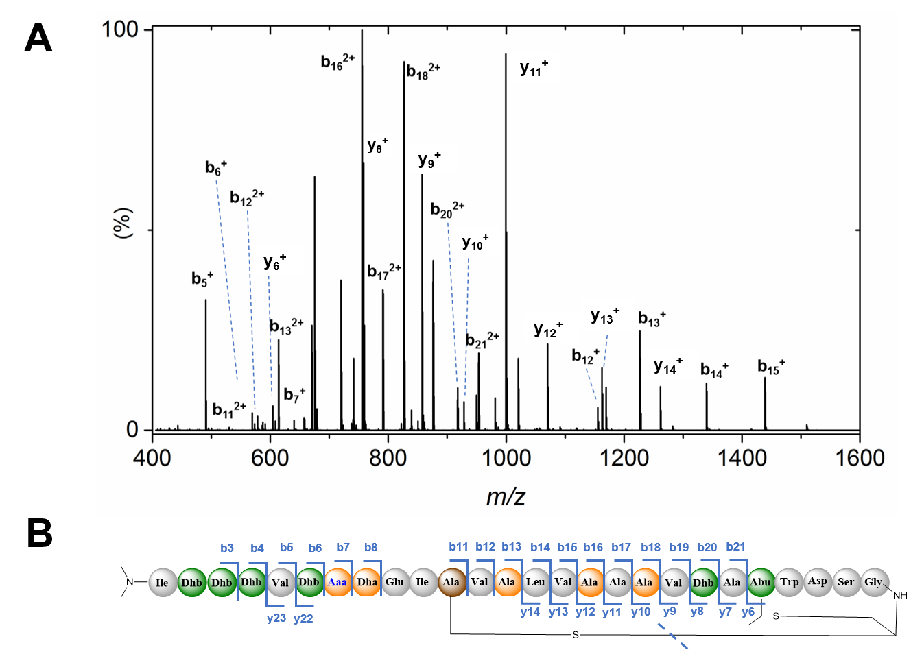
Figure S15. High Resolution De Novo Tandem MS analysis of kintamdin 1. The [M+3H]³⁺ ion at m/z 836.7524 was analysed by MS² and pseudo MS³ by FT-ICR MS. A. A typical MS2 spectrum is shown with assigned fragments annotated. B. The overall sequence coverage from combined fragmentation experiments is shown. Assigned fragments are also shown in Table S1.

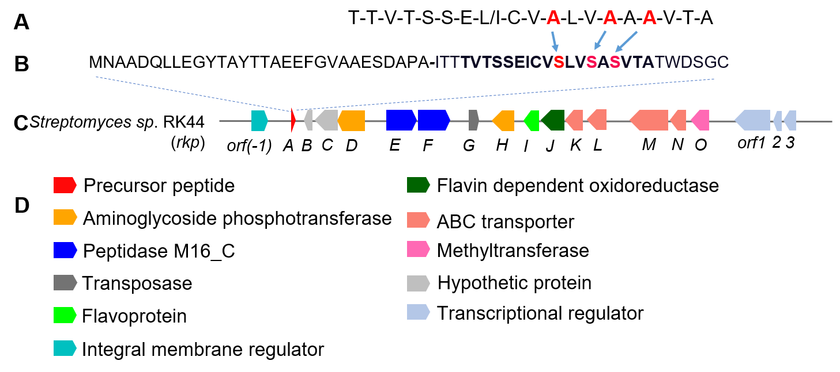
Figure S16. The putative BGC responsible for the kintamdin production in Streptomyces sp. RK44. A. The sequence tag generated from NMR and tandem MS analysis. B. the sequence of the precursor peptide (KinA). Three of Ser amino acids in the genomic sequence (Ser-13, 16 and 18, highlighted in red) was present in the final structure as Ala residues highlighted in red. C. the arrangement of the kin BGC. D. The biosynthetic genes in the kin BGC with assigned functions.

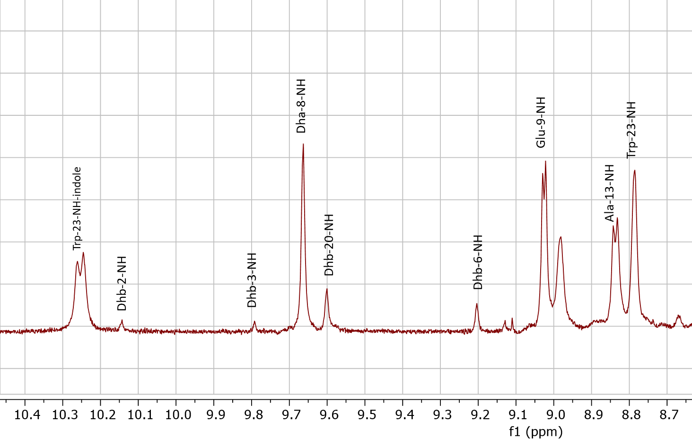

Figure S17. Expanded and annotated ¹H NMR spectrum of 1.

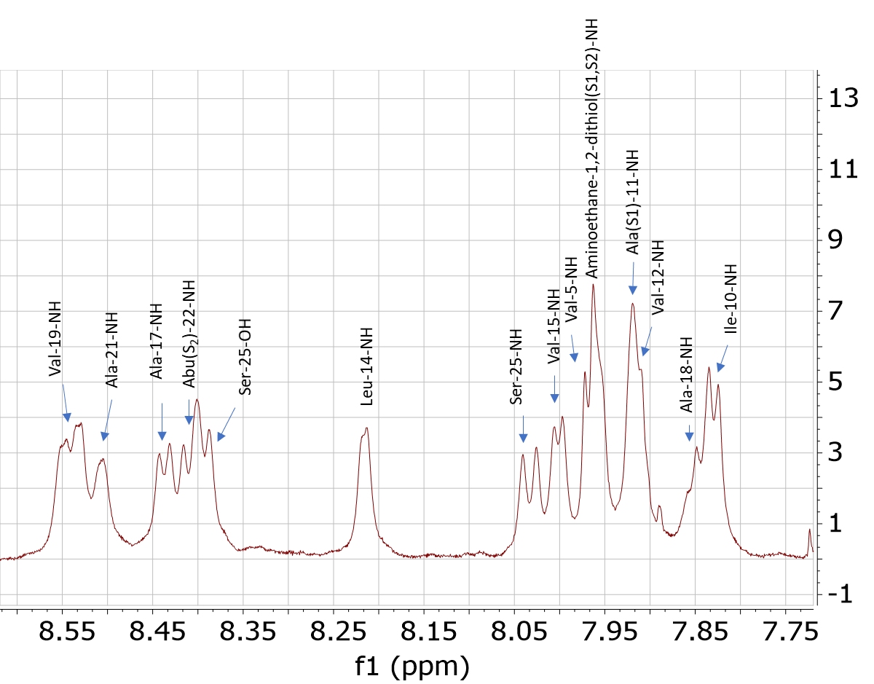

Figure S18. Expanded and annotated ¹H NMR spectrum of 1.

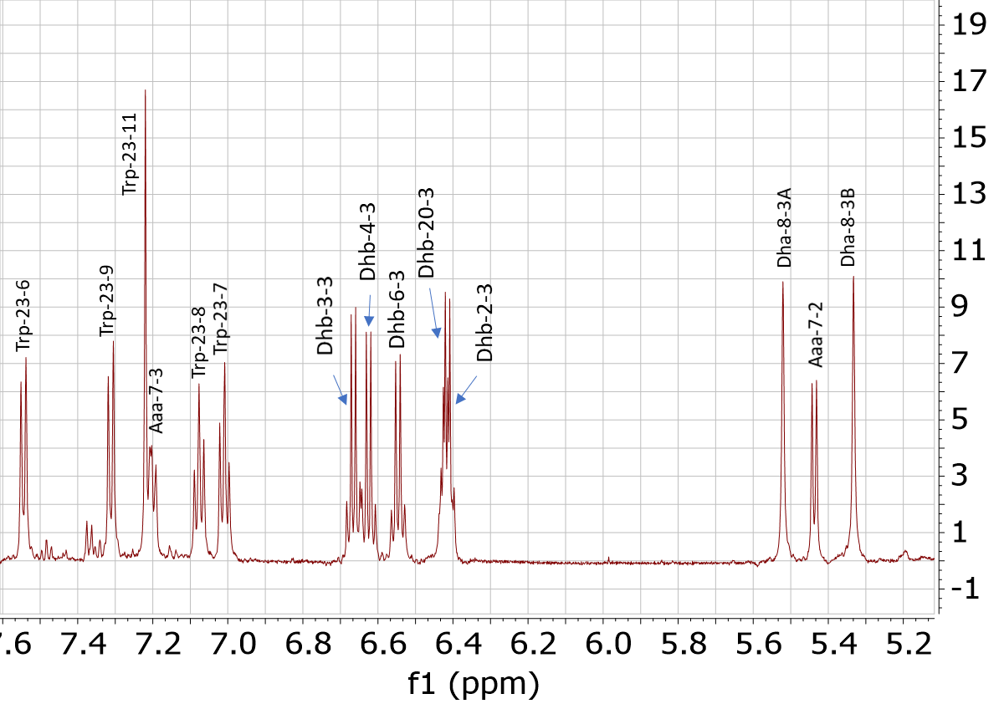

Figure S19. Expanded and annotated ¹H NMR spectrum of 1.

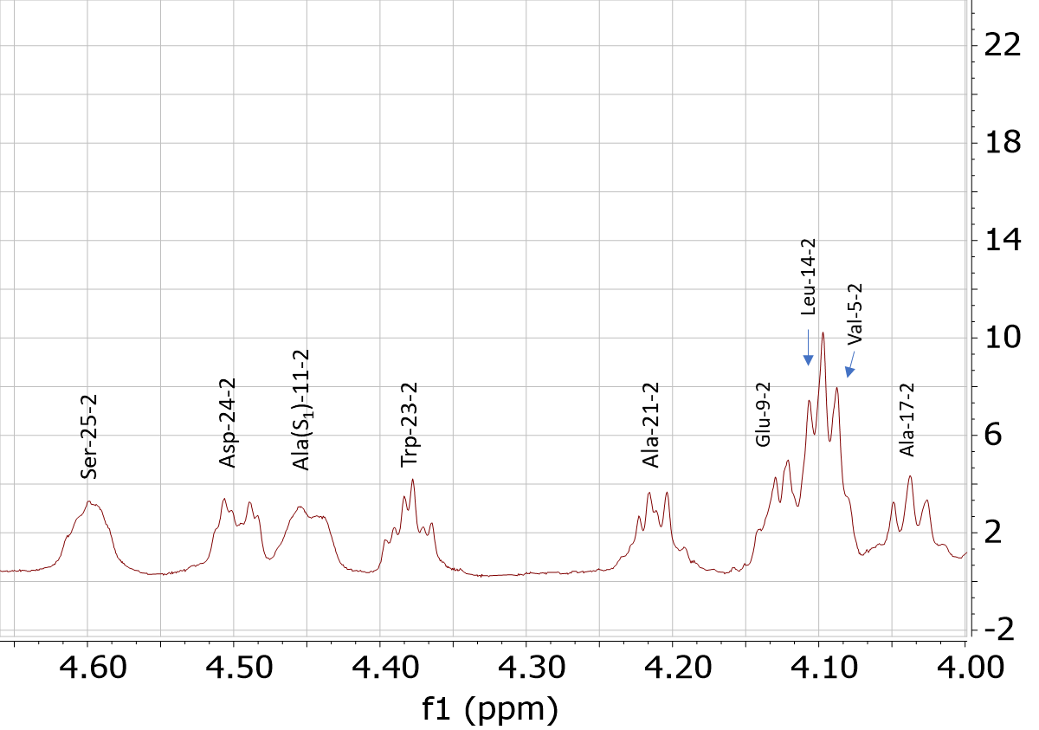

Figure S20. Expanded and annotated ¹H NMR spectrum of 1.

