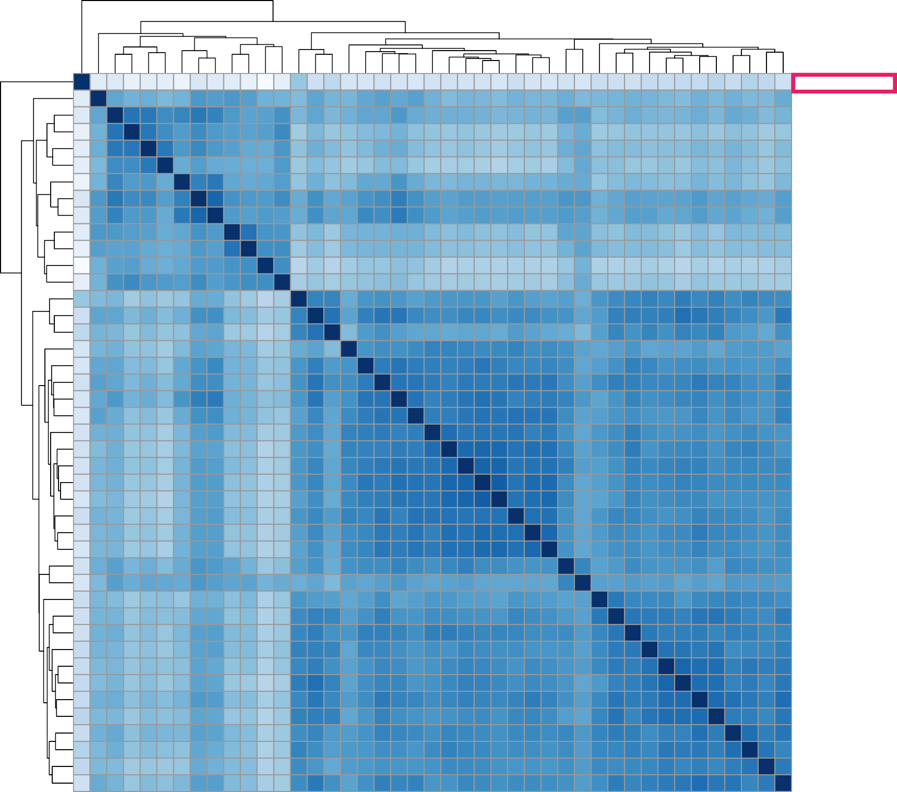
912_Recovered_One_dpi 907_Recovered_Seven_dpi 909_Non_Recovered_Seven_dpi 915_Non_Recovered_Seven_dpi 905_Non_Recovered_Seven_dpi 906_Non_Recovered_Seven_dpi 917_Non_Recovered_Seven_dpi 905_Non_Recovered_Pre_infection 915_Non_Recovered_Pre_infection 900_Recovered_Seven_dpi 912_Recovered_Seven_dpi 896_Non_Recovered_Pre_infection 897_Non_Recovered_Seven_dpi 911_Non_Recovered_One_dpi 897_Non_Recovered_Pre_infection 914_Non_Recovered_Seven_dpi 908_Recovered_Pre_infection 900_Recovered_Pre_infection 917_Non_Recovered_Pre_infection 908_Recovered_One_dpi 912_Recovered_Pre_infection 916_Non_Recovered_Pre_infection 909_Non_Recovered_Pre_infection 899_Recovered_Pre_infection 911_Non_Recovered_Pre_infection 913_Non_Recovered_Pre_infection 910_Non_Recovered_Pre_infection 906_Non_Recovered_Pre_infection 914_Non_Recovered_Pre_infection 899_Recovered_Seven_dpi 913_Non_Recovered_Seven_dpi 917_Non_Recovered_One_dpi 905_Non_Recovered_One_dpi 913_Non_Recovered_One_dpi 899_Recovered_One_dpi 897_Non_Recovered_One_dpi 909_Non_Recovered_One_dpi 896_Non_Recovered_One_dpi 910_Non_Recovered_One_dpi 914_Non_Recovered_One_dpi 916_Non_Recovered_One_dpi 900_Recovered_One_dpi 911_Non_Recovered_Seven_dpi

A
140

120

100

80

60

40

20

0

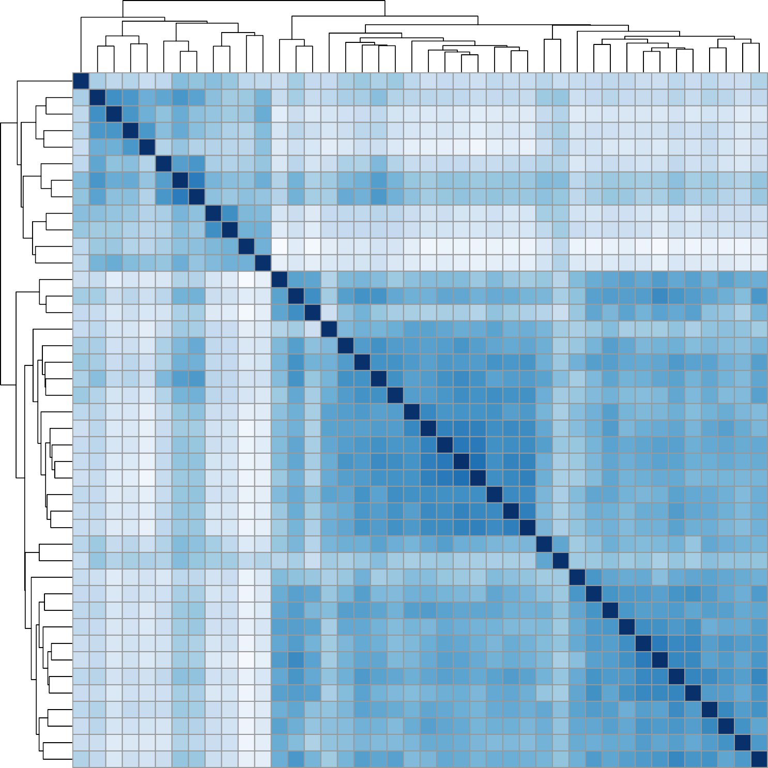
907−Recovered 909−Non_Recovered 915−Non_Recovered 905−Non_Recovered 906−Non_Recovered 917−Non_Recovered 905−Non_Recovered 915−Non_Recovered 900−Recovered 912−Recovered 896−Non_Recovered 897−Non_Recovered 911−Non_Recovered 897−Non_Recovered 914−Non_Recovered 908−Recovered 900−Recovered 917−Non_Recovered 908−Recovered 912−Recovered 916−Non_Recovered 909−Non_Recovered 899−Recovered 911−Non_Recovered 913−Non_Recovered 910−Non_Recovered 906−Non_Recovered 914−Non_Recovered 899−Recovered 913−Non_Recovered 917−Non_Recovered 905−Non_Recovered 913−Non_Recovered 899−Recovered 897−Non_Recovered 909−Non_Recovered 896−Non_Recovered 910−Non_Recovered 914−Non_Recovered 916−Non_Recovered 900−Recovered 911−Non_Recovered

B
100

80

60

40

20

0

Supplementary Figure 2 (FigS2): The heatmap of all samples with (A) and without the outlier sample (B).

