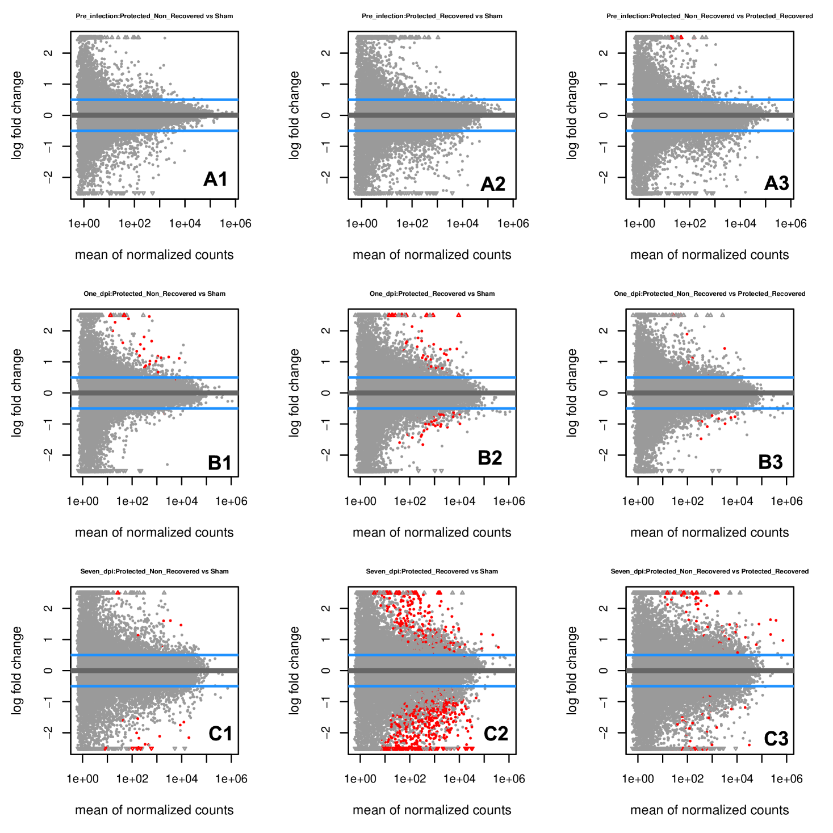

Supplementary Figure 3 (FigS3): The volcano graphs of the statistically significant DEGs (Red dots) between protection subgroup pairwise contrasts including protection and recovery combinations (1-3) with sampling time (A-C) (padj < 0.05)

