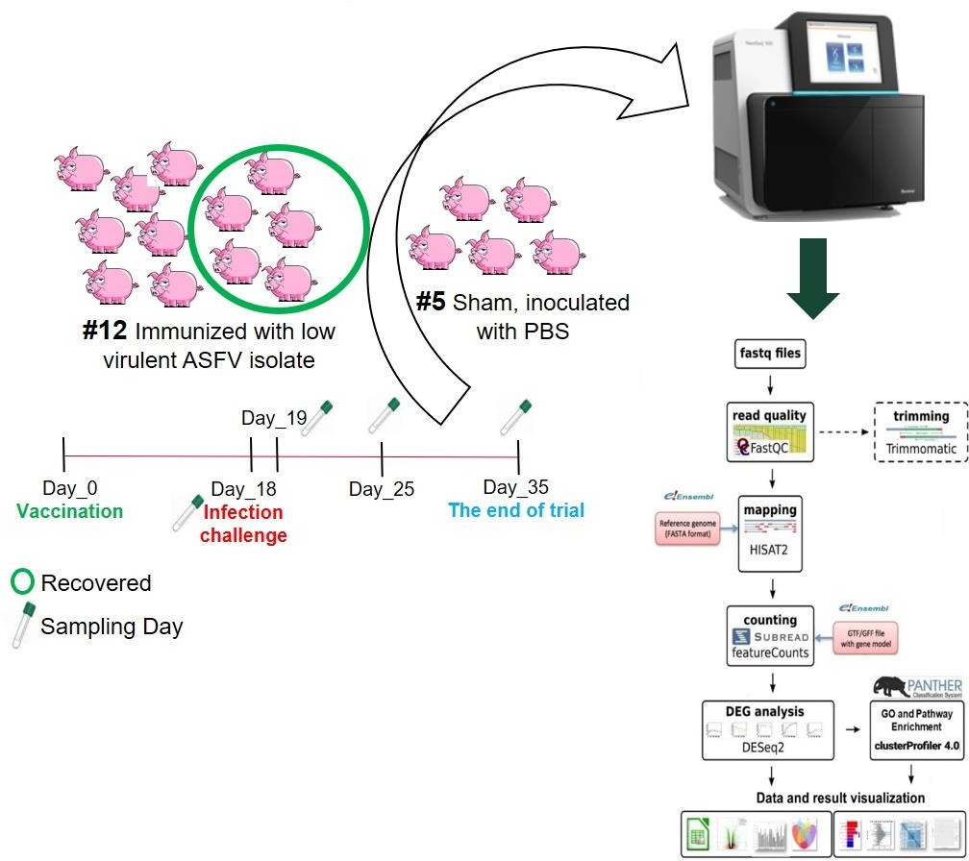

Supplementary Figure 1 (FigS1): The schematic experiment design and computational workflow.

