- (1) Firstly, establish the model in COMSOL, set up the geometry and divide the mesh, export the mesh into a txt file, and delete the non numerical parts in the txt file;
- Then open the input program code in MATLAB and input the generated txt file name in the corresponding section of the code；
- Finally, perform program operations and obtain a new txt file. Import the file into comsol and set it as an interpolation function；
- The Matlab code is shown in Fig 1：
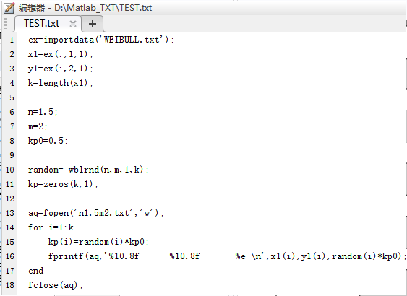
Fig 1 Matlab code of Weibull distribution function

