Figure A - Kombucha vinegar
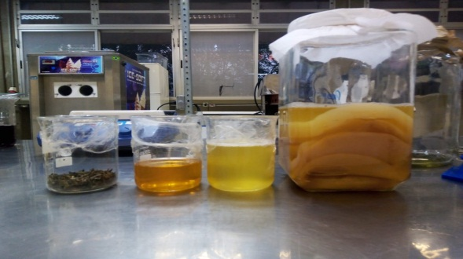
(a) green tea

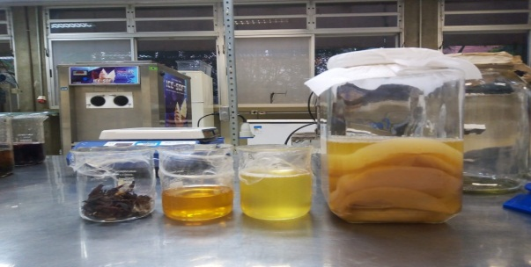
(b) hibiscus

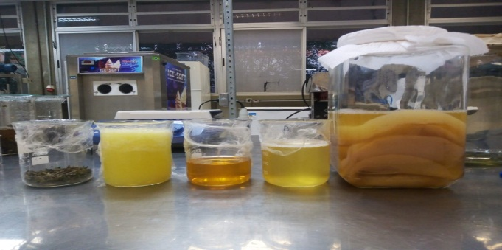
(c) pineapple

Figure B - Alcoholic curve

Figure C - Samples with different compositions.

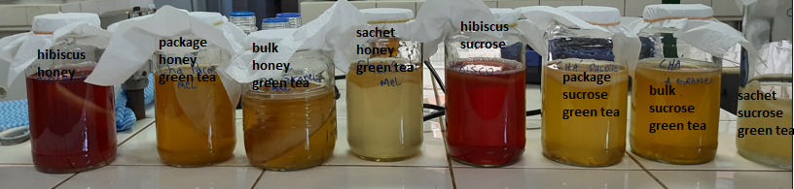

Figure D - Comparison with different compositions
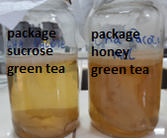 | 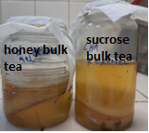 | 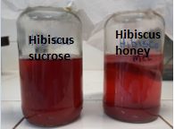

Table A - Composition of samples
Flavor | Honey | Scoby | Stater | Filtered drinking water
Green tea 5 g/L | 70 g/L | 115 g | 200 mL (10% of stater) | 1,800 mL
Hibiscus tea 5 g/L | 70 g/L | 115 g | 200 mL (10% of stater) | 1,800 mL
Green tea 5 g/L with pearl pineapple 125 g/L | 70 g/L | 115 g | 200 mL (10% of stater) | 1,800 mL

Table B - Physical-chemical analysis of commercial vinegar
Product | Acetic acid %(m/V) | pH | Crude °Brix | Filtered °Brix
Green tea kombucha vinegar | 0.24 ±0.02 | 3.14 | 3.4 | 1.8
Hibiscus kombucha vinegar | 1.34 ± 0.02 | 2.70 | 3.2 | 2.2
White commercial vinegar of alcohol | 4.04 ± 0.02 | 2.81 | 1.4 | 1.4

Table C - Means and standard deviations of acceptance of attributes for acetic fermented formulations
Formulation | Aroma |  | Color | Flavor
FAKCV | 6.12ª±0.21 |  | 6.29^{b}±0.23 | 6.42ª±0.25
FAKA | 5.69ª±0.28 |  | 5.39^{c}±0.24 | 4.79^{b}±0.30
FAKH | 5.32ª±0.28 |  | 7.55ª±0.20 | 5.67^{ab}±0.28
Note: Means in the same column, followed by different letters, differ according to Tukey's test at a significance level of 5%.

