Supplementary Figure
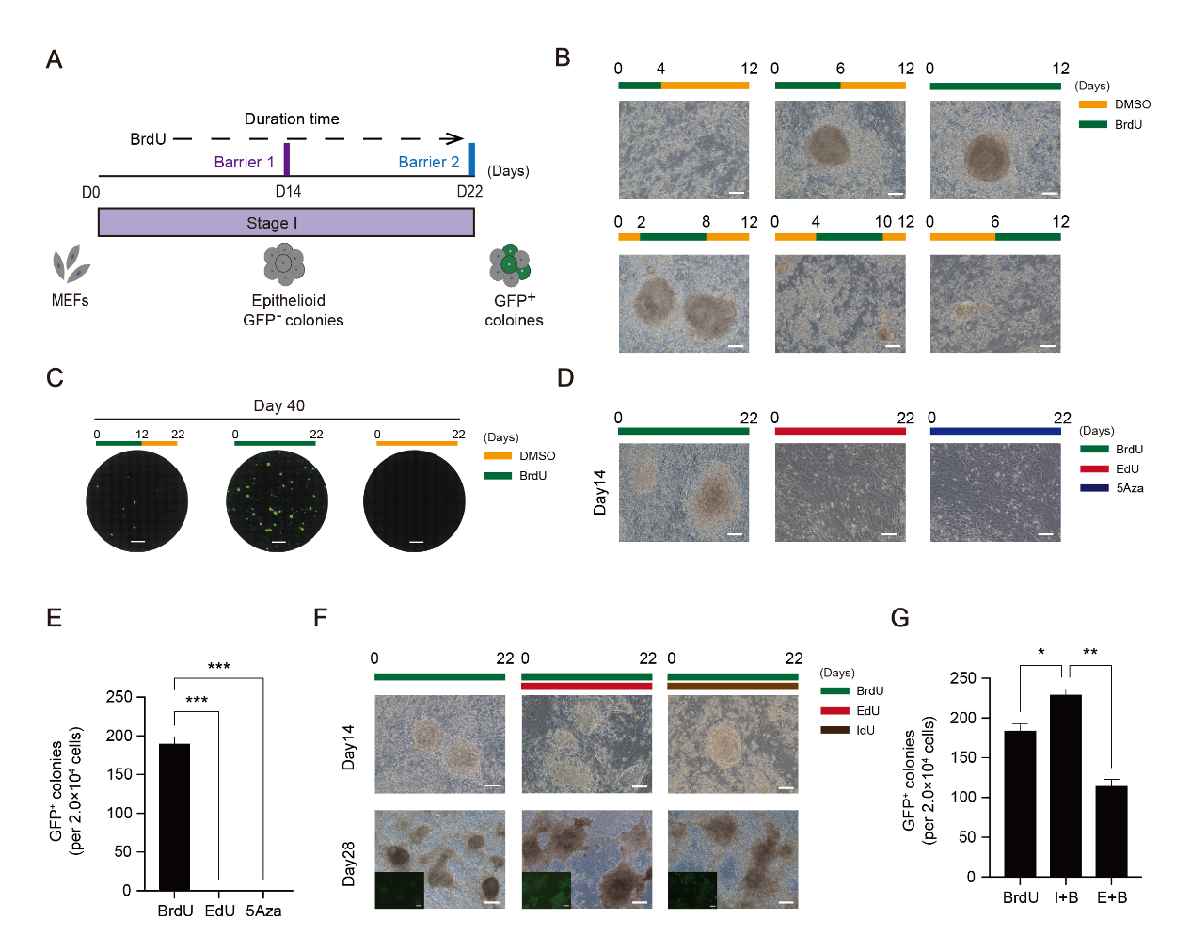

Figure S1
- Schematic diagram of the induction of stage1
- Morphological changes at barriers1 under indicated conditions. Scale bar 100$μ$m
- Images of GFP+ colonies taken by fluorescence microscope in situ. Scale bar,5mm.
- Morphological changes at barriers1 treated with BrdU, EdU or 5Aza.
- Number of Oct4-GFP+CiPSC colonies generated under BrdU,EdU or 5Aza.
- Morphological changes at distinct time points during induction of CiPSCs treated with BrdU ,I+B(IdU+BrdU) or B+E(BrdU+EdU). Scale bar 100$μ$m
- Number of Oct4-GFP+CiPSC colonies generated under BrdU,I+B or B+E.

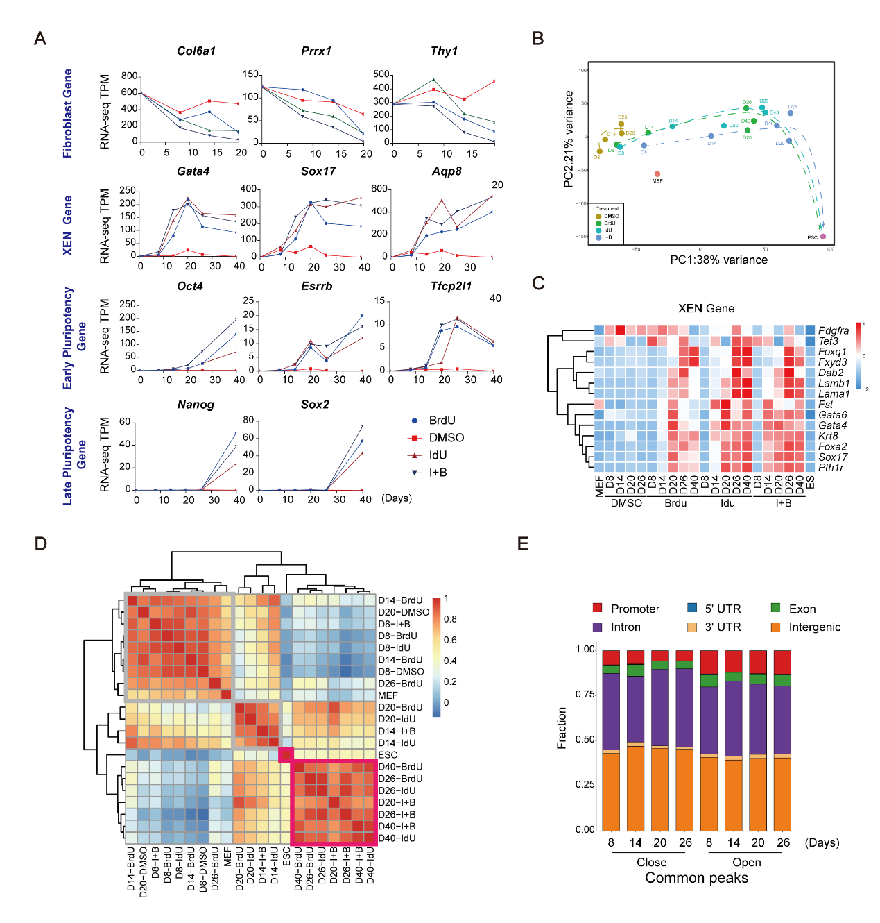

Figure S2
- Representative fibroblast genes, XEN genes and pluripotency genes peaks from RNA-seq for CIP at D8,14,20 and 26 with or without BrdU or IdU.
- PCA analysis for RNA-seq data from Cip under indicated conditions
- Heatmap of XEN genes related RNA-seq for CIP at D8,14,20 and 26 with or without BrdU or IdU.
- The R2 correlation coefficient matrix of all versus all RNA-seq datasets as indicated

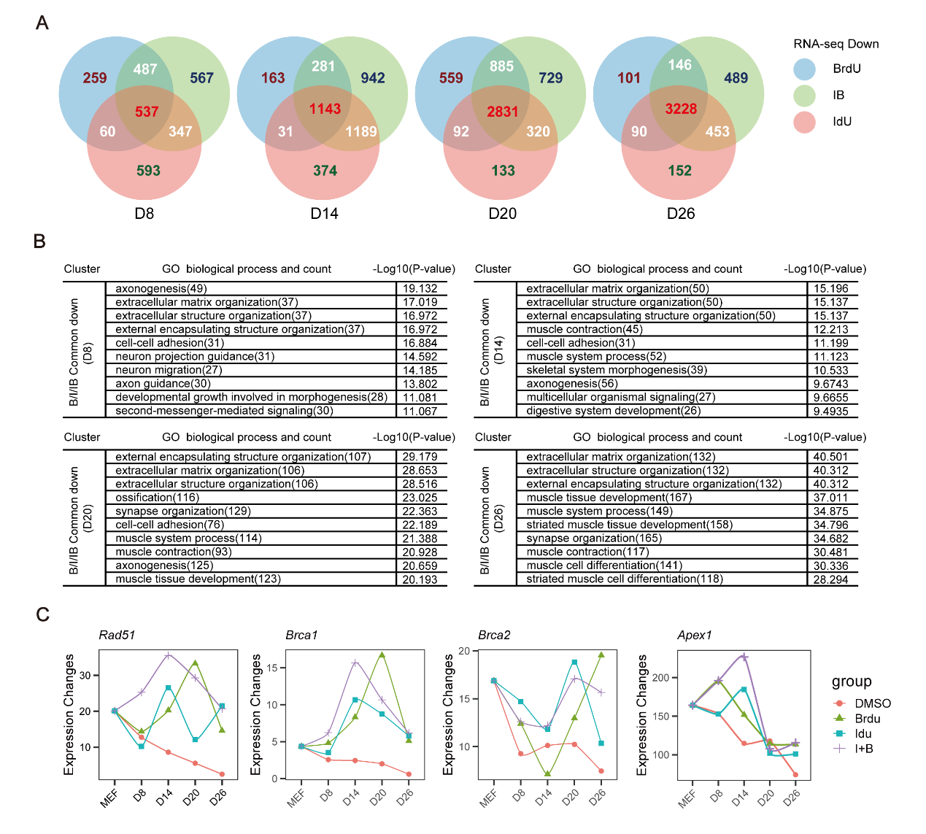

Figure S3
A. Venn plots for overlapping genes in the downregulated groups between BrdU, IdU, and BrdU+IdU versus the control.
B. Enriched GO functions in upregulated groups.
C. Representative DNA repair genes from RNA-seq for CIP.

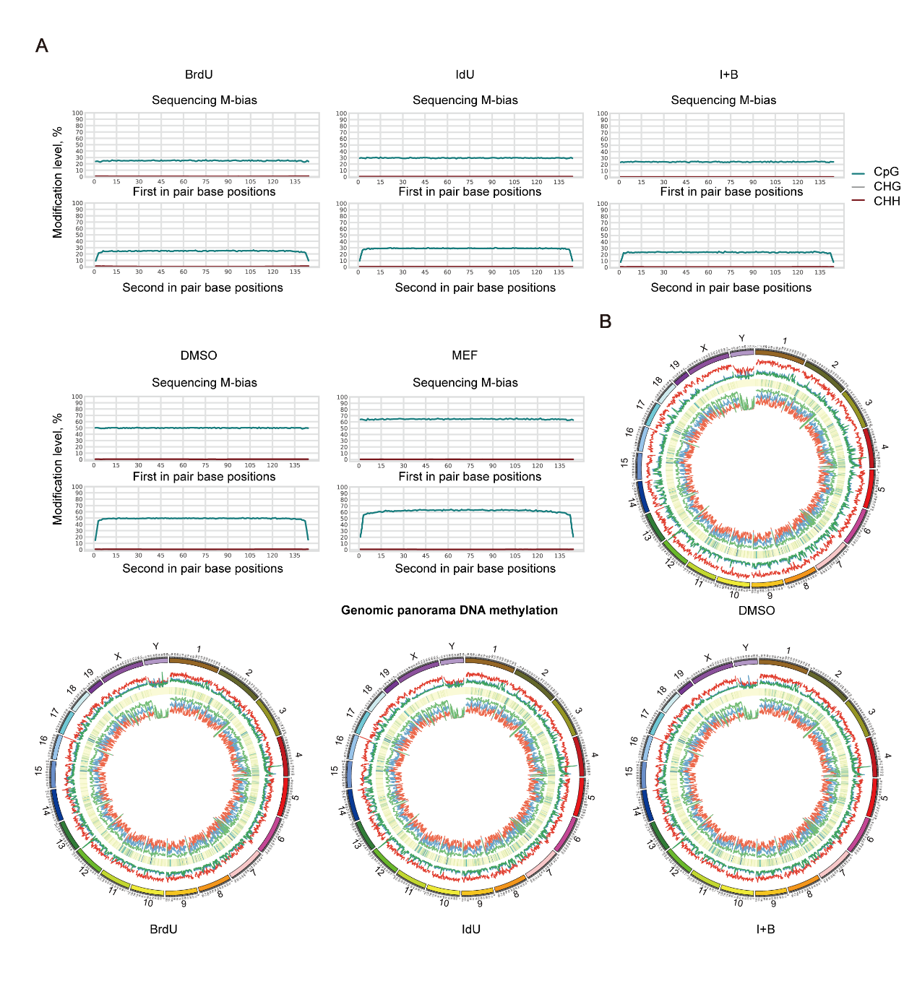

Figure S4
A. M-bias plot analysis
B. Genomic panorama DNA methylation.

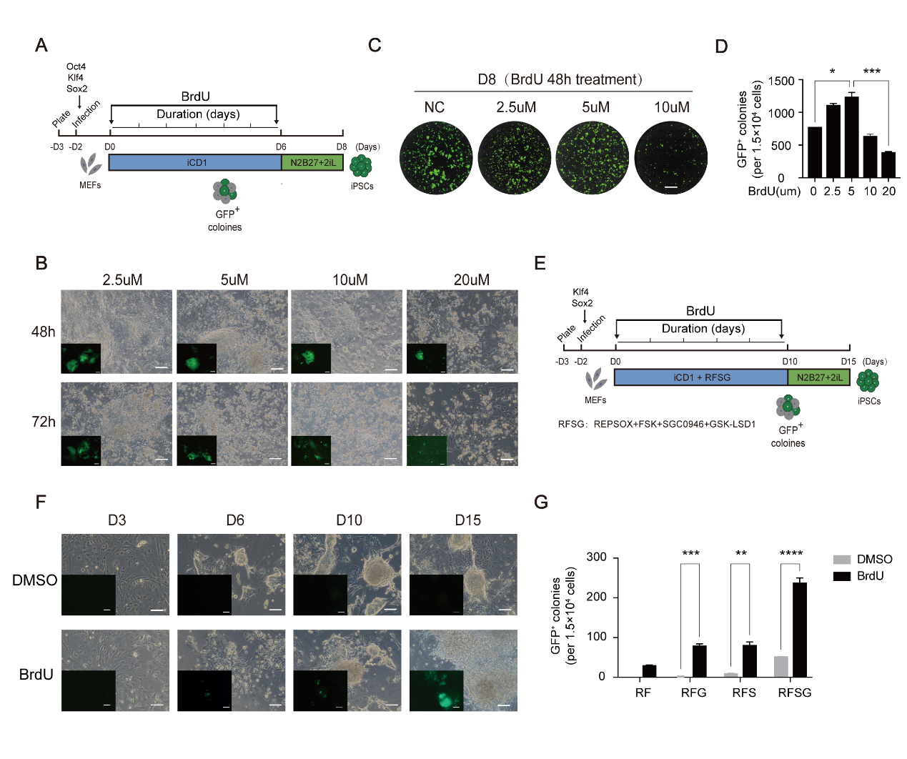

Figure S5
A. Schematic diagram of the induction of iPS from MEFs with OKS
B. Images of GFP+ colonies taken by fluorescence microscope in situ. Scale bar,5mm.
C. Number of Oct4-GFP+CiPSC colonies generated under indicated conditions.
D. Morphological changes at OKS treated with different concentrations BrdU
E. Schematic diagram of the induction of iPS from MEFs with KS
F. Morphological changes at KS treated with or without BrdU
G. Number of Oct4-GFP+CiPSC colonies generated under indicated conditions. R,Repsox,F,FSK,S,SGC0946,G,GSK-LSD1

Materials and methods

Mice
Beijing Vital River Laboratory supplied the 129Sv/Jae and ICR mice, while The Jackson Laboratory provided the Oct4-GFP(OG2) transgenic allele-carrying mice (CBA/CaJ X C57BL/6J). All animal experiments were carried out in compliance with the Animal Protection Guidelines of Guangzhou Institutes of Biomedicine and Health, located in Guangzhou, China and affiliated with the Chinese Academy of Sciences.

Cell culture

Mouse embryonic fibroblasts (MEFs)
To isolate Mouse Embryonic Fibroblasts (MEFs), E13.5 embryos were dissected and all internal organs, head, limbs, and tails were removed and discarded. The remaining tissue was sliced into small pieces and dissociated with a digestive solution (consisting of 0.25% trypsin and 0.05% trypsin in a 1:1 ratio from GIBCO) for 15 minutes at 37C to obtain a single-cell suspension. The cells from each embryo were then plated onto a 6-cm culture dish coated with 0.1% gelatin and cultured in DMEM (Hyclone) supplemented with 10% FBS (GIBCO), 1% GlutaMAX (GIBCO), and 1% NEAA (GIBCO), referred to as fibroblast medium.
mESCs
The feerder-free and serum-free ESC medium used for maintaining mESCs and CiPSCs consisted of DMEM supplemented with N2 (100X), B27 (50X), LIF, 1% GlutMax, 1% NEAA, 0.1 mM beta-mercaptoethanol, and 3 µM CHIR99021 and 1 µM PD0325901. Additionally, the cell lines were tested negative for mycoplasma using Lonza's Kit (LT07-318).

Culture medium preparation
Chemical reprogramming stage 1:
iCD1 medium (Chen et al., 2011a) comprises Vitamin C (50 mg/ml), bFGF (10 ng/ml), and CHIR99021 (3 mM), along with several small molecules, including Brdu (10 µM), RepSox (5 mM), FSK (10 mM), VPA (0.1 mM), AM580 (0.05 mM), EPZ5676 (5 mM), DZNeP (0.05 mM), SGC0946 (5 mM), BMP4 (10 ng/ml), and Capmatinib（5µM).
Chemical reprogramming stage 2:
DMEM (high glucose, Hyclone), 1% N2 (GIBCO), 2% B27 (GIBCO), 1% GlutMax (GIBCO), 1% NEAA (GIBCO), 1% sodium pyruvate (GIBCO) 3 mM CHIR99021, 1 mM PD0325901 and 1000 U LIF.
KS reprogramming stage 1:
iCD1 medium, Repsox(5 μM), FSK(10 μM), SGC0946(1 μM), GSK-LSD1(1 μM) and BrdU(2.5 μM).
KS reprogramming stage 2:
iCD1 medium, Repsox(5 μM), FSK(10 μM), SGC0946(1 μM), GSK-LSD1(1 μM).
KS reprogramming stage 3:
DMEM (high glucose, Hyclone), 1% N2 (GIBCO), 2% B27 (GIBCO), 1% GlutMax (GIBCO), 1% NEAA (GIBCO), 1% sodium pyruvate (GIBCO) 3 mM CHIR99021, 1 mM PD0325901 and 1000 U LIF.

Chemical induction of iPSCs from mouse fibroblasts
The 12-well plates were pre-coated with 0.1% gelatin and seeded with MEFs at a density of 20,000 cells per well in 10% fibroblast medium. The following day, Stage 1 chemical reprogramming medium was added and refreshed daily. After day 22, the medium was changed to Stage 2 chemical reprogramming medium. On day 40, the Oct4-GFP colonies were either counted or detected via FACS.

Klf4 and Sox2 mediated MEF reprogramming
Plasmids carrying murine Klf4, Sox2 cDNA were purchased from Addgene, and the fragments were then ligated to the PMX vector to obtain a recombinant plasmid. PlatE cells were transfected with individual plasmids with the Ca3(PO4)2-method. After 48 hours of transfection, the virus supernatant was collected and used to infect cells. Approximately 15,000 cells were seeded per well in 24-well plates containing DMEM medium supplemented with 10% FBS, and were cultured for 24-12 hours prior to MEF infection. The Klf4 and Sox2 virus solution was filtered using a 0.45 µm filter, and then 8 µg/ml of polybrene was added for cell infection. The cells were subjected to a second infection after 24 hours. After 48 hours of MEF cell infection, the cells were transferred to induction medium, with the day of medium change being designated as day 0. KS reprogramming stage 1 medium was used for the first 6 days, stage 2 medium was used from day 6 to day 10, and stage 3 medium was used from day 10 onwards. The medium was changed every 24 hours.

Immunofluorescence staining
The coverslip-grown cells were washed twice with PBS and fixed using 4% paraformaldehyde (PFA) at room temperature for 30 minutes. Next, the samples were treated with 1N HCl on ice for 10 minutes, followed by 2N HCl at room temperature for 10 minutes and then 2N HCl at 37°C for 20 minutes. After washing thrice with PBS for 5 minutes each, the cells were permeabilized with 0.1% Triton X-100 for 30 minutes. Subsequently, the cells were blocked with 3% BSA for an hour and washed thrice with PBS for 5 minutes each while shaking. The cells were then incubated overnight at 4°C with primary antibodies, diluted in 3% BSA (1:250) in PBS. After four washes with PBS for 5 minutes each while shaking, the cells were incubated for an hour at room temperature with secondary antibodies, diluted in 3% BSA (1:200) in PBS. Later, the cells were incubated in DAPI for 1 minute, washed twice with PBS, and finally, the coverslips were mounted on the slides for observation under a confocal microscope (Andor Dragonfly 200). The following antibodies were used: anti-BrdU (Sigma), anti-γ-H2AX (Abcam), secondary antibodies Alexa Fluor 568 goat anti-mouse IgG (Invitrogen) and Alexa Fluor 488 goat anti-mouse IgG (Invitrogen).
Comet assay
During the chemical reprogramming process, the control and experimental group cells at D14, D16, D24, and D30 were digested with 0.25% trypsin into single cells, and resuspended in PBS at a concentration of 10,000 cells/ml. The Oxiselect Comet Assay Kit (Cell-Biolabs) was used as a reference for the experiment. The cell suspension was mixed with agarose, and then incubated in the dark at 4℃ for 15 minutes. The mixture was placed on a slide and immersed in lysis buffer, then incubated in the dark at 4℃ for 60 minutes. The slide was transferred to an alkaline solution, and incubated in the dark at 4℃ for 30 minutes. The slide was then placed into an electrophoresis chamber, and alkaline electrophoresis buffer was added under the conditions of 300 mA and 15 minutes. After electrophoresis, the slide was transferred to water and soaked for 2 minutes. Then it was transferred to 70% ethanol and soaked for 5 minutes. The slide was placed in a 37℃ oven overnight. Vista Green DNA dye was added for 10 minutes, and the cells were observed and recorded using an inverted fluorescence microscope (ZEISS). The software cometscore was used to analyze the tail moment of the cells.

FACS analysis
The cells were rinsed with PBS and then digested with 0.25% trypsin at 37°C for 5 minutes. The digestion was stopped by adding 10% FBS DMEM medium. After filtering with a sieve and centrifuging at 250 g for 5 minutes, the supernatant was discarded and the cells were resuspended in PBS at a concentration of 100,000 to 1,000,000 cells/ml. The percentage of positive cells was detected using a BD Accuri™ C6 Plus flow cytometer. The flow cytometry data was analyzed using FlowJo7.6.1.

Bisulfite genomic sequencing
Extract DNA template. After centrifuging the cells, add 600 μl of Nuclei Lysis Solution (Promega) and mix by pipetting. Add 200 μl of Protein Precipitation Solution (Promega) and mix by pipetting. Let it sit on ice for 10 minutes. Centrifuge at 12,000 rpm for 10 minutes. Take the supernatant, add 600 μl of isopropanol, and let it sit on ice for 10 minutes. Centrifuge at 12,000 rpm for 5 minutes. Discard the supernatant, add 600 μl of 70% ethanol. Heat in a metal bath at 60°C for 5 minutes. Add RNAase-free water and heat in a metal bath at 60°C for 30 minutes. Take 2 μg of template DNA and bisulfite treat according to the EpiTect Bisulfite Kit (QIAGEN) manual. Amplify the Aqp8 and Pth1r promoter regions by PCR. Clone and sequence using the pMD18-T vector (TaKara).

RNA-seq and data analysis
Cells were treated with TRIzol to extract total RNA, which was then converted into cDNA using ReverTra Ace (Toyobo) and oligo-dT (Takara). The resulting cDNAs were analyzed using Premix Ex Taq (Takara) in qPCR experiments. For library construction, the TruSeq RNA Sample Prep Kit (RS-122-2001, Illumina) was employed, and RNA-seq was performed using the Miseq Reagent Kit V2 (MS-102-2001, Illumina).
The original sequencing data was quality-controlled using FASTQC, and low-quality bases and sequencing adapters were removed using trim_galore. HISAT2(11) was used to align the filtered clean reads with the mouse mm10 reference genome. Samtools(12) was used to filter out unaligned or unpaired sequencing fragments and obtain the bam file. featureCounts(13) software was used to quantify gene expression levels. EdgeR was used to identify differentially expressed genes. ClusterProfiler(14) was used to perform GO or KEGG functional enrichment analysis to determine the molecular functions of the differentially expressed genes.

ATAC-seq
The ATAC-seq procedure was carried out following the previously published protocols(15,16) and TruePrep DNA Library Prep Kit V2 for Illumina. Briefly, 50,000 cells were washed with 50 mL of cold PBS and suspended in 50 mL of lysis buffer containing 10 mM Tris-HCl pH 7.4, 10 mM NaCl, 3 mM MgCl2, and 0.2% (v/v) IGEPAL CA-630. The cell suspension was centrifuged at 500 g for 10 minutes at 4°C, followed by the addition of 50 mL of transposition reaction mix from the TruePrep DNA Library Prep Kit V2 for Illumina. The resulting samples were subjected to PCR amplification and incubated at 37°C for 30 minutes. VAHTS DNA Clean Beads (Vazyme #N411) were used for purification and recovery of the DNA fragments.The purified product was amplified. VAHTS DNA Clean Beads were used for further purify and separate 200-700bp fragments. The ATAC library was finally sequenced on a NextSeq 500, using a NextSeq 500 High Output Kit v2 (150 cycles) (FC-404-2002, Illumina), following the manufacturer's instructions.

Cut&tag
According to the protocol of the Hyperactive universal Cut&Tag assay Kit for Illumina, library construction was performed. 100,000 cells were collected and incubated with processed ConA beads. The sample was incubated with primary antibody overnight at 4℃, followed by incubation with secondary antibody at room temperature for 1 hour. The sample was then incubated with transposase pA/G-Tnp at room temperature for 1 hour, and the DNA was fragmented for 1 hour before extraction. After amplifying DNA fragments according to concentration, VAHTS DNA Clean Beads (Vazyme #N411) were used for purification and recovery of the DNA fragments.

ATAC-seq and Cut&tag bioinformatics analysis
The original sequencing data was quality-controlled using FASTQC, and low-quality bases and sequencing adapter sequences were removed using trim_galore. Bowtie2(17) was used to align high-quality sequencing fragments with the mouse mm10 reference genome. Samtools was used to retain only paired and uniquely aligned sequences, exclude mitochondrial sequence fragments, and obtain the bam file. Picard(http://broadinstitute.github.io/picard/) was used to remove duplicate fragments caused by PCR amplification during library preparation. Deeptools(18) was used to convert the bam file to a bw file, and the results were visualized using IGV(https://igv.org/). The peak calling software MACS2(19) was used to detect enrichment regions of open chromatin or DNA fragments. HOMER was used to identify transcription factor binding motifs enriched in chromatin regions. CHIPseeker(20) was used to annotate genomic features (such as genes, promoters, enhancers, and transcription factor binding sites) of peaks intervals. Bedtools(21) was used to analyze differential binding sites, and deeptools was used to generate signal matrix files and visualize the results. Other analyses were performed using glbase(22).

GM-seq
The Gm-seq procedure was carried out following the previously published protocols in cooperation with Gene plus company(23). We utilized Hieff NGS® Ultima Pro DNA Library Prep Kitfor Illumina (Yeason, cat. on. 12201ES96) for end repair, A-tailing, and adaptor ligation. After magnetic beads were purified, 5-methylcytosine (5mC) and 5-hydroxymethylcytosine (5hmC) were oxidized to 5-acylcytosine (5fC) or 5-carboxyl cytosine (5caC) by TET enzyme, then 5fC or 5caC was treated with pyridine borane and reduced to dihydrouracil (DHU). Finally, PCR amplification is performed and barcode is introduced to obtain the sequencing library. After going through this series of processes the methylated cytosine would be identified as thymine (T) by MGI T7 sequencing platform. The samples for whole genome sequencing directly were also going through the same procedures that were used for GM-seq but without oxidation and pyridine borane reduction preparation. Whole genome analyses were performed by the sequencing library we constructed above.

GM-seq bioinformatics analysis
The raw fastq and bam files were evaluated using BWA and SAMtools software. Alignment and analysis of DNA sequencing data were performed utilizing asTair tools in automated mode from raw fastq files to finalized genotyping data. This pipeline utilized GATK tools and ExomeDepth tools to perform base quality score, genotype calling and variant annotation, including SNP and Indel. And ichorCNA were employed to analyze genome-wide CNV and calculate insert size. Sequencing data were analyzed by three computational pipelines in order to understand the reliability of the detection of fungi, bacteria, and viruses: Kraken, Kaiju and SNAP. BLAST was used to compare the sequencing results with the high-risk microorganisms. For methylation analyses, diagrams for CpG coverage were generated using methylKit 1.4.0. The GC bias plot was generated using Picard’s CollectGCBiasMetrics. Correlation analysis was performed using methylKit version 1.4.0 with default settings except for a minimum coverage threshold of one read.

Quantification And Statistical Analysis
Sample size was not predetermined using statistical methods, and the experiments were not randomized. The investigators were not blinded during the experiment or outcome assessment. The data was presented as mean±s.d. Statistical analysis was conducted using either two-tailed unpaired student’s t-test or one-way ANOVA with GraphPad Prism 6, and a P-Value of <0.05 was considered statistically significant. The level of significance was indicated as ∗P < 0.05, ∗∗P < 0.01, ∗∗∗P < 0.001 and ∗∗∗∗P < 0.001. The relevant figure legends provided information on the statistical test, precise P-Value, exact sample sizes, and independent experiments.

