Figure A - Flowchart for obtaining microcrystals 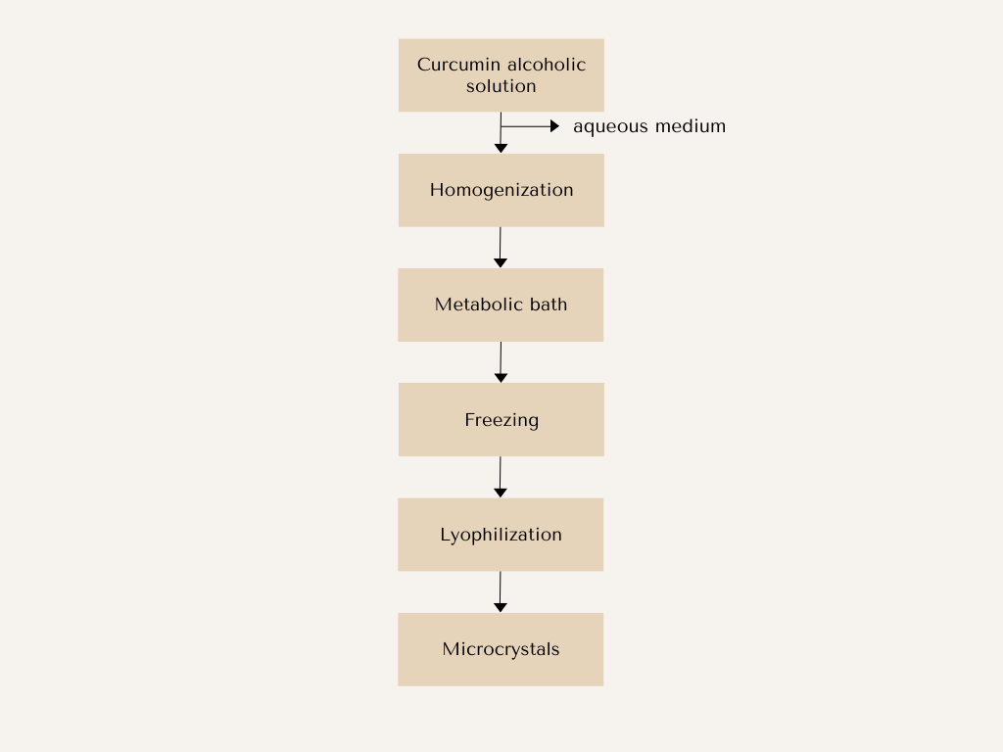

Figure B - Mortadella processing flowchart
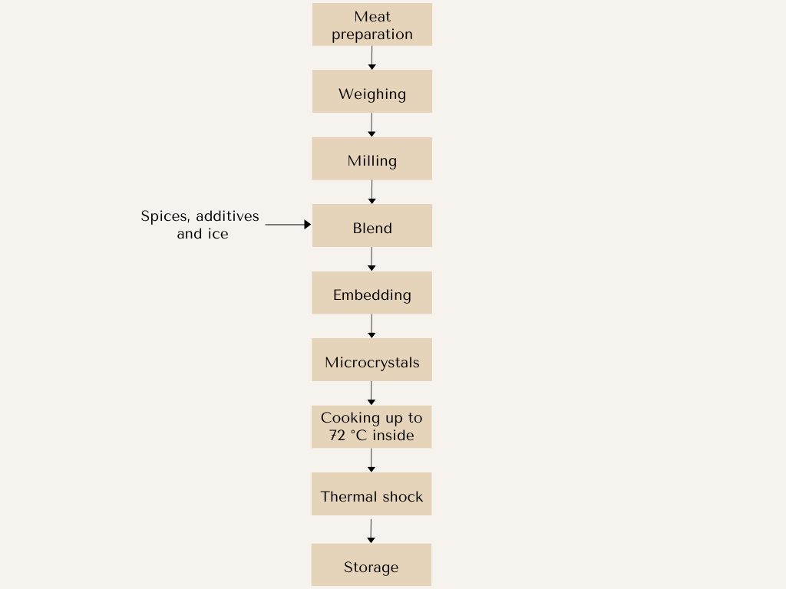

Figure C - Mortadella samples prepared with pigment concentrations
(a) F1, (b) F2, (c) F3, (d) F4, and (e) F5
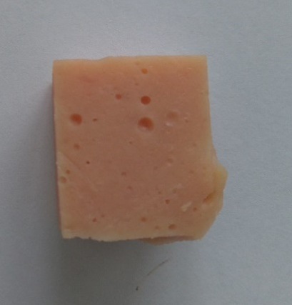
(a)
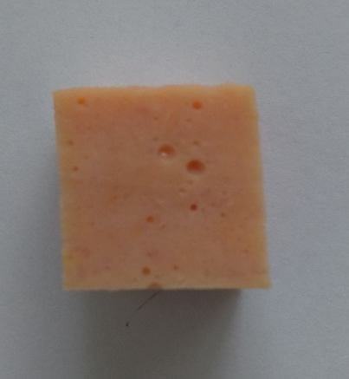
(b)

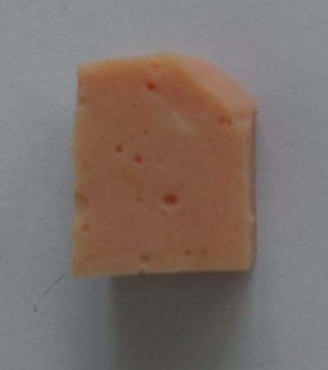
(c)

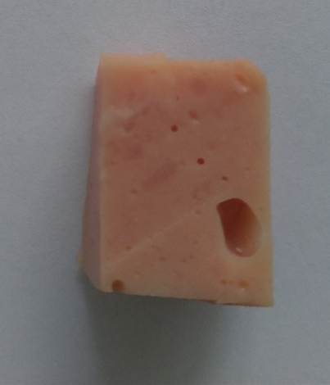
(d)

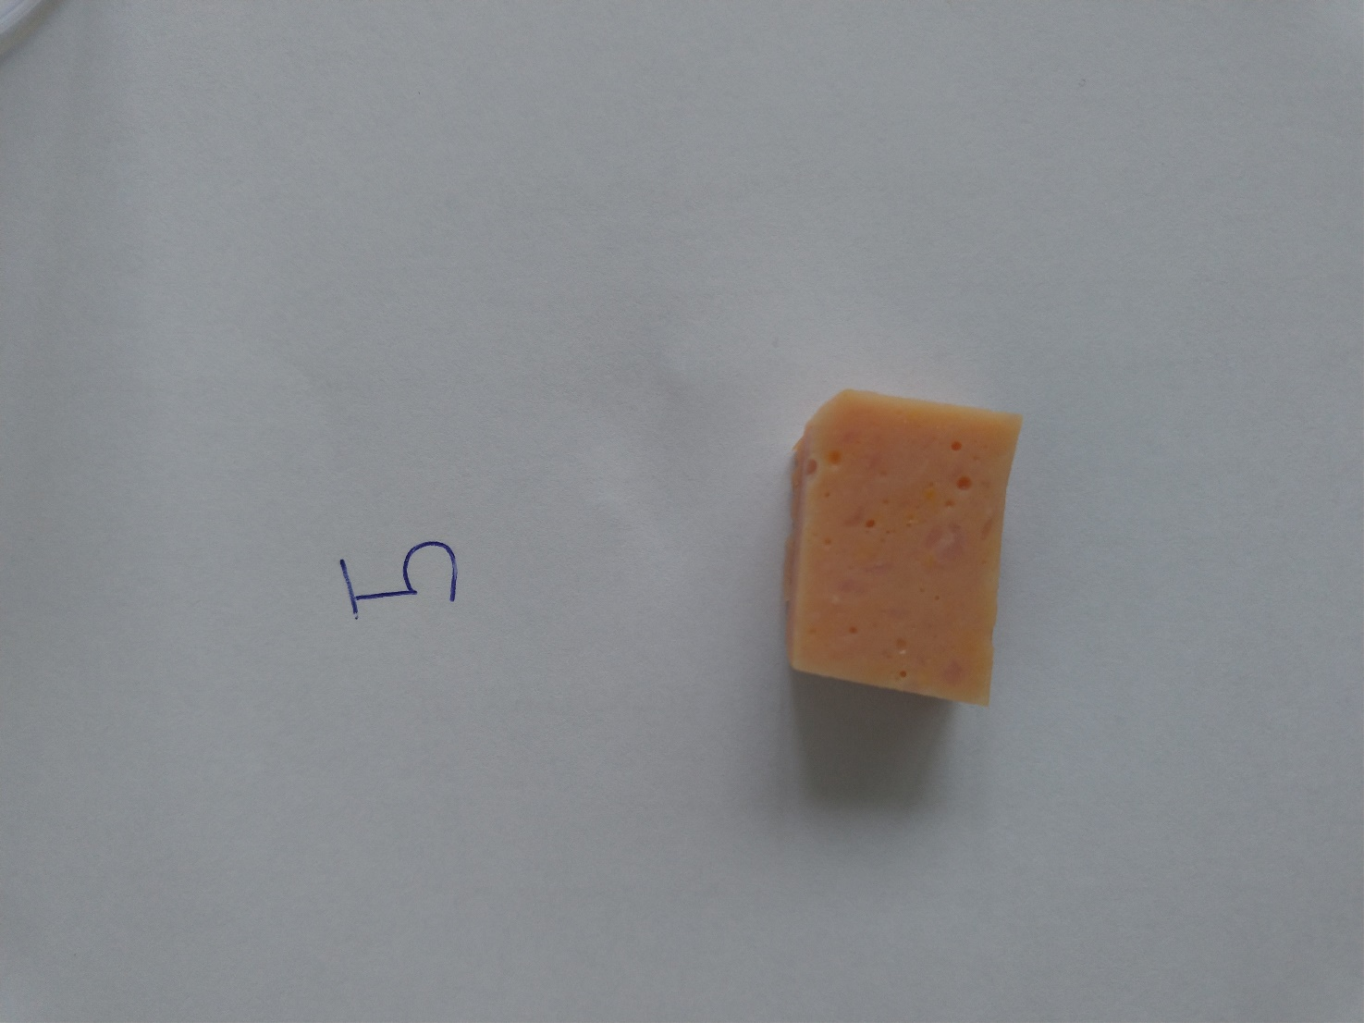
(e)

Figure D - Mortadella formulations on day 0 (a) F1, (b) F2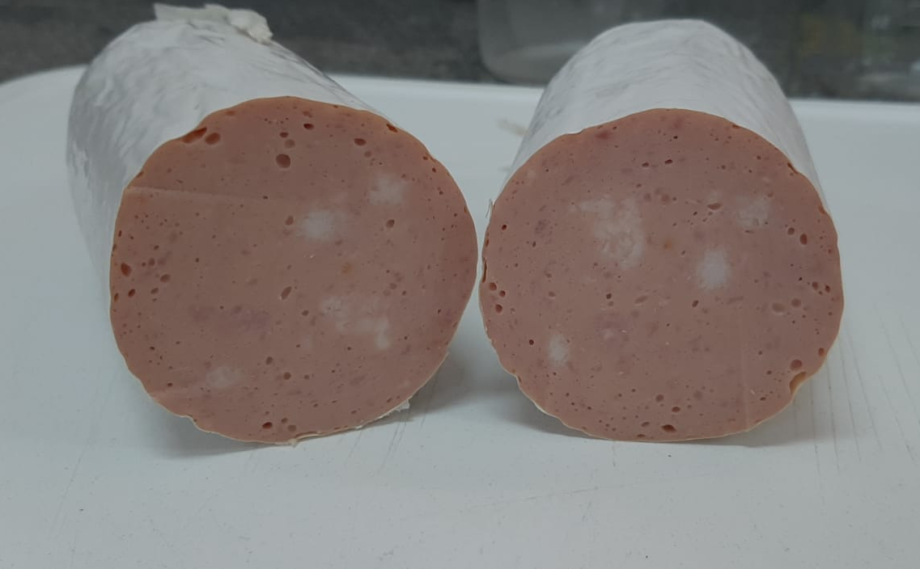
(a)
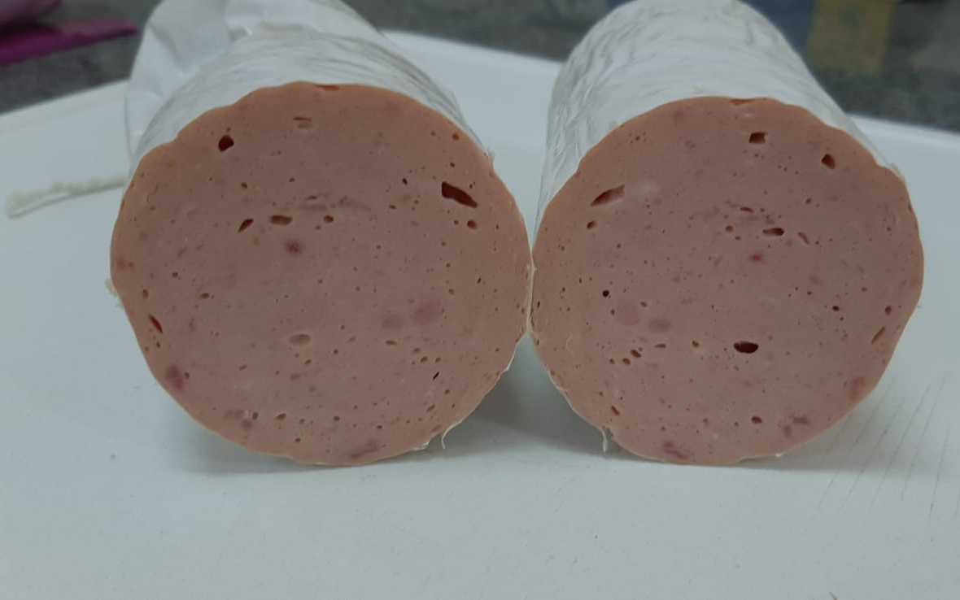
(b)

Figure E - Mortadella formulations on day 60 (a) F1, (b) F2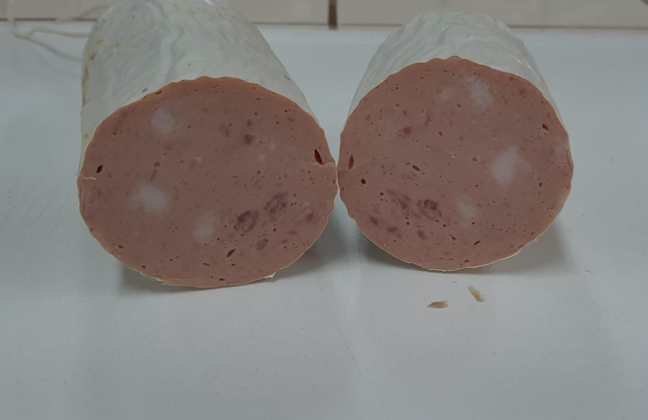
(a)
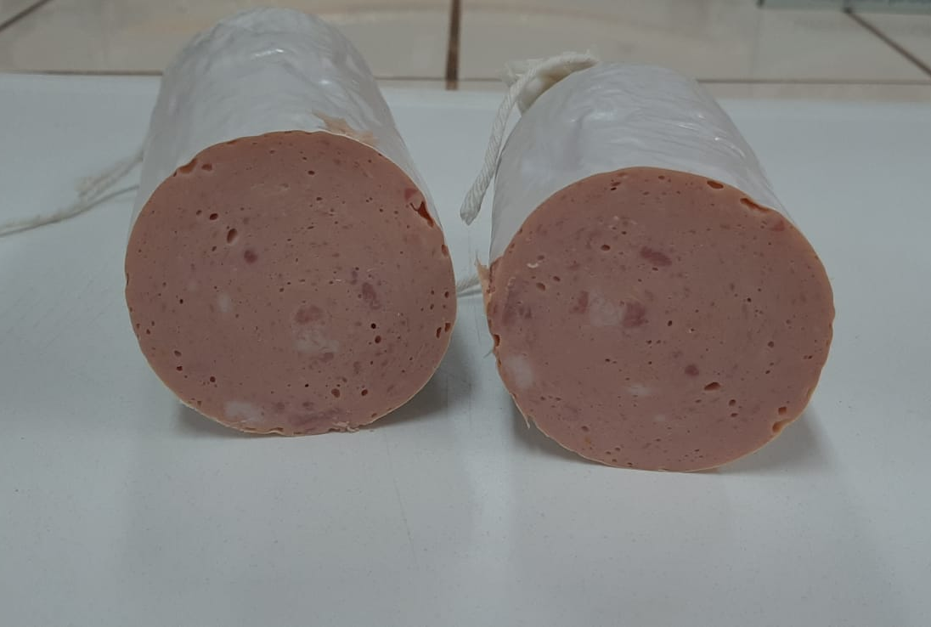
(b)

Table A - Results of microbiological analyzes of mortadella formulations
Formulations | Coliforms at 45°C/g | Staphylococcus coagulase positive/g | Clostridium sulfite reducer | Salmonella sp./25g
F1 | <10/g | <10/g | <10/g | Absent/25g
F2 | <10/g | <10/g | <10/g | Absent/25g
F3 | <10/g | <10/g | <10/g | Absent/25g
F4 | <10/g | <10/g | <10/g | Absent/25g
F5 | <10/g | <10/g | <10/g | Absent/25g
required standards | 10³ CFU/g | 3X10³ CFU/g | 5X10² CFU/g | Absent/25g
*CFU/g – Colony Forming Units per grams

Table B - Significant relationships (p<0.05) between sensory attributes and common dimensions
Relationship with CD1 |  | Relationship with CD2
Negative | Positive | Negative | Positive
pink color (10) | pink color (1) | firmness (2) | presence of fat (3)
firmness (1) | humidity (1) | mortadella odor (1) | firmness (1)
brightness (1) | homogeneity (1) |  | flavor enhancer flavor (1)
pepper flavor (1) | i like fat (1) |  | mortadella flavor (1)
fat flavor (1) | orange color (1) |  | sausage odor (1)
 | mortadella flavor (1) |  | fat flavor (1)
 |  |  | salty flavor (1)

