Figure 1.
Group differences between Asian and Caucasian students. A. Age differences; B: emotion perception scores as measured by CAVEAT-S; C. alexithymia scores as measured by TAS-20; D. stress levels as measured by the stress subscale of DASS-21. * p < .05, ** p < .01
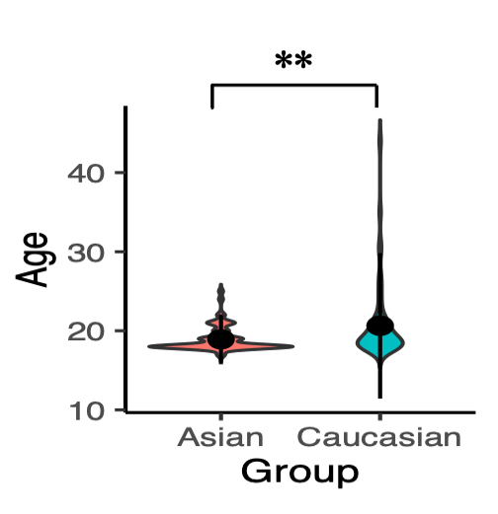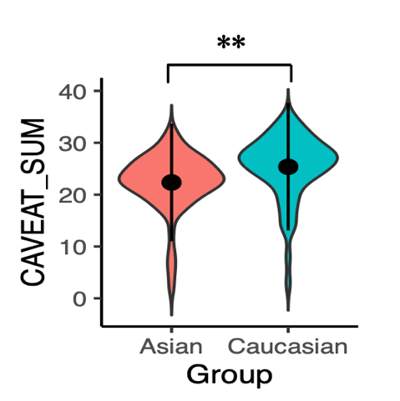
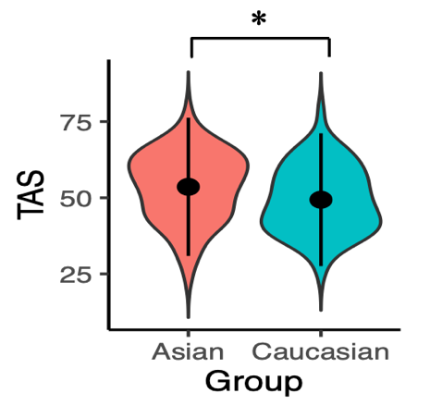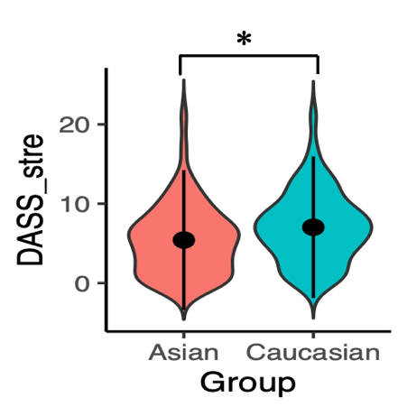

Figure 2.
Correlations between emotion perception scores as measured by CAVEAT-S and A. age; B. alexithymia scores as measured by TAS-20; C. stress level as measured by the stress subscale of DASS-2. * p < .05, ** p < .01

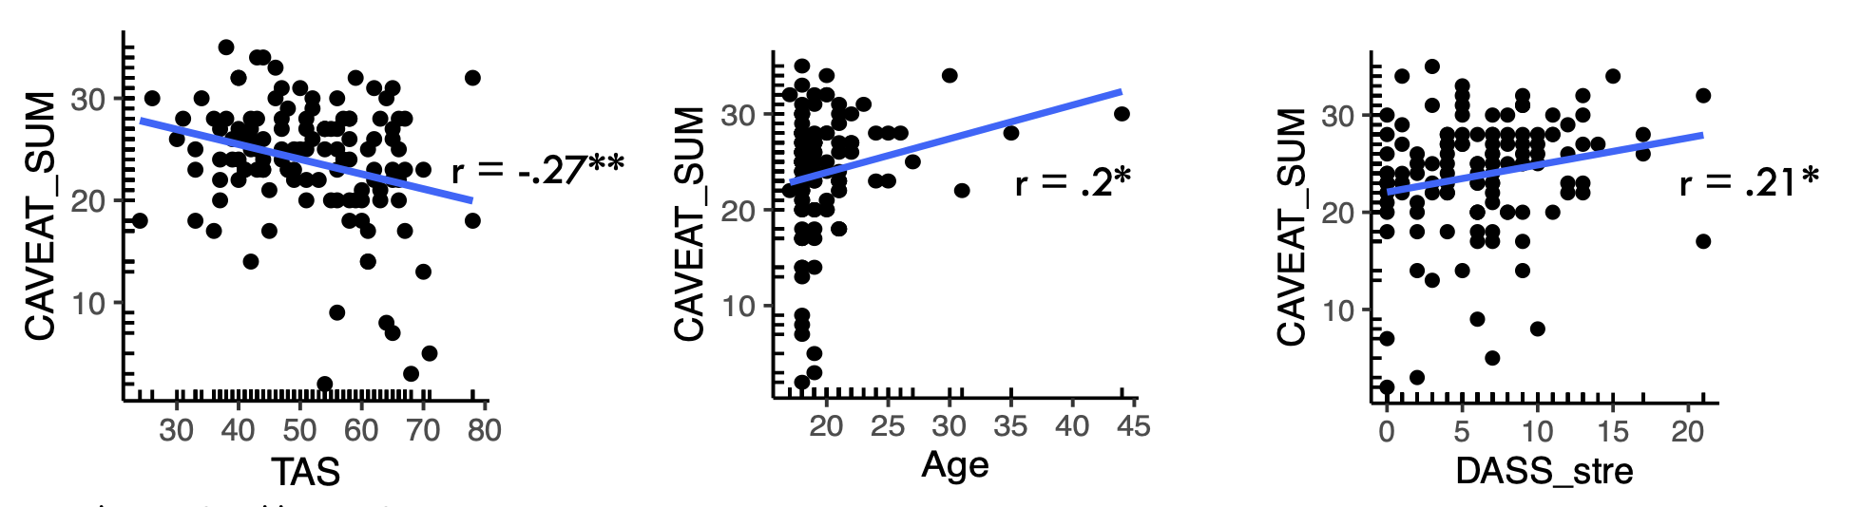

Table 1
Sociodemographic summary of participants

 | Asian  (n = 64) |  | Caucasian  (n = 60)
 | M | SD | M | SD
Age | 18.9 | 1.5 | 20.6 | 4.6
Years of education in English | 13.7 | 1.8 | 14.2 | 1.9
 | n | % | n | %
Gender
Female | 35 | 54.7 | 41 | 68.3
Male | 27 | 42.2 | 18 | 30
Other | 2 | 3.1 | 1 | 1.6
Place of birth
Australia | 49 | 76.6 | 52 | 86.7
China | 6 | 9.4 | – | –
Other | 9 | 14.1 | 8 | 13.3
First language(s)
English only | 31 | 48.4 | 55 | 91.7
English & Other | 25 | 39.1 | 2 | 3.3
Other | 8 | 12.5 | 3 | 5

Parents’ first language is English

Both parents | 11 | 17.17% | 49 | 81.67%
One parent | 3 | 3.16% | 5 | 8.33%
Neither parent | 50 | 78.13% | 6 | 10%

Table 2

Variable correlations for the Asian Australian group

p-value adjustment method: none
Observations: 124
> correlation::correlation(df_Asian[,col_comp],include_factors = TRUE,
+ method = "pearson",p_adjust = "none") # Asian
# Correlation Matrix (pearson-method)

Parameter1 | Parameter2 | r | 95% CI | t(62) | p
----------------------------------------------------------------------------
Age | CAVEAT_SUM | 0.04 | [-0.21, 0.28] | 0.28 | 0.782
Age | CAVEAT_pos | 6.31e-03 | [-0.24, 0.25] | 0.05 | 0.961
Age | CAVEAT_neg | 0.06 | [-0.19, 0.30] | 0.47 | 0.638
Age | TAS | -0.08 | [-0.32, 0.17] | -0.59 | 0.555
Age | TAS_DDF | -0.21 | [-0.43, 0.04] | -1.70 | 0.094
Age | TAS_DIF | -0.14 | [-0.37, 0.11] | -1.09 | 0.280
Age | TAS_EOT | 0.21 | [-0.03, 0.44] | 1.72 | 0.090
Age | DASS_total | -0.09 | [-0.33, 0.16] | -0.74 | 0.464
Age | DASS_depr | -0.14 | [-0.37, 0.11] | -1.11 | 0.270
Age | DASS_stre | -0.12 | [-0.36, 0.13] | -0.98 | 0.330
Age | DASS_anxi | 0.04 | [-0.21, 0.28] | 0.28 | 0.777
Age | PANAS_pos | 0.09 | [-0.15, 0.33] | 0.75 | 0.456
Age | PANAS_neg | 0.10 | [-0.15, 0.33] | 0.77 | 0.446
Age | SCS_interdep | -0.09 | [-0.33, 0.16] | -0.72 | 0.473
Age | SCS_indep | 0.13 | [-0.11, 0.37] | 1.07 | 0.289
Age | concept | 0.10 | [-0.15, 0.34] | 0.78 | 0.436
CAVEAT_SUM | CAVEAT_pos | 0.89 | [ 0.83, 0.93] | 15.57 | < .001***
CAVEAT_SUM | CAVEAT_neg | 0.84 | [ 0.74, 0.90] | 12.01 | < .001***
CAVEAT_SUM | TAS | -0.14 | [-0.37, 0.11] | -1.11 | 0.273
CAVEAT_SUM | TAS_DDF | 0.02 | [-0.23, 0.26] | 0.15 | 0.885
CAVEAT_SUM | TAS_DIF | -0.05 | [-0.29, 0.20] | -0.42 | 0.678
CAVEAT_SUM | TAS_EOT | -0.34 | [-0.54, -0.10] | -2.82 | 0.007**
CAVEAT_SUM | DASS_total | 0.22 | [-0.03, 0.44] | 1.79 | 0.078
CAVEAT_SUM | DASS_depr | 0.17 | [-0.08, 0.40] | 1.39 | 0.171
CAVEAT_SUM | DASS_stre | 0.26 | [ 0.01, 0.47] | 2.11 | 0.039*
CAVEAT_SUM | DASS_anxi | 0.16 | [-0.09, 0.39] | 1.29 | 0.201
CAVEAT_SUM | PANAS_pos | -0.05 | [-0.29, 0.20] | -0.36 | 0.721
CAVEAT_SUM | PANAS_neg | 0.12 | [-0.13, 0.36] | 0.97 | 0.337
CAVEAT_SUM | SCS_interdep | 0.15 | [-0.10, 0.38] | 1.20 | 0.236
CAVEAT_SUM | SCS_indep | -0.07 | [-0.31, 0.18] | -0.55 | 0.581
CAVEAT_SUM | concept | 0.06 | [-0.19, 0.30] | 0.46 | 0.647
CAVEAT_pos | CAVEAT_neg | 0.50 | [ 0.29, 0.66] | 4.54 | < .001***
CAVEAT_pos | TAS | -0.20 | [-0.42, 0.05] | -1.57 | 0.121
CAVEAT_pos | TAS_DDF | 0.02 | [-0.23, 0.26] | 0.16 | 0.876
CAVEAT_pos | TAS_DIF | -0.12 | [-0.36, 0.12] | -0.99 | 0.326
CAVEAT_pos | TAS_EOT | -0.39 | [-0.58, -0.16] | -3.33 | 0.001**
CAVEAT_pos | DASS_total | 0.24 | [-0.01, 0.46] | 1.93 | 0.058
CAVEAT_pos | DASS_depr | 0.18 | [-0.06, 0.41] | 1.47 | 0.146
CAVEAT_pos | DASS_stre | 0.29 | [ 0.05, 0.50] | 2.36 | 0.021*
CAVEAT_pos | DASS_anxi | 0.16 | [-0.09, 0.39] | 1.30 | 0.197
CAVEAT_pos | PANAS_pos | -0.02 | [-0.26, 0.23] | -0.14 | 0.888
CAVEAT_pos | PANAS_neg | 0.04 | [-0.21, 0.28] | 0.29 | 0.772
CAVEAT_pos | SCS_interdep | 0.14 | [-0.11, 0.37] | 1.11 | 0.271
CAVEAT_pos | SCS_indep | 0.04 | [-0.21, 0.28] | 0.29 | 0.775
CAVEAT_pos | concept | 0.07 | [-0.18, 0.31] | 0.51 | 0.609
CAVEAT_neg | TAS | -0.03 | [-0.27, 0.22] | -0.23 | 0.818
CAVEAT_neg | TAS_DDF | 0.01 | [-0.24, 0.26] | 0.09 | 0.929
CAVEAT_neg | TAS_DIF | 0.05 | [-0.20, 0.29] | 0.39 | 0.695
CAVEAT_neg | TAS_EOT | -0.17 | [-0.40, 0.08] | -1.39 | 0.171
CAVEAT_neg | DASS_total | 0.14 | [-0.11, 0.37] | 1.09 | 0.281
CAVEAT_neg | DASS_depr | 0.11 | [-0.14, 0.35] | 0.87 | 0.390
CAVEAT_neg | DASS_stre | 0.15 | [-0.10, 0.38] | 1.17 | 0.245
CAVEAT_neg | DASS_anxi | 0.11 | [-0.14, 0.35] | 0.89 | 0.376
CAVEAT_neg | PANAS_pos | -0.07 | [-0.31, 0.18] | -0.52 | 0.608
CAVEAT_neg | PANAS_neg | 0.19 | [-0.06, 0.42] | 1.52 | 0.134
CAVEAT_neg | SCS_interdep | 0.12 | [-0.13, 0.35] | 0.94 | 0.349
CAVEAT_neg | SCS_indep | -0.18 | [-0.41, 0.07] | -1.43 | 0.157
CAVEAT_neg | concept | 0.03 | [-0.21, 0.28] | 0.26 | 0.797
TAS | TAS_DDF | 0.83 | [ 0.73, 0.89] | 11.63 | < .001***
TAS | TAS_DIF | 0.90 | [ 0.84, 0.94] | 16.55 | < .001***
TAS | TAS_EOT | 0.62 | [ 0.44, 0.75] | 6.25 | < .001***
TAS | DASS_total | 0.53 | [ 0.33, 0.69] | 4.91 | < .001***
TAS | DASS_depr | 0.52 | [ 0.32, 0.68] | 4.81 | < .001***
TAS | DASS_stre | 0.42 | [ 0.20, 0.60] | 3.66 | < .001***
TAS | DASS_anxi | 0.50 | [ 0.28, 0.66] | 4.49 | < .001***
TAS | PANAS_pos | -0.11 | [-0.34, 0.14] | -0.86 | 0.394
TAS | PANAS_neg | 0.60 | [ 0.41, 0.74] | 5.89 | < .001***
TAS | SCS_interdep | -6.06e-03 | [-0.25, 0.24] | -0.05 | 0.962
TAS | SCS_indep | -0.17 | [-0.40, 0.08] | -1.39 | 0.171
TAS | concept | -0.12 | [-0.36, 0.13] | -0.95 | 0.346
TAS_DDF | TAS_DIF | 0.70 | [ 0.54, 0.81] | 7.66 | < .001***
TAS_DDF | TAS_EOT | 0.27 | [ 0.03, 0.48] | 2.20 | 0.031*
TAS_DDF | DASS_total | 0.44 | [ 0.22, 0.62] | 3.87 | < .001***
TAS_DDF | DASS_depr | 0.46 | [ 0.24, 0.63] | 4.02 | < .001***
TAS_DDF | DASS_stre | 0.37 | [ 0.14, 0.56] | 3.14 | 0.003**
TAS_DDF | DASS_anxi | 0.36 | [ 0.13, 0.56] | 3.08 | 0.003**
TAS_DDF | PANAS_pos | -0.07 | [-0.31, 0.18] | -0.58 | 0.562
TAS_DDF | PANAS_neg | 0.41 | [ 0.19, 0.60] | 3.56 | < .001***
TAS_DDF | SCS_interdep | 0.04 | [-0.21, 0.28] | 0.29 | 0.770
TAS_DDF | SCS_indep | -0.06 | [-0.31, 0.18] | -0.51 | 0.612
TAS_DDF | concept | -0.08 | [-0.32, 0.17] | -0.64 | 0.526
TAS_DIF | TAS_EOT | 0.33 | [ 0.09, 0.53] | 2.74 | 0.008**
TAS_DIF | DASS_total | 0.57 | [ 0.38, 0.72] | 5.51 | < .001***
TAS_DIF | DASS_depr | 0.57 | [ 0.38, 0.72] | 5.49 | < .001***
TAS_DIF | DASS_stre | 0.47 | [ 0.26, 0.65] | 4.25 | < .001***
TAS_DIF | DASS_anxi | 0.51 | [ 0.30, 0.67] | 4.62 | < .001***
TAS_DIF | PANAS_pos | 9.89e-03 | [-0.24, 0.26] | 0.08 | 0.938
TAS_DIF | PANAS_neg | 0.63 | [ 0.46, 0.76] | 6.45 | < .001***
TAS_DIF | SCS_interdep | 0.09 | [-0.16, 0.33] | 0.71 | 0.482
TAS_DIF | SCS_indep | -0.11 | [-0.35, 0.14] | -0.87 | 0.390
TAS_DIF | concept | -0.23 | [-0.45, 0.02] | -1.84 | 0.071
TAS_EOT | DASS_total | 0.18 | [-0.07, 0.41] | 1.42 | 0.162
TAS_EOT | DASS_depr | 0.14 | [-0.11, 0.38] | 1.14 | 0.260
TAS_EOT | DASS_stre | 0.09 | [-0.16, 0.33] | 0.75 | 0.459
TAS_EOT | DASS_anxi | 0.26 | [ 0.02, 0.48] | 2.16 | 0.035*
TAS_EOT | PANAS_pos | -0.25 | [-0.47, 0.00] | -2.04 | 0.046*
TAS_EOT | PANAS_neg | 0.32 | [ 0.08, 0.52] | 2.62 | 0.011*
TAS_EOT | SCS_interdep | -0.19 | [-0.42, 0.05] | -1.56 | 0.124
TAS_EOT | SCS_indep | -0.26 | [-0.48, -0.02] | -2.14 | 0.037*
TAS_EOT | concept | 0.09 | [-0.16, 0.33] | 0.72 | 0.475
DASS_total | DASS_depr | 0.89 | [ 0.83, 0.93] | 15.77 | < .001***
DASS_total | DASS_stre | 0.91 | [ 0.86, 0.95] | 17.56 | < .001***
DASS_total | DASS_anxi | 0.91 | [ 0.85, 0.94] | 16.94 | < .001***
DASS_total | PANAS_pos | -0.07 | [-0.31, 0.17] | -0.59 | 0.558
DASS_total | PANAS_neg | 0.67 | [ 0.51, 0.79] | 7.14 | < .001***
DASS_total | SCS_interdep | 0.09 | [-0.16, 0.33] | 0.72 | 0.476
DASS_total | SCS_indep | -0.10 | [-0.34, 0.14] | -0.83 | 0.409
DASS_total | concept | -0.18 | [-0.41, 0.07] | -1.44 | 0.154
DASS_depr | DASS_stre | 0.69 | [ 0.53, 0.80] | 7.48 | < .001***
DASS_depr | DASS_anxi | 0.72 | [ 0.58, 0.82] | 8.15 | < .001***
DASS_depr | PANAS_pos | -0.18 | [-0.41, 0.07] | -1.46 | 0.149
DASS_depr | PANAS_neg | 0.57 | [ 0.37, 0.71] | 5.42 | < .001***
DASS_depr | SCS_interdep | 0.09 | [-0.16, 0.33] | 0.73 | 0.467
DASS_depr | SCS_indep | -0.09 | [-0.33, 0.16] | -0.69 | 0.493
DASS_depr | concept | -0.20 | [-0.43, 0.05] | -1.63 | 0.109
DASS_stre | DASS_anxi | 0.78 | [ 0.66, 0.86] | 9.78 | < .001***
DASS_stre | PANAS_pos | 0.02 | [-0.23, 0.26] | 0.14 | 0.887
DASS_stre | PANAS_neg | 0.64 | [ 0.46, 0.76] | 6.48 | < .001***
DASS_stre | SCS_interdep | 0.07 | [-0.17, 0.31] | 0.59 | 0.561
DASS_stre | SCS_indep | -0.10 | [-0.34, 0.15] | -0.81 | 0.418
DASS_stre | concept | -0.11 | [-0.35, 0.14] | -0.88 | 0.380
DASS_anxi | PANAS_pos | -0.03 | [-0.27, 0.22] | -0.23 | 0.819
DASS_anxi | PANAS_neg | 0.62 | [ 0.45, 0.75] | 6.29 | < .001***
DASS_anxi | SCS_interdep | 0.08 | [-0.17, 0.32] | 0.62 | 0.537
DASS_anxi | SCS_indep | -0.09 | [-0.33, 0.15] | -0.75 | 0.458
DASS_anxi | concept | -0.18 | [-0.41, 0.07] | -1.43 | 0.158
PANAS_pos | PANAS_neg | 0.19 | [-0.06, 0.42] | 1.54 | 0.128
PANAS_pos | SCS_interdep | 0.34 | [ 0.10, 0.54] | 2.86 | 0.006**
PANAS_pos | SCS_indep | 0.57 | [ 0.38, 0.72] | 5.52 | < .001***
PANAS_pos | concept | -0.22 | [-0.44, 0.03] | -1.75 | 0.086
PANAS_neg | SCS_interdep | 0.14 | [-0.11, 0.37] | 1.08 | 0.283
PANAS_neg | SCS_indep | -0.20 | [-0.43, 0.05] | -1.62 | 0.110
PANAS_neg | concept | -0.34 | [-0.54, -0.11] | -2.87 | 0.006**
SCS_interdep | SCS_indep | 0.32 | [ 0.09, 0.53] | 2.70 | 0.009**
SCS_interdep | concept | -0.20 | [-0.43, 0.05] | -1.63 | 0.109
SCS_indep | concept | -0.01 | [-0.26, 0.23] | -0.10 | 0.919

p-value adjustment method: none
Observations: 64

Table 3
Variable correlations for the Caucasian Australian group

> correlation::correlation(df_Ca[,col_comp],include_factors = TRUE,
+ method = "pearson",p_adjust = "none") # Caucasian
# Correlation Matrix (pearson-method)

Parameter1 | Parameter2 | r | 95% CI | t(58) | p
--------------------------------------------------------------------------------
Age | CAVEAT_SUM | 0.21 | [-0.05, 0.44] | 1.61 | 0.112
Age | CAVEAT_pos | 0.25 | [ 0.00, 0.47] | 1.96 | 0.055
Age | CAVEAT_neg | 0.14 | [-0.12, 0.38] | 1.04 | 0.301
Age | TAS | -0.43 | [-0.62, -0.20] | -3.66 | < .001***
Age | TAS_DDF | -0.27 | [-0.49, -0.02] | -2.16 | 0.035*
Age | TAS_DIF | -0.34 | [-0.55, -0.10] | -2.79 | 0.007**
Age | TAS_EOT | -0.36 | [-0.56, -0.12] | -2.93 | 0.005**
Age | DASS_total | -0.10 | [-0.34, 0.16] | -0.75 | 0.455
Age | DASS_depr | -0.10 | [-0.35, 0.16] | -0.77 | 0.443
Age | DASS_stre | 0.02 | [-0.24, 0.27] | 0.12 | 0.907
Age | DASS_anxi | -0.20 | [-0.43, 0.06] | -1.55 | 0.125
Age | PANAS_pos | -0.14 | [-0.38, 0.12] | -1.08 | 0.285
Age | PANAS_neg | -0.03 | [-0.28, 0.23] | -0.19 | 0.847
Age | SCS_interdep | 0.03 | [-0.23, 0.28] | 0.22 | 0.823
Age | SCS_indep | 0.12 | [-0.13, 0.37] | 0.95 | 0.349
Age | concept | 0.05 | [-0.20, 0.30] | 0.41 | 0.681
CAVEAT_SUM | CAVEAT_pos | 0.93 | [ 0.88, 0.96] | 18.76 | < .001***
CAVEAT_SUM | CAVEAT_neg | 0.93 | [ 0.88, 0.96] | 19.06 | < .001***
CAVEAT_SUM | TAS | -0.33 | [-0.54, -0.09] | -2.71 | 0.009**
CAVEAT_SUM | TAS_DDF | -0.04 | [-0.29, 0.22] | -0.30 | 0.767
CAVEAT_SUM | TAS_DIF | -0.31 | [-0.52, -0.06] | -2.47 | 0.017*
CAVEAT_SUM | TAS_EOT | -0.42 | [-0.61, -0.18] | -3.48 | < .001***
CAVEAT_SUM | DASS_total | -0.02 | [-0.27, 0.24] | -0.14 | 0.890
CAVEAT_SUM | DASS_depr | -0.06 | [-0.31, 0.19] | -0.48 | 0.634
CAVEAT_SUM | DASS_stre | 0.08 | [-0.18, 0.33] | 0.63 | 0.531
CAVEAT_SUM | DASS_anxi | -0.08 | [-0.33, 0.18] | -0.60 | 0.551
CAVEAT_SUM | PANAS_pos | -0.34 | [-0.55, -0.10] | -2.76 | 0.008**
CAVEAT_SUM | PANAS_neg | -0.19 | [-0.42, 0.07] | -1.47 | 0.147
CAVEAT_SUM | SCS_interdep | -0.02 | [-0.28, 0.23] | -0.18 | 0.857
CAVEAT_SUM | SCS_indep | -0.12 | [-0.37, 0.13] | -0.95 | 0.344
CAVEAT_SUM | concept | 0.26 | [ 0.00, 0.48] | 2.02 | 0.048*
CAVEAT_pos | CAVEAT_neg | 0.72 | [ 0.57, 0.82] | 7.92 | < .001***
CAVEAT_pos | TAS | -0.34 | [-0.54, -0.09] | -2.72 | 0.009**
CAVEAT_pos | TAS_DDF | -0.09 | [-0.33, 0.17] | -0.67 | 0.506
CAVEAT_pos | TAS_DIF | -0.27 | [-0.49, -0.01] | -2.09 | 0.041*
CAVEAT_pos | TAS_EOT | -0.42 | [-0.61, -0.19] | -3.57 | < .001***
CAVEAT_pos | DASS_total | 0.05 | [-0.21, 0.30] | 0.35 | 0.726
CAVEAT_pos | DASS_depr | 0.03 | [-0.22, 0.28] | 0.25 | 0.807
CAVEAT_pos | DASS_stre | 0.11 | [-0.15, 0.36] | 0.85 | 0.397
CAVEAT_pos | DASS_anxi | -0.03 | [-0.28, 0.22] | -0.24 | 0.811
CAVEAT_pos | PANAS_pos | -0.30 | [-0.52, -0.05] | -2.43 | 0.018*
CAVEAT_pos | PANAS_neg | -0.14 | [-0.38, 0.12] | -1.06 | 0.295
CAVEAT_pos | SCS_interdep | -0.05 | [-0.30, 0.21] | -0.37 | 0.716
CAVEAT_pos | SCS_indep | -0.07 | [-0.31, 0.19] | -0.50 | 0.619
CAVEAT_pos | concept | 0.26 | [ 0.01, 0.49] | 2.08 | 0.042*
CAVEAT_neg | TAS | -0.29 | [-0.50, -0.03] | -2.27 | 0.027*
CAVEAT_neg | TAS_DDF | 0.01 | [-0.24, 0.27] | 0.11 | 0.913
CAVEAT_neg | TAS_DIF | -0.31 | [-0.52, -0.06] | -2.46 | 0.017*
CAVEAT_neg | TAS_EOT | -0.35 | [-0.55, -0.10] | -2.82 | 0.006**
CAVEAT_neg | DASS_total | -0.08 | [-0.33, 0.18] | -0.60 | 0.548
CAVEAT_neg | DASS_depr | -0.15 | [-0.39, 0.11] | -1.13 | 0.261
CAVEAT_neg | DASS_stre | 0.04 | [-0.21, 0.29] | 0.32 | 0.750
CAVEAT_neg | DASS_anxi | -0.11 | [-0.36, 0.14] | -0.87 | 0.387
CAVEAT_neg | PANAS_pos | -0.33 | [-0.54, -0.08] | -2.64 | 0.011*
CAVEAT_neg | PANAS_neg | -0.21 | [-0.44, 0.04] | -1.67 | 0.101
CAVEAT_neg | SCS_interdep | 3.41e-03 | [-0.25, 0.26] | 0.03 | 0.979
CAVEAT_neg | SCS_indep | -0.16 | [-0.40, 0.09] | -1.27 | 0.209
CAVEAT_neg | concept | 0.21 | [-0.04, 0.44] | 1.66 | 0.102
TAS | TAS_DDF | 0.82 | [ 0.72, 0.89] | 10.93 | < .001***
TAS | TAS_DIF | 0.78 | [ 0.66, 0.87] | 9.65 | < .001***
TAS | TAS_EOT | 0.62 | [ 0.44, 0.76] | 6.06 | < .001***
TAS | DASS_total | 0.38 | [ 0.13, 0.57] | 3.09 | 0.003**
TAS | DASS_depr | 0.30 | [ 0.05, 0.51] | 2.37 | 0.021*
TAS | DASS_stre | 0.31 | [ 0.07, 0.53] | 2.52 | 0.015*
TAS | DASS_anxi | 0.42 | [ 0.19, 0.61] | 3.56 | < .001***
TAS | PANAS_pos | 0.08 | [-0.18, 0.32] | 0.57 | 0.569
TAS | PANAS_neg | 0.44 | [ 0.21, 0.63] | 3.75 | < .001***
TAS | SCS_interdep | 0.13 | [-0.13, 0.37] | 0.96 | 0.339
TAS | SCS_indep | -0.16 | [-0.40, 0.10] | -1.21 | 0.229
TAS | concept | -4.45e-03 | [-0.26, 0.25] | -0.03 | 0.973
TAS_DDF | TAS_DIF | 0.47 | [ 0.24, 0.65] | 4.05 | < .001***
TAS_DDF | TAS_EOT | 0.38 | [ 0.14, 0.58] | 3.11 | 0.003**
TAS_DDF | DASS_total | 0.25 | [-0.01, 0.47] | 1.93 | 0.059
TAS_DDF | DASS_depr | 0.18 | [-0.07, 0.42] | 1.42 | 0.161
TAS_DDF | DASS_stre | 0.22 | [-0.04, 0.45] | 1.70 | 0.094
TAS_DDF | DASS_anxi | 0.27 | [ 0.02, 0.49] | 2.16 | 0.035*
TAS_DDF | PANAS_pos | 0.01 | [-0.24, 0.27] | 0.11 | 0.914
TAS_DDF | PANAS_neg | 0.32 | [ 0.08, 0.53] | 2.61 | 0.012*
TAS_DDF | SCS_interdep | 0.13 | [-0.13, 0.37] | 0.97 | 0.335
TAS_DDF | SCS_indep | -0.25 | [-0.47, 0.01] | -1.95 | 0.056
TAS_DDF | concept | 0.12 | [-0.14, 0.36] | 0.94 | 0.352
TAS_DIF | TAS_EOT | 0.16 | [-0.10, 0.39] | 1.21 | 0.232
TAS_DIF | DASS_total | 0.40 | [ 0.16, 0.59] | 3.30 | 0.002**
TAS_DIF | DASS_depr | 0.34 | [ 0.10, 0.55] | 2.77 | 0.008**
TAS_DIF | DASS_stre | 0.37 | [ 0.13, 0.57] | 3.03 | 0.004**
TAS_DIF | DASS_anxi | 0.37 | [ 0.13, 0.57] | 3.02 | 0.004**
TAS_DIF | PANAS_pos | 0.03 | [-0.23, 0.28] | 0.23 | 0.821
TAS_DIF | PANAS_neg | 0.47 | [ 0.24, 0.64] | 4.02 | < .001***
TAS_DIF | SCS_interdep | 0.22 | [-0.04, 0.45] | 1.68 | 0.097
TAS_DIF | SCS_indep | 0.10 | [-0.16, 0.34] | 0.74 | 0.461
TAS_DIF | concept | -0.10 | [-0.35, 0.16] | -0.78 | 0.437
TAS_EOT | DASS_total | 0.16 | [-0.09, 0.40] | 1.26 | 0.212
TAS_EOT | DASS_depr | 0.10 | [-0.16, 0.35] | 0.79 | 0.435
TAS_EOT | DASS_stre | 0.07 | [-0.19, 0.32] | 0.53 | 0.595
TAS_EOT | DASS_anxi | 0.30 | [ 0.05, 0.51] | 2.39 | 0.020*
TAS_EOT | PANAS_pos | 0.14 | [-0.12, 0.38] | 1.09 | 0.281
TAS_EOT | PANAS_neg | 0.15 | [-0.11, 0.39] | 1.17 | 0.245
TAS_EOT | SCS_interdep | -0.11 | [-0.36, 0.15] | -0.86 | 0.396
TAS_EOT | SCS_indep | -0.27 | [-0.49, -0.01] | -2.12 | 0.039*
TAS_EOT | concept | -0.01 | [-0.26, 0.24] | -0.08 | 0.938
DASS_total | DASS_depr | 0.90 | [ 0.85, 0.94] | 16.19 | < .001***
DASS_total | DASS_stre | 0.91 | [ 0.86, 0.95] | 16.98 | < .001***
DASS_total | DASS_anxi | 0.89 | [ 0.82, 0.93] | 14.64 | < .001***
DASS_total | PANAS_pos | -0.34 | [-0.54, -0.09] | -2.72 | 0.009**
DASS_total | PANAS_neg | 0.68 | [ 0.51, 0.80] | 7.04 | < .001***
DASS_total | SCS_interdep | 0.09 | [-0.16, 0.34] | 0.72 | 0.474
DASS_total | SCS_indep | -0.01 | [-0.27, 0.24] | -0.11 | 0.911
DASS_total | concept | 0.09 | [-0.16, 0.34] | 0.72 | 0.477
DASS_depr | DASS_stre | 0.72 | [ 0.57, 0.82] | 7.91 | < .001***
DASS_depr | DASS_anxi | 0.70 | [ 0.55, 0.81] | 7.52 | < .001***
DASS_depr | PANAS_pos | -0.45 | [-0.63, -0.23] | -3.88 | < .001***
DASS_depr | PANAS_neg | 0.59 | [ 0.40, 0.74] | 5.60 | < .001***
DASS_depr | SCS_interdep | 0.13 | [-0.13, 0.37] | 1.00 | 0.322
DASS_depr | SCS_indep | -6.32e-04 | [-0.25, 0.25] | -4.81e-03 | 0.996
DASS_depr | concept | 0.07 | [-0.19, 0.32] | 0.51 | 0.610
DASS_stre | DASS_anxi | 0.74 | [ 0.60, 0.84] | 8.33 | < .001***
DASS_stre | PANAS_pos | -0.26 | [-0.48, 0.00] | -2.01 | 0.049*
DASS_stre | PANAS_neg | 0.67 | [ 0.50, 0.79] | 6.92 | < .001***
DASS_stre | SCS_interdep | 0.03 | [-0.23, 0.28] | 0.23 | 0.817
DASS_stre | SCS_indep | 0.01 | [-0.24, 0.26] | 0.08 | 0.933
DASS_stre | concept | 0.17 | [-0.09, 0.40] | 1.28 | 0.207
DASS_anxi | PANAS_pos | -0.17 | [-0.41, 0.09] | -1.33 | 0.188
DASS_anxi | PANAS_neg | 0.56 | [ 0.36, 0.72] | 5.20 | < .001***
DASS_anxi | SCS_interdep | 0.09 | [-0.16, 0.34] | 0.73 | 0.471
DASS_anxi | SCS_indep | -0.06 | [-0.31, 0.20] | -0.45 | 0.655
DASS_anxi | concept | 7.43e-03 | [-0.25, 0.26] | 0.06 | 0.955
PANAS_pos | PANAS_neg | -0.02 | [-0.28, 0.23] | -0.17 | 0.863
PANAS_pos | SCS_interdep | -0.03 | [-0.29, 0.22] | -0.26 | 0.796
PANAS_pos | SCS_indep | 0.22 | [-0.04, 0.45] | 1.69 | 0.096
PANAS_pos | concept | -0.24 | [-0.47, 0.01] | -1.89 | 0.064
PANAS_neg | SCS_interdep | 0.05 | [-0.21, 0.30] | 0.35 | 0.725
PANAS_neg | SCS_indep | -0.14 | [-0.38, 0.11] | -1.10 | 0.274
PANAS_neg | concept | -0.04 | [-0.29, 0.21] | -0.33 | 0.743
SCS_interdep | SCS_indep | 0.11 | [-0.15, 0.35] | 0.83 | 0.412
SCS_interdep | concept | 0.07 | [-0.19, 0.32] | 0.53 | 0.601
SCS_indep | concept | 0.11 | [-0.15, 0.35] | 0.82 | 0.416

p-value adjustment method: none
Observations: 60

