Appendix
- Tunnal Scene:
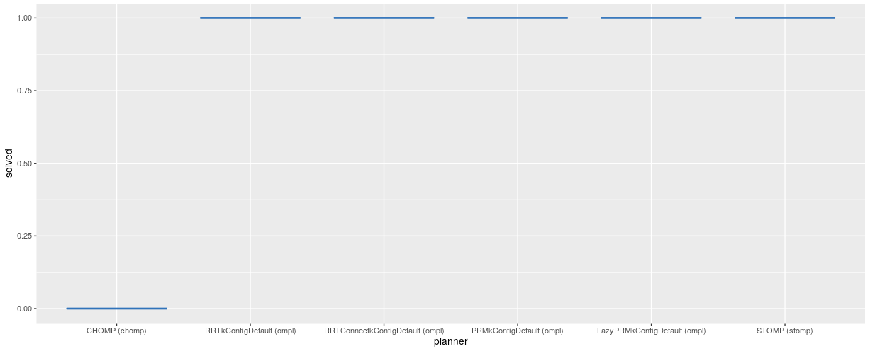
Tunnal_Solved
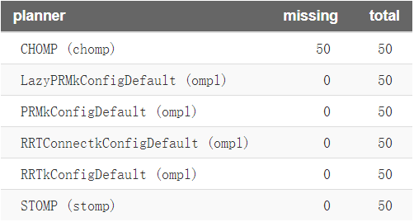
Number of missing data points out of the total number of runs per planner
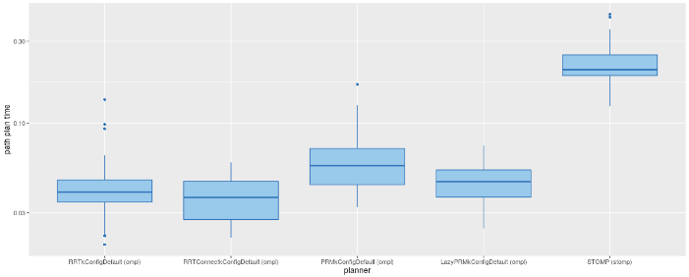
Tunnal_Original_PathTime
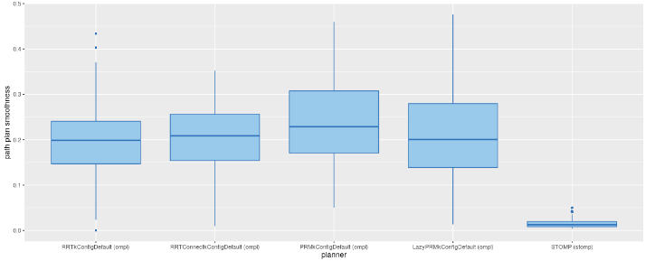
Tunnal_Original_Smooth
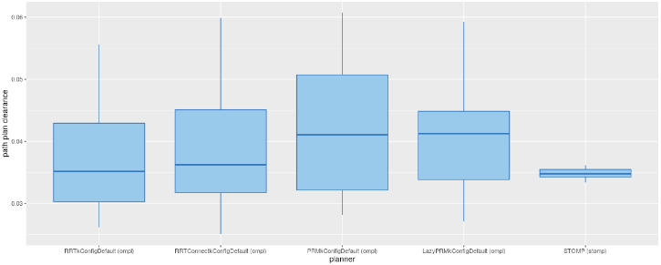
Tunnal_Original_Clearance
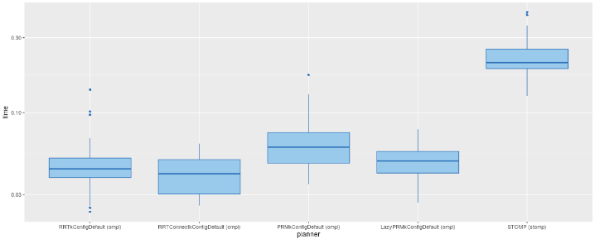
Tunnal_Original_time
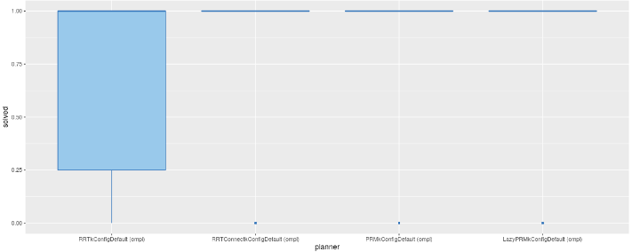
Tunnal_Optimized by CHOMP_Solve
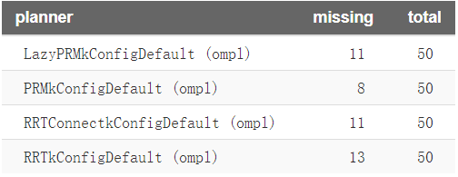
Number of missing data points out of the total number of runs per planner
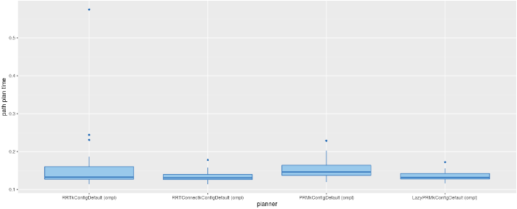
Tunnal_Optimized by CHOMP_PathTime

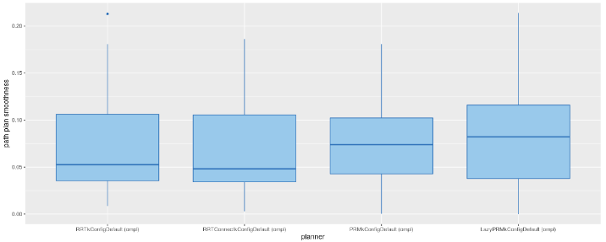
Tunnal_Optimized by CHOMP_Smooth
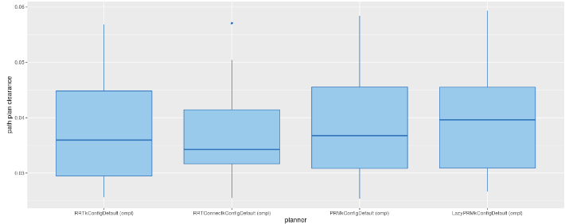
Tunnal_Optimized by CHOMP_Clearance
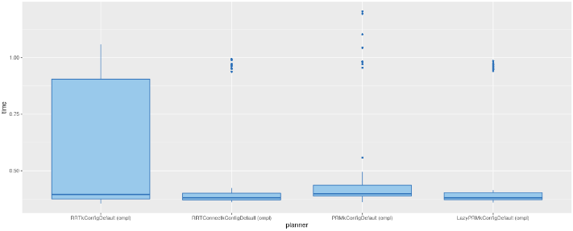
Tunnal_Optimized by CHOMP_Time
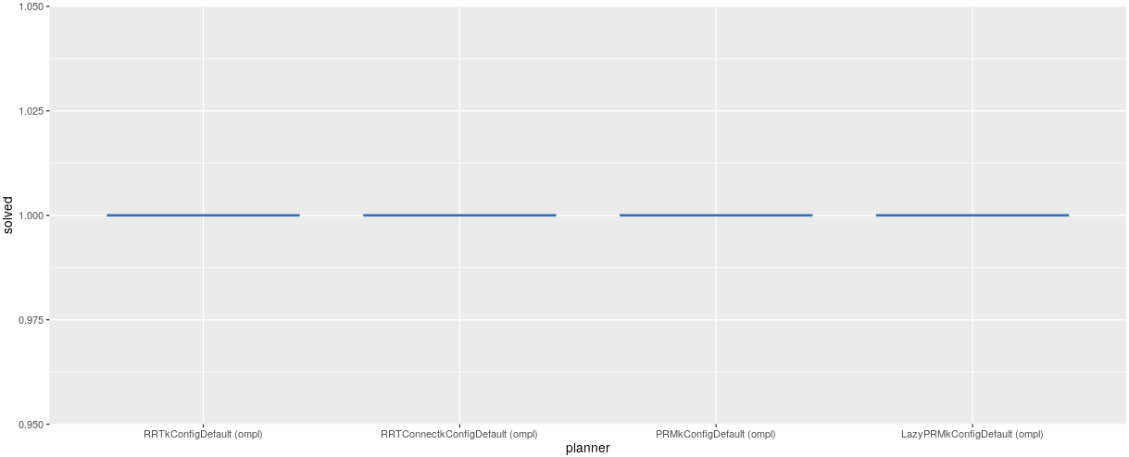
Tunnal_Optimized by STOMP_Solve
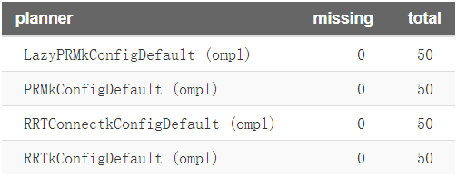
Number of missing data points out of the total number of runs per planner
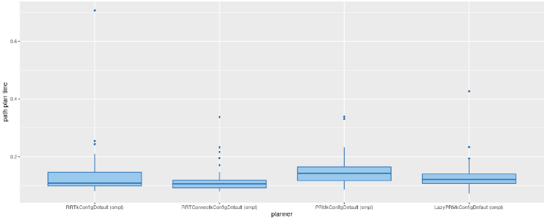
Tunnal_Optimized by STOMP_PathTime

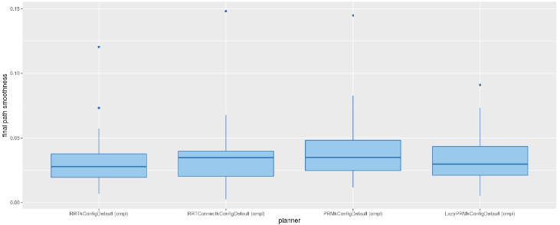
Tunnal_Optimized by STOMP_Smooth
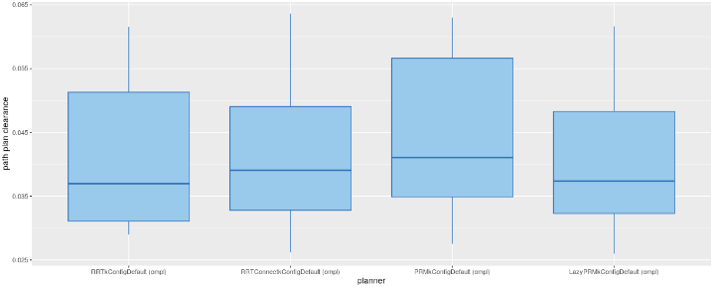
Tunnal_Optimized by STOMP_Clearance
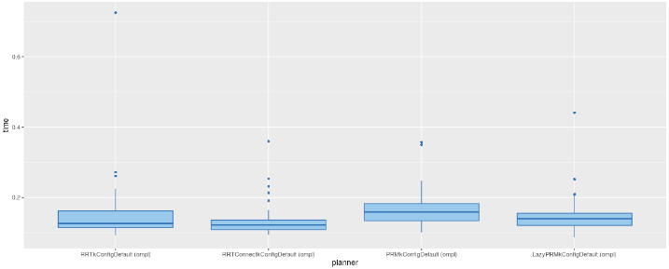
Tunnal_Optimized by STOMP_Total Time
- Industrial workshop：
- Query a: The robotic arm picks parts from the box on the second floor of the parts table and brings them to the workbench:
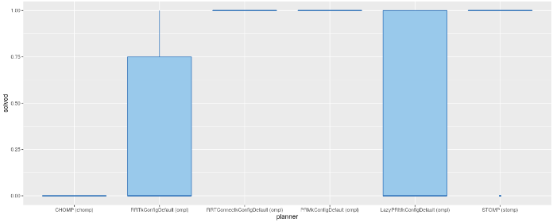
Ind_STT_Original_Solved
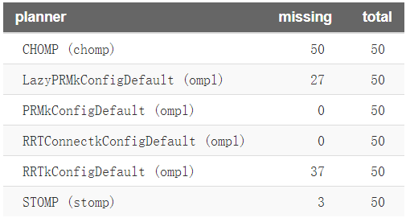
Number of missing data points out of the total number of runs per planner
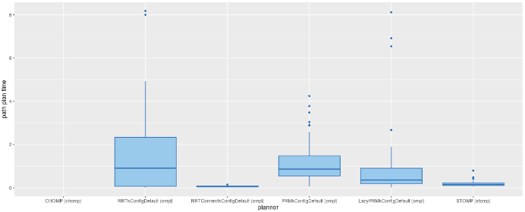
Ind_STT_Original_Path time
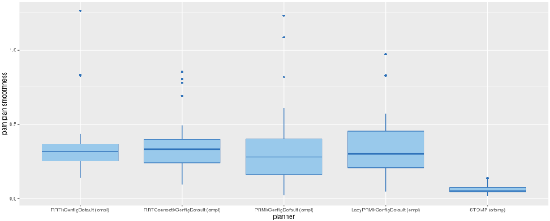
Ind_STT_Original_Smooth
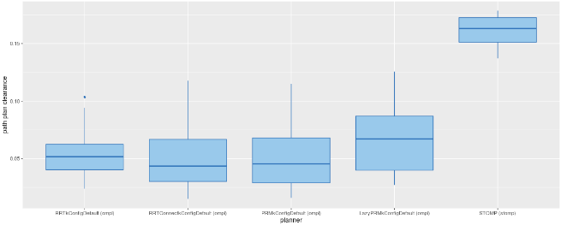
Ind_STT_Original_Clearance
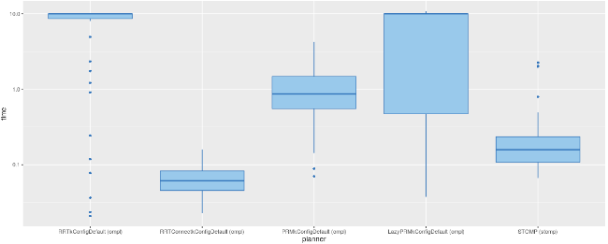
Ind_STT_Original_Total Time

Original algorithm after CHOMP:
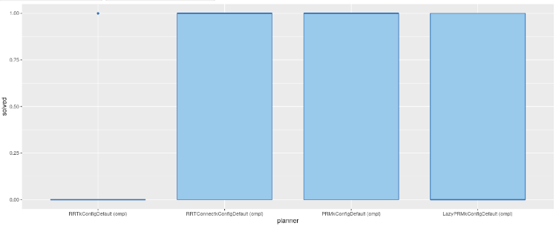
Ind_STT_Original_CHOMP_Solve
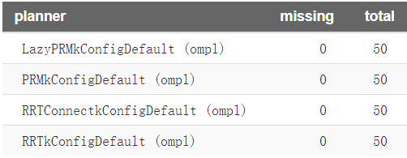
Number of missing data points out of the total number of runs per planner
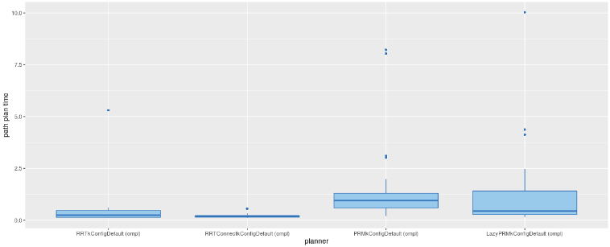
Ind_STT_Original_CHOMP_Path time
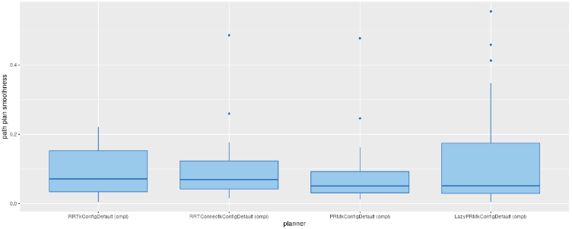
Ind_STT_Original_CHOMP_Path Smoothness
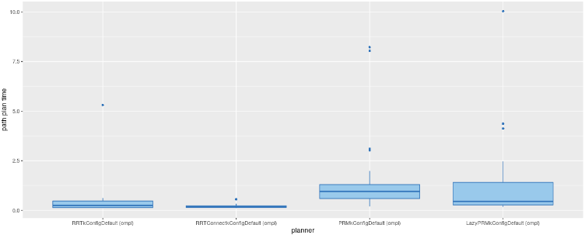
Ind_STT_Original_CHOMP_Path Clearance
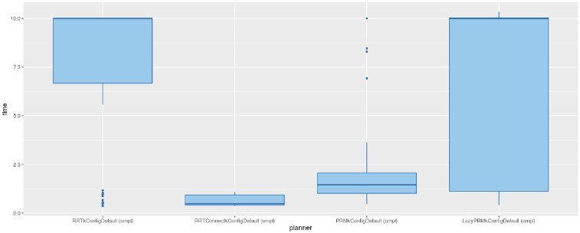
Ind_STT_Original_CHOMP_Total Time
Original algorithm after STOMP:
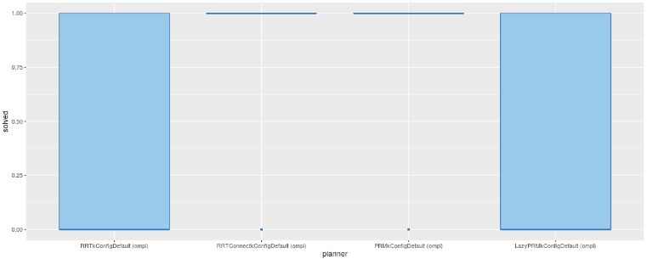
Ind_STT_Original_STOMP_Solve
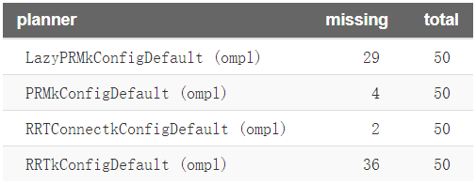
Number of missing data points out of the total number of runs per planner
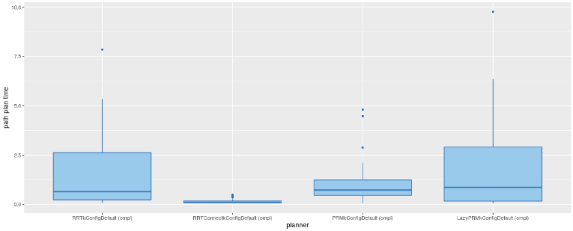
Ind_STT_Original_STOMP _Path time
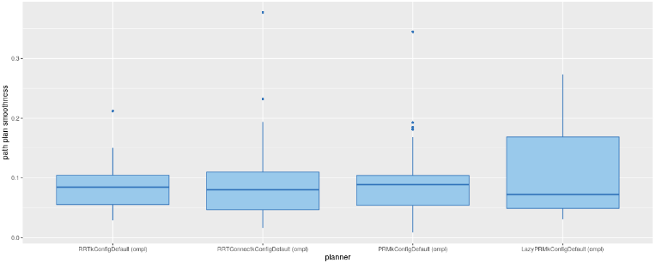
Ind_STT_Original_STOMP _Path Smoothness
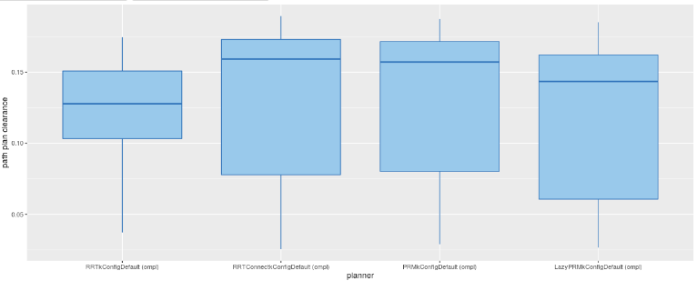
Ind_STT_Original_STOMP _Path Clearance
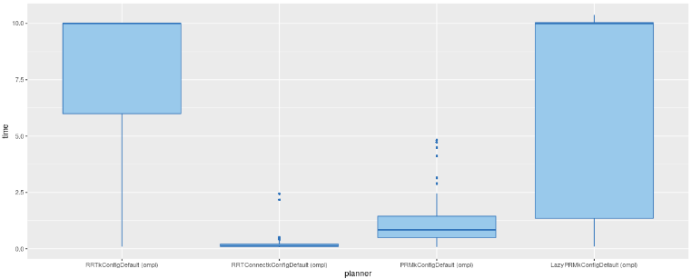
Ind_STT_Original_STOMP _Total Time

Query b: The robotic arm selects parts from the first layer of the parts table and brings the parts to the workbench:
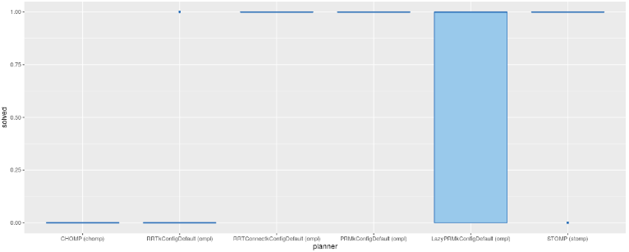
Ind_FTT_Original_Solve
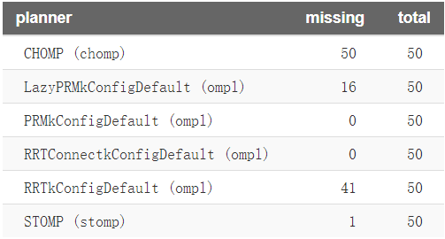
Number of missing data points out of the total number of runs per planner
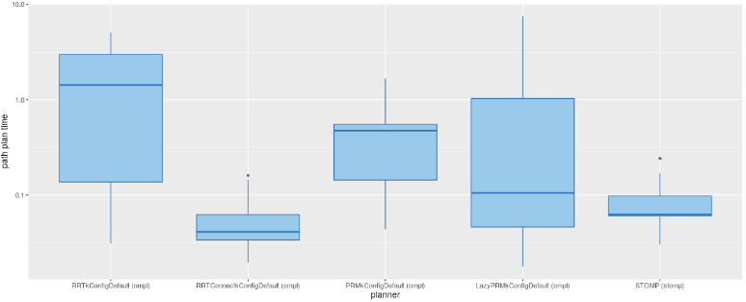
Ind_FTT_Original_Path time
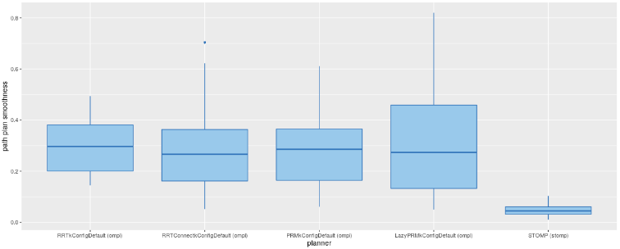
Ind_FTT_Original_Path Smoothness
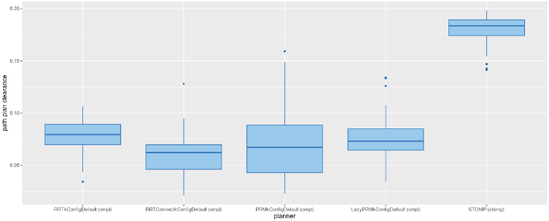
Ind_FTT_Original_Path Clearance
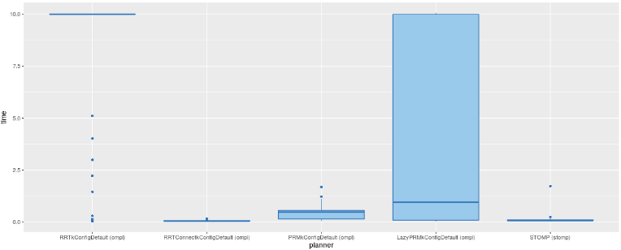
Ind_FTT_Original_Total Time
Original algorithm after CHOMP:
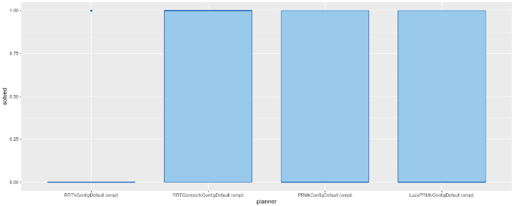
Ind_FTT_Original_CHOMP_Solve
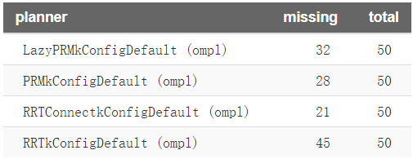
Number of missing data points out of the total number of runs per planner
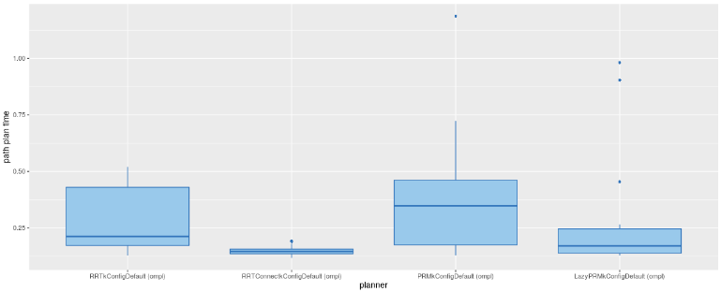
Ind_FTT_Original_CHOMP_Path time
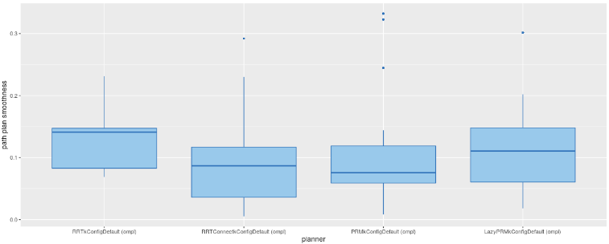
Ind_FTT_Original_CHOMP_Path Smoothness
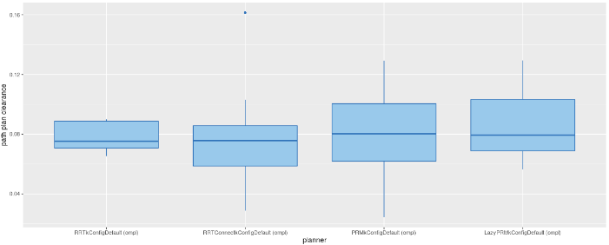
Ind_FTT_Original_CHOMP_Path Clearance
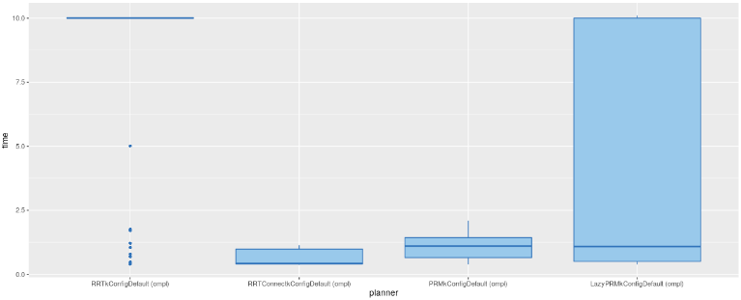
Ind_FTT_Original_CHOMP_Total time
Original algorithm after STOMP:
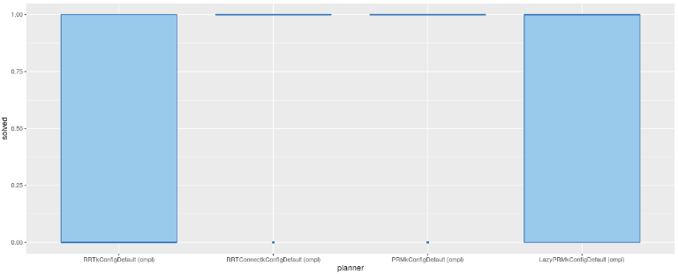
Ind_FTT_Original_STOMP_Solve
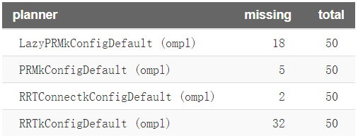
Number of missing data points out of the total number of runs per planner
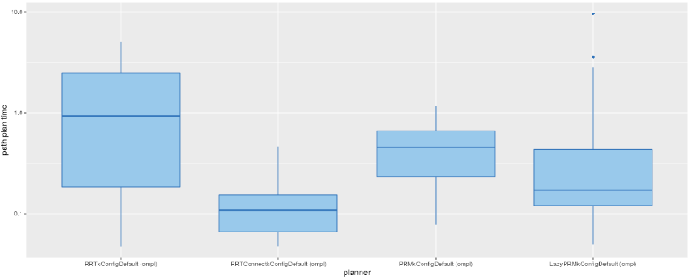
Ind_FTT_Original_STOMP_Path time
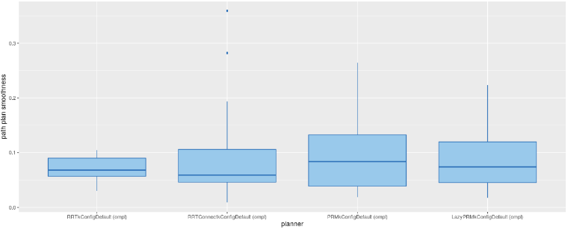
Ind_FTT_Original_STOMP_Path Smoothness
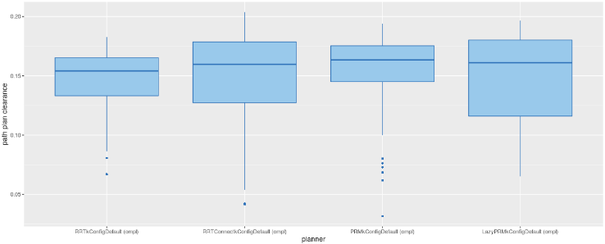
Ind_FTT_Original_STOMP_Path Clearance
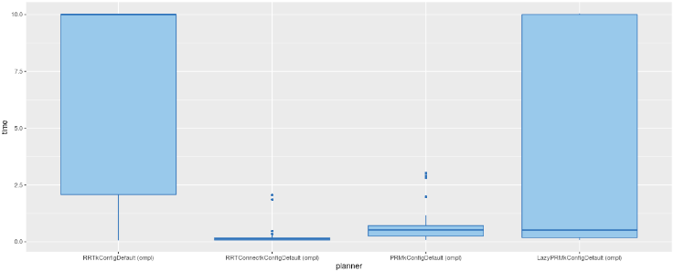
Ind_FTT_Original_STOMP_Total Time

Library Scene：
- Query a: The robotic arm moves the arm from under the table to the top of the table.
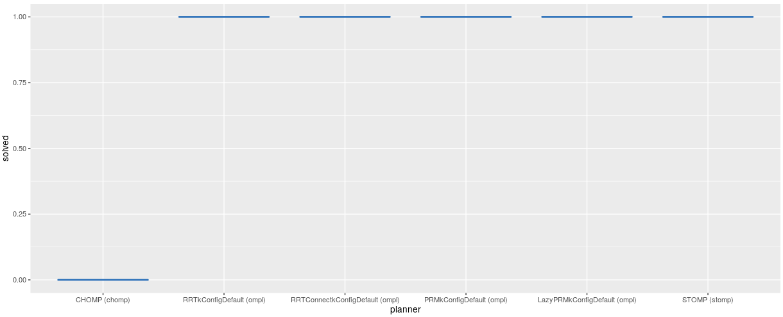
Library_DTU_Original_Solved
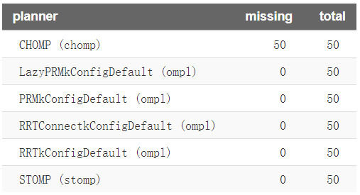
Number of missing data points out of the total number of runs per planner
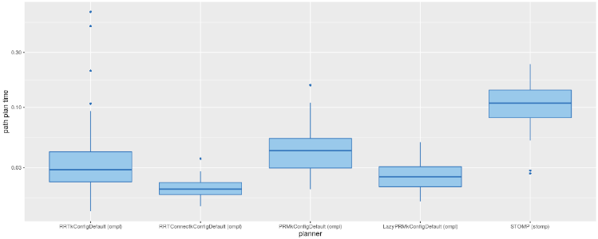
Library_DTU_Original_Path time
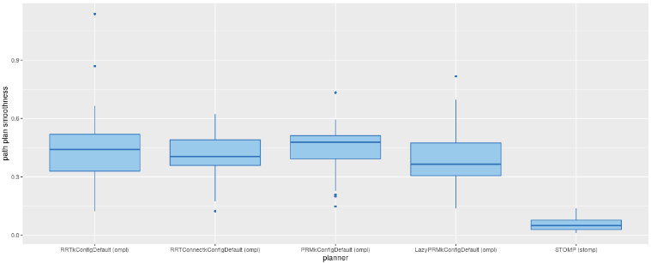
Library_DTU_Original_Smoothness
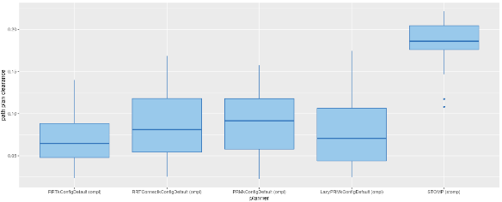
Library_DTU_Original_Clearance
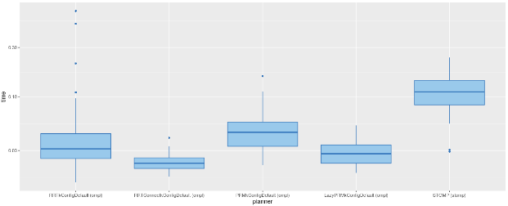
Library_DTU_Original_Total time
Original algorithm after CHOMP:
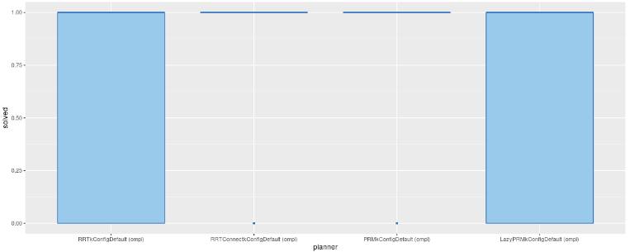
Library_DTU_Original_CHOMP_Solved
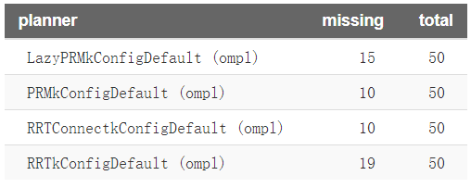
Number of missing data points out of the total number of runs per planner
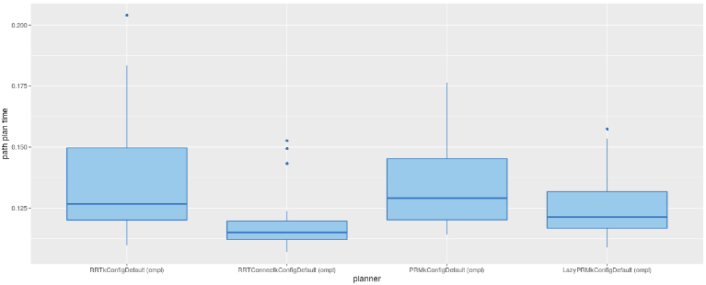
Library_DTU_Original_CHOMP_Path time
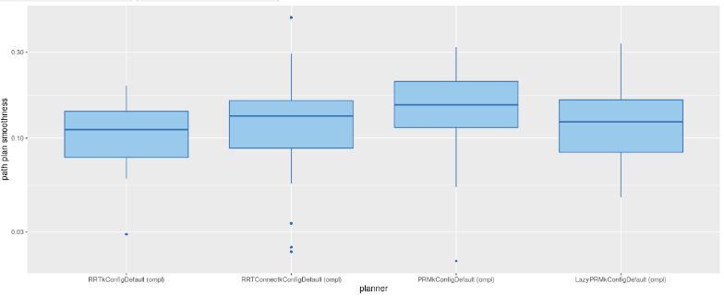
Library_DTU_Original_CHOMP_Smoothness
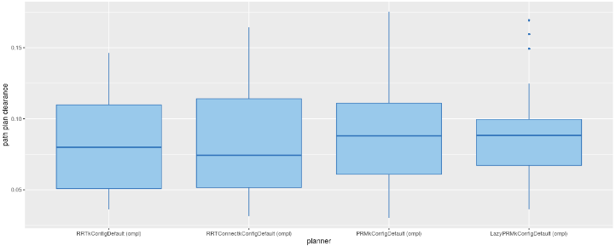
Library_DTU_Original_CHOMP_Clearance
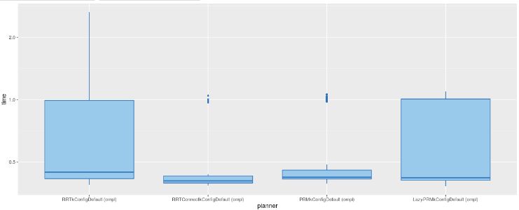
Library_DTU_Original_CHOMP_Total time

Original algorithm after STOMP:
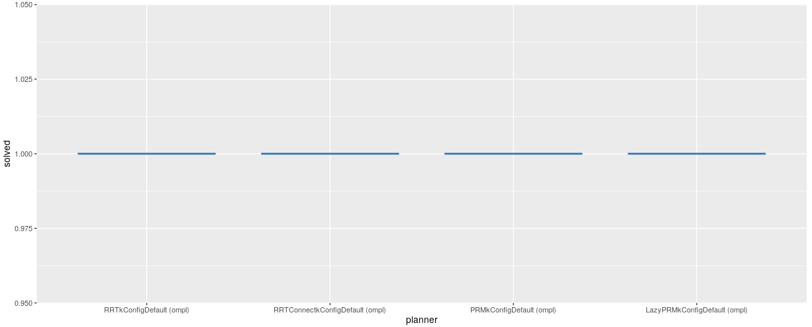
Library_DTU_Original_STOMP_Solved
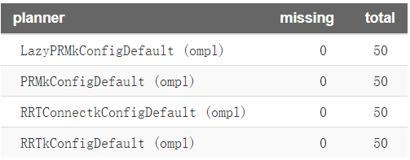
Number of missing data points out of the total number of runs per planner
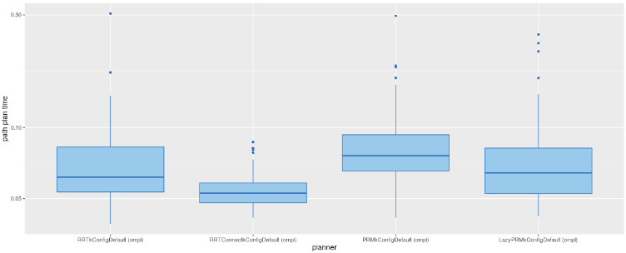
Library_DTU_Original_STOMP_Path time
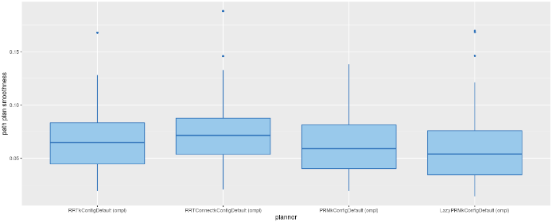 Library_DTU_Original_STOMP_Smoothness
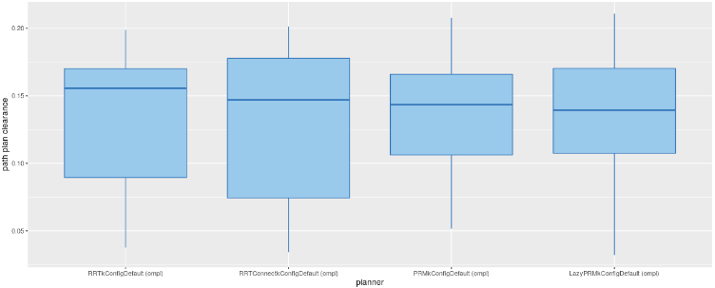
Library_DTU_Original_STOMP_Clearance
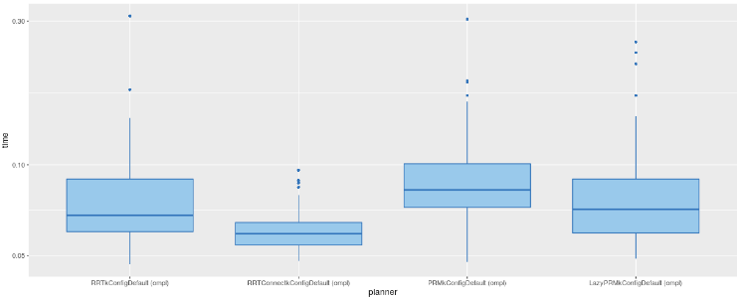
Library_DTU_Original_STOMP_Total time

- Query b: The robotic arm moves from the table to the bookshelf.
Library_TTB_Original:
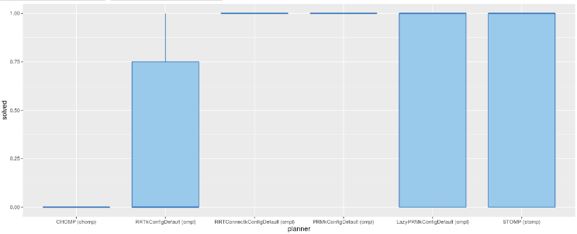
Library_TTB_Original_Solve
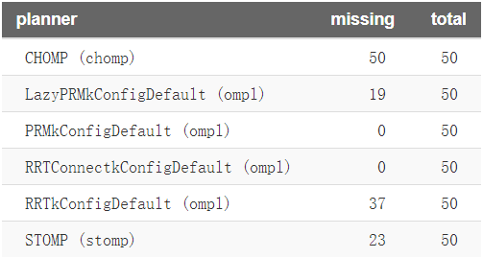
Number of missing data points out of the total number of runs per planner
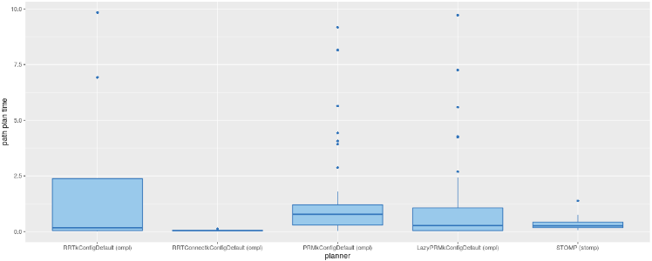
Library_TTB_Original_path time
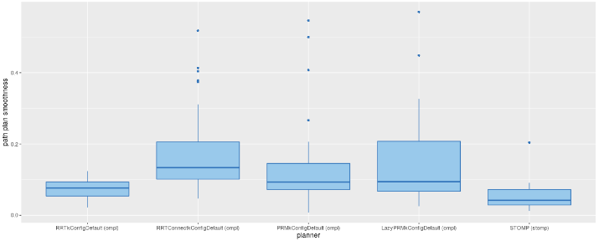
Library_TTB_Original_Smoothness
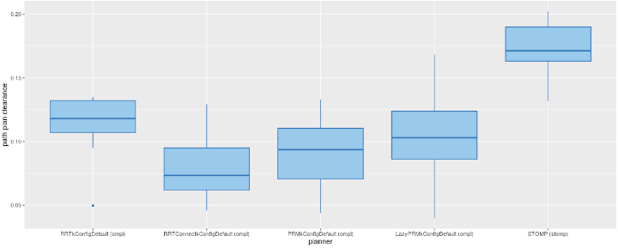
Library_TTB_Original_Clearance
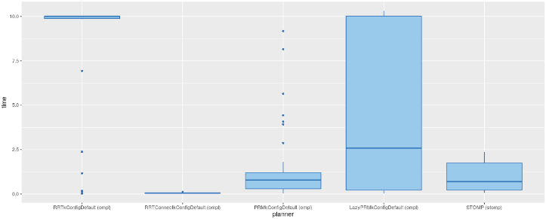
Library_TTB_Original_Total time

Original algorithm after CHOMP:
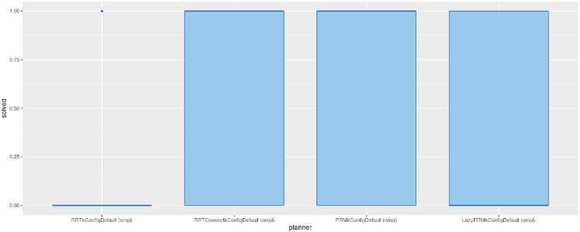
Library_TTB_Original_CHOMP_Solve
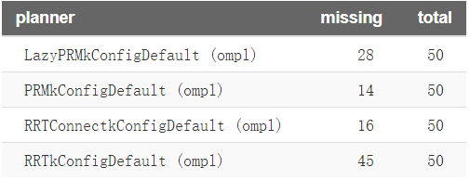
Number of missing data points out of the total number of runs per planner
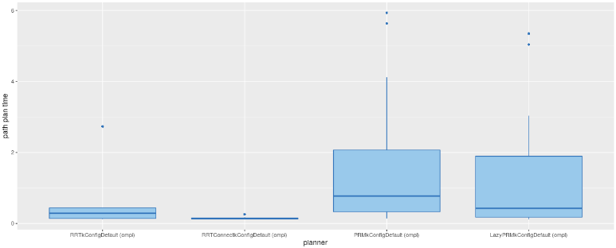
Library_TTB_Original_CHOMP_Path time
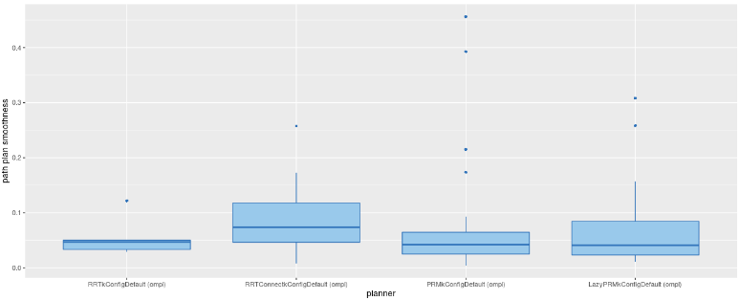
Library_TTB_Original_CHOMP_Smoothness
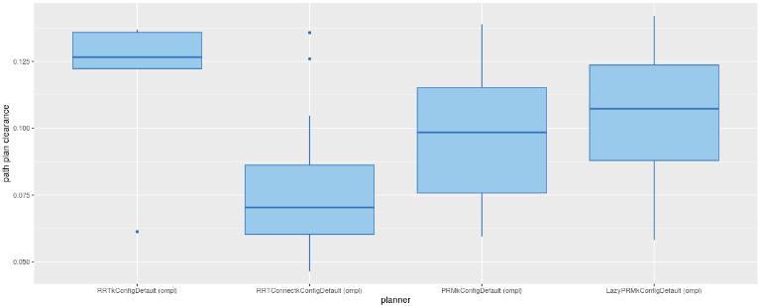
Library_TTB_Original_CHOMP_Clearance
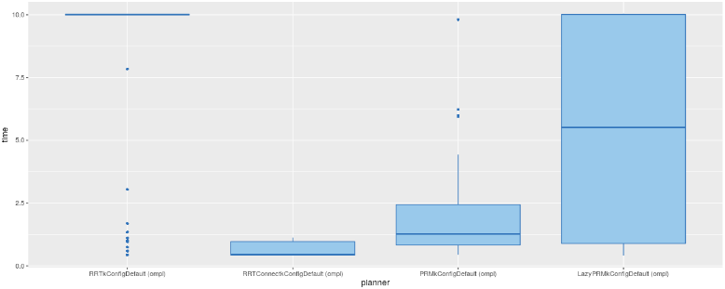
Library_TTB_Original_CHOMP_Total time

Original algorithm after STOMP:
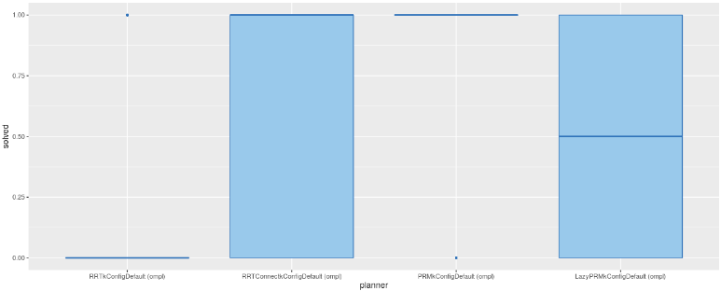
Library_TTB_Original_STOMP_Solve
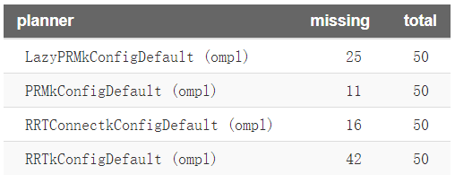
Number of missing data points out of the total number of runs per planner
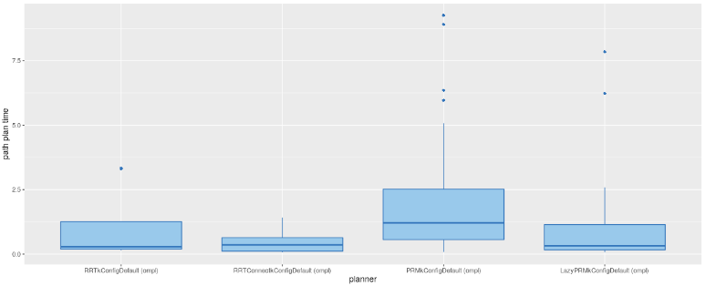
Library_TTB_Original_STOMP_Path Time
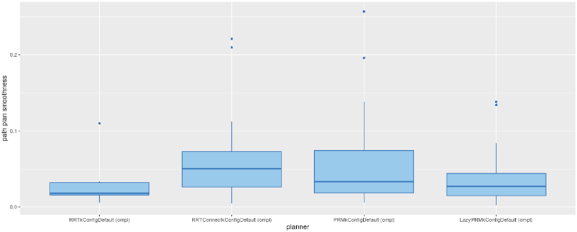
Library_TTB_Original_STOMP_Smoothness
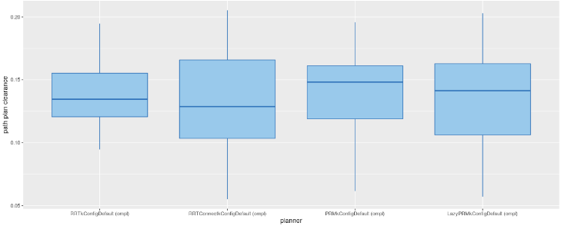
Library_TTB_Original_STOMP_Clearance
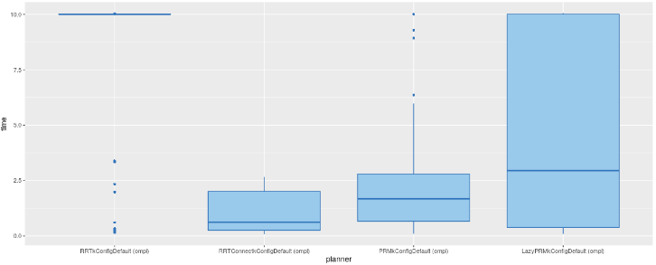
Library_TTB_Original_STOMP_Total time

- Query c: The robotic arm moves from the third level of the bookshelf to the second level of the bookshelf.
Library_B3TB2_Original:
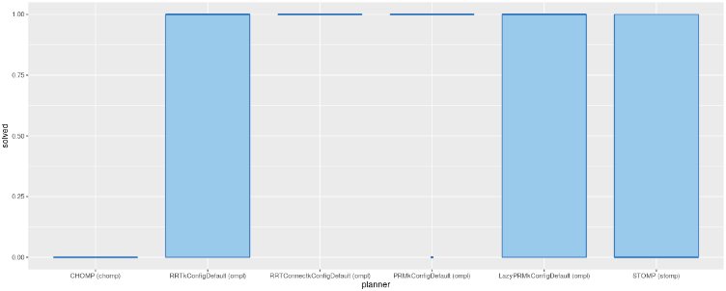
Library_B3TB2_Original _Solved:
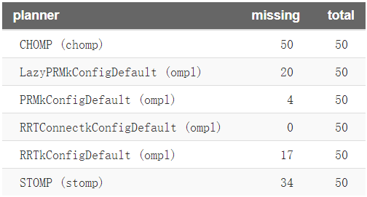
Number of missing data points out of the total number of runs per planner
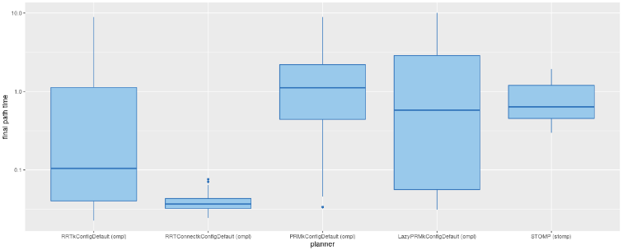
Library_B3TB2_Original _Path time
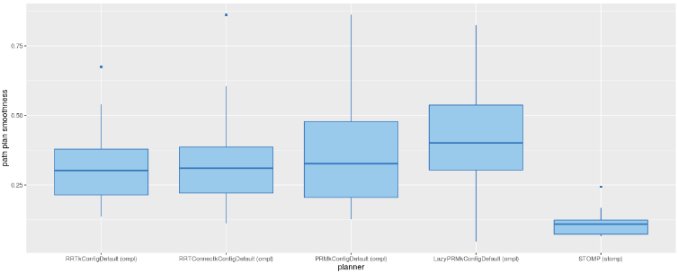
Library_B3TB2_Original _Smoothness
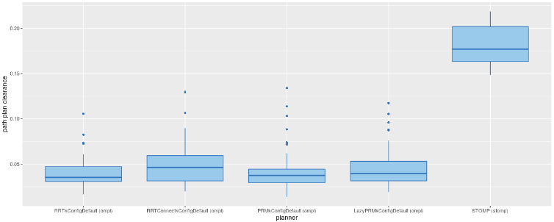
Library_B3TB2_Original _Clearance
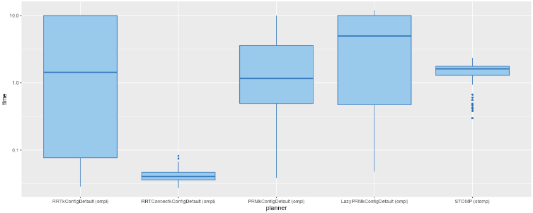
Library_B3TB2_Original _Total time

Original algorithm after CHOMP:
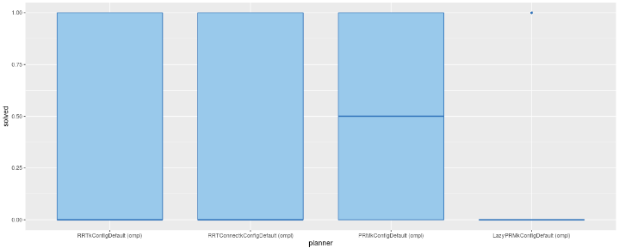
Library_B3TB2_Original_CHOMP_Solved
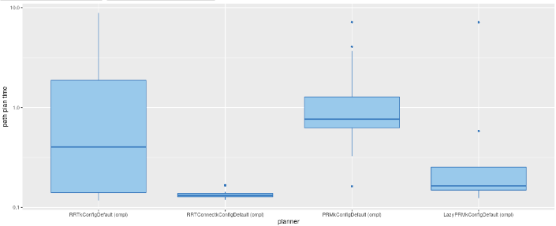
Library_B3TB2_Original_CHOMP_Path time
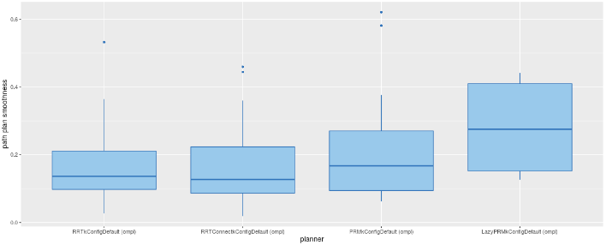
Library_B3TB2_Original_CHOMP_Smoothness
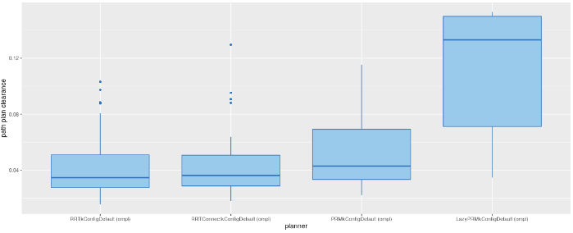
Library_B3TB2_Original_CHOMP_Clearance
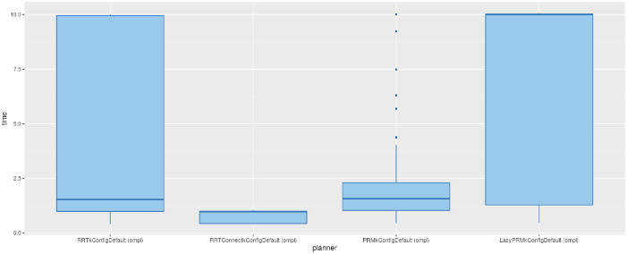
Library_B3TB2_Original_CHOMP_Total time

Original algorithm after STOMP:
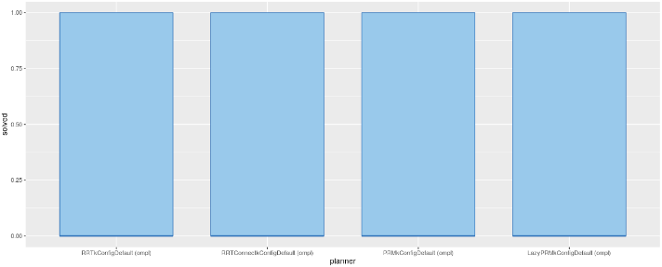
Library_B3TB2_Original_STOMP_Solved
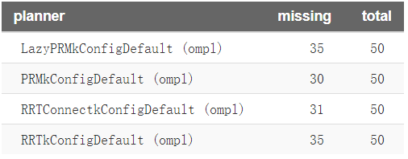
Number of missing data points out of the total number of runs per planner
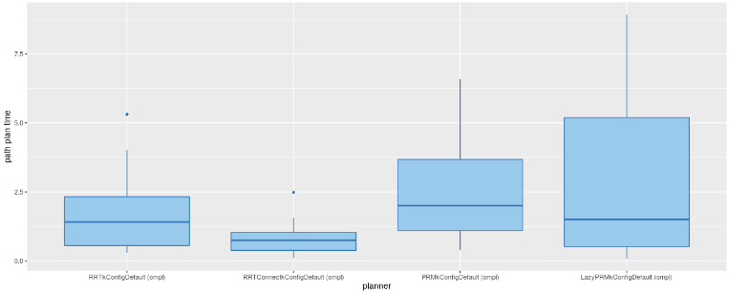
Library_B3TB2_Original_STOMP_Path Time
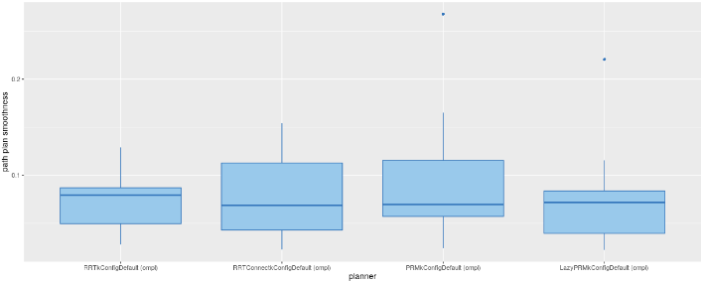
Library_B3TB2_Original_STOMP_Smoothness
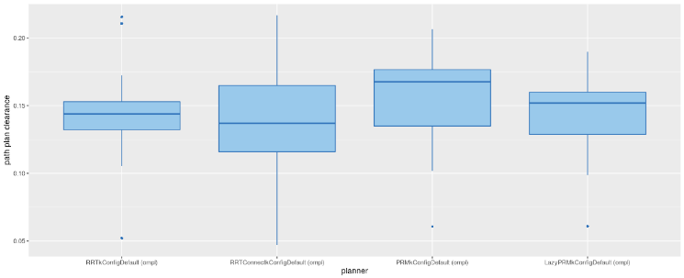
Library_B3TB2_Original_STOMP_Clearance
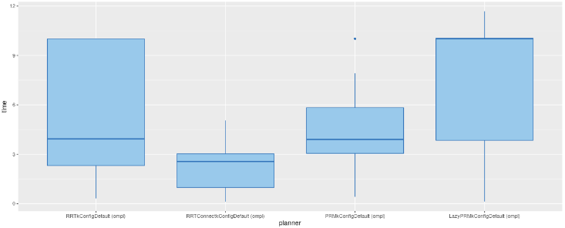
Library_B3TB2_Original_STOMP_Total time

