Supporting Information
Theoretical Research on Cage-like Oxadiazole-based Energetic Compounds and Its Derivatives
Yan Huang, Le-Wu Zhan, Qian Zhang, Jing Hou*, and Bin-Dong Li*
School of Chemical Engineering, Nanjing University of Science and Technology, Nanjing 210094, China

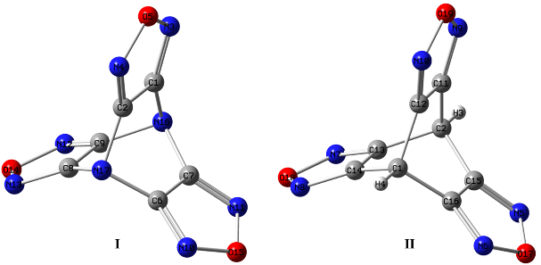
Figure S1. Designed Molecules Structures (B3PW91/6-311G++(2d,p))
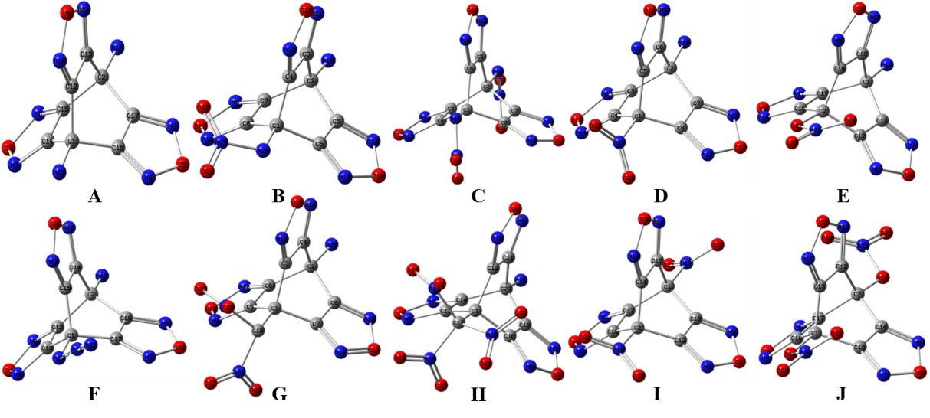
Figure S2. Derivatives Molecular Structures (B3PW91/6-311G++(2d,p))
Table S1. HOMO and LUMO Energy and Energy Gaps of Designed Compounds
Compounds | Formula | MW | HOMO |  | LUMO |  | $$∆E_{LUMO-HOMO}$$
Compounds | Formula | MW | Orbital | a.u | Orbital | a.u | a.u
I | C₆O₃N₈ | 232.12 | 58 | -0.328801 | 59 | -0.120653 | 0.208148
II | C₈H₂O₃N₆ | 230.14 | 58 | -0.330917 | 59 | -0.10294 | 0.227977
A | C₈H₄O₃N₈ | 260.17 | 66 | -0.305563 | 67 | -0.099324 | 0.206239
B | C₈H₃O₅N₉ | 305.17 | 77 | -0.315438 | 78 | -0.113028 | 0.20241
C | C₈H₂O₇N₁₀ | 350.17 | 88 | -0.344907 | 89 | -0.127938 | 0.216968
D | C₈H₂O₅N₈ | 290.16 | 73 | -0.318699 | 74 | -0.121806 | 0.196893
E | C₈H₂O₆N₈ | 306.15 | 77 | -0.314756 | 78 | -0.111098 | 0.203658
F | C₈H₂O₃N₁₀ | 286.17 | 72 | -0.311115 | 73 | -0.107806 | 0.20331
G | C₉H₃O₇N₉ | 349.18 | 88 | -0.317565 | 89 | -0.127408 | 0.190157
H | C₉H₂O₉N₁₀ | 394.18 | 99 | -0.320204 | 100 | -0.145924 | 0.17428
I | C₈O₇N₈ | 320.14 | 80 | -0.359228 | 81 | -0.133461 | 0.225767
J | C₈O₉N₈ | 352.14 | 88 | -0.347981 | 89 | -0.120126 | 0.227855
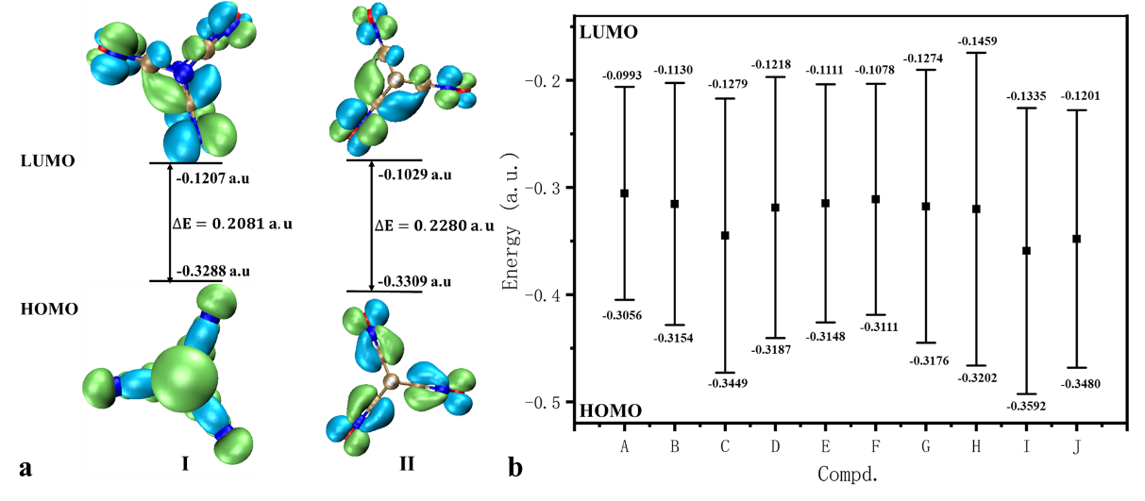
Figure S3. Molecular HOMO and LUMO Energy and Energy Gaps
The orbital-weighted nucleophilic Fukui function as:
$f_{w}^{-}\left(\vec{r}\right)=\sum_{i=1}^{HOMO}{w_{i}ρ_{i}(\vec{r})}$ (1)
where $w_{i}$ are the weightings factor and can be obtained by:
$w_{i}=\frac{exp⁡[-{\left(\frac{μ-ε_{i}}{∆}\right)}^{2}]}{\sum_{i}^{HOMO}{exp⁡[-{\left(\frac{μ-ε_{i}}{∆}\right)}^{2}]}}$ (2)
where $μ$, $ε_{i}$, and $Δ$ represent the chemical potential, orbital energy in au, and the width of the Gaussian function.
$f_{w}^{+}\left(\vec{r}\right)=\sum_{i=LUMO}^{I=∞}{w_{i}ρ_{i}(\vec{r})}$ (3)
$f_{w}^{(2)}\left(\vec{r}\right)=f_{w}^{+}\left(\vec{r}\right)-f_{w}^{-}\left(\vec{r}\right)$ (4)
Table S2. Physicochemical Properties of Designed Compounds
Compounds | Volume | $$σ_{+}^{2}$$ | $$σ_{-}^{2}$$ | $$v$$ | $$vσ_{tot}^{2}$$ | $$∆H_{vap}$$ | $$∆H_{sub}$$ | $$S_{m}^{0}$$ | $$C_{p,m}^{0}$$ | $$H_{T}^{0}$$
I | 1366.15 | 116.74 | 13.88 | 0.09 | 12.40 | 15.44 | 19.30 | 392.50 | 172.30 | -891.73
II | 1441.31 | 122.82 | 15.75 | 0.10 | 13.96 | 16.28 | 20.57 | 399.01 | 178.62 | -859.72
A | 1667.14 | 147.27 | 21.69 | 0.11 | 18.91 | 18.50 | 24.26 | 463.59 | 229.54 | -970.38
B | 1862.68 | 188.22 | 32.48 | 0.13 | 27.70 | 20.95 | 28.79 | 520.53 | 260.27 | -1174.84
C | 2059.14 | 213.71 | 29.61 | 0.11 | 26.01 | 22.36 | 31.88 | 566.26 | 291.01 | -1379.29
D | 1755.25 | 180.11 | 25.74 | 0.11 | 22.52 | 17.04 | 21.99 | 480.84 | 234.16 | -1119.51
E | 1829.23 | 152.66 | 14.02 | 0.08 | 12.84 | 19.24 | 25.70 | 519.02 | 257.02 | -1194.69
F | 1789.29 | 139.87 | 18.22 | 0.10 | 16.12 | 19.43 | 26.01 | 502.73 | 243.80 | -1078.60
G | 2094.35 | 201.24 | 19.66 | 0.08 | 17.91 | 21.39 | 30.09 | 580.33 | 297.89 | -1363.26
H | 2274.64 | 187.28 | 10.35 | 0.05 | 9.81 | 21.24 | 30.35 | 622.32 | 337.56 | -1567.71
I | 1842.64 | 169.18 | 14.15 | 0.07 | 13.06 | 19.27 | 25.77 | 544.78 | 255.57 | -1268.63
J | 1991.19 | 108.64 | 8.40 | 0.07 | 7.79 | 19.88 | 27.32 | 563.11 | 284.65 | -1418.99
* $σ_{+}^{2}$, $σ_{-}^{2}$, $vσ_{tot}^{2}$: (kal/mol)^2; $∆H_{vap}$, $∆H_{sub}$: kal/mol; $S_{m}^{0}$, $C_{p,m}^{0}$: J/mol/K;
$H_{T}^{0}$: kJ/mol
Table S3. Condensed Fukui Functions Properties of Designed Molecules Calculated Using PBE0/def2-SVP Method
Compounds | $$∆=0.1 Hartree$$
I | Atom q(N) q(N+1) q(N-1) f- f+ f0 CDD  1(C ) 0.0659 0.0150 0.1031 0.0372 0.0510 0.0441 0.0138  2(C ) 0.0660 0.0150 0.1030 0.0371 0.0510 0.0440 0.0139  3(C ) 0.0660 0.0471 0.1030 0.0371 0.0188 0.0280 -0.0183  4(C ) 0.0660 0.0471 0.1030 0.0370 0.0188 0.0279 -0.0182  5(C ) 0.0660 0.0472 0.1032 0.0371 0.0188 0.0280 -0.0183  6(C ) 0.0660 0.0472 0.1031 0.0371 0.0188 0.0279 -0.0183  7(O ) 0.0332 -0.0964 0.0785 0.1117 0.0632 0.0874 -0.0484  8(O ) 0.0332 -0.0964 0.0785 0.1117 0.0632 0.0874 -0.0485  9(O ) 0.0333 -0.1203 0.0785 0.1118 0.0871 0.0994 -0.0247  10(N ) 0.0263 -0.1530 0.0382 0.0645 0.1266 0.0956 0.0621  11(N ) 0.0263 -0.1530 0.0382 0.0645 0.1267 0.0956 0.0622  12(N ) 0.0263 -0.1023 0.0382 0.0645 0.0760 0.0703 0.0115  13(N ) 0.0263 -0.1023 0.0382 0.0645 0.0760 0.0703 0.0115  14(N ) 0.0263 -0.1024 0.0382 0.0645 0.0761 0.0703 0.0116  15(N ) 0.0263 -0.1024 0.0382 0.0645 0.0761 0.0703 0.0116  16(N ) 0.0692 -0.0951 0.0415 0.0276 0.0259 0.0268 -0.0017  17(N ) 0.0692 -0.0951 0.0415 0.0276 0.0259 0.0268 -0.0017
II | Atom q(N) q(N+1) q(N-1) f- f+ f0 CDD  1(C ) 0.0232 0.0058 0.0407 0.0176 0.0174 0.0175 -0.0002  2(C ) 0.0232 0.0058 0.0407 0.0176 0.0174 0.0175 -0.0002  3(H ) 0.0863 0.0621 0.1105 0.0242 0.0242 0.0242 -0.0000  4(H ) 0.0863 0.0621 0.1105 0.0242 0.0242 0.0242 -0.0000  5(O ) -0.0441 -0.1059 0.0648 0.1089 0.0617 0.0853 -0.0472  6(O ) -0.0442 -0.1297 0.0647 0.1088 0.0855 0.0972 -0.0233  7(O ) -0.0441 -0.1059 0.0647 0.1088 0.0618 0.0853 -0.0470  8(N ) -0.0492 -0.1223 0.0122 0.0614 0.0731 0.0673 0.0117  9(N ) -0.0492 -0.1223 0.0122 0.0614 0.0731 0.0673 0.0117  10(N ) -0.0492 -0.1222 0.0122 0.0614 0.0730 0.0672 0.0115  11(N ) -0.0492 -0.1222 0.0122 0.0614 0.0730 0.0672 0.0116  12(N ) -0.0492 -0.1706 0.0122 0.0614 0.1214 0.0914 0.0600  13(N ) -0.0492 -0.1706 0.0122 0.0614 0.1214 0.0914 0.0600  14(C ) 0.0347 0.0165 0.0717 0.0369 0.0182 0.0276 -0.0187  15(C ) 0.0348 0.0165 0.0716 0.0369 0.0182 0.0276 -0.0186  16(C ) 0.0348 -0.0153 0.0717 0.0369 0.0500 0.0435 0.0131  17(C ) 0.0348 -0.0153 0.0717 0.0369 0.0501 0.0435 0.0132  18(C ) 0.0348 0.0167 0.0717 0.0370 0.0181 0.0275 -0.0188  19(C ) 0.0348 0.0167 0.0717 0.0369 0.0181 0.0275 -0.0188
Table S4 Orbital Contribution(%) of Designed Molecules ($∆=0.1 Hartree$)
Orbital | I | II
HOMO energy | -0.312929 a.u. | -0.307703 a.u.
LUMO energy | -0.190834 a.u. | -0.157882 a.u.
Chemical potential | -0.251882 a.u. | -0.232793 a.u.
*HOMO | 17.49 % | 13.48 %
*HOMO-1 | 12.26 % | 9.19 %
*HOMO-2 | 8.14 % | 8.97 %
*HOMO-3 | 7.80 % | 8.97 %
*HOMO-4 | 7.10 % | 8.66 %
*HOMO-5 | 7.10 % | 8.66 %
*HOMO-6 | 6.94 % | 8.53 %
*HOMO-7 | 6.94 % | 7.93 %
*HOMO-8 | 6.39 % | 7.93 %
*HOMO-9 | 6.38 % | 5.53 %
**LUMO | 24.24 % | 28.82 %
**LUMO+1 | 24.24 % | 28.81 %
**LUMO+2 | 12.31 % | 13.71 %
**LUMO+3 | 11.46 % | 6.91 %
**LUMO+4 | 6.63 % | 6.91 %
**LUMO+5 | 6.62 % | 6.12 %
**LUMO+6 | 4.66 % | 2.96 %
**LUMO+7 | 4.66 % | 2.96 %
**LUMO+8 | 3.94 % | 1.88 %
* 10 Highest weights in orbital-weighted f-;
** 10 Highest weights in orbital-weighted f+.
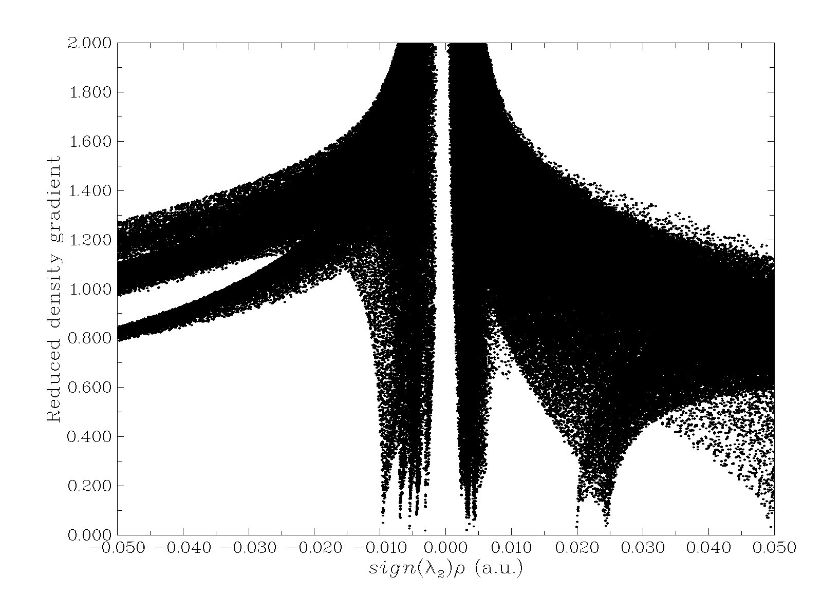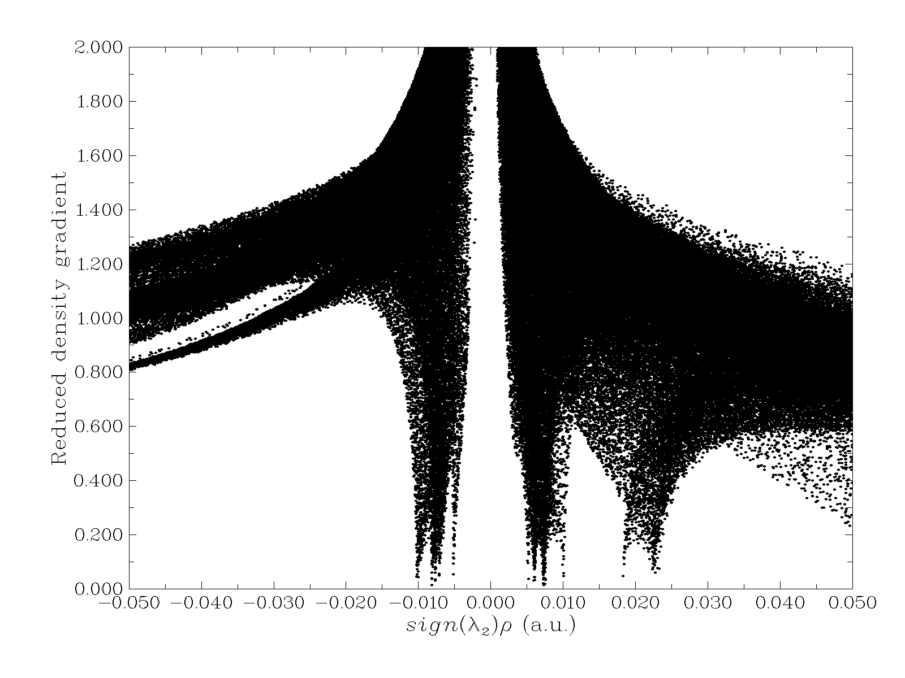
Figure S4. RDG Graft of Designed Molecules
(Left: Molecule I; Right: Molecule II)

