Supplementary figure captions
Fig. 1 PCR based screening of chromate reductase genes in Serratia sp. GP01
Fig. 2 Sequence similarity of chromate reductase genes ChR with the Serratia sp. GP01with other bacteria
Fig. 3 SEM EDX spectra showing the intensity and concentrations of heavy metals absorption on bacterial surface
Fig. 4 FT-IR analysis of control bacteria (black line), K₂Cr₂O₇ enriched bacteria (red line), 10% (v/v) effluent enriched bacteria (blue line)

Fig. 1
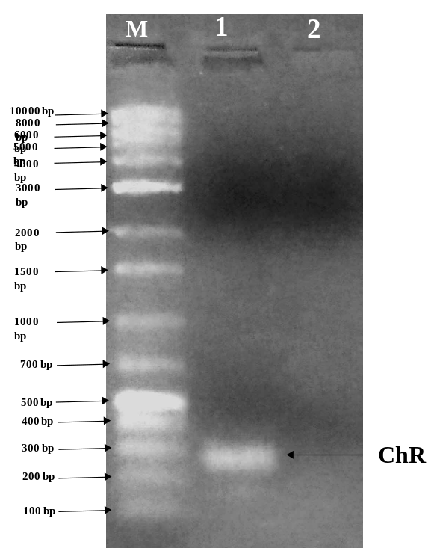
Here ‘M’ indicates marker, Lane-1: represents the amplified chromate reductase (ChR) gene product (268bp), Lane-2: reflects the absence of ChrT gene.

Fig. 2
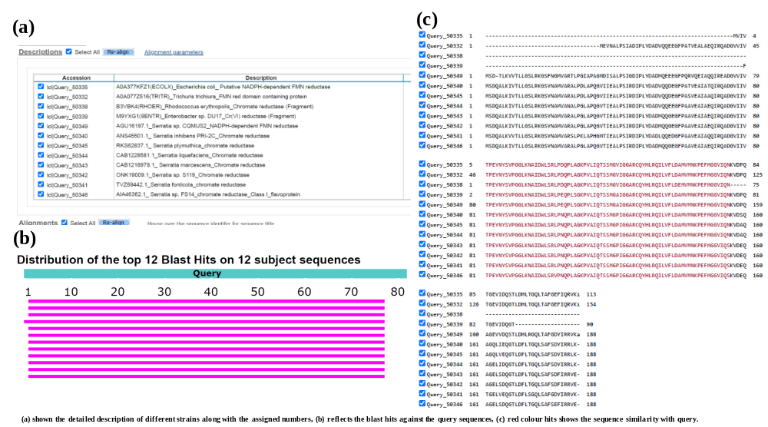

Fig. 3
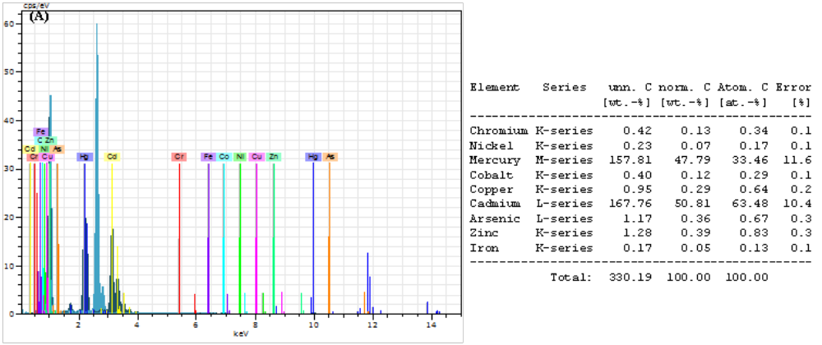

Fig. 4
