Supplementary Information

Enhancing CO₂ Electroreduction Precision to Ethylene and Ethanol: The Role of Additional Boron Catalytic Sites in Cu-Based Tandem Catalysts

Fuqing Yu¹, Minxing Shu¹, Guangyao Zhang¹, Qiming Yu¹, Guomin Xia², Hongming Wang^{1,2}*
¹College of Chemistry and Chemical Engineering and ²Institute for Advanced Study
Nanchang University
Nanchang 330031, China
E-mail: hongmingwang@ncu.edu.cn

Chemicals
Cupric chloride (CuCl₂·H₂O, purity>99%), Sodium borohydride (NaBH₄, >99%), Methanol (CH₃OH), ethanol, potassium bicarbonate (KHCO₃, ≥99.5%), Nickel acetate tetrahydrate (Ni(OAc)₂·4H₂O, ≥99.5%), triethylamine, sodium citrate (>99%), Hydrochloric acid (HCl, vol%>37%) were purchased from China National Medicines Corporation Ltd. 1,2,4,5-benzenetetramine hydrochloride, 1,3,5-trimethylbenzene were purchased from Shanghai Aladdin Bio-Chem Technology Co., LTD. All chemicals were used without further purification.
All materials were used directly with no further purification. Milli-Q (DI) water (>18.0 MΩ) was purified with a Sartorius arium mini ultrapure water system.

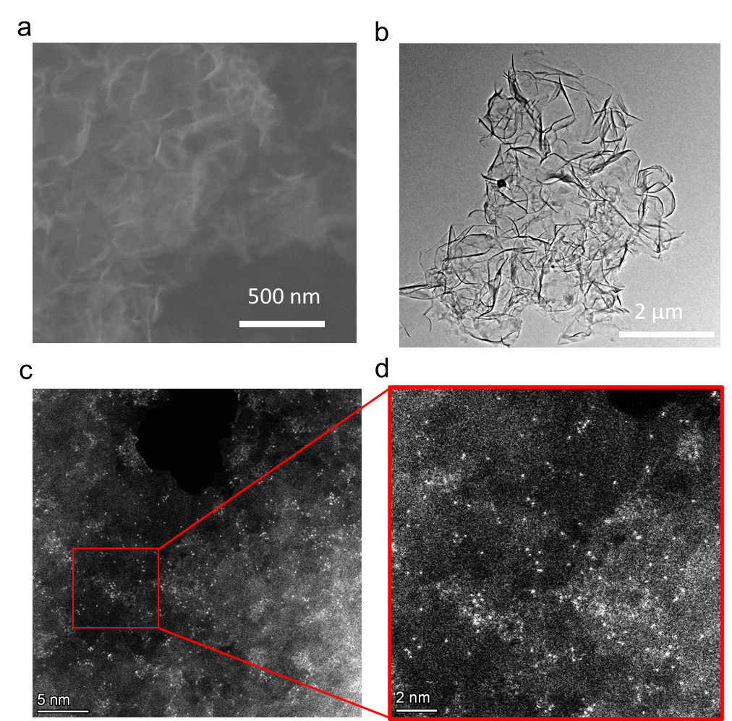
Figure S1 . a) SEM , b)TEM and c) HADDF-TEM images of Ni-SAC. d) Magnified HADDF-TEM images of Ni atomic dispersion.

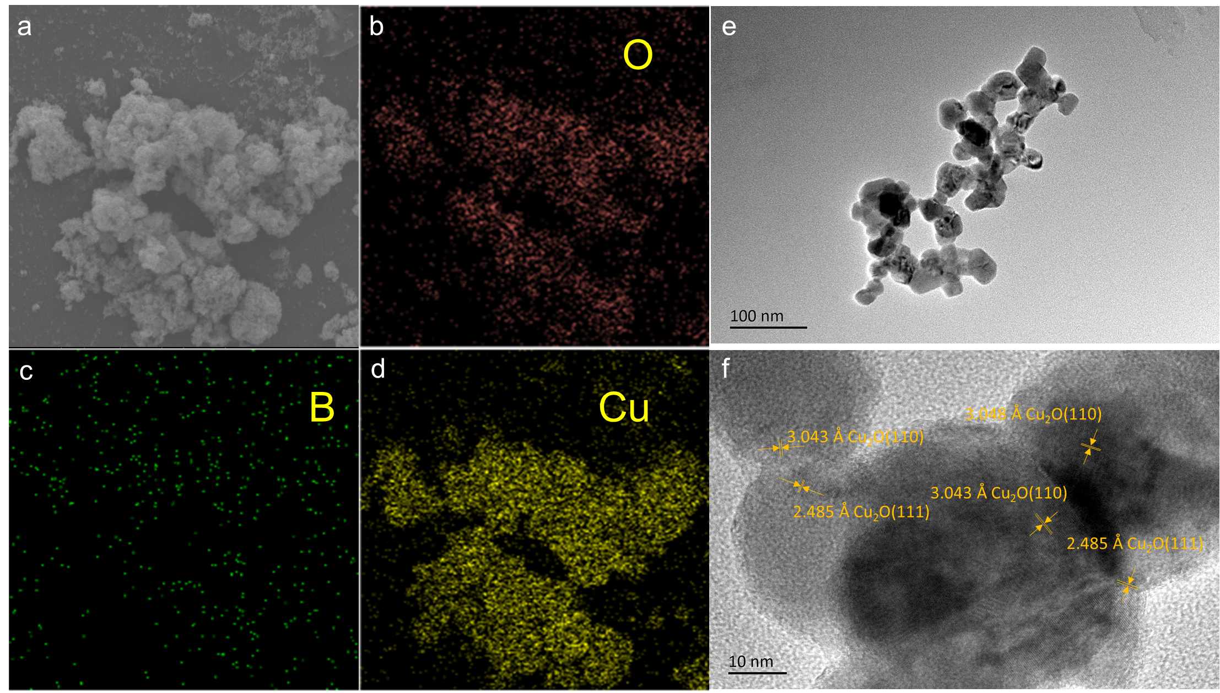
Figure S2 . a) SEM images and Mapping of b) O c) B d) Cu elemental surface distributionsof CuB₂. e) TEM and HRTEM image of CuB₂.

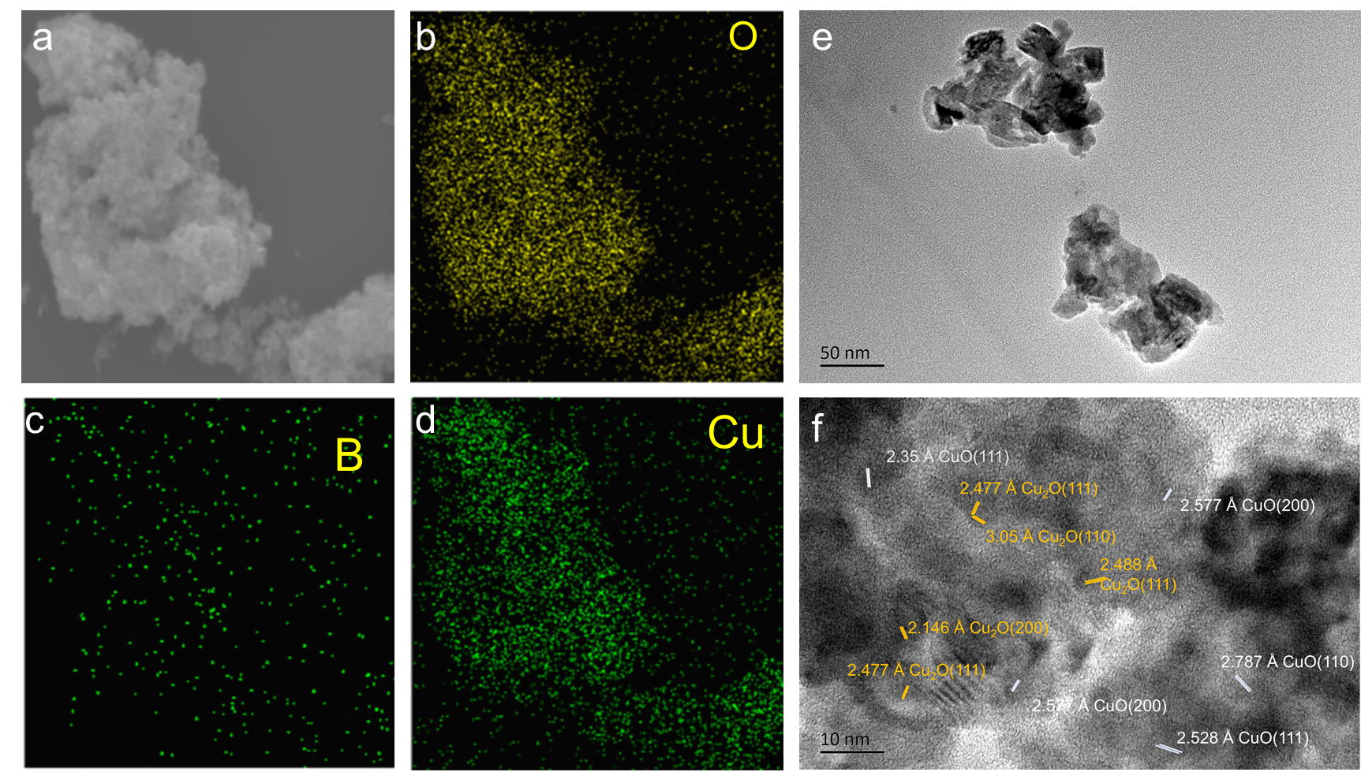
Figure S3 . a) SEM images and Mapping of b) O c) B d) Cu elemental surface distributionsof CuB₅. e) TEM and HRTEM image of CuB₅.

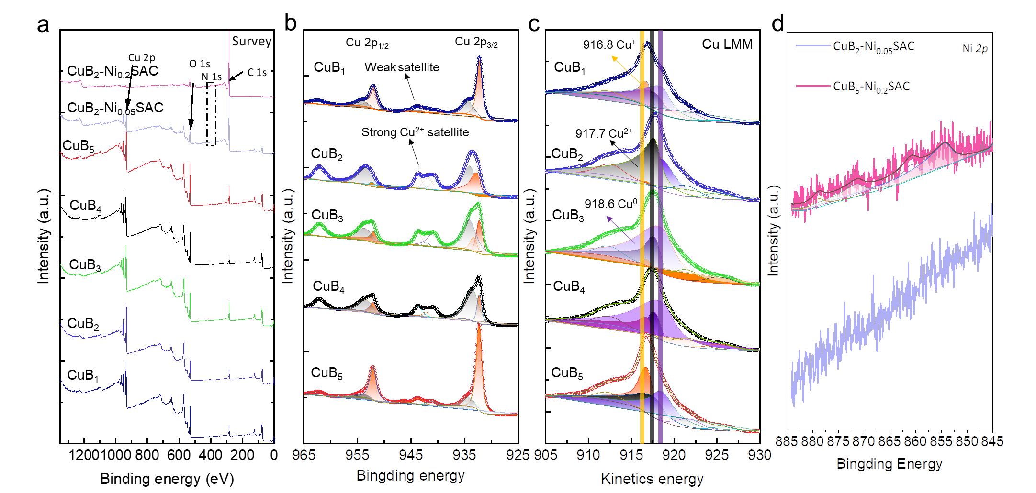
Figure S4 a) Survey , b) Cu 2p c) Cu LMM d) Ni 2p XPS spectra of the CuB_{x}-Ni_{y}SAC.

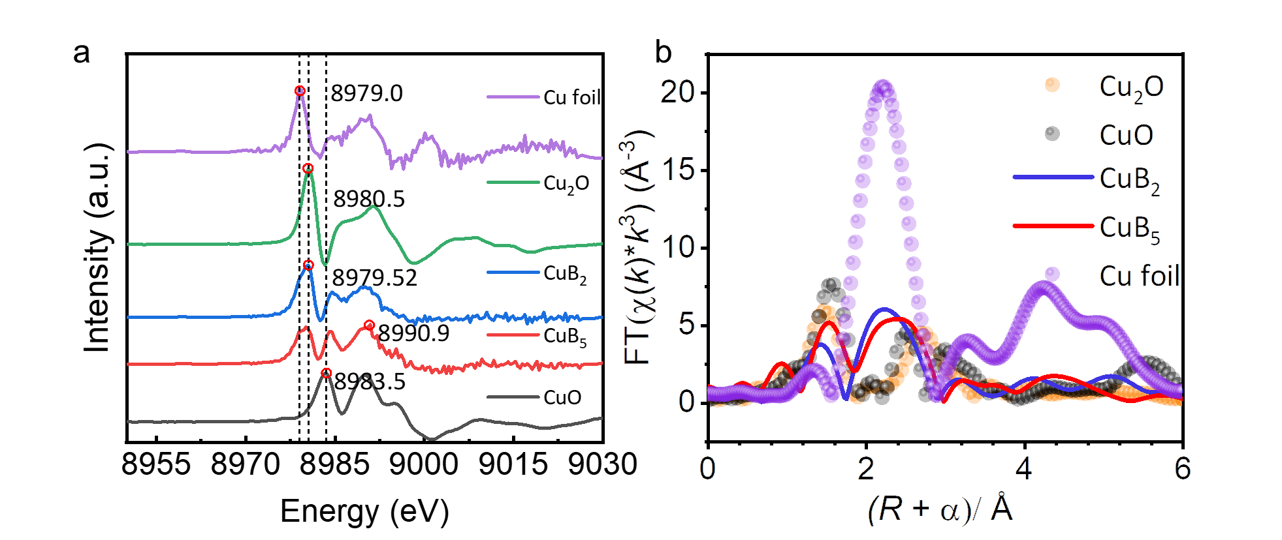
Figure S5 a) The near-edge first-order derivative diagram of Cu K-edge Survey of CuB_{X}, b) Cu K-edge EXAFS curvefit for CuB₂, CuB₅ and standard sample shown in R-space The data are k³-weighted and not phase-corrected.

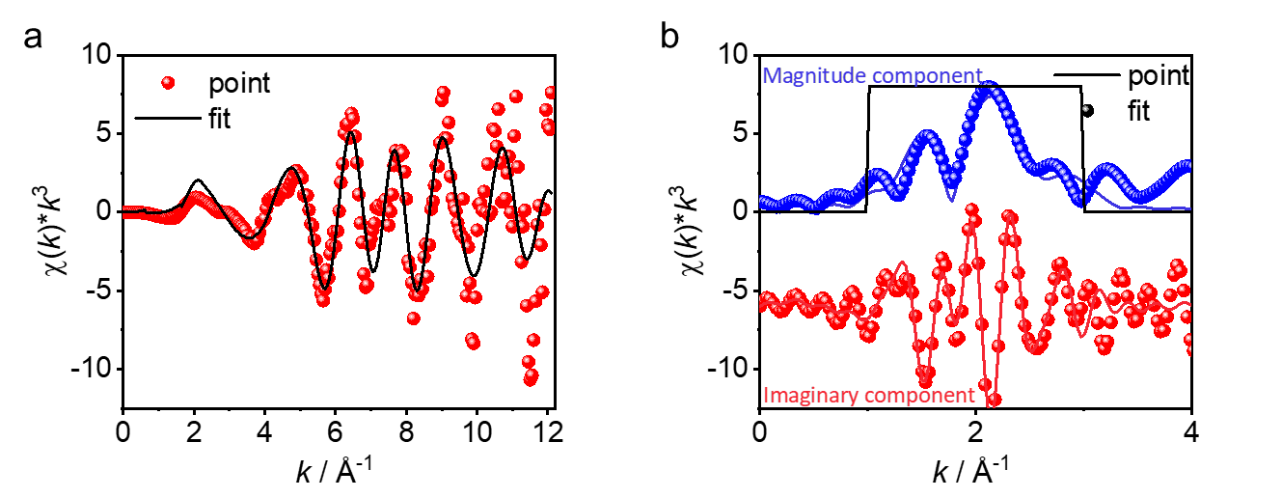
Figure S6. a) Cu K-edge EXAFS (points) and the curvefit (line) for CuB₂ shown in k³weighted k-space. b) Cu K-edge EXAFS (points) and curvefit (line) for CuB₂ shown in R-space (FT magnitude and imaginary component). The data are k³-weighted and not phase-corrected.

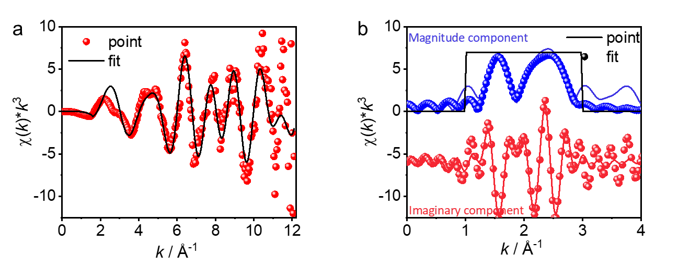
Figure S7. a) Cu K-edge EXAFS (points) and the curvefit (line) for CuB₅ shown in k³weighted k-space. b) Cu K-edge EXAFS (points) and curvefit (line) for CuB₅ shown in R-space (FT magnitude and imaginary component). The data are k³-weighted and not phase-corrected.

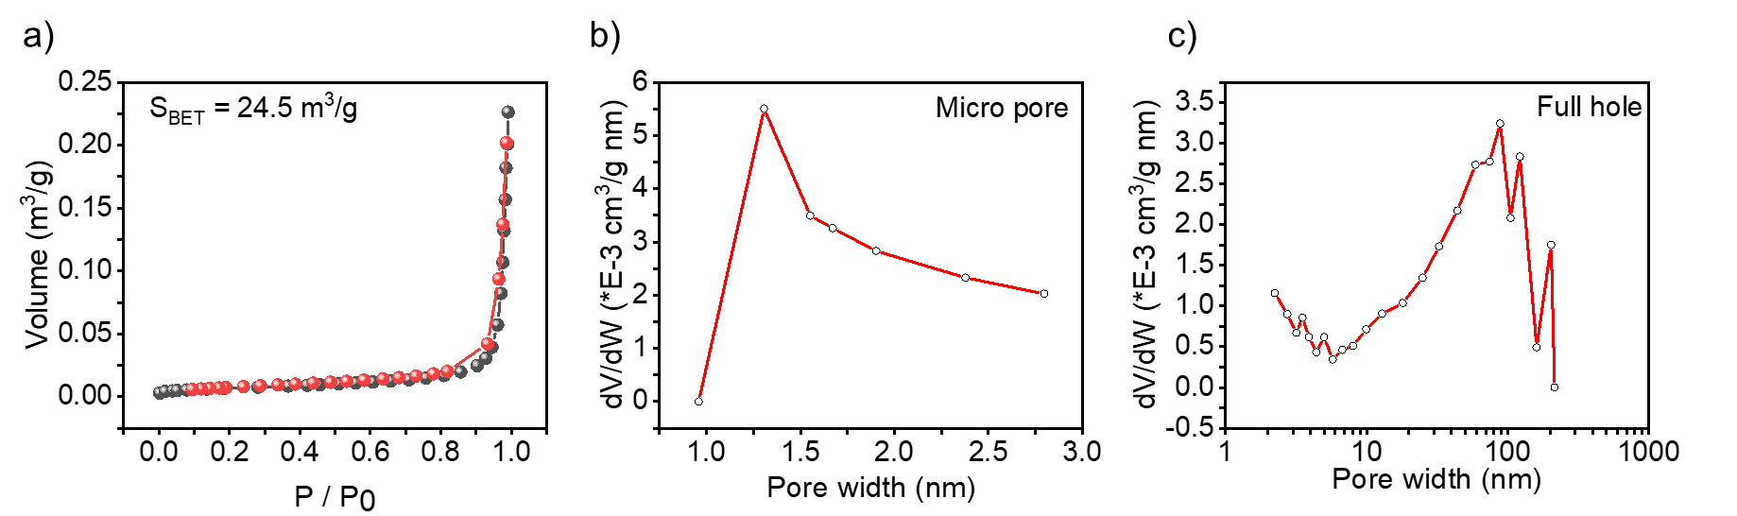
Figure S8. a) Adsorption and desorption isotherm and specific surface area measurements of CuB₂ sample. b,c ) Pore size distribution of CuB₂ micropores and whole pores, respectively.

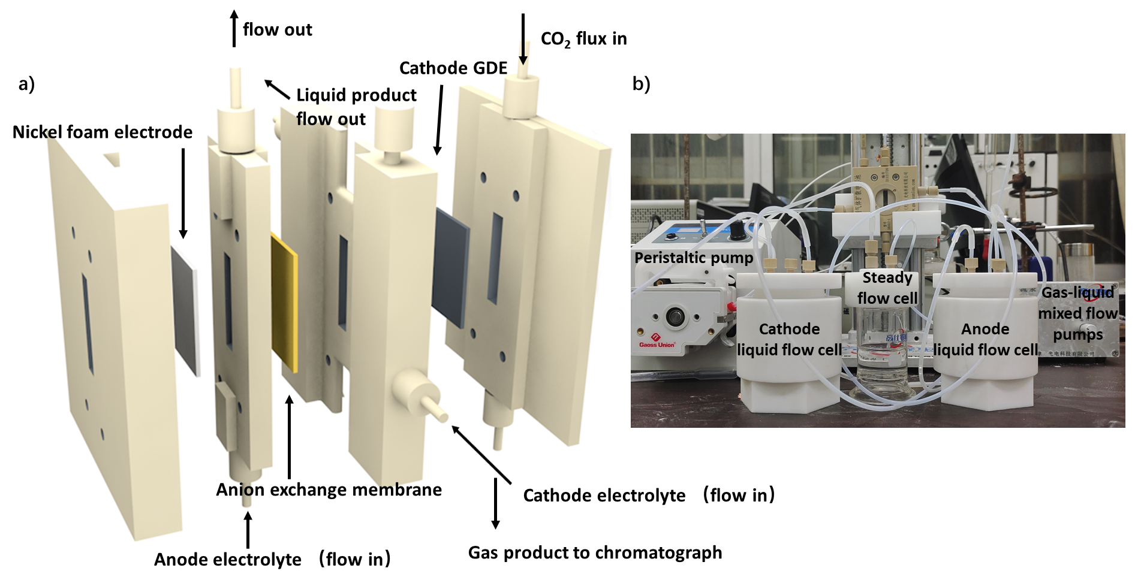
Figure S9. Diagram of the control experimental group with a photograph of the catalyst ink and the corresponding catalyst spray.
Figure S10. CO₂RR performance of Ni-SAC in a flow cell with 0.5 M KHCO₃ electrolyte.

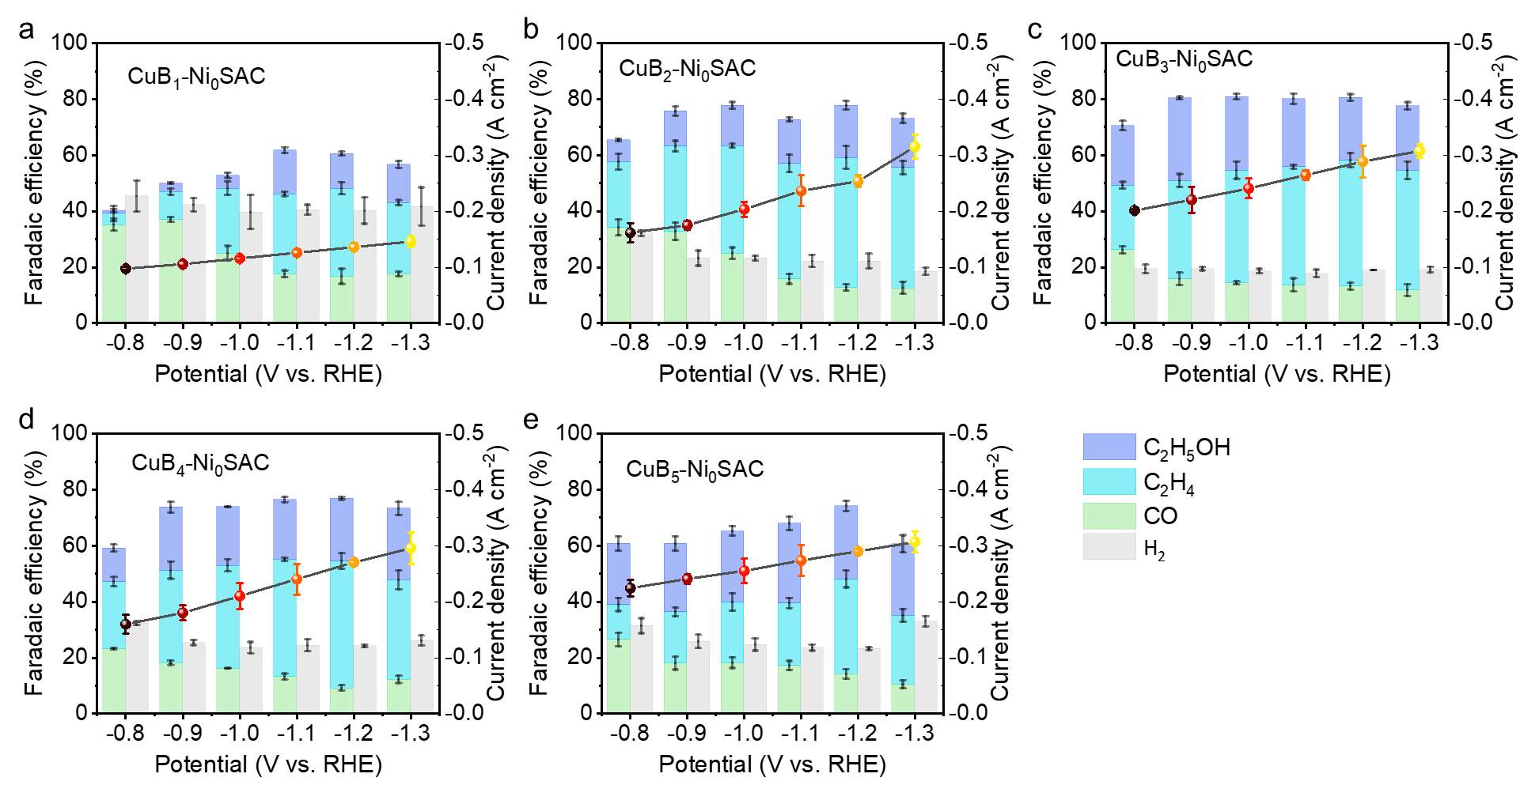
Figure S11. The CO₂RR performance of unhybridized Ni-SAC with different contents of CuB_{x} at -0.8 to -1.3 V vs. RHE.

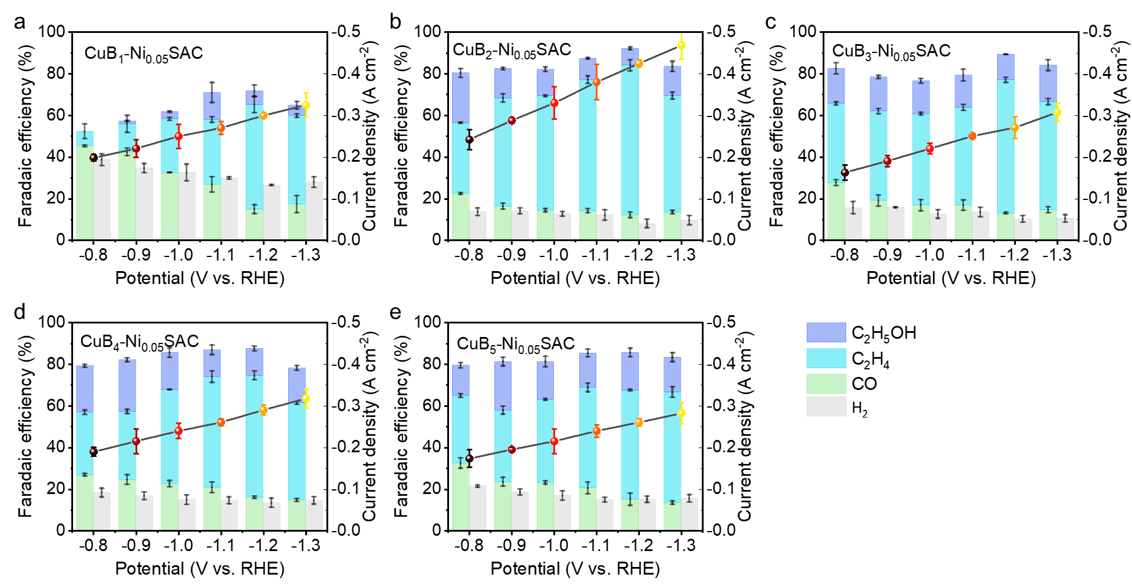
Figure S12.The mass ratio of Ni-SAC hybridized with different contents of CuB_{x} is 0.05, which corresponds to the CO₂RR performance at -0.8 to -1.3 V vs. RHE.

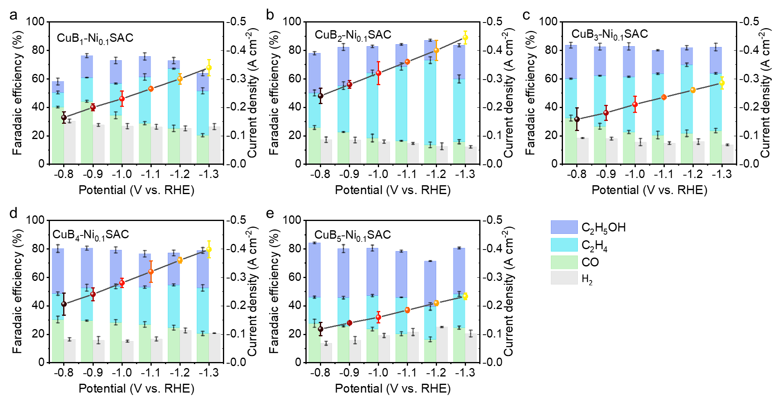
Figure S13.The mass ratio of Ni-SAC hybridized with different contents of CuB_{x} is 0.1, which corresponds to the CO₂RR performance at -0.8 to -1.3 V vs. RHE.

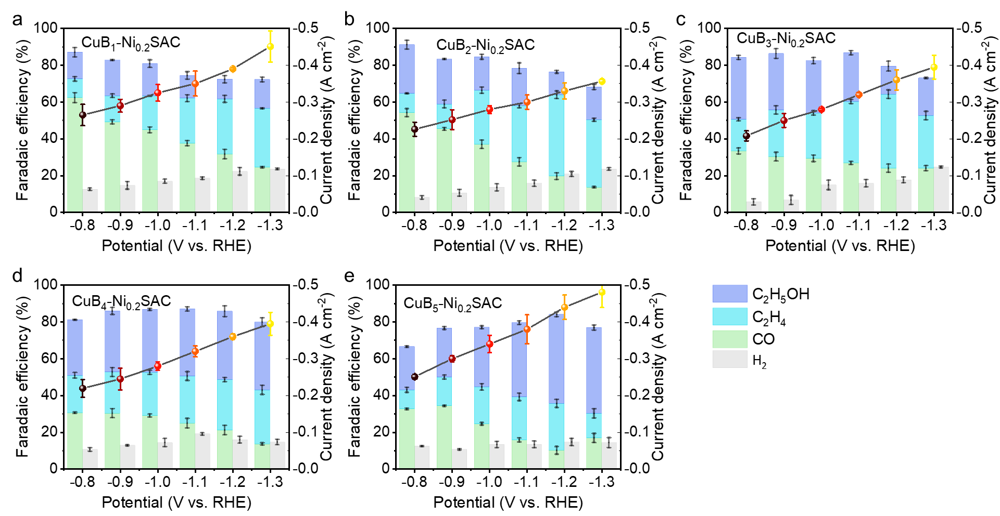
Figure S14.The mass ratio of Ni-SAC hybridized with different contents of CuB_{x} is 0.2, which corresponds to the CO₂RR performance at -0.8 to -1.3 V vs. RHE.

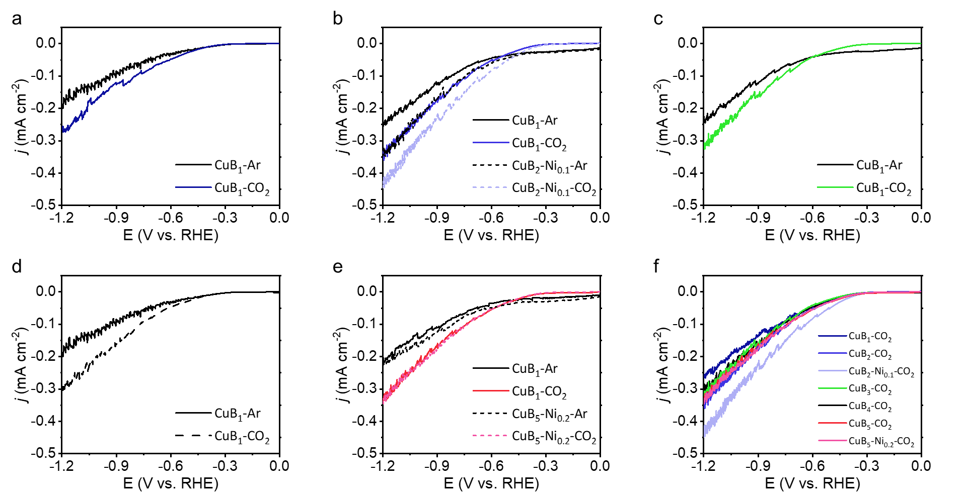
Figure S15. Linear voltammetric curves of hybrid catalysts with different B contents of CuB_{x} as well as partially doped Ni-SAC under different atmospheres. The CO₂RR performance of the synthesized catalysts was tested in a flow cell in 0.5 M KHCO₃ electrolyte.

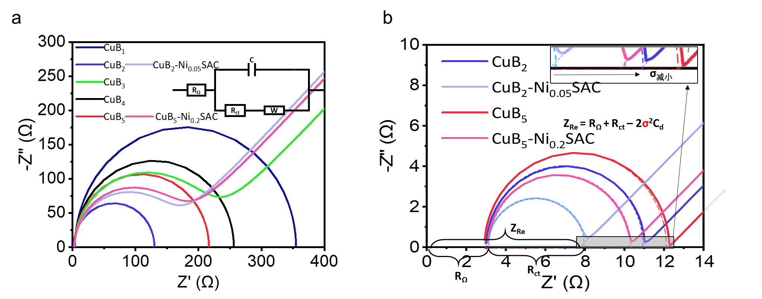
Figure S16. Electrochemical AC impedance Nyquist curves of hybrid catalysts with different B contents of CuB_{x} as well as partially doped Ni-SAC. Additionally, the EIS experiments for CO₂RR were conducted at the open voltage and an amplitude of the sinusoidal voltage of 5 mV (in a frequency range of 1-10⁶ Hz)

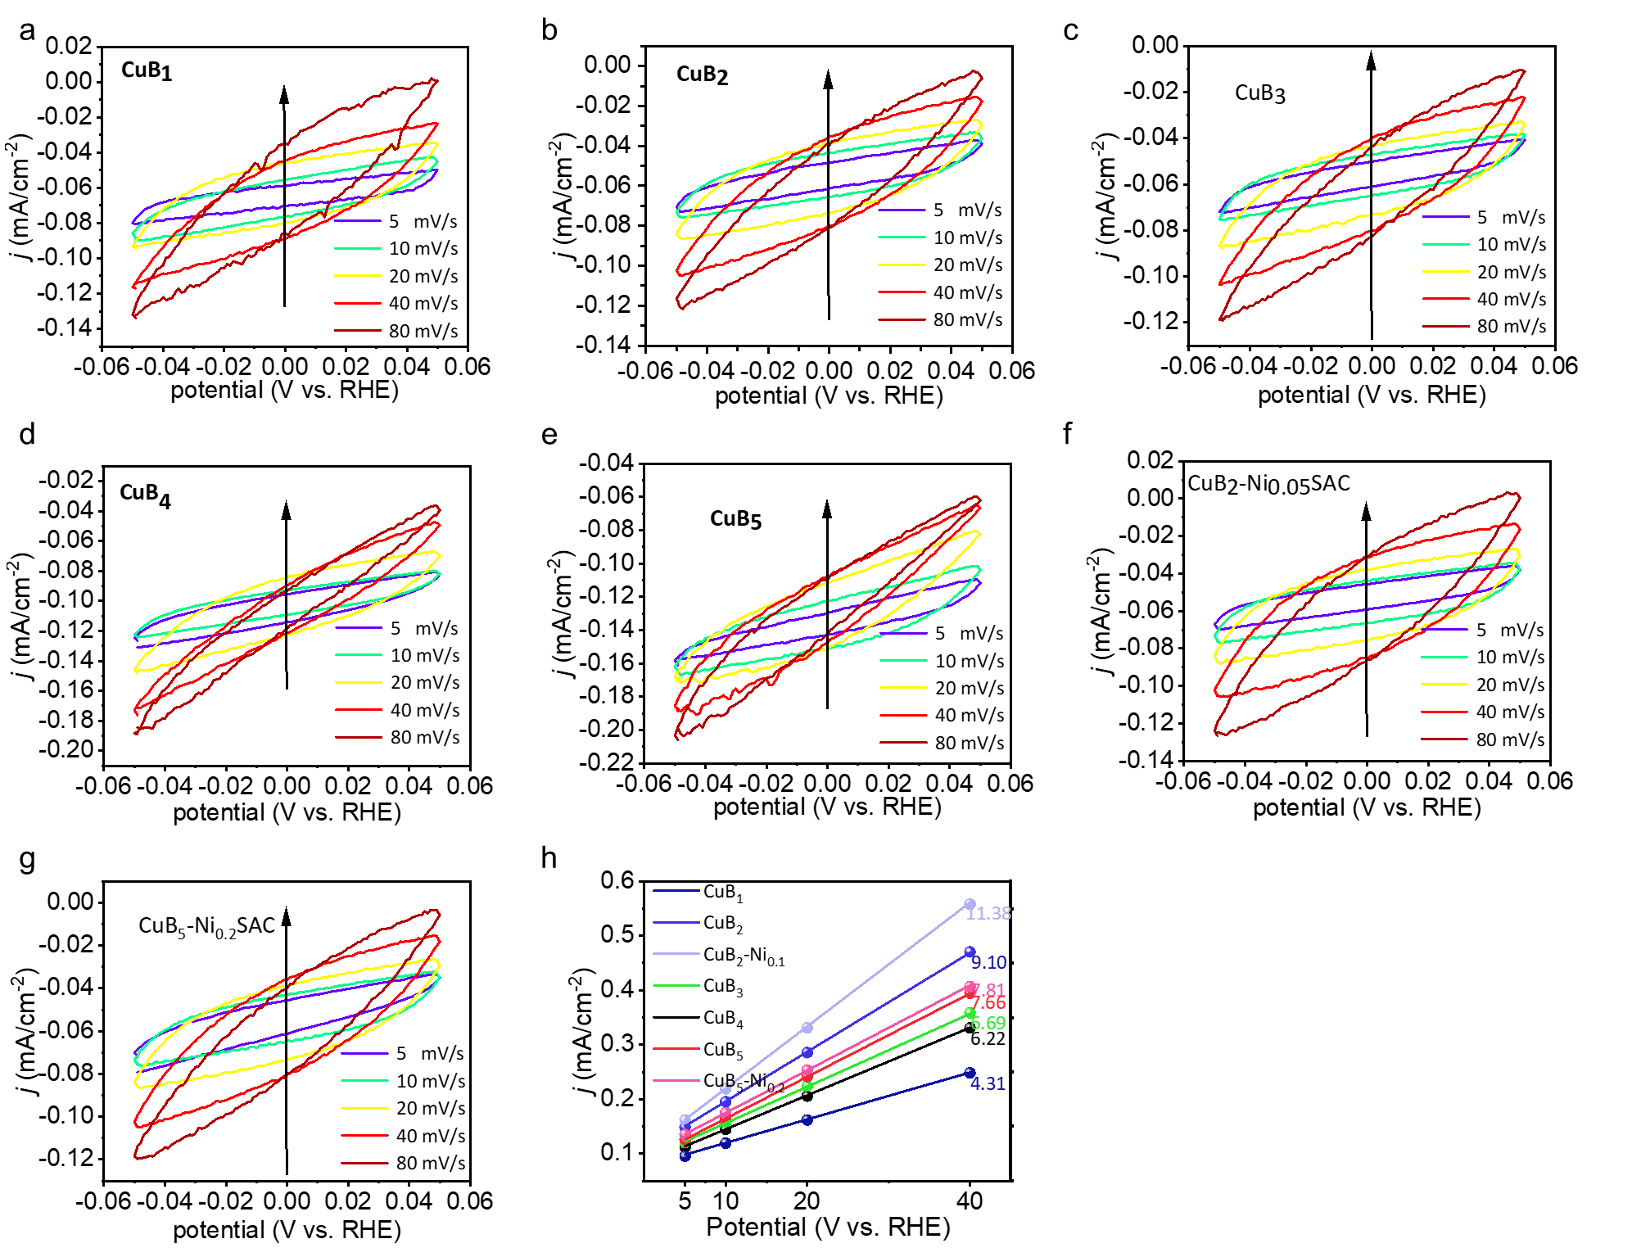
Figure S17. Electrochemically active surface area curves of hybrid catalysts with different B contents of CuB_{x} as well as partially doped Ni-SAC by cyclic voltammetry.
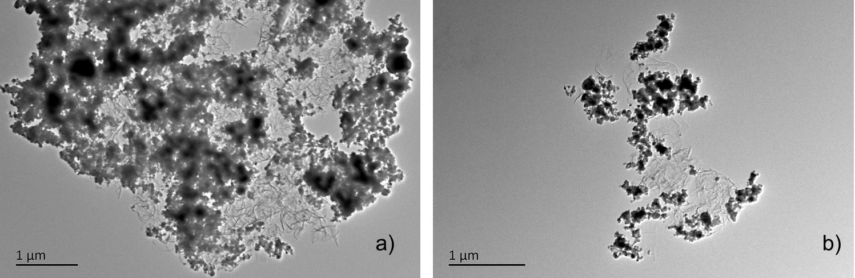Figure S18. TEM images of CuB₂-Ni_{0.05}SAC (a) and CuB₅-Ni_{0.2}SAC (b) after electrolysis.

Figure S19. Solid-state Raman spectra of the Cu and CuB_{2.}

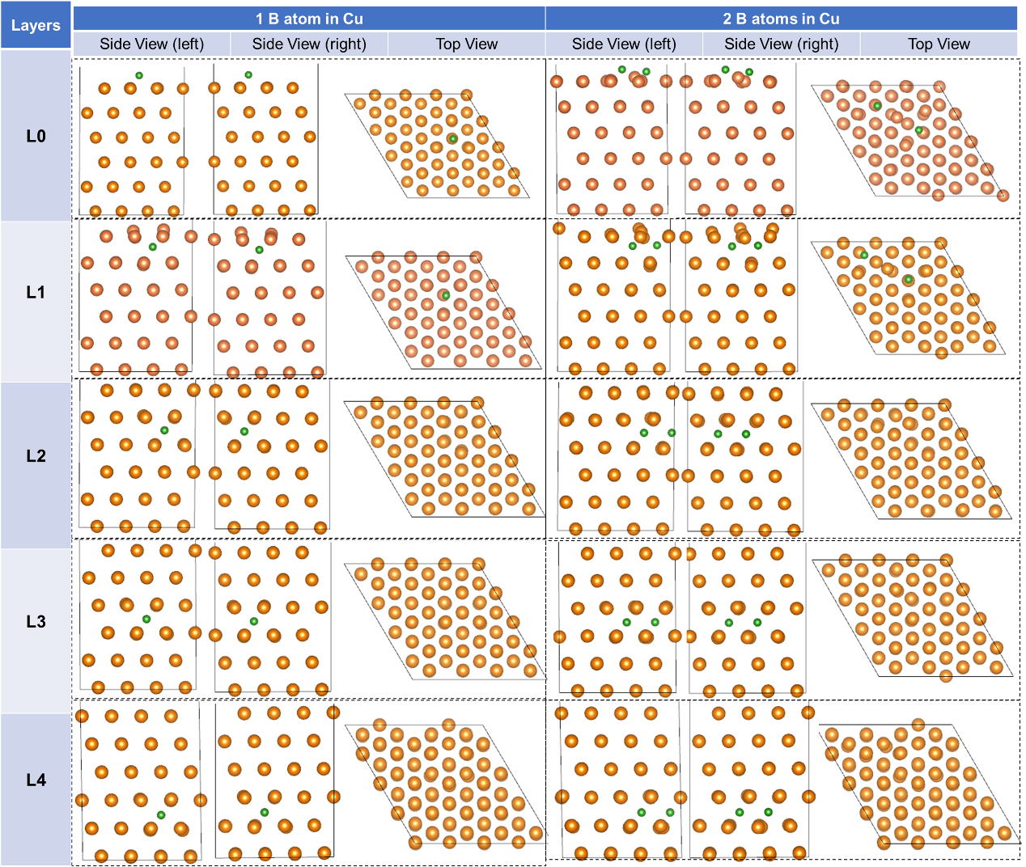
Figure S20. Conformations of 1 B atom and 2 B atoms in different layers of the Cu crystalline phase.

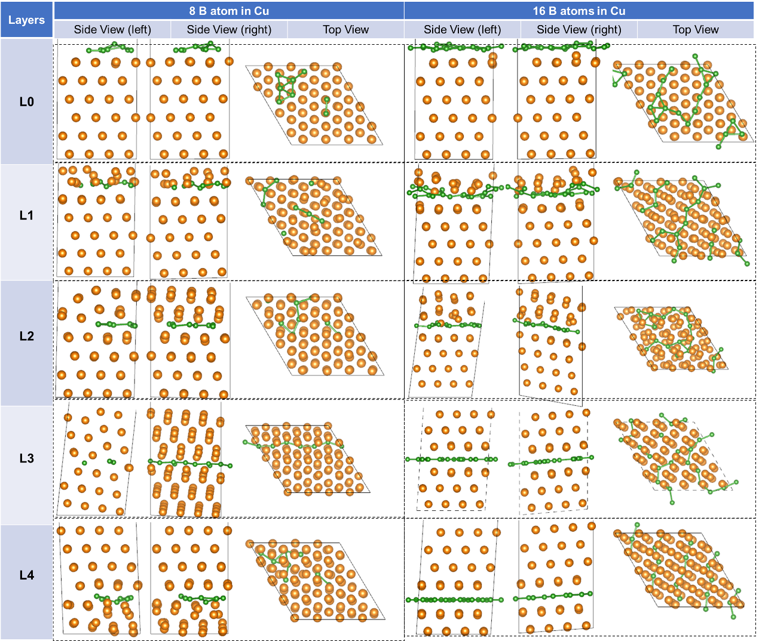
Figure S21. Configurations of 8 B atom and 16 B atoms in different layers of the Cu crystalline phase.

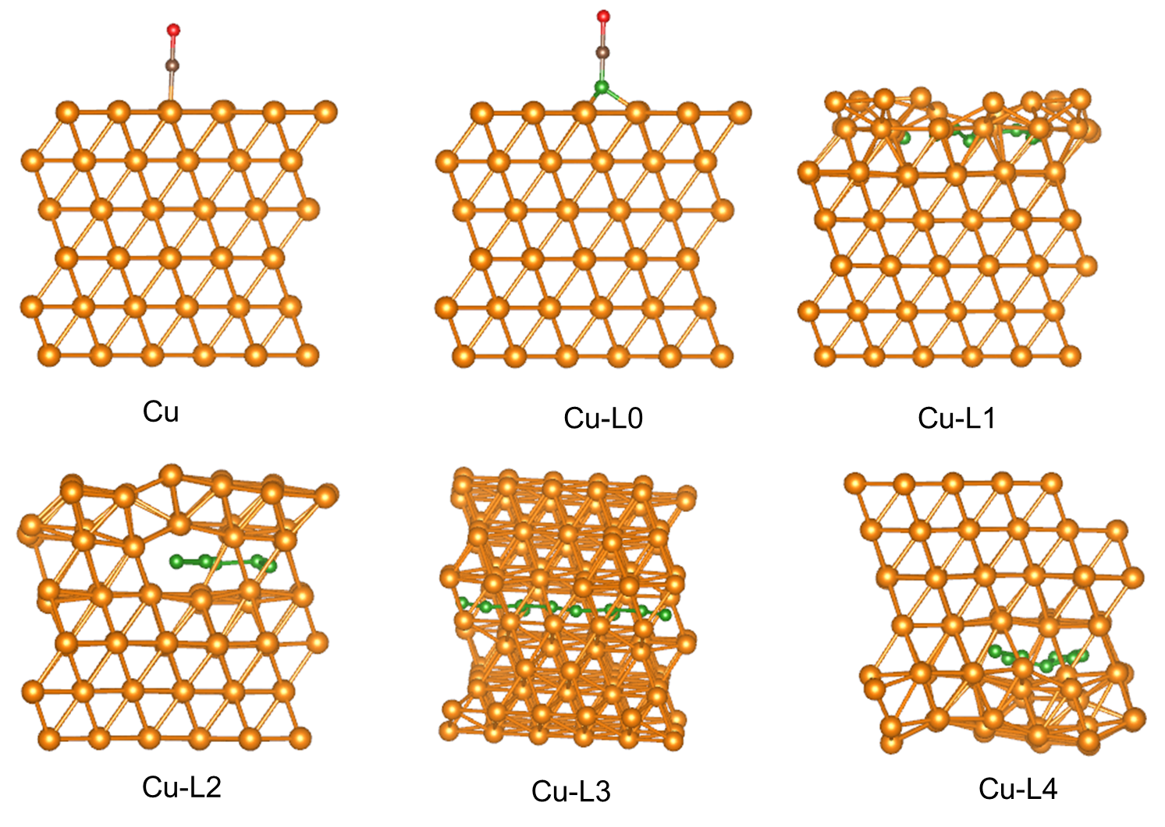
Figure S22. Catalytic configuration for calculating the adsorption energy of *CO.

Table S1 B contents in samples synthesized using different amount of CuCl₂.
Samples | CuB₁ | CuB₂ | CuB₃ | CuB₄ | CuB₅
CuCl₂ | 400 | 300 | 200 | 100 | 50
B/Cu (wt %) | 1.07 | 1.20 | 2.03 | 2.30 | 3.12

Table S2 Curvefit Parametesª for Cu K-edge EXAFS for CuB₂ standards.
Path | d^{b}/Å | N | R (ΔR) / Å | σ²/ Å²
[Cu]Cu-Cu1 | 2.556 | 8.0(±1) | 2.58(0.02) | 0.017
[Cu₂O]Cu-O1 | 1.841 | 4^{c} | 1.90(0.06) | 0.00618
[CuO]Cu-O2 | 1.947 | 4^{c} | 2.00(0.05) | 0.00618
[CuO]Cu-O3 | 2.766 | 2^{c} | 2.83(0.07) | 0.00662
[CuO]Cu-Cu2 | 2.884 | 4^{c} | 2.87(-0.01) | 0.00662
[CuO]Cu-Cu3 | 3.158 | 2^{c} | 3.10(-0.06) | 0.00618
ª S₀² was fixed as 0.92 (From the same experimental group of Cu standard sample). ΔE₀ was refined as a segregate fit parameter, returning a value of (-2 ± 1) eV for Cu₂O, (6 ± 1) eV for CuO. Data ranges: 2 ≤ k ≤ 12 Å⁻¹, 1.0 < R < 3.0 Å. The number of variable parameters is 12, out of a total of 12.43 independent data points. R factor for this fit is 3.0%. ^{b} The distances for Cu-O and Cu-Cu are from the crystal structure of Cu, Cu₂O and CuO. ^{c} These coordination numbers were constrained as N(Cu – O) and N(Cu – Cu) based on the crystal structure. ^{d} The Debye-Waller factors were constrained as σ²(Cu-O1) = σ²(Cu-O2) = σ²(Cu-Cu3) and σ²(Cu-O3) = σ²(Cu-Cu2) for decreasing the correlation (or reducing the number of variables)

Table S3. Curvefit Parametersª for Cu K-edge EXAFS for CuB₅ standards
Path | d^{b}/Å | N | R (ΔR) / Å | σ²/ Å²
[Cu₂O]Cu-O | 1.841 | 4^{c} | 1.93(0.09) | 0.009
[CuO]Cu-O1 | 1.947 | 4^{c} | 2.04(0.09) | 0.006
[CuO]Cu-Cu1 | 2.884 | 3.2(±0.6) | 2.82(-0.06) | 0.005
ª S₀² was fixed as 0.92 (From the same experimental group of Cu standard sample). ΔE₀ was refined as a segregate fit parameter, returning a value of (9 ± 1) eV for Cu₂O, (7 ± 1) eV for CuO. Data ranges: 3 ≤ k ≤ 12 Å⁻¹, 1.0 < R < 3.0 Å. The number of variable parameters is 9, out of a total of 11.25 independent data points. R factor for this fit is 4.7%. ^{b} The distances for Cu-O and Cu-Cu1 are from the crystal structure of Cu₂O and CuO. ^{c} These coordination numbers were constrained as N(Cu – O1) = 4 and N(Cu – O2) = 4 based on the crystal structure.

