Charge compensation improves energy transfer to realize anti-thermal-quenching and improve the CaMoO₄: Sm³⁺ phosphors optical temperature measurement sensitivity base on the FIR model

Hongyue Wu^{a, e1}, Bo Hu^{a1}, Xu Tangª, Beibei Chenª, Dongyi Li^{b}, Jialin Liang^{d}, Binrong Li^{c}, Pengwei Huoª, Jun Zhao^{b}, Zhongfei Maª, Zhi Zhu^{a, b*}

- Institute for Advanced Materials, School of Materials Science and Engineering, College of environmental science and engineering, School of Chemistry and Chemical Engineering, Jiangsu University, Zhenjiang 212000, P.R. China
- Department of Biology, Hong Kong Baptist University, Kowloon Tong, Hong Kong 999077, P.R. China
- National and Local Joint Engineering Laboratory of Municipal Sewage Resource Utilization Technology, School of Environmental Science and Engineering, Suzhou University of Science and Technology, Su Zhou 215009, P.R. China
- College of Resources and Environment, Zhongkai University of Agriculture and Engineering, Guangzhou, 510225, China
- Department of Chemistry, Tonghua Normal University, Tonghua 134002, P.R. China

Corresponding Authors：
Email: zhuzhi@ujs.edu.cn

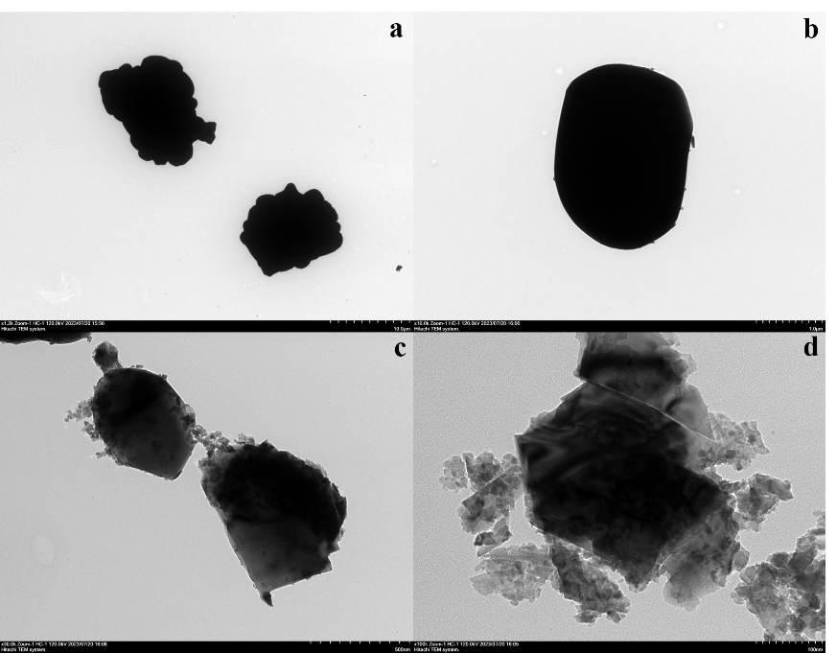
Fig. S1. TEM image of CaMoO₄ (a, b) andCaMoO₄:0.02Sm³⁺ (c, d).

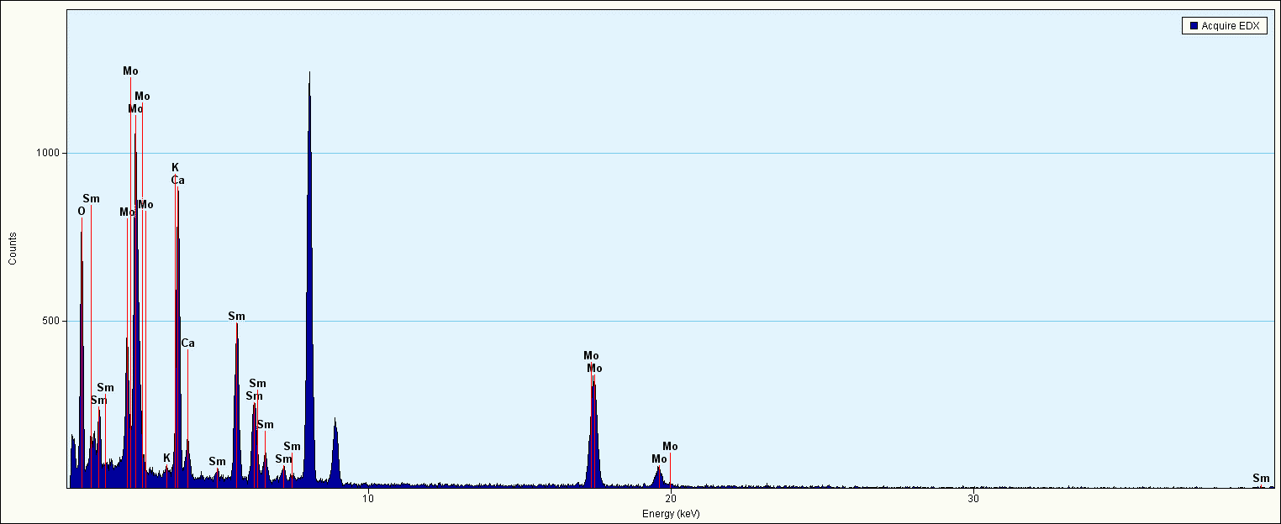
Fig. S2. EDS analysis of CaMoO₄:0.02Sm³⁺, 0.02K⁺.

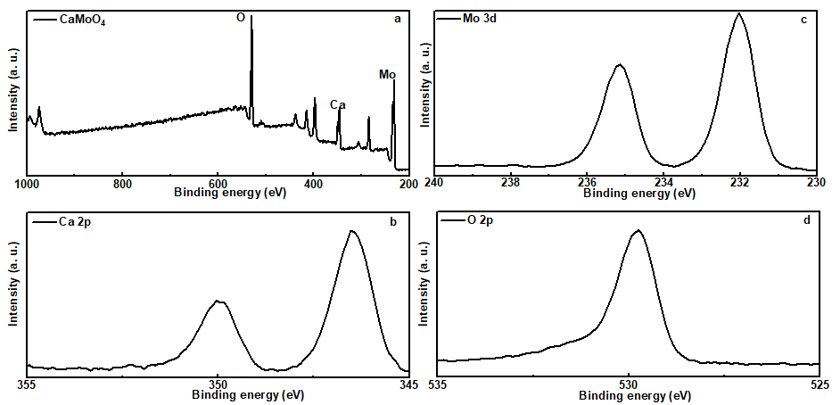
Fig. S3. XPS of CaMoO₄.

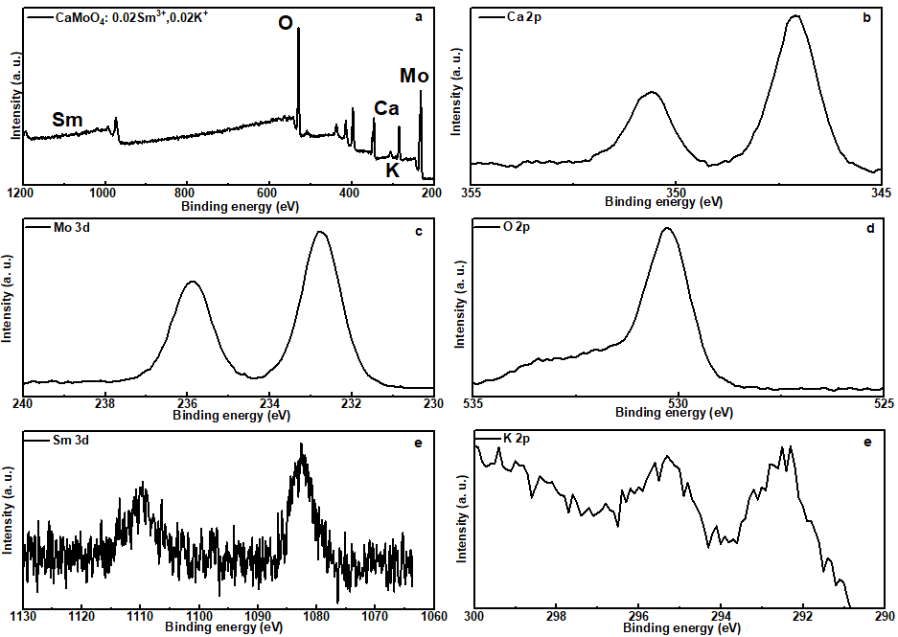
Fig. S4. XPS of CaMoO₄: 0.02Sm³⁺, 0.02K⁺.

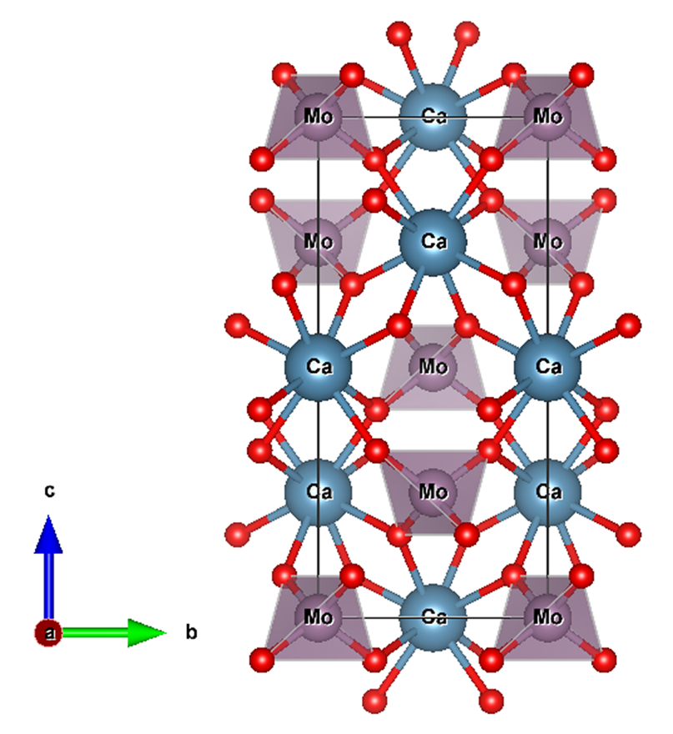
Fig. S5. The schematic diagram of CaMoO₄ of scheelite structure.

Fig. S6. The PLE spectra of the CaMoO₄: xSm³⁺ (x = 0.005, 0.01, 0.015, 0.02, 0.025) phosphors (a). The PLE spectra of the CaMoO₄: 0.02Sm³⁺, CaMoO₄: 0.02Sm³⁺, 0.02Li⁺, CaMoO₄: 0.02Sm³⁺, 0.02Na⁺ and CaMoO₄: 0.02Sm³⁺, 0.02K⁺ phosphors (b). The PLE spectra of the CaMoO₄: ySm³⁺, yK⁺ (y = 0.02, 0.04, 0.06, 0.08, 0.10) phosphors (c).

The emission peaks of Sm³⁺are separated by subtracting the emission spectra of CaMoO₄ host from CaMoO₄: 0.001Sm³⁺, 0.001K⁺, which had been normalized at 506 nm. The temperature dependent emission spectra of Sm³⁺ after separation is depicted in Fig.S7.
Fig. S7. Temperature dependent emission spectra of Sm³⁺ ions after separation.

