Supplementary Material

Module 1: Aorta thickness measurement
Aorta sample was obtained from one AAA patient through open surgery, as shown in Figure S1, with surrounding connective tissue removed and the sample preserved in sterile paraffin oil. Within 48 hours, an in vitro stretching experiment was conducted. The aorta sample were washed with physiological saline and cut using a rectangular cutter. The length, width, and thickness of the samples were measured three times and averaged, as shown in Table S1. In this experiment, aorta thickness of 2.27 mm and a width of 3.59 cm were measured. This test has obtained ethical approval from the Ethics Committee of Zhongshan Hospital, Fudan University.
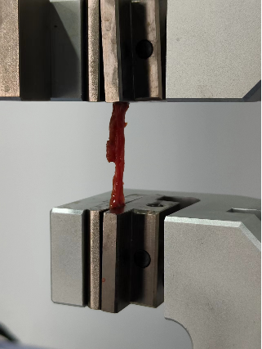
Fig. S1. One aorta Sample.
Table S1: Thickness and width of Aorta sample.
 | Thickness (mm) | Width (cm)
1 | 2.36 | 3.88
2 | 2.20 | 3.24
3 | 2.26 | 3.64
Mean value | 2.27 | 3.59

Module 2：Strain energy function
Within each unit volume on the two-layered blood vessel, elastic proteins, four clusters of collagen fibers, and one cluster of smooth muscle fibers are spatially correlated, as illustrated in Figure S2.
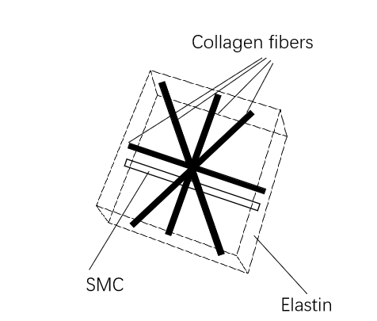
Fig. S2. The spatial correspondence of the six components within the unit volume of each layer of the blood vessel.
The total strain energy function within the unit volume of each layer of the blood vessel wall is given by equation s1^{[1]}:
$$W_{M}=ρ_{t}\left(ϕ_{M}^{e}Ψ^{e}+ϕ_{M}^{e}\left(Ψ_{pas}^{m}+Ψ_{act}^{m}\right)+\sum_{i=1}^{4}{ϕ_{M}^{c_{i}}}Ψ^{c_{i}}\right) \\ W_{M}=ρ_{t}\left(ϕ_{A}^{e}Ψ^{e}+ϕ_{A}^{e}\left(Ψ_{pas}^{m}+Ψ_{act}^{m}\right)+\sum_{i=1}^{4}{ϕ_{A}^{c_{i}}}Ψ^{c_{i}}\right)$$ | (s1)
$ρ_{t}$ represent the total mass density，$ϕ_{C}^{i}$, ($C∈(A, M)$, $i∈(e, c_{j}, m)$) means the mass fractions of elastin, collagen fibers, and smooth muscle in the middle layer and adventitia layer, respectively.，$Ψ^{i}$, $i∈(e, c_{j}, m)$ represents the strain energy function corresponding to the unit mass of different components.
- For elastin, the strain energy function can be represented as：
$$Ψ^{e}=\frac{μ^{e}}{2}\left({\overline{I}}_{1}^{e}-3\right)+κ{\left(J_{el}-1\right)}^{2}$$ | (s2)
Among them, ${\overline{I}}_{1}^{e}$represents the first invariant of the strain tensor without including volume changes, $κ$ represents the bulk modulus, and$μ^{e}$represents the material parameter. According to the continuum mechanics theory, we have the following relationship:
${\overline{I}}_{1}^{e}=tr({\overline{C}}_{el}^{e})$; ${\overline{C}}_{el}^{e}={\left({\overline{F}}_{el}^{e}\right)}^{T}{\overline{F}}_{el}^{e}$; ${\overline{F}}_{el}^{e}=J_{el}^{-\frac{1}{3}}F_{el}^{e}$ | (s3)
- For smooth muscle, both passive force and active contraction will generate mechanical responses. The strain energy function corresponding to passive force can be expressed as:
$$Ψ_{pas}^{m}\left(I_{4}^{m}\right)=\frac{k_{1}^{m}}{2k_{2}^{m}}[e^{k_{2}^{m}{\left(I_{4}^{m}-1\right)}^{2}}-1]$$ | (s4)
Where, $k_{1}^{m}$ is a material parameter related to stress,，$k_{2}^{m}$ is a dimensionless set of material parameters, and the fourth invariant $I_{4}^{m}$ can be expressed as^{[2]}：
$$I_{4}^{m}=C_{el}^{m}:\left(a^{m}⊗a^{m}\right)={\left(λ_{el}^{m}\right)}^{2};a^{m}=\frac{F_{gr}^{m}a_{0}^{m}}{\left\|F_{gr}^{m}a_{0}^{m}\right\|}$$ | (s5)
The strain energy function generated by active contraction of smooth muscle can be expressed as follows:：
$$Ψ_{act}^{m}\left(λ_{m}\right)=\frac{σ_{actmax}}{ρ_{0}}(λ_{act}+\frac{1}{3}\frac{{\left(λ_{m}-λ_{act}\right)}^{3}}{{\left(λ_{m}-λ_{0}\right)}^{2}})$$ | (s6)
Where $λ_{act}$ is the active stretch in the fiber direction, $λ_{m}$ and $λ_{0}$ are the maximum stretch of smooth muscle tissue and the stretch at zero contraction rate, respectively.
- The strain energy function for collagen fibers can be expressed as：
$$Ψ^{c_{j}}\left(I_{4}^{c_{j}}\right)=\frac{k_{1}^{c_{j}}}{2k_{2}^{c_{j}}}[e^{k_{2}^{c_{j}}{\left(I_{4}^{c_{j}}-1\right)}^{2}}-1]$$ | (s7)
and the fourth invariant $I_{4}^{c_{j}}$ for each cluster collagen fiber can be expressed as：
$$I_{4}^{m}=C_{el}^{c_{j}}:\left(a^{c_{j}}⊗a^{c_{j}}\right)={\left(λ_{el}^{c_{j}}\right)}^{2};a^{c_{j}}=\frac{F_{gr}^{c_{j}}a_{0}^{c_{j}}}{\left\|F_{gr}^{c_{j}}a_{0}^{c_{j}}\right\|}$$ | (s8)

Module 3: Mass turnover
In normal and diseased states, the tissue components within the arterial wall have different turnover rates, and the process of mass turnover is jointly controlled by biomechanical factors and biochemical environment.
- In this study, the mass turnover of the collagen fiber family is primarily mediated by the stress on smooth muscle cells in the tunica media of blood vessels and collagen fibers in the adventitia. The time derivative of the density of collagen fibers in different layers can be written as: ^{[1]}：
$${\dot{ρ}}_{med}^{c_{j}}\left(t\right)=ρ_{t}^{c_{j}}k_{σ}^{c_{j}}\frac{σ^{m}-σ_{h}^{m}}{σ_{h}^{m}}+{\dot{D}}_{g}^{c_{j}}$$  $${\dot{ρ}}_{adv}^{c_{j}}\left(t\right)=ρ_{t}^{c_{j}}k_{σ}^{c_{j}}\frac{σ^{c_{j}}-σ_{h}^{c_{j}}}{σ_{h}^{c_{j}}}+{\dot{D}}_{g}^{c_{j}}$$ | (s9)
where，$ρ_{t}^{c_{j}}$ represented he density of collagen fiber clusters in the current configuration, $k_{σ}^{c_{j}}$ represents The gain factor that controls the deposition of collagen fibers mediated by stress, $σ_{h}^{m}$ and $σ_{h}^{c_{j}}$ represents the stress in smooth muscle tissue and collagen fibers at homeostasis state, while $σ^{m}$ and $σ^{c_{j}}$ represent the stress in smooth muscle tissue and collagen fibers in the current configuration. The change in smooth muscle density over time follows a similar form to equation (s9), therefore it is not repeated here.
- For elastin, their turnover time is extremely long. During the growth of an arterial aneurysm, elastic fibers will only degrade and not regenerate, leading to a deposition effect of other substances to compensate for the loss of mass.

Module 4: Growth and remodeling
Assuming that the $i-th$ component in the mixture is deposited into the existing matrix at a rate of ${\dot{ρ}}_{0+}^{i}$ under the pre-stress $σ_{pre}^{i}$, while the existing material degrades at a rate of ${\dot{ρ}}_{0-}^{i}$. It is assumed that the current stress σ of the degraded existing material is different from the stress of the newly deposited mass$σ_{pre}^{i}$. This leads to changes in the stress-free configuration of the$i-th$ component. In the absence of any local volume changes, the changes in the stress-free state are referred to as remodeling. The volume change of the infinitesimal volume element in the stress-free configuration is called growth.
For the$i-th$ component, the total rate of change in mass density is determined by the combined effects of degradation and deposition, and can be described as:
$${\dot{ρ}}^{i}= {\dot{ρ}}_{0+}^{i}+{\dot{ρ}}_{0-}^{i}$$ | (s10)
During the growth and remodeling process of an arterial aneurysm, the total deformation gradient can be represented as:
$$F_{tot}^{i}=FG_{h}^{i}$$ | (s11)
Where $F_{tot}^{i}$ represents the total deformation gradient for each component, $G_{h}^{i}$ represents the deposition stretch tensor at the initial time for each component, and $F$ represents the deformation gradient relative to the reference configuration at the homeostasis state.
Given the assumption that the blood vessel transitions from a state without any traction to an in vivo stress state (with prestress) that is incompressible, the initial deposition stretch tensor for the elastic protein can be defined as:
$$G_{h}^{e}=diag[\frac{1}{λ_{θ}^{e}λ_{z}^{e}},λ_{θ}^{e},λ_{z}^{e}]$$ | (s12)
The initial deposition stretch tensors for collagen fibers and SMCs are:
$$G_{h}^{i}=λ^{i}a_{0}^{i}⊗a_{0}^{i}+\frac{1}{\sqrt{λ^{i}}}(I-a_{0}^{i}⊗a_{0}^{i})$$ | (s13)
To facilitate the description of the growth and remodeling processes of materials in soft tissues, the total deformation gradient in equation (s11) can be written as:
$$F_{tot}^{i}=F_{el}^{i}F_{gr}^{i}$$ | (s14)
$F_{el}^{i}$ and $F_{gr}^{i}$ represent the elastic and inelastic deformation gradients of each component respectively, where $k∈( c_{j}, m)$. $λ_{θ}^{e}$ and $λ_{z}^{e}$are the initial deposition stretch tensors of the elastic protein in the circumferential and axial directions, and $λ^{k}$ is the initial deposition stretch tensor of the $k$-th component along the unit direction $a_{0}^{k}$.
It should be noted that each component has a different zero-stress state. For elastic proteins, stress is generated when subjected to forces. For collagen fibers and SMCs, the fibers only start bearing stress and deviate from their wavy initial configuration when stretched to a certain extent. For the i-th component, the gradient of non-elastic deformation can be decomposed as follows:
$$F_{gr}^{i}=F_{r}^{i}F_{g}^{i}$$ | (s15)
$F_{r}^{i}$represents the change in deposition stretch caused by the deposition of new components, while $F_{g}^{i}$ is related to the mass change within a unit volume.
The rate of change of the average Cauchy stress solely due to mass turnover can be represented by ${\dot{F}}_{e}^{i}$, which does not consider volume changes, i.e^{[3]}.
$${\dot{σ}}_{r}^{i}={\left[\frac{∂σ^{i}}{∂F_{e}^{i}}:{\dot{F}}_{e}^{i}\right]}_{F_{tot}^{i}, F_{g}=const}={\left[\frac{∂σ^{i}}{∂C_{e}^{i}}:{\dot{C}}_{e}^{i}\right]}_{F_{tot}^{i}, F_{g}=const}$$ | (s16)
From $C_{e}^{i}={\left(F_{e}^{i}\right)}^{T}F_{e}^{i}$, we can obtain：
$${\dot{C}}_{e}^{i}=({{\dot{F}}_{e}^{i})}^{T}F_{e}^{i}+{\left(F_{e}^{i}\right)}^{T}{\dot{F}}_{e}^{i}$$ | (s17)
Assuming that the total deformation gradient and growth-related deformation gradient are constant during the mass turnover process, we have:
$${\dot{F}}_{e}^{i}F_{r}^{i}+F_{e}^{i}{\dot{F}}_{r}^{i}=0$$ | (s18)
Which can obtain：
$${\dot{F}}_{e}^{i}=-F_{e}^{i}{\dot{F}}_{r}^{i}{\left(F_{r}^{i}\right)}^{-1}$$ | (s19)
The velocity gradient of non-elastic remodeling deformation can be expressed as^{[4]}:
$$L_{r}^{i}={\dot{F}}_{r}^{i}{\left(F_{r}^{i}\right)}^{-1}$$ | (s20)
In this case, we have：
$${\dot{σ}}_{r}^{i}={\left[\frac{∂σ^{i}}{∂C_{e}^{i}}:[C_{e}^{i}L_{r}^{i}+{\left(L_{r}^{i}\right)}^{T}C_{e}^{i}]\right]}_{F_{tot}^{i}, F_{g}=const}$$ | (s21)
Combining the literature by Cyron et al.^{[3]}, we can obtain:
$${\left\lfloor \frac{{\dot{ρ}}_{t}^{i}}{ρ_{t}^{i}}+\frac{1}{T^{i}}\right\rfloor \left[σ^{i}-σ_{pre}^{i}\right]=\left[\frac{∂σ^{i}}{∂C_{e}^{i}}:[C_{e}^{i}L_{r}^{i}+{\left(L_{r}^{i}\right)}^{T}C_{e}^{i}]\right]}_{F_{tot}^{i}, F_{g}=const}$$ | (s22)
From $σ_{i}=\frac{1}{J}FS^{i}F^{T}$，we can obtain：
$$\left\lfloor \frac{{\dot{ρ}}_{t}^{i}}{ρ_{t}^{i}}+\frac{1}{T^{i}}\right\rfloor \left[S^{i}-S_{pre}^{i}\right]=2\frac{∂S^{i}}{∂C_{e}^{i}}:C_{e}^{i}L_{r}^{i}$$ | (s23)
In the equation (s23), $S^{i}$ represents the second Piola-Kirchhoff stress tensor of the $i th$ material component, and $T^{i}$represents the average mass turnover time. Assuming that elastin to be produced in the human body after adulthood and they have a half-life of several decades, their velocity gradient for plastic deformation is $0$, the rate of plastic deformation gradient is $0$, and the plastic deformation gradient is equal to the identity tensor $I$.
If the remodeling is taking place along the fiber direction $a_{0}^{k}$, the rate of change of stretch of the $i-th$ component at time $t$ can be expressed as:
$${\dot{λ}}_{r}^{i}=\left(\frac{{\dot{ρ}}_{t}^{i}}{ρ_{t}^{i}}+\frac{1}{T^{i}}\right)\frac{λ^{i}}{{λ_{e}^{i}}^{2}}{\left(\frac{∂σ^{i}}{∂λ_{e}^{i}}\right)}^{-1}×(σ^{i}-σ_{pre}^{i})$$ | (s24)
In equation (s24), ${\dot{λ}}_{r}^{i}$represents the velocity during remodeling, and the deformation gradient tensor corresponding to tissue remodeling is given by:：
$$F_{r}^{i}=λ_{r}^{i}a_{0}^{i}⊗a_{0}^{i}+\frac{1}{\sqrt{λ_{r}^{i}}}(I-a_{0}^{i}⊗a_{0}^{i})$$ | (s25)
Braeu et al. argue that the non-elastic deformation gradient of all components is the same^{[4]}，the overall rate of non-elastic growth deformation gradient is equal to the sum of the growth deformation gradient rates of each component, that is:
$${\dot{F}}_{g}=\sum_{i=1}^{n}{\frac{{\dot{ρ}}_{t}^{i}}{ρ_{t}^{tot}{F_{g}^{i}}^{-T}:a_{g}^{i}⊗a_{g}^{i}}}a_{g}^{i}⊗a_{g}^{i}$$ | (s26)
The change in volume of a mixture can be measured by the change in mass density, that is:
$$\det\left(F_{g}\right)=\frac{ρ_{r}}{ρ_{0}}$$ | (s27)
Assuming growth is anisotropic and along the thickness direction, we have:
$$F_{g}=I+\frac{ρ_{r}}{ρ_{0}}a_{0}^{⊥}⊗a_{0}^{⊥}-a_{0}^{⊥}⊗a_{0}^{⊥}$$ | (s28)
Based on the above, the deformation gradient for growth and remodeling is:
$$F_{gr}^{i}=λ_{r}^{i}a_{0}^{i}⊗a_{0}^{i}+\frac{1}{\sqrt{λ_{r}^{i}}}(I-a_{0}^{i}⊗a_{0}^{i}+\frac{ρ_{r}}{ρ_{0}}a_{0}^{⊥}⊗a_{0}^{⊥}-a_{0}^{⊥}⊗a_{0}^{⊥})$$ | (s29)

Module 5: Stress matrix and stiffness matrix
The growth and remodeling processes of an arterial aneurysm can be implemented in the finite element analysis software Abaqus. The Newton-Raphson iterative method is used to solve the stress matrix and stiffness matrix at each time step, and the material parameters in different regions are updated in real-time.
The second Piola-Kirchhoff stress can be obtained by taking the partial derivative of the strain energy function with respect to the right Cauchy-Green strain tensor, i.e.^{[2]}:
$$\begin{aligned}&φ^{e}S^{e}=ρ_{0}^{e}(t)\left[{\left(J_{el}^{e}\right)}^{-2/3}μ^{e}\left({\left(C_{gr}^{e}\right)}^{-1}-\frac{1}{3}tr⁡\left(C_{el}^{e}\right)C^{-1}\right)+κJ_{el}^{e}\left(J_{el}^{e}-1\right)C^{-1}\right] \\ &φ^{c_{j}}S^{c_{j}}=ρ_{0}^{c_{j}}(t)\frac{2\left[k_{1}^{c_{j}}\left(I_{4}^{c_{j}}-1\right)exp⁡\left(k_{2}^{c_{j}}{\left(I_{4}^{c_{j}}-1\right)}^{2}\right)\right]}{{∥F_{gr}^{c_{j}}a_{0}^{c_{j}}∥}^{2}}a_{0}^{c_{j}}⊗a_{0}^{c_{j}} \\ &φ^{m}S^{m}=ρ_{0}^{m}(t)\frac{2\left[k_{1}^{m}\left(I_{4}^{m}-1\right)exp⁡\left(k_{2}^{m}{\left(I_{4}^{m}-1\right)}^{2}\right]\right)}{{∥F_{gr}^{m}a_{0}^{m}∥}^{2}}a_{0}^{m}⊗a_{0}^{m} \\ &+\frac{ϱ_{0}^{m}(t)}{ϱ_{0}(0)}\frac{σ_{actmax}}{\left[C:\left(a_{0}^{m}⊗a_{0}^{m}\right)\right]}\left(1-\frac{{\left(λ_{max}-λ_{act}\right)}^{2}}{{\left(λ_{max}-λ_{0}\right)}^{2}}\right)a_{0}^{m}⊗a_{0}^{m}\end{aligned}$$ | (s30)
According to the equation$σ_{i}=\frac{1}{J}FS^{i}F^{T}$, the Cauchy stress can be expressed as^{[2]}:
$$\begin{aligned}φ^{e}σ^{e}&=ρ^{e}(t){\left(J_{el}^{e}\right)}^{-2/3}μ^{e}\left(B_{el}^{e}-\frac{1}{3}tr⁡\left(C_{el}^{e}\right)I\right)+ρ_{0}^{e}(t){\left(J_{gr}^{e}\right)}^{-1}κ\left(J_{el}^{e}-1\right)I \\ φ^{c_{j}}σ^{c_{j}}&=2ρ^{c_{j}}(t)\left[k_{1}^{c_{j}}\left(I_{4}^{c_{j}}-1\right)exp⁡\left(k_{2}^{c_{j}}{\left(I_{4}^{c_{j}}-1\right)}^{2}\right)\right]\frac{\left({Fa}_{0}^{c_{j}}\right)⊗\left({Fa}_{0}^{c_{j}}\right)}{{∥F_{gr}^{c_{j}}a_{0}^{c_{j}}∥}^{2}} \\ φ^{m}σ^{m}&=2ρ^{m}(t)\left[k_{1}^{m}\left(I_{4}^{m}-1\right)exp⁡\left(k_{2}^{m}{\left(I_{4}^{m}-1\right)}^{2}\right]\right)\frac{\left({Fa}_{0}^{m}\right)⊗\left({Fa}_{0}^{m}\right)}{{∥F_{gr}^{m}a_{0}^{m}∥}^{2}} \\ &+\frac{ρ^{m}(t)}{ρ_{0}(0)}σ_{actmax}\left(1-\frac{{\left(λ_{max}-λ^{m}λ_{0}^{m}\right)}^{2}}{{\left(λ_{max}-λ_{0}\right)}^{2}}\right)\frac{\left({Fa}_{0}^{m}\right)⊗\left({Fa}_{0}^{m}\right)}{{∥{Fa}_{0}^{m}∥}^{2}}\end{aligned}$$ | (s31)
In equation (31), $B_{el}^{e}$ is the left Cauchy-Green strain tensor which does not include volume changes.
The stiffness matrix is the first-order partial derivative of the second Piola-Kirchhoff stress with respect to the right Cauchy-Green strain tensor, i.e.:
$$\begin{aligned}&C_{vol}^{e}=κ^{e}J_{el}^{e}\left(\left(2J_{el}^{e}-1\right)C^{-1}⊗C^{-1}-2\left(J_{el}^{e}-1\right)C^{-1}⊙C^{-1}\right) \\ &C_{iso}^{e}=\frac{2}{3}μ^{e}J_{el}^{e-2/3}\left(tr⁡\left(C_{el}^{e}\right)C^{-1}⊙C^{-1}+\frac{1}{3}tr⁡\left(C_{el}^{e}\right)C^{-1}⊗C^{-1}\right. \\ &\left.-C_{gr}^{e-1}⊗C^{-1}-C^{-1}⊗C_{gr}^{e-1}\right) \\ &C_{pas}^{m}=4k_{1}^{m}\left(1+2k_{2}^{m}{\left(λ_{e}^{m2}-1\right)}^{2}\right)exp⁡\left(k_{2}^{m}{\left(λ_{e}^{m2}-1\right)}^{2}\right)\frac{a_{0}^{m}⊗a_{0}^{m}⊗a_{0}^{m}⊗a_{0}^{m}}{{∥F_{gr}^{m}a_{0}^{m}∥}^{4}} \\ &C_{act}^{m}=\frac{-2σ_{actmax}}{ρ_{R}(0)λ^{2}}\left(1-\frac{{\left(λ_{m}-λ_{act}\right)}^{2}}{{\left(λ_{m}-λ_{0}\right)}^{2}}\right)a_{0}^{m}⊗a_{0}^{m}⊗a_{0}^{m}⊗a_{0}^{m} \\ &C^{c_{i}}=4k_{1}^{c_{i}}\left(1+2k_{2}^{c_{i}}{\left(λ_{e}^{c_{i2}}-1\right)}^{2}\right)exp⁡\left(k_{2}^{c_{i}}{\left(λ_{e}^{c_{i}2}-1\right)}^{2}\right)\frac{a_{0}^{c_{i}}⊗a_{0}^{c_{i}}⊗a_{0}^{c_{i}}⊗a_{0}^{c_{i}}}{{∥F_{gr}^{c_{i}}a_{0}^{c_{i}}∥}^{4}}\end{aligned}$$ | (s32)
It is possible to define a strain energy function that varies both in time and space within the UMAT by using equations (s31) and (s32).

Module 6: Morphological and material evolution processes of an ideal thick-walled cylindrical tube.
The growth process of the ideal thick-wall cylinder over a period of 15 years was numerically simulated using finite element software Abaqus. The analysis evaluated the influence of various growth parameter variations on the final morphological development and material evolution, laying the theoretical foundation for further quantification of patient-specific abdominal aortic aneurysm (AAA) growth processes.
The axial length of the cylinder = 180mm, with a thickness of 1.41mm. The internal diameter is set to 20mm^{[4]}. In the thickness direction, the blood vessel is modeled as consisting of the middle layer and outer layer that primarily bear the stress. The mesh information is shown in Figure S3.
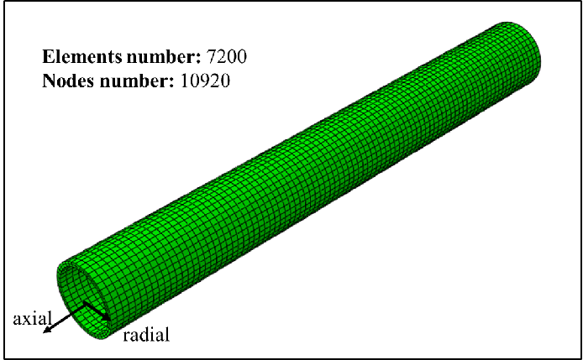
Fig. S3. The geometric shape and mesh partition results of an ideal cylinder.

The material parameter settings can be referenced from the work of Braeu et al^{[4]}. Among them, the amplification factor $K_{σ}^{c_{j}}$ takes values of [0.05, 0.07, 0.09, 0.11, 0.13, 0.15]/(101days). By simulating, the morphology of the aneurysm after 15 years is obtained as shown in Figure S4. It can be observed that as the elastic protein degrades in the middle of the artery, the vessel undergoes dilation and the volume of the aneurysm tends to increase. Furthermore, this expansion trend gradually spreads towards both ends of the artery. Additionally, as $K_{σ}^{c_{j}}$ increases, the expansion trend weakens gradually. These findings are consistent with the results of the study conducted by Cyron et al^{[3]}.
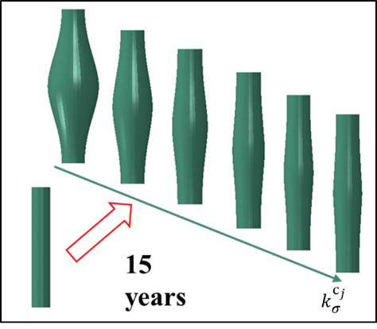
Fig. S4. The morphology of the aneurysm after 15 years for different amplification factors is as follows:
Next, the variation trend of the maximum diameter of the aneurysm over time is extracted for each amplification factor $K_{σ}^{c_{j}}$, and compared with the results of Braeu et al.'s study^{[4]}, as shown in Figure S5.
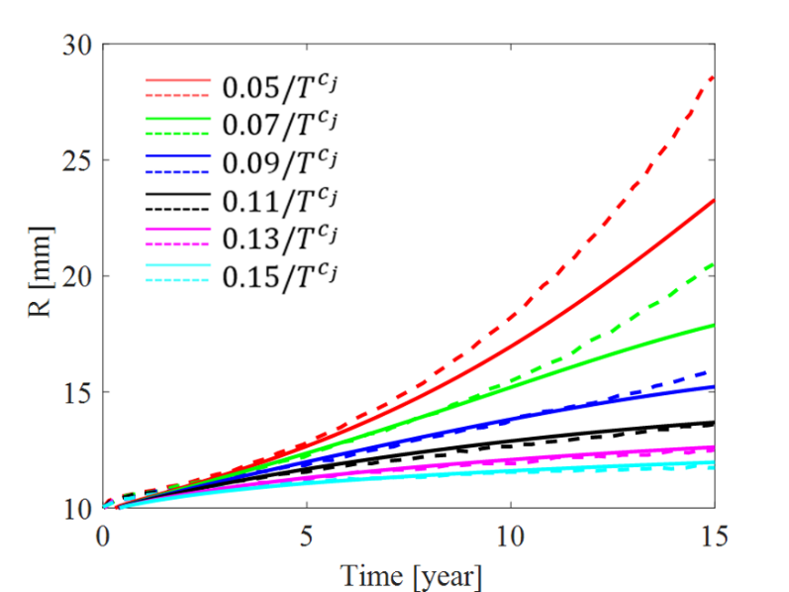
Fig. S5. The variation of the maximum diameter of the aneurysm over time under the influence of different amplification factors. The solid line represents the simulated results obtained from this study, while the dashed line represents the results from the study by Braeu et al^{[4]}.
It can be observed that when the amplification factor is small, the aneurysm expands rapidly, exhibits an unstable morphology, and the diameter continues to increase. On the contrary, when the amplification factor is large, the aneurysm only experiences slight expansion, and after a certain period of time, the morphology of the aneurysm stabilizes and no longer increases in size.
In addition, the change in the amplification factor significantly affects the deposition of collagen fibers, as shown in Figure S6.
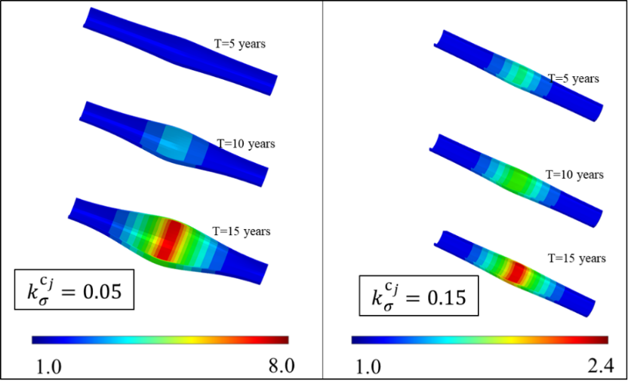
Fig. S6. The relative density of collagen fibers compared to the initial time point under the influence of different amplification factors
Collagen fibers undergo significant deposition effects in the region where elastin degradation is the most pronounced in the artery. When $K_{σ}^{c_{j}}$ = 0.05/(101days), the deposition effect is significant, and after 15 years of growth and remodeling (G&R) process, the maximum relative density of collagen fibers is 8 times that of the initial time point. On the contrary, when $K_{σ}^{c_{j}}$ = 0.15/(101days), the deposition effect is weaker, and the maximum relative density of collagen fibers after 15 years is only 2.4 times that of the initial time point. The density of collagen fiber deposition shows an inverse correlation with the magnitude of the amplification factor, consistent with the results of studies by Mousavi and Braeu^{[1,4]}. The magnitude of $K_{σ}^{c_{j}}$ has a significant impact on the morphology and material changes of the aneurysm, making it a primary factor in controlling the long-term G&R process of the aneurysm.
Next, we set $t_{dam}$ = 20 days, 40 days, and 80 days, respectively, and analyze the impact of the time diffusion factor of elastin damage on the G&R process. The results are shown in Figure S7.
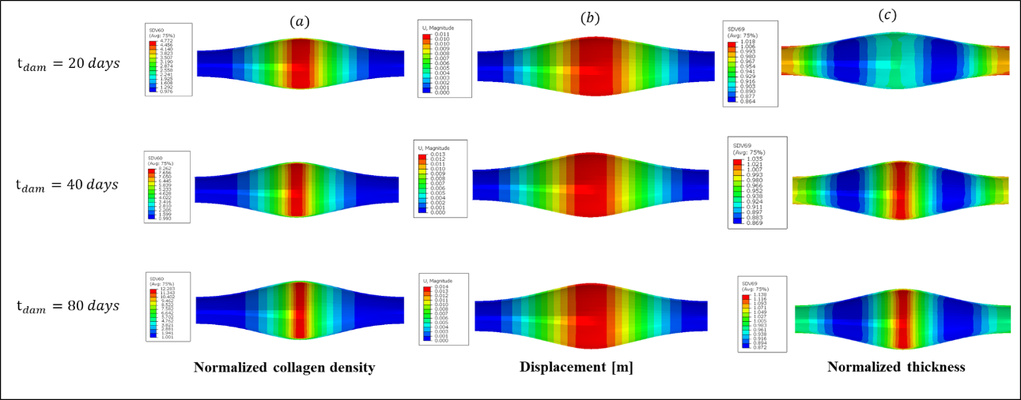
Fig. S7. Distribution of (a) standard density of collagen fibers, (b) displacement, and © standard thickness under the influence of different values of $t_{dam}$.
As $t_{dam}$ increases, the normalized density of collagen fibers in Figure S7 (a) gradually increases after undergoing a 15-year G&R process, with the maximum value increasing from 4.78 to 12.28. This indicates that an increase in the rate of elastin degradation significantly affects the deposition process of collagen fibers. The change in $t_{dam}$ does not significantly affect the final morphology of the aneurysm, as indicated by the similar maximum diameter values in Figure S7 (b) corresponding to different $t_{dam}$ values. Most collagen fibers are deposited in the middle region of the artery where elastin degradation is the fastest. Furthermore, an increase in $t_{dam}$ is accompanied by arterial wall thickening (Figure S7 (c)), with the normalized maximum arterial wall thickness increasing from 1.02 to 1.14. This suggests that as elastin degrades, damages occur, and collagen fibers deposit, the stiffness of the arterial wall gradually increases. These findings are consistent with the results of Mousavi et al.'s study^{[1]}.
In Figure S8, the influence of $λ_{actmax}^{smc}$ on the G&R process is depicted. It can be observed that as $λ_{actmax}^{smc}$ increases, the SMCs exhibit a deposition effect in the middle region of the artery. After 15 years, the mass density significantly increases from 157.5 kg/m³ (as shown in Figure S8 (a)). The maximum diameter gradually decreases, and there is a phenomenon of narrowing near the aneurysm neck region (as shown in Figure S8 (b)). Furthermore, the active stretching of smooth muscle also shows a decreasing trend (as shown in Figure S8 (c)).
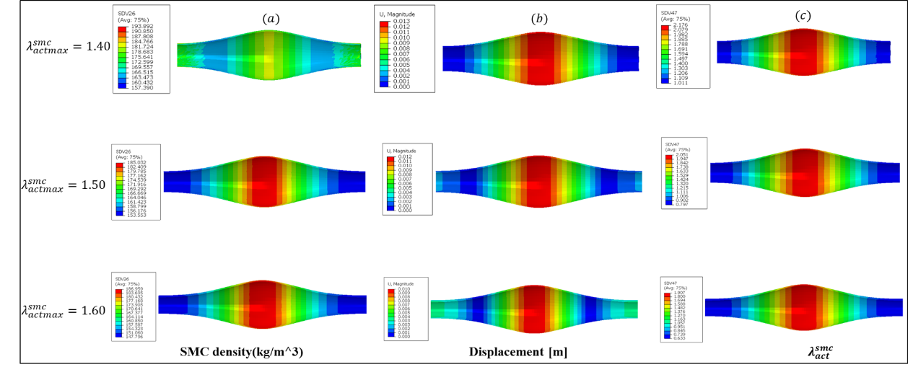
Fig. S8. Distribution of (a) smooth muscle density, (b) vessel wall displacement, and (c) active stretching of smooth muscle under the influence of different values of $λ_{actmax}^{smc}$.

Reference
[1] MOUSAVI S J, FARZANEH S, AVRIL S. Patient-specific predictions of aneurysm growth and remodeling in the ascending thoracic aorta using the homogenized constrained mixture model[J/OL]. Biomechanics and Modeling in Mechanobiology, 2019, 18(6): 1895-1913. DOI:10.1007/s10237-019-01184-8.
[2] GHAVAMIAN A, MOUSAVI S J, AVRIL S. Computational Study of Growth and Remodeling in Ascending Thoracic Aortic Aneurysms Considering Variations of Smooth Muscle Cell Basal Tone[J/OL]. Frontiers in Bioengineering and Biotechnology, 2020, 8: 587376. DOI:10.3389/fbioe.2020.587376.
[3] CYRON C J, AYDIN R C, HUMPHREY J D. A homogenized constrained mixture (and mechanical analog) model for growth and remodeling of soft tissue[J/OL]. Biomechanics and Modeling in Mechanobiology, 2016, 15(6): 1389-1403. DOI:10.1007/s10237-016-0770-9.
[4] BRAEU F A, SEITZ A, AYDIN R C, 等. Homogenized constrained mixture models for anisotropic volumetric growth and remodeling[J/OL]. Biomechanics and Modeling in Mechanobiology, 2017, 16(3): 889-906. DOI:10.1007/s10237-016-0859-1.

