Deciphering the molecular pathogenesis behind neurological manifestations of SARS-CoV-2 and drug repurposing, a systems biology approach
Maryam Mozafar¹, Seyed Amir Mirmotalebisohi ^{2,3}, Marzieh Sameni^{2,3}, Zeinab Dehghan^{2,3}, Yalda Khazaei-Poul^{2,3}, Zargham Sepehrizadeh⁴, Mohammad Ali Faramarzi⁴, Ahmad Reza Shahverdi⁴, Hakimeh Zali^{5,6*}
¹ Department of Pharmaceutical Biotechnology, Faculty of Pharmacy, Tehran University of Medical Science, Tehran, Iran
² Student Research Committee, Department of Biotechnology, School of Advanced Technologies in Medicine, Shahid Beheshti University of Medical Sciences, Tehran, Iran
³ Cellular and Molecular Biology Research Center, Shahid Beheshti University of Medical Sciences, Tehran, Iran
⁴ Department of Pharmaceutical Biotechnology, School of Pharmacy Biotechnology Research Center, Tehran University of Medical Sciences, Tehran, Iran
⁵ Proteomics Research Center, Shahid Beheshti University of Medical Science, Tehran, Iran
⁶ Department of Tissue Engineering and Applied Cell Sciences, School of Advanced Technologies in Medicine, Shahid Beheshti University of Medical Sciences, Tehran, Iran

*Corresponding author
E-mail: Hakimeh Zali: hakimehzali@gmail.com, h.zali@sbmu.ac.ir,
Tel:+982122439848 Proteomics Research Center, Shahid Beheshti University of Medical Science, Tehran, Iran

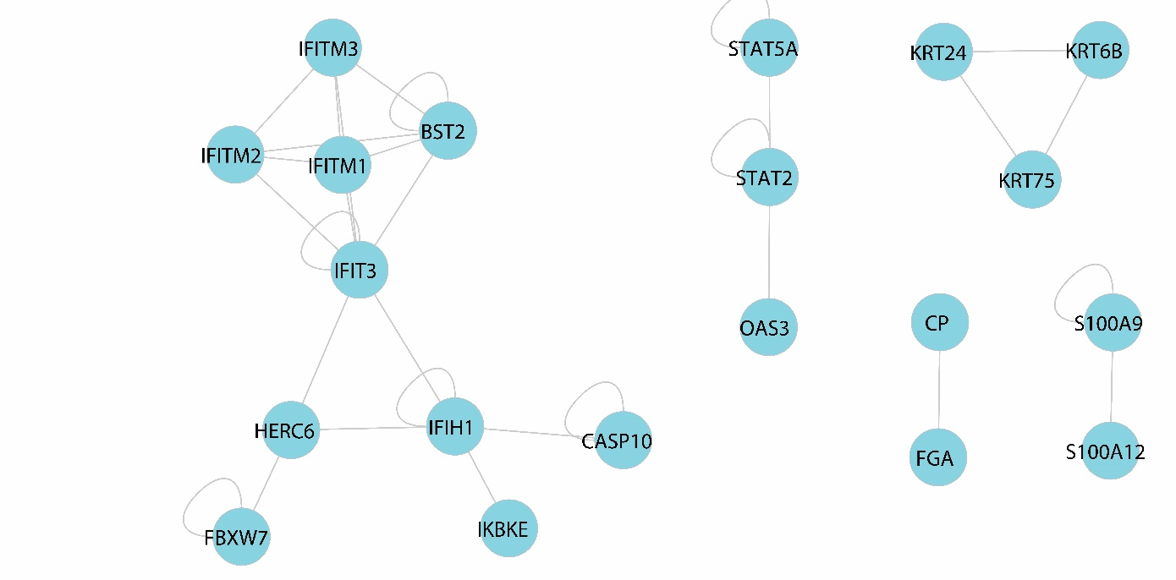
Supplementary fig.S1 The intersection of PPI networks between HCoV-OC43 (24h) & SARS-CoV-2 treated cell up-regulated DEG networks

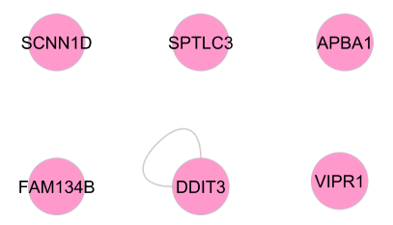
Supplementary fig.S2 The intersection of PPI networks between HCoV-OC43 (24h) & SARS-CoV-2 treated cell down-regulated DEG networks

Supplementary fig.S3- fig.S6: Size3 Network Motifs list obtained using FANMOD software. Sub-graphs are sorted based on Z-Score>2 (P-Value < 0.05). Each edge color specifies one special type of regulatory interaction between the two terms as follows below:
1)
TF-gene
2)
miR-gene
3)
TF-miR
4)
miR-TF

Fig.S3 Significant 3node size motifs for HCoV-OC43 treated cells up-regulated GRN
ID | Adj | Frequency  [Original] | Mean-Freq  [Random] | Standard-Dev  [Random] | Z-Score | p-Value
78 | 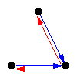 | 0.068083% | 0.041045% | 4.566e-005 | 5.9216 | 0
78 | 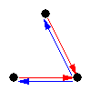 | 0.022166% | 0.014139% | 1.519e-005 | 5.2844 | 0
36 | 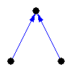 | 21.871% | 21.775% | 0.00023726 | 4.0543 | 0
14 | 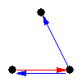 | 0.25035% | 0.22419% | 7.5316e-005 | 3.4736 | 0
164 | 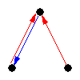 | 0.23186% | 0.20642% | 8.4042e-005 | 3.0273 | 0.003
14 | 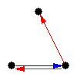 | 0.33927% | 0.30649% | 0.00012122 | 2.7048 | 0.002
6 | 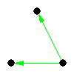 | 3.3766% | 3.3729% | 1.5206e-005 | 2.4377 | 0.007
36 |  | 5.1431% | 5.1374% | 2.3161e-005 | 2.4377 | 0.007
36 | 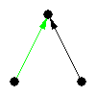 | 10.94% | 10.928% | 4.9265e-005 | 2.4377 | 0.007
36 | 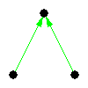 | 19.863% | 19.842% | 8.945e-005 | 2.4377 | 0.007
6 | 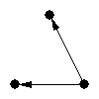 | 20.73% | 20.708% | 9.3354e-005 | 2.4377 | 0.007
14 | 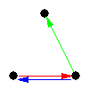 | 0.24364% | 0.22421% | 8.9861e-005 | 2.1624 | 0.016

Fig.S4 Significant 3node size motifs for HCoV-OC43 treated cells down-regulated GRN
ID | Adj | Frequency  [Original] | Mean-Freq  [Random] | Standard-Dev  [Random] | Z-Score | p-Value
78 |  | 0.039961% | 0.024832% | 2.639e-005 | 5.7331 | 0
78 |  | 0.014894% | 0.0095287% | 9.6814e-006 | 5.5423 | 0
36 |  | 13.584% | 13.534% | 0.00015416 | 3.2418 | 0.001
14 |  | 0.17526% | 0.15901% | 5.3004e-005 | 3.0663 | 0
164 |  | 0.13783% | 0.12358% | 4.6741e-005 | 3.0492 | 0.001
36 |  | 4.2019% | 4.1986% | 1.291e-005 | 2.6032 | 0.004
6 |  | 7.2505% | 7.2447% | 2.2276e-005 | 2.6032 | 0.004
36 |  | 10.899% | 10.89% | 3.3485e-005 | 2.6032 | 0.004
36 |  | 21.484% | 21.467% | 6.6007e-005 | 2.6032 | 0.004
6 |  | 25.954% | 25.933% | 7.9739e-005 | 2.6032 | 0.004
14 |  | 0.31459% | 0.28714% | 0.00011181 | 2.4547 | 0.003
14 |  | 0.1988% | 0.1826% | 6.7221e-005 | 2.4094 | 0.002

Fig.S5 Significant 3node size motifs for SARS-CoV-2 treated cells up-regulated GRN
ID | Adj | Frequency  [Original] | Mean-Freq  [Random] | Standard-Dev  [Random] | Z-Score | p-Value
78 |  | 0.066497% | 0.041403% | 4.4606e-005 | 5.6256 | 0
78 |  | 0.024602% | 0.015554% | 1.6606e-005 | 5.4484 | 0
36 |  | 24.589% | 24.485% | 0.0002199 | 4.7155 | 0
164 |  | 0.23723% | 0.20765% | 8.1541e-005 | 3.6269 | 0
14 |  | 0.29618% | 0.27148% | 8.796e-005 | 2.8073 | 0.004
36 |  | 15.965% | 15.946% | 7.6437e-005 | 2.5441 | 0.004
14 |  | 0.33213% | 0.30501% | 0.00011293 | 2.4013 | 0.003
6 |  | 21.33% | 21.307% | 9.6294e-005 | 2.3262 | 0.008

Fig.S6 Significant 3node size motifs for SARS-CoV-2 treated cells down-regulated GRN
ID | Adj | Frequency  [Original] | Mean-Freq  [Random] | Standard-Dev  [Random] | Z-Score | p-Value
78 |  | 0.11388% | 0.060846% | 7.1449e-005 | 7.423 | 0
78 |  | 0.032263% | 0.019609% | 2.3663e-005 | 5.3475 | 0
36 |  | 36.934% | 36.767% | 0.00035153 | 4.7396 | 0
14 |  | 0.35761% | 0.31511% | 0.00011562 | 3.6751 | 0
14 |  | 0.56522% | 0.48942% | 0.00021948 | 3.4534 | 0
12 | 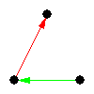 | 0.015622% | 0.015585% | 1.1408e-007 | 3.2491 | 0
6 |  | 1.2584% | 1.2554% | 9.1894e-006 | 3.2491 | 0
36 |  | 5.0365% | 5.0245% | 3.678e-005 | 3.2491 | 0
6 |  | 9.2277% | 9.2058% | 6.7387e-005 | 3.2491 | 0
36 |  | 9.376% | 9.3538% | 6.847e-005 | 3.2491 | 0
36 |  | 15.162% | 15.126% | 0.00011072 | 3.2491 | 0
164 |  | 0.37912% | 0.3309% | 0.00015557 | 3.0996 | 0

